ASSIGNMENT: We are given assignment to create database,table and perform CRUD operations.

1) Creating database

query: CREATE DATABASE company;

2) Creating table

query: CREATE TABLE employee (
empid int,
empname varchar(25),
phno int,
emailid varchar(25),
Address varchar(255),
doj date
);

3) Inserting values to table

queries:

INSERT INTO employee VALUES (101,"seema",901227377,"seemahubli08@gmail.com","navanagar",'2018-03-12');

INSERT INTO employee VALUES (102,"mubeen",865446588,"mubeen08@gmail.com","dharwad",'2018-05-11');

INSERT INTO employee VALUES (103,"gouri",865446577,"gour12@gmail.com","belgaum",'2017-04-11');

INSERT INTO employee VALUES (104,"vidya",965556577,"vidya12@gmail.com","hubli",'2017-02-11');

INSERT INTO employee VALUES (105,"nitin",965558777,"nitin42@gmail.com","vidyanagar",'2018-03-24');

INSERT INTO employee VALUES (106,"vinaya",978558777,"vinaya02@gmail.com","karwar",'2016-03-24');

INSERT INTO employee VALUES (107,"rashmi",978788777,"rashmi82@gmail.com","gadag",'2013-03-26');

INSERT INTO employee VALUES (108,"soumya",938798777,"soumya82@gmail.com","gadag",'2013-05-26');

INSERT INTO employee VALUES (109,"sushmita",938745777,"sush123@gmail.com","hubli",'2018-05-26');

INSERT INTO employee VALUES (110,"chaitra",938745702,"chaitra23@gmail.com","hubli",'2018-08-26');

4)Displaying table

query: select *from employee;
Result:

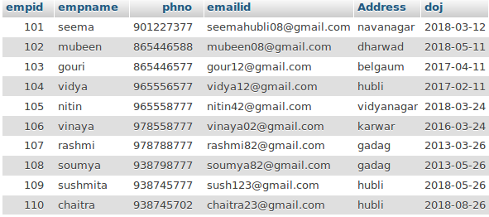

5) Deleting records from table

query 1): DELETE FROM employee
WHERE empid='107';
Result:

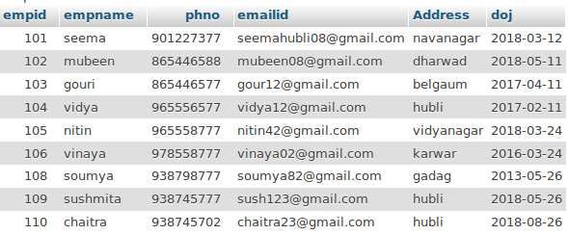

query 2): DELETE FROM employee
WHERE address='gadag';

Result:

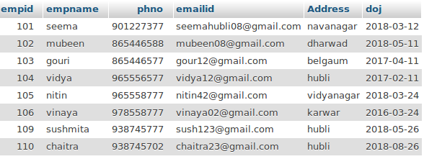

6) Updating records in table

query 2): UPDATE employee
SET phno = '78479956',Address='bangalore'
WHERE empid = 110;

Result:

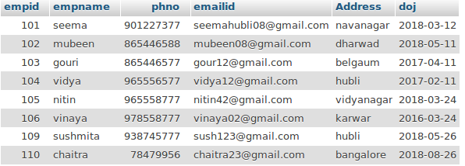
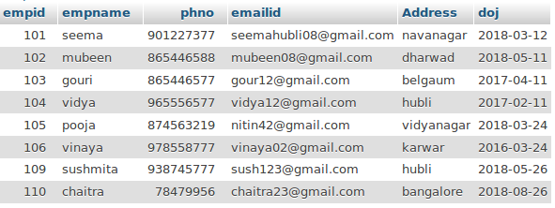

query 2): UPDATE employee
SET empname = 'pooja',phno='874563219'
WHERE empid=105;

Result:

7) Selecting distinct record from table

query: SELECT DISTINCT empid FROM employee;

Result:
