Smart Home Automation

Project Definition:
Objective: Develop a smart home automation system to enable users to control and monitor home devices remotely or automatically via a centralized interface (mobile app or web platform).
Scope:
- Control devices such as lights, thermostats, door locks, and security cameras.
- Support automation rules (e.g., "turn on lights at 6 PM").
- Provide real-time monitoring and notifications.
- Ensure secure communication and user authentication.
- Integrate with IoT protocols (e.g., MQTT, Zigbee).
Stakeholders:
- Homeowners (end-users).
- System administrators.
- IoT device manufacturers.
- Developers and maintenance team.
Deliverables:
- Mobile and web applications for device control.
- Backend server for device communication and data storage.
- Documentation, including requirements, UML diagrams, and prototypes.
- GitHub repository with all project artifacts.

Vision Statement:
Our vision is to deliver an intuitive, secure, and scalable smart home automation system that empowers users to effortlessly control and monitor their home devices through a unified mobile or web interface. By leveraging IoT technology, the system will enhance user convenience, promote energy efficiency, and ensure robust home security, creating a seamless and modern living experience.

Functional Requirements:
- User Authentication:
  - Users shall register and log in using email and password.
  - Support multi-factor authentication (MFA).

- Device Control:
  - Users shall control devices (e.g., turn lights on/off, adjust thermostat) via mobile or web app.
  - Support scheduling for automated device actions.
- Real-Time Monitoring:
  - The system shall display real-time status of devices (e.g., light on/off, door locked/unlocked).
  - Provide live camera feeds for security devices.
- Automation Rules:
  - Users shall create rules (e.g., "if motion detected, turn on lights").
  - Support time-based and event-based triggers.
- Notifications:
  - The system shall send push/email notifications for critical events (e.g., door unlocked, smoke detected).
- Device Integration:
  - The system shall integrate with IoT devices using standard protocols (e.g., MQTT, Zigbee).
  - Support adding/removing devices dynamically.

Non-Functional Requirements:
- Performance:
  - The system shall respond to user commands within 1 second.
  - Support up to 100 simultaneous device connections per household.
- Security:
  - All communications shall use TLS encryption.
  - User data shall be stored securely with AES-256 encryption.
- Scalability:
  - The system shall scale to support 10,000 users without performance degradation.
- Usability:
  - The interface shall be intuitive, with a learning curve of less than 5 minutes for new users.
- Reliability:
  - The system shall have 99.9% uptime.
  - Handle device failures gracefully with fallback options.
- Compatibility:
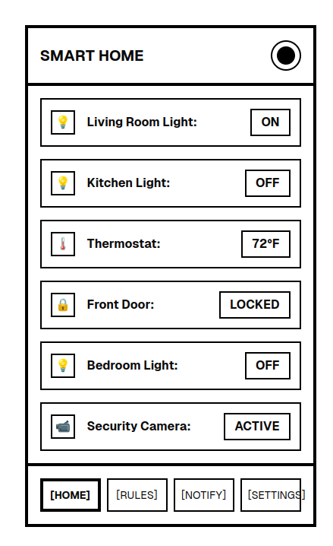
  - The app shall support iOS 15+, Android 10+, and modern web browsers (Chrome, Firefox, Safari).

Low-Fidelity Prototypes

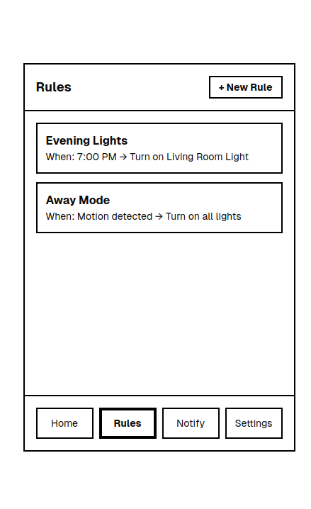

High-Fidelity Prototypes:
