**Problem Instances**

1.

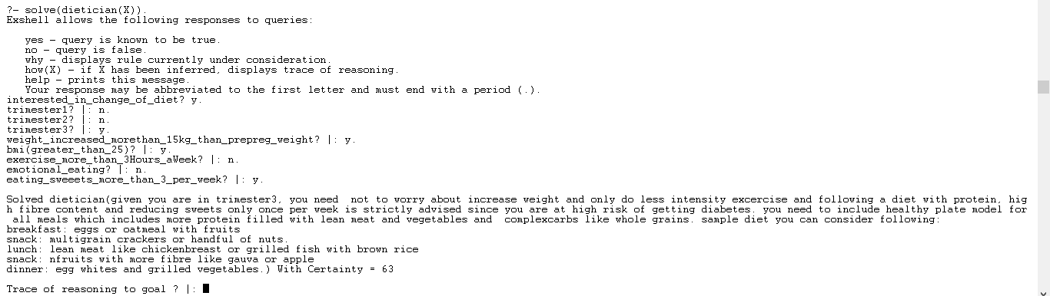

2.

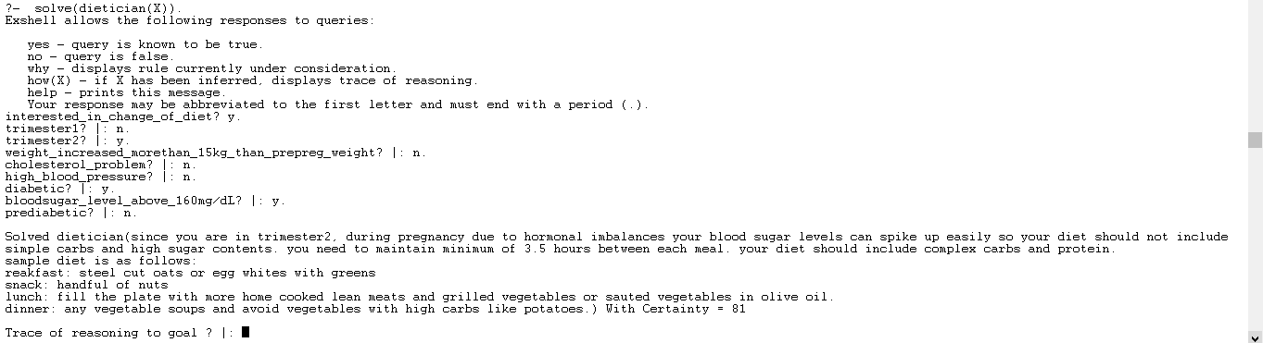

3.

