**User Report on Expert System on Gestational Diabetes Diet.**

* Step 1: Download the “Swi-proglog” open source software from the internet and have it installed and running.
* Step 2: right click on the file and open it with Swi-prolog application. (or) open the Swi-prolog application and go to file > consult > select the file. And you have the file ready to run, but make sure that you compile the file before.
* Step 3: type “solve(dietician(X)).” And press enter.
* Step 4: the following will appear on your screen.
* Step 5: Given an appropriate ‘y’ and ‘n’ answers and type in the required answers if asked for.
* Step 6:

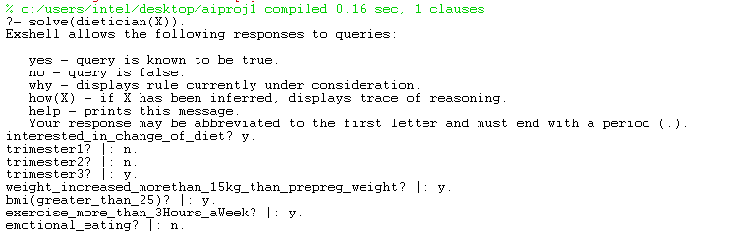

* Step7: based on your input the system gives the output.