Experiment 1 :
Objective : To design and simulate a simple computer network using various connection topologies(bus, star, ring, mesh). Compare the advantages and disadvantages of each topology in terms of data flow and network efficiency.

Components required :
Hardware Components (in Cisco Packet Tracer):
PCs
Switches
Hub
Routers
Copper Straight-Through Cable
Copper Cross-Over Cable

Network Design :

Bus Topology
Advantages:
Simple and easy to implement.
Low cost (less cable required).
Suitable for small networks.
Disadvantages:
High collision rate.
Performance decreases as devices increase.
If backbone fails, entire network fails.
Difficult to troubleshoot.

Star Topology :
Advantages:
Better performance than Bus.
Easy to add/remove devices.
Failure of one cable does not affect others.
Disadvantages:
If central switch fails, entire network fails.
More cable required.
Slightly higher cost.

Ring Topology :
Advantages:
No collision.
Equal access for all devices.
Predictable performance.
Disadvantages:
Failure of one node can break entire network.
Difficult to troubleshoot.
Adding/removing devices affects the whole network.

Mesh Topology :
Advantages:
Very high reliability.
High fault tolerance.
No traffic congestion (multiple paths).
Disadvantages:
Very expensive.
Complex configuration.
Requires large number of cables.

Bus Topology
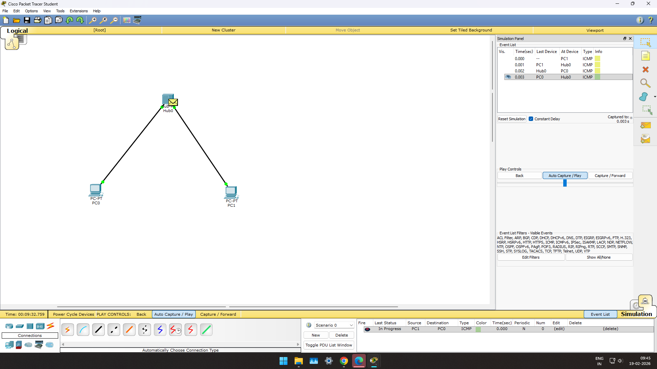

Star Topology
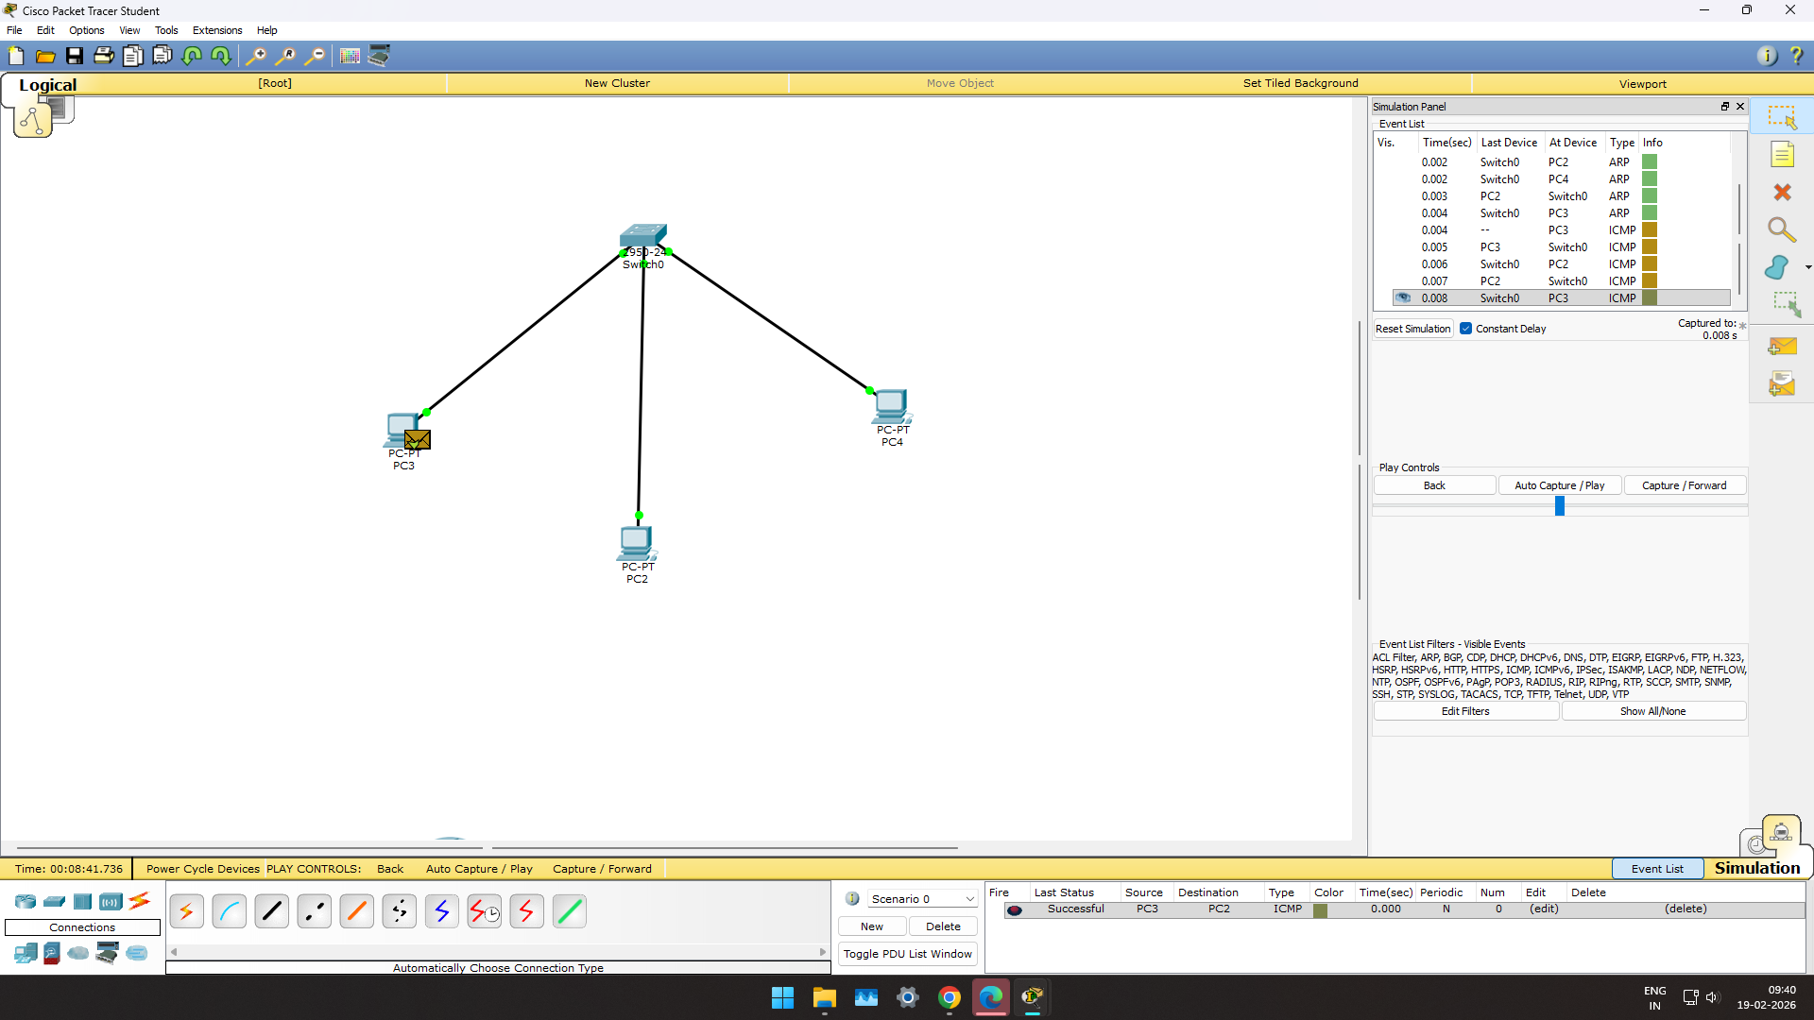

Ring Topology
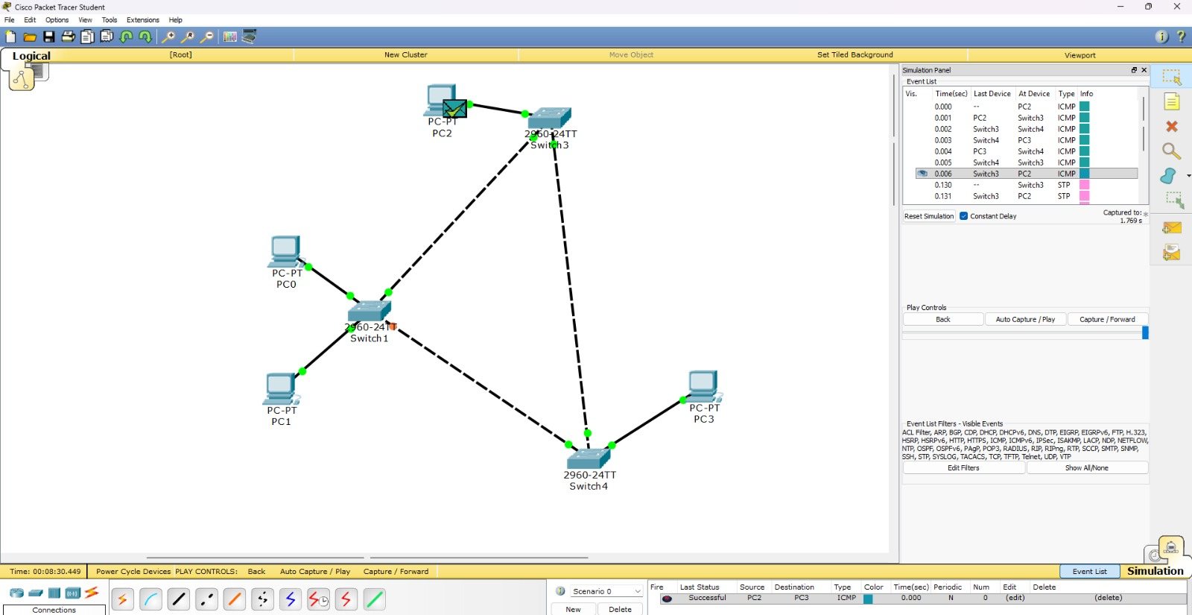
Mesh Topology

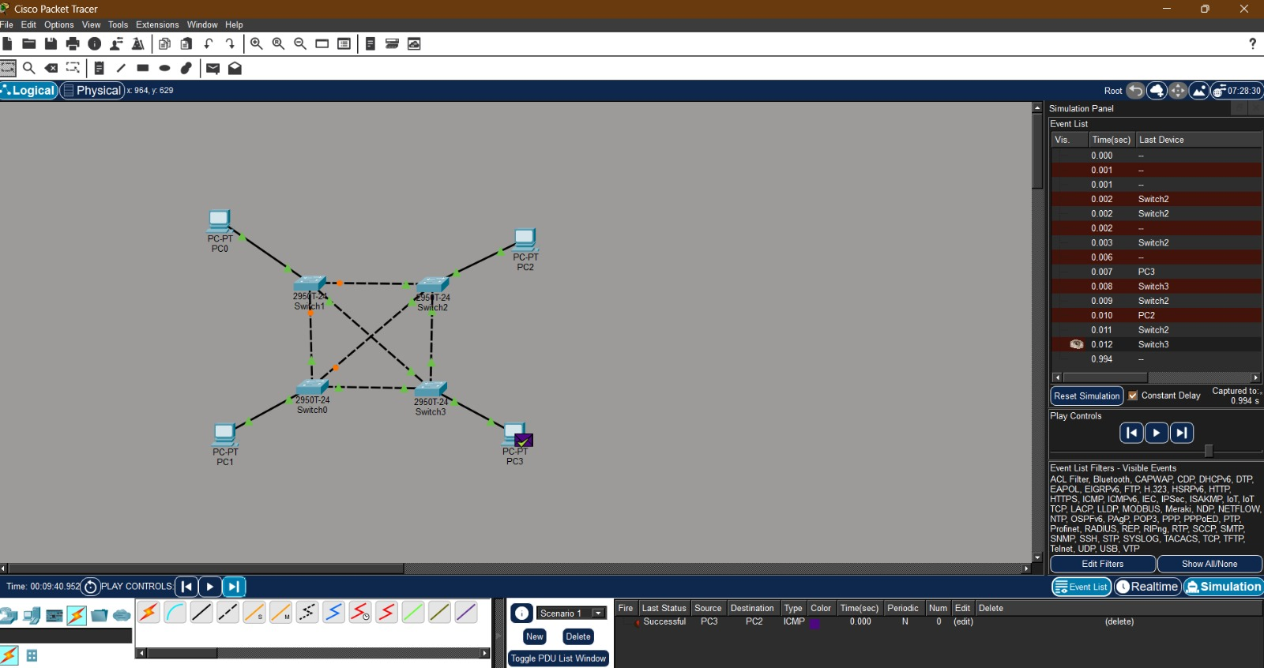
Conclusion :
Bus topology is simple but inefficient for large networks.
Star topology provides better performance and is widely used in modern LANs.
Ring topology avoids collisions but is less flexible.
Mesh topology offers the highest reliability and efficiency but at high cost and complexity.
·

Experiment 2 :

Objective : To create a network simulation to demonstarte packet switching and circuit switching. Compare the performance and efficiency of both methods by simulating a series of data transmission scenarios.

Components Required :
Hardware Components (in Cisco Packet Tracer):
PCs
Switches
Routers
Copper Straight-Through Cables

Network Design

Circuit Switching Simulation
Working Principle:
A fixed communication path is established before data transmission.
Bandwidth is reserved for the entire session.
Data follows the same path until communication ends.

Performance Characteristics:
Fixed delay.
No packet loss due to congestion (if bandwidth reserved).
Inefficient use of bandwidth during idle time.

Packet Switching Simulation
Working Principle:
Data is divided into packets.
Each packet may take a different path.
No dedicated path is reserved.

Performance Characteristics:
Efficient bandwidth utilization.
Possible delay variation.
Packets may arrive out of order.

Conclusion
Circuit Switching provides stable and predictable performance but wastes bandwidth.
Packet Switching is more efficient and scalable, making it suitable for modern networks like the Internet.

