1. Project Overview
Medicature is a web based prescription management platform designed with the help of support to patients and caregivers to carefully supervise medication routine. The platform will be accompanied by a convenient dashboard that will enable the organization of prescriptions, with the advantage of a well-developed notification system that will remind the users of the exact time they will need to take medicine. Further more, the system will also include detailed profile administration functions in such a way that the relevant personal and clinical data is easily accessible and safely stored.
2. Key Features
User Management: Secure registration and login authentication.
Profile Management: Update personal details, change passwords, and manage notification settings.
Medication Tracking: Add, edit, and view medicines with specific dosages and schedules.
Smart Notifications: Real-time browser notifications with alarm to remind users of due medications.
Dynamic Dashboard: Visual overview of upcoming medications and adherence status.

3. System Diagrams

3.1. Use Case Diagram
This diagram illustrates the primary interactions between the User and the Medicature system.

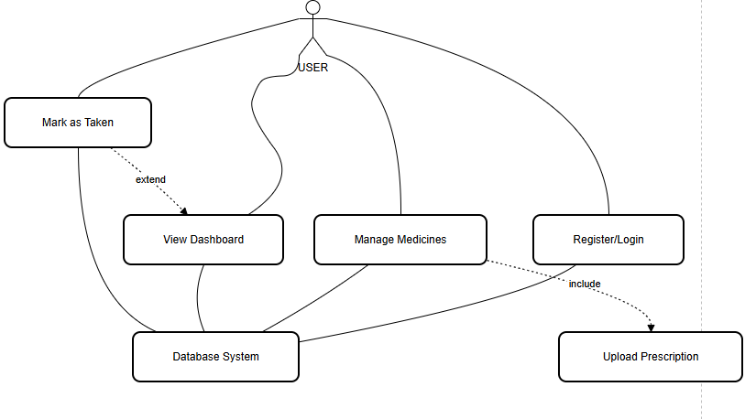
### 3.2. Activity Diagram (Notification Flow)
The following activity diagram details the process of how the system triggers text and audio reminders for the user.
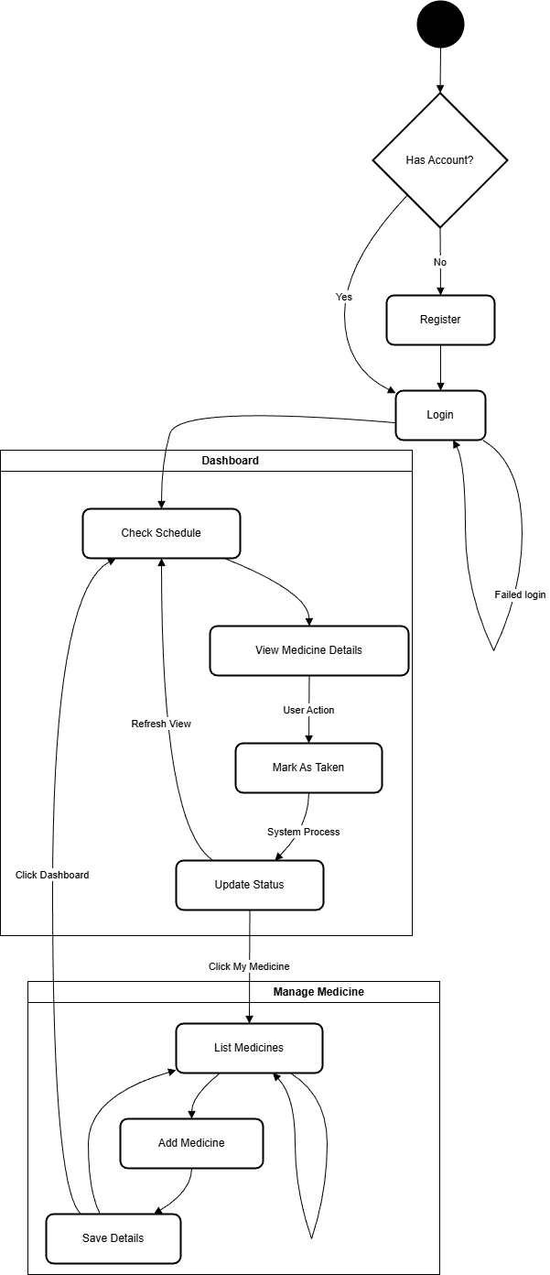

### 3.3. Database Diagram (ERD)
The database schema consists of users, medicines, schedules, and reminder logs.
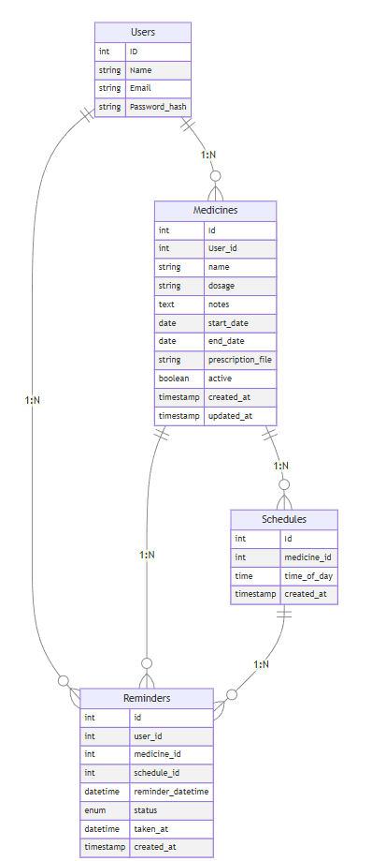
4. User Interface Gallery
Login Page
The entry point for the application, ensuring secure access.
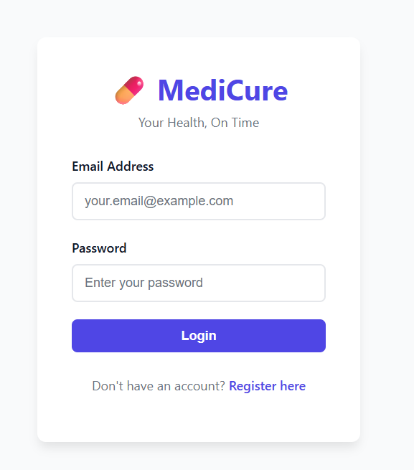
After Registering Successfully:
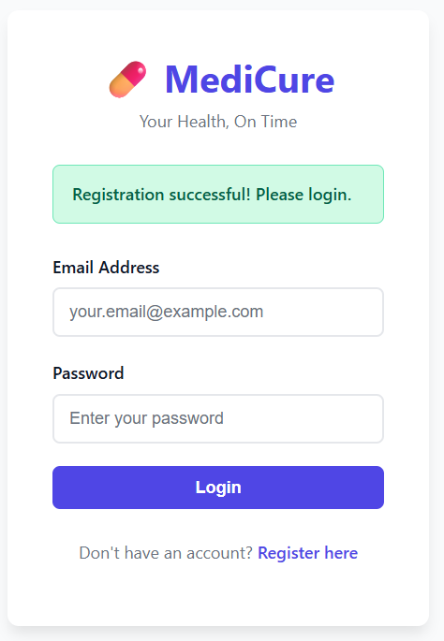
Registraion Page:
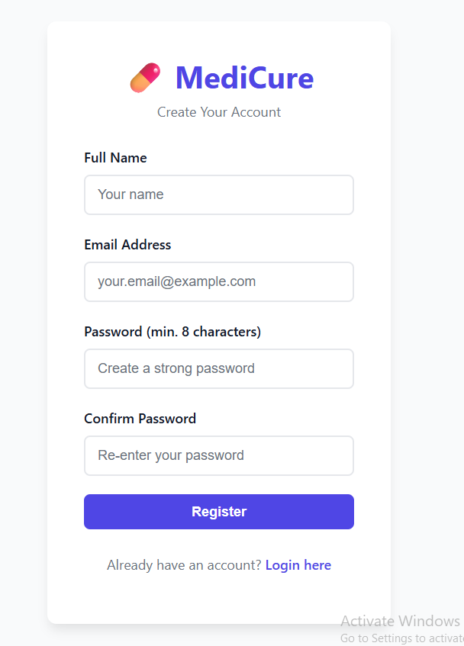
Here the user have to enter the name, email address, password and confirm their password to register.
Profile Management (Update 1)
The profile management function can be accessed from the top right as the image shows it also indicates that we are in the profile management section. Users can update their personal information, enable notifications and securely change their passwords.
The email is unchangeable but the user can change the name at the same time it also shows that the notifications are already enabled.
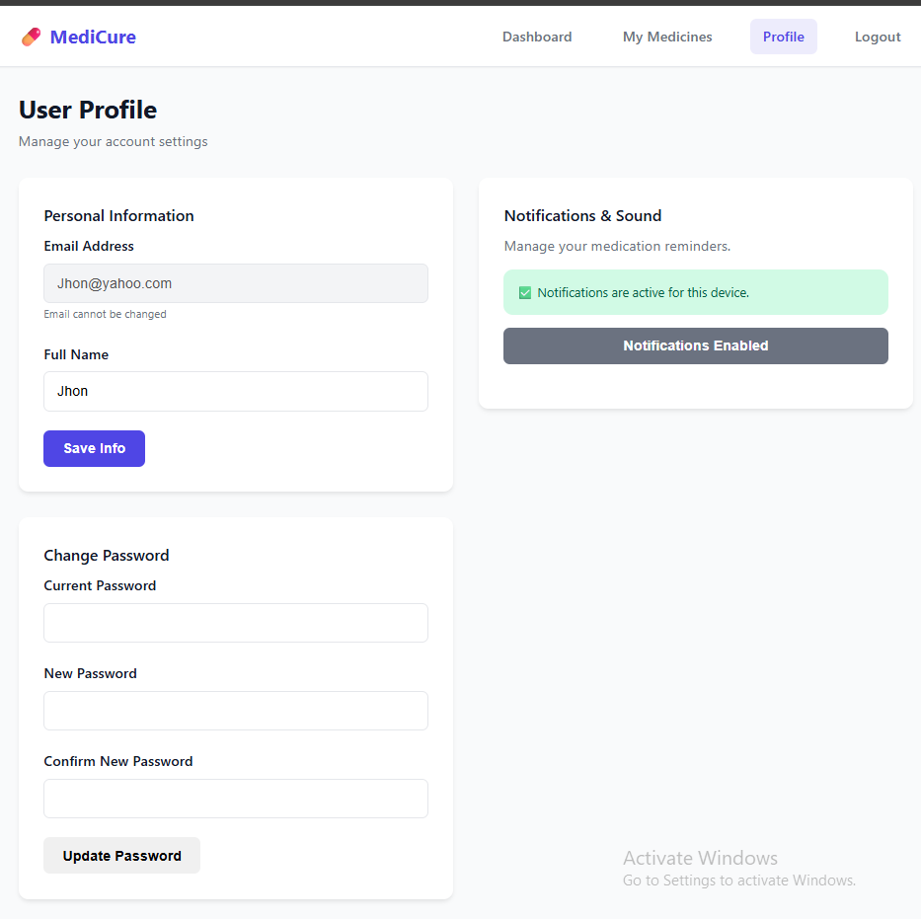
My Medicines:
Here the user can see what are the medicines they have added or they will take.
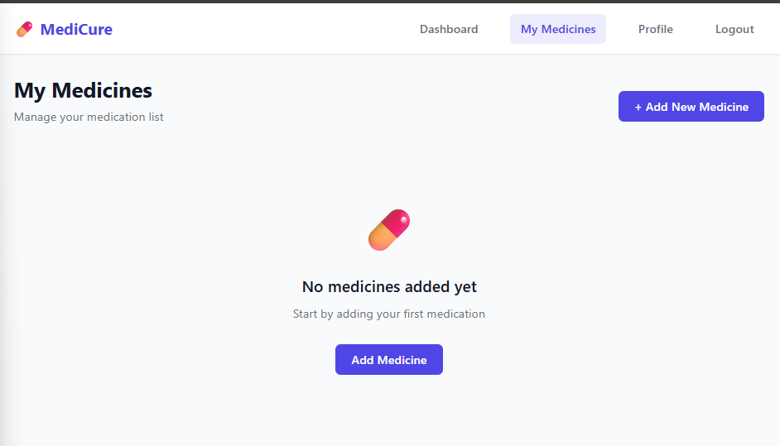
This is how it looks after an medicine is added.
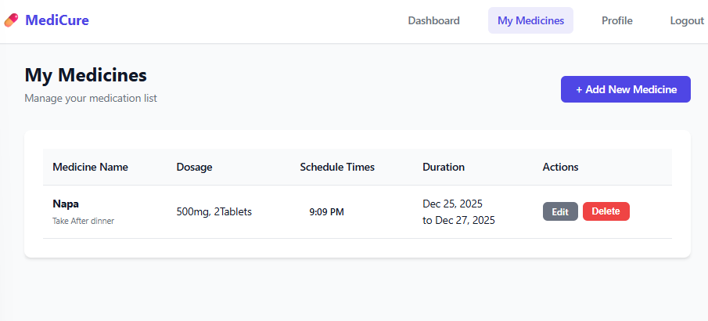
Adding New Medicine: Here the user add his medicine there are multiple sections here like the medicine name part is for the name of the medicine, the dosage part is for how much medicine the user will take, there are note and instructions part for valuable guidelines for the medicines, there are start and end date part the part is kept optional with the thought of medicine like Monas which is an allergy based medicine or like the person has Diabetes then they go through like a lifetime of medicine, there are schedule time part the user can add multiple times here like the same medicine can be prescribed both in the night and in the morning and there is also an prescription upload part an optional part which is kept even though unnecessary.
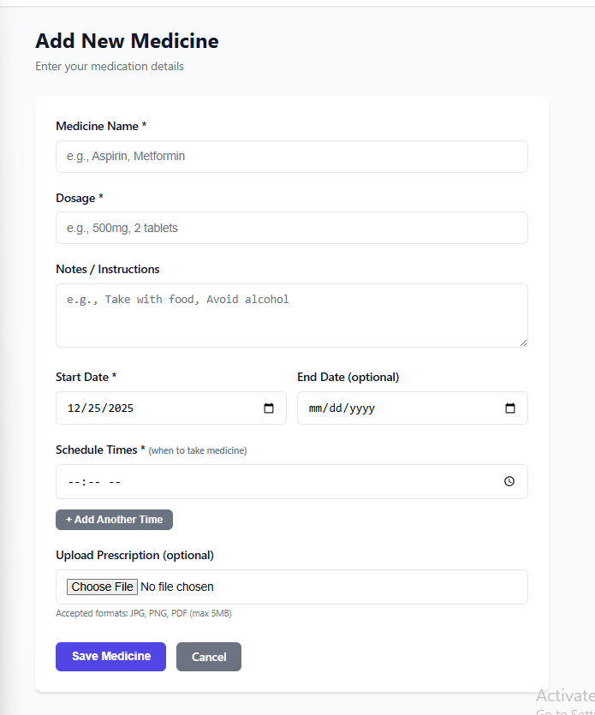
This is how it looks after and medicine is added and we can access this in edit medicine part in the website.
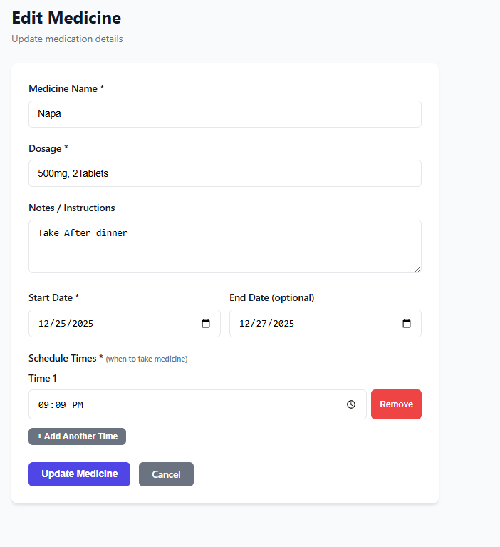
Dashboard:
Finally, this is how our dashboard looks like the important part is that the upper section where we see the Active Medicine part the Does today part and taken part.
Active Medicine: How many total medicines are registered here in the app.
Doses Today: How many doses we total have to take today.
Taken: Shows How many we have taken today we have to click mark as taken then the taken will add one to it and negate 1 from the active medicines.
This is a simple way to show actually if the Doses today is 4 and the taken is 3 the user can come to the realization that the user haven’t taken an medicine today.
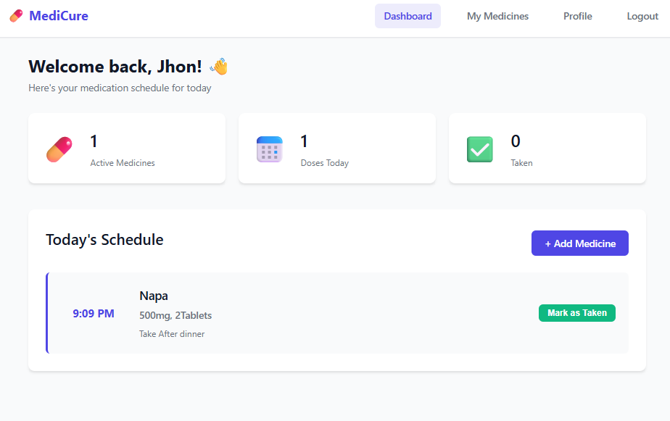
After clicking the Marks as taken.
