Fuzzy logic controller:
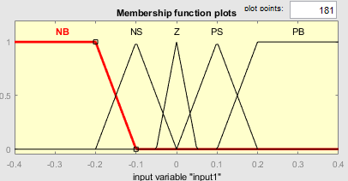
Input1
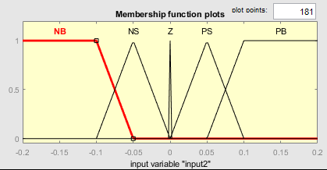
Input2
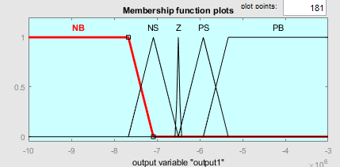
Output
Truth table:
Delta P/Delta V | NB | NS | Z | PS | PB
NB | PB | PS | NB | NS | NS
NS | PS | PS | NB | NS | NS
Z | NS | NS | NS | PB | PB
PS | NS | PB | PS | NB | PB
PB | NB | NB | PB | PS | PB

