SYSTEM MANUAL • FEATURE GUIDE • TRAINING RESOURCE
GLV Management System
A visual guide to customer management, installment accounts, collections, procurement, staff control, reporting, and security
OPERATIONS  Customers • Accounts • Payments | CONTROL  Audit • Permissions • Security | INTELLIGENCE  Reports • Deposits • Profitability
Prepared for God's Love Ventures
Training, onboarding, demonstrations, and feature communication

How to Use This Guide
This guide explains what each major GLV Management System screen does, how it supports daily operations, and where it fits into management control. Screenshots were captured from the live system in read-only fashion; no form was submitted and no business record was created, changed, approved, or deleted.
Privacy note: Some screenshots contain live operational names and figures. Before using this guide in public advertising, replace or anonymise sensitive customer, staff, receipt, and financial information.

Core Business Flow
Products define the commercial terms. Staff are assigned customers. Customers receive one or more product accounts. Payments reduce account balances and create receipts. Completed accounts move into delivery control. Collections feed reports, procurement readiness, payroll analysis, deposits, reconciliation, credits, and audits.

Guide Contents
No. | Screen / capability
1 | Business Dashboard
2 | Activity Monitoring
3 | Customer Directory
4 | Customer Profile
5 | Create Customer
6 | Edit Customer
7 | Account Management
8 | Account Details
9 | Create Customer Account
10 | Payments Ledger
11 | Payment Recording Popup
12 | Full Payment Form
13 | Credits and Refunds
14 | Product Catalogue
15 | Product Details
16 | Create Product
17 | Edit Product
18 | Procurement Overview
19 | Procurement Details
20 | Staff Management
21 | Staff Profile
22 | Create Staff
23 | Edit Staff and Permissions
24 | Financial Intelligence and Reports
25 | Audit Logs
26 | My Profile
27 | Profile Change Approvals
28 | System Settings
29 | Weekly Report Import and Recovery

FEATURE 01

Business Dashboard
Provides an executive view of customers, staff, accounts, collections, receivables, product exposure, payroll, refunds, and projected profitability.
How it is used: Use it as the daily starting point for assessing business position and identifying areas that need attention.
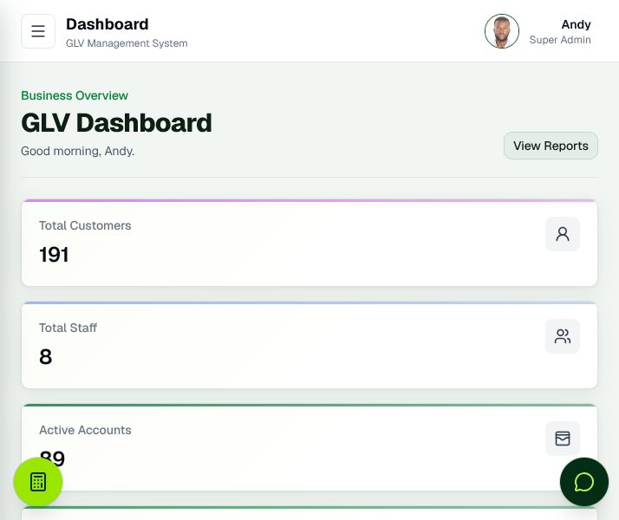
Figure 1. Business Dashboard

FEATURE 02

Activity Monitoring
Summarises recent customer, account, and payment activity so administrators can see what changed and when.
How it is used: Use it for operational awareness, follow-up, and quick investigation of newly recorded work.
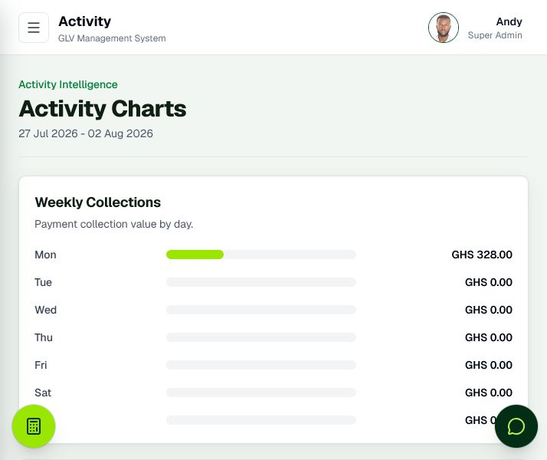
Figure 2. Activity Monitoring

FEATURE 03

Customer Directory
Centralises customer records with search, sorting, assignment, account counts, and quick access to customer actions.
How it is used: Use it to locate customers, review ownership, open profiles, create accounts, and manage assignments.
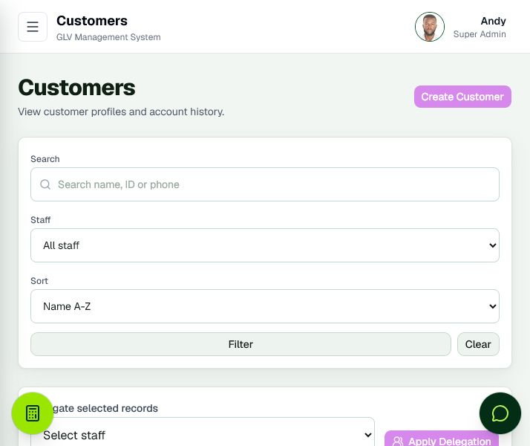
Figure 3. Customer Directory

FEATURE 04

Customer Profile
Combines customer identity, assigned staff, accounts, payment progress, credits, delivery status, and account actions in one profile.
How it is used: Use it when assisting a specific customer or reviewing the customer’s complete relationship with GLV.
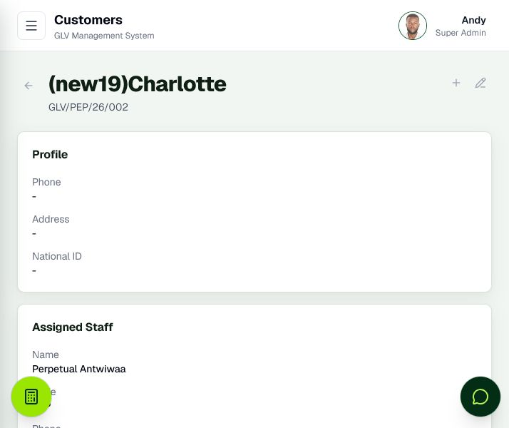
Figure 4. Customer Profile

FEATURE 05

Create Customer
Captures the information required to register a customer and assign responsibility to a staff member.
How it is used: Use it for onboarding. Required information and access rules help keep customer records consistent.
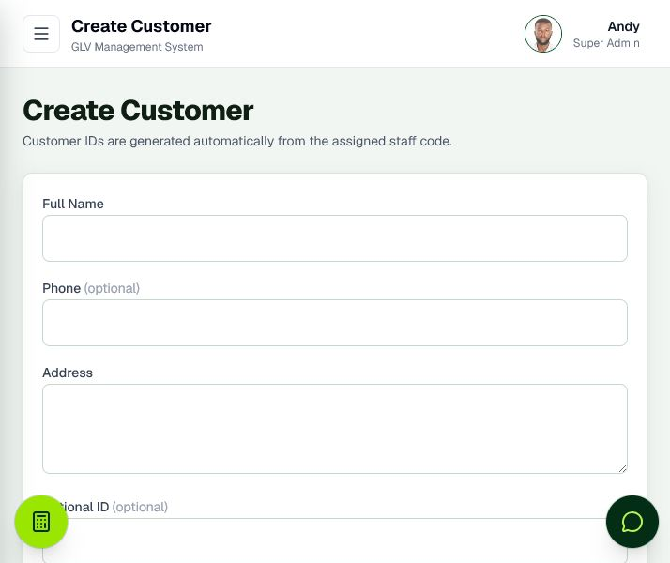
Figure 5. Create Customer

FEATURE 06

Edit Customer
Allows authorised users to correct or update customer information without recreating the record.
How it is used: Use it when contact, address, identity, or assignment information changes.
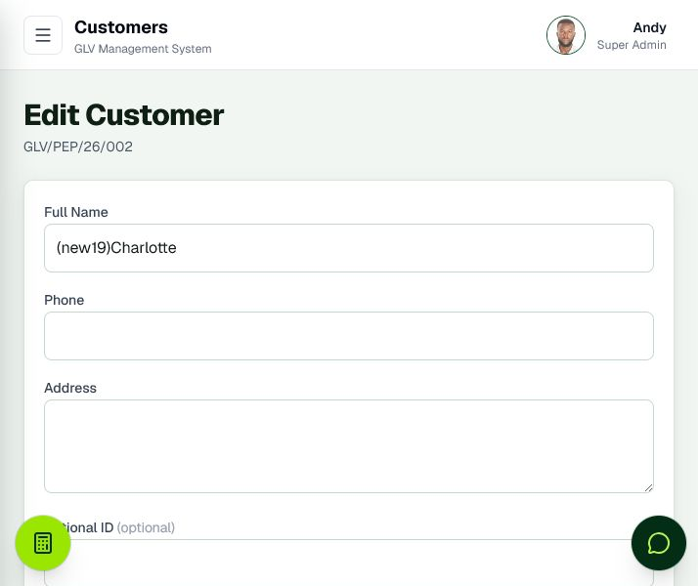
Figure 6. Edit Customer

FEATURE 07

Account Management
Lists customer product accounts with balances, progress, lifecycle status, delivery state, filters, and payment shortcuts.
How it is used: Use it to monitor active agreements, overdue exposure, completed accounts, and account-level actions.
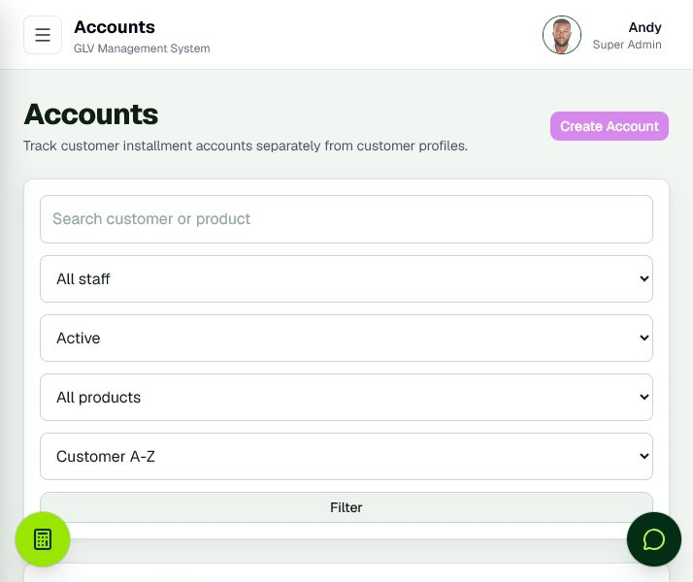
Figure 7. Account Management

FEATURE 08

Account Details
Shows the complete financial and operational history of a single product account, including payments, balance, delivery, credits, and lifecycle controls.
How it is used: Use it to answer account-specific questions and verify the evidence behind the current balance.
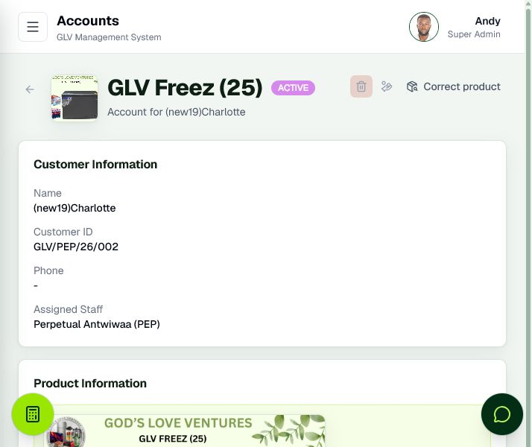
Figure 8. Account Details

FEATURE 09

Create Customer Account
Creates a layaway account by linking a customer to a product and automatically calculating the applicable terms.
How it is used: Use it for first and additional customer accounts. After creation, the same customer can be carried forward to create another account.
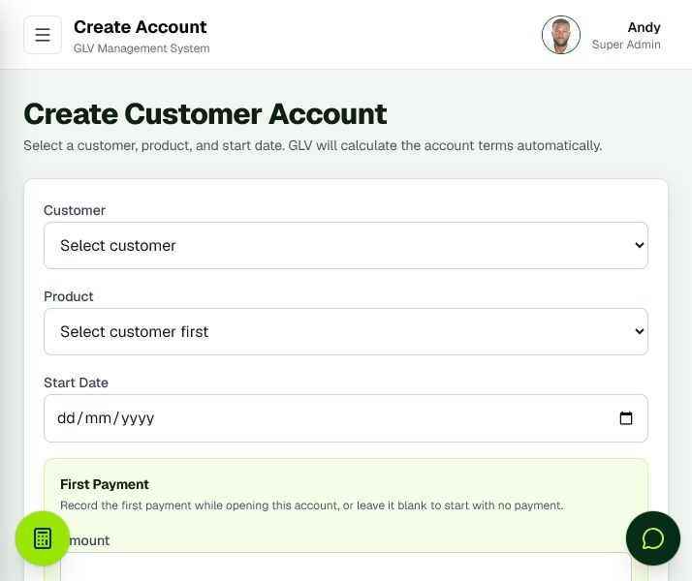
Figure 9. Create Customer Account

FEATURE 10

Payments Ledger
Organises recorded collections by staff and customer, with receipt, method, amount, date, credit, search, and filtering information.
How it is used: Use it to verify collections, locate receipts, review payment history, and investigate recorded amounts.
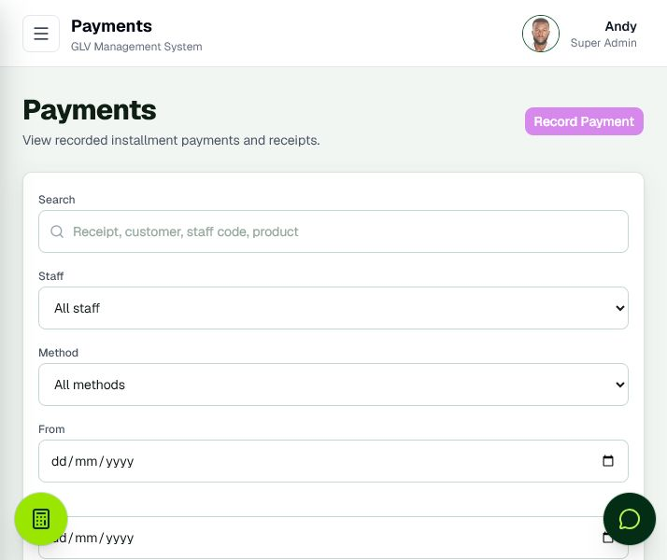
Figure 10. Payments Ledger

FEATURE 11

Payment Recording Popup
Records a payment without leaving the current operational page, reducing repeated page loading during collection entry.
How it is used: Use it to select an account, enter the amount, date, method, and notes, then confirm the payment and receipt.
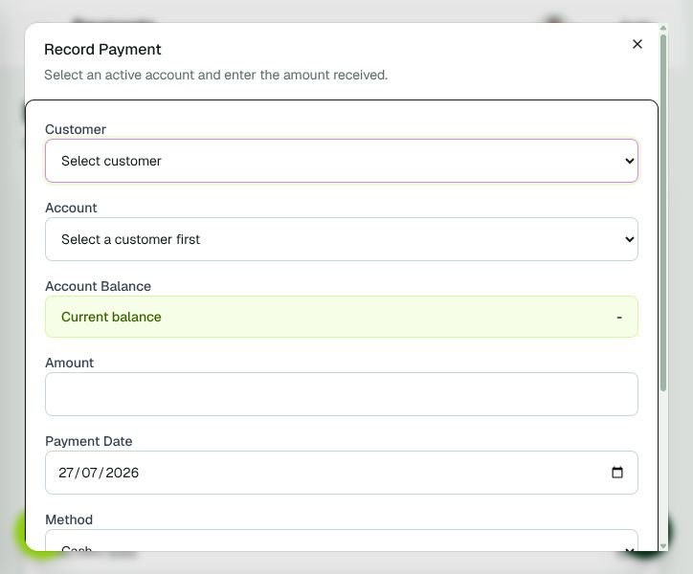
Figure 11. Payment Recording Popup

FEATURE 12

Full Payment Form
Provides the complete standalone payment-entry workflow for selecting customers and eligible accounts.
How it is used: Use it when starting payment recording from a general shortcut rather than a specific customer or account.
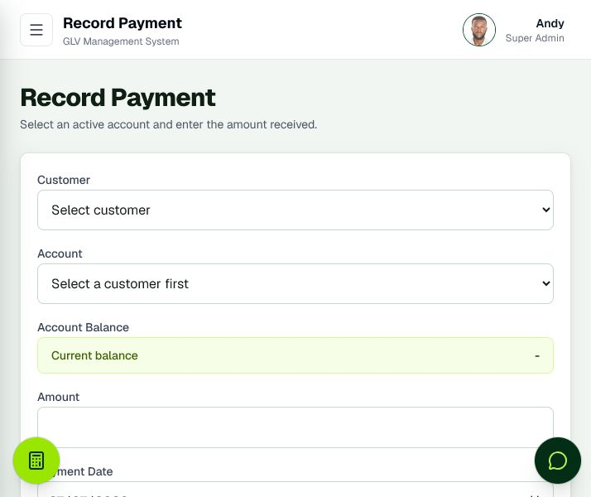
Figure 12. Full Payment Form

FEATURE 13

Credits and Refunds
Tracks overpayments, closure refunds, remaining credit, and resolution status.
How it is used: Use it to control money owed back or available to customers and to preserve an auditable refund process.
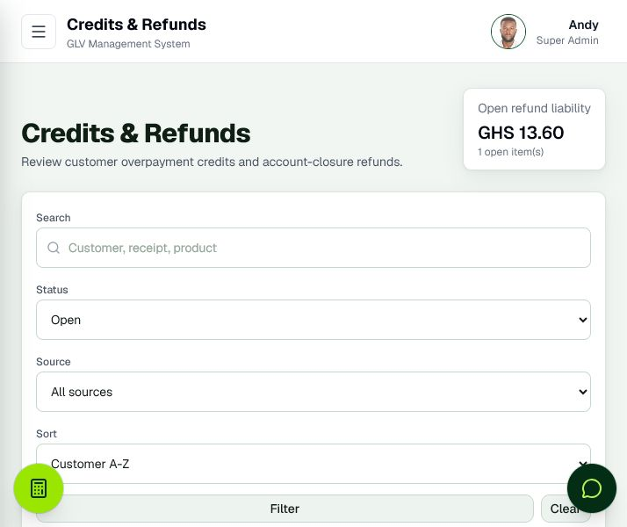
Figure 13. Credits and Refunds

FEATURE 14

Product Catalogue
Maintains product pricing, cost, transport, layaway terms, images, profitability, and active status.
How it is used: Use it to manage the commercial rules that drive customer accounts and profit calculations.
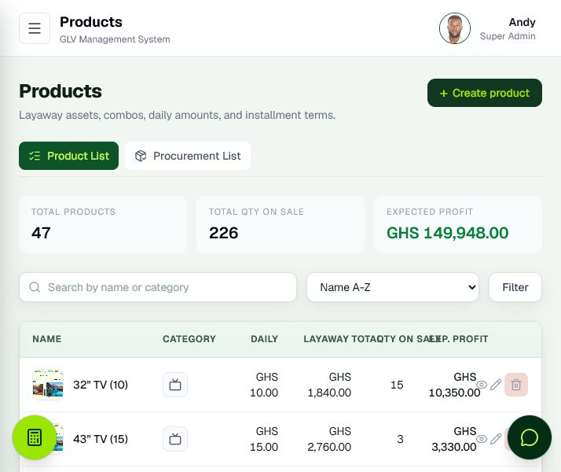
Figure 14. Product Catalogue

FEATURE 15

Product Details
Explains the pricing and profitability of a single product and provides access to its linked operational information.
How it is used: Use it to validate product economics before selling or procuring additional units.
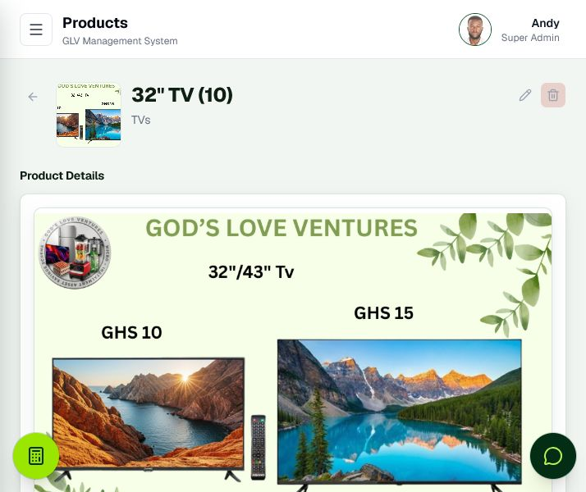
Figure 15. Product Details

FEATURE 16

Create Product
Captures product cost, pricing, category, image, duration, and daily installment rules.
How it is used: Use it to introduce a product into the catalogue with consistent financial terms.
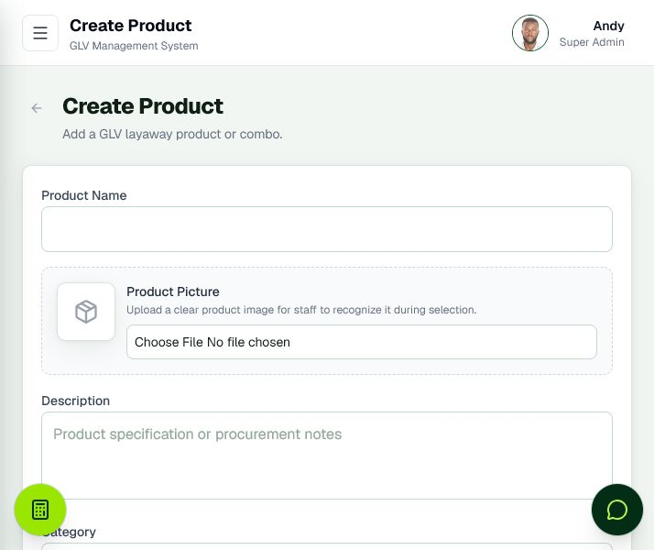
Figure 16. Create Product

FEATURE 17

Edit Product
Allows authorised correction of product descriptions, pricing inputs, images, and operating rules.
How it is used: Use it when the commercial terms or product presentation changes.
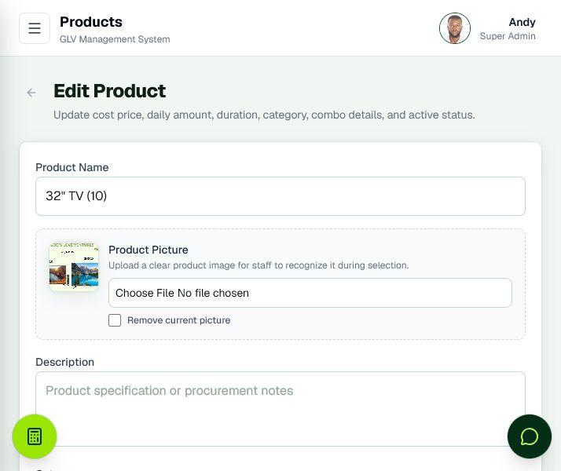
Figure 17. Edit Product

FEATURE 18

Procurement Overview
Identifies products that have crossed the configured collection threshold and may be ready for purchasing.
How it is used: Use it to prioritise procurement based on customer commitments and money already collected.
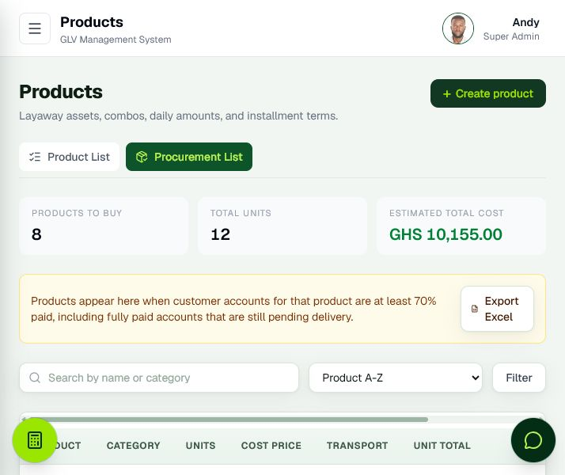
Figure 18. Procurement Overview

FEATURE 19

Procurement Details
Shows the customer accounts contributing to procurement demand for a selected product.
How it is used: Use it to validate quantities, collection progress, and the evidence behind a procurement decision.
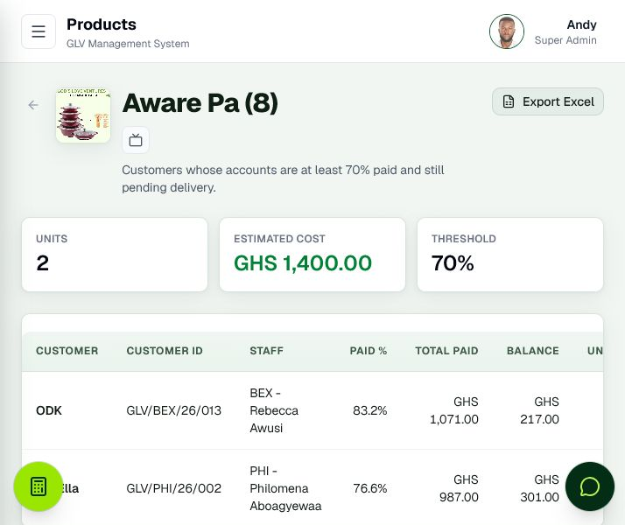
Figure 19. Procurement Details

FEATURE 20

Staff Management
Maintains staff records, roles, permissions, status, customer assignments, inventory, and access-related actions.
How it is used: Use it to administer the workforce and control what each user can see or manage.
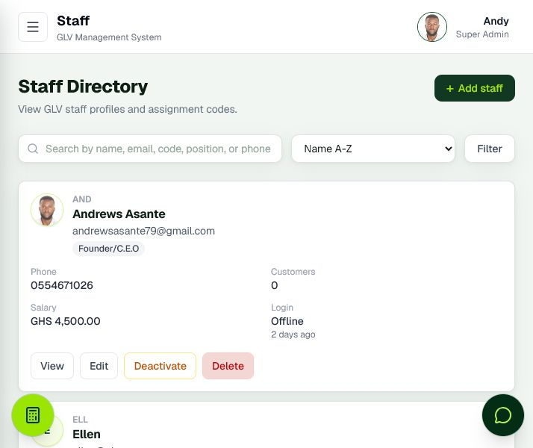
Figure 20. Staff Management

FEATURE 21

Staff Profile
Combines staff identity, assigned customers, performance information, permissions, and related operational records.
How it is used: Use it for staff supervision, responsibility reviews, and access-control decisions.
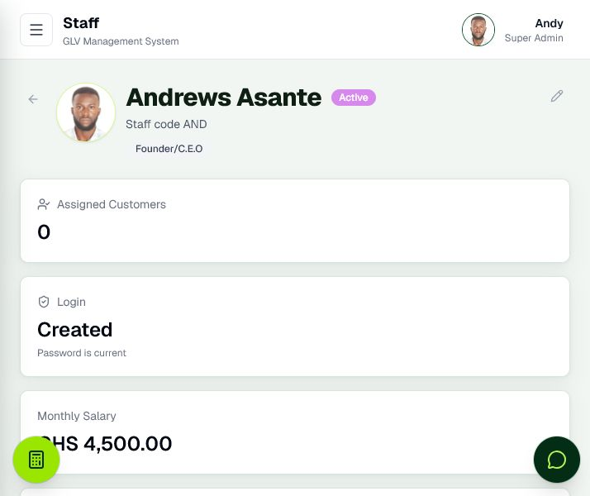
Figure 21. Staff Profile

FEATURE 22

Create Staff
Registers a staff profile with the core information needed for assignment and system access.
How it is used: Use it during onboarding before creating or linking the corresponding user account.
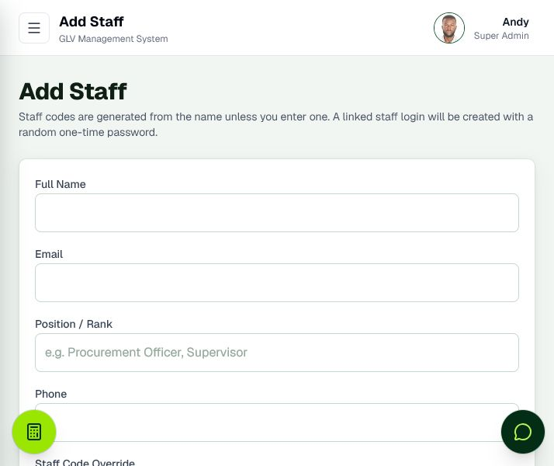
Figure 22. Create Staff

FEATURE 23

Edit Staff and Permissions
Allows authorised administrators to maintain staff details and operational privileges.
How it is used: Use it to adjust responsibilities carefully; permission changes affect which modules and actions the staff member can access.
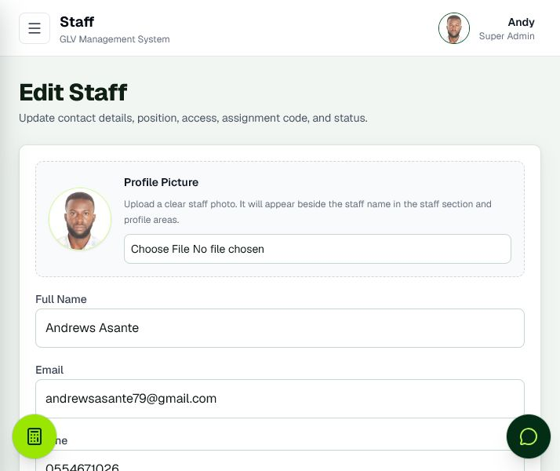
Figure 23. Edit Staff and Permissions

FEATURE 24

Financial Intelligence and Reports
Combines business performance, weekly staff collections, physical deposits, shortage or surplus, payroll, product profitability, and Excel export.
How it is used: Use it for weekly control meetings, staff accountability, salary tracking, reconciliation, and management reporting.
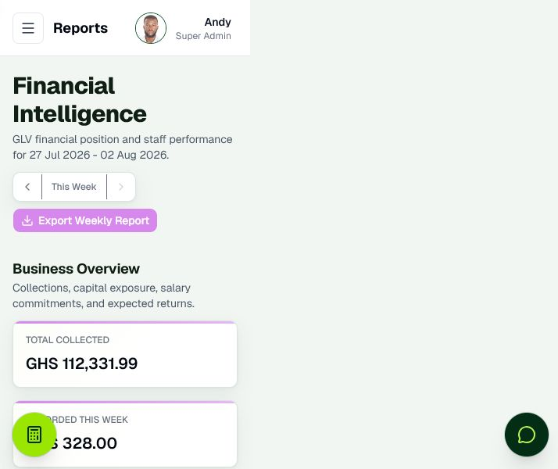
Figure 24. Financial Intelligence and Reports

FEATURE 25

Audit Logs
Records important system actions with user, entity, action, and timing information.
How it is used: Use it to investigate changes, support accountability, and demonstrate operational traceability.
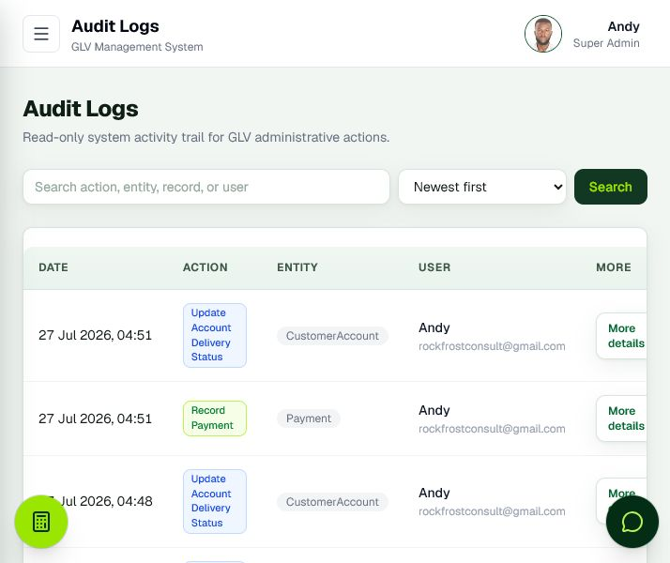
Figure 25. Audit Logs

FEATURE 26

My Profile
Provides personal profile information and controlled requests for sensitive profile changes.
How it is used: Use it to review account identity, request permitted updates, and access personal security controls.
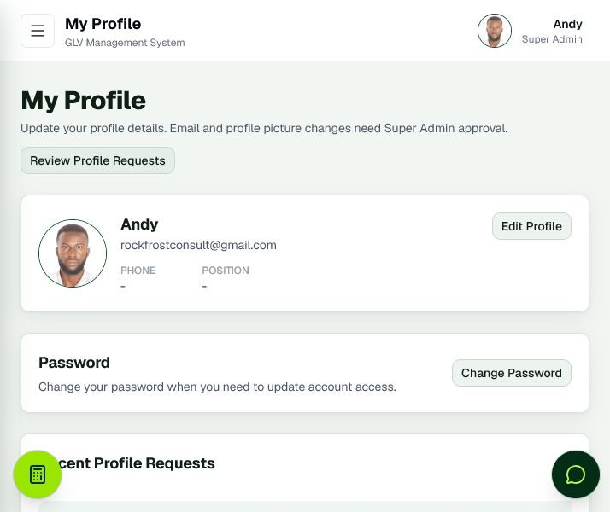
Figure 26. My Profile

FEATURE 27

Profile Change Approvals
Allows authorised administrators to review pending email and profile-image change requests.
How it is used: Use it to keep sensitive identity changes controlled rather than immediately self-approved.
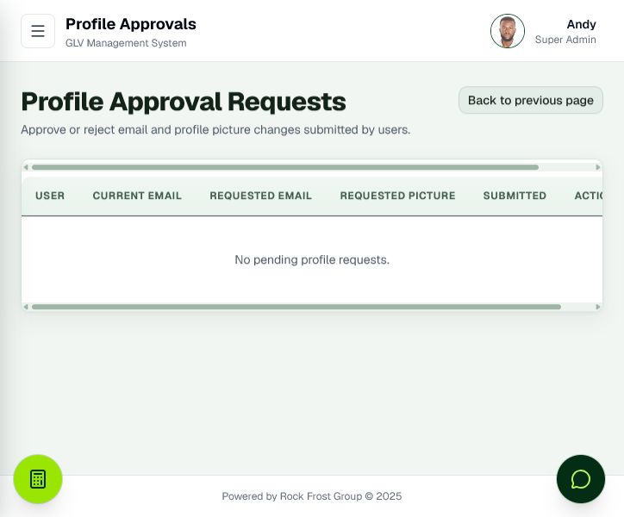
Figure 27. Profile Change Approvals

FEATURE 28

System Settings
Centralises company identity, receipt rules, account controls, security settings, backup, import, and operational configuration.
How it is used: Use it for system-wide administration. Changes here can affect all users and workflows.
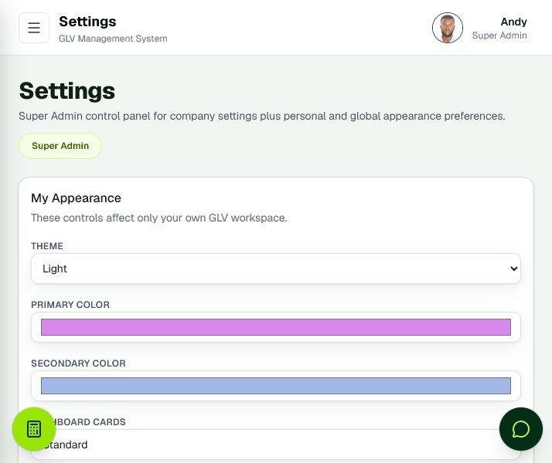
Figure 28. System Settings

FEATURE 29

Weekly Report Import and Recovery
Provides a controlled preview-and-import workflow for recovering supported data from exported weekly reports.
How it is used: Use it only after reviewing the preview and matching recovered records to current staff and products.
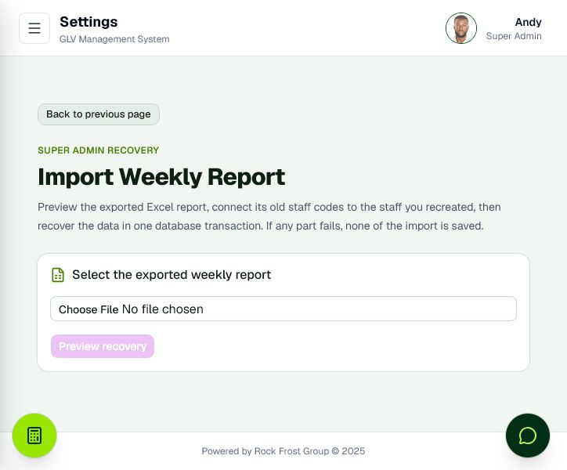
Figure 29. Weekly Report Import and Recovery

Operational Training Notes

Accuracy before speed
Confirm the customer, product account, amount, and payment date before submitting financial information. Use the confirmation summary before final payment recording.

Use assigned ownership
Customer and account reporting attributes collections to the staff member responsible for the customer. Keep staff assignments current so performance reports remain meaningful.

Reconcile collections and deposits
Recorded weekly collections represent payments entered for a staff member’s assigned customers. Staff deposits represent money physically deposited into company accounts. A negative variance is a shortage; a positive variance is a surplus.

Protect administrator access
Use the least privilege necessary. Super administrator and administrator functions include sensitive configuration, deletion, approvals, payroll, deposits, recovery, and access management.

Preserve the audit trail
Correct records through authorised edit or controlled delete workflows. Avoid informal workarounds that leave financial information outside the system.

Use exports and backups
Weekly Excel exports support analysis and recovery, while database backups provide broader protection. Exports are useful business records but should not be treated as a full substitute for tested database restoration.

Feature Summary for Demonstrations
GLV Management System brings customer onboarding, installment account management, payment collection, receipt tracking, product profitability, procurement readiness, staff accountability, physical deposit reconciliation, payroll, refunds, audit logs, security, backups, and recovery into one role-controlled platform.
The system is designed for organisations that collect many small installments and need a reliable way to connect every payment to a customer, account, product, staff member, receipt, balance, and management report.

