SYSTEM MANUAL • FEATURE GUIDE • TRAINING RESOURCE
GLV Management System
A visual guide to customer management, installment accounts, collections, procurement, staff control, reporting, and security
OPERATIONS  Customers • Accounts • Payments | CONTROL  Audit • Permissions • Security | INTELLIGENCE  Reports • Deposits • Profitability
Prepared for God's Love Ventures
Training, onboarding, demonstrations, and feature communication

How to Use This Guide
This guide explains what each major GLV Management System screen does, how it supports daily operations, and where it fits into management control. Screenshots were captured from the live system in read-only fashion; no form was submitted and no business record was created, changed, approved, or deleted.
Privacy note: Some screenshots contain live operational names and figures. Before using this guide in public advertising, replace or anonymise sensitive customer, staff, receipt, and financial information.

Core Business Flow
Products define the commercial terms. Staff are assigned customers. Customers receive one or more product accounts. Payments reduce account balances and create receipts. Completed accounts move into delivery control and are archived two days after delivery; an archived plan still counts as a completed sale. Collections feed reports, procurement readiness, payroll analysis, deposits, reconciliation, credits, and audits.

Guide Contents
No. | Screen / capability
1 | Business Dashboard
2 | Activity Monitoring
3 | Customer Directory
4 | Customer Profile
5 | Create Customer
6 | Edit Customer
7 | Account Management
8 | Account Details
9 | Create Customer Account
10 | Payments Ledger
11 | Payment Recording Popup
12 | Full Payment Form
13 | Credits and Refunds
14 | Product Catalogue
15 | Product Details
16 | Create Product
17 | Edit Product
18 | Procurement Overview
19 | Procurement Details
20 | Inventory
21 | Inventory Movements
22 | Staff Management
23 | Staff Profile
24 | Create Staff
25 | Edit Staff and Permissions
26 | Financial Intelligence and Reports
27 | Audit Logs
28 | My Profile
29 | Profile Change Approvals
30 | System Settings
31 | Weekly Report Import and Recovery

FEATURE 01

Business Dashboard
Provides an executive view of customers, staff, accounts, collections, receivables, product exposure, payroll, refunds, and projected profitability, with a weekly collections trend chart, an account status breakdown chart, and week-over-week up/down indicators on the KPI cards that support them. The Total Customers, Total Staff, New Accounts This Week, and Collected This Week cards (My Customers, Collected Today, and Collected This Week on the staff view) show an animated analog meter: a curved progress arc that sweeps from last week's position to this week's the moment the page loads.
How it is used: Use it as the daily starting point for assessing business position and identifying areas that need attention. Watch the animated meters: the arc visibly advancing means that figure grew since last week, and it visibly pulling back means it shrank; a small tick mark stays on the track afterward to show exactly where it started. A green up arrow means that figure grew since last week; a red down arrow means it shrank; figures without an arrow or a meter (account status counts, cash position) reflect the current moment rather than a week-over-week change.
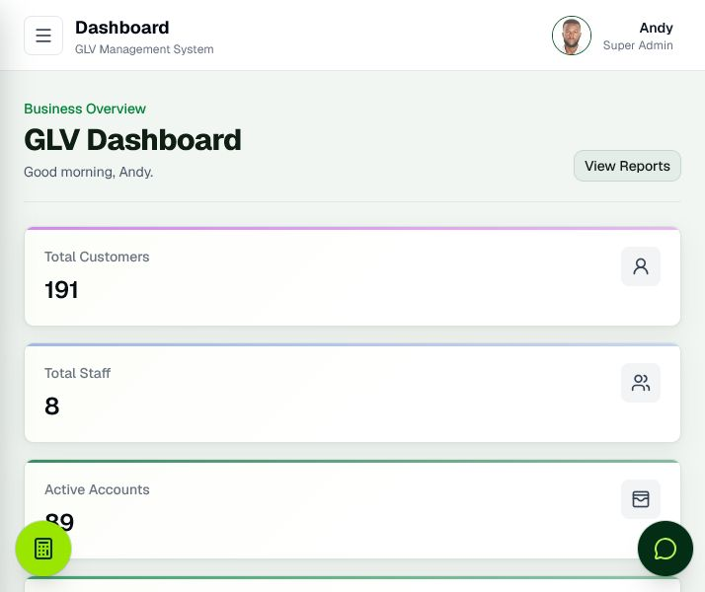
Figure 1. Business Dashboard

FEATURE 02

Activity Monitoring
Summarises recent customer, account, and payment activity so administrators can see what changed and when.
How it is used: Use it for operational awareness, follow-up, and quick investigation of newly recorded work.
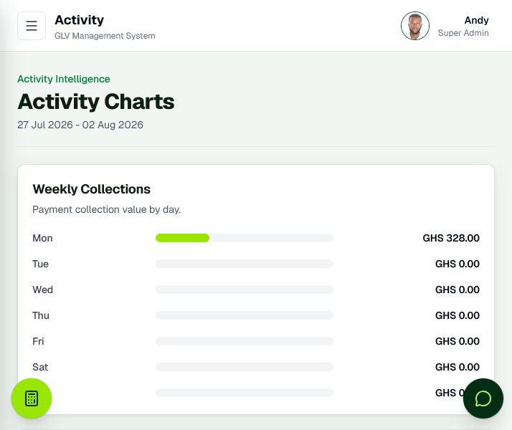
Figure 2. Activity Monitoring

FEATURE 03

Customer Directory
Centralises customer records with search, sorting, assignment, account counts, and quick access to customer actions.
How it is used: Use it to locate customers, review ownership, open profiles, create accounts, and manage assignments.
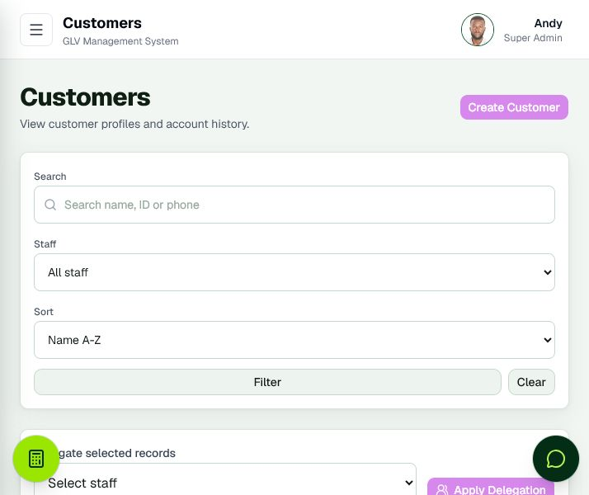
Figure 3. Customer Directory

FEATURE 04

Customer Profile
Combines customer identity, assigned staff, accounts, payment progress, credits, delivery status, and account actions in one profile.
How it is used: Use it when assisting a specific customer or reviewing the customer’s complete relationship with GLV.
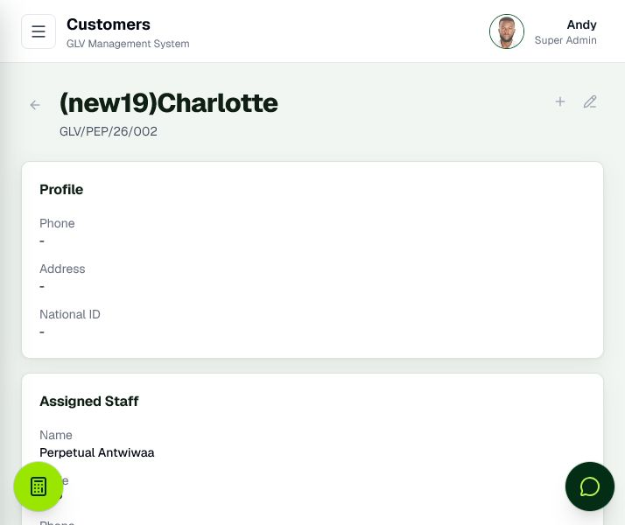
Figure 4. Customer Profile

FEATURE 05

Create Customer
Captures the information required to register a customer and assign responsibility to a staff member.
How it is used: Use it for onboarding. Required information and access rules help keep customer records consistent.
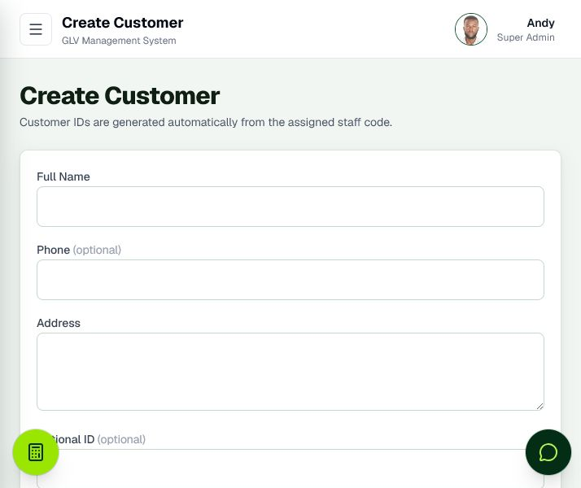
Figure 5. Create Customer

FEATURE 06

Edit Customer
Allows authorised users to correct or update customer information without recreating the record.
How it is used: Use it when contact, address, identity, or assignment information changes.
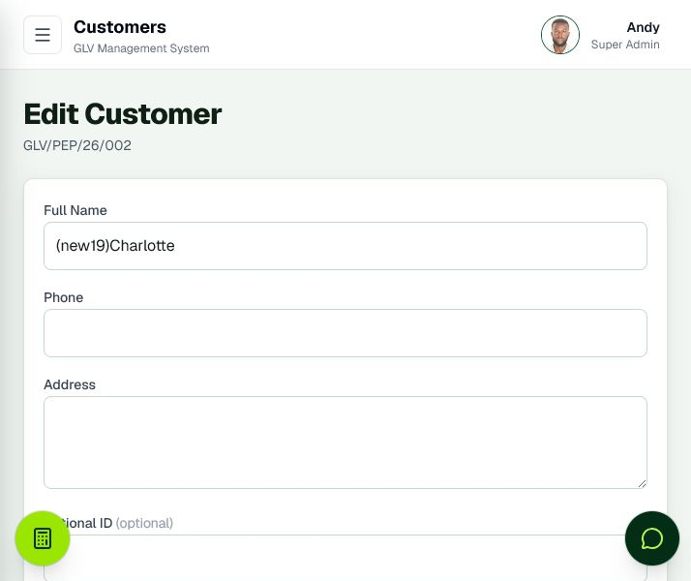
Figure 6. Edit Customer

FEATURE 07

Account Management
Lists customer product accounts with balances, progress, lifecycle status, delivery state, filters, and payment shortcuts.
How it is used: Use it to monitor active agreements, overdue exposure, completed accounts, and account-level actions.
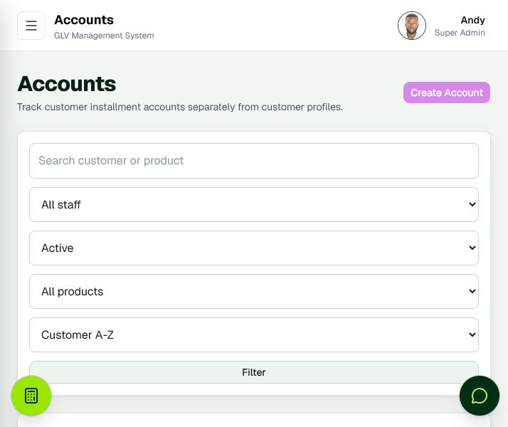
Figure 7. Account Management

FEATURE 08

Account Details
Shows the complete financial and operational history of a single product account, including payments, balance, delivery, credits, and lifecycle controls.
How it is used: Use it to answer account-specific questions and verify the evidence behind the current balance.
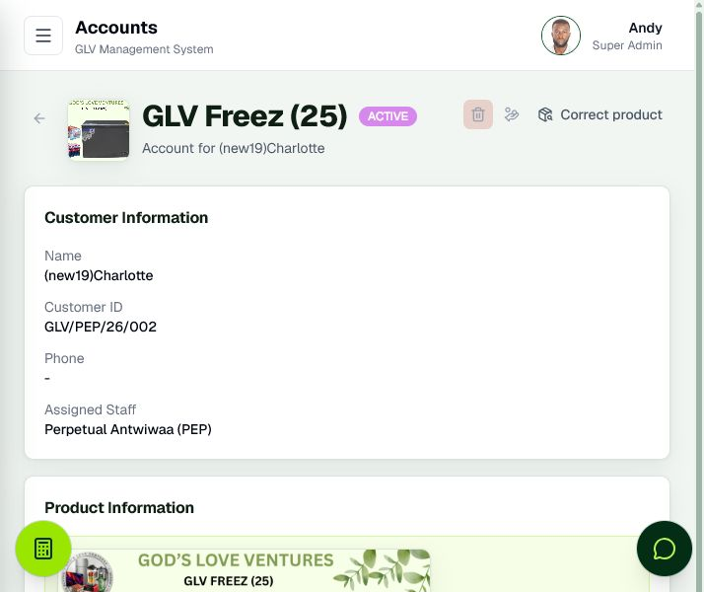
Figure 8. Account Details

FEATURE 09

Create Customer Account
Creates a layaway account by linking a customer to a product and automatically calculating the applicable terms.
How it is used: Use it for first and additional customer accounts. After creation, the same customer can be carried forward to create another account.
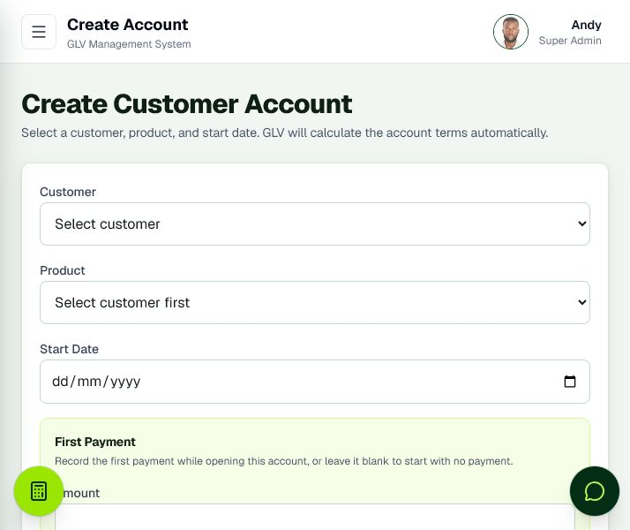
Figure 9. Create Customer Account

FEATURE 10

Payments Ledger
Organises recorded collections by staff and customer, with receipt, method, amount, date, credit, search, and filtering information.
How it is used: Use it to verify collections, locate receipts, review payment history, and investigate recorded amounts.
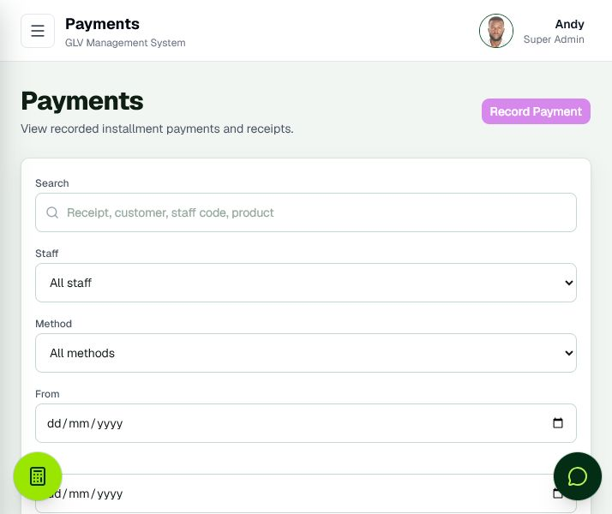
Figure 10. Payments Ledger

FEATURE 11

Payment Recording Popup
Records a payment without leaving the current operational page, reducing repeated page loading during collection entry.
How it is used: Use it to select an account, enter the amount, date, method, and notes, then confirm the payment and receipt.
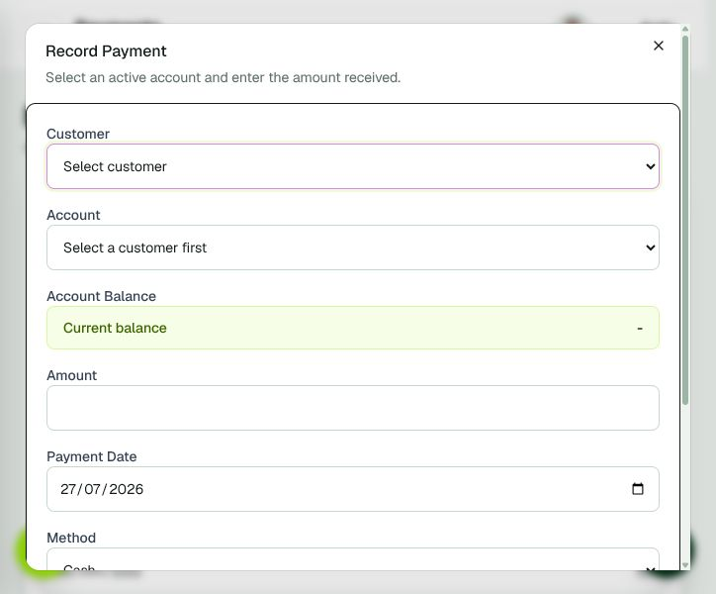
Figure 11. Payment Recording Popup

FEATURE 12

Full Payment Form
Provides the complete standalone payment-entry workflow for selecting customers and eligible accounts.
How it is used: Use it when starting payment recording from a general shortcut rather than a specific customer or account.
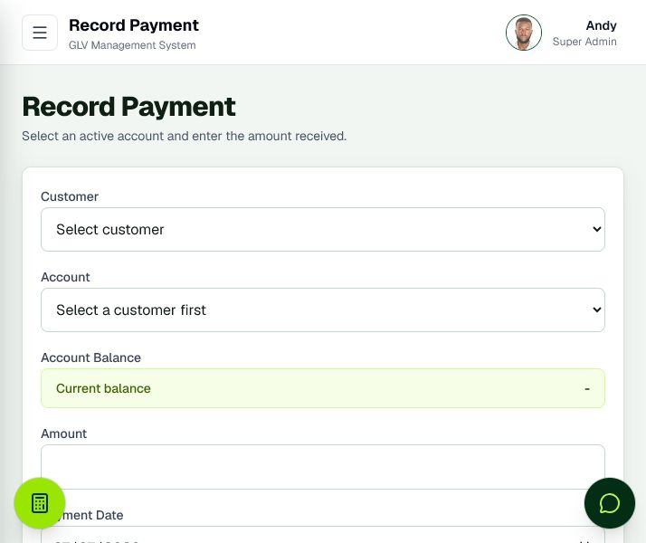
Figure 12. Full Payment Form

FEATURE 13

Credits and Refunds
Tracks overpayments, closure refunds, remaining credit, and resolution status.
How it is used: Use it to control money owed back or available to customers and to preserve an auditable refund process.
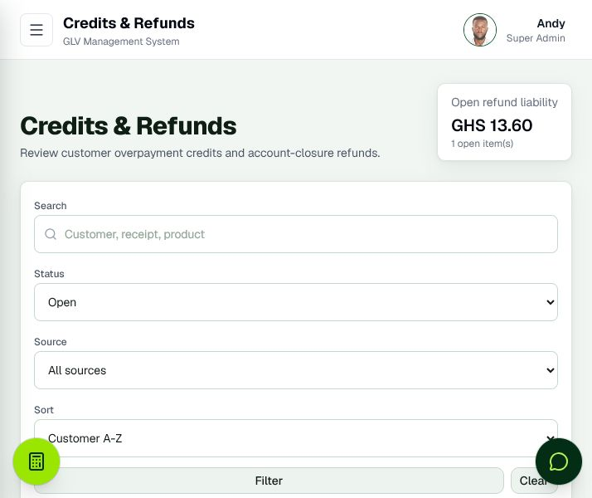
Figure 13. Credits and Refunds

FEATURE 14

Product Catalogue
Maintains product pricing, cost, transport, layaway terms, images, profitability, and active status.
How it is used: Use it to manage the commercial rules that drive customer accounts and profit calculations.
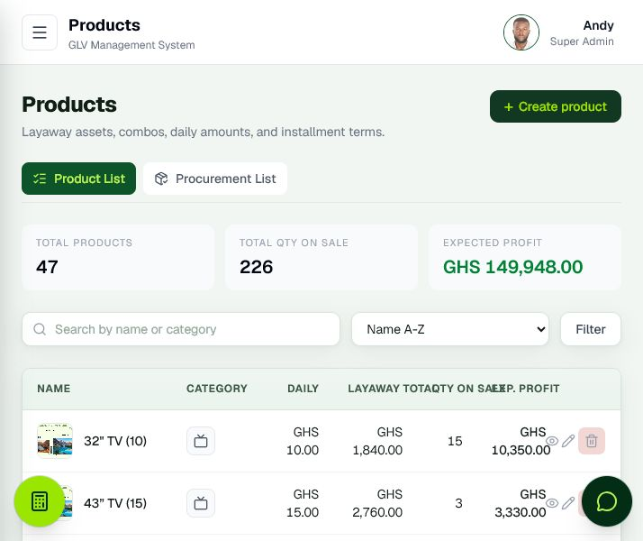
Figure 14. Product Catalogue

FEATURE 15

Product Details
Explains the pricing and profitability of a single product and provides access to its linked operational information.
How it is used: Use it to validate product economics before selling or procuring additional units.
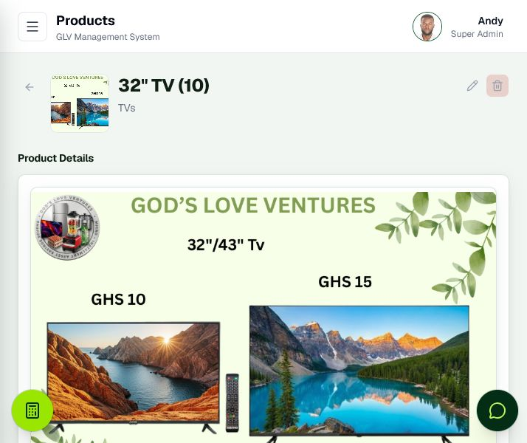
Figure 15. Product Details

FEATURE 16

Create Product
Captures product cost, pricing, category, image, duration, and daily installment rules.
How it is used: Use it to introduce a product into the catalogue with consistent financial terms.
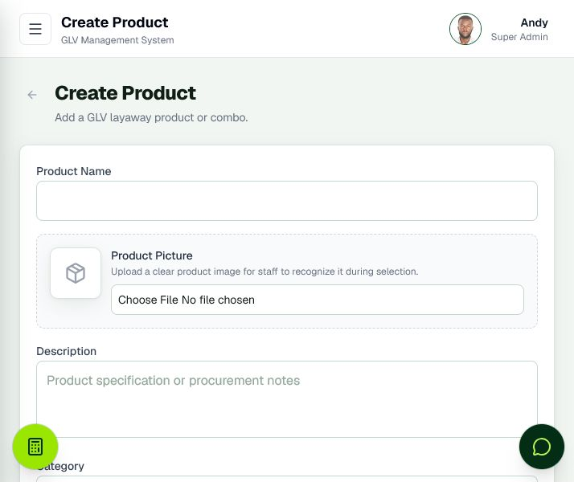
Figure 16. Create Product

FEATURE 17

Edit Product
Allows authorised correction of product descriptions, pricing inputs, images, and operating rules.
How it is used: Use it when the commercial terms or product presentation changes.
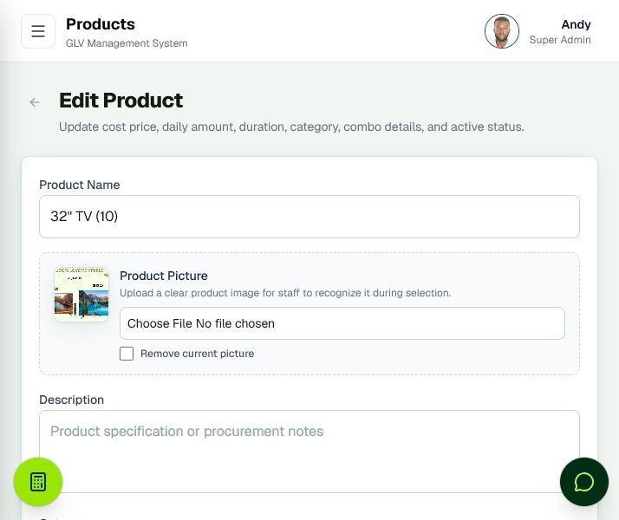
Figure 17. Edit Product

FEATURE 18

Procurement Overview
Lists products whose customers are owed more units than the store room currently holds, so it shows only what still has to be bought.
How it is used: Use it to plan a buying trip from customer commitments and money already collected, then receive the stock so the list reflects what is still outstanding.
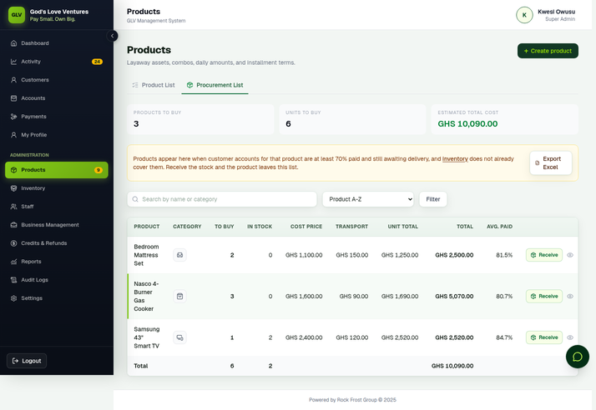
Figure 18. Procurement Overview

FEATURE 19

Procurement Details
Shows the customer accounts contributing to procurement demand for a selected product, marking each one In stock or To buy.
How it is used: Use it to validate quantities, collection progress, and the evidence behind a procurement decision. It is a read-only breakdown; receive stock from the Procurement List tab or the Inventory page.
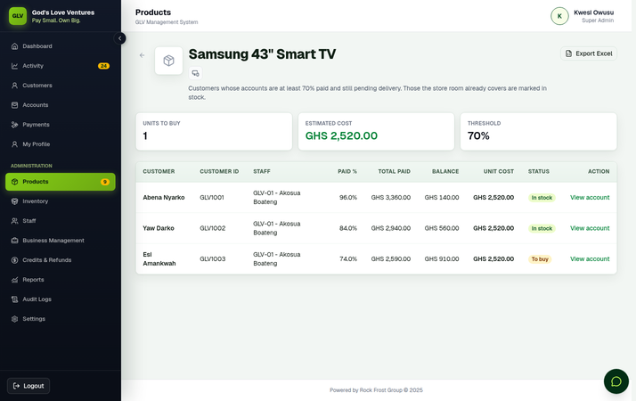
Figure 19. Procurement Details

FEATURE 20

Inventory
Shows how many units of each product are physically in the store room, how many customers are owed, and how many still have to be bought.
How it is used: Use it to receive purchased stock, correct a shelf count after a stock take, and check the stock value held.
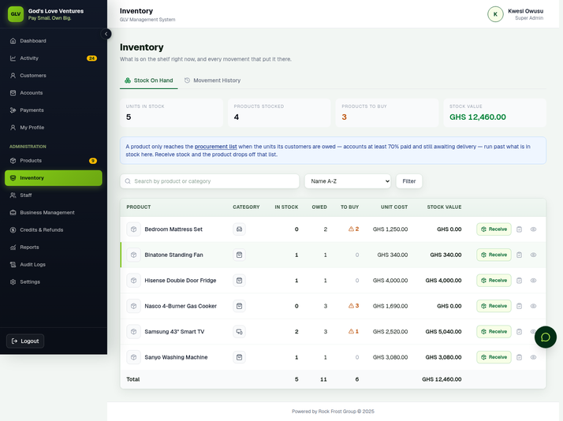
Figure 20. Inventory

FEATURE 21

Inventory Movements
Lists every change to stock: units received, units delivered to customers, reversals, and corrections, each with the person, the time, the reason and the resulting balance.
How it is used: Use it to explain any stock figure, investigate a discrepancy, and trace who changed a count and why.
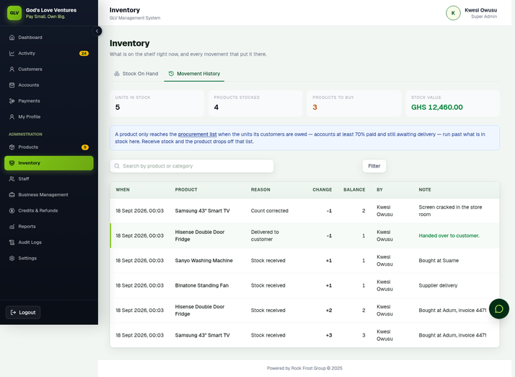
Figure 21. Inventory Movements

FEATURE 22

Staff Management
Maintains staff records, roles, permissions, status, customer assignments, inventory, and access-related actions.
How it is used: Use it to administer the workforce and control what each user can see or manage.
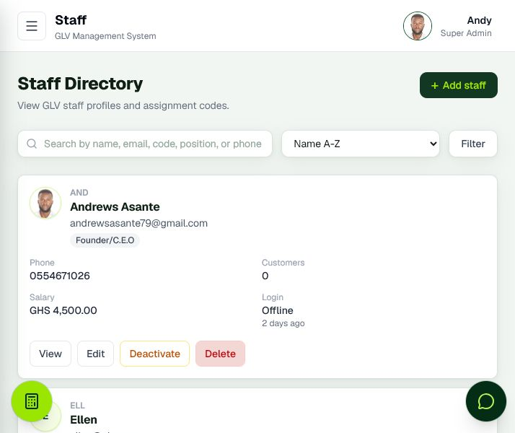
Figure 22. Staff Management

FEATURE 23

Staff Profile
Combines staff identity, assigned customers, performance information, permissions, and related operational records.
How it is used: Use it for staff supervision, responsibility reviews, and access-control decisions.
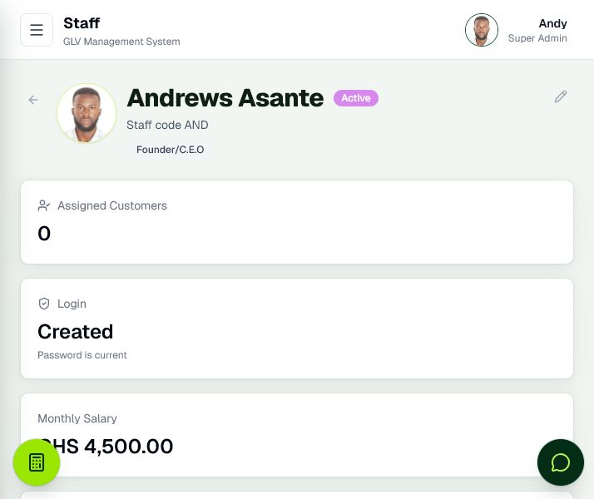
Figure 23. Staff Profile

FEATURE 24

Create Staff
Registers a staff profile with the core information needed for assignment and system access.
How it is used: Use it during onboarding before creating or linking the corresponding user account.
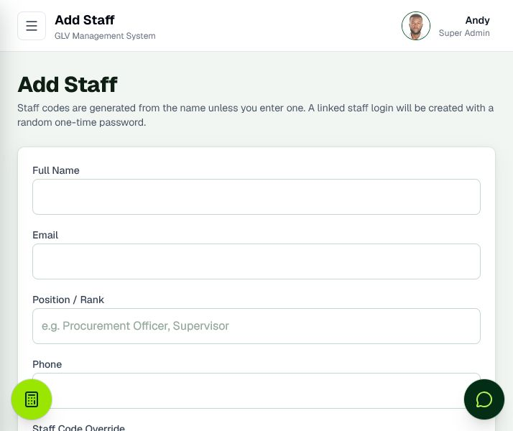
Figure 24. Create Staff

FEATURE 25

Edit Staff and Permissions
Allows authorised administrators to maintain staff details and operational privileges.
How it is used: Use it to adjust responsibilities carefully; permission changes affect which modules and actions the staff member can access.
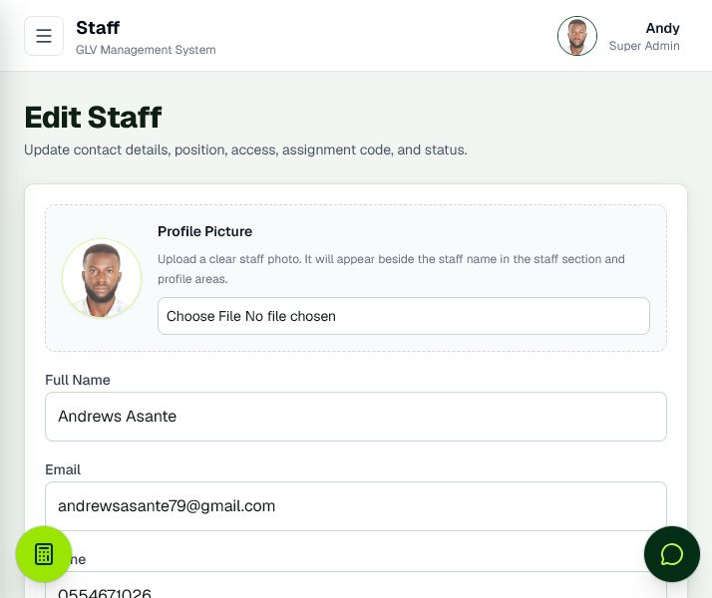
Figure 25. Edit Staff and Permissions

FEATURE 26

Financial Intelligence and Reports
Combines business performance, weekly staff collections, physical deposits, shortage or surplus, payroll, product profitability, and Excel export. The page opens with a section menu and groups the headline figures under Collections and Banking, Receivables and Exposure, Payroll, and Profitability.
How it is used: Use it for weekly control meetings, staff accountability, salary tracking, reconciliation, and management reporting. Jump straight to a section from the menu under the page title, and read each group together rather than card by card.
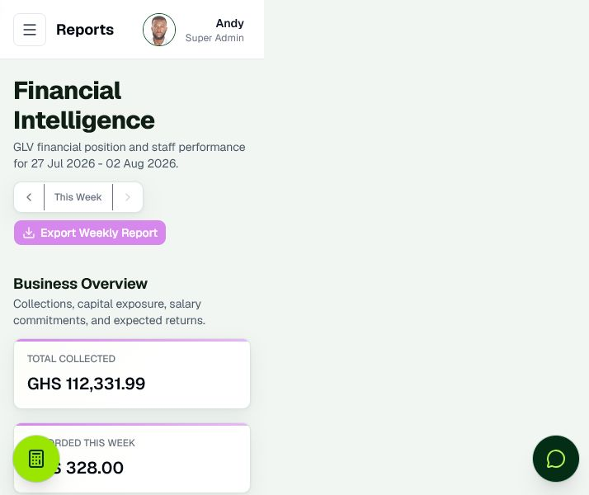
Figure 26. Financial Intelligence and Reports

FEATURE 27

Audit Logs
Records important system actions with user, entity, action, and timing information.
How it is used: Use it to investigate changes, support accountability, and demonstrate operational traceability.
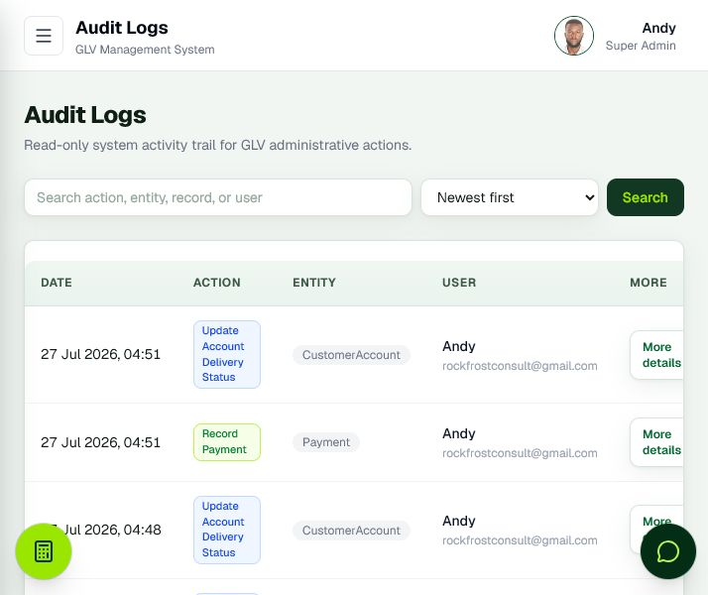
Figure 27. Audit Logs

FEATURE 28

My Profile
Provides personal profile information and controlled requests for sensitive profile changes.
How it is used: Use it to review account identity, request permitted updates, and access personal security controls.
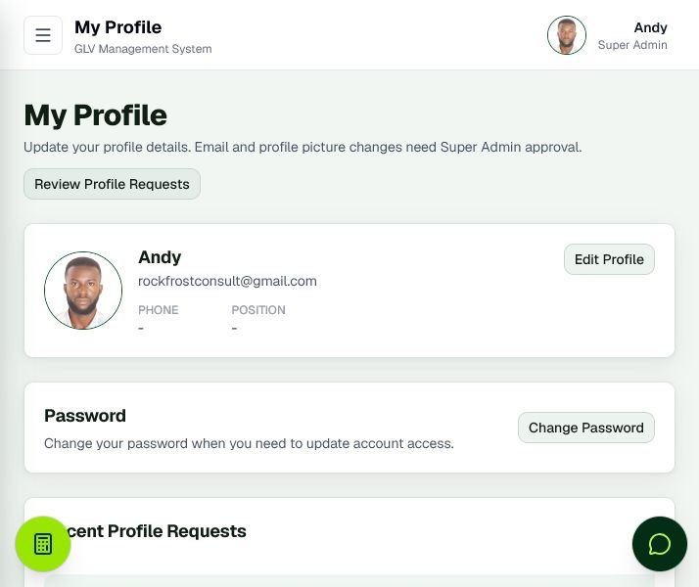
Figure 28. My Profile

FEATURE 29

Profile Change Approvals
Allows authorised administrators to review pending email and profile-image change requests.
How it is used: Use it to keep sensitive identity changes controlled rather than immediately self-approved.
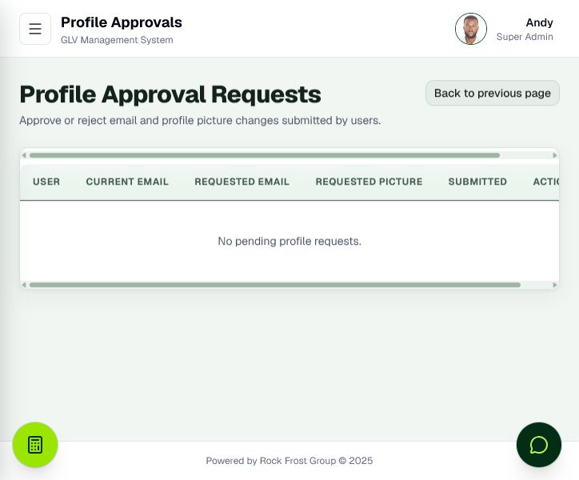
Figure 29. Profile Change Approvals

FEATURE 30

System Settings
Centralises company identity, business rules, payroll, notifications, security, appearance, product categories, and data administration, organised as tabs across the top of the page.
How it is used: Use it for system-wide administration, including addressed Terms and Conditions. Each tab has its own Save button and saves only that tab, so finish one tab before moving to the next. Changes here can affect all users and workflows.
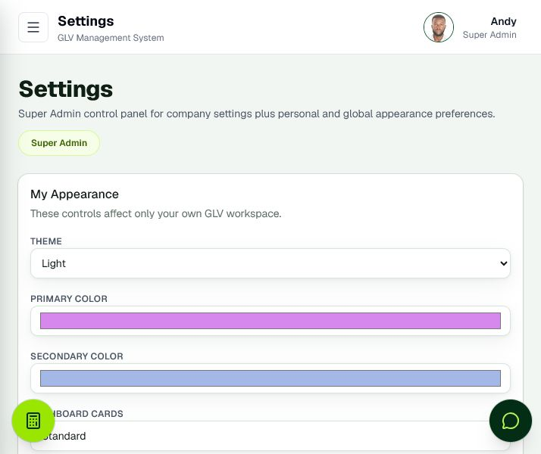
Figure 30. System Settings

FEATURE 31

Weekly Report Import and Recovery
Provides a controlled preview-and-import workflow for recovering supported data from exported weekly reports.
How it is used: Use it only after reviewing the preview and matching recovered records to current staff and products.
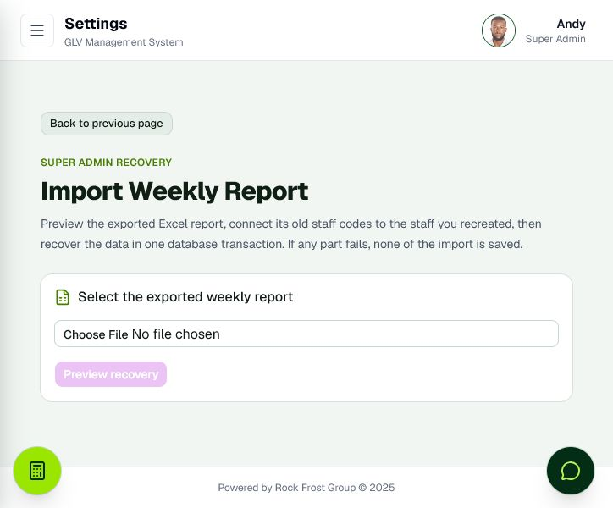
Figure 31. Weekly Report Import and Recovery

Operational Training Notes

Accuracy before speed
Confirm the customer, product account, amount, and payment date before submitting financial information. Use the confirmation summary before final payment recording.

Use assigned ownership
Customer and account reporting attributes collections to the staff member responsible for the customer. Keep staff assignments current so performance reports remain meaningful.

Reconcile collections and deposits
Recorded weekly collections represent payments entered for a staff member’s assigned customers. Staff deposits represent money physically deposited into company accounts. A negative variance is a shortage; a positive variance is a surplus.

Protect administrator access
Use the least privilege necessary. Super administrator and administrator functions include sensitive configuration, deletion, approvals, payroll, deposits, recovery, and access management.

Preserve the audit trail
Correct records through authorised edit or controlled delete workflows. Avoid informal workarounds that leave financial information outside the system.

Use exports and backups
Weekly Excel exports support analysis and recovery, while database backups provide broader protection. Exports are useful business records but should not be treated as a full substitute for tested database restoration.

Issue customer legal documents at the correct stage
A new product account automatically creates addressed Terms and Conditions. Administrators regenerate terms from Settings. Cancellation calculations are available only for closed or cancelled accounts, while reactivation calculations require lifecycle eligibility. Generated documents remain attached to the account for audit and PDF access.

Know what reactivation does to a closed account
An administrator can bring back a dormant, probation or closed account once six months of inactivity have passed, using the amber Reactivate panel on the account page and confirming with an administrator password. GLV deducts a 32 percent service fee from what the customer had already paid, recalculates the balance, sends the customer a reactivation calculation, and voids any closure refund credit still open on that account, because the customer cannot keep the refund and the plan. A product already handed over stays delivered; an undelivered plan returns to pending. The account then restarts the dormancy ladder from the day it was reactivated, so it is not closed again by the next lifecycle check and is not charged the deduction twice. Collect a payment as soon as the plan restarts.

Retract a mistake within three hours
Five actions can be taken back after they are done: reactivating an account, deleting a payment, deleting a staff deposit, deleting a salary payment, and marking a customer credit as refunded. For three hours afterwards an administrator sees the action listed with an Undo button, on the page where it was done and on the Activity page, with the time remaining shown. Retracting puts the affected records back exactly as they were. If something has changed in the meantime, such as a payment recorded against a reactivated account, GLV refuses the retraction and asks you to correct the record directly, so a retraction never quietly erases newer work. Messages and documents already sent to a customer are not withdrawn. After three hours the record stands and must be corrected through the normal workflow.

Use the correct customer communication channel
The system queues only one enabled channel. Legal and document messages prefer email, then WhatsApp, then SMS. Payment receipts prefer WhatsApp, then SMS, then email. If the customer has neither email nor phone, nothing is queued; staff explain the terms verbally and show the in-system receipt and product tracking information.

Wait for the button to finish saving
Every Save, Record, Approve, Reject, and Delete button shows a brief loading state and disables itself while GLV processes the request. Wait for that state to clear before moving on. Clicking the same button again while it is disabled does not start a second request, so it no longer creates duplicate payments, deposits, or other records.

Receive stock after every buying trip
Inventory and procurement are one loop. A product reaches the procurement list only when the units its customers are owed are more than the units already in the store room, so anything on that list is genuinely still to buy. After a buying trip, press Receive on the product's row, either on the Procurement List tab or on the Inventory page, and enter how many units you bought. Those units go into stock and the list reduces by exactly that quantity, so a part purchase leaves the rest outstanding instead of clearing the whole product. Receiving stock is not the same as delivering: you still confirm delivery on the customer's account when they receive the product, and that is what takes the unit back off the shelf.

Keep the shelf count honest
Confirming a delivery reduces stock by one automatically, and reversing a delivery puts the unit back if that delivery took one. If stock shows zero when you confirm a delivery, GLV still records the delivery, because the customer is standing there and must not be turned away, but it warns you that the count did not have the unit. Fix it on the Inventory page using the correct-count action, which asks for the counted figure and a written reason. Every receipt, delivery, reversal and correction is kept in the movement history against your name, so any figure can be explained later.

Work the delivery queue and trust the archive
When a customer pays off a plan it waits for delivery. Find every such plan with the Awaiting delivery filter on the Accounts page, the Paid, Awaiting Delivery card on the dashboard, or the sidebar alert. Press the package icon in the list, or Mark delivered on the account or customer page, when the customer receives the product. Two days after delivery the plan moves to the archive. The archive only ever holds plans that are paid off and handed over: if an archived plan is found to be still owed its product, GLV returns it to the delivery queue automatically, and if it owes money again, for example after a payment is deleted, it returns to collection. Archived plans still count as completed and delivered on the dashboard and in reports, and their profit stays in the profit figures. If a product was handed over earlier and nobody recorded it, an administrator opens the account and uses Handed over earlier and never recorded to enter the real date; this records the delivery without taking a unit off the shelf, because that unit already left. Marking an archived plan pending again is an administrator correction and puts the plan back in the delivery queue.

Deliver before full payment only for customers who have earned it
Some long-standing customers receive their product before they finish paying. Only an Admin or Super Administrator can do this, from the account page, using Deliver with balance owing. GLV asks for a written reason and an explicit confirmation, and records how much was still owed at the moment of handover. The account stays open: the customer must keep paying until the balance reaches zero, and the outstanding amount stays visible on the accounts list, the customer profile and in reports. An account delivered this way shows a blue delivery badge instead of the green one, so anyone reviewing the records can see at a glance that money is still owed on a product the customer already has. Use this sparingly, for consistent and well-behaved customers, and never as a way to clear a slow-paying account.

Save one settings tab at a time
Settings is split into tabs: Company, Business Rules, Payroll, Notifications, Security, Appearance, Product Categories, and Data and System. Each tab has its own Save button and saves only the fields on that tab, so changes on one tab are never affected by another. Finish and save the tab you are on before switching. On a brand-new system, save Company Information first, because the company name and phone number are required before anything else can be stored. The System Notes fields on the Data and System tab are labels the operator maintains by hand; editing them records a note and does not change anything about the live database or storage.

Read the dashboard trend arrows and meters correctly
The Total Customers, Total Staff, New Accounts, and Collected This Week cards on the dashboard show a small arrow comparing this week to last week: a green up arrow is growth, a red down arrow is a decline, and a flat dash means no change. The same cards also show an animated meter that sweeps from last week's position to this week's when the page loads, with a tick mark left behind at last week's position. These week-over-week comparisons only appear on figures that can be safely measured over time; current-status figures such as Active Accounts, Overdue Accounts, and cash position are shown as a plain snapshot number without an arrow or meter because there is no historical status record to compare against.

Automatic SMS notifications
Enable SMS Notifications in Settings after configuring BMS Africa. The approved GLV sender is GODS LOVE V. New salary payment records send a staff alert. New product payment plans send one welcome message at their start date. Payments reaching at least 70 percent of the target send one progress message per plan, including payments that jump beyond 70 percent.
Active or overdue plans with an outstanding balance receive a missed-payment reminder after fourteen full days without payment, which is two full weeks, then at most once per further two-week period. A newly entered payment, including a backdated one, restarts the interval, and so does reactivating an account, so a reactivated plan is never texted about the months it spent dormant. Completed, closed, cancelled, archived, suspended, dormant and probation accounts do not receive missed-payment reminders. The Missed payment template supports staffName, which inserts the assigned staff member's first name. A daily job checks at 09:00 Ghana time; messages are also dispatched after qualifying actions and during signed-in use.
When a staff deposit is recorded for a week, GLV totals each assigned customer's payments from Monday through Sunday across all product accounts. Each customer who paid receives one weekly summary. Customers with no payment receive no summary. The staff, customer and week key prevents duplicates if another deposit is recorded; a pending summary may be refreshed, but an accepted summary is never resent automatically.
The weekly summary comes in two versions and GLV chooses the right one for each customer. A customer's expected weekly amount is the daily amount of every plan they are still paying on, multiplied by seven. If the customer paid that amount or more, GLV sends the encouraging version that congratulates them for meeting the target. If the customer paid less, GLV sends a different, respectful version that states the weekly target, states how much is still short, and asks the customer to contact their staff member to catch up. This means a customer who fell short is never congratulated for a good week. A customer with no plan currently being collected on counts as on target.
Super administrators open Settings > Notifications > Open SMS settings and delivery to reach the dedicated SMS configuration and delivery page. It shows provider, API key status, approved sender, schedule and all the automatic rules; the master switch is saved there. The same page lists the latest 100 messages and retries failures after correcting a phone number, credit balance or provider setup. Accepted means BMS accepted the campaign; verify delivery in BMS campaign history. Unknown outcomes require operator reconciliation before resending. Turning SMS off pauses new alerts and queued delivery. Old welcome and salary events are not backfilled. Restored pending messages are held as Unknown to prevent duplicate sends.
The SMS page also lets super administrators edit six messages: Salary payment, Customer welcome, 70 percent progress, Missed payment, Weekly summary - target met, and Weekly summary - below target. Each editor shows the placeholders allowed for that event and a sample preview. Both weekly messages can show the expected weekly amount; only the below-target message can show the shortfall. Messages must contain text, stay within 612 template characters and use only the listed placeholders. Reset all restores GLV defaults. Saved changes apply only to notifications queued afterward; an already queued message keeps its reviewed wording. Salary messages go only to the staff member on the salary payment. The customer messages go only to the customer on the qualifying account or weekly payment total.
A customer or staff member with no phone number, or with a number GLV cannot read as a valid Ghana number, is skipped completely. No message is queued for them, no message is attempted, and no failed entry appears in the delivery list. So if an expected message is missing, check the phone number on the customer or staff record first rather than looking for a failure to retry. Correct the number and the next qualifying event will queue normally. If a number is removed after a message was already queued, GLV cancels that message instead of trying to send it.
Default message text is branded Rock Frost Group. Staff and customer name placeholders always render only the first name. The BMS handset sender is Rock Frost, which fits the provider's 11-character limit and must remain approved in BMS before it is configured in production.
Server setup requires MNOTIFY_API_KEY, MNOTIFY_SENDER_ID and CRON_SECRET, plus the SMS queue database migration. Deploy migrations explicitly with npm run db:deploy from a trusted operator environment using DATABASE_URL_UNPOOLED before releasing dependent code. Vercel builds do not migrate through the port 6543 transaction pooler. Store secrets only in approved environments. These alerts use a separate SMS queue; existing document and receipt channel preferences remain separate. Provider configuration and live delivery must be verified before describing the feature as operational.

Integrated Business Management
Administrators use one Business Management page for People, Payroll, Accounting and Analytics. These sections share GLV staff, customer payment, salary and expense records; they are not separate modules and do not require duplicate setup.
People records leave requests with approve or reject decisions and dated performance reviews scored from one to five. Payroll records salary payments using the existing salary history and sends the existing salary SMS only to the paid staff member. Accounting records operating expenses and builds a cash position from customer collections less salary payments and expenses; staff deposits are reconciliation records and are not counted again as revenue. Analytics shows current month revenue, payroll, expenses, net cash, headcount, leave and performance figures from the same records.
Only administrators can open this page or change its records. Writes are audit logged. Apply migration 20260909183000_integrated_business_management before release. Version 1 application backup and restore does not yet carry the new leave, performance review and expense records, so operators must retain database-level backups and must not rely on an older application backup to recover this data.

Feature Summary for Demonstrations
GLV Management System brings customer onboarding, installment account management, payment collection, receipt tracking, product profitability, procurement readiness, staff accountability, physical deposit reconciliation, payroll, refunds, audit logs, security, backups, and recovery into one role-controlled platform.
The system is designed for organisations that collect many small installments and need a reliable way to connect every payment to a customer, account, product, staff member, receipt, balance, and management report.

