CAMPUSFIX CAMPUS MAINTENANCE MANAGER
A PROJECT REPORT
Submitted by
SEERALAN M
(2116241501193)
in partial fulfilment of the End Semester Examination for the course
CB23F35 –
LOW-CODE APPLICATION DEVELOPMENT USING ZOHO CREATOR
in
BACHELOR OF TECHNOLOGY
ARTIFICIAL INTELLIGENCE AND MACHINE LEARNING

RAJALAKSHMI ENGINEERING COLLEGE
(An Autonomous Institution, Affiliated to Anna University, Chennai)
Rajalakshmi Nagar, Thandalam, Tamil Nadu – 602 105
NOVEMBER 2026

RAJALAKSHMI ENGINEERING COLLEGE
(An Autonomous Institution, Affiliated to Anna University, Chennai)
BONAFIDE CERTIFICATE
Certified that this project report titled “CampusFix Campus Maintenance Manager” is the coursework report of Seeralan M (2116241501193) for the course CB23F35 - Low-Code Application Development using Zoho Creator, during the academic year 2026-2027, Semester V. The report describes the implemented demonstration and clearly identifies features that remain proposed or unverified.
SIGNATURE  ____________________  HEAD OF THE DEPARTMENT  Department of Artificial Intelligence and Machine Learning  Rajalakshmi Engineering College | SIGNATURE  ____________________  COURSE FACULTY  Department of Artificial Intelligence and Machine Learning  Rajalakshmi Engineering College

Submitted for the End Semester Examination (Individual Project) held on ____________________.
INTERNAL EXAMINER | EXTERNAL EXAMINER

DECLARATION
I, Seeralan M (2116241501193), submit this report titled “CampusFix Campus Maintenance Manager” for the End Semester Examination of CB23F35 - Low-Code Application Development using Zoho Creator. It records the CampusFix application in my Zoho Creator account, with implemented features distinguished from proposed extensions. The application and report were prepared with acknowledged AI assistance and the supplied academic template.
The existing Creator starter application was retained and extended with the CampusFix form, reports, dashboard and validation workflow. External documentation and assistance are acknowledged. This declaration is provided for the student to review and sign after confirming the report and institutional requirements.
Place: Chennai SIGNATURE OF THE STUDENT
Date: ____________________ Seeralan M
2116241501193

ACKNOWLEDGEMENT
I express my gratitude to the management of Rajalakshmi Engineering College for the infrastructure and facilities provided for academic work.
I thank the Principal of Rajalakshmi Engineering College for encouraging practical learning and application development.
I thank the Head of the Department of Artificial Intelligence and Machine Learning for the academic support extended during the course.
I thank the course faculty for the prescribed project format and learning activities that guided the scope of the application.
I acknowledge Zoho Corporation for the Creator platform and documentation. I also acknowledge the existing starter application, the supplied report template, and AI assistance used for application configuration, Deluge scripting, documentation and verification. I thank my family and friends for their support.

SEERALAN M

ABSTRACT
Campus maintenance requests often begin as messages, verbal reports or paper notes. In a demonstration scenario, this can make it difficult to locate the latest request details, know which repair team is responsible, and reconcile unresolved issues. CampusFix Campus Maintenance Manager addresses this coordination problem through a Zoho Creator application for structured request capture and progress reporting. The application was configured in the existing Creator workspace and uses a dedicated Maintenance Requests form containing twelve fields. Each request has a unique ticket reference, reporter details, location, category, priority, dates, status, assigned team, issue description and resolution notes. A form validation workflow written in Deluge checks date order, rejects future reported dates, requires a meaningful description, requires team assignment before progress beyond Reported, and requires notes before resolution. The same saved records are presented through a list report and a Kanban board grouped by four status values. An HTML and Deluge dashboard calculates total, reported, assigned, in-progress, resolved and overdue unresolved counts when loaded. Eight fictional records were entered and inspected. Live negative tests rejected the five invalid conditions and a duplicate ticket reference, while a valid record update changed the dashboard status counts as expected. The reviewed records contain one Reported request, three Assigned requests, two In Progress requests and two Resolved requests. This is an authenticated online demonstration; integrations, independent restricted-user testing, staged deployment and measured performance optimisation remain future work. The report presents the actual configuration, source logic, screenshot evidence, tests and remaining limitations, allowing the student to explain the implementation and demonstrate its behaviour without overstating production readiness.

Keywords: Low-Code Development; Zoho Creator; Deluge Scripting; Campus Maintenance; Request Tracking; Dashboard

PROJECT AT A GLANCE
Attribute | Details
Project Title | CampusFix Campus Maintenance Manager
Application Domain | Education / Campus maintenance
Student Name & Register No. | Seeralan M - 2116241501193
Zoho Creator Edition | Existing account; Trial has expired shown in the header
Application Name (Link Name) | CampusFix - Campus Maintenance Manager (my-first-creator-app)
Published / Live URL | https://creatorapp.zoho.in/seeralan.m.2024.aiml_raja/my-first-creator-app/#Page:CampusFix_Dashboard
Demo Credentials (per role) | Authorized owner sign-in; credentials are not published
Number of Forms / Subforms | 1 project form / 0 subforms
Number of Reports (by type) | List: 1; Kanban: 1; Calendar: 0; Pivot/Chart: 0
Number of Pages / Dashboards | 1 CampusFix dashboard
Number of Workflows | Form validation: 1; schedule/approval/Blueprint/batch: 0
Deluge Functions / Custom Actions | No reusable custom functions or custom report actions
Integrations | None implemented
Roles & Profiles Defined | Owner session verified; new restricted profiles not tested
Environments Used | Existing authenticated live application only
Date of Production Deployment | No staged production deployment performed

TABLE OF CONTENTS
ABSTRACT iv
PROJECT AT A GLANCE v
LIST OF TABLES ix
LIST OF FIGURES x
LIST OF ABBREVIATIONS xi
INTRODUCTION 1
1.1 Background 1
1.2 Problem Statement 1
1.3 Objectives 1
1.4 Scope of the Project 1
1.5 Justification for a Low-Code Approach 2
1.6 Organisation of the Report 2
LITERATURE SURVEY AND SYSTEM STUDY 3
2.1 Study of the Existing System 3
2.2 Limitations of the Existing System 3
2.3 Low-Code versus Traditional Development 3
2.4 Literature Survey 4
2.5 Emerging Trends in Low-Code Development 5
2.6 Proposed System 5
REQUIREMENT ANALYSIS 6
3.1 Stakeholders and User Roles 6
3.2 Functional Requirements 6
3.3 Non-Functional Requirements 7
3.4 Hardware and Software Requirements 7
3.5 Use Case Model 8
SYSTEM DESIGN 9
4.1 System Architecture 9
4.2 Data Model 10
4.3 Form Design 10
4.4 Process and Workflow Design 11
4.5 User Interface and Navigation Design 12
4.6 Access Control Design 12
IMPLEMENTATION 13
5.1 Application Setup 13
5.2 Forms and Data Capture 13
5.3 Reports 14
5.4 Pages and Dashboards 15
5.5 Deluge Scripting 16
5.6 Workflows and Automation 17
5.7 Integrations 17
5.8 User Management and Role-Based Access 18
5.9 AI and Analytics Features 18
5.10 Pro-Code Extension 19
5.11 Mobile and Portal Access 19
TESTING AND DEBUGGING 20
6.1 Testing Strategy 20
6.2 Test Cases 20
6.3 Debugging Deluge Scripts 21
6.4 Defect Log 22
6.5 User Acceptance Testing 22
DEPLOYMENT, SECURITY AND GOVERNANCE 23
7.1 Environments and Deployment Strategy 23
7.2 Performance Optimisation 24
7.3 Security Features 24
7.4 Governance and Administration 24
RESULTS AND DISCUSSION 26
8.1 Application Output 26
8.2 Achievement of Objectives 27
8.3 Comparison with the Existing System 28
8.4 Limitations of the Low-Code Approach 28
8.5 Reflection on the No-Code → Low-Code → Pro-Code Spectrum 28
CONCLUSION AND FUTURE ENHANCEMENTS 29
9.1 Conclusion 29
9.2 Future Enhancements 29
9.3 Learning Outcomes and Career Relevance 29
REFERENCES 30
APPENDIX A – ZOHO CREATOR FEATURE COVERAGE CHECKLIST 31
APPENDIX B – COURSE OUTCOME MAPPING 33
APPENDIX C – COMPLETE DELUGE SOURCE CODE 34
APPENDIX D – USER MANUAL 35
D.1 Accessing the Application 35
D.2 Instructions for the Owner Demonstration 35
D.3 Instructions for Reviewing Reports 35
APPENDIX E – EVALUATION RUBRIC 36
APPENDIX F – VIVA-VOCE RECORD SHEET 38

LIST OF TABLES
Table 2.1: Comparison of Low-Code and Traditional Development for the Proposed Application 3
Table 2.2: Summary of Literature Survey 4
Table 3.1: Stakeholders and User Roles 6
Table 3.2: Functional Requirements 6
Table 3.3: Non-Functional Requirements 7
Table 3.4: Hardware and Software Requirements 7
Table 3.5: Use Case Description - Update a Maintenance Request 8
Table 4.1: Entities and Relationships 10
Table 4.2: Field Specification - Maintenance Requests Form 10
Table 4.3: Role–Permission Matrix 12
Table 5.1: Reports Implemented 14
Table 5.2: Deluge Scripts Implemented 16
Table 5.3: Workflows Implemented 17
Table 5.4: Integrations Implemented 17
Table 6.1: Test Cases 20
Table 6.2: Defect Log 22
Table 6.3: User Acceptance Feedback 22
Table 7.1: Deployment Checklist 23
Table 7.2: Performance Optimisation Results 24
Table 7.3: Security Controls Implemented 24
Table 8.1: Mapping of Objectives to Outcomes 27
Table 8.2: Existing System versus Proposed Application 28
Table A.1: Feature Coverage Checklist 31
Table B.1: Mapping of Course Outcomes to Report Chapters 33
Table E.1: Evaluation Rubric for the Individual Project 36
Table E.2: Performance Level Descriptors 37
Table F.1: Viva-Voce Questions and Responses 38
Table F.2: Marks Summary 38

LIST OF FIGURES
Figure 2.1: Illustrative manual maintenance request process 3
Figure 3.1: CampusFix use cases with implemented owner access and proposed roles 8
Figure 4.1: CampusFix application architecture 9
Figure 4.2: CampusFix single-form data model 10
Figure 4.3: Maintenance request validation and update flow 11
Figure 4.4: CampusFix project navigation structure 12
Figure 5.1: CampusFix dashboard and project navigation 13
Figure 5.2: Maintenance Requests in the form builder 14
Figure 5.3: Maintenance Requests in live mode 14
Figure 5.4: Repair Status Board grouped by Status 15
Figure 5.5: CampusFix Dashboard with saved-record indicators 16
Figure 5.6: Created or Edited validation workflow and saved Deluge action 17
Figure 5.7: Current Users settings and email-confirmation prerequisite 18
Figure 5.8: CampusFix count indicators used for reconciliation 19
Figure 6.1: Actual rejection of a future reported date 22
Figure 7.1: Current CampusFix application settings 25
Figure 8.1: Maintenance Requests form for issue capture 26
Figure 8.2: Saved CF-008 maintenance request details 27
Figure 8.3: Dashboard after the saved status update 27

LIST OF ABBREVIATIONS
Abbreviation | Expansion
API | Application Programming Interface
CRUD | Create, Read, Update, Delete
ER | Entity-Relationship
HTML | HyperText Markup Language
KPI | Key Performance Indicator
LCAP | Low-Code Application Platform
RBAC | Role-Based Access Control
REST | Representational State Transfer
SDLC | Software Development Life Cycle
UAT | User Acceptance Testing
UI | User Interface
UTC | Coordinated Universal Time

CHAPTER 1

INTRODUCTION

1.1 Background
CampusFix is an educational demonstration for a college maintenance setting. Typical issues include electrical failures, plumbing leaks, network faults, damaged furniture and cleaning requests. The intended participants are reporters, a maintenance coordinator and repair staff. In the implemented application, these responsibilities are demonstrated through the owner account rather than through separately configured user profiles. The dataset consists of fictional campus locations and example.com contact addresses.

1.2 Problem Statement
The project addresses the lack of a consistent maintenance request record and a readily reviewable status summary in an illustrative message-based process. A coordinator needs a single place to capture a request, identify its team and target date, review progress and retain the resolution explanation.
- Unstructured messages can omit the location, category or description needed to start a repair.
- Repeated follow-ups make it difficult to identify the latest assignment and status.
- Separate manual summaries can disagree with individual request records.

1.3 Objectives
- To capture maintenance requests in a twelve-field form with required and unique reference checks.
- To reject the five invalid data conditions through a Deluge validation workflow.
- To display the same saved requests in a list and a four-status Kanban board.
- To calculate six dashboard indicators from saved records and verify them against the reports.
- To test valid submission, record updates and invalid entries using fictional data, and document unimplemented extensions honestly.

1.4 Scope of the Project
The implemented scope is an authenticated browser application containing one project form, two reports, one dashboard and one form-validation workflow. It handles capture, manual assignment, status editing and resolution notes. The original order-template components remain in the workspace but are excluded from the project counts. Separate user roles, notifications, external integrations, approval processes, mobile/portal access and staged production deployment are outside the demonstrated scope.

1.5 Justification for a Low-Code Approach
Zoho Creator provides linked form, record and report components within a hosted application [1]. For this project, visual field configuration reduces the amount of interface and storage code that must be written, while Deluge expresses the specific rejection rules [2], [3]. This supports a small instructional application whose schema and reports can be inspected in one workspace. No development-time or cost saving was measured against a separately built traditional application.

1.6 Organisation of the Report
Chapter 2 reviews the existing system and related low-code literature. Chapter 3 presents the requirement analysis. Chapter 4 describes the system design. Chapter 5 details the implementation on Zoho Creator. Chapter 6 covers testing and debugging. Chapter 7 discusses deployment, performance optimisation, security and governance. Chapter 8 presents results and discussion, and Chapter 9 concludes the report with future enhancements.
CHAPTER 2

LITERATURE SURVEY AND SYSTEM STUDY

2.1 Study of the Existing System
The illustrative existing process begins when a reporter notices a fault and sends a message or paper note to a coordinator. The coordinator contacts a repair team and later requests a progress update. A summary is prepared separately from those communications. Figure 2.1 is a process design illustration, not a measured study of a particular department.

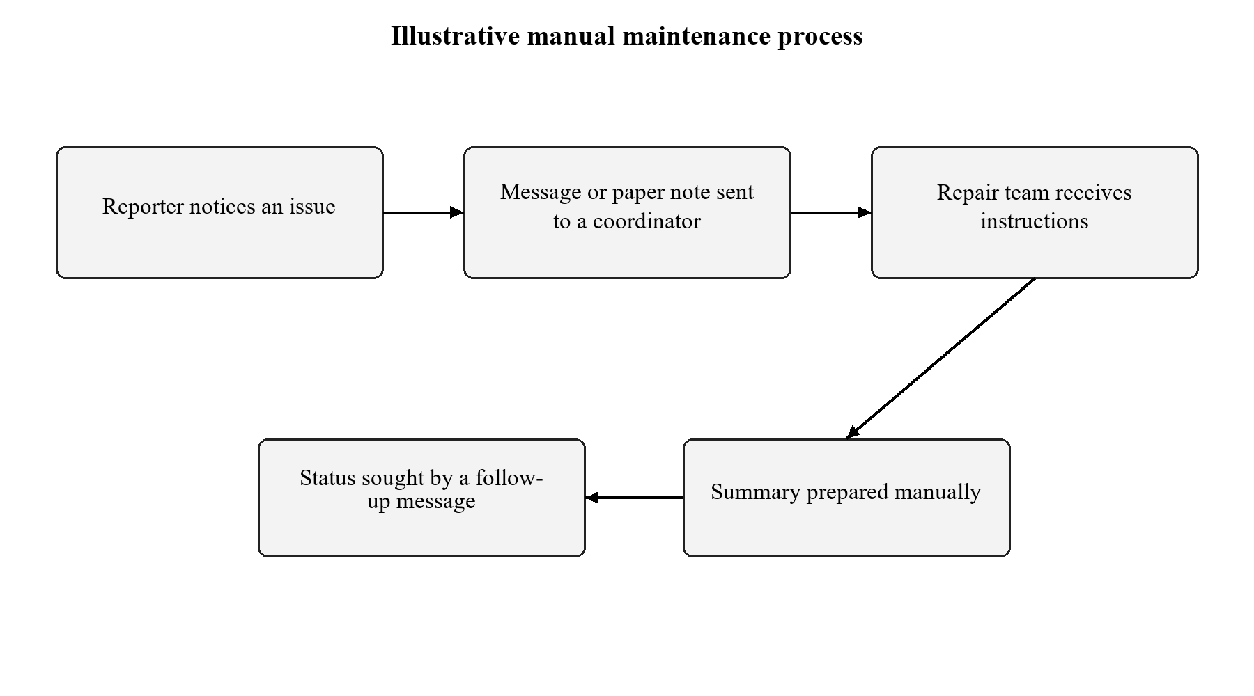
Figure 2.1: Illustrative manual maintenance request process

2.2 Limitations of the Existing System
- The initial message may not contain all information required for a repair.
- Assignments and status changes may be distributed across separate conversations.
- A manual summary must be reconciled again whenever a request changes.

2.3 Low-Code versus Traditional Development
Table 2.1: Comparison of Low-Code and Traditional Development for the Proposed Application
Criterion | Traditional (Pro-Code) Development | Low-Code on Zoho Creator
Development time | Separate interface, storage and report implementation needed | Configured visual components; no time benchmark
Skills required | Database, interface and service programming | Form/report configuration and Deluge
Hosting & infrastructure | Hosting must be selected and maintained | Existing Creator-hosted workspace
Mobile application | Separate responsive/mobile validation required | Mobile behaviour remains unverified
Security & access control | Application security must be implemented and tested | Platform permissions available; restricted roles not tested
Maintenance & change | Changes span application components | Schema and report changes managed in Creator
Customisation limits | Greater control with more code to maintain | Current dashboard uses HTML and Deluge
Cost | Not measured | Subscription limits observed; cost comparison not measured

2.4 Literature Survey
Table 2.2: Summary of Literature Survey
S.No. | Author(s) / Source & Year | Title / Product | Key Findings | Relevance to this Project
1 | Zoho Corporation [1], accessed 2026 | Understand Applications | Forms store data; reports and pages present it | Basis of the form/list/page architecture
2 | Zoho Corporation [2], accessed 2026 | Understanding form builder | Fields and properties are configured in the builder | Basis of field choices and validation properties
3 | Zoho Corporation [3], accessed 2026 | Understanding workflows | Events trigger defined actions | Basis of the Created or Edited validation workflow
4 | Zoho Corporation [4], accessed 2026 | Understanding permissions | Permission sets control component and record actions | Basis of proposed role tests, not evidence of implementation
5 | Zoho Corporation [5], accessed 2026 | Deluge Count | Criteria select the records counted | Basis of the six dashboard counters

2.5 Emerging Trends in Low-Code Development
CampusFix uses visual configuration for structured capture and reports, and low-code scripting for business rules. AI assistance supported configuration and documentation, but the saved definitions and live tests were checked separately. Integration, role-based collaboration and governed releases are relevant extensions; their availability in a platform does not mean they were implemented in this project.

2.6 Proposed System
The proposed system was implemented as CampusFix. A single saved request supplies the form detail, list row and status-board card. The dashboard counts those records through criteria-based aggregate queries [5]. This provides a consistent demonstration of capture, repair coordination and workload reporting without maintaining a second summary dataset.
CHAPTER 3

REQUIREMENT ANALYSIS

3.1 Stakeholders and User Roles
Table 3.1: Stakeholders and User Roles
Role | Description | Key Responsibilities in the Application
Owner / administrator | Implemented access used in this demonstration | Configure components, submit/edit records and inspect views
Campus reporter | Proposed restricted role | Submit issues and view permitted own requests
Maintenance coordinator | Proposed restricted role | Assign teams and review allowed workload
Repair staff | Proposed restricted role | Update permitted assignments and resolution notes

3.2 Functional Requirements
Table 3.2: Functional Requirements
FR ID | Requirement | Role(s) | Priority
FR-01 | Capture a request with required ticket, reporter, email, location, choices, dates and description | Owner demo | High
FR-02 | Reject duplicate ticket references | Owner demo | High
FR-03 | Reject target dates before reported dates and future reported dates | Owner demo | High
FR-04 | Reject descriptions shorter than ten trimmed characters | Owner demo | High
FR-05 | Require a team beyond Reported and notes for Resolved | Owner demo | High
FR-06 | List saved requests and group board cards by Status | Owner demo | High
FR-07 | Calculate six workload counts and reflect saved updates on reload | Owner demo | High

3.3 Non-Functional Requirements
Table 3.3: Non-Functional Requirements
NFR ID | Category | Requirement
NFR-01 | Performance | A small demonstration must load and reconcile; no response-time benchmark is claimed
NFR-02 | Security | Authorized owner sign-in only verified; role isolation requires future tests
NFR-03 | Usability | Named fields, readable statuses and navigation links in the browser
NFR-04 | Availability | Requires internet and a working Creator account
NFR-05 | Maintainability | Stable field link names and documented validation rules
NFR-06 | Auditability | Documented source and test evidence; platform audit trail not verified

3.4 Hardware and Software Requirements
Table 3.4: Hardware and Software Requirements
Category | Specification
Platform | Zoho Creator India data centre; existing trial-expired workspace
Scripting language | Deluge; HTML for the dashboard snippet
Browser | Internet-connected supported desktop browser
API testing tool | Not used in this implementation
Other Zoho services | No additional service connection implemented
Mobile | Not tested
Client hardware | A desktop/laptop capable of running the browser; no minimum benchmark performed

3.5 Use Case Model

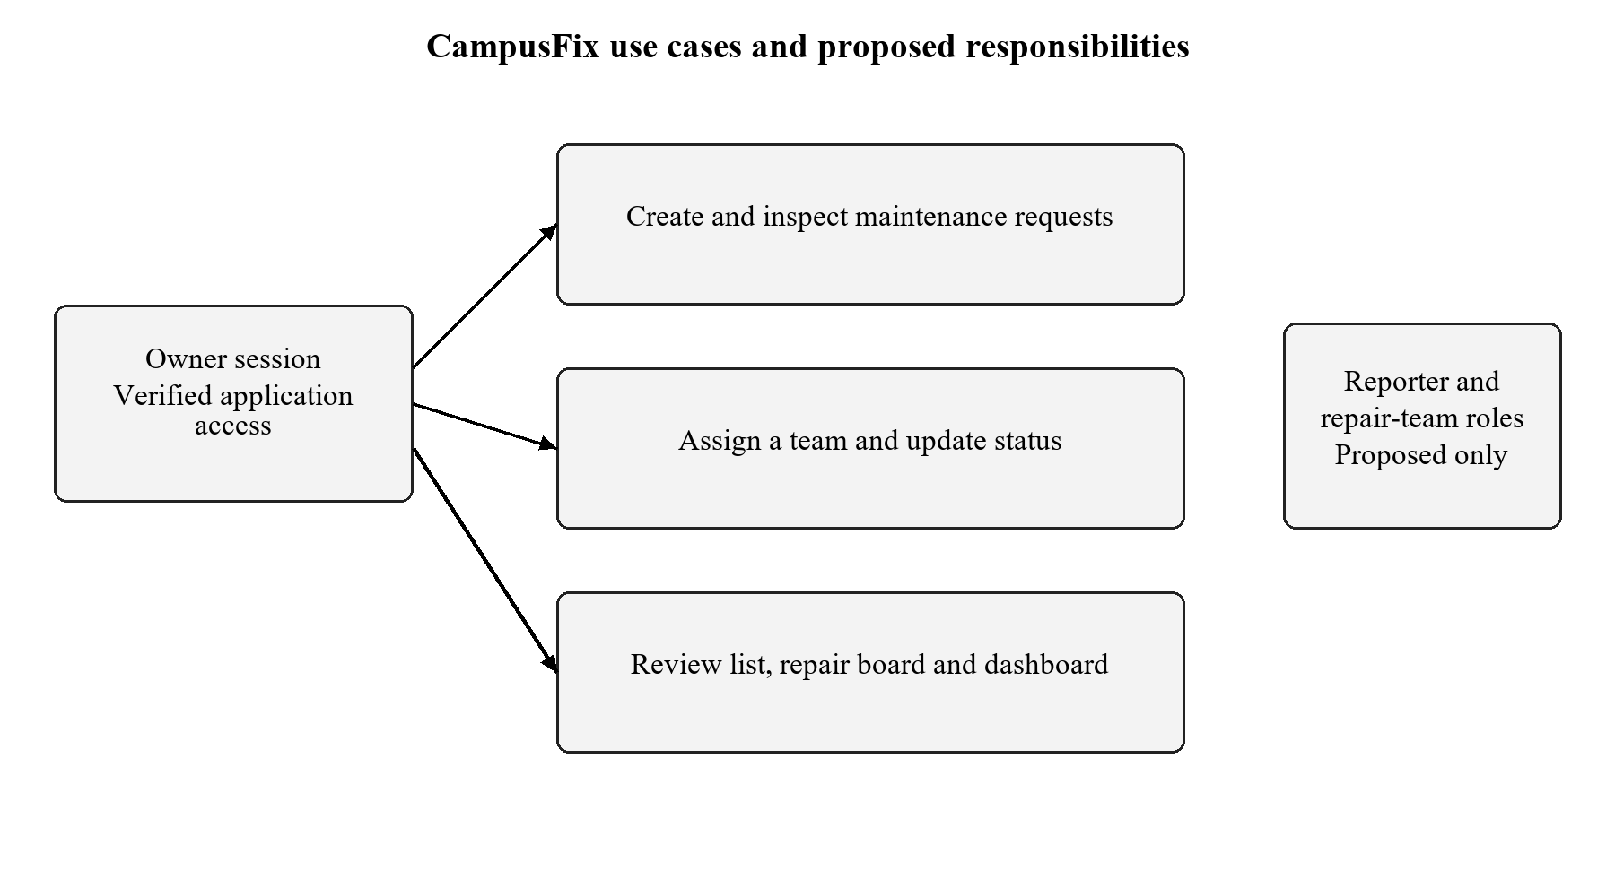
Figure 3.1: CampusFix use cases with implemented owner access and proposed roles
Table 3.5: Use Case Description - Update a Maintenance Request
Use Case ID | UC-01
Use Case Name | Update a maintenance request
Actor(s) | Owner demonstrating coordinator responsibilities
Pre-condition | Existing saved request and authorized account access
Main Flow | 1. Open record. 2. Choose Edit. 3. Set team/status/notes. 4. Update.
Alternate Flow | Missing team or notes is rejected when required by status
Post-condition | Saved record is reflected in reports after reload
Related FR | FR-05, FR-06, FR-07
CHAPTER 4

SYSTEM DESIGN

4.1 System Architecture

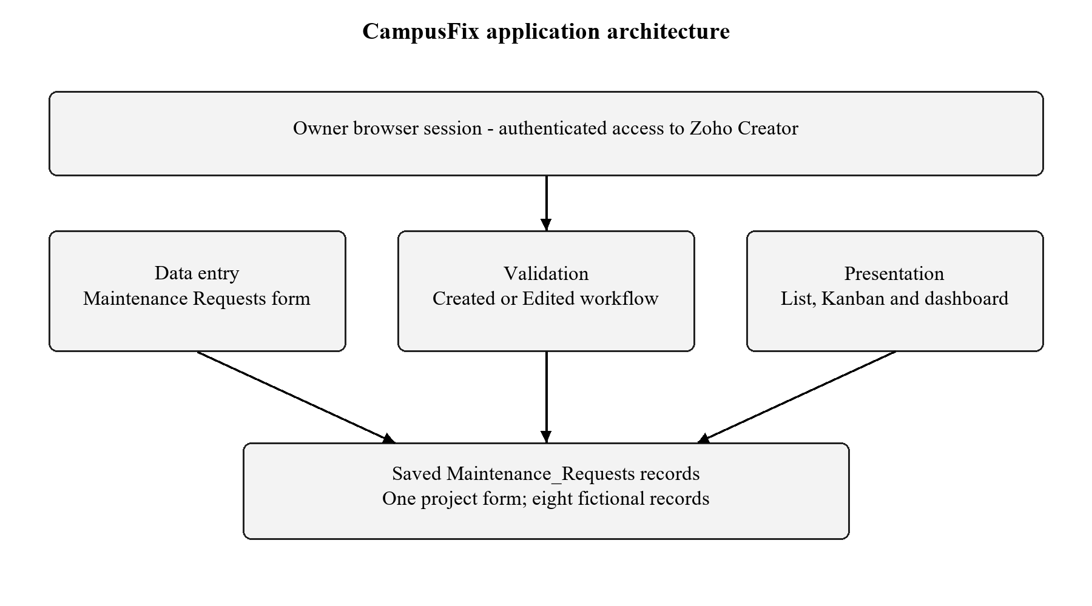
Figure 4.1: CampusFix application architecture
The browser is the access layer. The Maintenance Requests form collects data, the validation workflow checks submissions, and Creator stores the accepted records. The list, board and dashboard form the presentation layer. No external integration layer was configured. The original order components share the workspace but are not part of this maintenance model.

4.2 Data Model

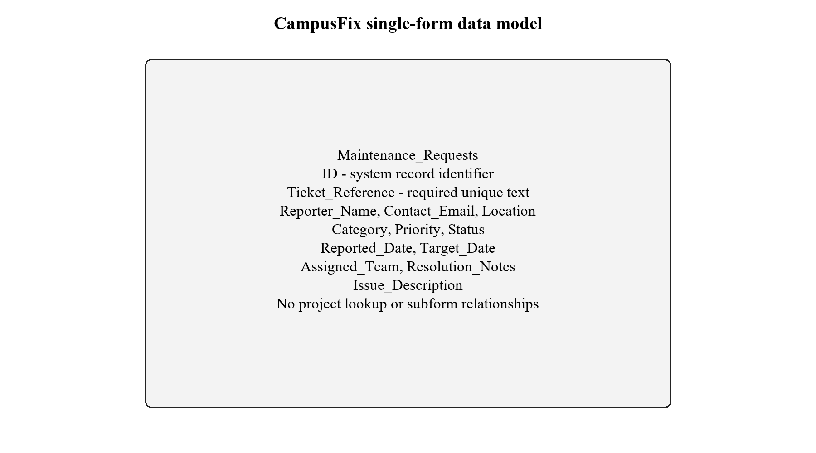
Figure 4.2: CampusFix single-form data model
Table 4.1: Entities and Relationships
Entity (Form) | Key Fields | Related To | Relationship Type | Implemented Using
Maintenance Requests | ID; unique Ticket_Reference; reporter/location/status/dates | None in project scope | Single form | Creator saved records
Category/Priority/Status choices | Configured dropdown values | Maintenance Requests | Enumerated field choices | Drop Down fields
Original order template | Excluded from project model | Not related to CampusFix records | Retained starter content | Not counted as maintenance work

4.3 Form Design
Table 4.2: Field Specification - Maintenance Requests Form
Field Label | Link Name | Field Type | Mandatory | Validation / Default | Remarks
Ticket Reference | Ticket_Reference | Single Line | Yes | Unique; no duplicates | User-entered reference
Reporter Name | Reporter_Name | Single Line | Yes | Required | Fictional demo reporter
Contact Email | Contact_Email | Email | Yes | Required; personal-data flag | example.com addresses
Location | Location | Single Line | Yes | Required | Campus issue location
Category | Category | Drop Down | Yes | Five categories | Electrical/Plumbing/Network/Furniture/Cleaning
Priority | Priority | Drop Down | Yes | Low/Medium/High | Required choice
Status | Status | Drop Down | Yes | Default Reported | Four configured values
Target Date | Target_Date | Date | Yes | Not before reported date | dd-MMM-yyyy
Reported Date | Reported_Date | Date | Yes | Not in future | dd-MMM-yyyy
Assigned Team | Assigned_Team | Single Line | Conditional | Required beyond Reported | Text; not a security role
Resolution Notes | Resolution_Notes | Multi Line | Conditional | Required for Resolved | Retains repair explanation
Issue Description | Issue_Description | Multi Line | Yes | Minimum 10 trimmed characters | Checked in workflow

4.4 Process and Workflow Design

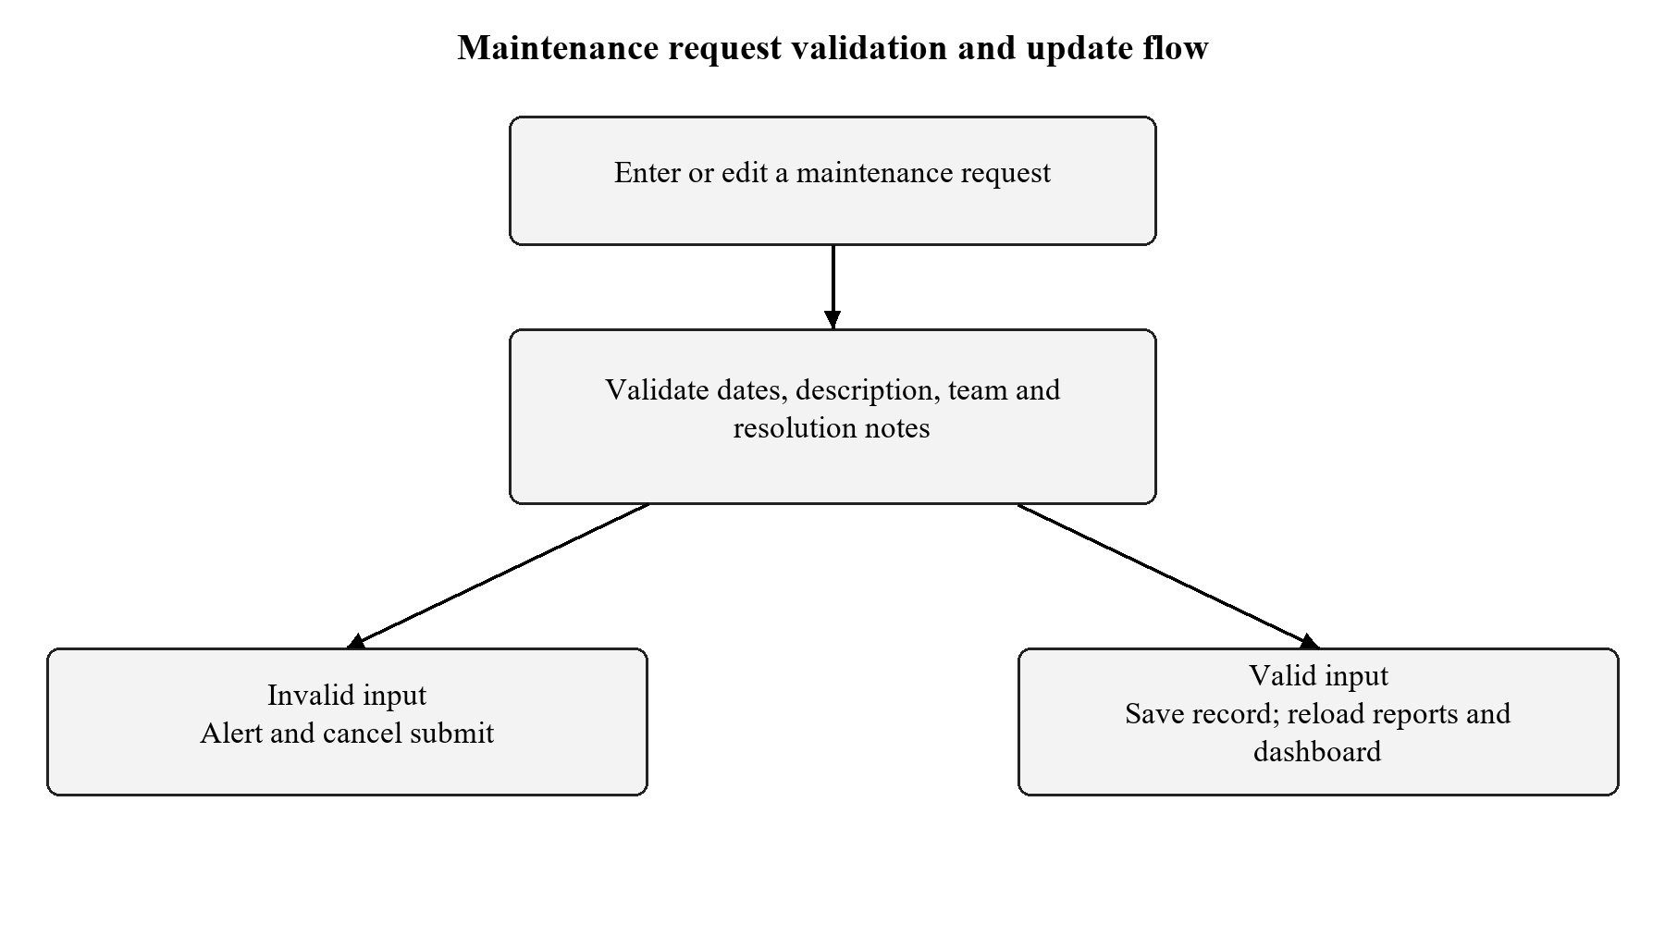
Figure 4.3: Maintenance request validation and update flow

4.5 User Interface and Navigation Design

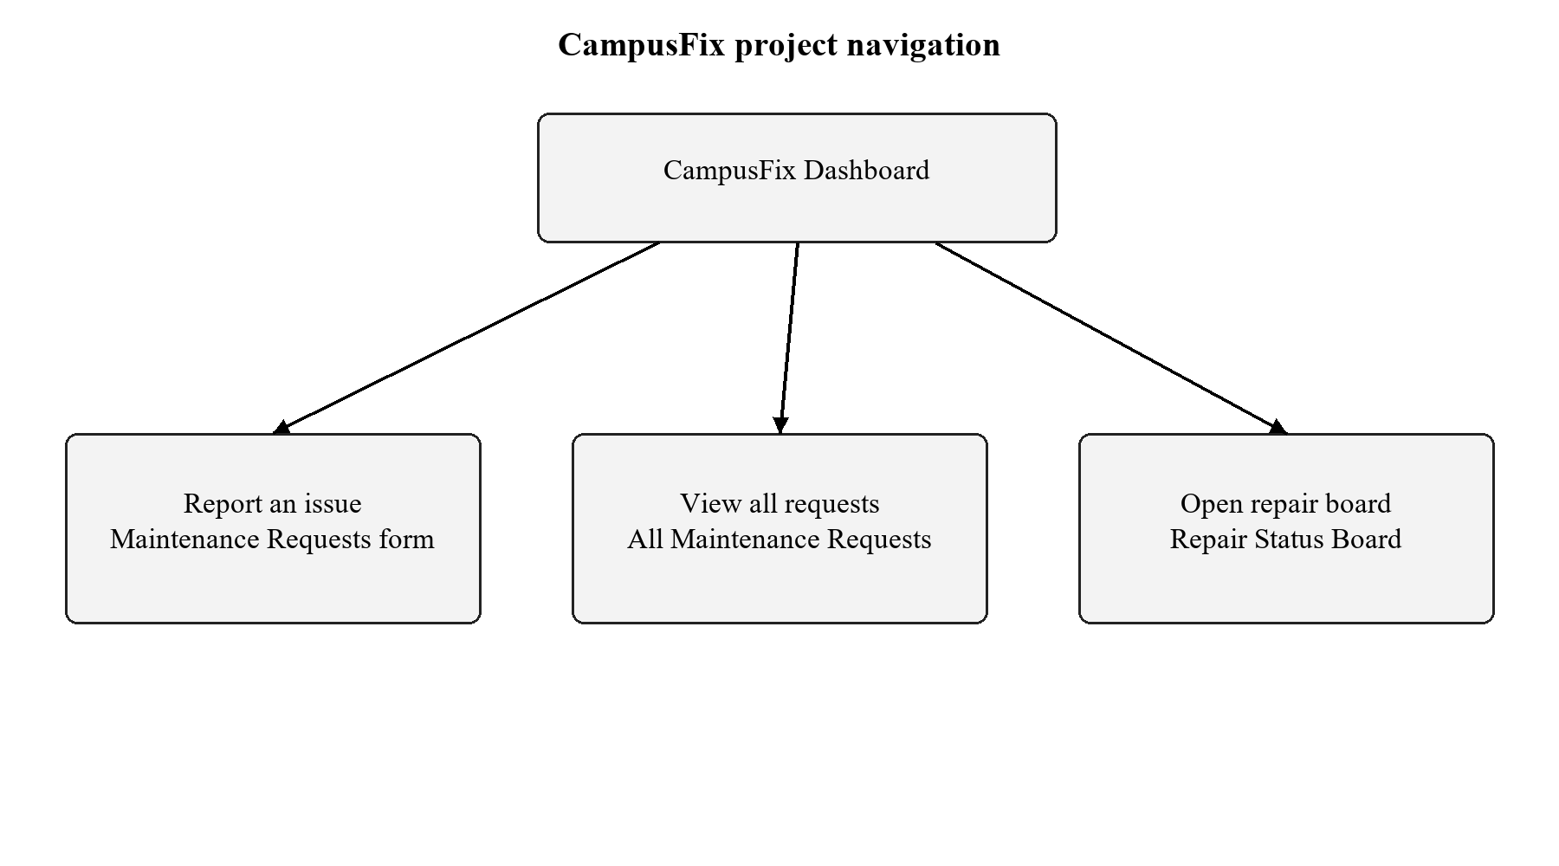
Figure 4.4: CampusFix project navigation structure

4.6 Access Control Design
Table 4.3: Role–Permission Matrix
Component | Owner session | Coordinator | Repair staff | Portal user
Maintenance Requests form | A E V D | Proposed only | Proposed only | Not configured
All Maintenance Requests | V | Proposed only | Proposed only | Not configured
Repair Status Board | V / edit record | Proposed only | Proposed only | Not configured
CampusFix Dashboard | V | Proposed only | Proposed only | Not configured
CHAPTER 5

IMPLEMENTATION

5.1 Application Setup
The account already contained a starter order application. The current subscription permitted only one application, so CampusFix components were added to that workspace while the original order components were retained. The application display name is CampusFix - Campus Maintenance Manager; the existing link name remains my-first-creator-app. The project uses a teal and white HTML dashboard, with links to its form and reports.

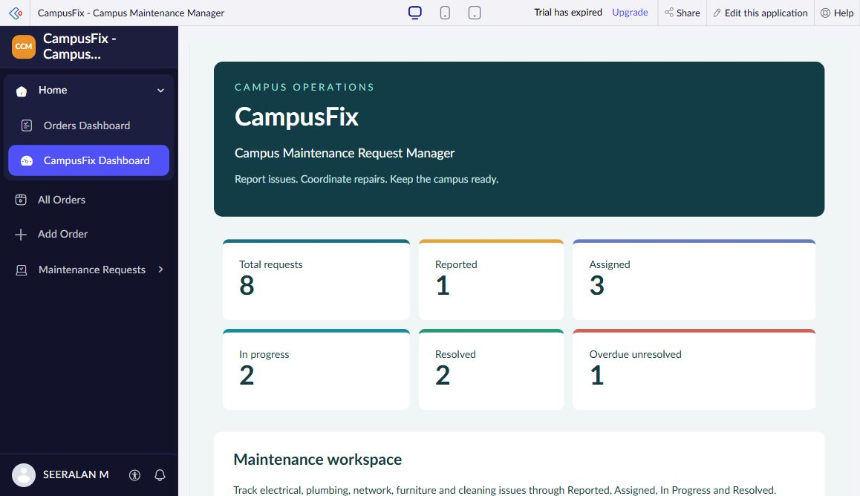
Figure 5.1: CampusFix dashboard and project navigation

5.2 Forms and Data Capture
Maintenance Requests was created from scratch in the form builder. Its twelve fields use five distinct field types: Single Line, Email, Drop Down, Date and Multi Line. Ticket Reference is mandatory and unique. Status defaults to Reported. Assigned Team and Resolution Notes are optional field controls with conditional requirements enforced by the validation workflow. Contact Email is marked as personal data in the saved definition. No project lookup or subform is present.

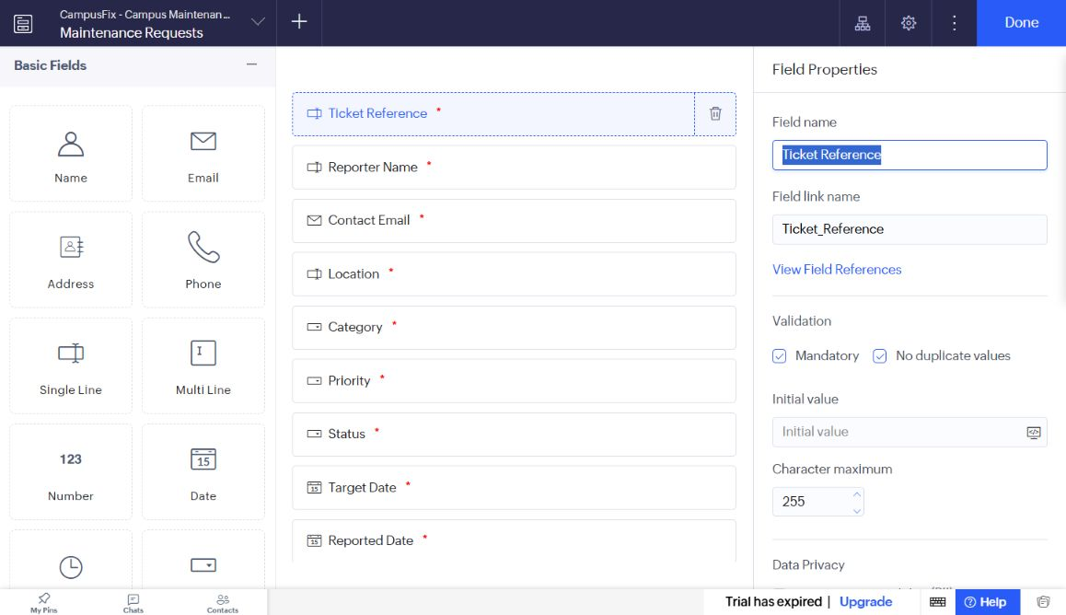
Figure 5.2: Maintenance Requests in the form builder

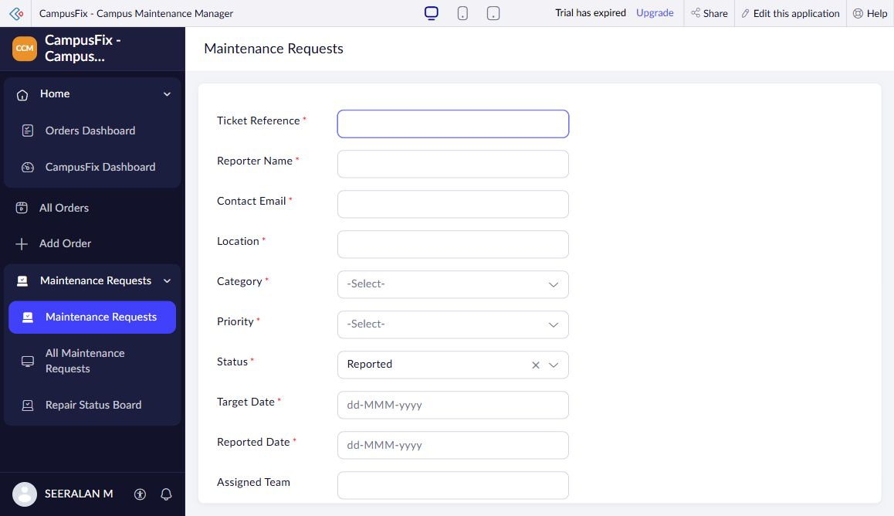
Figure 5.3: Maintenance Requests in live mode

5.3 Reports
Table 5.1: Reports Implemented
Report Name | Type | Source Form | Filter / Grouping / Sorting | Custom Actions | Roles
All Maintenance Requests | List | Maintenance_Requests | Saved record listing; 8 of 8 reviewed | Standard add/edit/detail actions | Owner session
Repair Status Board | Kanban | Maintenance_Requests | Columns grouped by Status | Open/edit record | Owner session

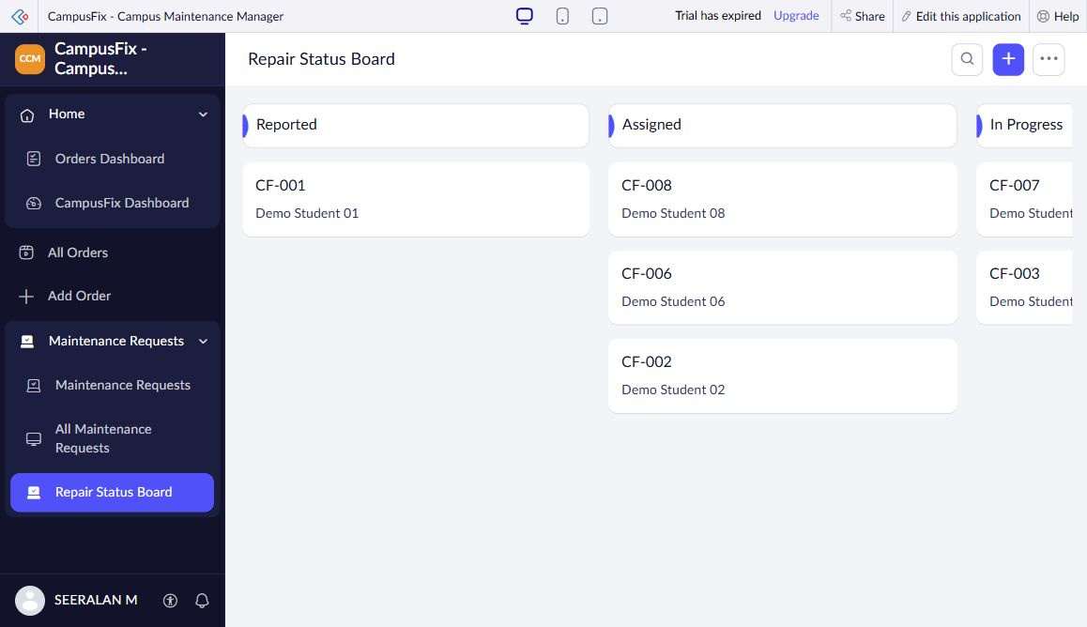
Figure 5.4: Repair Status Board grouped by Status

5.4 Pages and Dashboards
CampusFix Dashboard is a page containing an HTML and Deluge snippet. It presents six indicators and links to Report an issue, Open repair board and View all requests. The values are evaluated from saved Maintenance_Requests records when the page loads. The November 2 review showed 8 total, 1 Reported, 3 Assigned, 2 In Progress, 2 Resolved and 1 overdue unresolved. The overdue indicator is a subset of unresolved requests and changes with the current date.

Figure 5.5: CampusFix Dashboard with saved-record indicators

5.5 Deluge Scripting
Table 5.2: Deluge Scripts Implemented
Script ID | Location / Trigger | Purpose | Deluge Concepts Used
DS-01 | Maintenance Requests - Created or Edited, On Validate | Reject invalid submissions | if, ifnull, trim, date comparison, alert, cancel submit
DS-02 | CampusFix Dashboard HTML snippet - page load | Calculate six counts | criteria fetch, count, current date

Code 5.1: DS-01 Maintenance request validation excerpt
// DS-01 excerpt: reject invalid target date
if(input.Target_Date < input.Reported_Date)
{
alert "Target date must be on or after the reported date.";
cancel submit;
}

Code 5.2: DS-02 Dashboard aggregate queries
// DS-02: dashboard aggregation
total = Maintenance_Requests[ID != 0].count();
reported = Maintenance_Requests[Status == "Reported"].count();
assigned = Maintenance_Requests[Status == "Assigned"].count();
progress = Maintenance_Requests[Status == "In Progress"].count();
resolved = Maintenance_Requests[Status == "Resolved"].count();
overdue = Maintenance_Requests[
Target_Date < zoho.currentdate && Status != "Resolved"
].count();

DS-01 runs before record submission on creation or editing. It uses if statements, null-safe string checks, date comparisons, alerts and cancel submit. DS-02 uses criteria-based count queries; it does not change records. The complete validation source and all six queries are provided in Appendix C. No notification script was implemented.

5.6 Workflows and Automation
Table 5.3: Workflows Implemented
Workflow Name | Type | Trigger / Event | Condition | Action(s) | Script Ref.
Validate Maintenance Requests | Form validation | Created or Edited; form submission | Five invalid input conditions | Show alert; cancel submission | DS-01

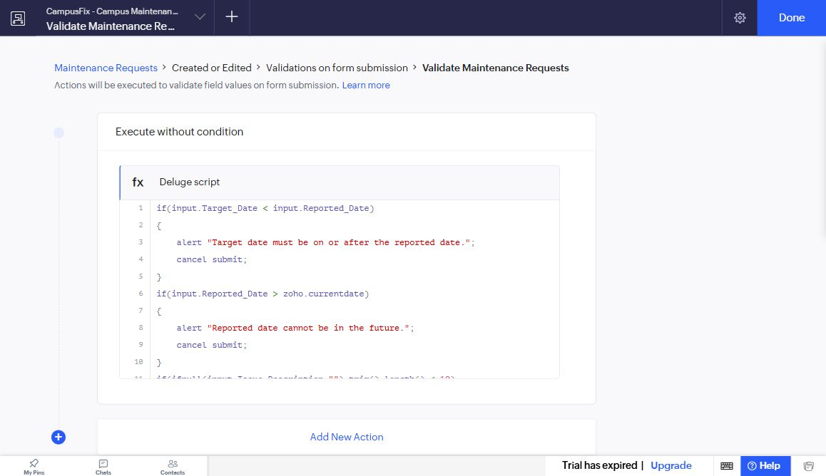
Figure 5.6: Created or Edited validation workflow and saved Deluge action

5.7 Integrations
Table 5.4: Integrations Implemented
Integration | Service / Endpoint | Method | Authentication | Data Exchanged / Purpose
None implemented | No external endpoint configured | Not applicable | No connection or token created | Application uses its own saved records
No Zoho-service connection, external REST request, webhook or Creator API integration was implemented. The core application reads its own saved records. Integration configuration, authorization and sanitized response testing are future work; no successful response is claimed.

5.8 User Management and Role-Based Access
The implemented demonstration uses the owner account. Reporter, coordinator and repair-team responsibilities are an access-control design rather than tested saved profiles. The current Users settings state that the account email must be confirmed before users can be added. No credentials are included in this report. A production rollout would require configured permissions and independent tests with each intended user [4].

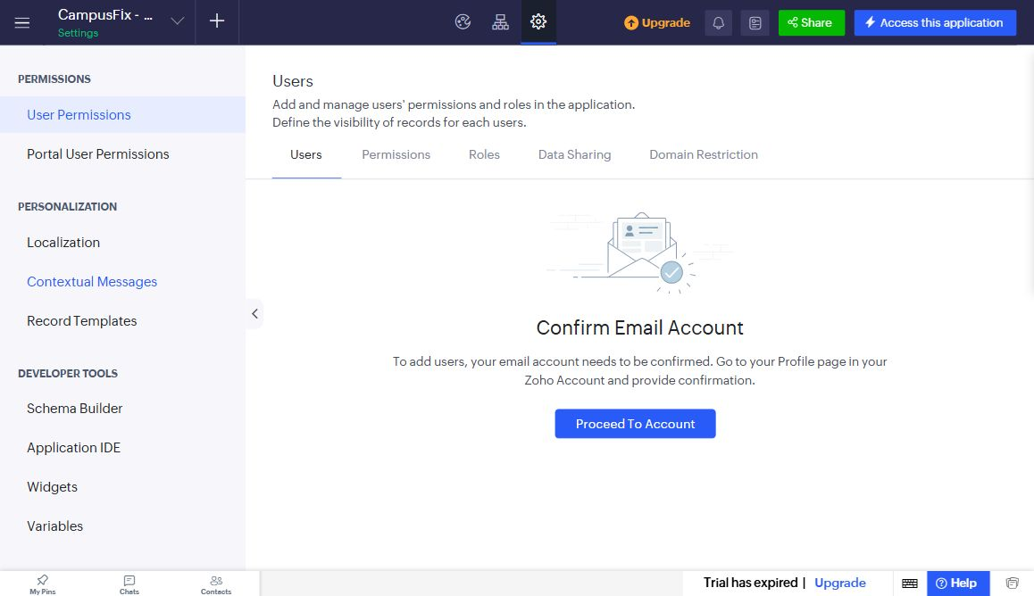
Figure 5.7: Current Users settings and email-confirmation prerequisite

5.9 AI and Analytics Features
The implemented analytics are the six count indicators and an independent reconciliation against the list and Kanban groups. Two of eight requests are resolved, which is 25 percent. No Zia prediction, AI field, pivot chart or Zoho Analytics connection was executed. AI assistance used during project preparation is acknowledged; it is not evidence of an in-application Zia feature.

Figure 5.8: CampusFix count indicators used for reconciliation

5.10 Pro-Code Extension
No Catalyst service, JavaScript widget or reusable custom function was implemented. The validation script and HTML/Deluge page were sufficient for the current demonstration. A later extension could provide a tested notification or integration service, with authentication and error handling designed before release.

5.11 Mobile and Portal Access
Mobile application and customer portal access were not implemented or tested. The demonstrated access channel is the authenticated desktop browser.
CHAPTER 6

TESTING AND DEBUGGING

6.1 Testing Strategy
Functional testing used fictional request data. The initial build tested valid submission, duplicate references, five rejection conditions and an edited status reflected in dashboard counts. Subsequent inspection reconciled all eight records across the list, board and dashboard. Tests were performed through the owner browser session. Independent UAT, restricted-user enforcement, API behaviour, mobile layouts and performance under load remain unverified.

6.2 Test Cases
Table 6.1: Test Cases
TC ID | FR Ref. | Test Description | Input / Steps | Expected Result | Actual Result | Status
TC-01 | FR-01 | Valid submission | Complete fictional request | Record saved | Eight valid requests saved | Pass
TC-02 | FR-02 | Duplicate reference | Reuse CF-001 | Reject duplicate | Unique-value error shown | Pass
TC-03 | FR-03 | Date order | Target earlier than reported | Reject | Date-order alert shown | Pass
TC-04 | FR-03 | Future report date | Use 01-Jan-2030 | Reject | Future-date alert shown | Pass
TC-05 | FR-04 | Short description | Use Fan | Reject | Minimum-length alert shown | Pass
TC-06 | FR-05 | Missing team | Assigned with blank team | Reject | Team-required alert shown | Pass
TC-07 | FR-05 | Missing notes | Resolved with blank notes | Reject | Resolution-notes alert shown | Pass
TC-08 | FR-06 | List consistency | Open saved list | 8 records | Showing 8 of 8 | Pass
TC-09 | FR-06 | Board grouping | Inspect four status columns | 1 / 3 / 2 / 2 | Groups match saved records | Pass
TC-10 | FR-07 | Dashboard total | Reconcile status values | Total 8 | 1+3+2+2 = 8 | Pass
TC-11 | FR-07 | Saved status update | CF-008 Reported to Assigned | Counts update on reload | 2/2 changed to 1/3 | Pass
TC-12 | FR-01 | Default status | Open a new blank form | Reported | Reported shown | Pass
TC-13 | FR-01 | Category choices | Open Category choices | Five defined categories | Choices verified live | Pass
TC-14 | FR-01 | Priority choices | Open Priority choices | Low/Medium/High | Choices verified live | Pass
TC-15 | FR-06 | Record detail | Open CF-008 | Saved team/status/dates | Assigned; Facilities Team shown | Pass
TC-16 | NFR-02 | Restricted-user test | Separate account/profile | Enforce allowed actions | Not executed | Pending
TC-17 | NFR-01 | Load benchmark | Representative larger dataset | Measured response times | Not executed | Pending
TC-18 | NFR-03 | Independent UAT | Two end-user sessions | Record feedback | Not executed | Pending

6.3 Debugging Deluge Scripts
The Deluge editor identified a field-link-name error for Assigned_Team during the build. The field label had changed locally while the saved link name had not persisted. The form properties were saved, the actual link names were verified in the live form, and the validation action compiled successfully. Submission alerts then provided direct feedback for the negative tests. Figure 6.1 shows a real rejected future-date entry.

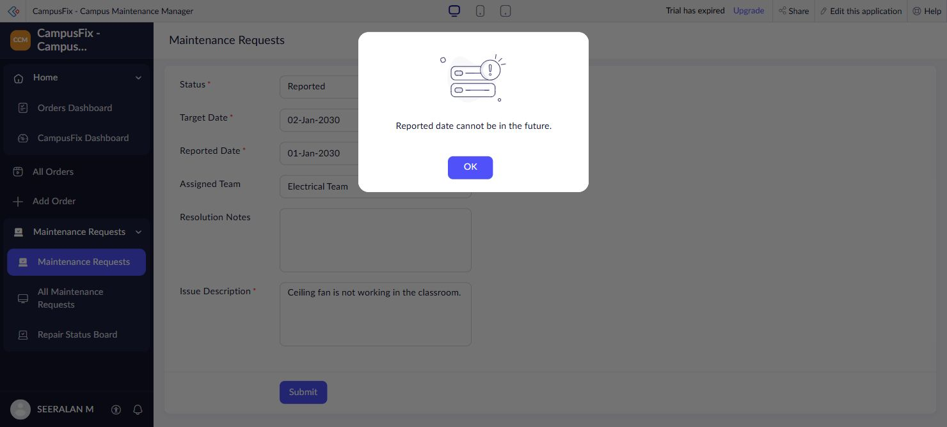
Figure 6.1: Actual rejection of a future reported date

6.4 Defect Log
Table 6.2: Defect Log
Bug ID | Description | Root Cause | Fix Applied | Status
BUG-01 | Assigned_Team link not recognized by script | Field rename had not persisted | Saved and rechecked field link names; action compiled | Closed
BUG-02 | Dropdown choices not reflected in live form | Property edits had not persisted | Saved properties and verified live dropdown choices | Closed

6.5 User Acceptance Testing
Table 6.3: User Acceptance Feedback
User | Role Tested | Feedback | Action Taken
End user 1 | Not tested | No independent feedback collected | Arrange a supervised review
End user 2 | Not tested | No independent feedback collected | Arrange a supervised review
CHAPTER 7

DEPLOYMENT, SECURITY AND GOVERNANCE

7.1 Environments and Deployment Strategy
CampusFix is accessible in the existing authenticated Creator application. The current header displays Trial has expired. No Development to Stage to Production release was executed, and no public portal was published. The repository contains component definitions and documentation; these are not a complete restorable application backup. A complete export, controlled restore test and release procedure are required before production deployment.
Table 7.1: Deployment Checklist
S.No. | Checklist Item | Done (✓)
1 | All test cases executed in Development / Stage | No - owner-session functional tests only
2 | Sample/test data removed or isolated | Fictional records identified as demo data
3 | Roles, permissions and users configured in Production | No
4 | Connections authorised in Production | Not applicable - none created
5 | Schedules and workflows enabled | Validation workflow tested; no schedule
6 | Application published and URL verified | Authenticated app URL verified; no staged release
7 | Version / release notes recorded | Source and evidence documented; no release pipeline

7.2 Performance Optimisation
Table 7.2: Performance Optimisation Results
Optimisation Applied | Component | Before | After | Improvement
Criteria-based count queries | Dashboard | No separate baseline measured | Six saved queries used | No timing improvement claimed
Status-based board grouping | Repair Status Board | No baseline measured | Four status groups shown | Functional organisation only
Future representative benchmark | Application | Not measured | Not measured | Pending

7.3 Security Features
Table 7.3: Security Controls Implemented
Security Control | Where Applied | Threat Mitigated
Authenticated account access | Creator owner session | Limits unauthenticated access; independent security testing pending
Required and unique fields | Maintenance Requests | Incomplete and duplicate entries
Conditional validation | Submission workflow | Inconsistent dates and missing repair information
Personal-data designation | Contact Email field | Identifies contact data; does not prove role isolation or encryption

7.4 Governance and Administration
Components use consistent Maintenance_Requests and CampusFix names. The repository retains the saved form, report and workflow definitions, documentation and evidence. The exact dashboard implementation must also be retained for a complete rebuild; a wrapper referencing an HTML snippet alone is insufficient. Audit-trail review, scheduled backups and independent restore testing remain future administration tasks. The app settings currently show UTC and dd-MMM-yyyy; intended campus timezone boundaries should be confirmed before rollout.

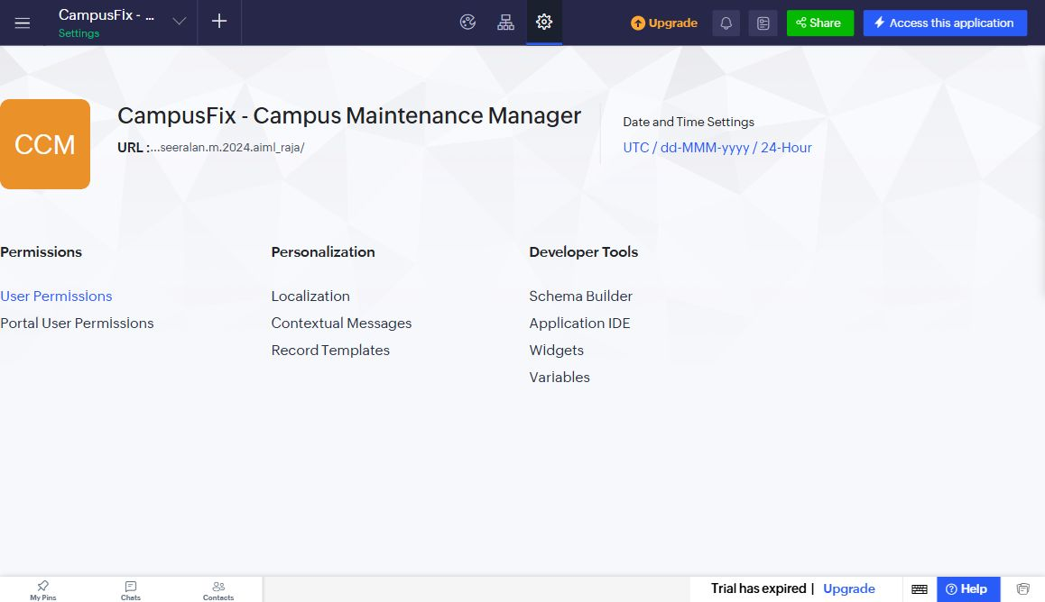
Figure 7.1: Current CampusFix application settings
CHAPTER 8

RESULTS AND DISCUSSION

8.1 Application Output
CF-008 is the demonstrated desk-repair request. The form captures its location, category and description; the saved detail contains its target date and Facilities Team assignment. During the build, CF-008 was changed from Reported to Assigned and the dashboard counters changed from 2/2 to 1/3 for those statuses. The current board places it in Assigned. The walkthrough is one owner-session demonstration, not a multi-user approval process.

Figure 8.1: Maintenance Requests form for issue capture

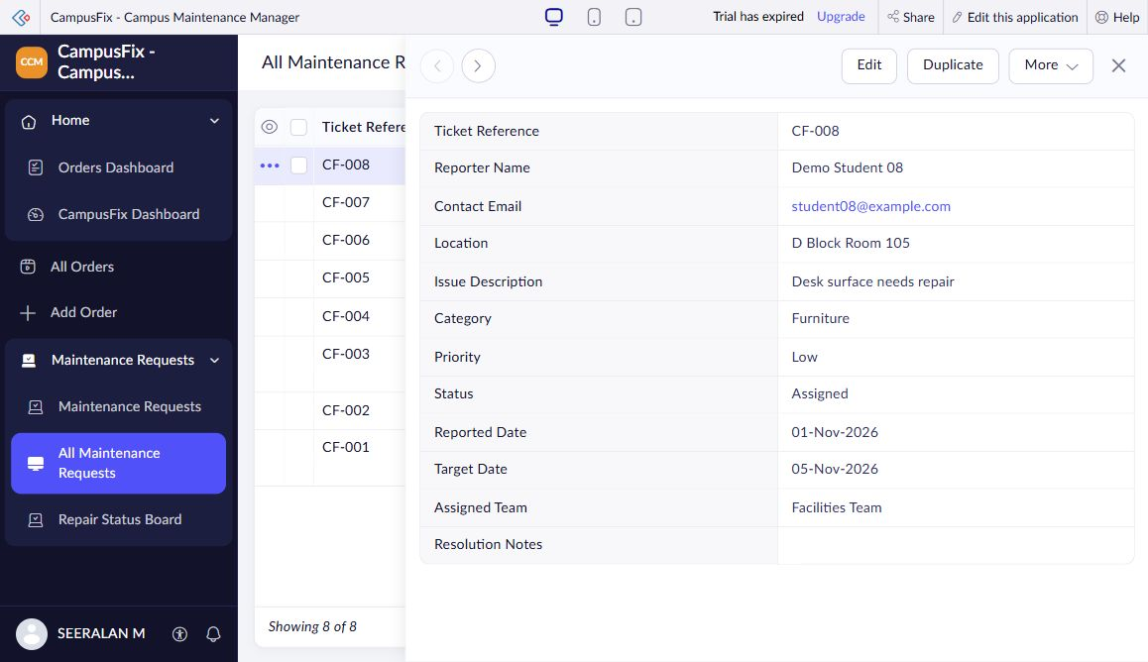
Figure 8.2: Saved CF-008 maintenance request details

Figure 8.3: Dashboard after the saved status update

8.2 Achievement of Objectives
Table 8.1: Mapping of Objectives to Outcomes
Objective (Sec. 1.3) | Implemented Through | Outcome / Evidence
Structured capture | 5.2; Maintenance Requests | Twelve fields and eight saved requests
Five validation rules | 5.5, 5.6; DS-01 | Five negative tests rejected
Consistent views | 5.3; list and Kanban | Eight records; groups 1/3/2/2
Live dashboard counts | 5.4; DS-02 | Total 8 and update reflected after reload
Document tests and limits | 6; 7; Appendix A | Passes and pending checks distinguished

8.3 Comparison with the Existing System
Table 8.2: Existing System versus Proposed Application
Parameter | Existing System | Proposed Application | Improvement
Request details | Illustrative separate messages | One saved form record | Structured information; no time saving measured
Status review | Illustrative follow-up messages | Kanban status groups | Current saved status visible
Summary preparation | Illustrative separate manual summary | Count queries on page load | No duplicate summary dataset
Access model | No measured baseline | Owner access verified only | Restricted roles still require testing

8.4 Limitations of the Low-Code Approach
The one-application subscription limit required the project to reuse an existing workspace. Original order components therefore remain visible in navigation but are excluded from maintenance counts. Field edits sometimes appeared locally before persisting, so link names and dropdown choices were checked again in live mode. The board may require horizontal scrolling. Separate roles, integration quotas, high-volume behaviour and complete export/restore have not been tested. These are concrete limits of the demonstrated scope rather than measured platform-wide limits.

8.5 Reflection on the No-Code → Low-Code → Pro-Code Spectrum
Visual form and report configuration are the no-code portion of CampusFix. Deluge validation and aggregate queries form its low-code portion. The HTML dashboard adds manually authored presentation code. A future external service or custom widget would introduce a pro-code boundary and would need independent interface, security and deployment tests. The appropriate choice depends on the requirement, not on assuming that every feature must be scripted.
CHAPTER 9

CONCLUSION AND FUTURE ENHANCEMENTS

9.1 Conclusion
CampusFix implements structured campus issue capture, a saved-record list, a status Kanban board and a workload dashboard in Zoho Creator. Its validation workflow rejects five invalid input conditions, and ticket references are unique. Eight fictional requests and the edited CF-008 record provide the working demonstration. The project establishes the core maintenance workflow while explicitly retaining unverified integrations, roles, performance and deployment activities as future work.

9.2 Future Enhancements
- Configure and test reporter, coordinator and repair-team permissions after account email confirmation.
- Add notification and external-summary integration only after authorization, failure handling and response tests are defined.
- Add a complete backup/restore procedure, timezone review, mobile checks, staged deployment and representative performance measurements.

9.3 Learning Outcomes and Career Relevance
The project develops skills in form modelling, report configuration, Deluge conditions, aggregate queries, debugging, screenshot evidence and technical documentation. These skills support entry-level low-code development, solutions analysis and automation work. Further learning should cover access control, reliable integrations, release management and independent acceptance testing. Understanding the limits of the current demonstration is part of presenting it accurately.

REFERENCES
[1] Zoho Corporation, “Understand Applications,” Zoho Creator Help. [Online]. Available: https://help.zoho.com/portal/en/kb/creator/developer-guide/creating-applications/understand-applications/articles/understand-application (accessed Nov. 2, 2026).
[2] Zoho Corporation, “Understanding form builder,” Zoho Creator Help. [Online]. Available: https://help.zoho.com/portal/en/kb/creator/developer-guide/forms/the-concept-of-forms/articles/form-builder (accessed Nov. 2, 2026).
[3] Zoho Corporation, “Understanding workflows,” Zoho Creator Help. [Online]. Available: https://help.zoho.com/portal/en/kb/creator/developer-guide/workflows/understand-workflows/articles/understand-workflows (accessed Nov. 2, 2026).
[4] Zoho Corporation, “Understanding permissions,” Zoho Creator Help. [Online]. Available: https://help.zoho.com/portal/en/kb/creator/developer-guide/application-settings/manage-and-configure-user-permissions/articles/understand-permissions (accessed Nov. 2, 2026).
[5] Zoho Corporation, “Count,” Zoho Deluge Help. [Online]. Available: https://www.zoho.com/deluge/help/data-access/aggregate-records/count.html (accessed Nov. 2, 2026).

APPENDIX A – ZOHO CREATOR FEATURE COVERAGE CHECKLIST
Table A.1: Feature Coverage Checklist
Unit | Zoho Creator Feature | Done | Where in the Application | Report Section | Figure / Code No.
I | Application created & sections/menu organised | Y | Existing app and CampusFix menu | 5.1 | Fig. 5.1
II | Forms with ≥ 8 distinct field types | N | Not implemented / not verified | 5.2 | Not applicable
II | Lookup field (relationship between forms) | N | Not implemented / not verified | 4.2, 5.2 | Not applicable
II | Subform (parent–child data) | N | Not implemented / not verified | 4.2, 5.2 | Not applicable
II | Field validations / layout rules | Y | Form properties and DS-01 | 5.2 | Code 5.1
II | List report with filter, grouping, custom action | N | Not implemented / not verified | 5.3 | Not applicable
II | Kanban / Calendar / Timeline / Map report | Y | Repair Status Board | 5.3 | Fig. 5.4
II | Pivot table / chart report | N | Not implemented / not verified | 5.3 | Not applicable
II | Page / dashboard built with UI Builder | Y | CampusFix Dashboard | 5.4 | Fig. 5.5
II | Deluge – form events (validate / success / field actions) | Y | DS-01 On Validate | 5.5 | Code 5.1
II | Deluge – functions, fetch, loops, collections | N | Not implemented / not verified | 5.5 | Not applicable
II | Email / in-app notifications | N | Not implemented / not verified | 5.5, 5.6 | Not applicable
II | Form workflow | Y | Validate Maintenance Requests | 5.6 | Fig. 5.6
II | Scheduled workflow | N | Not implemented / not verified | 5.6 | Not applicable
II | Approval process | N | Not implemented / not verified | 5.6 | Not applicable
II | Blueprint | N | Not implemented / not verified | 5.6 | Not applicable
II | Batch / report workflow | N | Not implemented / not verified | 5.6 | Not applicable
II | Testing & debugging evidence | Y | Negative tests and defect log | 6 | Fig. 6.1; Table 6.1
III | Integration with a Zoho service | N | Not implemented / not verified | 5.7 | Not applicable
III | Connection / REST API call (invokeurl) | N | Not implemented / not verified | 5.7 | Not applicable
III | Webhook or Creator REST API | N | Not implemented / not verified | 5.7 | Not applicable
III | Users, roles and permission profiles | N | Not implemented / not verified | 5.8 | Not applicable
III | Record-level access criteria / customer portal | N | Not implemented / not verified | 5.8 | Not applicable
III | Zia / AI feature | N | Not implemented / not verified | 5.9 | Not applicable
III | Analytics (charts / Zoho Analytics) | N | Not implemented / not verified | 5.9 | Not applicable
IV | Performance optimisation applied & measured | N | Not implemented / not verified | 7.2 | Not applicable
IV | Deployment across environments | N | Not implemented / not verified | 7.1 | Not applicable
IV | Security controls (encryption, OAuth, permissions) | N | Not implemented / not verified | 7.3 | Not applicable
IV | Governance (audit trail, administration) | N | Not implemented / not verified | 7.4 | Not applicable
V | Pro-code extension (Catalyst / widgets / custom functions) | N | Not implemented / not verified | 5.10 | Not applicable
V | Low-code limitations & spectrum analysis | Y | Limitations and spectrum reflection | 8.4, 8.5 | Sections 8.4-8.5
— | Mobile app / portal access | N | Not implemented / not verified | 5.11 | Not applicable

Total features fully evidenced against the combined checklist criteria: 8 / 32. A negative entry may include a partially implemented component; the corresponding section explains the scope.

APPENDIX B – COURSE OUTCOME MAPPING
Table B.1: Mapping of Course Outcomes to Report Chapters
CO | Course Outcome Statement | Evidenced In | Self-Assessed Level | Examiner Level
CO1 | Explain the principles, architecture, and business value of low-code application development using Zoho Creator. | Ch. 1, 2 | 2
CO2 | Develop business applications using Zoho Creator forms, reports, workflows, and Deluge scripting. | Ch. 4, 5 (5.1–5.6), 6 | 2
CO3 | Integrate Zoho Creator applications with Zoho services and external systems using APIs, connections, and role-based security. | Ch. 4.6, 5.7–5.9 | 1
CO4 | Deploy, secure, and manage Zoho Creator applications across development and production environments following governance best practices. | Ch. 7 | 1
CO5 | Evaluate low-code development strategies, AI-assisted application development, and the transition from citizen developer to professional developer. | Ch. 5.9, 5.10, 8.4, 8.5, 9.3 | 2

APPENDIX C – COMPLETE DELUGE SOURCE CODE
C.1 Maintenance Requests validation workflow
// DS-01 | Maintenance Requests | Created or Edited
// Event: Validations on form submission
if(input.Target_Date < input.Reported_Date)
{
alert "Target date must be on or after the reported date.";
cancel submit;
}
if(input.Reported_Date > zoho.currentdate)
{
alert "Reported date cannot be in the future.";
cancel submit;
}
if(ifnull(input.Issue_Description,"").trim().length() < 10)
{
alert "Please describe the issue using at least 10 characters.";
cancel submit;
}
if(input.Status != "Reported" &&
ifnull(input.Assigned_Team,"").trim() == "")
{
alert "Assign a repair team before progressing this request.";
cancel submit;
}
if(input.Status == "Resolved" &&
ifnull(input.Resolution_Notes,"").trim() == "")
{
alert "Resolution notes are required before closing a request.";
cancel submit;
}

C.2 CampusFix Dashboard aggregate queries
// DS-02 | CampusFix Dashboard HTML snippet
// Event: page load | no record changes
total = Maintenance_Requests[ID != 0].count();
reported = Maintenance_Requests[Status == "Reported"].count();
assigned = Maintenance_Requests[Status == "Assigned"].count();
progress = Maintenance_Requests[Status == "In Progress"].count();
resolved = Maintenance_Requests[Status == "Resolved"].count();
overdue = Maintenance_Requests[
Target_Date < zoho.currentdate && Status != "Resolved"
].count();

APPENDIX D – USER MANUAL

D.1 Accessing the Application
Open the application URL in an internet-connected browser and sign in with the authorized Zoho account. Select CampusFix Dashboard under Home. Access remains governed by Creator permissions; no public or embedded credentials are supplied.

D.2 Instructions for the Owner Demonstration
- Select Report an issue. Enter a new unique reference, fictional reporter and email, location, category, priority, reported and target dates, and a description of at least ten characters. Submit valid data.
- Open All Maintenance Requests, inspect the new record, choose Edit, assign a team and update its status. Enter resolution notes before selecting Resolved. Use Update to save the change.

D.3 Instructions for Reviewing Reports
- Open Repair Status Board to see the four configured status columns. Scroll horizontally if needed. Open a card to inspect its details.
- Return to CampusFix Dashboard to recalculate the six indicators. Reconcile the status totals with the list count and explain that overdue is a subset, not an additional status.

APPENDIX E – EVALUATION RUBRIC
(For Examiner Use Only)
Student Name | Seeralan M | Register No. | 2116241501193
Project Title | CampusFix Campus Maintenance Manager | Date | ____________________

Table E.1: Evaluation Rubric for the Individual Project
S.No. | Criterion | Indicators | Max. Marks | Marks Awarded
1 | Problem Definition & Requirement Analysis | Clarity of problem, measurable objectives, complete FR/NFR, use cases | 10
2 | System Design | Architecture, ER/data model, form specifications, workflow design, permission matrix | 10
3 | Forms, Reports & Pages | Variety of field types, lookups/subforms, report types, UI Builder dashboards | 15
4 | Deluge Scripting & Workflows | Correctness and depth of scripts; form, schedule, approval, Blueprint, batch workflows | 15
5 | Integration, RBAC & AI | Zoho/external integrations, connections, roles & permissions, Zia/analytics | 10
6 | Testing, Deployment, Security & Governance | Test coverage, environments, optimisation, security controls, audit | 10
7 | Live Demonstration | End-to-end working of the application across roles; feature checklist verified | 15
8 | Project Report | Adherence to template and format, clarity, figures, references | 5
9 | Viva-Voce | Understanding of the platform, design decisions and low-code concepts | 10
 | TOTAL |  | 100

Table E.2: Performance Level Descriptors
Level | % of Max. Marks | Descriptor
Excellent | 90–100 | Feature implemented completely, correctly and beyond the basic requirement; student explains design choices confidently.
Good | 70–89 | Feature implemented correctly with minor gaps; explanation adequate.
Satisfactory | 50–69 | Feature partially implemented or works only for the main path; limited explanation.
Needs Improvement | < 50 | Feature missing, non-functional or not understood by the student.

Signature of Internal Examiner  Name: ____________________ | Signature of External Examiner  Name: ____________________

APPENDIX F – VIVA-VOCE RECORD SHEET
(For Examiner Use Only)
Student Name | Seeralan M | Register No. | 2116241501193
Department / Section | AIML | Date of Viva | ____________________
Application URL Verified | For examiner verification | Demo Duration | ______ min
Table F.1: Viva-Voce Questions and Responses
Q.No. | Question / Topic Asked | Unit | Response (E / G / S / NI) | Remarks
1
2
3
4
5
6
7
8
E – Excellent G – Good S – Satisfactory NI – Needs Improvement
Table F.2: Marks Summary
Component | Max. Marks | Marks Awarded
Criteria 1–8 (Appendix E) | 90
Viva-Voce | 10
TOTAL | 100

Examiners’ Remarks:
____________________________________________________________________
____________________________________________________________________
INTERNAL EXAMINER  Name: ____________________ | EXTERNAL EXAMINER  Name: ____________________

