Experiment 4 Business Data Modelling and Form Design
CB23F35 Low Code Application Development using Zoho Creator
CampusFix Campus Maintenance Manager | Form configuration inspected

Aim
Describe the Maintenance Requests data model and its configured field rules.

Theory
CampusFix stores ticket reference, reporter name, contact email, location, category, priority, status, target date, reported date, assigned team, resolution notes and issue description. Ticket Reference is required and unique. Status defaults to Reported. The saved definition marks Contact Email as personal data. No related team form, lookup or subform was verified.

Procedure
1. Inspect the required fields in Maintenance Requests.
2. Review category, priority and status choices in the saved form definition.
3. Check which fields are optional in the form and conditionally required by validation.

Observations
• Categories are Electrical, Plumbing, Network, Furniture and Cleaning.
• Priority choices are Low, Medium and High; status choices are Reported, Assigned, In Progress and Resolved.
• The form uses a text ticket reference; automatic numbering was not observed.
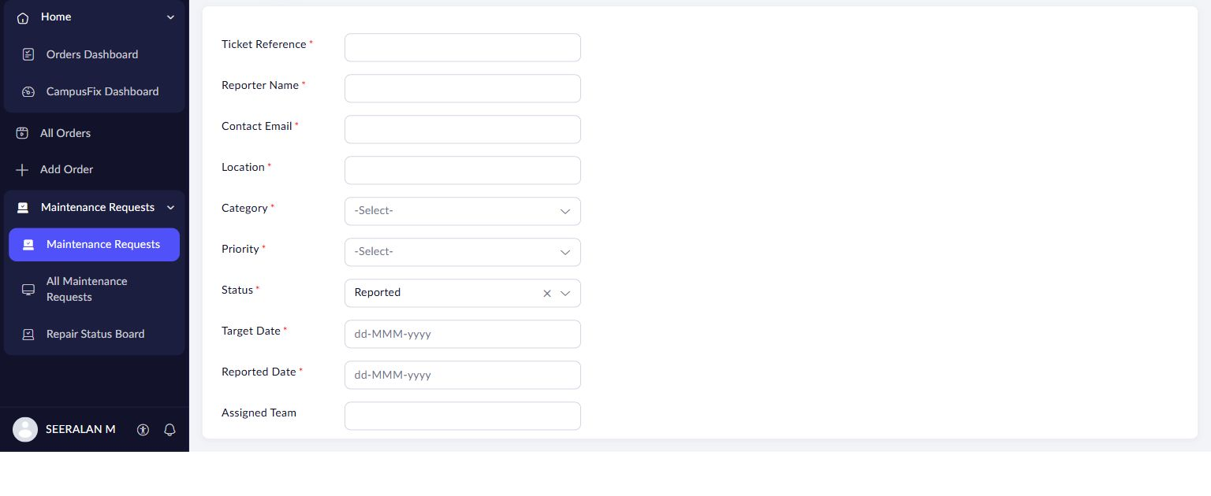
Figure 1 CampusFix request form with required fields and default Reported status.

Result
A single-form maintenance request model is implemented. Relationships and repeating subforms remain outside the verified model.

Sources
CampusFix live application and saved component definitions reviewed on 2 November 2026. Screenshot captured from the project without a mouse pointer.
Experiment topics and report structure adapted from san342147/CB23F35-Low-Code-Zoho-Creator. The screenshots and case study in this revision describe CampusFix.

