Experiment 5 Reports and the CampusFix Dashboard
CB23F35 Low Code Application Development using Zoho Creator
CampusFix Campus Maintenance Manager | Reports and dashboard verified

Aim
Compare the request list, repair board and dashboard against the same saved records.

Theory
All Maintenance Requests lists records from Maintenance_Requests. Repair Status Board groups cards by Status. CampusFix Dashboard presents workload indicators and links to the form and reports. The dashboard note states that counts are calculated from saved records when the page loads.

Procedure
1. Open All Maintenance Requests and confirm Showing 8 of 8.
2. Inspect the four status groups on Repair Status Board.
3. Compare those groups with the dashboard counters.

Observations
• The list contains eight fictional requests, CF-001 through CF-008.
• The board groups are Reported 1, Assigned 3, In Progress 2 and Resolved 2.
• The dashboard agrees with those counts and shows 1 overdue unresolved request, a subset of unresolved work.
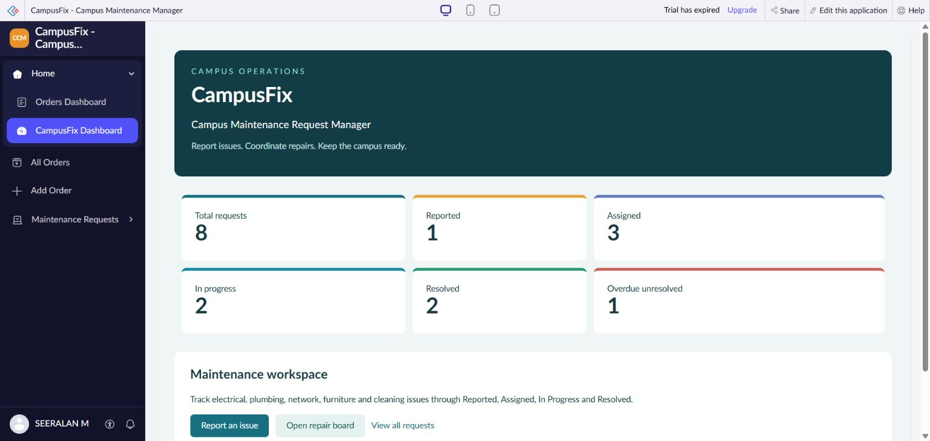
Figure 1 CampusFix dashboard showing the verified maintenance request totals.

Result
List, board and dashboard agree on eight requests. Pivot charts, pivot tables and Zoho Analytics integration were not demonstrated for CampusFix.

Sources
CampusFix live application and saved component definitions reviewed on 2 November 2026. Screenshot captured from the project without a mouse pointer.
Experiment topics and report structure adapted from san342147/CB23F35-Low-Code-Zoho-Creator. The screenshots and case study in this revision describe CampusFix.

