Experiment 6 Deluge Workflows Testing and Debugging
CB23F35 Low Code Application Development using Zoho Creator
CampusFix Campus Maintenance Manager | Workflow inspected and test plan prepared

Aim
Review the saved CampusFix validation workflow and define meaningful negative tests.

Theory
Validate_Maintenance_Requ runs on add or edit during validation. Its five conditions reject invalid dates, a short description, missing assignment information and missing resolution notes. Each failure uses an alert and cancel submit. Reviewing the code establishes configuration; actual submission tests are still required to establish enforcement.

Procedure
1. Read Validate_Maintenance_Requ in the Application IDE or repository.
2. Prepare separate tests for each rejection condition in a test copy.
3. Confirm that rejected submissions do not add records and valid submissions do.

Observations
• Target Date must not precede Reported Date, and Reported Date must not be in the future.
• The trimmed description must have at least 10 characters; any status beyond Reported requires an assigned team.
• Resolved requires resolution notes. Fresh rejection alerts were not executed or captured during this review.
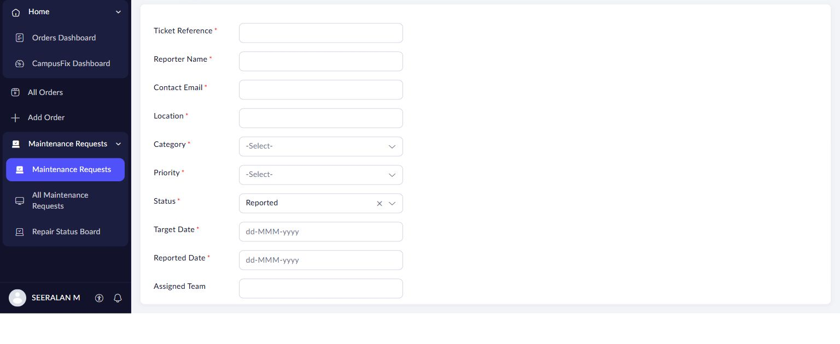
Figure 1 CampusFix request form governed by the saved validation workflow; no rejection test is shown.

Result
Five configured rules were inspected. Negative input tests and enforcement through board interactions remain pending.

Sources
CampusFix live application and saved component definitions reviewed on 2 November 2026. Screenshot captured from the project without a mouse pointer.
Experiment topics and report structure adapted from san342147/CB23F35-Low-Code-Zoho-Creator. The screenshots and case study in this revision describe CampusFix.

