Experiment 9 AI Assistance and Dashboard Verification
CB23F35 Low Code Application Development using Zoho Creator
CampusFix Campus Maintenance Manager | Analytical check completed and AI exercise proposed

Aim
Define how AI assistance could support verification while retaining independent checks.

Theory
An AI response can suggest checks but cannot prove that a component exists or that a metric is correct. CampusFix totals can be reconciled directly with the list and status board. No CampusFix Zia response was captured; the procedure below is a proposed guided verification exercise.

Procedure
1. Ask an approved assistant how to reconcile status counts without requesting app changes.
2. Check its advice against the saved list and board.
3. Record the actual response and explain any disagreement before claiming the AI activity complete.

Observations
• The independently observed status counts are 1, 3, 2 and 2, summing to 8.
• Resolved requests represent 2 of 8 records, or 25 percent.
• The overdue count is a subset; adding it to the status totals would double-count work.
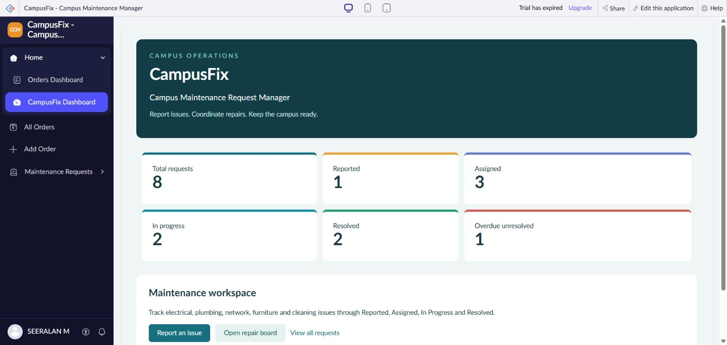
Figure 1 CampusFix dashboard used for independent count reconciliation.

Result
The dashboard has an independent arithmetic check. An AI-assisted run remains proposed and is not represented by the screenshot.

Sources
CampusFix live application and saved component definitions reviewed on 2 November 2026. Screenshot captured from the project without a mouse pointer.
Experiment topics and report structure adapted from san342147/CB23F35-Low-Code-Zoho-Creator. The screenshots and case study in this revision describe CampusFix.

