Experiment 10 Query Design and Performance Evaluation
CB23F35 Low Code Application Development using Zoho Creator
CampusFix Campus Maintenance Manager | Performance study not benchmarked

Aim
Assess the limits of the small CampusFix dataset and propose representative performance tests.

Theory
Eight demonstration requests can establish that views display data; they cannot establish throughput, latency or concurrency behavior. Count and criteria-based aggregation can avoid unnecessary record transfer, but the dashboard HTML Snippet implementation has not been fully exported. No query execution plan, custom database index or subform limit was verified for CampusFix.

Procedure
1. Record the current dataset size and the questions answered by the dashboard.
2. Design repeated tests with representative request volume and concurrent users.
3. Measure report load times under comparable conditions before claiming an optimization.

Observations
• The visible list states Showing 8 of 8.
• No latency benchmark or measured speedup was produced.
• Ticket uniqueness is a field constraint, not evidence that a manual database index was created.
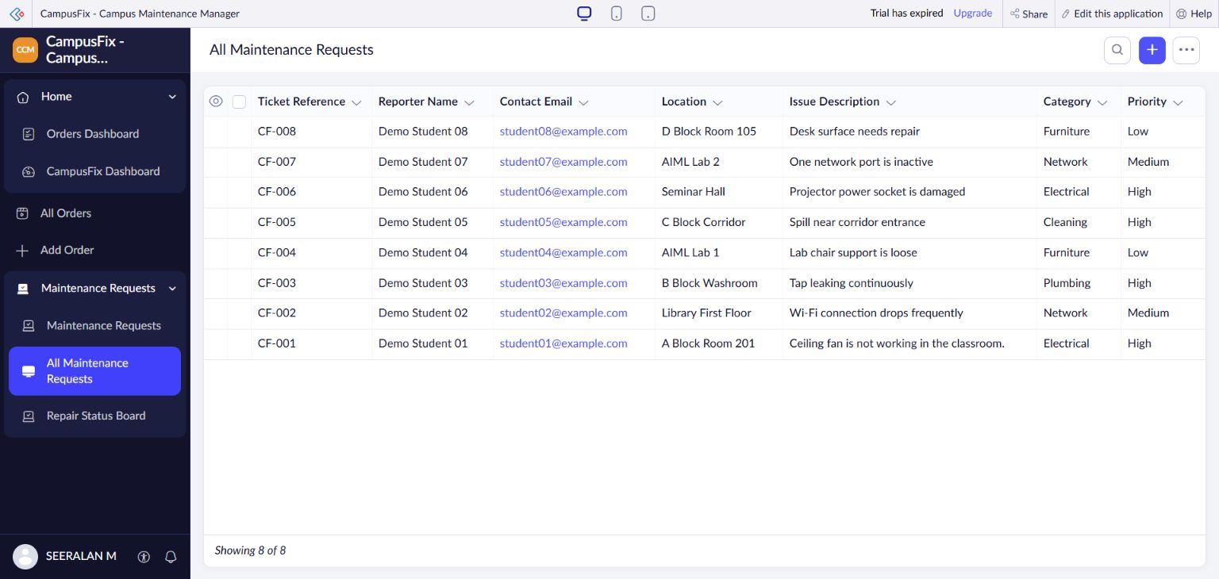
Figure 1 CampusFix list showing the eight-record dataset used in the scope assessment.

Result
A performance evaluation plan is established. The present dataset supports functional checks only.

Sources
CampusFix live application and saved component definitions reviewed on 2 November 2026. Screenshot captured from the project without a mouse pointer.
Experiment topics and report structure adapted from san342147/CB23F35-Low-Code-Zoho-Creator. The screenshots and case study in this revision describe CampusFix.

