Experiment 15 Career Pathways and the Future of Low Code
CB23F35 Low Code Application Development using Zoho Creator
CampusFix Campus Maintenance Manager | Presentation and learning plan

Aim
Present the CampusFix work and connect demonstrated skills to further learning.

Theory
The project exercises field modelling, report configuration, scripted validation and evidence-based documentation. Development, analysis, administration and QA roles use these skills in different proportions. The exercise is a learning plan, not a claim about current vacancies, salaries or guaranteed outcomes.

Procedure
1. Show the maintenance problem and the request form.
2. Demonstrate the dashboard and reconcile its counters with the saved records.
3. Explain configured validation and the outstanding integration, access and deployment tests.

Observations
• A developer can deepen Deluge and reusable component design.
• An analyst can turn maintenance policies into fields, states and acceptance criteria.
• A QA or administrator learning plan should include negative tests, separate-user checks and restore verification.
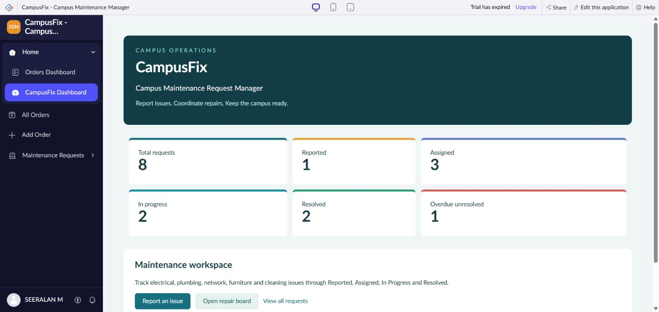
Figure 1 CampusFix dashboard used for the project presentation.

Result
CampusFix provides a concrete portfolio demonstration with clearly stated limits. Further learning should focus on independently verified behavior and operational readiness.

Sources
CampusFix live application and saved component definitions reviewed on 2 November 2026. Screenshot captured from the project without a mouse pointer.
Experiment topics and report structure adapted from san342147/CB23F35-Low-Code-Zoho-Creator. The screenshots and case study in this revision describe CampusFix.

