Experiment 2 Zoho Creator Setup and Platform Architecture
CB23F35 Low Code Application Development using Zoho Creator
CampusFix Campus Maintenance Manager | Existing application inspected

Aim
Explain the builder and live application using the existing CampusFix project.

Theory
The live CampusFix application runs in the India data centre. The builder separates Design, Workflow and Settings. Forms define data entry, reports present saved records, pages combine information, and workflows apply rules. The current header displays Trial has expired; paid features must not be assumed available.

Procedure
1. Open CampusFix in the live application.
2. Identify the Maintenance Requests form, list, board and dashboard.
3. Inspect the existing Application IDE definitions without changing the app.

Observations
• CampusFix Dashboard is separate from the original Orders Dashboard template.
• The app retains Add Order and All Orders navigation from the template.
• This review used an existing account and app; it did not create a new account.
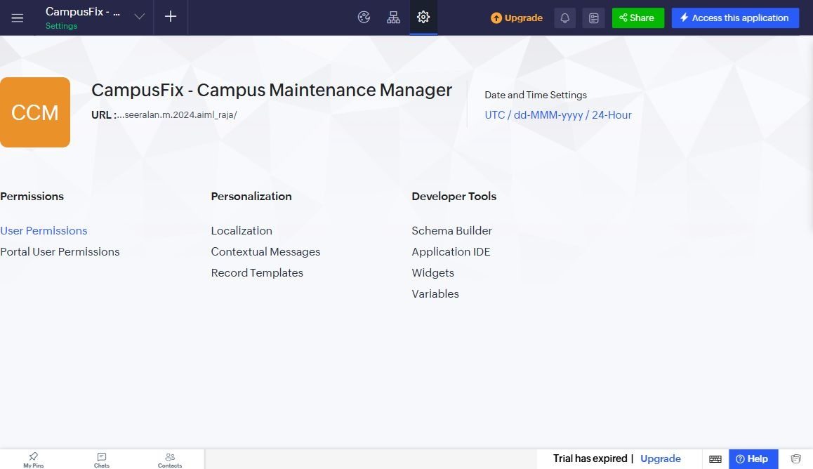
Figure 1 CampusFix application settings captured from Seeralan’s project without a mouse pointer.

Result
The live application and its component architecture were inspected. Account creation and subscription changes were outside this activity.

Sources
CampusFix live application and saved component definitions reviewed on 2 November 2026. Screenshot captured from the project without a mouse pointer.
Project evidence: CampusFix in Seeralan M’s account. Related platform documentation: https://www.zoho.com/creator/help/.

