Experiment 3 Survey of Low Code Development Practices
CB23F35 Low Code Application Development using Zoho Creator
CampusFix Campus Maintenance Manager | Design study

Aim
Relate common low code practices to CampusFix and identify extensions that need further work.

Theory
This is a desk-based design study, not a survey of participants. CampusFix illustrates visual forms, reusable views and scripted validation. Integrations, AI assistance and governed releases are possible extensions, but their presence must be established independently. A dashboard screenshot cannot prove that those extensions were configured.

Procedure
1. Identify the visual form, saved-record reports and validation workflow.
2. List potential integration, analytics and governance improvements.
3. Separate observed features from proposed future work.

Observations
• The implemented dashboard summarizes saved maintenance records.
• Integration execution, AI output and staged release results were not captured for CampusFix.
• No market-growth figures, questionnaire responses or adoption statistics were collected.
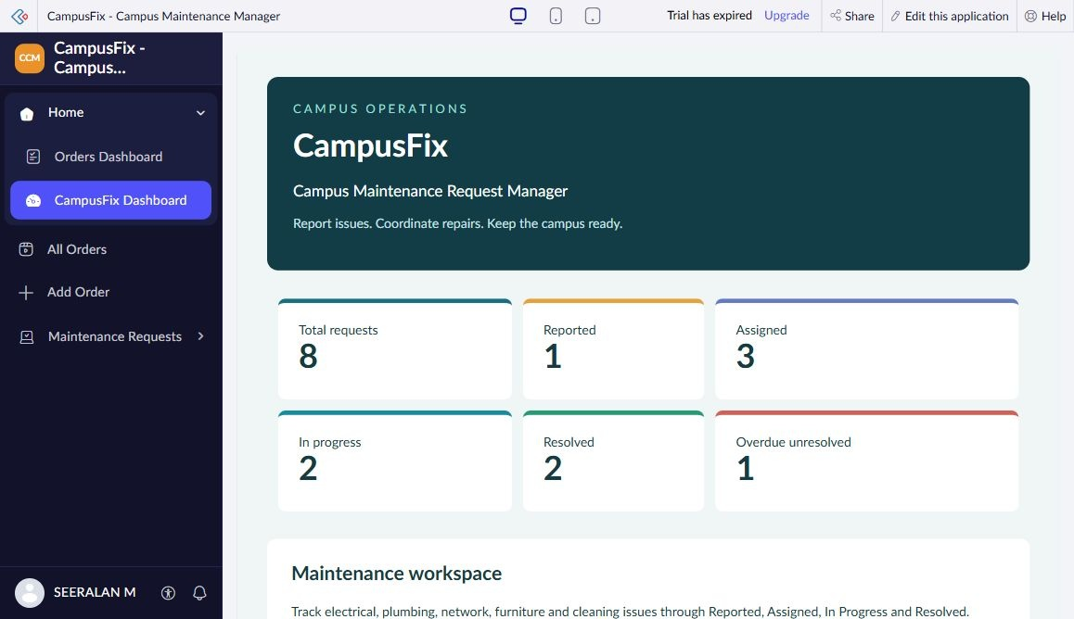
Figure 1 CampusFix dashboard captured from Seeralan’s project without a mouse pointer.

Result
The study maps low code practices to the project while recording unverified extensions as future work.

Sources
CampusFix live application and saved component definitions reviewed on 2 November 2026. Screenshot captured from the project without a mouse pointer.
Project evidence: CampusFix in Seeralan M’s account. Related platform documentation: https://www.zoho.com/creator/help/.

