Experiment 12 Security Privacy and Application Governance
CB23F35 Low Code Application Development using Zoho Creator
CampusFix Campus Maintenance Manager | Field privacy setting inspected

Aim
Review visible privacy controls and identify governance checks needed for CampusFix.

Theory
The saved form marks Contact_Email as personal data and limits it to 80 characters. Screenshots show fictional Demo Student records with example.com addresses. This limits exposure in the demonstration but does not prove complete security or compliance. Permissions, retention and administrative controls need their own evidence.

Procedure
1. Inspect the Contact_Email properties in the saved form definition.
2. Use fictional records for demonstration screenshots.
3. Review access, retention and audit requirements before accepting real campus reports.

Observations
• The source includes personal data = true for Contact_Email.
• The request list contains fictional Demo Student entries and example.com email addresses.
• MFA, encryption configuration, audit retention and cross-user restrictions were not verified.
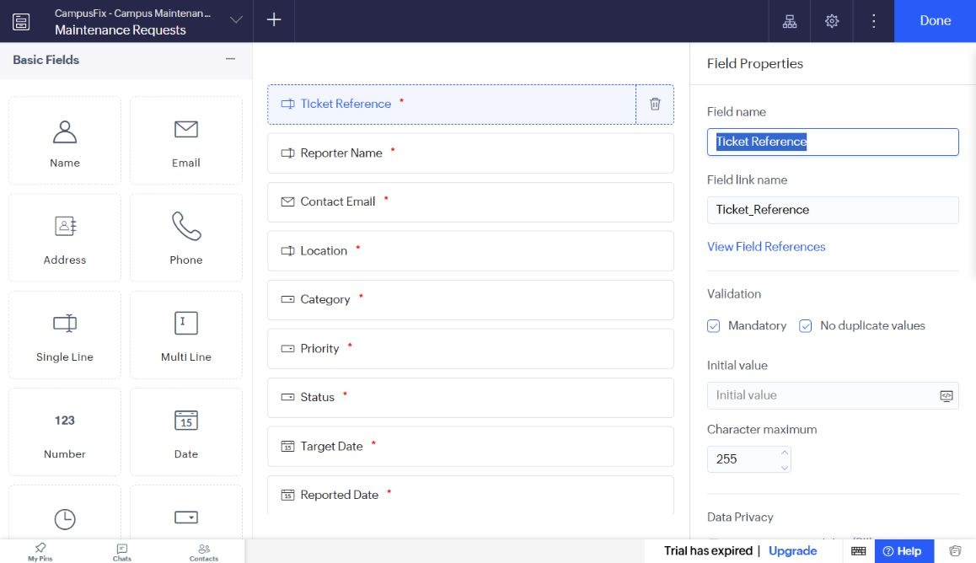
Figure 1 Maintenance Requests form builder captured from Seeralan’s project without a mouse pointer.

Result
A specific personal-data field setting is documented. Broader security assurance and policy compliance remain unassessed.

Sources
CampusFix live application and saved component definitions reviewed on 2 November 2026. Screenshot captured from the project without a mouse pointer.
Project evidence: CampusFix in Seeralan M’s account. Related platform documentation: https://www.zoho.com/creator/help/.

