Experiment 13 Enterprise Limitations Case Study
CB23F35 Low Code Application Development using Zoho Creator
CampusFix Campus Maintenance Manager | Case study

Aim
Evaluate the boundary between the CampusFix demonstration and a campus-wide service.

Theory
A campus-wide maintenance service may need equipment relationships, dependable notifications, escalation rules, operational reporting and service continuity. CampusFix demonstrates intake, status tracking and basic validation. The success of eight sample records does not establish capacity or reliability for a large deployment.

Procedure
1. Map the implemented components to the needs of reporters and repair coordinators.
2. Identify missing integration, permissions, reliability and operational evidence.
3. Define acceptance criteria before expanding the service to real users.

Observations
• The dashboard distinguishes reported, assigned, in-progress and resolved work.
• One overdue unresolved request identifies a need for follow-up but does not prove an automatic escalation exists.
• Notifications, service-level enforcement, recovery and high-volume tests were not demonstrated.
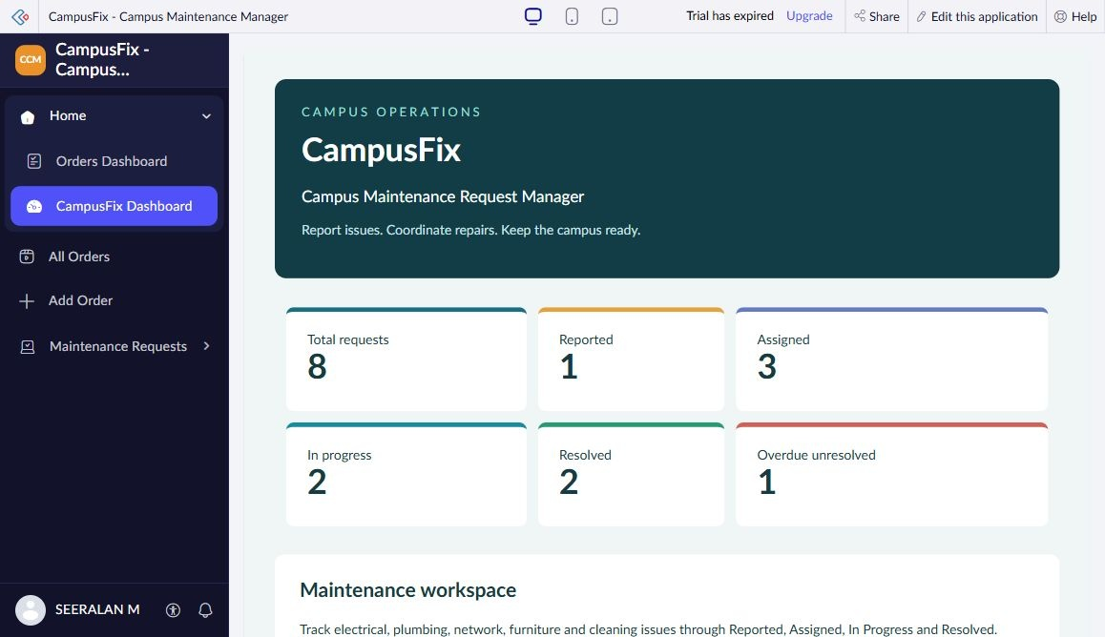
Figure 1 CampusFix dashboard captured from Seeralan’s project without a mouse pointer.

Result
The prototype is suitable as a documented teaching case. Further engineering and user testing are needed before campus-wide rollout.

Sources
CampusFix live application and saved component definitions reviewed on 2 November 2026. Screenshot captured from the project without a mouse pointer.
Project evidence: CampusFix in Seeralan M’s account. Related platform documentation: https://www.zoho.com/creator/help/.

