Experiment 14 Pro Code Extension Using Deluge
CB23F35 Low Code Application Development using Zoho Creator
CampusFix Campus Maintenance Manager | Existing workflow inspected and extension proposed

Aim
Examine the scripted extension already present in CampusFix and plan a reusable summary function.

Theory
CampusFix already uses Deluge inside an add-or-edit validation workflow. A reusable summary function could later calculate counts and return a structured result. That function would be a separate component requiring implementation and tests. No reusable CampusFix custom function, Catalyst service or external runtime execution was verified.

Procedure
1. Review the five rules in Validate_Maintenance_Requ.
2. Define the output fields for a proposed reusable maintenance summary.
3. Implement and test the new function separately before claiming its output matches the dashboard.

Observations
• The saved workflow checks dates, description length, assigned team and resolution notes.
• The dashboard provides expected counts for a future summary-function comparison.
• A proposed function is not the same as an executed custom function or deployed external service.
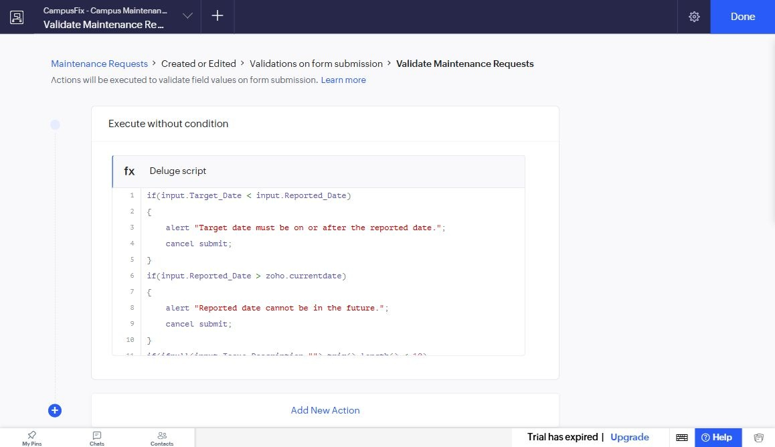
Figure 1 saved maintenance validation workflow captured from Seeralan’s project without a mouse pointer.

Result
The existing Deluge validation is documented. A reusable function remains a proposed extension.

Sources
CampusFix live application and saved component definitions reviewed on 2 November 2026. Screenshot captured from the project without a mouse pointer.
Project evidence: CampusFix in Seeralan M’s account. Related platform documentation: https://www.zoho.com/creator/help/.

