ShopSmart
Multi-Tenant E-Commerce Platform

Project Report

Submitted by
Seerat E Zahra — 23i-0640
Minahil Kashif — 23i-0554

1. Project Overview
ShopSmart is a full-stack, multi-tenant e-commerce platform that gives small businesses their own branded online storefront — with complete personalization capabilities and no coding required. Store owners can configure brand colors, fonts, layout, announcements, and content through an intuitive admin panel, with all changes reflecting live via CSS variables without any redeployment.

The platform supports two primary roles — customers and administrators — each with a distinct, purpose-built experience. Customers can browse, search, add items to cart, and complete checkout as guests or authenticated users. Administrators get a full-featured dashboard covering product management, order tracking, user administration, and storefront configuration.

2. Team
Name | Roll Number | Contribution
Seerat E Zahra | 23i-0640 | Backend API, Authentication, Database design, Testing
Minahil Kashif | 23i-0554 | Frontend (Next.js), Admin dashboard, Store personalization, UI/UX, Deployment

3. Technology Stack
Layer | Technology
Frontend Framework | Next.js 16.2.4 · React 19
Styling | Tailwind CSS v4 · Framer Motion 12
Backend | Node.js · Express 5
Database | MongoDB Atlas · Mongoose 9
Authentication | JWT (HttpOnly cookies) · bcryptjs · Refresh tokens
Email | Nodemailer (password reset flow)
Image Storage | Cloudinary
Testing | Jest · Supertest (25 tests)
Deployment | Vercel (frontend) · Render / Railway (backend)

4. System Architecture
ShopSmart follows a client-server architecture with a clear separation of concerns between the Next.js frontend and the Express.js REST API backend. The frontend communicates exclusively through a versioned API, and authentication state is managed via HttpOnly cookie-stored JWTs to prevent XSS token theft.

4.1 Project Structure
Directory | Purpose
client/app/ | Next.js pages: home, products, cart, checkout, orders, auth, admin
client/components/ | Reusable UI: Navbar, Footer, ProductCard, ProductGrid, AnnouncementBar
client/context/ | React Context providers: AuthContext, CartContext, StoreContext
client/lib/ | Axios instance, theme utilities, formatPrice helper
server/src/controllers/ | Business logic: auth, products, orders, admin, store, reviews
server/src/middleware/ | JWT verification, role-based access guard
server/src/models/ | Mongoose schemas: User, Product, Order, Store
server/src/routes/ | Express routers: auth, products, orders, admin, store
server/src/utils/ | Email helper (Nodemailer)
server/tests/ | Jest + Supertest test suite (25 tests)

5. Feature Breakdown

5.1 Authentication & Session Management
- Register, login, and logout with JWT stored in HttpOnly cookies
- Forgot password and reset password via time-limited email link (Nodemailer)
- Access tokens paired with refresh tokens for seamless session renewal
- Role-based access control: customer and admin roles enforced at middleware level
- Protected routes — unauthenticated users are redirected to login

5.2 Product Catalogue
- Public paginated product listing with full-text search and category filters
- Product detail page with stock status indicator and add-to-cart action
- Admin: create, edit, and soft-delete products (data never hard-deleted)
- Image hosting via Cloudinary with Next.js remote image pattern configuration

5.3 Cart & Checkout
- Persistent cart stored in localStorage — survives page refresh
- Animated cart badge in the Navbar reflecting live item count
- Checkout form with shipping address collection
- Guest checkout supported — no account required to place an order
- Stock validation performed at order creation to prevent overselling

5.4 Order Management
- Order creation atomically decrements product stock
- Authenticated users can view full order history and order detail pages
- Admin order management dashboard with status controls

5.5 Admin Dashboard
- Analytics overview: total users, products, orders, and revenue
- User management: view list, activate/deactivate accounts, change roles
- Product and order management tables with inline actions

5.6 Store Personalization
Admins configure their storefront through a 4-tab settings panel. All changes apply live via CSS variables with no redeployment required.

Setting | Options
Brand & Accent Colors | Any hex color
Font Family | Inter, Poppins, Playfair Display, Space Grotesk, DM Sans
Theme | Minimal · Bold · Elegant · Playful
Color Scheme | Light · Dark · System (follows OS preference)
Hero Banner | Headline, subtext, CTA text + URL, background image
Announcement Bar | Text, background color, enable/disable toggle
Product Grid Layout | 2-column or 3-column
Store Info | Name, tagline, logo, contact email, phone, address
Social Links | Instagram, Facebook, Twitter
Currency & Locale | Used in all price displays across the storefront

6. Security Implementation

6.1 Password Security
- All passwords are hashed using bcryptjs before storage — plain-text passwords are never stored or logged
- Password comparison is performed using bcrypt's secure hash-comparison function, not string equality
- Password strength is enforced both client-side (browser validation) and server-side before processing

6.2 Token-Based Authentication
- JWTs stored in HttpOnly cookies, inaccessible to JavaScript — mitigates XSS attacks
- Refresh token rotation implemented for sustained sessions without exposing access tokens
- Password reset uses time-limited, single-use tokens delivered via email

6.3 Role-Based Access Control
- Two roles defined in the database: customer and admin
- Backend middleware checks role on every protected route before processing the request
- Admin dashboard routes return 403 to non-admin users; frontend additionally hides admin navigation
- Frontend navigation dynamically changes based on the logged-in user's role

7. Form Validation
- Client-side: required fields, email format, and password strength enforced in the browser before submission
- Server-side: all inputs sanitized and validated independently of client checks
- Clear, inline error messages displayed to the user for invalid or missing inputs
- Duplicate registration detected server-side with a descriptive error response

8. API Reference
Method | Endpoint | Auth | Description
POST | /api/auth/register | — | Register a new user
POST | /api/auth/login | — | Login; sets HttpOnly cookie
POST | /api/auth/logout | — | Clears session cookie
GET | /api/auth/me | cookie | Returns current authenticated user
POST | /api/auth/forgot-password | — | Sends password reset email
POST | /api/auth/reset-password | — | Resets password using token
GET | /api/products | — | Paginated list (search, category, page)
GET | /api/products/:id | — | Single product detail
POST | /api/products | admin | Create a new product
PUT | /api/products/:id | admin | Update product details
DELETE | /api/products/:id | admin | Soft-delete a product
POST | /api/orders | optional | Create order (guest or user)
GET | /api/orders/my | user | Authenticated user's order history
GET | /api/orders/:id | user | Order detail
GET | /api/admin/users | admin | List all users
PUT | /api/admin/users/:id/role | admin | Change user role
PUT | /api/admin/users/:id/status | admin | Toggle user active status
GET | /api/admin/analytics | admin | Platform statistics
GET | /api/store/default | — | Storefront configuration
PUT | /api/store | admin | Update store settings
GET | /api/health | — | Health check

9. Environment Configuration
Variable | Purpose
MONGO_URI | MongoDB Atlas connection string
JWT_SECRET | Secret key for signing access tokens
JWT_EXPIRES_IN | Access token expiry duration
REFRESH_TOKEN_SECRET | Secret key for refresh tokens
CLIENT_URL | Frontend URL (used for CORS and email links)
EMAIL_HOST / EMAIL_PORT | SMTP configuration
EMAIL_USER / EMAIL_PASS | SMTP credentials (Gmail App Password recommended)
CLOUDINARY_CLOUD_NAME | Cloudinary account identifier
CLOUDINARY_API_KEY / SECRET | Cloudinary authentication credentials
ADMIN_EMAIL / ADMIN_PASSWORD | Seed admin account credentials
NODE_ENV | Runtime environment (development / production)
PORT | Backend server port (default 5000)

10. Testing
The backend includes a comprehensive test suite of 25 tests built with Jest and Supertest, covering the two most critical domain areas:

Test Group | Cases Covered
Authentication | Register (valid, duplicate email, weak password), login, /me endpoint, forgot-password flow, logout
Products | CRUD operations, pagination, search, category filter, soft delete, 401/403 authorization guards

Run the full suite from the server directory:
cd server && npm test

11. Local Setup & Installation

Prerequisites
- Node.js 18 or later
- A MongoDB Atlas cluster (free tier is sufficient)
- A Gmail account with an App Password for email delivery

Setup Steps
- Clone the repository: git clone https://github.com/seerat-e-zahra/ShopSmart.git
- Install backend dependencies: cd server && npm install
- Create server/.env with the variables listed in Section 9
- Install frontend dependencies: cd client && npm install
- Create client/.env.local with NEXT_PUBLIC_API_URL=http://localhost:5000/api
- Start backend: cd server && npm run dev (runs on http://localhost:5000)
- Start frontend: cd client && npm run dev (runs on http://localhost:3000)
- Verify health: curl http://localhost:5000/api/health → {"status":"ok"}
- Register an account, then set role: "admin" in MongoDB Atlas to access the admin panel

12. Deployment

Backend — Render / Railway
- Set Root Directory to server, build command npm install, start command node src/index.js
- Add all production environment variables from Section 9
- After frontend is deployed, update CLIENT_URL_PROD to the Vercel URL for CORS

Frontend — Vercel
- Import the GitHub repository and set Root Directory to client
- Add environment variable: NEXT_PUBLIC_API_URL=https://your-backend-url/api
- Deploy — Vercel auto-detects Next.js and configures the build pipeline

13. Application Screenshots
The following section presents key screens of the ShopSmart platform.

Login & Registration
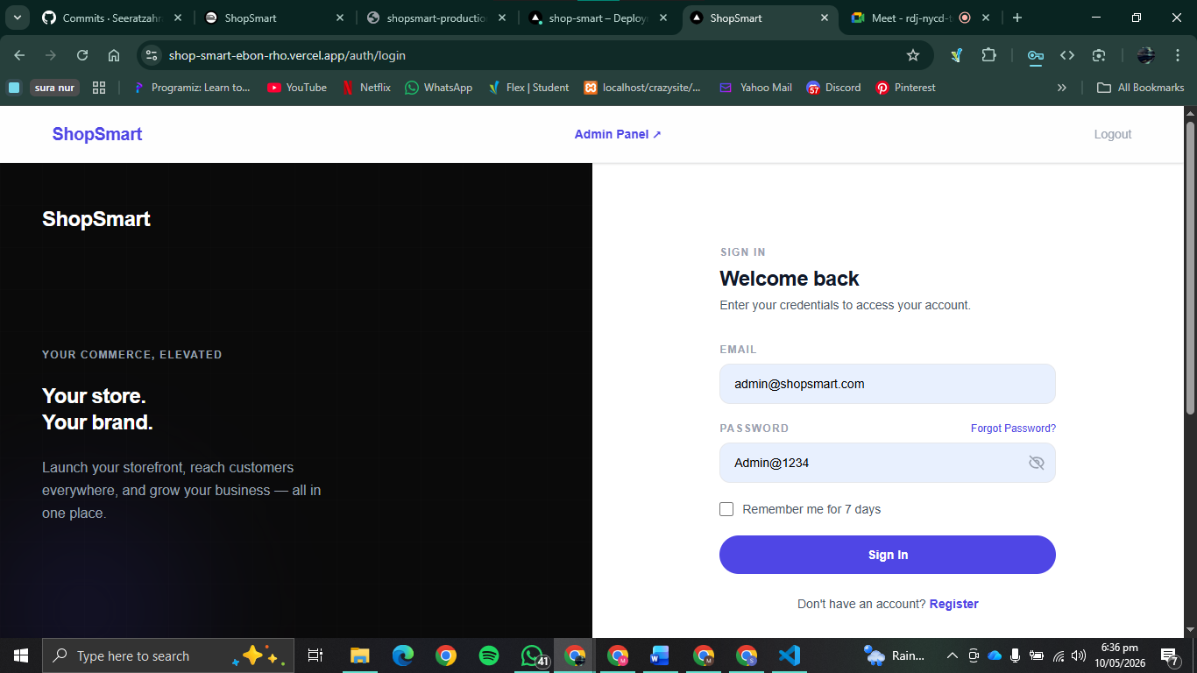

Shop Dashboard
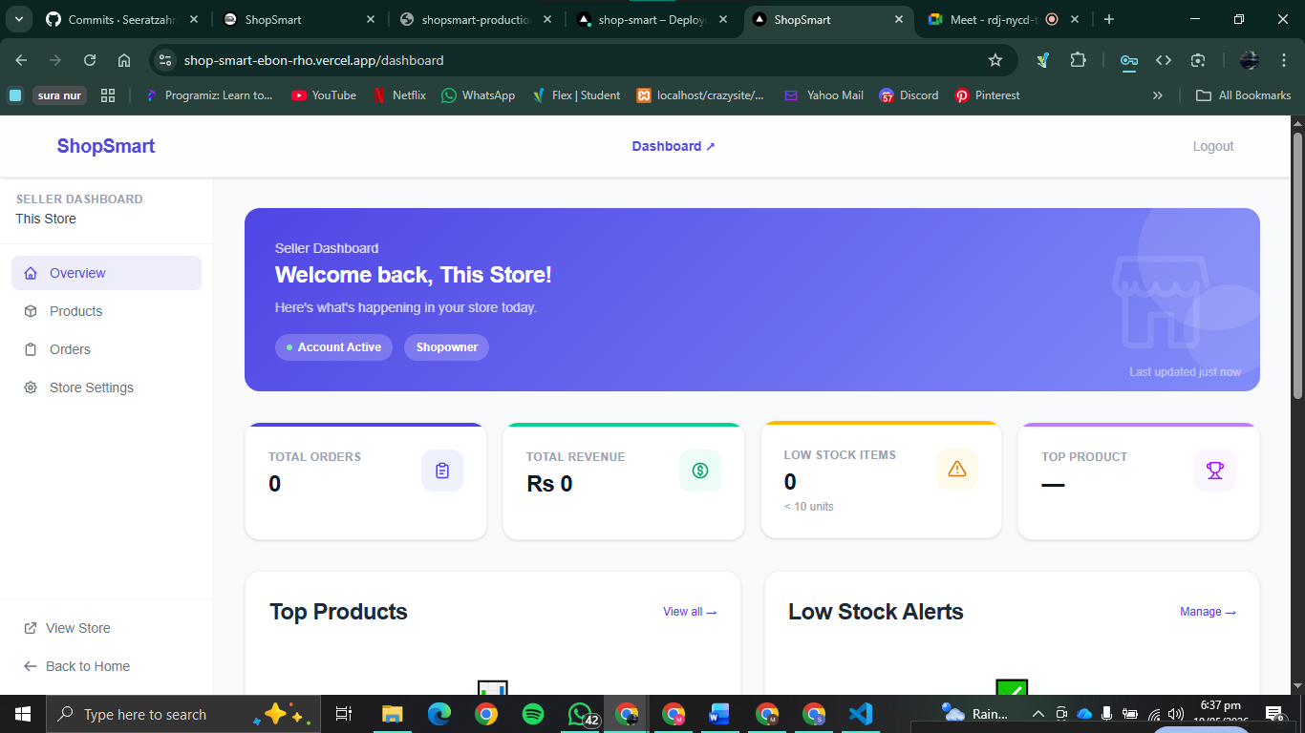

Shop Product Management
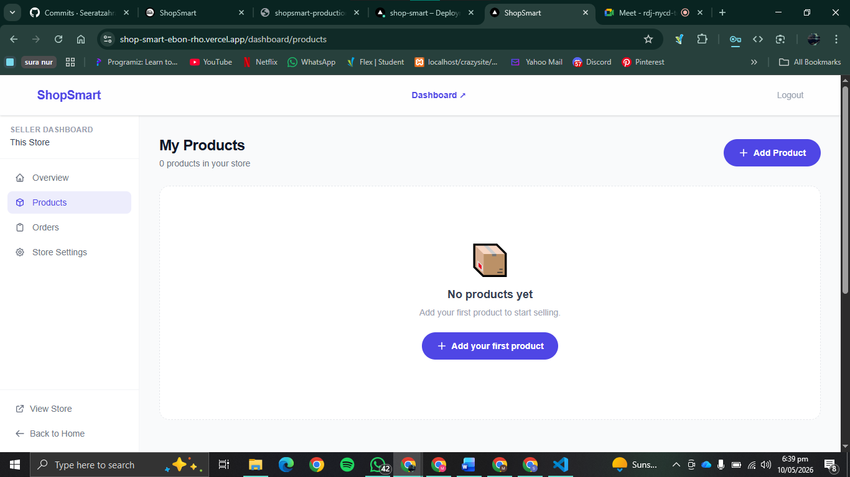

14. Version Control
The project is hosted on GitHub with a structured commit history following conventional commit conventions (feat:, fix:, docs:, chore:). The repository contains a minimum of 10 meaningful commits reflecting incremental development from initial setup through to production-ready features.

- Repository: https://github.com/seerat-e-zahra/ShopSmart
- Branching strategy: main branch for stable releases; feature branches merged via pull requests
- Commit messages follow the pattern: feat: add cart persistence, fix: token refresh on expiry, etc.

15. UI / UX Design
- Clean, consistent layout with a unified color palette, typography, and spacing system
- Responsive design using Tailwind CSS — adapts correctly across desktop, tablet, and mobile
- Framer Motion used for tasteful animations: page transitions, cart badge count, and hover micro-interactions
- Sticky, responsive navbar with dynamic menu items based on the user's authentication state and role
- Announcement bar configurable by admin with custom text and color
- Footer present on all pages with store contact info, social links, and copyright notice

16. Conclusion
ShopSmart successfully delivers a production-grade, multi-tenant e-commerce platform that goes well beyond a generic template. It combines a thoughtfully secured authentication system, live storefront personalization, a robust admin panel, and a clean customer-facing shopping experience — all built on a modern, maintainable tech stack.

The platform demonstrates strong software engineering practices: role-based access control enforced at every layer, secure password handling, token-based session management, comprehensive API test coverage, and clean separation of client and server concerns. It is ready for real-world deployment and extension.

