ResolveNow

Online Complaint Registration and Management System
Comprehensive Project Report with UI Designs, Testing Documentation, and Deployment Guide
Generated on: March 03, 2026

Abstract
ResolveNow is a full-stack web-based Online Complaint Registration and Management System
developed to streamline complaint submission, tracking, assignment, and resolution processes.
The system enhances transparency and improves customer satisfaction through structured workflows,
real-time notifications, secure authentication, and centralized complaint management.
Built using React.js, Node.js, Express.js, and MongoDB, the platform ensures scalability,
security, and maintainability. This report provides a detailed explanation of system architecture,
design methodology, database structure, UI pages, testing strategies, deployment guide,
security considerations, and future enhancements.

1. Introduction
In modern organizations, customer satisfaction plays a crucial role in maintaining brand reputation.
Traditional complaint handling systems often suffer from delays, lack of tracking, and inefficient communication.
ResolveNow addresses these issues by providing a centralized digital platform where users can register complaints,
track progress, communicate with assigned agents, and provide feedback upon resolution.

2. Problem Statement
Many organizations lack a structured system for handling complaints. Manual processes result in lost records,
poor accountability, and customer dissatisfaction. There is a need for a secure, scalable, and user-friendly
complaint management system that automates workflows and provides real-time tracking.

3. Objectives
• Develop a centralized complaint platform.
• Enable secure authentication and authorization.
• Provide real-time complaint tracking.
• Implement agent-user chat system.
• Ensure data security and regulatory compliance.

4. Literature Review
Existing CRM and ticketing systems provide complaint tracking but often lack customization and real-time communication.
Research indicates that automated routing, centralized dashboards, and real-time messaging significantly improve resolution time.
ResolveNow integrates these modern approaches using MERN stack technologies.

5. System Architecture
ResolveNow follows a client-server architecture.
Frontend: React.js with Bootstrap and Material UI.
Backend: Node.js with Express.js.
Database: MongoDB using Mongoose ODM.
Communication: REST APIs with Axios and real-time chat using Socket.io.
Authentication: JWT-based secure authentication system.

6. Feasibility Study
Technical Feasibility: Uses widely adopted MERN stack technologies.
Economic Feasibility: Low-cost deployment using cloud services.
Operational Feasibility: User-friendly interface requiring minimal training.
Legal Feasibility: Ensures data protection compliance using encryption and access control.

7. Database Design
The database consists of three main collections:
Users Collection: Stores user details and roles.
Complaints Collection: Stores complaint details and status.
Messages Collection: Stores chat messages linked to complaints.
Relationships are maintained using ObjectId references.

8. Modules Description
User Module: Registration, login, complaint submission, tracking.
Agent Module: Assigned complaints, status updates, communication.
Admin Module: Assign complaints, monitor system, manage users.

9. Security Implementation
• Password hashing using bcrypt.
• JWT token authentication.
• Role-based authorization middleware.
• Secure file uploads.
• Environment variables for sensitive data.
• HTTPS configuration in production.

10. Performance Considerations
MongoDB indexing improves query speed.
Efficient API routing reduces latency.
Socket.io ensures low-latency real-time communication.
Scalable deployment using cloud infrastructure.

11. Limitations
• Dependent on internet connectivity.
• Requires server maintenance.
• Limited AI automation in current version.

12. Future Enhancements
• AI-based complaint categorization.
• SMS integration.
• Mobile application.
• Advanced analytics dashboard.
• Multi-language support.

13. Testing Documentation
Testing Strategy includes Unit Testing, Integration Testing, System Testing,
Security Testing, and User Acceptance Testing.
Sample Test Cases:
1. User Registration – Account creation and email verification.
2. Complaint Submission – Data stored successfully.
3. Agent Assignment – Notification sent correctly.
4. Status Update – Real-time dashboard update.
5. Chat System – Messages delivered instantly.

14. Deployment Guide
Prerequisites:
• Node.js and npm
• MongoDB or MongoDB Atlas
• Git
Backend Deployment:
1. Clone repository.
2. Install dependencies.
3. Configure .env file.
4. Run server.
Frontend Deployment:
1. Install dependencies.
2. Configure API base URL.
3. Build production version.
Cloud Deployment:
• Backend: Render / AWS / Railway.
• Frontend: Vercel / Netlify.
• Database: MongoDB Atlas.

15. Conclusion
ResolveNow provides a structured, secure, and scalable complaint management platform.
By integrating modern technologies and best practices, the system improves transparency,
reduces response time, and enhances customer satisfaction.

16. User Interface (Input and Output Pages)
Below are sample UI wireframes representing input and output pages of the system.

Login Page
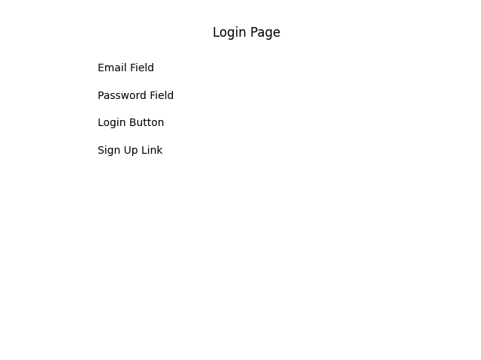

User Dashboard
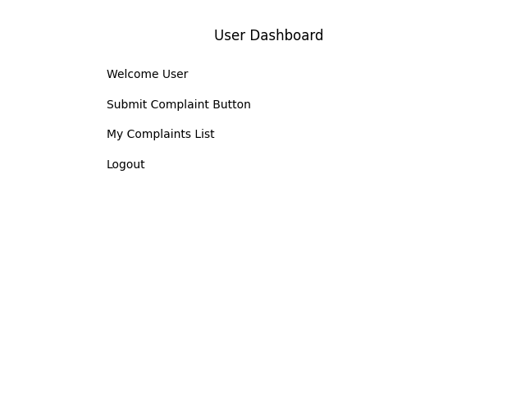

Submit Complaint Page
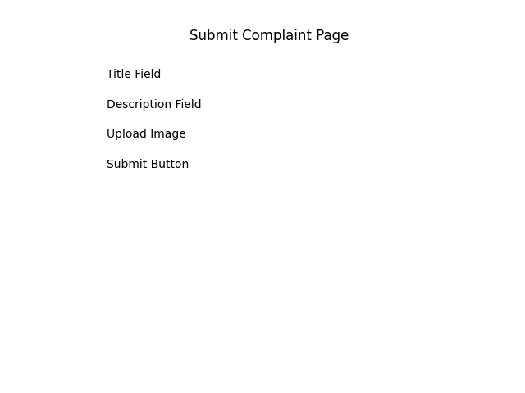

Admin Panel
