Software Design Document

| Document Approvals: | | |
| --- | --- | --- |
| Name and Function | Signature | Date |
| Brian M Childers | Signature and Date Captured in M-Files | |

|  |  |  |  |
| --- | --- | --- | --- |
| Revision History: | | | |
| Document Version Number | Document Revision Date | Written By | Change Summary  (Reference section[s] changed) |
| 1 | 06-May-2019 | Bharat Rathod/ Kajal Inamdar | Initial Writing |

1. Overview

1.1 Table of Contents

|  |
| --- |
| 1.0 Overview  1.1 Table of Contents  1.2 Purpose  1.3 Acronyms and Definitions  1.4 References  2.0 System Flow  3.0 Functional Decomposition  4.0 System Module Definition  4.1 MyFreeStyle Content Architecture  5.0 Critical Design Considerations  5.1 Templates  5.2 Components  5.2.1 Header  5.2.2-Footer  5.2.3 Hero Panel  5.2.4 Lite Right Image Panel  5.2.5 Data Cable Products  5.2.6 Lite Left Image Panel  5.2.7 Header Migration  5.2.8-Footer US  5.2.9 FAQ  5.2.10 Rich Text  5.2.11 Warranty Registration  5.2.12 Download Coupon  5.2.13 Newsletter Signup  5.2.14 Check Out the Stories  5.2.15 Geo Location Message  6. Dispatcher and Apache configuration set up  7. Error Handling  8. Dispatcher Flush UI Pages & configurations  Editing configuration:  9. i18N  10. System Design Constraints  11. System Module x |

1.2 Purpose

This document is the design for development of templates and components needed for building or restructuring My Freestyle site. The intended audience of this document is technical in nature.

1.3 Acronyms and Definitions

|  |  |
| --- | --- |
| Term, Acronym | Definition |
| AEM | Adobe Experience Manager, the product group that Adobe belongs to and the product offering for the AIS platform |
| AIS | Abbott Internet Services, the functional area of BTS |
| COTS | Commercial off the Shelf |
| CMS | Content Management System |
| Component | AEM code that renders content and/or provided functionality. Used to create web pages |
| DAM | Digital Asset Management |
| FRS | Functional Requirements Specification |
| OOTB | Out of the Box |
| SOW | Statement of Work |

1.4 References

| Document Number | Document Title |
| --- | --- |
| BTSQC09.05 | BTS IT Computerized Lifecycle. |

2.0 System Flow

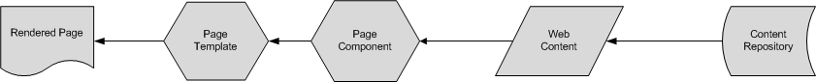System flow as described is supported by the Adobe AEM product and does not contain any custom system flow aspects. This consists of creating, editing and rendering of content. Creating and editing of content are also known as authoring.

Pages are rendered using the AEM’s CRX repository that stores the content, designs and the application logic.

3.0 Functional Decomposition

NA

4.0 System Module Definition

**NA**

4.1 MyFreeStyle Content Architecture

Content for various sections such as header, body and footer would be stored in the AEM CRX repository hierarchy. This hierarchy would be useful for categorizing the contents based on the various sections of pages across website.

Below are screenshots for Content Hierarchy of the website.

**+content**

**+adc**

**+myfreestyle**

**+** **global**

**+us**

**+en**

**+pages**

**+ home**

**+utils**

**+ header boiler plate**

**+ footer boiler plate**

**+ header boiler plate Neo**

**+ footer boiler plate Neo**

**+errors**

**+countries**

**+us**

**+en**

**+pages**

**+home**

**….**

**+utils**

**+ header boiler plate**

**+ footer boiler plate**

**+ header boiler plate Neo**

**+ footer boiler plate Neo**

+**errors**

5.0 Critical Design Considerations

5.1 Templates

Template Design

Each of the templates will have pre-defined set of presentation components present and having the place holders for drag-n-drop appropriate components which would require the page to be completed. The details of the presentation components would be explained in detail in subsequent section.

|  |  |  |  |
| --- | --- | --- | --- |
| S No. | Template Name | Description | Pages |
| 1 | Home Page Template | Home page template used to create home page of the site | MyFreeStyle index page use this template |
| 2 | Boiler Plate Template | Template for header and footer boiler plate | Used for the Header and Footer sections for all pages |

**Base Layout**

Base Layout/page will be the basic structure for all the templates. Base Layout/page template will extend foundation Page template. Base Page template uses body.html which contains header.html, content.html, footer.html.

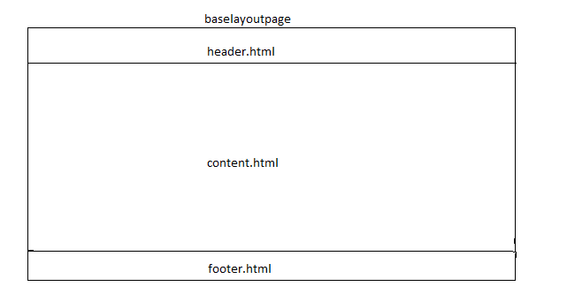

**5.1.1 Home Page Template**

Below table information depicts the properties that would be captured against this template during the development process.

|  |  |  |
| --- | --- | --- |
| Fields | Value | Additional Inputs |
| Template Path | /apps/adc/myfreestyle/templates/page-home |  |
| Title | MyFreeStyle Site Home Page |  |
| Description | Template for initial or main page of the site. |  |
| Resource Type | /apps/adc/myfreestyle/components/structure/page-home |  |
| allowed Paths | /content/adc (/. *)? |  |

**5.1.2** **Boiler Plate Template**

Boiler Plate template is used to create the contents for header and footer section for any website created using reusable templates and components. Content Author creates the header and footer pages under Site hierarchy and enters the contents for these sections. All pages such as home and content pages of website would refer these pages for displaying header and footer sections. All content modification will be done in boiler plate pages and it will be automatically reflected in all other pages.

Header and Footer pages will be created under the Utils in the site hierarchy as mentioned in below screenshots

Below table depicts the location of boiler plate pages in global site

|  |  |  |  |
| --- | --- | --- | --- |
| **S. No** | **Page Title** | **Page Name** | **Location in Site Structure** |
| 1 | Header Boiler Plate Page | header-boilerplate | /content/adc/myfreestyle/global/us/en/utility/header-boilerplate |
| 2 | Footer Boiler Plate Page | footer-boilerplate | /content/adc/myfreestyle/global/us/en/utility/footer-boilerplate |
| 3 | Header Boiler plate Neo | header-boilerplate-neo | /content/adc/myfreestyle/global/us/en/utility/header-boilerplate-neo |
| 4 | Footer Boiler plate Neo | footer-boilerplate-neo | /content/adc/myfreestyle/global/us/en/utility/footer-boilerplate-neo |

|  |  |  |
| --- | --- | --- |
| Fields | Value | Additional Inputs |
| Template Path | /apps/adc/myfreestyle/templates/page-boilerplate |  |
| Title | MyFreeStyle Site Boilerplate Page |  |
| Description | Template for header and footer page of the site. |  |
| Resource Type | /apps/adc/myfreestyle/components/structure/page-boilerplate |  |
| allowedPaths | /content/adc (/. *)? |  |

|  |  |  |
| --- | --- | --- |
| Fields | Value | Additional Inputs |
| Neo Template Path | /apps/adc/myfreestyle/templates/page-boilerplate-neo |  |
| Title | MyFreeStyle Site Neo Boilerplate Page |  |
| Description | Template for header and footer page of the Neo site. |  |
| Resource Type | /apps/adc/myfreestyle/components/structure/page-boilerplate-neo |  |
| allowedPaths | /content/adc (/. *)? |  |

5.2 Components

### 5.2.1 Header

Component Name : Header

Component Group : ADC-MyFreeStyle

Drag-n-Drop : Yes

Component Edit : Dialog/Page level Edit bar option

Touch UI Dialog : Yes

Functionality – This component will be used in the section and author can author logo (right & left logos) and top navigation information.

**Component Dialog Fields– AUTHOR MODE**

|  |  |  |  |  |
| --- | --- | --- | --- | --- |
| **Field Label** | **Xtype** | **Description** | **Mandatory** | **Validation** |
| **Header** |  |  |  |  |
| Logo Path | pathfield | Place holder for content authors where the content authors can select a logo image from DAM | No |  |
| Background Image | pathfield | Allows author to provide background image | No |  |
| Text | textfield | Allows author to provide header text | No |  |
|  |  |  |  |  |
|  |  |  |  |  |
|  |  |  |  |  |
|  |  |  |  |  |
|  |  |  |  |  |
| **Tab Component** |  |  |  |  |
| Tab Title | Mulitifield with textfield | Allows author to add multiple tabs with title |  |  |
| ImageAccordian |  | Allows author to add multiple accordians |  |  |
| Accordian Title | textfield | Allows author to add accordion title |  |  |
| Accordian Text | textarea | Allows author to add accordion text |  |  |
| Accordion Subtext | textarea | Allows author to add accordion subtext |  |  |
| **Images** | Multifield | Allows author to add multiple images |  |  |
| Image Path | pathfield | Allows author to add image title |  |  |

**Component Dialog Design – AUTHOR MODE**

**Header**

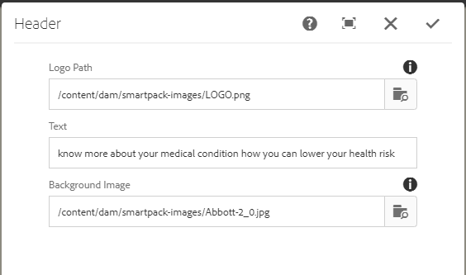

### 5.2.2-Footer

Component Name : Footer

Component Group : smartpack

Drag-n-Drop : Yes

Component Edit : Dialog

Touch UI Dialog : Yes

Functionality – This component will be used for footer section and copyright information.

|  |  |  |  |  |  |
| --- | --- | --- | --- | --- | --- |
| **Tabs** | **Field Name** | **Xtype** | **Description** | **Mandatory** | **Validation** |
| **Footer** |  |  |  |  | **Footer** |
| Enter Rights Reserved | textfield | Allows author to provide rights reserved text |  |  | Enter Rights Reserved |
| Enter License | textarea | Allows author to provide license information | No |  | Enter License |
| Footer Label | textarea | Allows author to provide footer label | No |  | Footer Label |
| Footer Link | pathfield | Allows author to provide footer link | No |  | Footer Link |
|  | Open in new tab? | checkbox | Allows author to select the open in new window value | No |  |
|  | Footer Logo Title | textfield | Allows author to provide footer logo title | Yes |  |

**Component Dialog Design – AUTHOR MODE**

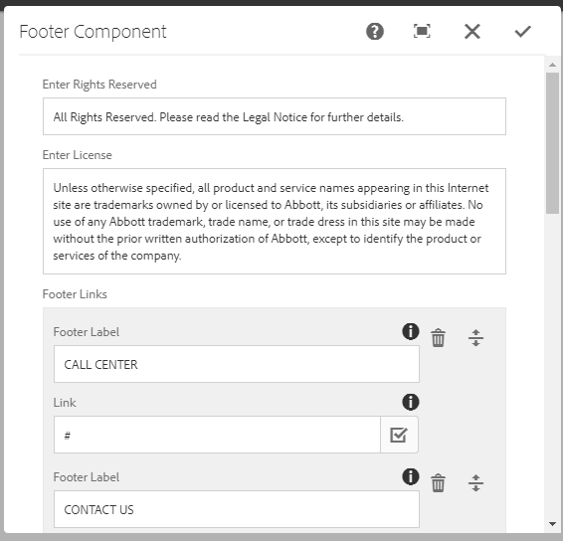

### 5.2.3 Tab Component

Component Name : Tab Component

Component Group : smartpack

Drag-n-Drop : Yes

Component Edit : Dialog

Touch UI Dialog : Yes

Functionality – Display ta

**Component Dialog Fields– AUTHOR MODE**

|  |  |  |  |  |
| --- | --- | --- | --- | --- |
| **Field Name** | **Xtype** | **Description** | **Mandatory** | **Validation** |
| **Tab Component** |  |  |  |  |
| Tab Title | Mulitifield with textfield | Allows author to add multiple tabs with title |  |  |
| ImageAccordian |  | Allows author to add multiple accordians |  |  |
| Accordian Title | textfield | Allows author to add accordion title |  |  |
| Accordian Text | textarea | Allows author to add accordion text |  |  |

**Component Dialog Design – AUTHOR MODE**

