Software Design Document

| Document Approvals: | | |
| --- | --- | --- |
| Name and Function | Signature | Date |
| Brian M Childers | Signature and Date Captured in M-Files | |

|  |  |  |  |
| --- | --- | --- | --- |
| Revision History: | | | |
| Document Version Number | Document Revision Date | Written By | Change Summary  (Reference section[s] changed) |
| 1 | 06-May-2019 | Bharat Rathod/ Kajal Inamdar | Initial Writing |

1. Overview

1.1 Table of Contents

|  |
| --- |
| 1.0 Overview  1.1 Table of Contents  1.2 Purpose  1.3 Acronyms and Definitions  1.4 References  2.0 System Flow  3.0 Functional Decomposition  4.0 System Module Definition  4.1 MyFreeStyle Content Architecture  5.0 Critical Design Considerations  5.1 Templates  5.2 Components  5.2.1 Header  5.2.2-Footer  5.2.3 Hero Panel  5.2.4 Lite Right Image Panel  5.2.5 Data Cable Products  5.2.6 Lite Left Image Panel  5.2.7 Header Migration  5.2.8-Footer US  5.2.9 FAQ  5.2.10 Rich Text  5.2.11 Warranty Registration  5.2.12 Download Coupon  5.2.13 Newsletter Signup  5.2.14 Check Out the Stories  5.2.15 Geo Location Message  6. Dispatcher and Apache configuration set up  7. Error Handling  8. Dispatcher Flush UI Pages & configurations  Editing configuration:  9. i18N  10. System Design Constraints  11. System Module x |

1.2 Purpose

This document is the design for development of templates and components needed for building or restructuring My Freestyle site. The intended audience of this document is technical in nature.

1.3 Acronyms and Definitions

|  |  |
| --- | --- |
| Term, Acronym | Definition |
| AEM | Adobe Experience Manager, the product group that Adobe belongs to and the product offering for the AIS platform |
| AIS | Abbott Internet Services, the functional area of BTS |
| COTS | Commercial off the Shelf |
| CMS | Content Management System |
| Component | AEM code that renders content and/or provided functionality. Used to create web pages |
| DAM | Digital Asset Management |
| FRS | Functional Requirements Specification |
| OOTB | Out of the Box |
| SOW | Statement of Work |

1.4 References

| Document Number | Document Title |
| --- | --- |
| BTSQC09.05 | BTS IT Computerized Lifecycle. |

2.0 System Flow

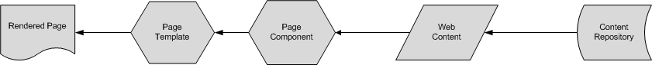System flow as described is supported by the Adobe AEM product and does not contain any custom system flow aspects. This consists of creating, editing and rendering of content. Creating and editing of content are also known as authoring.

Pages are rendered using the AEM’s CRX repository that stores the content, designs and the application logic.

3.0 Functional Decomposition

NA

4.0 System Module Definition

**NA**

4.1 MyFreeStyle Content Architecture

Content for various sections such as header, body and footer would be stored in the AEM CRX repository hierarchy. This hierarchy would be useful for categorizing the contents based on the various sections of pages across website.

Below are screenshots for Content Hierarchy of the website.

**+content**

**+adc**

**+myfreestyle**

**+** **global**

**+us**

**+en**

**+pages**

**+ home**

**+utils**

**+ header boiler plate**

**+ footer boiler plate**

**+ header boiler plate Neo**

**+ footer boiler plate Neo**

**+errors**

**+countries**

**+us**

**+en**

**+pages**

**+home**

**….**

**+utils**

**+ header boiler plate**

**+ footer boiler plate**

**+ header boiler plate Neo**

**+ footer boiler plate Neo**

+**errors**

5.0 Critical Design Considerations

5.1 Templates

Template Design

Each of the templates will have pre-defined set of presentation components present and having the place holders for drag-n-drop appropriate components which would require the page to be completed. The details of the presentation components would be explained in detail in subsequent section.

|  |  |  |  |
| --- | --- | --- | --- |
| S No. | Template Name | Description | Pages |
| 1 | Home Page Template | Home page template used to create home page of the site | MyFreeStyle index page use this template |
| 2 | Boiler Plate Template | Template for header and footer boiler plate | Used for the Header and Footer sections for all pages |

**Base Layout**

Base Layout/page will be the basic structure for all the templates. Base Layout/page template will extend foundation Page template. Base Page template uses body.html which contains header.html, content.html, footer.html.

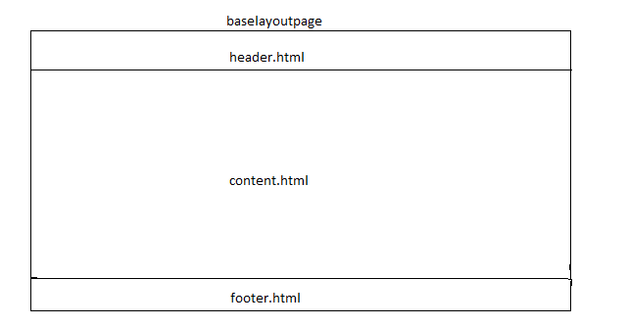

**5.1.1 Home Page Template**

Below table information depicts the properties that would be captured against this template during the development process.

|  |  |  |
| --- | --- | --- |
| Fields | Value | Additional Inputs |
| Template Path | /apps/adc/myfreestyle/templates/page-home |  |
| Title | MyFreeStyle Site Home Page |  |
| Description | Template for initial or main page of the site. |  |
| Resource Type | /apps/adc/myfreestyle/components/structure/page-home |  |
| allowed Paths | /content/adc (/. *)? |  |

**5.1.2** **Boiler Plate Template**

Boiler Plate template is used to create the contents for header and footer section for any website created using reusable templates and components. Content Author creates the header and footer pages under Site hierarchy and enters the contents for these sections. All pages such as home and content pages of website would refer these pages for displaying header and footer sections. All content modification will be done in boiler plate pages and it will be automatically reflected in all other pages.

Header and Footer pages will be created under the Utils in the site hierarchy as mentioned in below screenshots

Below table depicts the location of boiler plate pages in global site

|  |  |  |  |
| --- | --- | --- | --- |
| **S. No** | **Page Title** | **Page Name** | **Location in Site Structure** |
| 1 | Header Boiler Plate Page | header-boilerplate | /content/adc/myfreestyle/global/us/en/utility/header-boilerplate |
| 2 | Footer Boiler Plate Page | footer-boilerplate | /content/adc/myfreestyle/global/us/en/utility/footer-boilerplate |
| 3 | Header Boiler plate Neo | header-boilerplate-neo | /content/adc/myfreestyle/global/us/en/utility/header-boilerplate-neo |
| 4 | Footer Boiler plate Neo | footer-boilerplate-neo | /content/adc/myfreestyle/global/us/en/utility/footer-boilerplate-neo |

|  |  |  |
| --- | --- | --- |
| Fields | Value | Additional Inputs |
| Template Path | /apps/adc/myfreestyle/templates/page-boilerplate |  |
| Title | MyFreeStyle Site Boilerplate Page |  |
| Description | Template for header and footer page of the site. |  |
| Resource Type | /apps/adc/myfreestyle/components/structure/page-boilerplate |  |
| allowedPaths | /content/adc (/. *)? |  |

|  |  |  |
| --- | --- | --- |
| Fields | Value | Additional Inputs |
| Neo Template Path | /apps/adc/myfreestyle/templates/page-boilerplate-neo |  |
| Title | MyFreeStyle Site Neo Boilerplate Page |  |
| Description | Template for header and footer page of the Neo site. |  |
| Resource Type | /apps/adc/myfreestyle/components/structure/page-boilerplate-neo |  |
| allowedPaths | /content/adc (/. *)? |  |

5.2 Components

### 5.2.1 Header

Component Name : Header

Component Group : ADC-MyFreeStyle

Drag-n-Drop : Yes

Component Edit : Dialog/Page level Edit bar option

Touch UI Dialog : Yes

Functionality – This component will be used in the section and author can author logo (right & left logos) and top navigation information.

**Component Dialog Fields– AUTHOR MODE**

|  |  |  |  |  |  |
| --- | --- | --- | --- | --- | --- |
| **Tabs** | **Field Name** | **Xtype** | **Description** | **Mandatory** | **Validation** |
| **Left Logo** | Left Logo Image | html5smartimage | Place holder for content authors where the content authors can select a logo image from DAM | No |  |
|  | Left Logo Alt Text | textfield | Allows author to provide an alt text for the image. | No |  |
|  | Left Logo Title Text | textfield | Allows author to provide a title for the logo. | No |  |
|  | Left Logo Link | pathfield | Allows author to provide the link for the logo. | No |  |
|  | Open link in new window? | selection | Allows author to use a checkbox to open link in new window. | No |  |
| **Right Logo** | Right Logo Image | html5smartimage | Place holder for content authors where the content authors can select a logo image from DAM | No |  |
|  | Right Logo Alt Text | textfield | Allows author to provide an alt text for the image. | No |  |
|  | Right Logo Title Text | textfield | Allows author to provide a title for the image. | No |  |
|  | Right Logo Link | pathfield | Allows author to provide the link for the image. | No |  |
|  | Open link in new window? | selection | Allows author to use a checkbox to open link in new window. | No |  |
| **Product Top Navigation Links** | Language Text | textfield | Allows author to provide language text | No |  |
|  | Top Nav Links One | textfield | Allows author to provide link for language link one | No |  |
|  | Language Text One | textfield | Allows author to provide language text for link one | No |  |
|  | Top Nav Links Two | textfield | Allows author to provide language link for link two | No |  |
|  | Language Text Two | textfield | Allows author to provide language text for link two | No |  |
|  | HCP Text | textfield | Allows author to provide text for HCP | No |  |
|  | HCP link | textfield | Allows author to provide link for HCP | No |  |
|  | Open link in new window? | checkbox | Allows author to enable page to open in new tab | No |  |
|  | Products Navigation Header | textfield | Allows author to provide product header | No |  |
|  | Product Image one | pathfield | Allows author to provide product image path | No |  |
|  | Products image alt one | textfield | Allows author to provide alt text for products image | No |  |
|  | Product path one | pathfield | Allows author to provide products path one | No |  |
|  | Products text one | textfield | Allows author to provide products text one | No |  |
|  | Product bottom text one | textfield | Allows author to provide products bottom text one | No |  |
|  | Product menu | mtmulticompositefield | Allows author to provide values for products image, alt text, product text and product URL | No |  |
|  | Product bottom text two | textfield | Allows author to provide products bottom text two | No |  |
|  | Product Image three | pathfield | Allows author to provide product image path | No |  |
|  | Products image alt three | textfield | Allows author to provide alt text for products image | No |  |
|  | Product path three | pathfield | Allows author to provide products path three | No |  |
|  | Products text three | textfield | Allows author to provide products text three | No |  |
|  | Product bottom text three | textfield | Allows author to provide products bottom text three | No |  |
|  | Product Image four | pathfield | Allows author to provide product image | No |  |
|  | Products image alt four | textfield | Allows author to provide alt text for products image | No |  |
|  | Product path four | pathfield | Allows author to provide products path | No |  |
|  | Products text four | textfield | Allows author to provide products text | No |  |
|  | Product bottom text four | textfield | Allows author to provide products bottom label | No |  |
|  | Product Image five | pathfield | Allows author to provide products image path | No |  |
|  | Products image alt five | textfield | Allows author to provide alt text for product image | No |  |
|  | Product path five | pathfield | Allows author to provide path for product image | No |  |
|  | Products text five | textfield | Allows author to provide products text | No |  |
|  | Product bottom text five | textfield | Allows author to provide products bottom label | No |  |
| **Other Top Navigation Links** | Diabetes Nav Title | textfield | Allows author to provide diabetes title | No |  |
|  | Enter the sub links for diabetes navigation | mtmulticompositefield | Allows author to provide values for diabetes link text and diabetes link path | No |  |
|  | Support Nav Title | textfield | Allows author to provide support navigation title | No |  |
|  | Enter the sub links for support navigation | mtmulticompositefield | Allows author to provide values for support link text and support link URL | No |  |
|  | Offer Nav Title | textfield | Allows author to provide Offers title | No |  |
|  | Enter the sub links for offer navigation | mtmulticompositefield | Allows author to provide values for offers text and offers link URL | No |  |
| **Stage Analytics Code** | Adobe Analytics Code to add in Head Section | textarea | Placeholder to put DTM analytics head portion code | No |  |
|  | Adobe Analytics Code to add in Body Section | textarea | Placeholder to put DTM analytics code between <body></body> tag. | No |  |
| **Production Analytics Code** | PROD Adobe Analytics Code to add in Head Section | textarea | Placeholder to put DTM analytics head portion code | No |  |
|  | PROD Adobe Analytics Code to add in Body | textarea | Placeholder to put DTM analytics code between <body></body> tag. | No |  |
| **GTM Script** | Non GTM Script | textarea | Placeholder to put GTM script file | No |  |
|  | GTM Script | textarea | Placeholder to put GTM script | No |  |

**Component Dialog Design – AUTHOR MODE**

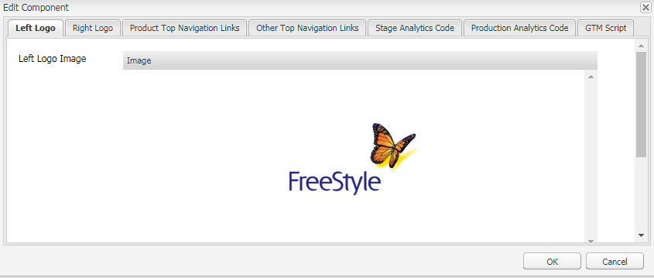

### 5.2.2-Footer

Component Name : Footer

Component Group : ADC-MyFreeStyle

Drag-n-Drop : Yes

Component Edit : Dialog

Touch UI Dialog : Yes

Functionality – This component will be used for footer section and copyright information.

|  |  |  |  |  |  |
| --- | --- | --- | --- | --- | --- |
| **Tabs** | **Field Name** | **Xtype** | **Description** | **Mandatory** | **Validation** |
| **Product Section** | Select the product values | mtmulticompositefield | Allows author to provide product values i.e., product image, alt text, product title, product URL, open in new tab and product image title | No |  |
|  | Product Heading | textfield | Allows author to provide products heading | Yes |  |
| Disclaimer Text | ISI Text | richtext | Allows author to provide ISI information content to be displayed in footer section | No |  |
|  | Copy Right Information | richtext | Allows author to provide Copyright information content to be displayed in footer section | Yes |  |
|  | Patent Text | textfield | Allows author to provide Patent Text | No |  |
|  | Select Footer links | mtmulticompositefield | Allows author to provide a footer links. | No |  |
| **Footer Links** | Heading for section one | textfield | Allows author to provide heading for section one | No |  |
|  | Diabetes Title | textfield | Allows author to provide diabetes title | No |  |
|  | Diabetes URL | pathfield | Allows author to provide Diabetes URL | No |  |
|  | Heading for section two | textfield | Allows author to provide section two title | No |  |
|  | Title for support | textfield | Allows author to provide support title | No |  |
|  | Support center URL | pathfield | Allows author to provide Support URL | No |  |
|  | Contact US title | textfield | Allows author to provide Contact-us title | No |  |
|  | Contact US URL | pathfield | Allows author to provide Contact us URL | No |  |
|  | Heading for section three | textfield | Allows author to provide section three title | No |  |
|  | Where to Buy Title | textfield | Allows author to provide where to buy title | No |  |
|  | Where to buy URL | pathfield | Allows author to provide Where to buy URL | No |  |
|  | Offers title | textfield | Allows author to provide offers title | No |  |
|  | Offers URL | pathfield | Allows author to provide Offers URL | No |  |
|  | Insurance Coverage title | textfield | Allows author to provide insurance coverage title | No |  |
|  | Insurance coverage URL | pathfield | Allows author to provide insurance coverage URL | No |  |
| **Social Collaboration** | Heading for social collaboration | textfield | Allows author to provide a title for the social collaboration. | No |  |
|  | Select Social collaboration links | mtmulticompositefield | Allows author to add multiple items | No |  |
| **Social Share Details** | Title | textfield | Allows author to provide title | No |  |
|  | Twitter icon image | pathfield | Allows author to provide twitter image path | No |  |
|  | Twitter Image Alt Text | textfield | Allows author to provide twitter image alt text | No |  |
|  | Facebook icon image | pathfield | Allows author to provide Facebook image path | No |  |
|  | Facebook Image Alt Text | textfield | Allows author to provide Facebook image alt text | No |  |
|  | Google Plus image | pathfield | Allows author to provide google plus image path | No |  |
|  | Google Plus Image Alt Text | textfield | Allows author to provide google plus image alt text | No |  |
|  | Twitter Icon URL | pathfield | Allows author to provide twitter icon URL | No |  |
|  | Twitter Icon Title | textfield | Allows author to provide twitter icon title | No |  |
|  | Facebook Icon URL | pathfield | Allows author to provide Facebook icon URL | No |  |
|  | Google Plus Icon URL | pathfield | Allows author to provide google plus icon URL | No |  |
|  | Facebook Icon Title | textfield | Allows author to provide Facebook icon title | No |  |
|  | Google Plus Icon Title | textfield | Allows author to provide google plus icon title | No |  |
| **Logo** | Footer Logo Image | html5smartimage | Allows author to provide footer logo | No |  |
|  | Alt Text | textfield | Allows author to provide alt text for footer logo | Yes |  |
|  | Footer Logo Link | pathfield | Allows author to provide footer logo path | Yes |  |
|  | Open in new tab? | checkbox | Allows author to select the open in new window value | No |  |
|  | Footer Logo Title | textfield | Allows author to provide footer logo title | Yes |  |

**Component Dialog Design – AUTHOR MODE**

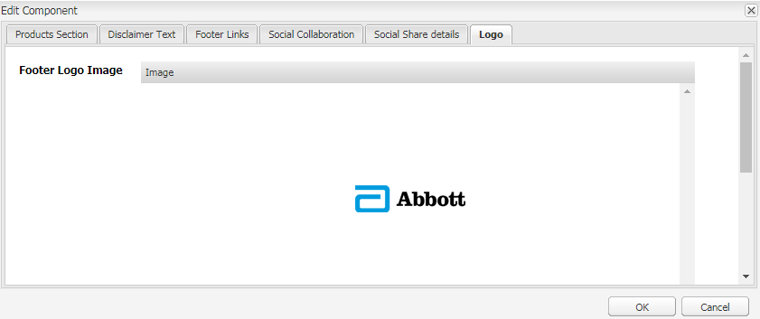

### 5.2.3 Hero Panel

Component Name : Hero Panel

Component Group : ADC-MyFreeStyle

Drag-n-Drop : Yes

Component Edit : Dialog

Touch UI Dialog : Yes

Functionality – Display carousal, text and individual panel image. Rating/reviews is to be integrated using 3rd party service “bazaar voice” using JavaScript embed approach.

**Component Dialog Fields– AUTHOR MODE**

|  |  |  |  |  |  |
| --- | --- | --- | --- | --- | --- |
| **Tabs** | **Field Name** | **Xtype** | **Description** | **Mandatory** | **Validation** |
| **Hero Panel** | Individual Panel | mtmulticompositefield | Allows author to provide multiple panel paths to display on page | No |  |
|  | Image Rotation | selection | Allows author to enable or disable image rotation | No |  |
|  | Transition Time (seconds) | textfield | Allows authors to provide transition time for carousal | No |  |
|  | Margin Bottom | selection | Allows author to enable margin for bottom | No |  |
|  | Margin Top | selection | Allows author to enable margin for top | No |  |

**Component Dialog Design – AUTHOR MODE**

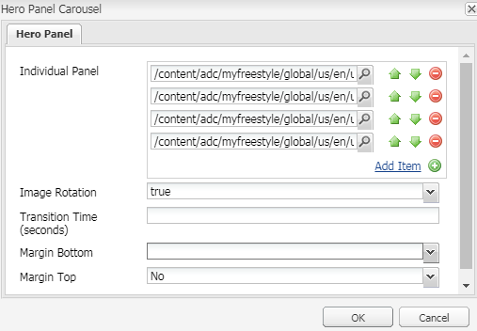

### 5.2.4 Lite Right Image Panel

Component Name : Lite Right Image Panel

Component Group : ADC-MyFreeStyle

Drag-n-Drop : Yes

Component Edit : Dialog

Touch UI Dialog : Yes

Functionality – This component is used to display text and image on right

**Component Dialog Fields – AUTHOR MODE**

|  |  |  |  |  |  |
| --- | --- | --- | --- | --- | --- |
| **Tabs** | **Field Name** | **Xtype** | **Description** | **Mandatory** | **Validation** |
| **Text Image Config** | Select the Background color | selection | Allows author to select background color | No |  |
|  | Icon Image | html5smartimage | Allows author to drag and drop icon image | No |  |
|  | Heading | richtext | Allows author to provide text for heading | No |  |
|  | Body Text | richtext | Allows author to provide body text for section | No |  |
|  | Alt text | textfield | Allows author to provide alt text for image | Yes |  |
|  | Image | html5smartimage | Allows author to drag and drop image | Yes |  |
|  | Additional Alt Text | textfield | Allows author to provide alt text for additional image | No |  |
|  | Additional Image | html5smartimage | Allows author to drag and drop additional image | No |  |

**Component Dialog Design – AUTHOR MODE**

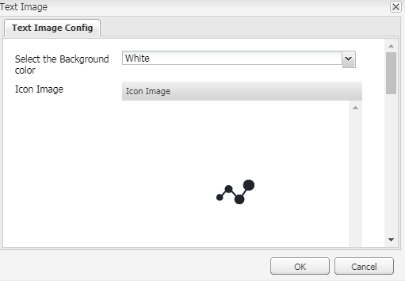

### 5.2.5 Data Cable Products

Component Name : Data Cable Products

Component Group : ADC-MyFreeStyle

Drag-n-Drop : Yes

Component Edit : Dialog

Touch UI Dialog : Yes

Functionality – This component is used to display data cable images and text

**Component Dialog Fields – AUTHOR MODE**

|  |  |  |  |  |  |
| --- | --- | --- | --- | --- | --- |
| **Tabs** | **Field Name** | **Xtype** | **Description** | **Mandatory** | **Validation** |
| **Data Cable Products** | Header Text | textfield | Allows author to provide header | Yes |  |
|  | Data cable Products Panel Background Color | selection | Allows author to select background color | No |  |
|  | Data cable Products Details | mtmulticompositefield | Allows author to provide values for product image title, product image, datacable text, text for button, button URL, button text color, button background color, product image title text one, product image one, datacable text one, text for button one, button one URL, button one text color and button one background color | No |  |
|  | Text for MLR | textfield | Allows author to provide text for mlr | No |  |
|  | Open Target Page in New Tab? | checkbox | Allows author to enable link to open in new window | No |  |

**Component Dialog Design – AUTHOR MODE**

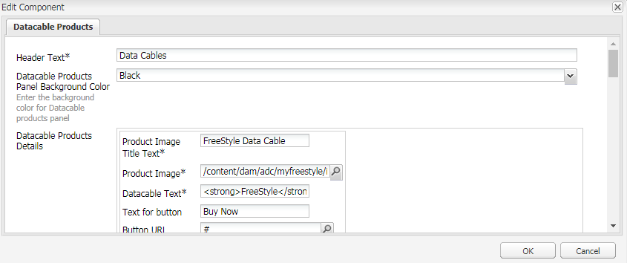

### 5.2.6 Lite Left Image Panel

Component Name : Lite Left Image Panel

Component Group : ADC-MyFreeStyle

Drag-n-Drop : Yes

Component Edit : Dialog

Touch UI Dialog : Yes

Functionality – This component is used to display text and image on Left

**Component Dialog Fields – AUTHOR MODE**

|  |  |  |  |  |  |
| --- | --- | --- | --- | --- | --- |
| **Tabs** | **Field Name** | **Xtype** | **Description** | **Mandatory** | **Validation** |
| **Text Image Config** | Select the Background color | selection | Allows author to select background color | No |  |
|  | Icon Image | html5smartimage | Allows author to drag and drop icon image | No |  |
|  | Heading | richtext | Allows author to provide text for heading | No |  |
|  | Body Text | richtext | Allows author to provide body text for section | No |  |
|  | Alt text | textfield | Allows author to provide alt text for image | Yes |  |
|  | Image | html5smartimage | Allows author to drag and drop image | Yes |  |

**Component Dialog Design – AUTHOR MODE**



### 5.2.7 Header Migration

Component Name : Header Migration

Component Group : ADC-MyFreeStyle

Drag-n-Drop : Yes

Component Edit : Dialog/Page level Edit bar option

Touch UI Dialog : Yes

Functionality – This component will be used in the section and author can author logo (right & left logos) and top navigation information.

**Component Dialog Fields– AUTHOR MODE**

|  |  |  |  |  |  |
| --- | --- | --- | --- | --- | --- |
| **Tabs** | **Field Name** | **Xtype** | **Description** | **Mandatory** | **Validation** |
| **Left Logo** | Left Logo Image | html5smartimage | Place holder for content authors where the content authors can select a logo image from DAM | No |  |
|  | Left Logo Alt Text | textfield | Allows author to provide an alt text for the image. | No |  |
|  | Left Logo Title Text | textfield | Allows author to provide a title for the logo. | No |  |
|  | Left Logo Link | pathfield | Allows author to provide the link for the logo. | No |  |
|  | Open link in new window? | selection | Allows author to use a checkbox to open link in new window. | No |  |
| **Right Logo** | Right Logo Image | html5smartimage | Place holder for content authors where the content authors can select a logo image from DAM | No |  |
|  | Right Logo Alt Text | textfield | Allows author to provide an alt text for the image. | No |  |
|  | Right Logo Title Text | textfield | Allows author to provide a title for the image. | No |  |
|  | Right Logo Link | pathfield | Allows author to provide the link for the image. | No |  |
|  | Open link in new window? | selection | Allows author to use a checkbox to open link in new window. | No |  |
| **Product Top Navigation Links** | Language Text | textfield | Allows author to provide language text | No |  |
|  | Top Nav Links One | textfield | Allows author to provide link for language link one | No |  |
|  | Language Text One | textfield | Allows author to provide language text for link one | No |  |
|  | Top Nav Links Two | textfield | Allows author to provide language link for link two | No |  |
|  | Language Text Two | textfield | Allows author to provide language text for link two | No |  |
|  | HCP Text | textfield | Allows author to provide text for HCP | No |  |
|  | HCP link | textfield | Allows author to provide link for HCP | No |  |
|  | Open link in new window? | checkbox | Allows author to enable page to open in new tab | No |  |
|  | Products Navigation Header | textfield | Allows author to provide product header | No |  |
|  | Product Image one | pathfield | Allows author to provide product image path | No |  |
|  | Products image alt one | textfield | Allows author to provide alt text for products image | No |  |
|  | Product path one | pathfield | Allows author to provide products path one | No |  |
|  | Products text one | textfield | Allows author to provide products text one | No |  |
|  | Product bottom text one | textfield | Allows author to provide products bottom text one | No |  |
|  | Product menu | mtmulticompositefield | Allows author to provide values for products image, alt text, product text and product url | No |  |
|  | Product bottom text two | textfield | Allows author to provide products bottom text two | No |  |
|  | Product Image three | pathfield | Allows author to provide product image path | No |  |
|  | Products image alt three | textfield | Allows author to provide alt text for products image | No |  |
|  | Product path three | pathfield | Allows author to provide products path three | No |  |
|  | Products text three | textfield | Allows author to provide products text three | No |  |
|  | Product bottom text three | textfield | Allows author to provide products bottom text three | No |  |
|  | Product Image four | pathfield | Allows author to provide product image | No |  |
|  | Products image alt four | textfield | Allows author to provide alt text for products image | No |  |
|  | Product path four | pathfield | Allows author to provide products path | No |  |
|  | Products text four | textfield | Allows author to provide products text | No |  |
|  | Product bottom text four | textfield | Allows author to provide products bottom label | No |  |
|  | Product Image five | pathfield | Allows author to provide products image path | No |  |
|  | Products image alt five | textfield | Allows author to provide alt text for product image | No |  |
|  | Product path five | pathfield | Allows author to provide path for product image | No |  |
|  | Products text five | textfield | Allows author to provide products text | No |  |
|  | Product bottom text five | textfield | Allows author to provide products bottom label | No |  |
| **Other Top Navigation Links** | Diabetes Nav Title | textfield | Allows author to provide diabetes title | No |  |
|  | Enter the sub links for diabetes navigation | mtmulticompositefield | Allows author to provide values for diabetes link text and diabetes link path | No |  |
|  | Support Nav Title | textfield | Allows author to provide support navigation title | No |  |
|  | Enter the sub links for support navigation | mtmulticompositefield | Allows author to provide values for support link text and support link URL | No |  |
|  | Offer Nav Title | textfield | Allows author to provide Offers title | No |  |
|  | Enter the sub links for offer navigation | mtmulticompositefield | Allows author to provide values for offers text and offers link URL | No |  |
| **Stage Analytics Code** | Adobe Analytics Code to add in Head Section | textarea | Placeholder to put DTM analytics head portion code | No |  |
|  | Adobe Analytics Code to add in Body Section | textarea | Placeholder to put DTM analytics code between <body></body> tag. | No |  |
| **Production Analytics Code** | PROD Adobe Analytics Code to add in Head Section | textarea | Placeholder to put DTM analytics head portion code | No |  |
|  | PROD Adobe Analytics Code to add in Body | textarea | Placeholder to put DTM analytics code between <body></body> tag. | No |  |
| **GTM Script** | Non GTM Script | textarea | Placeholder to put GTM script file | No |  |
|  | GTM Script | textarea | Placeholder to put GTM script | No |  |
| **Header Navigation** | First Level Nav links for header navigation | multifield | Allows author to provide values for header title, URL, icon, alttext, description, description, and secondnav | No |  |
|  | Second level subnav inside first nav navigation | multifield | Allows author to provide values for header navigation title, URL, icon, alttext, description, display button, coupon title, coupon description, coupon icon, coupon alttext, coupon description, coupon display button and thirdnav. | No |  |
|  | Third level subnav inside second navigation | multifield | Allows author to provide values for header navigation title, URL, icon, alttext, description, description, and fourthnav | No |  |
|  | Fourth level subnav inside third navigation | multifield | Allows author to provide values for title, URL | No |  |

### 5.2.8-Footer US

Component Name : Footer US

Component Group : ADC-MyFreeStyle

Drag-n-Drop : Yes

Component Edit : Dialog

Touch UI Dialog : Yes

Functionality – This component will be used for footer section and copyright information.

|  |  |  |  |  |  |
| --- | --- | --- | --- | --- | --- |
| **Tabs** | **Field Name** | **Xtype** | **Description** | **Mandatory** | **Validation** |
| **Disclaimer Text** | Copy Right Information | richtext | Allows author to provide Copyright information content to be displayed in footer section | No |  |
| **Logo** | Footer logo image | pathfield | Allows author to provide footer logo image path | No |  |
|  | Footer Logo Alt Text | textfield | Allows author to provide alternate text for image | No |  |
|  | Title text | textfield | Allows author to provide title text for footer | No |  |
|  | Footer Logo Link | pathfield | Allows author to provide footer logo link | No |  |
|  | Open in new tab? | checkbox | Allows author to provide options to open page link in new tab | No |  |
|  | Google Analytics Name for Logo URL | textfield | Allows author to provide google analytics text | No |  |
|  | Tagging Function value | textfield | Allows author to provide tagging function value in the text field | No |  |
| **Footer Links** | Link Title | textfield | Allows author to provide link title in text field | No |  |
|  | Target Link | pathfield | Allows author to provide target URL | No |  |
|  | Open in new tab? | checkbox | Allows author to provide options to open page link in new tab | No |  |
|  | Enable Popup? | checkbox | Allows author to provide options to enable pop up | No |  |
|  | Popup ID | textfield | Allows author to provide popup id | No |  |
|  | Google Analytics Name for Logo URL | textfield | Allows author to provide google analytics text | No |  |
|  | Custom Function Name | textfield | Allows author to provide customer function name | No |  |
|  | Custom Function Action Value | textfield | Allows author to provide custom function value. | No |  |
|  | Tagging Function value | textfield | Allows author to provide tagging function value in the text field | No |  |
| **Social Media Config** | Heading for social collaboration | textfield | Allows author to provide a title for the social collaboration. | No |  |
|  | Facebook Link | textfield | Allows author to provide a link in the text field. | No |  |
|  | Facebook Google Analytics Name | textfield | Allows author to provide a Facebook google analytics name in the text field. | No |  |
|  | Tagging Function value | textfield | Allows author to provide a tagging function value in the text field. | No |  |
|  | Twitter Link | textfield | Allows author to provide a link in the text field. | No |  |
|  | Twitter Google Analytics Name | textfield | Allows author to provide a twitter google analytics name in the text field. | No |  |
|  | YouTube Link | textfield | Allows author to provide a link in the text field. | No |  |
|  | YouTube Google Analytics Name | textfield | Allows author to provide a YouTube google analytics name in the text field. | No |  |
| **Safety Information config** | Section ID | textfield | Allows author to provide section ID | No |  |
|  | Safety Information | richtext | Allows author to provide safety information in the richtext field | No |  |
| **Third Party Popup** | Third Party Popup Content | richtext | Allows author to provide third party popup content | No |  |
|  | Third Party Yes Button Value | textfield | Allows author to provide third party button value in the text field | No |  |
|  | Third Party No Button Value | textfield | Allows author to provide third party no button value in the text field | No |  |
| **Order Now Third Party** | Order Now Third-Party Content | richtext | Allows author to provide ordernow third party content | No |  |
|  | Order Now Third Party Yes Button Value | textfield | Allows author to provide ordernow third party yes button value in the text field | No |  |
|  | Order Now Third Party No Button Value | textfield | Allows author to provide ordernow third party no button value in the text field | No |  |

### 5.2.9 FAQ

Component Name : FAQ

Component Group : ADC-MyFreeStyle

Drag-n-Drop : Yes

Component Edit : Dialog

Touch UI Dialog : Yes

Functionality – This component will be used for FAQ accordion in product precision neo page,

|  |  |  |  |  |  |
| --- | --- | --- | --- | --- | --- |
| **Tabs** | **Field Name** | **Xtype** | **Description** | **Mandatory** | **Validation** |
| **FAQ Editor** | FAQ Header Text | textfield | Allows author to provide heading | No |  |
|  | FAQ Background color | selection | Allows author to select FAQ background color | No |  |
|  | FAQ Icon Title | mtmulticompositefield | Allows author to provide icon title | No |  |
|  | FAQ Icon | html5smartimage | Allows author to drag and drop icon | No |  |
|  | FAQ Icon Alt Text | textfield | Allows author to provide alt text for FAQ icon | Yes |  |
|  | Expand All Text | textfield | Allows author to provide label for expand all | No |  |
|  | Collapse All Text | textfield | Allows author to provide label for collapse all | No |  |
|  | FAQ Image Title | textfield | Allows author to provide FAQ image title | No |  |
|  | FAQ Image | html5smartimage | Allows author to drag and drop FAQ image | No |  |
|  | FAQ Image Alt Text | textfield | Allows author to provide alt text for FAQ image | Yes |  |
|  | See All Text | textfield | Allows author to provide label for see all | No |  |
|  | See All URL | pathfield | Allows author to provide URLs | No |  |
|  | Scroll ID | textfield | Allows author to provide scroll ID | No |  |
| **Questions and Answers** | FAQ list | mtmulticompositefield | Allows author to provide values for questions text and answers text | No |  |

### 5.2.10 Rich Text

Component Name : Rich Text

Component Group : ADC-MyFreeStyle

Drag-n-Drop : Yes

Component Edit : Dialog

Touch UI Dialog : Yes

Functionality – This component will be used to display text with image

|  |  |  |  |  |  |
| --- | --- | --- | --- | --- | --- |
| **Tabs** | **Field Name** | **Xtype** | **Description** | **Mandatory** | **Validation** |
| **Text** | Text | richtext | Allows author to provide description | No |  |

### 5.2.11 Warranty Registration

Component Name : Registration form

Component Group : ADC-MyFreeStyle

Drag-n-Drop : Yes

Component Edit : Dialog

Touch UI Dialog : Yes

Functionality – This component will be used for filling up registration details of new user under product libre pages.

|  |  |  |  |  |  |
| --- | --- | --- | --- | --- | --- |
| **Tabs** | **Field Name** | **Xtype** | **Description** | **Mandatory** | **Validation** |
| **Warranty Registration Form** | Registration Form Header | richtext | Allows author to provide heading | No |  |
|  | First Name Label | textfield | Allows author to provide first name field | No |  |
|  | Last Name Label | textfield | Allows author to provide last name field | No |  |
|  | Title Text label | textfield | Allows author to provide title | No |  |
|  | Title Options | mtmulticompositefield | Allows author to provide options for title | No |  |
|  | Gender Text label | textfield | Allows author to provide gender label | No |  |
|  | Gender Options label | mtmulticompositefield | Allows author to provide options for gender | No |  |
|  | Year of Birth label | textfield | Allows author to provide year of birth label | No |  |
|  | Year of Birth Placeholder Popup | textfield | Allows author to provide year of birth popup text | No |  |
|  | FreeStyle Libre reader serial number label | textfield | Allows author to provide serial no. text | No |  |
|  | Reader Serial No Placeholder for Popup label | textfield | Allows author to provide serial no. popup text | No |  |
|  | Where did you acquire text | textfield | Allows author to provide where did you acquire text | No |  |
|  | Acquire System Month | mtmulticompositefield | Allows author to provide month values | No |  |
|  | *When did you acquire your FreeStyle Libre system? | mtmulticompositefield | Allows author to provide year values | No |  |
|  | When did you acquire text label | textfield | Allows author to provide when did you acquire text | No |  |
|  | Pharmacy Options label | mtmulticompositefield | Allows author to provide pharmacy options | No |  |
|  | Pharmacy Options Values label | mtmulticompositefield | Allows author to provide pharmacy options values for a pharmacy label | No |  |
|  | Email address label | textfield | Allows author to provide email address text | No |  |
|  | Address1 label | textfield | Allows author to provide address 1 text | Yes |  |
|  | Address2(Optional) label | textfield | Allows author to provide address 2 text | No |  |
|  | Postal Code label | textfield | Allows author to provide postal code text | No |  |
|  | Phone label | textfield | Allows author to provide phone label text | No |  |
|  | Extension (optional) label | textfield | Allows author to provide extension text | Yes |  |
|  | Register your FreeStyle Libre reader Button label | textfield | Allows author to provide submit button text | No |  |
|  | Thankyou Message Text | richtext | Allows author to provide thank you message text | No |  |
| **City, State and Country** | City Text label | textfield | Allows author to provide city text | No |  |
|  | City label | mtmulticompositefield | Allows author to provide different city label values | No |  |
|  | Province Text label | textfield | Allows author to provide province text | No |  |
|  | Province label | mtmulticompositefield | Allows author to provide different province label values | No |  |
|  | Country Text label | textfield | Allows author to provide country text | No |  |
|  | Country label | mtmulticompositefield | Allows author to provide different country label values | No |  |
| **Are You, Manage Diabetes, Previous Meter and Disclaimer** | Are You Text label | textfield | Allows author to provide AreYou text | No |  |
|  | Are you a: | mtmulticompositefield | Allows author to provide different AreYou label values | No |  |
|  | Manage Diabetes Text label | textfield | Allows author to provide manage diabetes text | No |  |
|  | How do you manage your diabetes? | mtmulticompositefield | Allows author to provide different ways to manage diabetes values | No |  |
|  | Previous Meter Text label | textfield | Allows author to previous meter text | No |  |
|  | What meter did you previously use? | mtmulticompositefield | Allows author to provide different meter values | No |  |
|  | Warranty Text label | textfield | Allows author to provide warranty text | No |  |
|  | Disclaimer Text label | textfield | Allows author to provide disclaimer text | No |  |
|  | Disclaimer Condition Text label | mtmulticompositefield | Allows author to provide different disclaimer conditions text values | No |  |
| **Error Messages** | Empty Field Error Message | textfield | Allows author to provide empty field error message text | No |  |
|  | First Name Error Message | textfield | Allows author to provide first name field error message text | No |  |
|  | Last Name Error Message | textfield | Allows author to provide last name field error message text | No |  |
|  | Gender Error Message | textfield | Allows author to provide last gender field error message text | No |  |
|  | Year of Birth Error Message | textfield | Allows author to provide last year of birth error message text | No |  |
|  | Reader Serial No Error Message | textfield | Allows author to provide last reader serial no. error message text | No |  |
|  | Acquire System Error Message | textfield | Allows author to provide acquire system error message text | No |  |
|  | Address1 Error Message | textfield | Allows author to provide Address 1 error message text | No |  |
|  | City Error Message | textfield | Allows author to provide city error message text | No |  |
|  | State Error Message | textfield | Allows author to provide state error message text | No |  |
|  | Country Error Message | textfield | Allows author to provide country error message text | No |  |
|  | Zip Postal Code Error Message | textfield | Allows author to provide postal code error message text | No |  |
|  | Phone Error Message | textfield | Allows author to provide phone code error message text | No |  |
|  | Extension Error Message | textfield | Allows author to provide extension error message text | No |  |
|  | Are You Error Message | textfield | Allows author to provide Are You error message text | No |  |
|  | Manage Diabetes Error Message | textfield | Allows author to provide Manage Diabetes error message text | No |  |
|  | Previous Meter Error Message | textfield | Allows author to provide previous meter error message text | No |  |
|  | Registration Success Message | textfield | Allows author to provide registration success message text | No |  |
|  | Registration Failure Message | textfield | Allows author to provide registration failure message text | No |  |
|  | Conditions Error Message | textfield | Allows author to provide conditions error message text | No |  |
|  | Privacy Policy Error Message | textfield | Allows author to provide privacy policy error message text | No |  |
|  | Purchase Location Error Message | textfield | Allows author to provide purchase location error message text | No |  |
|  | Age Error Message | textfield | Allows author to provide age error message text | No |  |

### 5.2.12 Download Coupon

Component Name : Download coupon

Component Group : ADC-MyFreeStyle

Drag-n-Drop : Yes

Component Edit : Dialog

Touch UI Dialog : Yes

Functionality – This component will be used for downloading coupons for a few FREE meter after filling up of details in a form.

|  |  |  |  |  |  |
| --- | --- | --- | --- | --- | --- |
| **Tabs** | **Field Name** | **Xtype** | **Description** | **Mandatory** | **Validation** |
| **Download coupon form** | Header Text | richtext | Allows author to provide heading text | No |  |
|  | Sub Heading Text | textfield | Allows author to provide subheading text | No |  |
|  | Question1 Text | textfield | Allows author to provide question 1 text | No |  |
|  | Question1 Options | mtmulticompositefield | Allows author to add multiple questions | No |  |
|  | Question2 Text | textfield | Allows author to provide question 2 text | No |  |
|  | Question2 Options | mtmulticompositefield | Allows author to add multiple questions | No |  |
|  | Select Options | textfield | Allows author to provide select options text | No |  |
|  | Question3 Text | textfield | Allows author to provide question 3 text | No |  |
|  | Question3Options | mtmulticompositefield | Allows author to add multiple questions | No |  |
|  | Question4 Text | textfield | Allows author to provide question 4 text | No |  |
|  | Question4 Options | mtmulticompositefield | Allows author to add multiple questions | No |  |
|  | First Name | textfield | Allows author to provide first name text | No |  |
|  | Last Name | textfield | Allows author to provide last name text | No |  |
|  | Email | textfield | Allows author to provide last email text | No |  |
|  | Disclaimer Condition Text | mtmulticompositefield | Allows author to add disclaimer conditions text multiple values | No |  |
|  | Disclaimer Text | textfield | Allows author to add disclaimer text | No |  |
|  | Button Text | textfield | Allows author to add button text | No |  |
|  | Thankyou Message Text | richtext | Allows author to add thnakyou message text | No |  |
|  | Personal Information | textfield | Allows author to add personal information text | No |  |
|  | Error message | textfield | Allows author to add error message text | No |  |

### 5.2.13 Newsletter Signup

Component Name : Newsletter signup

Component Group : ADC-MyFreeStyle

Drag-n-Drop : Yes

Component Edit : Dialog

Touch UI Dialog : Yes

Functionality – This component will be used for filling up email details for signup page.

|  |  |  |  |  |  |
| --- | --- | --- | --- | --- | --- |
| **Tabs** | **Field Name** | **Xtype** | **Description** | **Mandatory** | **Validation** |
| **Newsletter signup** | Header Text | richtext | Allows author to add header text message | No |  |
|  | Placeholder Text | textfield | Allows author to add placeholder text | No |  |
|  | Email | textfield | Allows author to add email text | No |  |
|  | Disclaimer Condition Text | mtmulticompositefield | Allows author to add disclaimer conditions text multiple values | No |  |
|  | Disclaimer Text | textfield | Allows author to add disclaimer text | No |  |
|  | Button Text | textfield | Allows author to add button text | No |  |
|  | Thankyou Message Text | richtext | Allows author to add thnakyou message text | No |  |
|  | GTM Classes | textfield | Allows author to add GTM text | No |  |
| **Error Messages** | Empty Field Error Message | textfield | Allows author to add empty field error message text | No |  |
|  | Email Field Invalid Message | textfield | Allows author to add email field invalid error message text | No |  |
|  | Email Already Exist Error Message | textfield | Allows author to add email already exist error message text | No |  |
|  | Newsletter Subscription Success Message | textfield | Allows author to add newsletter subscription success message text | No |  |
|  | Newsletter Subscription Error Message | textfield | Allows author to add newsletter subscription error message text | No |  |

### 5.2.14 Check Out the Stories

Component Name : Check Out the Stories

Component Group : ADC-MyFreeStyle

Drag-n-Drop : Yes

Component Edit : Dialog

Touch UI Dialog : Yes

Functionality – This component will be used for showing up stories based upon selection of Story type, Age Range, Story topic.

|  |  |  |  |  |  |
| --- | --- | --- | --- | --- | --- |
| **Tabs** | **Field Name** | **Xtype** | **Description** | **Mandatory** | **Validation** |
| **Check Out the Stories** | Header Text | richtext | Allows author to add header text message | No |  |
|  | Text Field | textfield | Allows author to add text | No |  |
|  | Story Type Label Field | textfield | Allows author to add email text | Yes |  |
|  | Story Type | mtmulticompositefield | Allows author to add story type multiple values | No |  |
|  | Age Range Label Field | textfield | Allows author to add age range text | Yes |  |
|  | Age Range | mtmulticompositefield | Allows author to add multiple age range values | No |  |
|  | Story Topic Label Field | textfield | Allows author to add thnakyou message text | No |  |
|  | Story Topic | mtmulticompositefield | Allows author to add multiple story topic values | No |  |
|  | Dynamic Text Field | textfield | Allows author to add dynamic message text | No |  |

### 5.2.15 Geo Location Message

Component Name : GeoLocation Message

Component Group : ADC-MyFreeStyle

Drag-n-Drop : No

Component Edit : Dialog

Touch UI Dialog : Yes

Functionality – This component will be used for showing up Popup on first visit of site

|  |  |  |  |  |  |
| --- | --- | --- | --- | --- | --- |
| **Tabs** | **Field Name** | **Xtype** | **Description** | **Mandatory** | **Validation** |
| **GeoLocation** | Logo Image Path for desktop | pathbrowser | Allows author to add logo image | No |  |
|  | Logo Image Path for mobile | pathbrowser | Allows author to add logo image for mobile devices | No |  |
|  | Choose the logo link | pathbrowser | Allows author to add Logo link | No |  |
|  | Text | richtext | Allows author to add Disclaimer text | No |  |
|  | First Button Text | textfield | Allows author to add First popup button text | No |  |
|  | First Button Hyperlink for 1st locale | pathbrowser | Allows author to add first button URL | No |  |
|  | Second Button Text | textfield | Allows author to add second button text | No |  |
|  | Second Button Hyperlink | pathbrowser | Allows author to add second button URL | No |  |
|  | First Button Text for 2nd locale | textfield | Allows author to add 2nd locale first button text | No |  |
|  | Second Button Text for 2nd locale | textfield | Allows author to add 2nd locale second button text | No |  |
|  | First Button Hyperlink for 2nd locale | textField | Allows author to add 2nd locale first button hyperlink | No |  |

6. Dispatcher and Apache configuration set up

**dispatcher.any**

$include "**adcmyfreestyle-com-publish-farm.any** "

**Adcmyfreestylefarm**

/adcmyfreestylefarm

{

# client headers which should be passed through to the render instances

# (feature supported since dispatcher build 2.6.3.5222)

/clientheaders

{

"referer"

"user-agent"

"from"

"content-type"

"content-length"

"accept-charset"

"accept-encoding"

"accept-language"

"accept"

"host"

"if-match"

"if-none-match"

"if-range"

"if-unmodified-since"

"max-forwards"

"proxy-authorization"

"proxy-connection"

"range"

"cookie"

"cq-action"

"cq-handle"

"handle"

"action"

"cqstats"

"depth"

"translate"

"expires"

"date"

"dav"

"ms-author-via"

"if"

"lock-token"

"x-expected-entity-length"

"destination"

"CSRF-Token"

}

# hostname globbing for farm selection (virtual domain addressing)

/virtualhosts

{

"www.myfreestyle.com"

"prod3-origin.myfreestyle.com"

"stage3.myfreestyle.com"

"dev3.myfreestyle.com"

}

# the load will be balanced among these render instances

/renders

{

$include "publish-renders.any"

}

# only handle the requests in the following acl. default is 'none'

# the glob pattern is matched against the first request line

/filter

{

# deny everything and allow specific entries

/0001 { /type "deny" /glob "*" }

/0100 { /type "allow" /glob "* /bin/abbott[./]*" }

/0101 { /type "allow" /glob "* /content*" }

/0102 { /type "allow" /glob "* /etc/clientcontext*" }

/0103 { /type "allow" /glob "* /etc/designs/adc/myfreestyle*" }

/0104 { /type "allow" /glob "* /etc/designs/adc/myfreestyle-neo*" }

# enable specific mime types in non-public content directories

/0104 { /type "allow" /glob "* *.css *" } # enable css

/0105 { /type "allow" /glob "* *.gif *" } # enable gifs

/0106 { /type "allow" /glob "* *.ico *" } # enable icos

/0107 { /type "allow" /glob "* *.js *" } # enable javascript

/0108 { /type "allow" /glob "* *.png *" } # enable png

/0109 { /type "allow" /glob "* *.swf *" } # enable flash

/0110 { /type "allow" /glob "* *.mp4 *" } # enable mp4

/0111 { /type "allow" /glob "* *.mp3 *" } # enable mp3

/0112 { /type "allow" /glob "* *.pdf *" } # enable pdf

/0113 { /type "allow" /glob "* *.jpeg *" } # enable jpeg

/0114 { /type "allow" /glob "* *.html *" } # enable html

/0115 { /type "allow" /glob "* *.jpg *" } # enable jpg

/0116 { /type "allow" /glob "* *.xml *" } # enable xml

/0117 { /type "allow" /glob "* *.txt *" } # enable txt

# enable csrf token from libs

/0118 { /type "allow" /glob "* /libs/granite/csrf/*" }

# enable features

/0119 { /type "allow" /glob "POST /content/[.]*.form.html" } # allow POSTs to form selectors under content

/0120 { /type "allow" /glob "* /libs/cq/personalization/*" } # enable personalization

/0121 { /type "allow" /glob "POST /content/[.]*.commerce.cart.json" } # allow POSTs to update the shopping cart

# deny content grabbing

/0122 { /type "deny" /glob "GET *.infinity.json*" }

/0123 { /type "deny" /glob "GET *.tidy.json*" }

/0124 { /type "deny" /glob "GET *.sysview.xml*" }

/0125 { /type "deny" /glob "GET *.docview.json*" }

/0126 { /type "deny" /glob "GET *.docview.xml*" }

/0127 { /type "deny" /glob "GET *.*[0-9].json*" }

/0128 { /type "deny" /glob "GET *.feed.xml*" }

# /0129 { /type "allow" /glob "GET *.1.json*" } # allow one-level json requests

# deny query

/0130 { /type "deny" /glob "* *.query.json*" }

/0131 { /type "allow" /glob "* /bin/servlet/abbott*" }

}

# allow propagation of replication posts (should seldomly be used)

/propagateSyndPost "0"

# the cache is used to store requests from the renders for faster delivery

# for a second time.

/cache

{

# the cacheroot must be equal to the document root of the webserver

/docroot "/mnt/var/www/html/content/adc/myfreestyle/countries"

# sets the level upto which files named ".stat" will be created in the

# document root of the webserver. when an activation request for some

# handle is received, only files within the same subtree are affected

# by the invalidation.

/statfileslevel "3"

# caches also authorized data

/allowAuthorized "0"

# the rules define, which pages should be cached. please note that

# - only GET requests are cached

# - only requests with an extension are cached

# - only requests without query parameters ( ? ) are cached

# - only unauthorized pages are cached unless allowUnauthorized is set to 1

/rules

{

/0000

{

# the globbing pattern to be compared against the url

# example: * -> everything

# : /foo/bar.* -> only the /foo/bar documents

# : /foo/bar/* -> all pages below /foo/bar

# : /foo/bar[./]* -> all pages below and /foo/bar itself

# : *.html -> all .html files

/glob "*"

/type "allow"

}

}

# the invalidate section defines those pages which are 'invalidated' after

# any activation. please note that, the activated page itself and all

# related documents are flushed on an modification. for example: if the

# page /foo/bar is activated, all /foo/bar.* files are removed from the

# cache.

/invalidate

{

/0000

{

/glob "*"

/type "deny"

}

/0001

{

/glob "*.html"

/type "allow"

}

/0002

{

/glob "/content/dam/adc/myfreestyle/*"

/type "allow"

}

/0003

{

/glob "*.json"

/type "allow"

}

}

/allowedClients

{

/0000

{

/glob "*.*.*.*"

/type "deny"

}

$include "publish-invalidate-allowed.any"

}

}

# the statistics define, how the load should be balanced among the renders

# according to the media-type.

/statistics

{

/categories

{

/html

{

/glob "*.html"

}

/others

{

/glob "*"

}

}

}

}

**/var/httpd/conf.d/enabled_vhosts/adcmyfreestyle.com.vhost**

# load required environment variables

PassEnv DISP_NUM

<VirtualHost *:80>

Include /etc/httpd/conf.d/adcmyfreestyle.com-rewrite.rules

DocumentRoot /mnt/var/www/html/content/adc/myfreestyle/countries

ErrorDocument 403 /errors/403.html

ErrorDocument 404 /errors/404.html

ServerName myfreestyle.com

ServerAlias www.myfreestyle.com

ServerAlias prod3-origin.myfreestyle.com

ServerAlias stage3.myfreestyle.com

ServerAlias dev3.myfreestyle.com

Header add X-Dispatcher ${DISP_NUM}

<Directory />

DirectorySlash Off

<IfModule disp_apache2.c>

SetHandler dispatcher-handler

ModMimeUsePathInfo On

</IfModule>

Options FollowSymLinks

AllowOverride None

</Directory>

</VirtualHost>

**/conf.d/**adcmyfreestyle.com-rewrite.rules

RewriteEngine On

#RewriteLog logs/adcmyfreestyle.com_www_rewrite_log

#RewriteLogLevel 3

RewriteCond %{HTTP:X-Forwarded-Proto} !https

RewriteRule (.*) https://%{SERVER_NAME}%{REQUEST_URI} [L,R]

RewriteRule ^/content/adc/myfreestyle/countries/us/(.*)/pages/(.*)$ /$1/$2 [R=301,NC]

#### static webroot assets

RewriteCond %{SERVER_NAME} dev3.myfreestyle.com [NC]

RewriteRule ^/robots.txt$ /content/dam/adc/myfreestyle/wwwroot/no-robots.txt [PT,NC,L]

RewriteCond %{SERVER_NAME} prod3.myfreestyle.com [NC,OR]

RewriteCond %{SERVER_NAME} stage3.myfreestyle.com [NC]

RewriteRule ^/robots.txt$ /content/dam/adc/myfreestyle/wwwroot/no-robots.txt [PT,NC,L]

RewriteRule ^/robots.txt$ /content/dam/adc/myfreestyle/wwwroot/robots.txt [PT,NC,L]

RewriteRule ^/favicon.ico$ /content/dam/adc/myfreestyle/wwwroot/favicon.ico [PT,NC,L]

RewriteRule ^/apple-touch-icon.png$ /content/dam/adc/myfreestyle/wwwroot/apple-touch-icon.png [PT,NC,L]

RewriteRule ^/sitemap.xml$ /content/dam/adc/myfreestyle/wwwroot/sitemap.xml [PT,NC,L]

RewriteRule ^/crossdomain.xml$ /content/dam/adc/myfreestyle/wwwroot/crossdomain.xml [PT,NC,L]

RewriteRule ^(/google[a-z0-9]{4,30}.html)$ /content/dam/adc/myfreestyle/wwwroot$1 [PT,NC,L]

>> /etc/map settings would also need to be done for Sling Resource resolver.

/etc

/map.prod.publish

/http

/www.myfreestyle.com.index

/www.myfreestyle.com.redirect

/www.myfreestyle.com.error

/www.myfreestyle.com.index

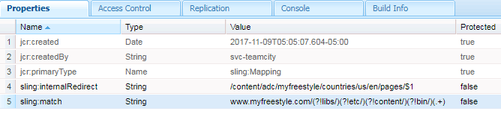

/www.myfreestyle.com.redirect

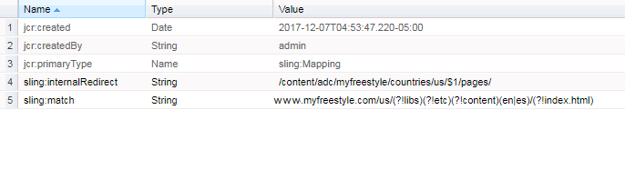

/www.myfreestyle.com.error

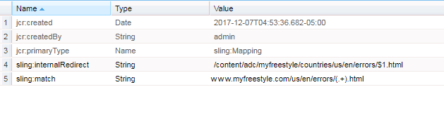

/etc

/map.prod.publish

/http

/prod3-origin.myfreestyle.com.index

/ prod3-origin.myfreestyle.com.redirect

/ prod3-origin.myfreestyle.com.error

/prod3-origin.myfreestyle.com.index

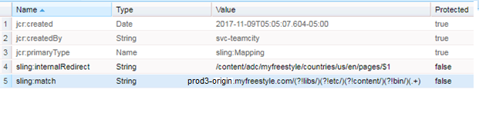

/ prod3-origin.myfreestyle.com.redirect

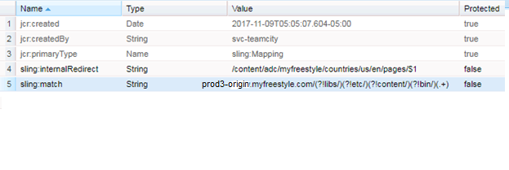

/ prod3-origin.myfreestyle.com.error

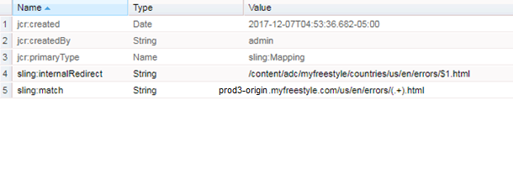

/etc

/map.stage.publish

/http

/stage3.myfreestyle.com.index

/stage3.myfreestyle.com.redirect

/stage3.myfreestyle.com.error

/stage3.myfreestyle.com.index

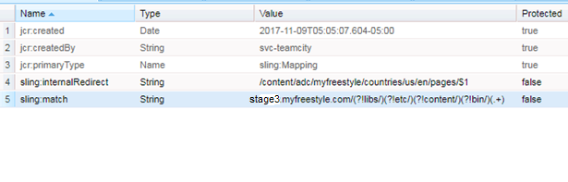

/stage3.myfreestyle.com.redirect

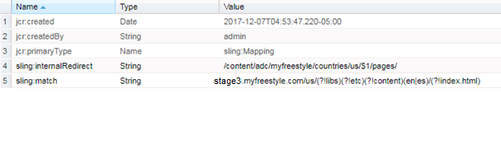

/stage3.myfreestyle.com.error

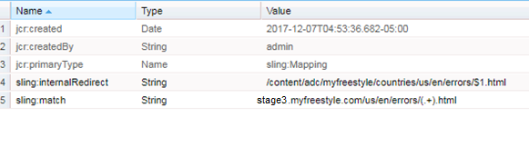

/etc

/map.dev.publish

/http

/dev3.myfreestyle.com.index

/dev3.myfreestyle.com.redirect

/dev3.myfreestyle.com.error

/dev3.myfreestyle.com.index

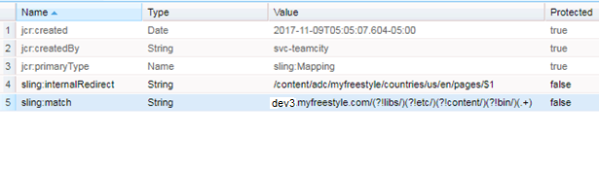

/dev3.myfreestyle.com.redirect

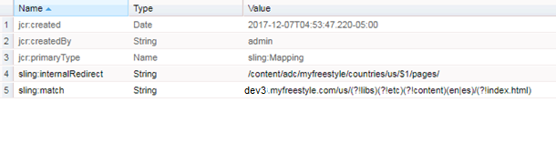

/dev3.myfreestyle.com.error

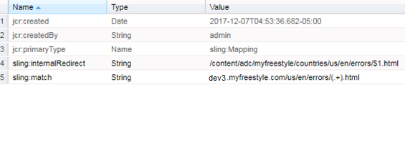

Note: All outgoing mappings will need to be set from single shared config (JCRResolver Factory config) i.e. /apps/bts/config.<env>.publish.

7. Error Handling

We are going to use the ACS Commons sling Error Handler in the Sling Error handler implementation.

It provides an author-able means for defining, creating and managing custom Error pages per content tree/site. Which gives us more flexibility for displaying Project specific Error pages related to 404, 500 etc.

Following are the steps to follow to achieve the Error handling via ACS Commons sling error handler.

1. **Create a sling:OsgiConfig node to enable the Error Page Handler**

We have to add the Sling Error handler related xml node at the below location, which will give the flexibility to redirect to the project specific error pages.

“/apps/adc/myfreestyle /config.<env>.publish/com.adobe.acs.commons.errorpagehandler.impl.ErrorPageHandlerImpl”

1. Create a CQ Page that will act as the default Error page and contain all custom variations of error pages. Each error page’s “name” (Node name) should correspond to the HTTP Response Status code it should respond to.

🡪500: Internal Server Error

🡪404: Not Found

1. Create any error-specific pages under this default error page. Note, it is critical that the page NAMES (node names) follow status codes. The Page Titles can be anything.

* Ex. /content/adc/myfreestyle/countries/us/en/errors/404
* Ex. /content/adc/myfreestyle/countries/us/en/errors/500

Example

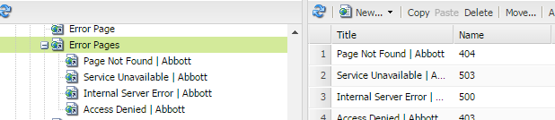

1. We have to ensure that the parent page of the project jcr:Content node has the below property.

|  |  |  |
| --- | --- | --- |
| **Name** | **Type** | **Value** |
| errorPages | String | /content/adc/myfreestyle/countries/us/en/errors |

404

PAGE NOT FOUND

We are sorry, the page you requested cannot be found. The page you are looking for might have been removed, had its name changed, or is temporarily unavailable. Please visit the [Home Page](https://www.freestylelibre.us/) for a more detailed listing of site content.

We apologize for the inconvenience.

500

INTERNAL SERVER ERROR

The server encountered an internal error and was unable to complete your request.

Please contact your Website Administrator and inform them of the time the error occurred. We apologize for the inconvenience.

Please visit our [Home Page](https://www.freestylelibre.us/).

8. Dispatcher Flush UI Pages & configurations

We are going to leverage the ACS commons Dispatcher Flush configuration UI pages for easy clearing of the dispatcher cache.

For this environment to setup we are going to follow these below mentioned steps

1. **sling:OsgiConfig Node creation**

Create a new **sling:OsgiConfig** node for each logical flush rule set. A good practice is to create a “global” configuration and separate configurations per “site”.

**Example:** Author configuration

* open crx/de lite ore crx/explorer and open the below path.
* /apps/adc/myfreestyle/config.<env>.publish ( if the configuration folder is not available, create a new one)
* Create a node of **sling:OsgiConfig** with the below name **“/apps/adc/myfreestyle/config.dev.publish/com.adobe.acs.commons.replication.dispatcher.impl.DispatcherFlushRulesImpl-adcFSLUS** “
* Add a multi property named “**prop.rules.hierarchical**” of type string[]

Once created the above property add the following property values

1. /content/adc/myfreestyle/countries/us/en/pages/(.*)=/content/adc/myfreestyle/countries/us/en/$1
2. /etc/designs/adc/myfreestyle/(.*)=/content/adc/myfreestyle/countries/en-us/etc/designs/adc/myfreestyle/$1
3. /content/dam/adc/myfreestyle/(.*)=/content/adc/myfreestyle/countries/en-us/content/dam/adc/myfreestyle/$1

* Add a property named “ **prop.replication-action-type** ” of type string and add the value “ACTIVATE ”

1. Creating the Dispatcher Flush UI pages for ADC MyFreestyle:

* Log in to AEM Author
* Navigate to Tools
* Create a folder named “dispatcher-flush” ( if already present use the same one)
* Under the dispatcher-flush folder, create a new Page of Template type “Dispatcher Flush”
* Give the page a logical naming ( Example “adc-myfreestyle” under “adc”)
* Open the page and edit the component for configuring the dispatcher flush paths. ( Here we can have either “Invalidate Cache” OR “ Delete Cache ” )
* Select “ Delete Cache ”
* And in the path field select the “**/content/adc/myfreestyle/countries/us/en**” path for the dispatcher flush page path.
* Click on OK button. Now it is ready for the dispatcher flush page to get used.
* For the next time onwards if any required to clear the dispatcher cache they just need to open this Flush UI page and click on the “Flush Paths on Dispatchers”

Editing configuration:

9. i18N

NA

10. System Design Constraints

#### 10.1 Adobe Analytics

The Adobe Analytics (OOTB) integration would be done through Analytics framework mapping or DTM (Dynamic Tag Management) approach.

**DTM Approach:**

Insert the following kinds of sample code into the **<head>** portionof the base page template (especially in “head.jsp”), ideally before other scripts in this section.

**Header Code**

Staging Header  
  
<script src="//assets.adobedtm.com/1b53c5850d5cfd2a9d4095a589f75aff7bf553e1/satelliteLib-28f3ae04fee3bbe724385eaf38ad206700e5a289-staging.js"></script>

Production Header  
  
<script src="//assets.adobedtm.com/1b53c5850d5cfd2a9d4095a589f75aff7bf553e1/satelliteLib-28f3ae04fee3bbe724385eaf38ad206700e5a289.js"></script>

 Insert the following code just before the closing **</body>** tag of base page template (especially in “body.jsp”)

Footer Code for Staging & Production:

<script type="text/javascript">_satellite.pageBottom();</script>

#### 10.2 Client Context

N/A

11. System Module x

NA

#### 11.1 Purpose of Module x

NA

#### 11.2 Detailed Design of Module x

NA

#### 11.3 Data Design for Module x

END OF DOCUMENT