|  |  |  |  |
| --- | --- | --- | --- |
| S No. | Template Name | Description | Pages |

|  |  |
| --- | --- |
| Fields | Value |
| Template Path | /apps/smartpack/templates/abbott |
| Title | abbott |
| Description | abbott |
| Resource Type | /apps/smartpack/components/structure/base |
| allowed Paths |  |
|  |  |
|  |  |

|  |  |
| --- | --- |
| Components | Path |
| header | /apps/smartpack/components/structure/header |
| footer | /apps/smartpack/components/structure/footer  smartpack.core.models.NodeModel |
| tabcomponent | /apps/smartpack/components/content/tabcomponent  smartpack.core.models.TabModel |
| imageaccordian | /apps/smartpack/components/content/ imageaccordian  smartpack.core.models.AccordianImageModel |
| exceldata | smartpack.core.servlet.ReadingExcelDataToNode |

Dialogues:

Header:

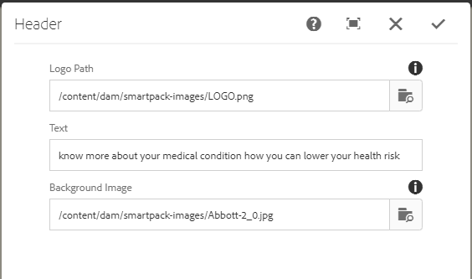

Footer:

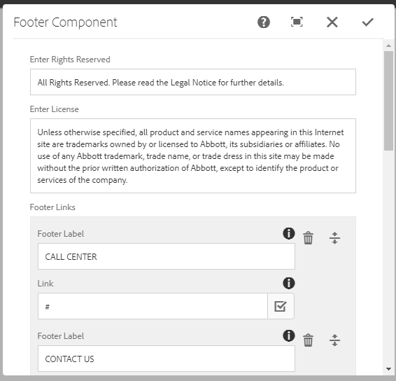

Tabcomponent:

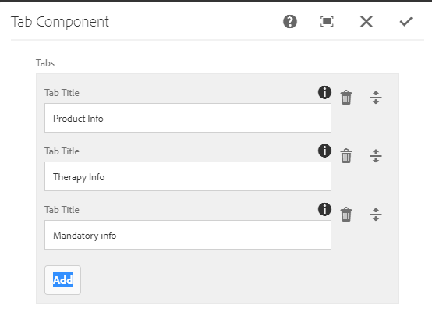

Imageaccordian:

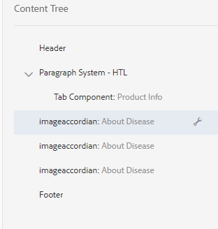

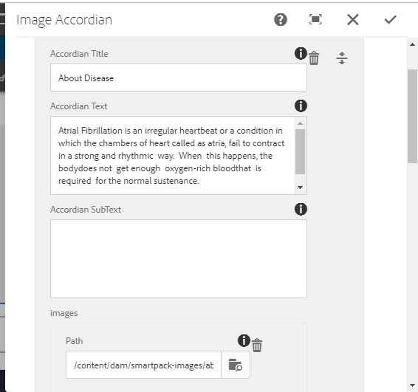

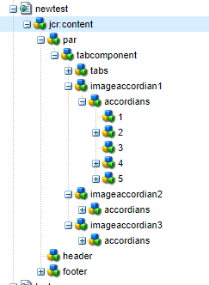

Page Content structure: