ICP 4

1. Source Code

The accuracy for he given model is 0.9403 by using Adam

Optimizer.

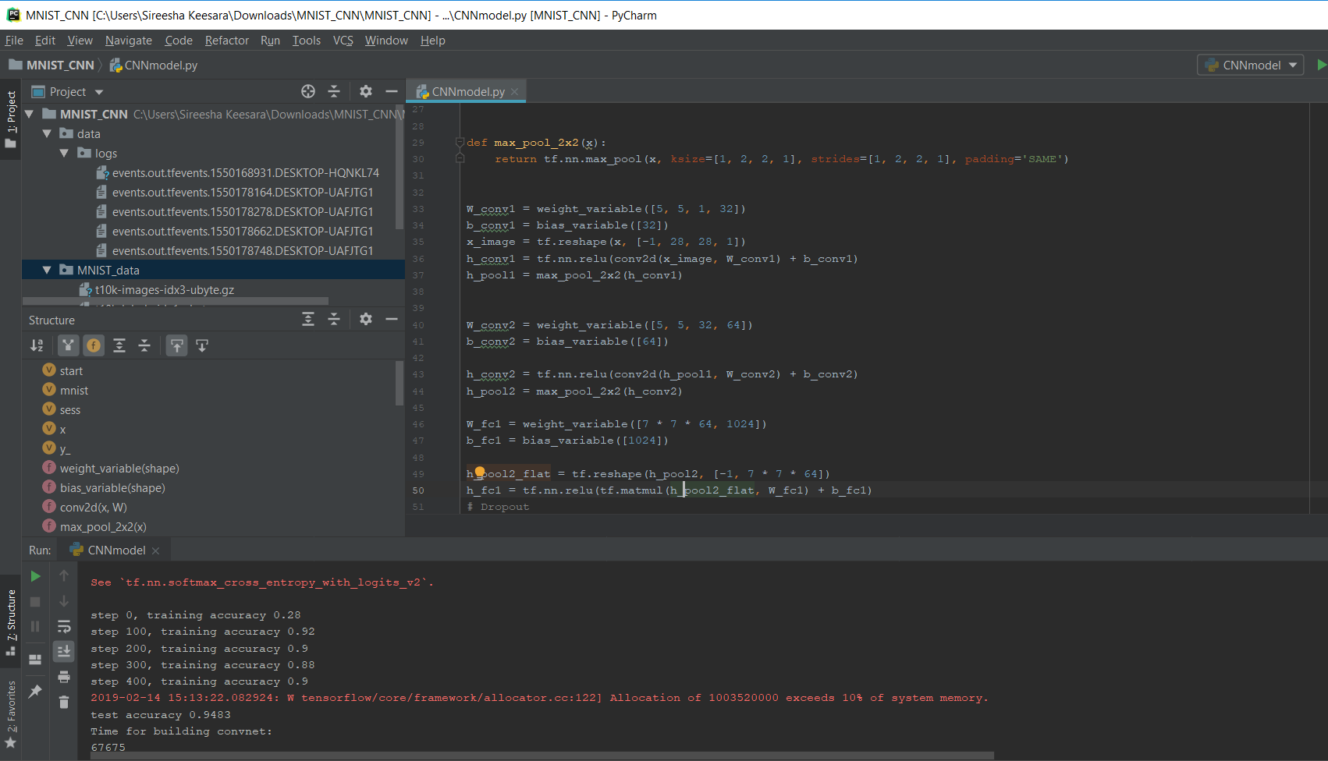

Using Ada delta optimizer the accuracy for the model has degraded drastically from 0.9 to 0.1

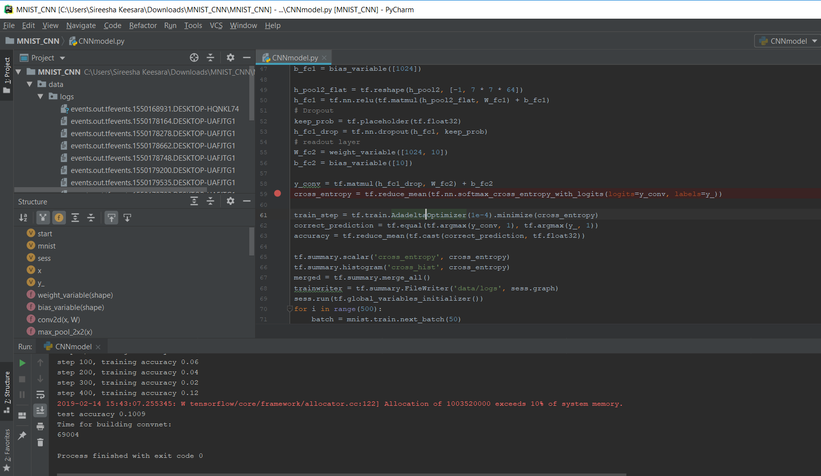

Using Adagrad Optimizer the accuracy if the model is reduced to half.

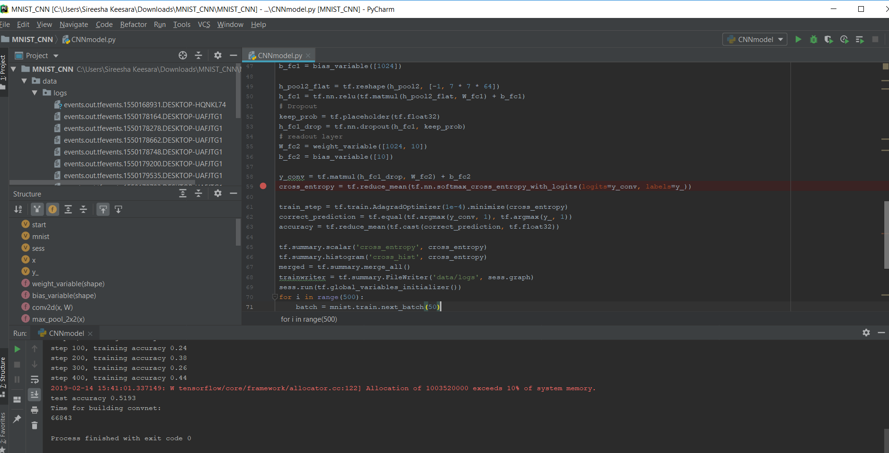

Using RMSProp Optimizer the accuracy is better than Adam Optimizer.

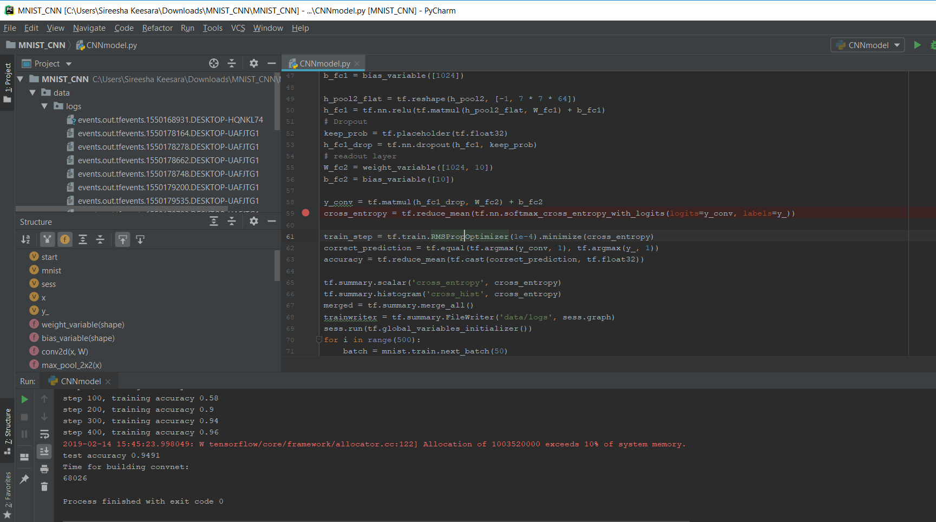

By changing the filter size from 32 to 16 the accuracy has been slightly reduced from 0.94 to 0.93.

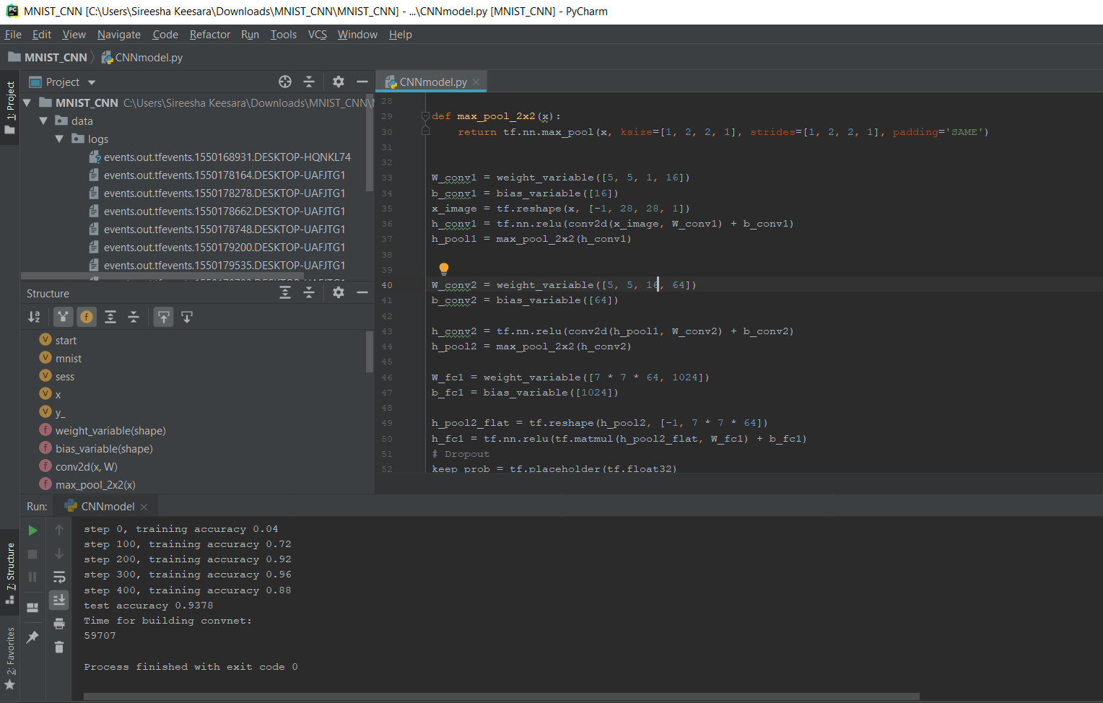

By changing the filter size from 32 to 36 the accuracy is almost same.

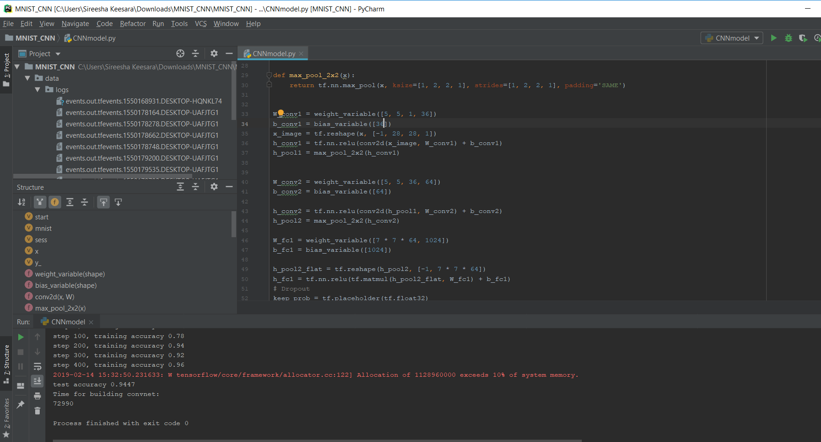

By changing the filter size from 32 to 128 the accuracy is almost same.

