**CENG482 Final**

**Name-Lastname: Sefa Uygun**

**Student ID: 200218015**

**Department: Software Engineering**

**5-** Run the simulation and press the button. Explains what happens. Include a screenshot.

First, the Hd44780-1 LCD displays the message "Great Cow Basic". After a short interval during which the screen is blank, the display changes to "START TEST DISPLAY ON". Then, it shows to "Cursor ON" and "_" right below it. This is followed by "Cursor OFF". Next, the screen shows "Flash ON", with the dot under the text flashing momentarily, and then it switches to "Flash OFF". The sequence continues with "CURSR & FLSH ON", with a flashing dot beneath the text, and after some time, it changes to "CURSR & FLSH OFF". Following this, the screen briefly flashes the message "Flashing Display" and then displays "DISPLAY & BACKL. FOR 5 SEC". After another brief period of a blank screen. The final message "END TEST" appears.

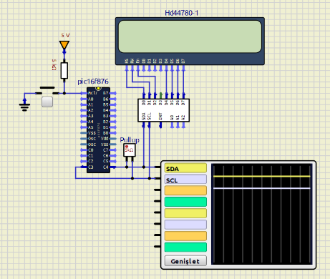-metin, ekran görüntüsü, diyagram, dikdörtgen içeren bir resim

Açıklama otomatik olarak oluşturuldu-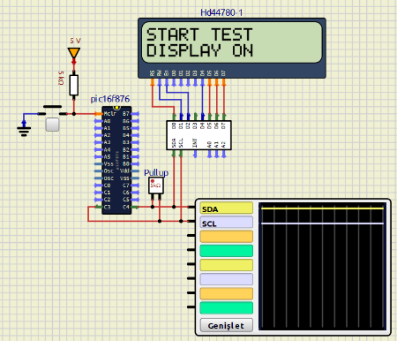

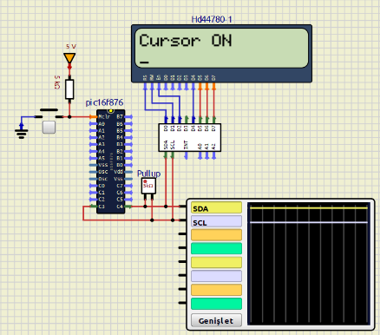-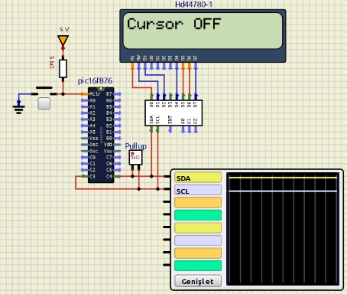-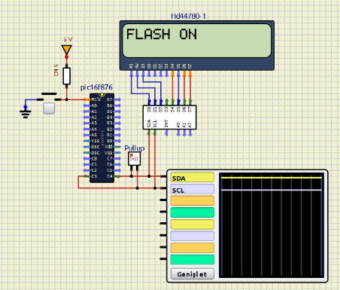

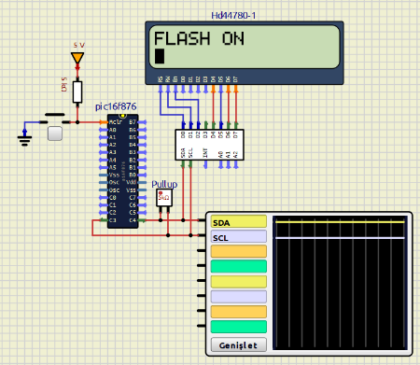-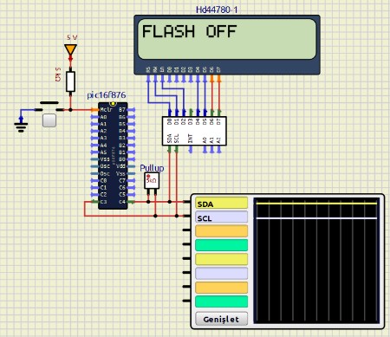-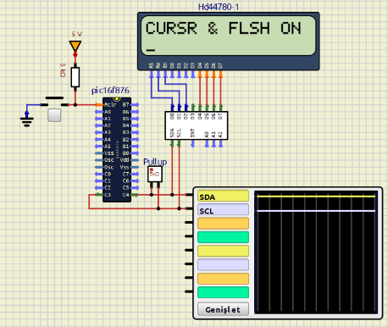

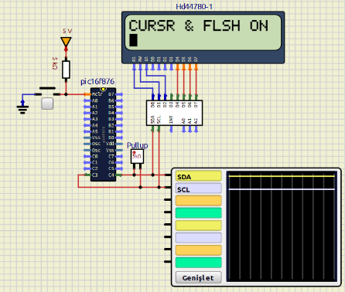-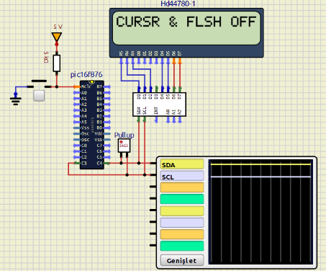-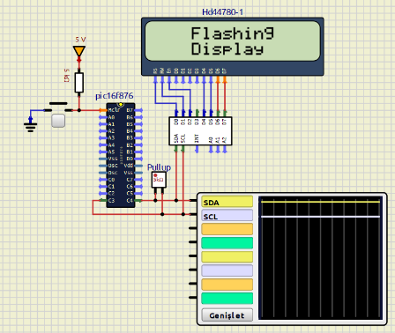

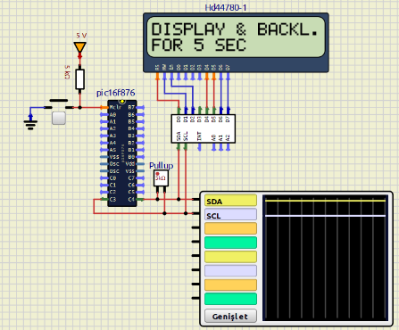-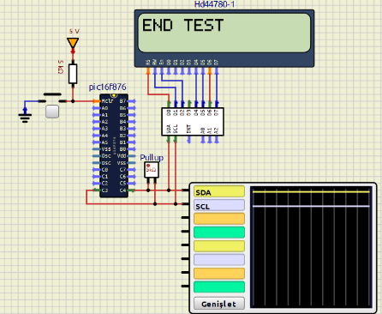

**6-** In the given Assembly Language code, explaining command with examples:

bcf f, b - Bit Clear f: Clears the specified bit “b” in register “f”.

movlw k - Move Literal to W: Loads the W register with the literal value “k”.

movwf f - Move W to f: Moves the value in the W register to register “f”.

call k - Call Subroutine: Calls the subroutine at the address “k”.

clrf f - Clear f: Clears the register “f”, setting all bits to zero.

decfsz f, d - Decrement f, Skip if Zero: Decrements the value in register “f” and skips the next instruction if the result is zero.

goto k - Go to Address: Jumps to the address “k”.

nop - No Operation: Does nothing for one instruction cycle.

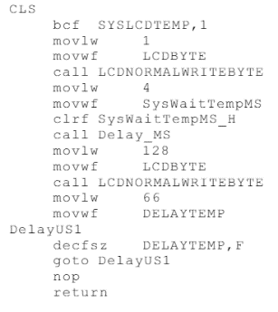

This code seems to interact with an LCD screen, probably doing some initial setup or clearing. It writes specific bytes, 1 and 128, to the LCD. The code includes delays in both milliseconds and microseconds, which are likely used to make sure the LCD has enough time to process the commands. The loop using the "DELAYTEMP" register acts as a delay mechanism, giving the LCD time to handle the previous instructions properly.

**7-** Research online: what is I2C? Write 1 paragraph to explain. Give two real world examples.

I2C (Inter-Integrated Circuit) is a communication protocol used to connect low-speed peripherals to processors and microcontrollers. Developed by Philips Semiconductor (now NXP Semiconductors) in the 1980s, I2C is a synchronous protocol that allows multiple devices (both masters and slaves) to communicate over the same two-wire bus. These two wires are called the Serial Data Line (SDA) and the Serial Clock Line (SCL). Each device on the bus has a unique address, making it easy to exchange data efficiently. I2C is popular because it's simple, scalable, and versatile, making it perfect for short-distance communication in various applications.

Examples:

**Sensor Modules in Embedded Systems:** Many environmental sensors, such as temperature, humidity, and pressure sensors, use I2C to communicate with microcontrollers in weather stations or smart home devices. For instance, a BMP280 pressure sensor can easily interface with an Arduino board via I2C to provide real-time atmospheric pressure readings.

**Consumer Electronics:** I2C is commonly used in smartphones and laptops to connect various internal components. For example, it can be used to connect the battery management system to the main processor, allowing the system to monitor and manage battery status and health efficiently.