BanglaCyberBench — Experiment Log (MASTERCLASS UPDATED)
Project: BanglaCyberBench: Transformer Ensemble for Cyberbullying Detection in Bengali
Authors: Sefayet Alam (sefayetalam14@gmail.com), Arafat Hossain
Date: April 2026
Repo: github.com/Sefayet-Alam/CyberBully_Detection_Paper
Target Venue: Q1 journal (IPM / ESWA) or ACL/EMNLP findings
Status: ALL EXPERIMENTS COMPLETE ✅
Purpose of this file: This is the single master reference for the whole research. A reader who knows nothing about the project should be able to understand the motivation, data, modeling, results, design decisions, limitations, and likely viva/seminar questions from this file alone.

0. One-Page Summary
This research tackles cyberbullying detection in Bengali/Bangla, where earlier work mostly used smaller datasets, single-source setups, coarser label schemes, and little or no robustness evaluation. We built BanglaCyberBench, a 135,575-sample, 4-source, multi-script benchmark covering both Bangla script and Romanized Bangla. We standardized heterogeneous datasets into one common schema, consolidated 89 raw abuse-type labels into a cleaner 9-class taxonomy, and trained a multi-task transformer system that predicts:

1. Binary harmfulness — harmful vs not harmful
2. Abuse type — one of 9 abuse categories

We fine-tuned BanglaBERT, MuRIL, and XLM-R, each with 3 seeds (9 total runs), then combined all 9 checkpoints using a weighted-logit ensemble optimized on the validation set. The final system achieved:

- Binary: Accuracy = 0.9256, Macro-F1 = 0.9247
- Abuse type (9-class): Accuracy = 0.8688, Macro-F1 = 0.7746

The benchmark also includes source-held-out and script-held-out evaluation to test robustness beyond a normal random split.

1. Title Explained in Simple Words

Full title
BanglaCyberBench: Transformer Ensemble for Cyberbullying Detection in Bengali

What each part means
- BanglaCyberBench
The name of the benchmark introduced in this work.
  - Bangla = language focus
  - Cyber = online/social media setting
  - Bench = benchmark
- Transformer Ensemble
The final system is not a single model. It combines several transformer models together.
- Cyberbullying Detection
The core task is to detect harmful online comments and, in the final setup, also identify the abuse type.
- in Bengali
The language focus is Bengali/Bangla.

Why the title is appropriate
The paper is both:
1. a benchmark/data paper (because we build BanglaCyberBench), and
2. a method paper (because we build and evaluate a strong transformer ensemble).

2. Beginner Glossary

2.1 Dataset / benchmark terms
- Source
Where the data came from. One public dataset = one source.
- Multi-source
Uses data from multiple dataset sources instead of only one.
- Script
The writing system used in the text.
- Bangla script
Native Bengali writing, e.g., বাংলা
- Romanized Bangla
Bangla written using English/Latin letters, e.g., tumi kemon acho
- Multi-script
The benchmark contains more than one writing form/script.
- Label
The answer attached to a text sample.
- Binary classification
Two classes only. Here: harmful vs not harmful.
- Multi-class classification
One text must be assigned one class out of several.
- Multi-label classification
One text may belong to multiple classes at the same time.
- Taxonomy
The final organized class system used in the paper.

2.2 Split / evaluation terms
- Train set
The data the model learns from.
- Validation set
The data used to tune the model and choose settings.
Fine-tuning means taking a pretrained model and training it further on a task-specific dataset.
- Test set
Final unseen data for reporting performance.
- In-domain testing
Train and test come from the same overall mixed benchmark distribution. This is the normal random test split.
- Source-held-out testing
Hold out one full dataset source from training and test only on that source. This checks cross-source generalization.
- Script-held-out testing
Hold out one writing form/script and test on it. This checks cross-script generalization.

2.3 Model / metric terms
- CLS pooling
Uses the transformer's special summary token as a sentence representation.
- Mean pooling
Averages all token representations.
- Ensemble
Combines several models to get a stronger final prediction.
- Threshold tuning
Chooses the decision cutoff for a binary prediction.
- Logit
The model's raw score before converting to a probability.
- Accuracy
Fraction of predictions that are correct.
- Precision
Of the items predicted as a class, how many are actually correct.
- Recall
Of the true items in a class, how many the model finds.
- F1-score
Balance between precision and recall.
- Macro-F1
Compute F1 for each class separately, then average equally. Small classes matter as much as large classes.
- Weighted-F1
Like F1, but larger classes get more weight.
- MCC
A balanced binary classification score that uses TP, TN, FP, and FN.
- AUROC
Measures how well the model separates classes across thresholds.
- AUPRC
Precision-recall area; useful for positive-class quality.

3. Research Problem and Motivation
Cyberbullying detection in Bengali is underdeveloped compared with English and some other major languages. Earlier Bangla cyberbullying work had several limitations:

1. Small datasets (roughly 2K–44K in prior work)
2. Single-source bias
3. Coarse label granularity (binary or 5-class)
4. No strong cross-source / cross-script robustness evaluation

Our work addresses these issues by building a larger, more diverse benchmark and testing performance beyond a simple random split.

4. Prior Work Comparison

4.1 Ahmed et al. (2021) — Hybrid Neural Network
- Dataset: 44,001 Facebook comments
- Classes: 5
- Method: CNN-LSTM hybrid + SVM ensemble
- Best results: Binary accuracy 87.91%, multiclass accuracy 85.00%
- Limitation: single source, no robustness evaluation

4.2 Sihab-Us-Sakib et al. (2024) — XLM-R on CBD
- Dataset: 2,751 labelled texts
- Classes: 5
- Method: XLM-R fine-tuning
- Best result: F1 = 0.83, accuracy = 82.61%
- Limitation: very small dataset, no ensemble, no robustness evaluation

4.3 Saifullah et al. (2024) — BullyFilterNeT
- Dataset: 44,001 Facebook comments
- Method: BanglaBERT-based model
- Best result: Accuracy = 88.04%
- Limitation: single source, no robustness evaluation

4.4 Hoque & Seddiqui (2025) — Transformer Stacking
- Dataset: 44,001 Facebook comments
- Classes: 5
- Method: stacking of XLM-R, mBERT, and Bangla-BERT
- Best results: Binary F1 = 93.61%, multiclass F1 = 89.23%
- Limitation: single source, no cross-source/cross-script testing, 5-class taxonomy

4.5 Main differences of our work

Difference | Our work
Dataset size | 135,575
Number of sources | 4
Script coverage | Bangla + Romanized
Final abuse taxonomy | 9 classes
Robustness evaluation | Yes
Multi-task setup | Yes
Ablation study | Yes

5. Dataset: BanglaCyberBench

5.1 Sources

Source | Samples | Script | Origin | Raw label style
banth | 73,999 | Romanized | Kaggle | One binary harmful column + several 0/1 type columns
bd_shs | 5,029 | Bangla | Mendeley | One harmful column + one type column
facebook_44001 | 44,001 | Bangla | Mendeley | One main label column (e.g., not bully, sexual, threat, troll, religious)
multilabel_12557 | 12,546 | Bangla | Kaggle | Separate binary columns: bully, sexual, religious, threat, spam

Total: 135,575 samples

Figure — Samples per source dataset
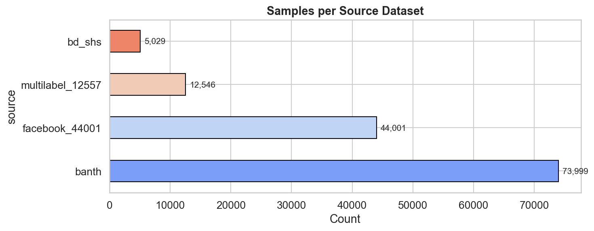

Beginner summary: This bar chart shows how much data came from each original source. It helps beginners quickly see that banth is the largest contributor, so later source-held-out testing is important to confirm the model is not overfitting to one dataset.

5.2 Why this benchmark is multi-source
Because it combines 4 different public datasets, not just one.

5.3 Why this benchmark is multi-script
Because it includes:
- Romanized Bangla: 73,999 (54.6%)
- Bangla script: 61,576 (45.4%)

5.4 Binary distribution

Label | Samples | Percentage
Not Harmful (0) | 75,545 | 55.7%
Harmful (1) | 60,030 | 44.3%

Ratio = 1.26:1, so the binary task is near-balanced.

Figure — Binary harmful vs not harmful distribution
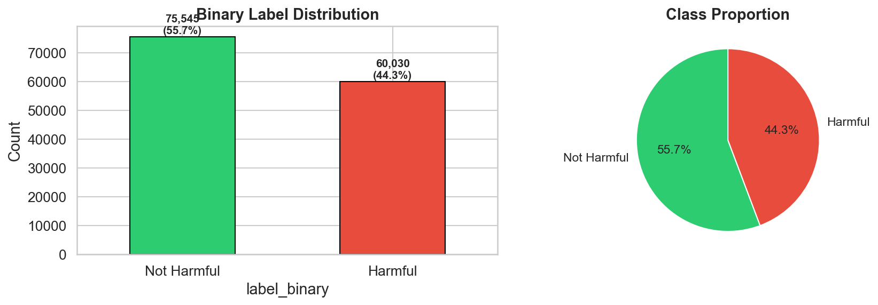

Beginner summary: This figure shows that the binary task is fairly balanced: about 55.7% not harmful and 44.3% harmful. That is useful because a near-balanced dataset makes the reported binary metrics easier to trust than in a highly skewed setup.

6. How the Datasets Were Merged
The raw datasets had very different schemas. To combine them, we standardized them into a common format.

6.1 Unified merged schema
The cleaned merged dataset uses columns such as:

- text
- label_binary
- label_type
- source
- script
- original_file

6.2 Why a unified schema was necessary
Without one schema:
- preprocessing would be inconsistent,
- splitting would be messy,
- model training would be harder,
- analysis across sources would be unreliable.

6.3 Source-wise raw label mapping

Dataset | Text column used | Raw binary signal | Raw type signal | Binary mapping | Type mapping into merged benchmark
banth | Text | Label | separate 0/1 type columns | label_binary = Label | active type columns joined; if none active then none
bd_shs | sentence | hate speech | type | label_binary = hate speech | label_type = type
facebook_44001 | comment | derived from label | label | not bully -> 0; other labels -> 1 | label_type = label
multilabel_12557 | comment | bully | separate 0/1 type columns | label_binary = bully | active type columns joined; if none active then none

7. Final 9-Class Abuse Taxonomy
Across the merged data, we found 89 unique raw `label_type` values. Many were too rare to model properly, so we consolidated them into 9 cleaner classes.

7.1 Why not keep all 89 classes?
Because:
- many classes were extremely small,
- some had fewer than 15 samples,
- training would be unstable,
- the final system would be harder to interpret and compare.

Figure — Raw abuse-type distribution before consolidation
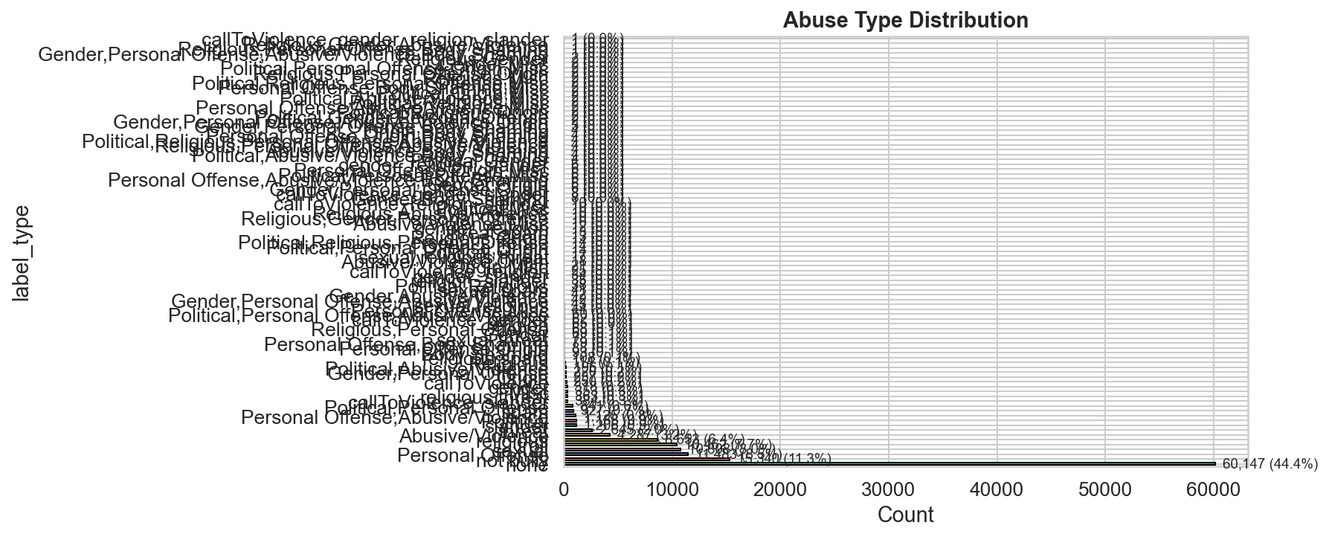

Beginner summary: This plot is intentionally messy, and that is the point. It shows how fragmented the original raw abuse labels were, which helps explain why collapsing them into a smaller 9-class taxonomy was necessary for stable training and clearer interpretation.

7.2 Final 9 classes
1. none
2. abusive
3. personal
4. sexual
5. religious
6. threat
7. political
8. other
9. gender

7.3 Mapping table

Final class | Raw labels / patterns mapped into it
none | none, not bully
abusive | Abusive/Violence, troll
personal | Personal Offense, Body Shaming, Origin, slander, Misc
sexual | sexual, sexual,religious
religious | religious, Religious, religion, religion_slander
threat | threat, callToViolence*, religious,threat, sexual,threat
political | Political
other | spam
gender | gender, Gender, gender_slander

7.4 Compound-label handling
Priority rule:

threat > sexual > religious > gender > political > abusive > personal > other > none

Example:
- sexual,religious → sexual
- religious,threat → threat
- sexual,threat → threat

7.5 Why this was necessary
Because the final abuse-type task is multi-class, not multi-label.
The benchmark needed one final class per text.

7.6 Multi-label vs multi-class
- multi-label = one text may have several tags
- multi-class = one final class only

The final system uses multi-class abuse-type classification.

Figure — Clean paper-ready view of dataset distribution
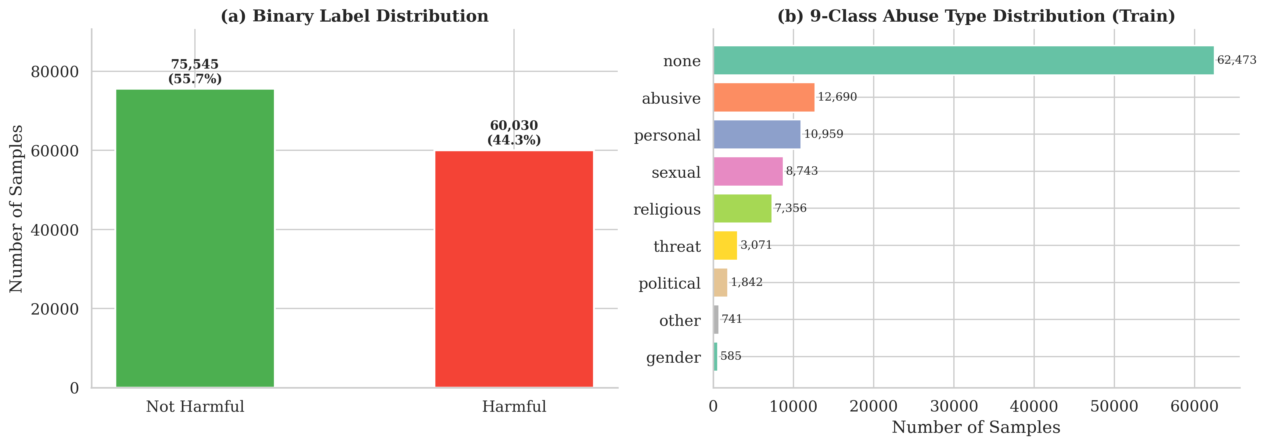

Beginner summary: The left panel confirms the binary class balance, while the right panel shows that the 9-class abuse-type task is much more uneven. In simple words, the model has many examples of none but far fewer examples of rare classes like gender, so those smaller classes are naturally harder.

8. Duplicate Handling

8.1 What we found
There were 40,590 raw duplicates across sources.

8.2 What we did
We did not deduplicate the final benchmark.

8.3 Why we kept duplicates
We kept them intentionally for realism and robustness-study relevance, because real online data and public datasets often overlap.

8.4 Honest limitation
A stricter fully deduplicated benchmark could be explored in future work.

9. Preprocessing

9.1 What preprocessing means
Cleaning and standardizing noisy social-media text before training.

9.2 Example
Raw text:
এটা একটা টেস্ট @user123 https://example.com 😂😂😂

After preprocessing:
- URL is masked
- user mention is masked
- emoji is normalized
- messy characters and spacing are cleaned

9.3 Preprocessing steps used
1. Unicode normalization (NFKC)
Makes text encoding more consistent.
2. Remove invisible special Bangla-related characters
Removes hidden formatting artifacts.
3. Mask URLs
Replace with [URL]
4. Mask user mentions
Replace with [USER]
5. Normalize hashtags
#topic -> [HASHTAG] topic
6. Map emojis into text markers
Uses an emoji library if available, otherwise regex fallback.
7. Reduce repeated characters
Example: খারাপপপপপ → normalized shorter form
8. Normalize whitespace
Cleans extra spaces/tabs/newlines

9.4 Final cleaned text field
After preprocessing, the notebook creates:
- text_clean

Figure — Text length before vs after cleaning
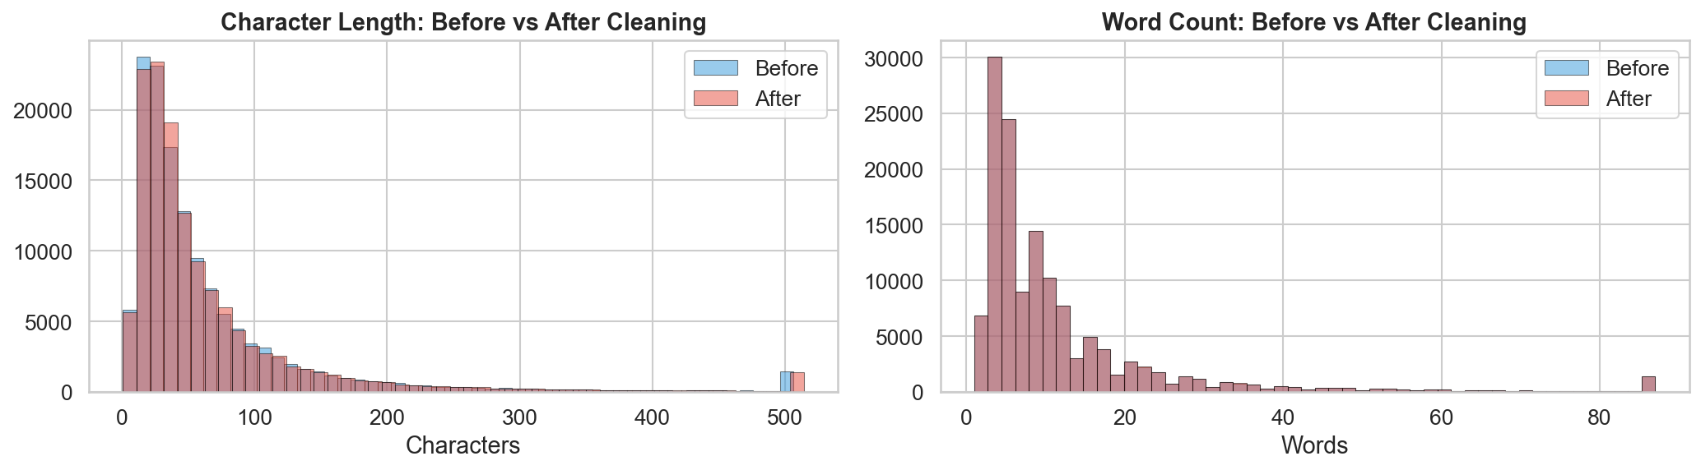

Beginner summary: The blue and red histograms almost overlap, which means preprocessing cleaned the text without dramatically changing its overall length pattern. That is a good sign because the pipeline removes noise while keeping most of the original linguistic signal.

9.5 Why preprocessing was light, not aggressive
We used light normalization suitable for mixed-script social media text, not heavy rewriting, because abusive language signal can be hidden in:
- emoji,
- repetition,
- hashtags,
- mentions,
- expressive writing style.

9.6 Did preprocessing help?
Yes, slightly. In ablation:
- Binary Macro-F1 dropped from 0.9081 to 0.9067 without preprocessing
- Abuse-type Macro-F1 dropped from 0.7424 to 0.7349

So preprocessing helped modestly.

Figure — Text length distribution by binary class
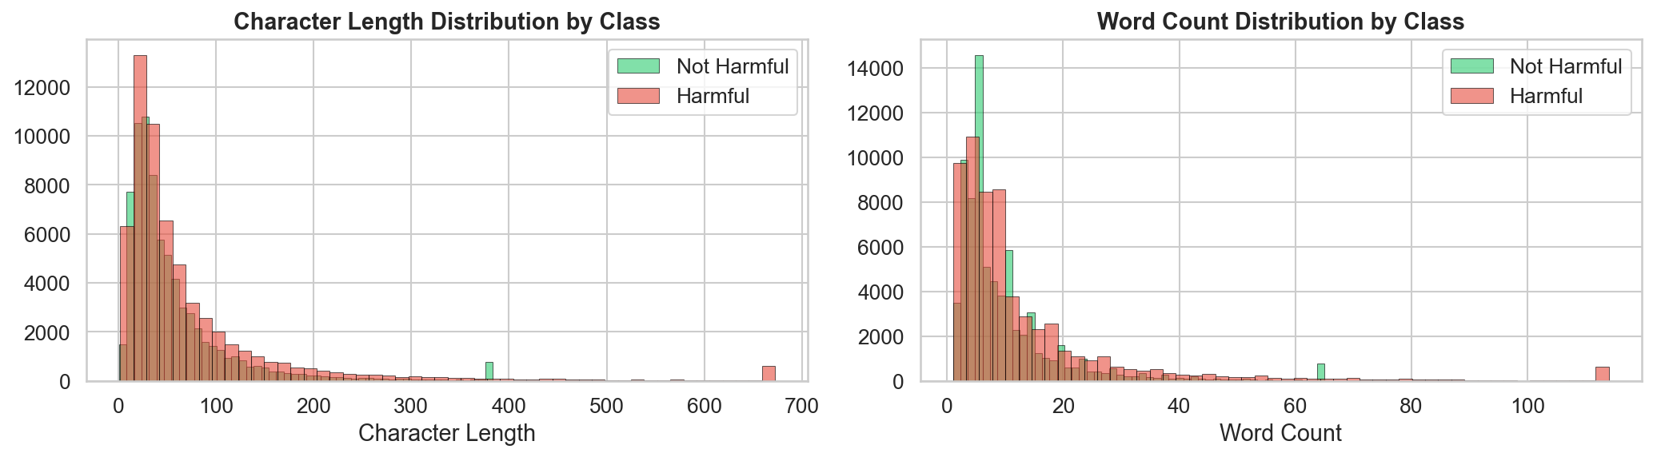

Beginner summary: Harmful and not-harmful comments have somewhat similar length distributions, so the task is not solved just by counting words or characters. This is useful for beginners because it shows the model must learn meaning and context, not only comment length.

10. Splits and Evaluation Settings

10.1 Random stratified split
- 80% train
- 10% validation
- 10% test

Final sample counts:
- Train = 108,460
- Validation = 13,557
- Test = 13,558

10.2 Why stratified?
To preserve the binary harmful/not-harmful balance across splits.

10.3 Source-held-out split
Hold out one full source from training and test only on that source.

This checks:
Can the model generalize to a completely unseen dataset source?

10.4 Script-held-out split
Hold out one script form and test only on that script.

The code looks for script names such as:
- romanized
- banglish
- roman
- mixed

Because the benchmark contains Romanized text, the script-held-out split holds out the Romanized side.

This checks:
Can the model generalize to a different writing form?

10.5 Why both random split and held-out splits were necessary
Because each split answers a different question:

- Random split: can the model perform on unseen examples from the same overall benchmark?
- Source-held-out: can the model generalize to a completely unseen source?
- Script-held-out: can the model generalize to a different script?

One evaluation is not enough for a benchmark paper.

11. Model Methodology in Easy Words

11.1 Big picture
For each comment, the final system does two predictions:

1. Binary classification
harmful vs not harmful
2. Abuse-type classification
one of 9 classes

11.2 Input-to-output flow
comment text
→ transformer reads it
→ model creates one internal representation
→ one head predicts binary
→ one head predicts abuse type
→ training compares both predictions with true labels
→ model updates its weights
→ test-time predictions are used to calculate final metrics

11.3 Why this is called multi-task
Because one shared model backbone is trained to do two tasks at once.

12. Transformer Models Used

12.1 Main backbones
- BanglaBERT
- MuRIL
- XLM-R

12.2 Why these models
- BanglaBERT: strongest language-specific Bangla option
- MuRIL: useful for multilingual / transliterated settings
- XLM-R: strong general multilingual baseline

12.3 Backbone details

Model | Pretrain source | Architecture
BanglaBERT | BUET CSE NLP | ELECTRA
MuRIL | Google | BERT-base
XLM-R | Meta AI | RoBERTa-base

13. Final Model Architecture
All three backbones use the same classifier architecture.

Component | Final implemented setup
Encoder backbone | BanglaBERT / MuRIL / XLM-R
Pooling | 0.5 × CLS + 0.5 × mean pooling
Shared head design | Dropout(0.25) → Linear(hidden, 384) → GELU → LayerNorm(384) → Dropout(0.25) → Linear(384, n_classes)
Binary head | same design with 2 outputs
Abuse-type head | same design with 9 outputs
Mixed precision | used
token_type_ids | used only for BERT-family models, not XLM-R

13.1 Why pooling was 0.5 × CLS + 0.5 × mean
Safe and honest explanation:

We used equal weighting as a simple balance between:
- CLS = global summary of the sentence
- mean pooling = information from all tokens

The final log supports the idea that this blend was better than using CLS only. We do not claim that 0.5/0.5 is a mathematically proven optimum over every other ratio.

14. How the Two Tasks Work

14.1 Binary classification
The binary head produces 2 scores:
- score for not harmful
- score for harmful

The higher score decides the predicted class.

14.2 Abuse-type classification
The abuse-type head produces 9 scores, one for each class:
- none
- abusive
- personal
- sexual
- religious
- threat
- political
- other
- gender

The highest score becomes the predicted abuse type.

14.3 How those 9 scores are produced
The model does not use hand-written rules like:
if a bad word appears, set sexual = 0.8

Instead, it learns weights during training.

Simple flow:
1. transformer reads the comment
2. pooled representation is created
3. first linear layer maps it into a 384-dimensional hidden space
4. GELU + LayerNorm + Dropout reshape/stabilize features
5. final linear layer maps 384 hidden features to 9 class scores

Very simply, one class score is:
weighted combination of hidden features + bias

Those weights are learned during training.

14.4 Why same architecture can still give different F1 by class
Same architecture does not mean same learning difficulty.

A class like gender had only 90 test samples and F1 0.56, while none had 7,830 samples and F1 0.93. Rare classes are harder because:
- the model sees fewer examples,
- they are easier to confuse with nearby classes,
- small support makes precision/recall less stable.

15. Losses, Training Tricks, and Why They Were Used

15.1 Easy definitions

Term | Easy meaning
Focal loss | pays more attention to hard examples
Class weighting | gives more importance to rare classes
Mixed precision | trains faster and uses less GPU memory
Early stopping | stops training when validation stops improving
Multiple seeds | trains several times with different random starts to check stability

15.2 Loss setup

Task | Loss
Binary | FocalLoss(gamma = 1.5) + effective-sample class weights
Abuse type | FocalLoss(gamma = 2.5) + same class weights

15.3 Why gamma differs
- 1.5 for binary = moderate focus on hard examples
- 2.5 for abuse type = stronger focus, because the 9-class task is harder

15.4 Important honesty note about focal loss
The ablation study showed focal loss was roughly neutral on this near-balanced dataset. So it was a reasonable choice, but not the main reason the system worked.

16. Training Hyperparameters

Hyperparameter | Value
max_length | 128
batch_size | 16
gradient_accumulation | 2
effective batch size | 32
epochs | 8
encoder learning rate | 2e-5
head learning rate | 8e-5
layer-wise LR decay | 0.90
label smoothing | 0.03
dropout | 0.25
head hidden dimension | 384
class_weight_beta | 0.999
focal gamma (binary) | 1.5
focal gamma (abuse type) | 2.5
early stopping patience | 3
monitor | 0.7 × binary_F1 + 0.3 × abuse_F1
num_workers | 0

16.1 Easy explanations of important constants
- dropout = 0.25
During training, 25% of units are randomly ignored so the classifier does not overfit too tightly.
- hidden_dim = 384
The size of the hidden classifier layer. Bigger = more capacity, smaller = simpler model. 384 was a practical middle-ground design choice.
- max_length = 128
Covers most social-media comments while keeping memory manageable.
- batch_size = 16
Fits the GPU memory.
- gradient_accumulation = 2
Simulates a larger batch (effective 32) without requiring more VRAM.
- encoder_lr = 2e-5
Small learning rate so pretrained knowledge is not destroyed too quickly.
- head_lr = 8e-5
Higher learning rate because the task heads are newly added.
- lr_decay = 0.90
Lower layers update more slowly than upper layers.
- label_smoothing = 0.03
Reduces overconfidence during training.
- patience = 3
Stops training if validation does not improve for 3 checks.
- monitor = 0.7 × binary_F1 + 0.3 × abuse_F1
Gives more emphasis to the main binary task while still tracking abuse-type quality.

16.2 Important ablation note on LR decay
Although LR decay was chosen for standard transfer-learning reasons, the ablation showed that removing LR decay actually improved performance. So this is a discussion point, not a final “best” claim.

17. Baselines

17.1 Baseline models
- TF-IDF + Logistic Regression
- TF-IDF + SVM
- TF-IDF + Random Forest
- BiLSTM

17.2 Why baselines matter
They provide a fair lower bar before using transformers.

17.3 Results

Model | Macro-F1 | Accuracy | MCC | AUROC
TF-IDF + Logistic Regression | 0.8669 | 0.8691 | 0.7342 | 0.9429
TF-IDF + SVM | 0.8877 | 0.8897 | 0.7760 | 0.9558
TF-IDF + Random Forest | 0.9090 | 0.9099 | 0.8183 | 0.9718
BiLSTM | 0.8914 | 0.8926 | 0.7828 | 0.9479

Strongest baseline: TF-IDF + Random Forest (0.9090 Macro-F1)

18. Transformer Fine-Tuning Results

18.1 Seeds used
- 42
- 123
- 456

18.2 Total runs
3 models × 3 seeds = 9 runs

18.3 Averaged transformer results

Model | Binary Macro-F1 | Abuse-Type Macro-F1 | Binary MCC | Abuse-Type MCC
BanglaBERT | 0.9071 ± 0.0030 | 0.7407 ± 0.0025 | 0.8146 ± 0.0060 | 0.7529 ± 0.0045
MuRIL | 0.9058 ± 0.0009 | 0.7303 ± 0.0042 | 0.8117 ± 0.0017 | 0.7480 ± 0.0021
XLM-R | 0.8960 ± 0.0032 | 0.7114 ± 0.0041 | 0.7922 ± 0.0061 | 0.7304 ± 0.0058

18.4 Interpretation
- BanglaBERT performed best on average
- MuRIL was close
- XLM-R was slightly behind
- low std across seeds indicates stable training

Figure — Training curves for the three transformer backbones
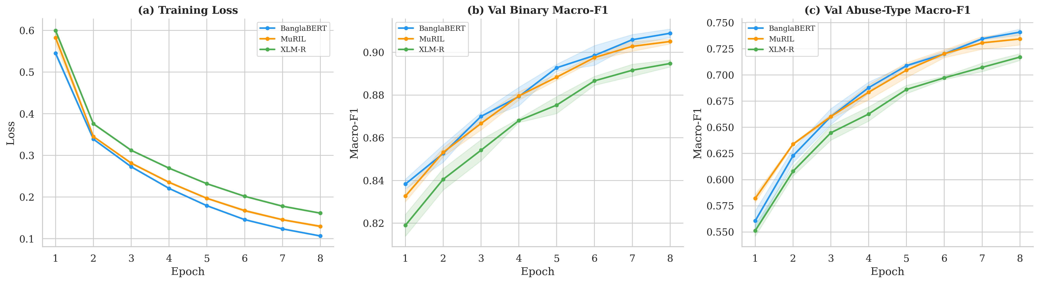

Beginner summary: The loss keeps going down while validation Macro-F1 goes up across epochs, which suggests the models are learning in a stable way. The curves also show that BanglaBERT and MuRIL stay slightly ahead of XLM-R on this benchmark.

19. Ensemble and Threshold Tuning

19.1 How the ensemble was built

Step | What was done
1 | Fine-tune 3 transformer backbones
2 | Train each with 3 seeds
3 | Save validation and test logits from all 9 runs
4 | Optimize ensemble weights on validation set using Nelder–Mead
5 | Combine logits using weighted averaging
6 | Tune binary threshold
7 | Evaluate final ensemble on test set

19.2 What is a logit?
A logit is the model's raw score before it turns into a probability.

Example:
- harmful: 2.3
- not harmful: -1.1

These are logits, not probabilities.

19.3 How ensemble weights were chosen
They were not manually chosen.

We used the validation-set logits from all 9 models and optimized the weights using Nelder–Mead. In simple words, this method keeps trying different weight combinations and keeps the ones that improve validation performance.

So a weight like 0.2817 for banglabert_seed42 means:
in the best validation-set mixture, that model deserved about 28.17% of the weighted signal.

Larger weight = model contributed more useful signal
Smaller weight = model contributed less useful signal

19.4 Final optimized weights

Model-Seed | Weight
banglabert_seed42 | 0.2817
muril_seed42 | 0.1680
xlmr_seed456 | 0.1625
muril_seed123 | 0.1187
banglabert_seed456 | 0.1163
muril_seed456 | 0.0664
banglabert_seed123 | 0.0422
xlmr_seed42 | 0.0336
xlmr_seed123 | 0.0107

19.5 Threshold tuning
The best binary threshold stayed at 0.50.
This makes sense because the binary dataset is near-balanced.

Figure — Optimized ensemble weights across model-seed runs
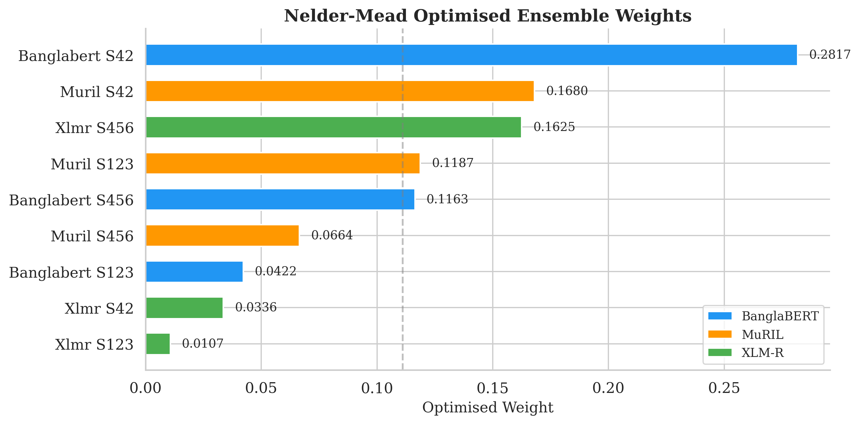

Beginner summary: This chart shows that all nine runs were not treated equally inside the final ensemble. The biggest weights went to stronger checkpoints such as BanglaBERT seed 42, which means the optimizer learned which models were most reliable on validation data.

20. Final Ensemble Results

20.1 Binary results

Metric | Value
Accuracy | 0.9256
Macro-F1 | 0.9247
Weighted-F1 | 0.9256
MCC | 0.8494
AUROC | 0.9731
AUPRC | 0.9658

20.2 Abuse-type results

Metric | Value
Macro-F1 | 0.7746
Accuracy | 0.8688

20.3 Per-class abuse-type report

Class | Precision | Recall | F1 | Support
none | 0.93 | 0.93 | 0.93 | 7,830
religious | 0.89 | 0.86 | 0.87 | 908
sexual | 0.79 | 0.81 | 0.80 | 1,083
personal | 0.79 | 0.78 | 0.78 | 1,344
other | 0.74 | 0.80 | 0.77 | 79
abusive | 0.76 | 0.75 | 0.76 | 1,600
political | 0.75 | 0.77 | 0.76 | 259
threat | 0.73 | 0.77 | 0.75 | 365
gender | 0.59 | 0.53 | 0.56 | 90

20.4 Main takeaways
- Ensemble improved binary F1 from best single 0.9095 to 0.9247
- Ensemble improved abuse-type F1 from best single about 0.74 to 0.7746
- gender was the weakest class because of very small support
- none was the strongest class

Figure — Main results overview
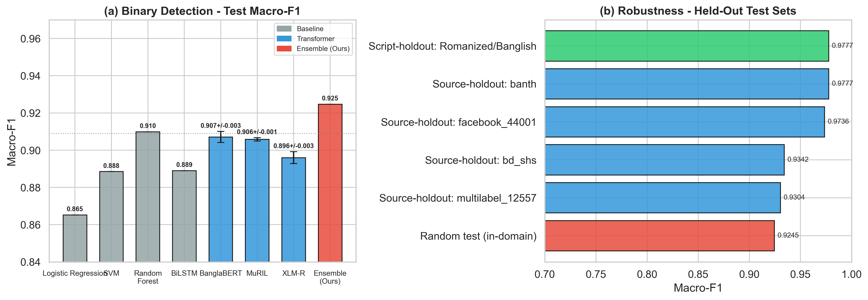

Beginner summary: The left panel shows the ensemble beating the classical baselines and individual transformers on binary Macro-F1. The right panel shows that performance also stays strong on held-out sources and the Romanized split, which supports the robustness claim.

Figure — Binary confusion matrix of the final ensemble
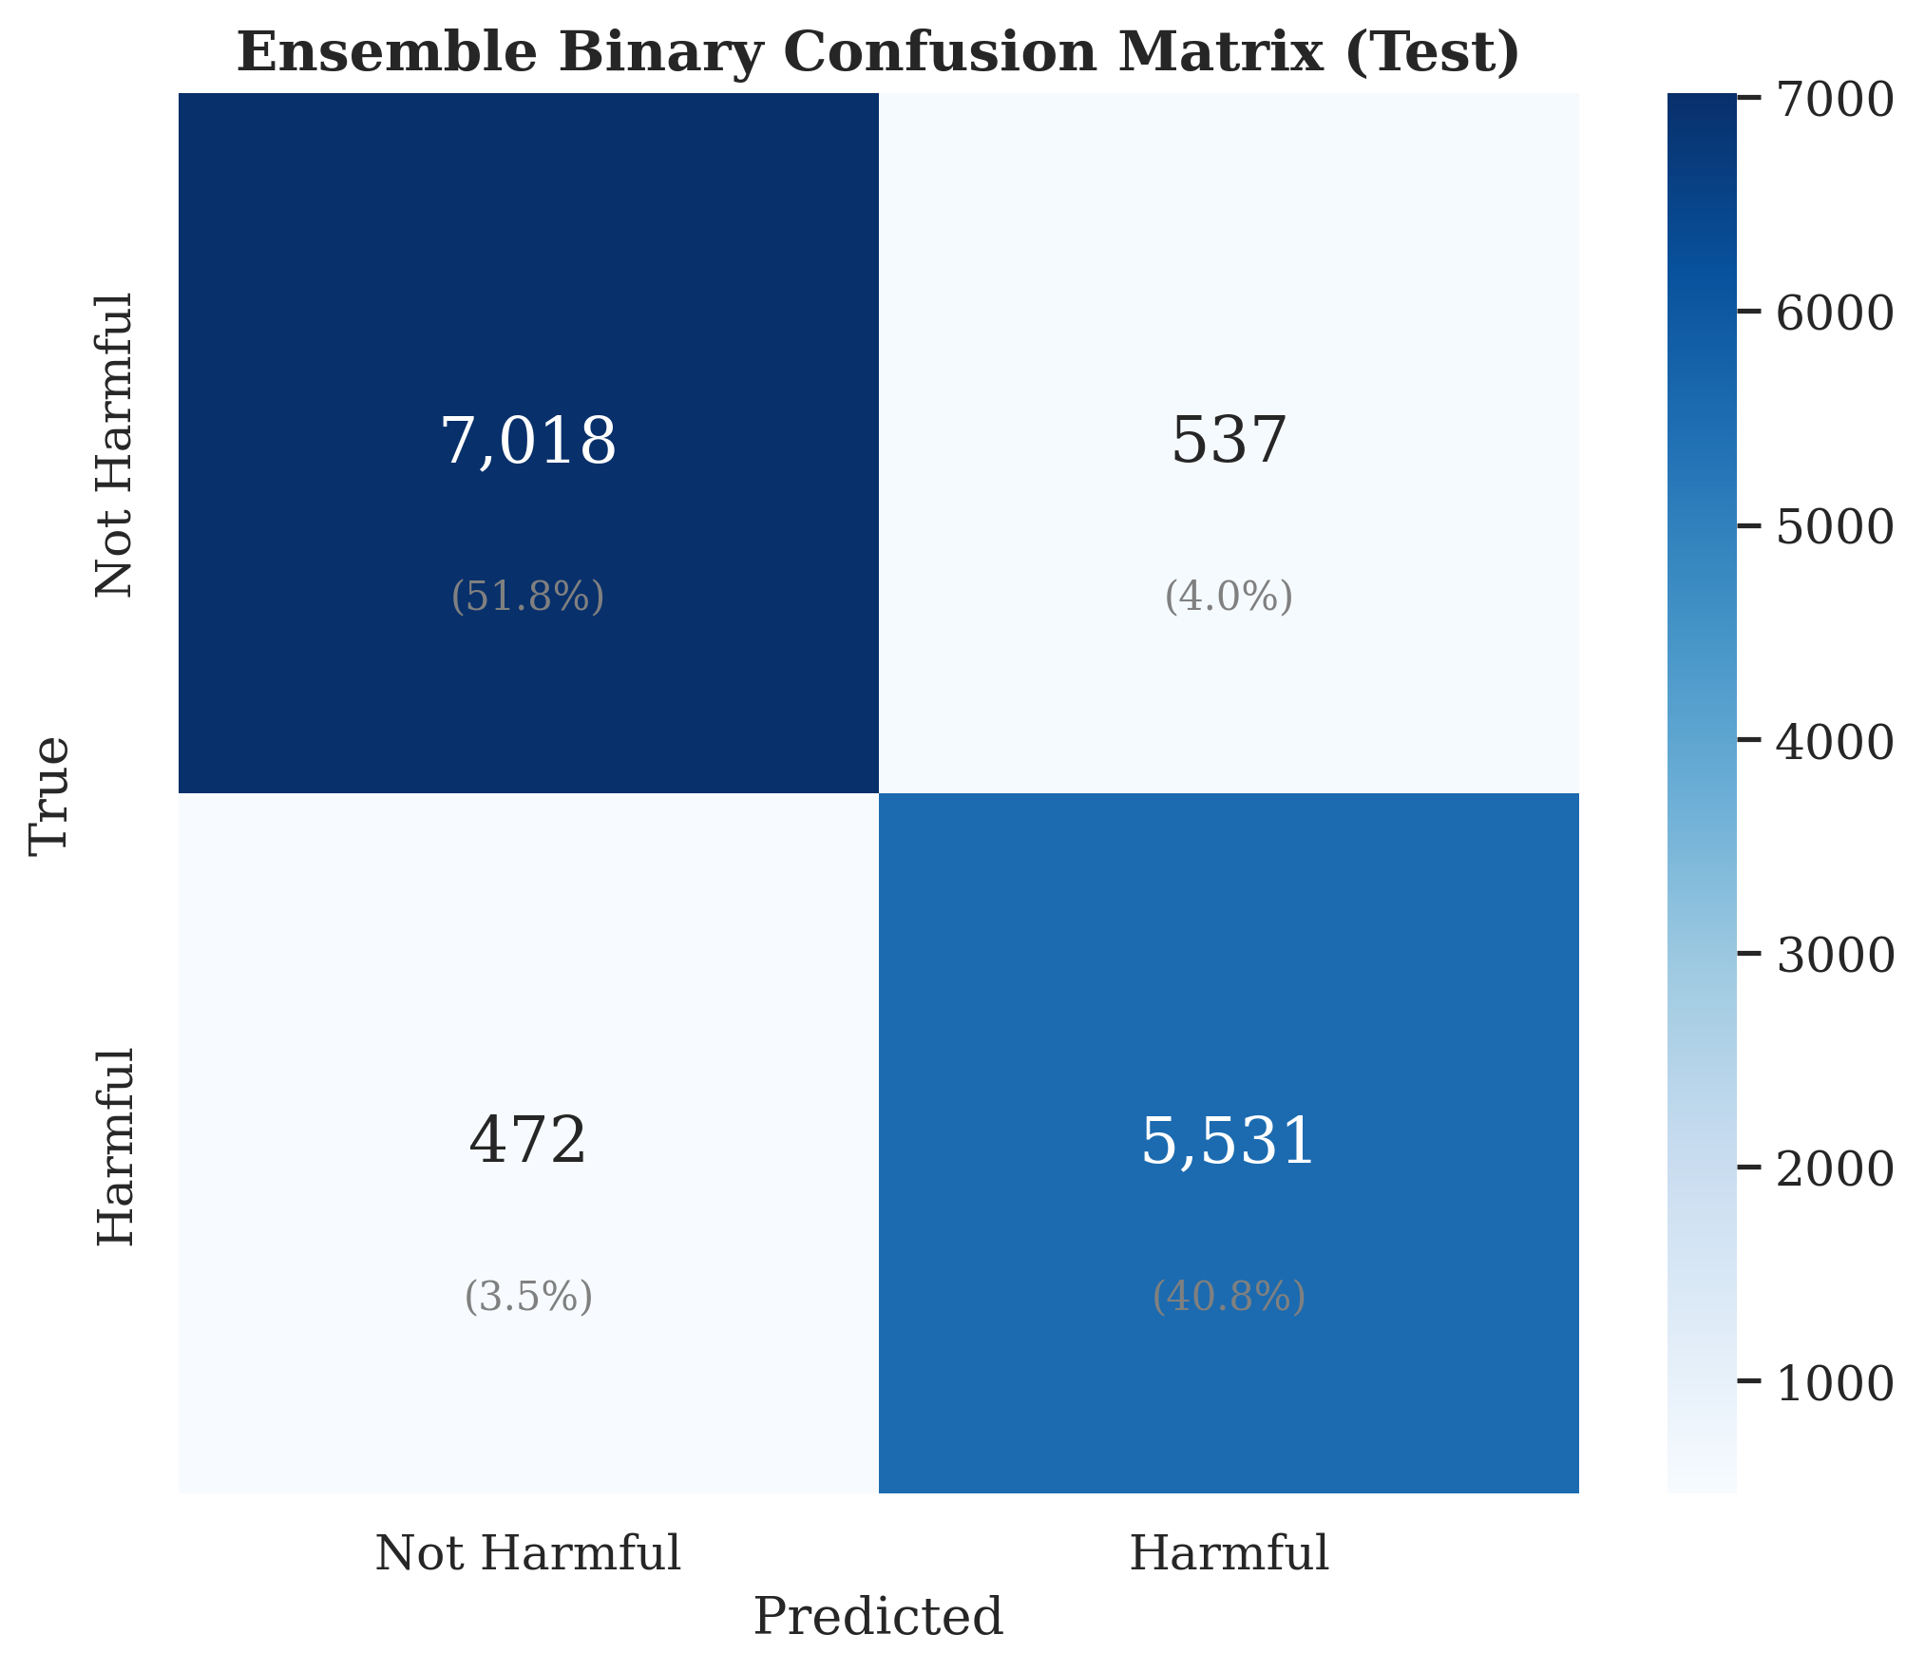

Beginner summary: Most samples fall on the correct diagonal cells, meaning the system is usually right for both harmful and not-harmful comments. The off-diagonal cells correspond to the 537 false positives and 472 false negatives discussed later in the error section.

Figure — Per-class F1 for the 9-class abuse-type task
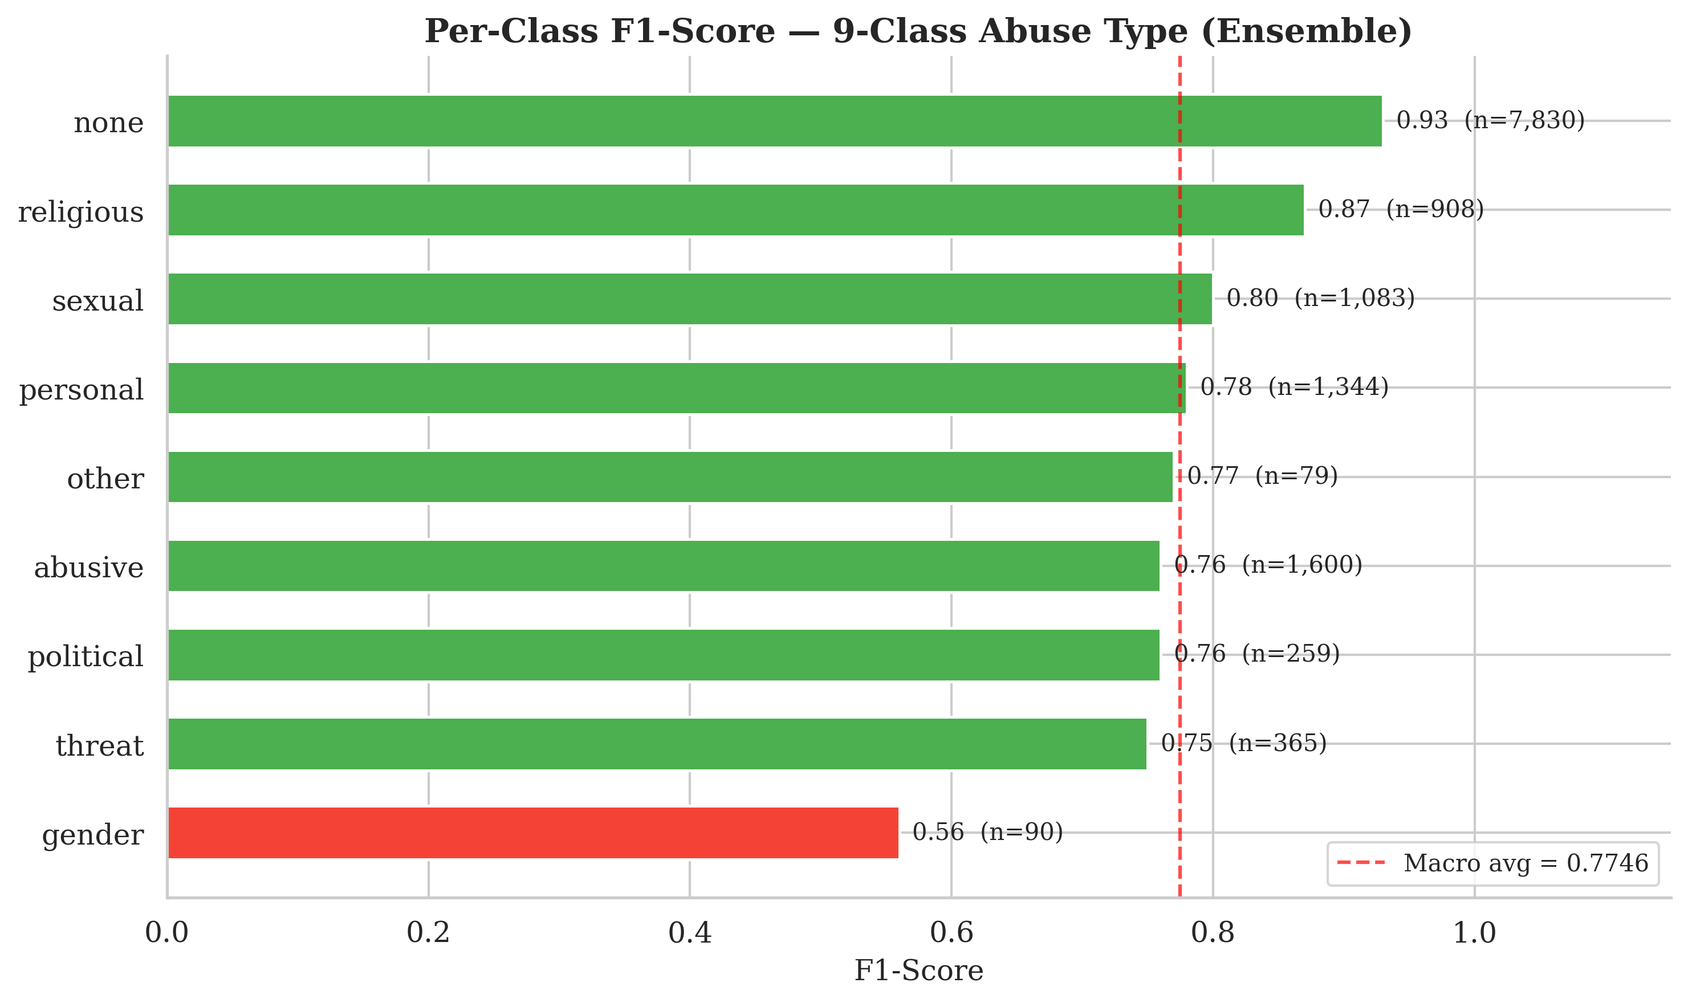

Beginner summary: This figure makes the class imbalance story very easy to see: none and religious perform strongly, while gender is the weakest class. The dashed line marks the overall macro average, so beginners can compare each class against the task-wide mean.

21. Why Macro-F1 Was the Main Metric

Easy explanation
Macro-F1 computes F1 for each class separately and then averages them equally.

Why this matters
It prevents large classes from hiding poor performance on small classes.

That is especially important in the 9-class abuse-type task, where some classes are much smaller than others.

22. Robustness Evaluation

22.1 Binary robustness results

Split | N | Macro-F1 | Weighted-F1 | Accuracy | MCC | AUROC
random_test (in-domain) | 13,558 | 0.9245 | 0.9254 | 0.9254 | 0.8489 | 0.9738
source_holdout_banth | 73,999 | 0.9777 | 0.9819 | 0.9819 | 0.9554 | 0.9959
source_holdout_bd_shs | 5,029 | 0.9342 | 0.9341 | 0.9342 | 0.8744 | 0.9926
source_holdout_facebook_44001 | 44,001 | 0.9736 | 0.9761 | 0.9761 | 0.9473 | 0.9952
source_holdout_multilabel_12557 | 12,546 | 0.9304 | 0.9358 | 0.9357 | 0.8608 | 0.9799
script_holdout_romanized | 73,999 | 0.9777 | 0.9819 | 0.9819 | 0.9554 | 0.9959

22.2 Key observations
1. All holdout splits stayed at F1 ≥ 0.93
2. source_holdout_banth and script_holdout_romanized are identical because banth is entirely Romanized
3. Some holdout scores are higher than in-domain random test, likely because those sources are cleaner or more separable
4. Hardest split: multilabel_12557

22.3 Important honesty note
source_holdout_banth and script_holdout_romanized should not be presented as fully independent evidence.

Figure — Robustness heatmap across held-out splits
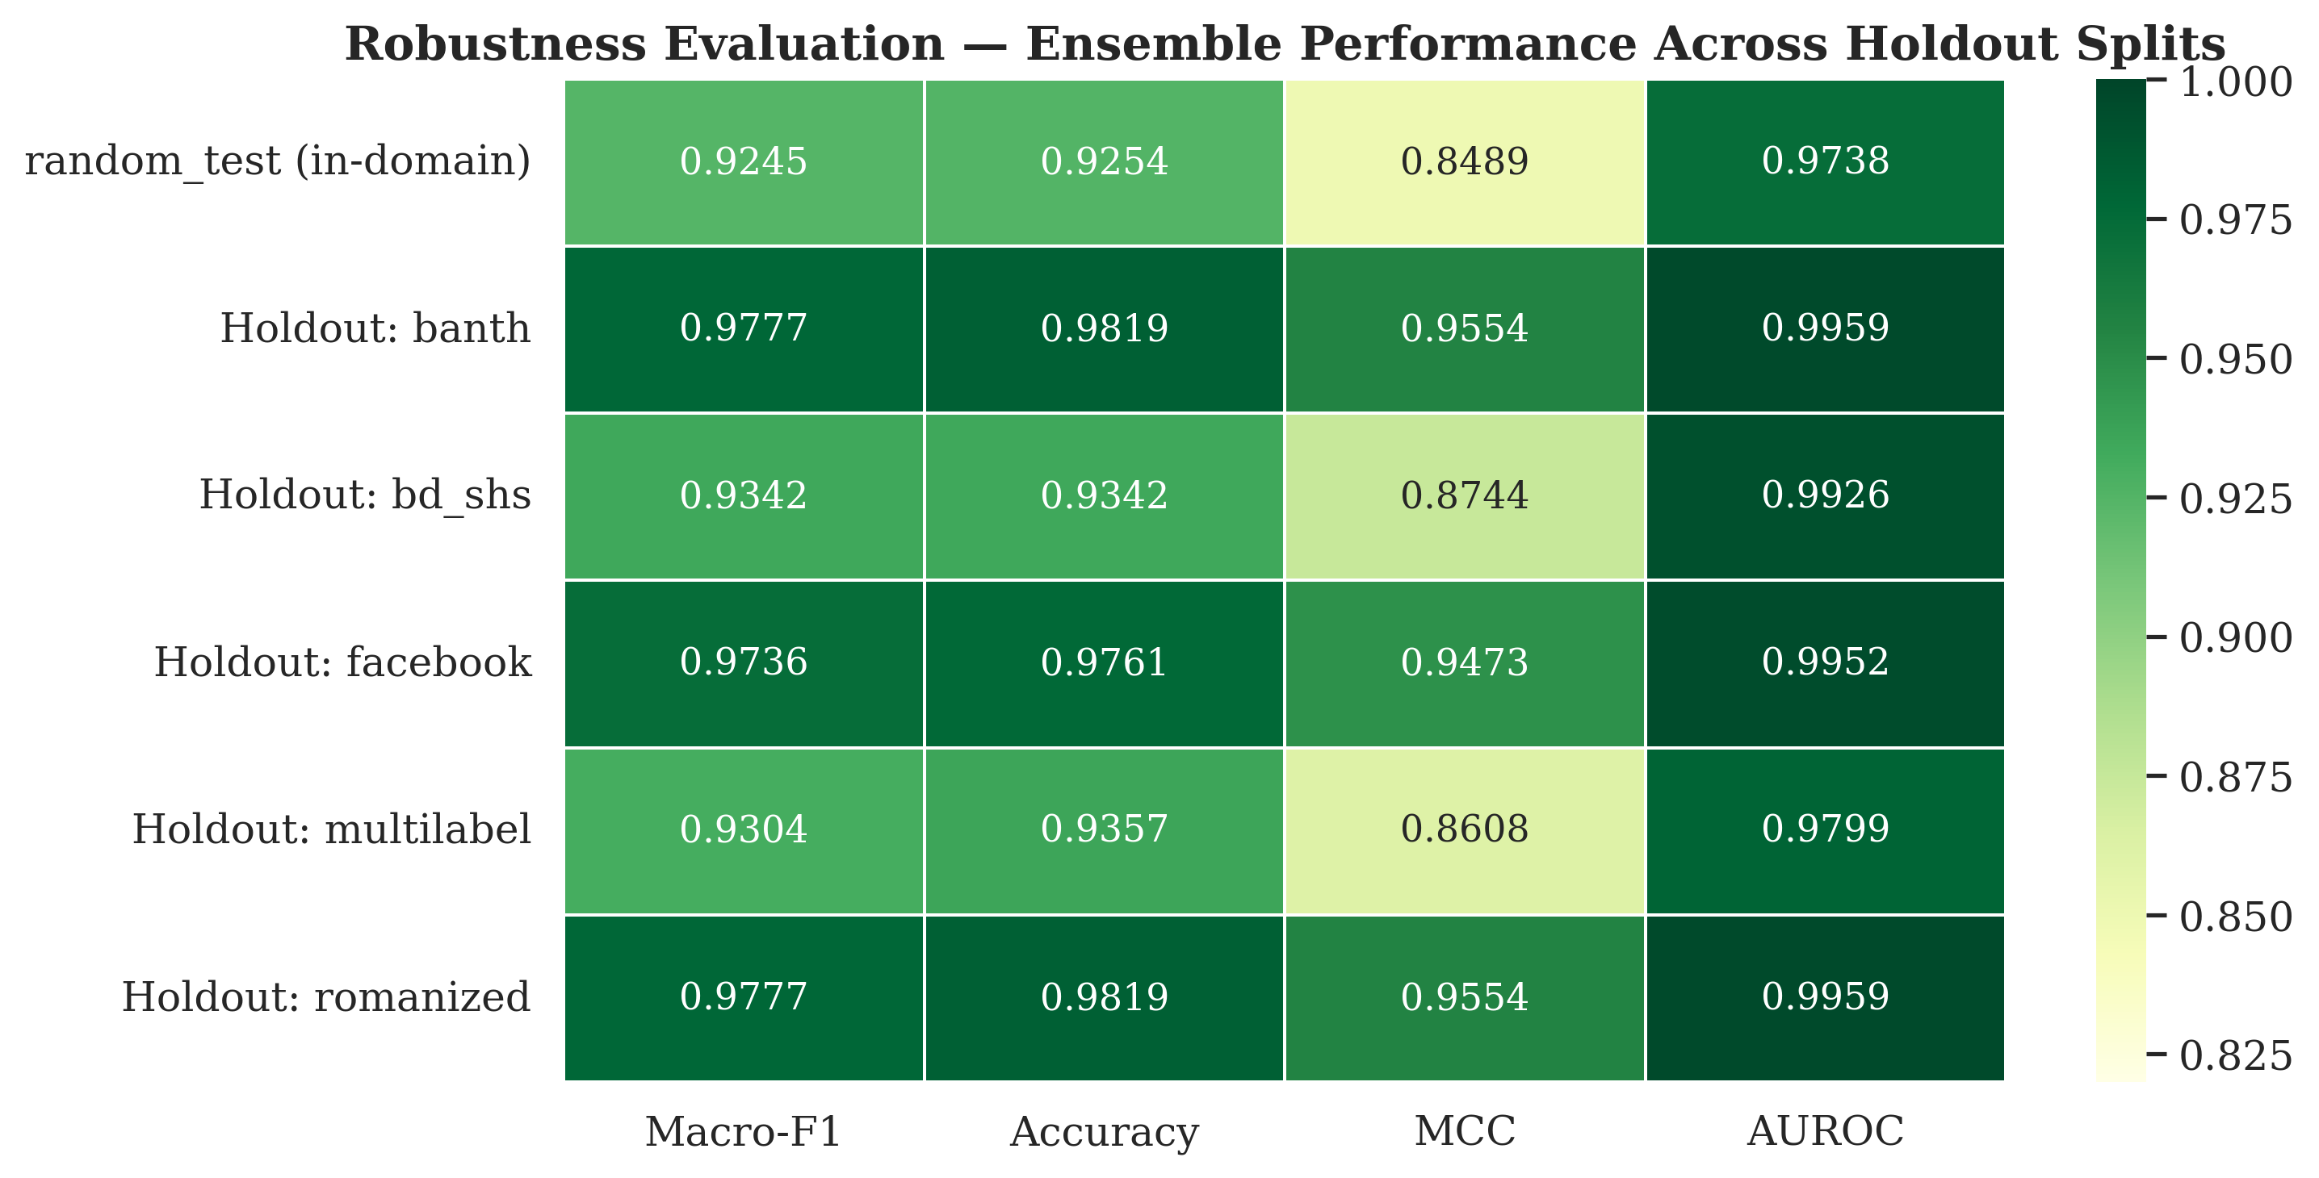

Beginner summary: Darker green cells mean stronger performance, and most cells stay very high across all held-out evaluations. This gives a quick visual proof that the ensemble remains reliable even when the test distribution changes by source or script.

23. Ablation Study

23.1 Results

Ablation | Binary Macro-F1 | Δ Binary | Abuse-Type Macro-F1 | Δ Abuse
full_multitask | 0.9081 | — | 0.7424 | —
binary_only | 0.9138 | +0.0057 | N/A | —
no_focal | 0.9109 | +0.0028 | 0.7444 | +0.0020
no_lrdecay | 0.9266 | +0.0185 | 0.7826 | +0.0402
no_preprocessing | 0.9067 | -0.0014 | 0.7349 | -0.0075

23.2 Main lessons
- binary_only helps binary slightly, but loses the 9-class task
- no_focal is almost neutral
- no_lrdecay is the surprising result: removing LR decay improved both tasks
- no_preprocessing hurts slightly

23.3 Seminar interpretation
The multi-task setup gives richer output with only a small binary trade-off.

Figure — Ablation study comparison
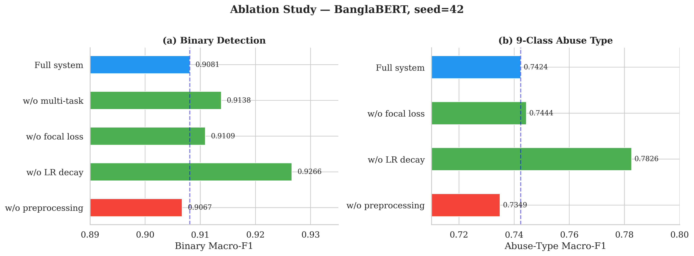

Beginner summary: Each bar shows what happened when one design choice was removed. The most surprising result is that removing LR decay improved both tasks, while removing preprocessing caused a small drop, which helps readers separate what mattered a lot from what mattered only a little.

24. Error Analysis

24.1 Overall
- Total FP = 537
- Total FN = 472
- Error rate = 7.4%

24.2 Error rate by source
- banth = 5.68%
- bd_shs = 14.45%
- facebook_44001 = 8.26%
- multilabel_12557 = 12.48%

24.3 Error rate by script
- Bangla = 9.57%
- Romanized = 5.68%

24.4 Main interpretation
- Hardest sources: bd_shs and multilabel_12557
- Romanized was easier than Bangla in this benchmark

Figure — Error analysis by source and script
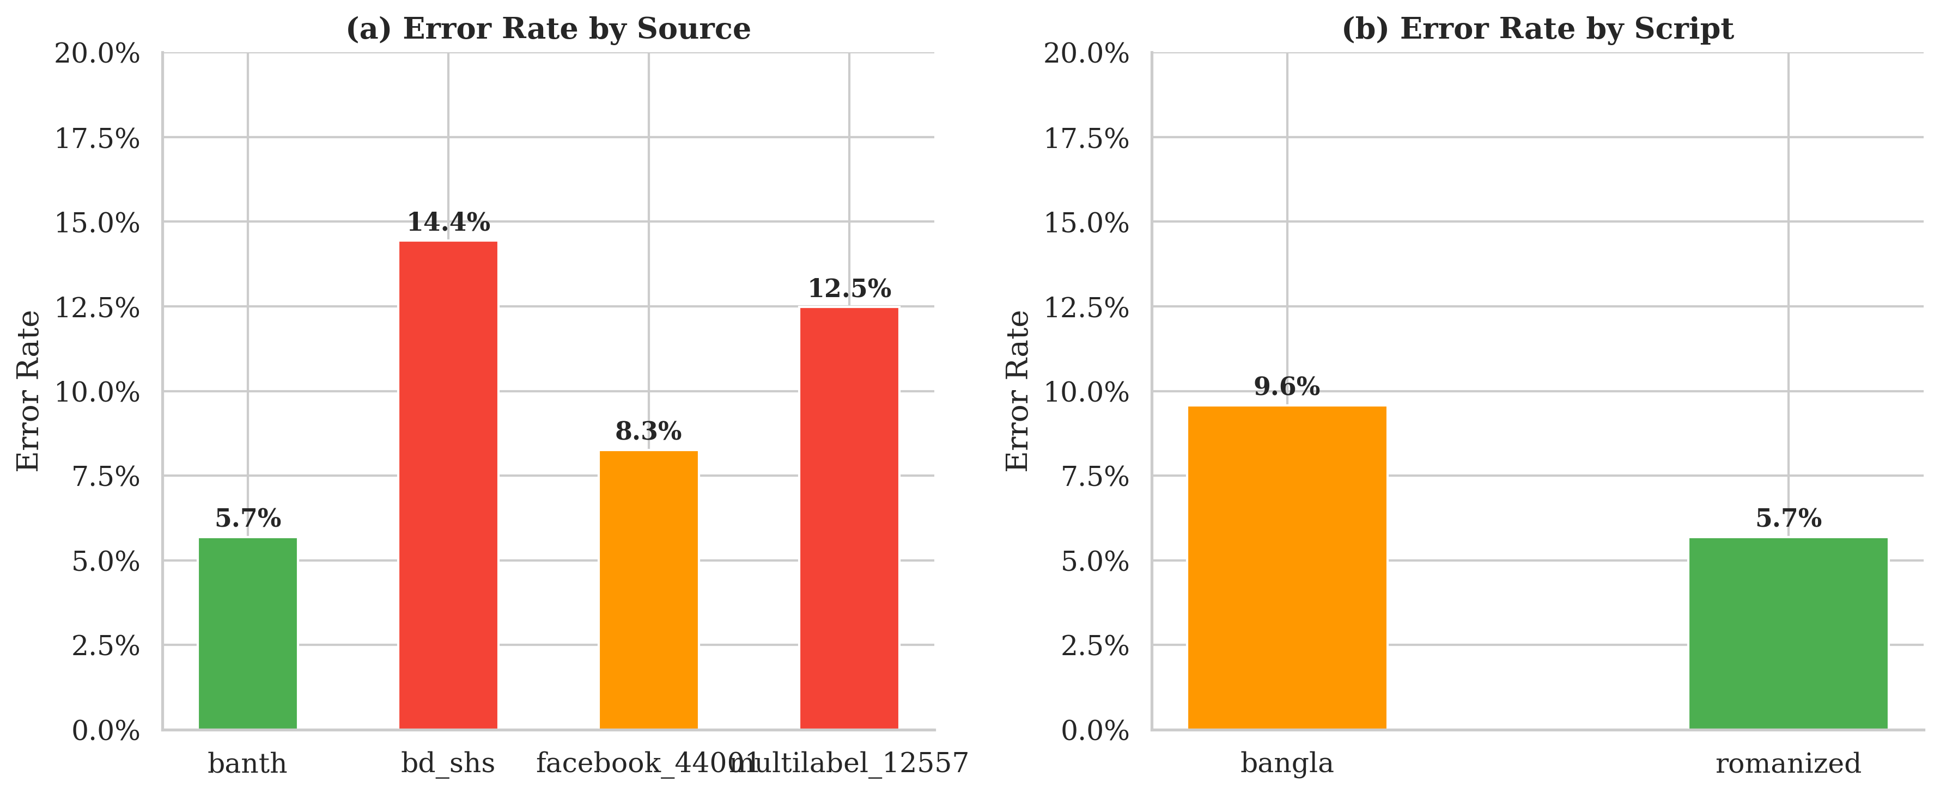

Beginner summary: This figure shows that errors are not evenly spread across the benchmark. The model struggles more on bd_shs and multilabel_12557, and it makes more mistakes on Bangla-script text than on Romanized text.

25. Key Design Decisions

Decision | Rationale
Multi-class (not multi-label) for abuse_type | Compound labels are about 11% of data; multi-class is simpler and more comparable
9 classes (not 89) | 89 classes were too sparse and imbalanced
Macro-F1 as primary metric | Gives equal importance to all classes
Default threshold 0.50 | Tuning found no benefit from moving it
Non-uniform ensemble weights | Validation-set optimization showed some models contributed more than others
3 seeds per model | Enough stability for submission-time experiments
CLS + mean pooling | Balanced global summary + token-level detail
Focal loss | Reasonable for imbalance, though ablation shows only small impact here
Duplicates kept | Realism for robustness study

26. Practical Viva / Seminar Explanations

26.1 Why is the benchmark multi-source?
Because it merges 4 public datasets instead of relying on one source.

26.2 Why is it multi-script?
Because it includes both Bangla script and Romanized Bangla.

26.3 Why did we merge labels into 9 classes?
Because 89 raw classes were too fragmented and many had too few examples.

26.4 Why did we keep duplicates?
For realism and overlap across public sources, though a deduplicated version is a possible future extension.

26.5 Why 0.5 × CLS + 0.5 × mean?
Because it balances global sentence summary and all-token information. It was a practical empirical blend, not a proven unique optimum.

26.6 Why does gender have lower F1?
Because the model had far fewer examples for that class, so it had fewer chances to learn its patterns and more confusion with nearby classes.

26.7 What is a logit?
The raw model score before probability conversion.

26.8 Why are ensemble weights different?
They were optimized on validation data using Nelder–Mead. Bigger weight means that model helped the ensemble more.

27. Output Directory Structure
../outputs/
├── models_v2_fix/
│ ├── label_encoders.json
│ ├── transformer_results_all.csv
│ ├── transformer_results_averaged.csv
│ ├── banglabert_seed42/
│ │ ├── best_model.pt
│ │ ├── val_logits.pt
│ │ ├── test_logits.pt
│ │ ├── results.json
│ │ └── label_encoders.json
│ ├── banglabert_seed{123,456}/
│ ├── muril_seed{42,123,456}/
│ └── xlmr_seed{42,123,456}/
├── ensemble/
│ ├── final_config.json
│ ├── ensemble_test_metrics.json
│ ├── test_preds.npy
│ ├── test_probs.npy
│ ├── threshold_tuning.png
│ └── cm_ensemble_test.png
├── robustness/
│ └── robustness_results.csv
├── ablations/
│ └── ablation_results.csv
├── baselines/
│ └── baseline_results.csv
└── paper/
├── results_summary.json
├── table1_main_results.csv
├── table1b_multitask.csv
├── table2_ablations.csv
├── table3_robustness.csv
├── table1.tex
├── table2.tex
├── table3.tex
├── fig_main_results.png
├── figures/
└── tables/

28. Bugs Fixed in v3 Notebooks

Bug | Affected | Fix
Python 3.13 install crash | NB05 | tokenizers≥0.19.0, transformers≥4.44.0
num_workers>0 deadlock on Windows Jupyter | NB05, NB09 | num_workers=0
sexual,religious wrongly mapped | NB05/06/08/09 | fixed priority: sexual > religious
abuse_type F1 collapsed with 89 classes | NB05 | 9-class consolidation + beta clamp
Only 1 model/seed ran | NB05 | all 3 models × 3 seeds enabled
NB06 label mismatch | NB06 | load shared label_encoders.json
NB09 binary labels all = -1 | NB09 | fix encoder lookup
NB09 model architecture mismatch | NB09 | align with NB05
NB08 rebuilt label encoders independently | NB08 | load label_encoders.json from NB05
deprecated GradScaler API | NB05, NB09 | use torch.amp.GradScaler('cuda')
XLM-R received token_type_ids | NB05/08/09 | skip token_type_ids for XLM-R
NB06 missing ensemble metrics json | NB06 | add save step
NB07 KeyError for macro_f1 | NB07 | correct column name

29. Limitations and Honest Claims
1. The final implemented system is 2-task, not 3-task.
It predicts binary harmfulness and 9-class abuse type. Do not claim the final reported system predicts severity.
2. source_holdout_banth and script_holdout_romanized overlap strongly and should not be treated as fully independent evidence.
3. Duplicates were intentionally kept. This is defendable, but a deduplicated benchmark remains future work.
4. The 0.5/0.5 pooling blend was a balanced empirical choice, not a proven global optimum.
5. The ablation suggests uniform LR may be better than the reported LR-decay setup, which is an important discussion point.

30. Critical Viva / Seminar Questions and Straight Answers

Q1. Why is your benchmark called multi-source?
Because it merges 4 different public datasets instead of using only one.

Q2. Why is it multi-script?
Because it contains both Bangla script and Romanized Bangla.

Q3. Why did you convert raw labels to 9 classes?
Because 89 classes were too sparse and unstable for reliable training.

Q4. Why not keep multi-label abuse type?
Because compound labels were only about 11% of the data, and a multi-class setup was simpler and easier to compare with prior work.

Q5. Why did you keep duplicates?
For realism and overlap across public sources, but we acknowledge deduplicated benchmarking as future work.

Q6. Why do you need source-held-out and script-held-out splits?
Because random split alone cannot prove the model generalizes to unseen sources or unseen writing forms.

Q7. Why are source_holdout_banth and script_holdout_romanized the same?
Because banth is entirely Romanized, so those evaluations use the same data.

Q8. Why use a multi-task setup?
It gives both yes/no harmfulness and 9-class abuse type. Binary-only improves slightly, but loses richer output.

Q9. Why is BanglaBERT better?
Because it has language-specific pretraining for Bangla.

Q10. Why is gender weaker?
Because it has very low support, so the model has fewer examples to learn from.

Q11. Why Macro-F1 instead of only accuracy?
Because Macro-F1 gives equal importance to every class, including small ones.

Q12. Why 0.5 × CLS + 0.5 × mean?
Because it balances global sentence summary and all-token information. It was a practical empirical blend, not a proven unique optimum.

Q13. Why are ensemble weights not equal?
Because validation-set optimization found some models more useful than others.

Q14. What is a logit?
A raw model score before converting to probability.

Q15. Why was threshold 0.50 best?
Because the binary dataset is near-balanced and tuning found no gain from shifting it.

Q16. Why did no_lrdecay perform better?
Likely because this large multi-script dataset benefited from more uniform and aggressive fine-tuning than originally expected.

Q17. Did preprocessing matter?
Yes, but modestly. Removing preprocessing reduced both binary and abuse-type Macro-F1 slightly.

Q18. What should you never overclaim in seminar?
Do not claim:
- a final severity model,
- fully independent evidence from banth/script holdout,
- exhaustive proof that 0.5/0.5 pooling is optimal,
- that duplicates cannot affect scores.

33. Detailed Comparison with Prior Work
This section provides a comprehensive comparison of our research against all significant prior work on Bengali cyberbullying/hate-speech detection, organized chronologically. Papers are grouped into tiers: foundational work, recent competitive work, and concurrent/latest work.

Master Comparison Table

# | Study | Year | Venue | Dataset | Size | Sources | Scripts | Task | Classes | Binary Best | Multi Best | Robustness | Multi-Task | Ensemble
P1 | Ahmed et al. | 2021 | arXiv | facebook_44001 | 44K | 1 | Bangla | Single | 5 | 87.91% acc | 85.00% acc | ✗ | ✗ | SVM
P2 | Emon et al. | 2022 | ICACDS | facebook_44001 | 44K | 1 | Bangla | Single | 5 | — | 85% acc, 86% F1 | ✗ | ✗ | ✗
P3 | Aurpa et al. | 2022 | SNAM | facebook_44001 | 44K | 1 | Bangla | Single | 5 | — | 85.00% acc | ✗ | ✗ | ✗
P4 | Akhter et al. | 2023 | NLP Journal | facebook_44001 | 44K | 1 | Bangla | Single | 5 | 98.57% acc† | 98.82% acc† | ✗ | ✗ | ✗
P5 | Sihab-Us-Sakib | 2024 | NLP Journal | CBD | 2.7K | 1 | Mixed | Single | 5 | 82.61% acc | — | ✗ | ✗ | ✗
P6 | Saifullah et al. | 2024 | EAI INIS | facebook_44001 | 44K | 1 | Bangla | Single | 5 | 88.04% acc | — | ✗ | ✗ | ✗
P7 | Nath et al. | 2024 | AETiC | Custom | 12K | 1 | Mixed | Single | 2 | 95.08% acc | — | ✗ | ✗ | ✗
P8 | Saha et al. | 2023 | IEEE STI | Custom | ~5K | 1 | Bangla | Single | 2 | 90% acc | — | ✗ | ✗ | ✗
P9 | Hoque & Seddiqui | 2024a | IJAI | facebook_44001 | 44K | 1 | Bangla | Single | 5 | 80.17% acc | — | ✗ | ✗ | ✗
P10 | Prova & Basak | 2025 | Springer LNNS | Balanced subset | 10K | 1 | Bangla | Single | 5 | — | 78.25% acc | ✗ | ✗ | ✗
P11 | Hoque & Seddiqui | 2025 | Frontiers AI | facebook_44001 + 2 ext. | 44K | 1(+2) | Bangla | Single | 5 | 93.62% acc | 89.23% acc | Partial‡ | ✗ | Stacking
P12 | Azhar et al. | 2026 | Discover Comp. | HateCorpBN-XL | 65K | 1 | Bangla | Single (HS) | 5 | 92% F1 | 90% F1 | ✗ | ✗ | Fusion
P13 | Raquib et al. | 2026 | arXiv | Multi-label CB | ~12K | 1 | Bangla | Multi-label | 4 | — | 94.31% acc | ✗ | ✗ | Fusion
P14 | Hossain et al. | 2025 | PeerJ CS | Kaggle Bengali | ~5K | 1 | Mixed | Single | 2 | 98.17% acc† | — | ✗ | ✗ | Fusion
P15 | BanCyB/HTLFF | 2025 | Preprint | BanCyB | 10K | 1 | Bangla | Multi-label | 4 | 92.37% F1 | 87.05% macro-F1 | ✗ | ✗ | Fusion
Ours | BanglaCyberBench | 2026 | — | 4 merged sources | 135K | 4 | Both | Multi-task | 9 | 92.47% F1 | 77.46% macro-F1 | ✓ (6 splits, all ≥0.93) | ✓ | Weighted logit

† Results likely inflated by evaluation protocol (data augmentation, aggressive resampling, or potential leakage). Not directly comparable.
‡ Hoque & Seddiqui (2025) tested on 2 external datasets for scalability, but did not perform systematic source-holdout or script-holdout robustness evaluation as our research does.

Why Direct Accuracy/F1 Comparison Is Misleading
Most prior work evaluates on a single dataset (usually the 44K Facebook dataset). Our research evaluates on a fundamentally different and harder problem:

Dimension | Prior Work (typical) | Our Research
Dataset size | 2.7K – 44K | 135,575
Number of sources | 1 | 4 (merged benchmark)
Scripts | Bangla only | Bangla + Romanized
Class granularity | 2 or 5 classes | 9 classes (finer-grained)
Label complexity | Clean labels | Compound labels requiring priority resolution
Evaluation | Single random test split | Random test + 4 source holdouts + 1 script holdout
Architecture | Single model or simple ensemble | Multi-task (binary + 9-class jointly) with 9-model weighted ensemble

A model achieving 93% on a clean 5-class single-source dataset is solving an easier problem than one achieving 92% on a noisy 9-class multi-source dual-script benchmark with compound labels.

Our Key Contributions vs the Field

Contribution | Novelty Level | Closest Prior Work | How We Differ
135K multi-source benchmark | Novel — no prior work combines 4 sources | Azhar et al. (65K, but single source, hate speech not CB) | 4 sources with cross-source robustness testing
Dual-script coverage | Novel — no prior work evaluates on both scripts | Ahmed et al. 2021 (Bangla-only), some have Romanized-only | 54.6% romanized + 45.4% Bangla, with script-holdout evaluation
9-class taxonomy with priority resolution | Novel — all prior work uses 2 or 5 classes | Hoque 2025 (5 classes), Raquib 2026 (4 multi-label) | Priority-based compound label resolution (89 → 9 classes)
Multi-task architecture | Novel for Bengali CB — no prior work does joint binary + abuse-type | Raquib 2026 (multi-label, but different formulation) | Shared encoder with 2 task-specific heads, joint focal loss
Cross-source & cross-script robustness | Novel — no prior work tests this | Hoque 2025 (tested on 2 external datasets, but not holdout) | Systematic holdout: 4 source + 1 script, all ≥ 0.93 F1
Weighted ensemble (Nelder-Mead) | Incremental — ensemble is common, but optimised weights are novel for this domain | Hoque 2025 (stacking with MLP), Ahmed 2021 (SVM ensemble) | 9-model weighted logit average with non-uniform optimised weights
Ablation study | Novel for Bengali CB — no prior work provides systematic ablations | — | 5 ablations covering multi-task, focal loss, LR decay, preprocessing

Papers to Cite in Related Work Section
Must cite (directly relevant, same task):
1. Ahmed et al. (2021) — foundational dataset, our source
2. Emon et al. (2022) — first transformer work on 44K
3. Hoque & Seddiqui (2025) — current SOTA, strongest competitor
4. Saifullah et al. (2024) — BullyFilterNeT, BanglaBERT baseline

Should cite (recent, strong results):
5. Raquib et al. (2026) — BanglaBERT-LSTM fusion, multi-label
6. Azhar et al. (2026) — HateBertBN, largest Bengali HS dataset
7. Sihab-Us-Sakib et al. (2024) — XLM-R on new CBD dataset
8. Hossain et al. (2025) — Transformer-XL fusion

Can cite (context, older work):
9. Aurpa et al. (2022) — BERT/ELECTRA on 44K
10. Akhter et al. (2023) — hybrid ML (cite with caveats about inflated metrics)
11. Nath et al. (2024) — BiLSTM baseline
12. Prova & Basak (2025) — low-accuracy transformer baseline

32. Final Handoff Checklist

Item | Status
All notebooks (NB04–NB10) | ✅
All model checkpoints | ✅
All logits | ✅
Ensemble config + predictions | ✅
Ablation CSV | ✅
Robustness CSV | ✅
Publication figures | ✅
LaTeX tables | ✅
Consolidated results JSON | ✅
This master experiment log | ✅

BanglaCyberBench Experiment Log — Masterclass Updated | April 2026

