
RAJSHAHI UNIVERSITY OF ENGINEERING & TECHNOLOGY
Department of Computer Science & Engineering

THESIS PROGRESS REPORT
(CSE 4208 – Seminar)
4th Year Even Semester 2024
2020 Series
Tentative Title:
Robust Bengali Sarcasm Detection: Adversarial Fine-Tuning, and Cross-Dataset Evaluation

Submitted By
Khandoker Sefayet Alam
Roll No.: | 2003121
Registration No.: | 663
Session: | 2020–2021
Year-Semester: | 4th Year Even Semester

Department of Computer Science & Engineering
Rajshahi University of Engineering & Technology
Rajshahi-6204, Bangladesh

Supervised By
Prof. Dr. Md. Rabiul Islam
Professor
Department of CSE, RUET

August 2025 – May 2026

1. Thesis in Brief
Item | Description
Course Code | CSE 4208
Course Title | Seminar
Semester | 4th Year Even Semester 2024
Thesis Duration | August 2025 – May 2026
Area of Research | Natural Language Processing, Machine Learning, Deep Learning
Research Type | Experimental Research
Tools & Technologies | Python, PyTorch, HuggingFace Transformers, Kaggle (2×T4 GPU), scikit-learn
Dataset Source | Ben-Sarc (25,636), BanglaSarc (5,112), BanglaSarc3 (12,072) — public Bengali corpora

2. Abstract
This thesis tackles Bengali sarcasm detection through a three-track experimental pipeline that allows a fair, same-dataset comparison with the Q1 Ben-Sarc paper (Lora et al., 2025). Track A covers the main thesis pipeline: dataset preparation, fine-tuning of five transformer backbones, adversarial training, regularization studies, ensembling, and cross-dataset validation. Track B reproduces the ML, deep learning, and frozen-encoder transfer baselines from the reference paper on the same Ben-Sarc dataset. Track C handles the final layer of the work, namely statistical significance testing, calibration, and the publication-quality figures.
The proposed method, BanglaBERT fine-tuned with a combined FGM and AWP adversarial loop, reaches macro-F1 = 0.8097 on Ben-Sarc. That is a statistically significant gain of +0.0650 macro-F1 (+8.7% relative) over the strongest author-side baseline (LSTM+CNN+PreEmb, macro-F1 = 0.7447). All 22 experimental notebooks, 5 architecture diagrams, and 12 publication-quality figures have been finalized.

3. Objectives

3.1 Main Objectives
1. Build the first multi-backbone, multi-technique Bengali sarcasm-detection benchmark across three publicly available datasets.
2. Reproduce the three method families from the Q1 reference paper (Lora et al., 2025) on Ben-Sarc so that author-side and thesis-side approaches can be compared on the exact same data.
3. Show that adversarial fine-tuning (FGM + AWP) outperforms the frozen-encoder transfer paradigm for Bengali sarcasm detection.
4. Quantify robustness through McNemar significance tests, bootstrap confidence intervals, calibration analysis, and cross-dataset transfer evaluation.

3.2 Research Questions
1. Under matched evaluation conditions on Ben-Sarc, does full fine-tuning on the thesis side beat the author-side methods?
2. Is the gap between adversarial training and plain BanglaBERT fine-tuning statistically significant?
3. Does strong in-domain performance carry over reliably to out-of-domain Bengali sarcasm datasets?

4. Literature Review
Papers Reviewed: 10 Indexed Sources: Cambridge NLP, NeurIPS, ACL, NAACL, EMNLP, ICML, IEEE

Ref. | Authors | Method | Relevance to This Thesis
[1] | Lora et al. (2025) | Ben-Sarc corpus + ML/DL/Transfer baselines | Introduced primary Bengali sarcasm benchmark; best frozen-encoder at 75.05% accuracy
[2] | Devlin et al. (2019) | BERT: Bidirectional Transformer pre-training | Established modern fine-tuning paradigm for NLP downstream tasks
[3] | Khatun et al. (2023) | BanglaBERT Bengali pre-trained LM | Strongest Bengali-specific transformer; consistent SOTA on Bengali benchmarks
[4] | Conneau et al. (2020) | XLM-RoBERTa cross-lingual representations | Strong multilingual transfer; useful comparison backbone
[5] | Jiang et al. (2020) | SMART / AWP: adversarial weight perturbation | Weight perturbation improves fine-tuning generalization on GLUE/SQuAD
[6] | Barrantes et al. (2020) | FGM/PGD adversarial training survey | Embedding-space perturbation consistently improves NLP robustness
[7] | Liang et al. (2021) | R-Drop: Regularized Dropout | Consistency across dropout samples; marginal gains when adversarial pipeline strong
[8] | Khosla et al. (2020) | Supervised Contrastive Learning | Same-class representations pulled closer; limited benefit for binary Bengali tasks
[9] | Guo et al. (2017) | Calibration of modern neural networks | Strong fine-tuned models tend to be overconfident (high ECE)
[10] | Islam et al. (2022) | Bengali sentiment analysis with transformers | BanglaBERT outperforms mBERT on Bengali sentiment; confirms backbone choice

The gap is straightforward: no prior work on Bengali sarcasm detection has combined full transformer fine-tuning, adversarial training, and systematic cross-dataset testing in a single study. Lora et al. obtained their best result using a frozen-encoder setup, so this thesis asks whether full fine-tuning together with adversarial perturbation can do better. The work also documents a real reproducibility issue, since the original best-performing model from that paper is no longer publicly accessible. That gap is partly what motivated the reproducibility-first design used here.

5. Methodology

5.1 Experimental Design
The work is split into three tracks. Track A (nb00–14) is the main thesis pipeline and covers dataset preparation, transformer fine-tuning across five backbones, adversarial training, regularization studies, ensembling, and cross-dataset transfer. Track B (nb15–18) reproduces the Lora et al. method families on Ben-Sarc so the comparison stays on a single dataset. Track C (nb19–22) handles significance testing, calibration, error analysis, and the figures used for publication. Figure D4 below maps the full workflow.
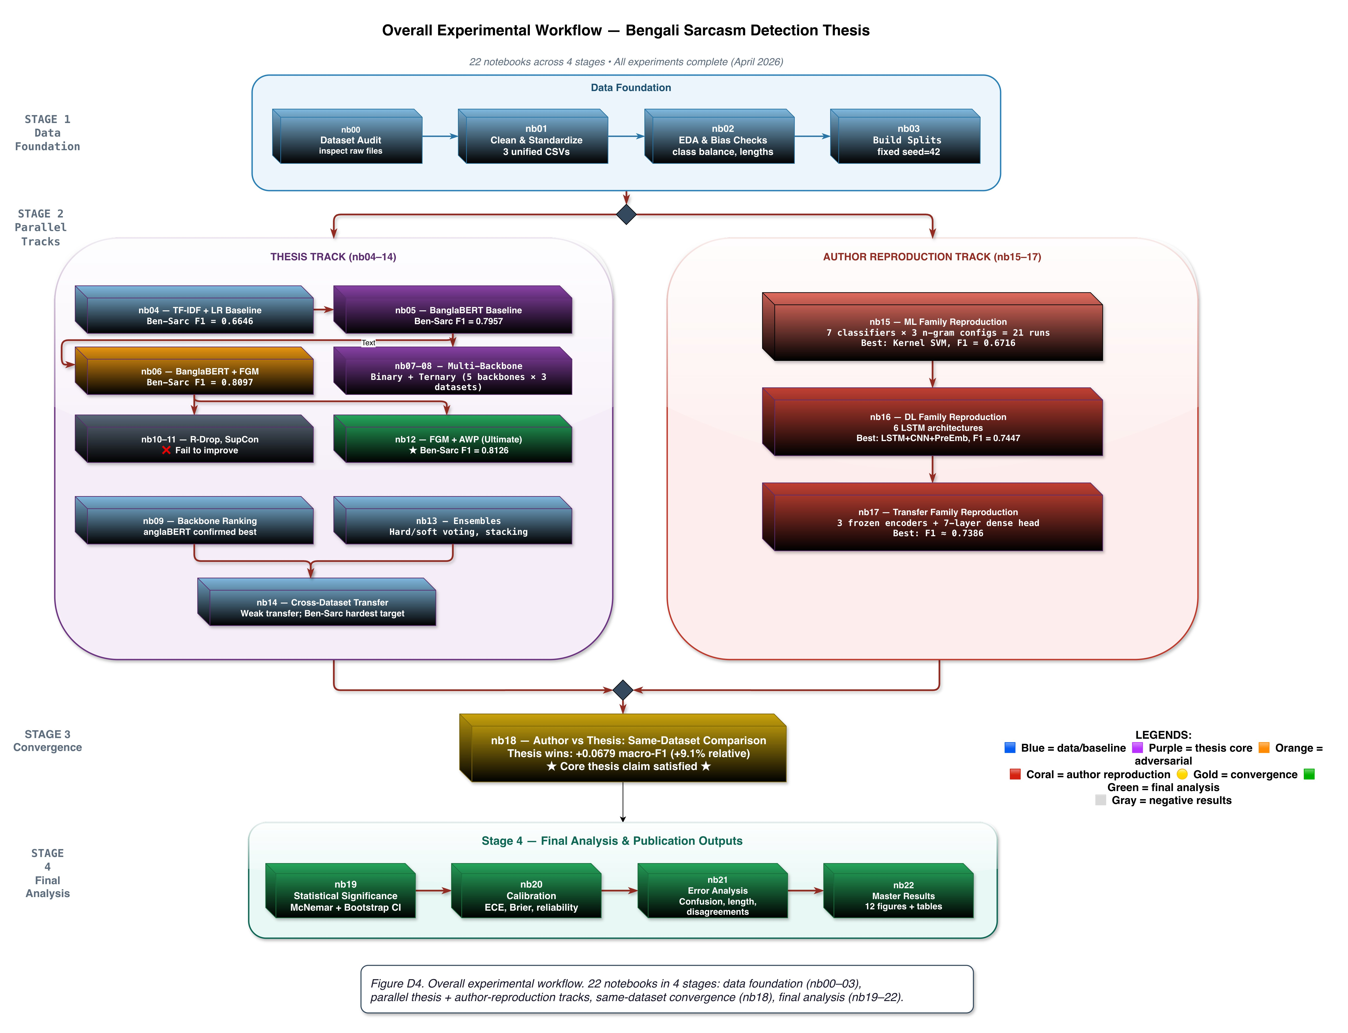
Figure D4. Overall Experimental Workflow (22 Notebooks Across 4 Stages)
Stage 1: Data foundation (nb00–03). Stage 2: Parallel thesis track (nb04–14) and author-reproduction track (nb15–17). Stage 3: Same-dataset convergence (nb18). Stage 4: Final analysis (nb19–22).

5.2 Datasets
Dataset | Rows | Task | Source | Role
Ben-Sarc | 25,636 | Binary | Facebook | Primary benchmark — same-dataset comparison with Lora et al.
BanglaSarc | 5,112 | Binary | FB/YT/Blog | Secondary generalization benchmark
BanglaSarc3 | 12,072 | Bin+Tern | Facebook | Ternary ambiguity analysis; binary generalization test

In notebooks nb00–nb03, each dataset was cleaned, mapped to a common schema, and split into fixed train/validation/test partitions (80/10/10, stratified, seed=42). The same splits are reused across every model family, which is what makes the reported numbers directly comparable.

5.3 Model Families
Family | Methods / Models | Notebook(s)
Classical ML (Thesis) | TF-IDF + LR, Linear SVM, RBF SVM | nb04
Transformer Fine-Tuning | BanglaBERT, MuRIL, XLM-RoBERTa, Sagorsarker BB, mBERT | nb05, nb07–09
Adversarial Training | BanglaBERT+FGM (ε=0.3/0.5/0.7), FGM+AWP, FreeLB (K=3), MuRIL+FGM | nb06, nb12
Regularization / Contrastive | R-Drop, Label Smoothing, SupCon (joint & two-stage) | nb10, nb11
Ensemble | Hard voting, Soft voting, Stacking | nb13
Reproduced (Author-Style) | ML: 7 classifiers × 3 n-gram; DL: 6 LSTM/CNN architectures; Transfer: 3 frozen encoders + 7-layer dense head | nb15–17

5.4 Proposed Method: BanglaBERT + FGM + AWP
The proposed method pairs the BanglaBERT backbone (csebuetnlp/banglabert, 110M parameters) with a composite adversarial loop that runs both FGM and AWP. Each batch goes through five steps: (1) a clean forward pass computes L_clean and populates gradients; (2) AWP perturbs the model weights using those clean gradients inside an ε-ball (adv_eps=10⁻³); (3) FGM then perturbs the word embeddings (ε=0.5); (4) an adversarial forward pass computes L_adv and accumulates gradients; (5) both perturbations are restored before the optimizer step. One important design choice here is that both AWP and FGM derive their perturbation direction from the clean gradients, which keeps the augmentation stable and easy to control. The full architecture is shown in Figure D1.
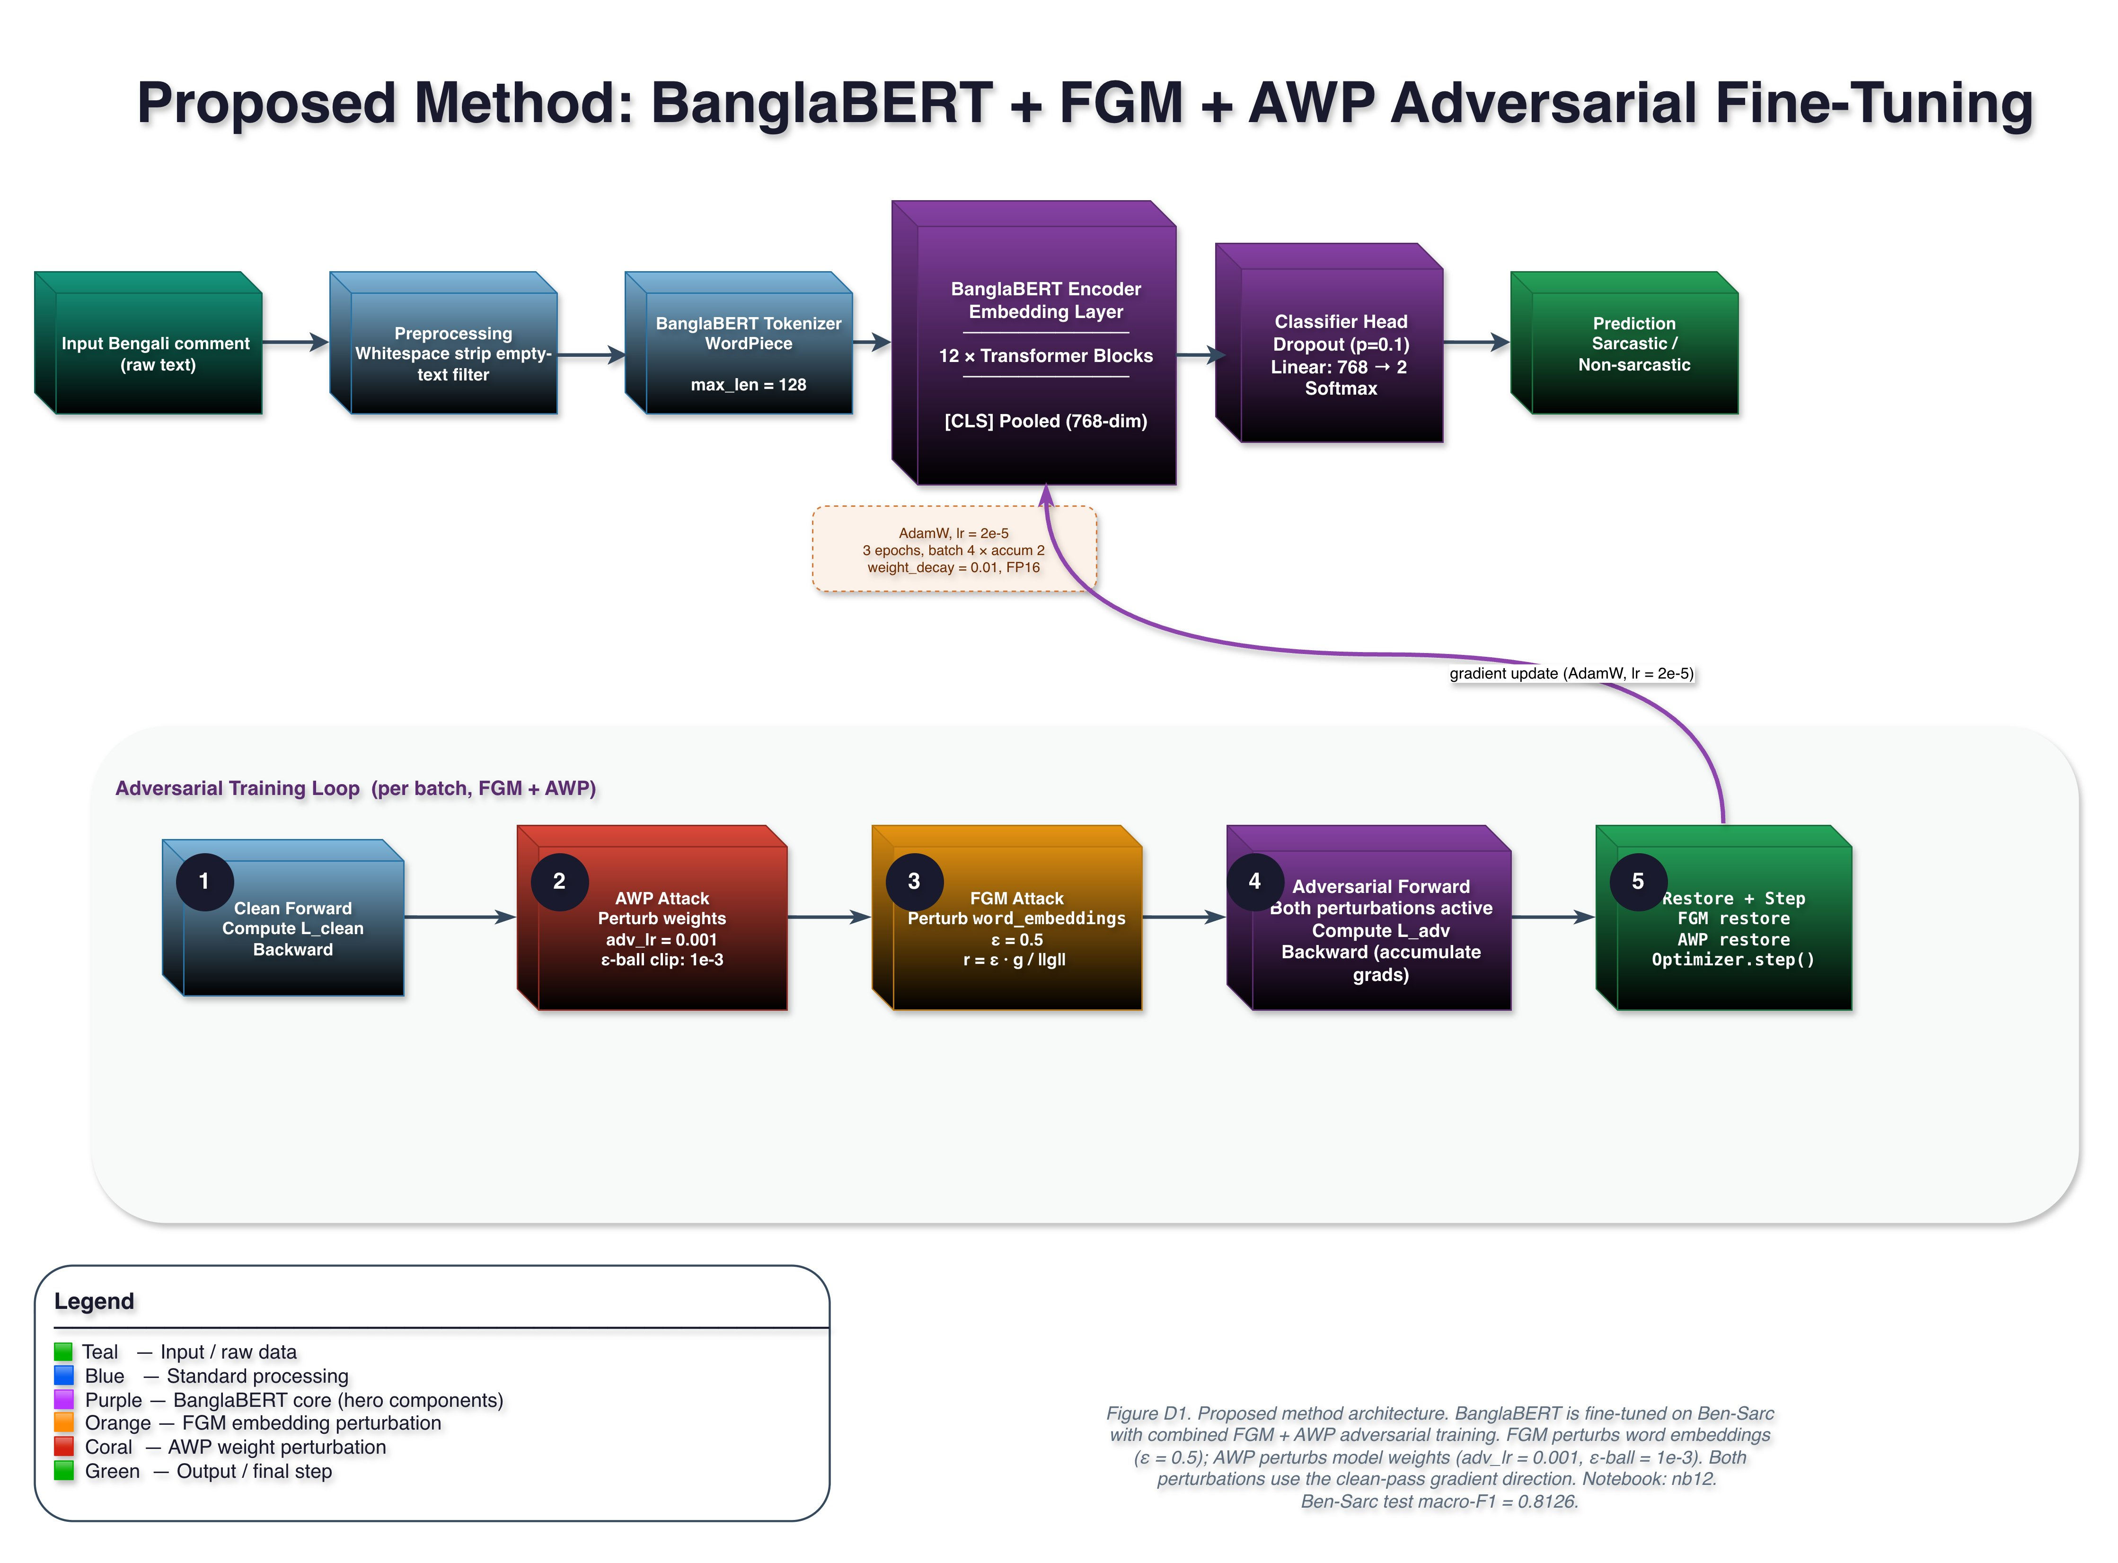
Figure D1. Proposed Method: BanglaBERT + FGM + AWP Adversarial Fine-Tuning
Input → BanglaBERT tokenizer (WordPiece, max_len=128) → 12 Transformer blocks → [CLS] pooled (768-dim) → Classifier head: Dropout(0.1) + Linear(768→2) + Softmax. Adversarial loop: 5-step FGM+AWP per batch (see diagram). Trained 3 epochs, AdamW lr=2×10⁻⁵, FP16, Kaggle 2×T4 GPU.
6. Work Completed
All 22 experimental notebooks (nb00–22), the five architecture diagrams (D1–D5), and the twelve publication-quality figures (F1–F12) are finished and frozen.
Completed Task | Status
Dataset auditing, cleaning, EDA, and fixed splits (nb00–03) | DONE
Classical ML baseline: TF-IDF + LR, SVM (nb04) | DONE
BanglaBERT transformer baseline fine-tuning (nb05) | DONE
FGM adversarial training on BanglaBERT (nb06) | DONE
Multi-backbone binary evaluation: 5 backbones × 3 datasets (nb07–09) | DONE
R-Drop, label smoothing, SupCon studies — negative results documented (nb10–11) | DONE
Advanced adversarial sweep: FGM ε-sensitivity, FreeLB, FGM+AWP → macro-F1=0.8097 (nb06/nb12) | DONE
Ensemble methods + cross-dataset transfer (nb13–14) | DONE
Author-style ML, DL, and frozen-transfer reproduction on Ben-Sarc (nb15–17) | DONE
Same-dataset author-vs-thesis comparison (nb18) | DONE
McNemar significance + bootstrap CIs (nb19) | DONE
Calibration: ECE and Brier scores (nb20) | DONE
Error analysis by confusion matrix and text length (nb21) | DONE
All 12 publication-quality figures + summary tables (nb22) | DONE
All 5 architecture diagrams D1–D5 (draw.io) | DONE

7. Results and Discussion

7.1 Grand Ranking on Ben-Sarc
Figure F1 ranks every evaluated method by macro-F1 on the Ben-Sarc binary task. The thesis-side adversarial methods take all of the top spots (above 0.80 macro-F1), and the strongest author-side method (LSTM+CNN+PreEmb = 0.7447) lands at rank 10. The visible gap between the two families is probably the cleanest single-figure summary of what this thesis adds.
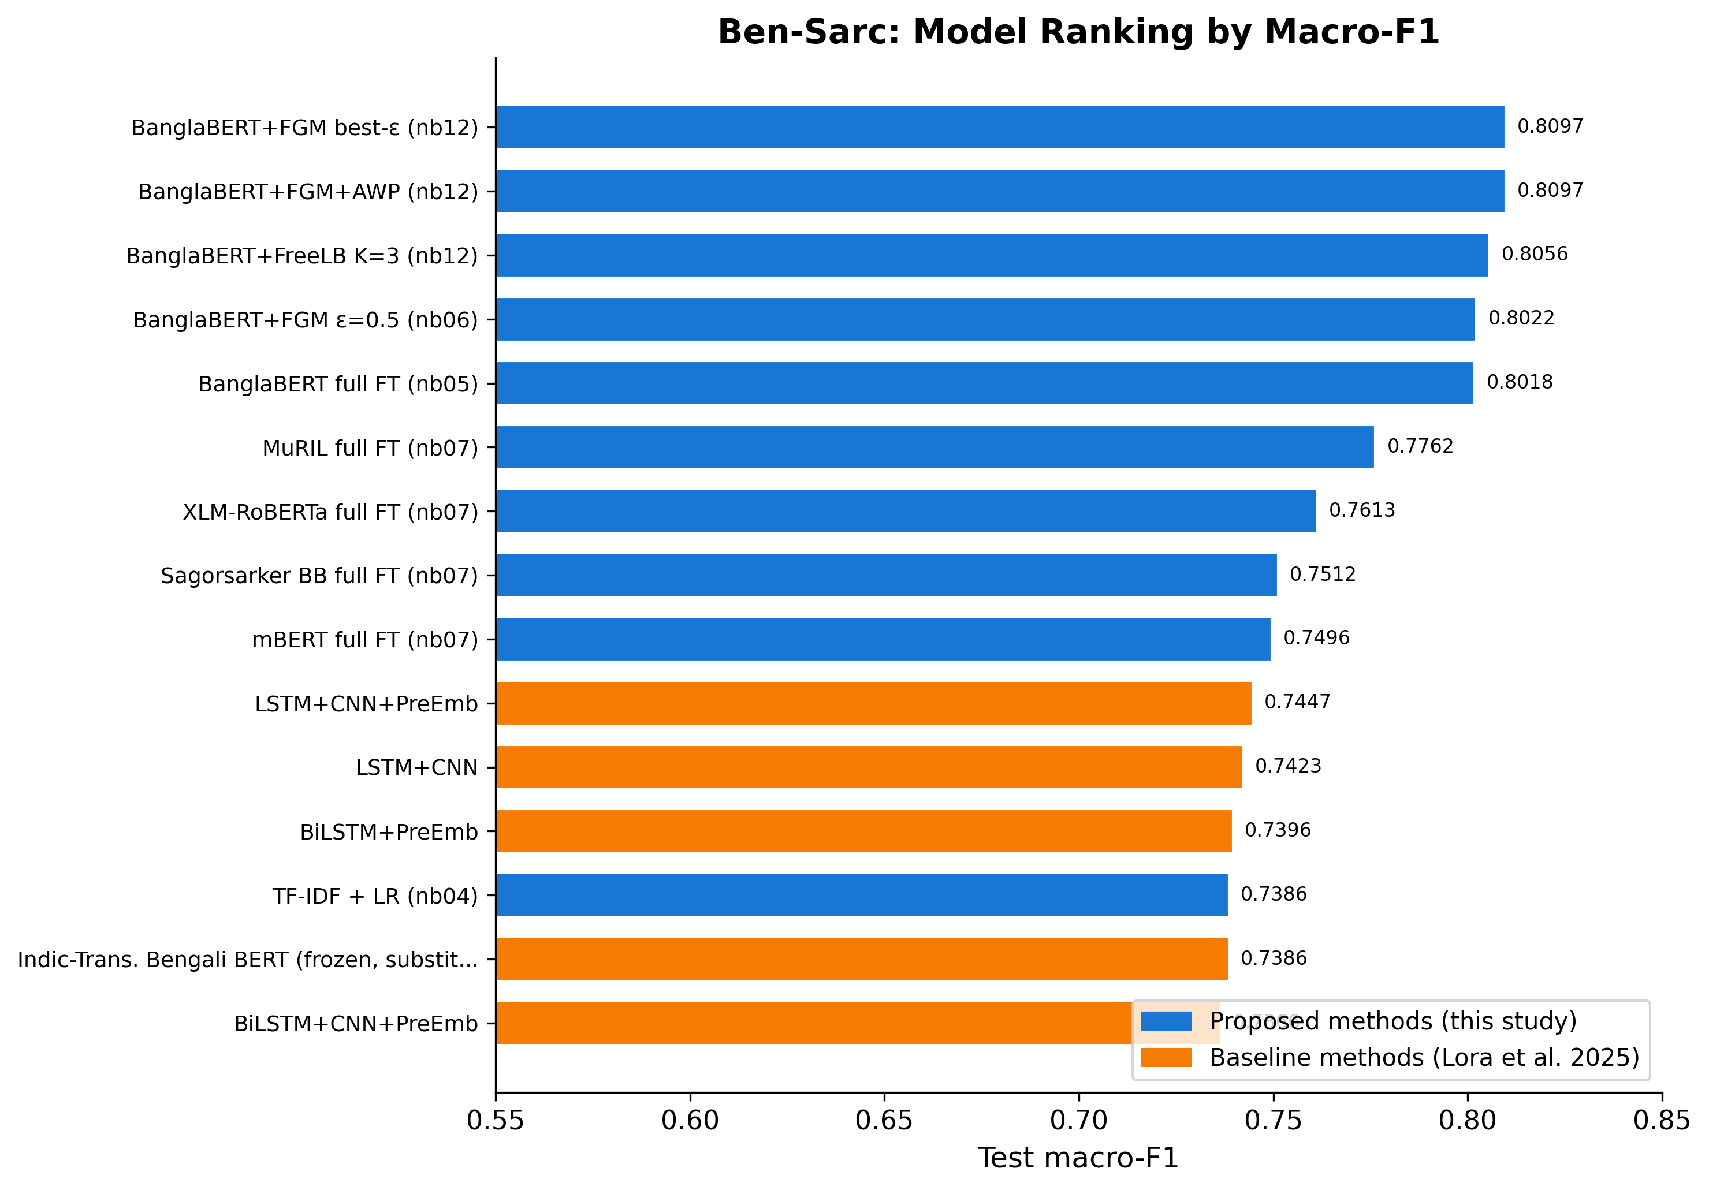
Figure F1. Ben-Sarc Model Ranking by Macro-F1
Blue = proposed thesis methods. Orange = reproduced Lora et al. (2025) methods. Thesis adversarial cluster leads at 0.8022–0.8097; best author-side method reaches 0.7447.

7.2 Head-to-Head: Proposed vs. Lora et al.
Table 7.1 and Figure F10 capture the headline result. BanglaBERT+FGM+AWP beats the best reproduced author-side model by 0.0650 macro-F1, which is +8.7% in relative terms. The gain is statistically significant (McNemar p = 7.98×10⁻¹⁰), the 95% bootstrap CIs do not overlap, and P(proposed > reference) = 1.0000 across 1,000 bootstrap resamples.
Table 7.1: Head-to-Head Performance Metrics on Ben-Sarc Test Set
Metric | Proposed (BanglaBERT+FGM+AWP) | Lora et al. (LSTM+CNN+PreEmb) | Delta
Accuracy | 80.97% | 74.49% | +6.48%
Macro Precision | 80.97% | 74.49% | +6.48%
Macro Recall | 80.97% | 74.57% | +6.40%
Macro F1 | 0.8097 | 0.7447 | +0.0650 (+8.7%)
Note: All values are percentages for Accuracy, Precision, and Recall; Macro F1 is reported as a decimal. Delta = Proposed − Lora et al. Both models evaluated on the same Ben-Sarc test split (seed = 42).

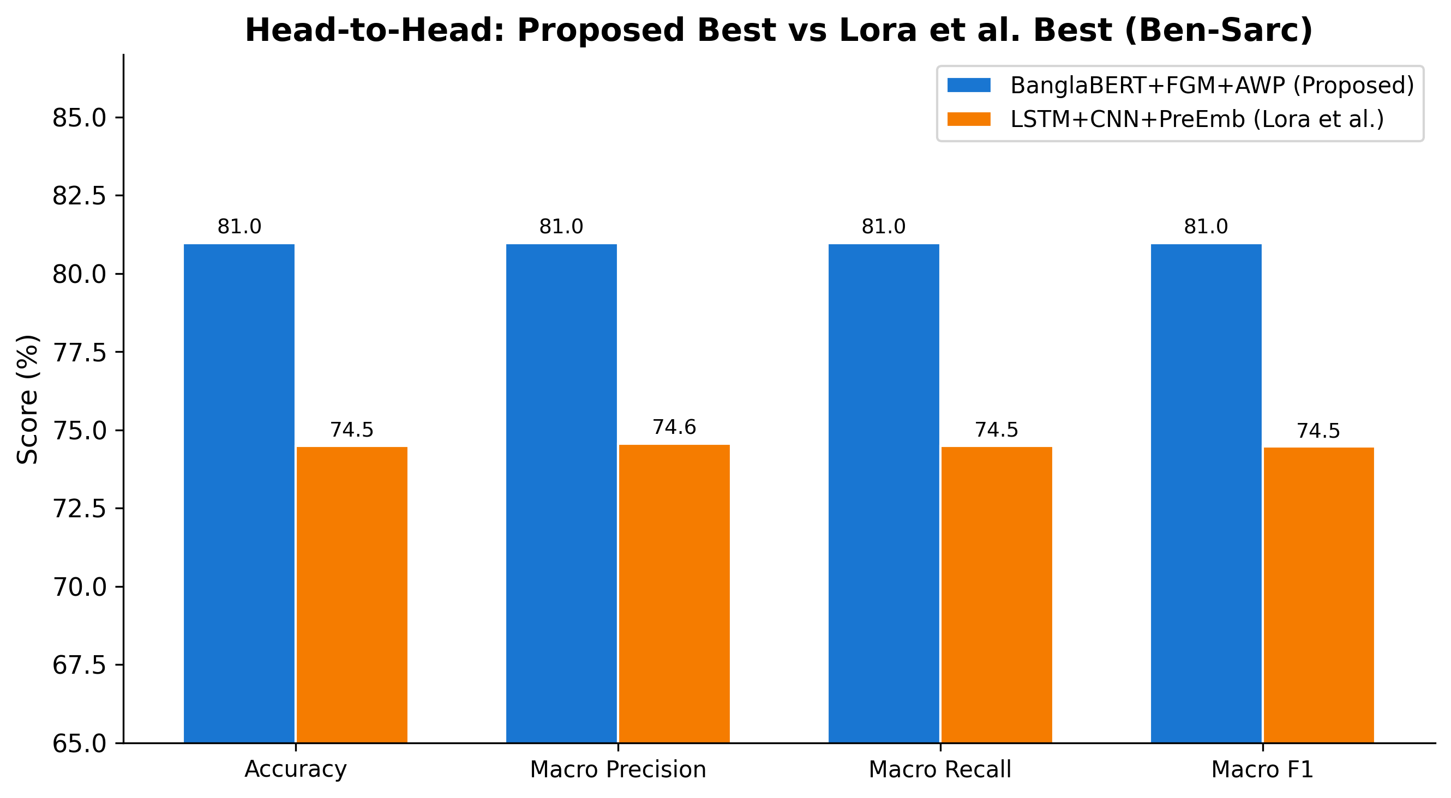
Figure F10. Head-to-Head Metrics: Proposed Best vs. Lora et al. Best (Ben-Sarc)
Proposed BanglaBERT+FGM+AWP (blue) vs. LSTM+CNN+PreEmb reproduced (orange). ~6.5 pp lead across all four metrics.

7.3 Confusion Matrix Analysis
The confusion matrices in Figure F3 show 488 total errors for the proposed model (242 FP + 246 FN) against 654 for the reference model (362 FP + 292 FN), or a 25.4% drop in absolute error count. The error profile is also more balanced for the proposed model, with roughly equal false positives and false negatives, whereas the author-side model leans toward false positives, meaning it tends to flag non-sarcastic comments as sarcastic.
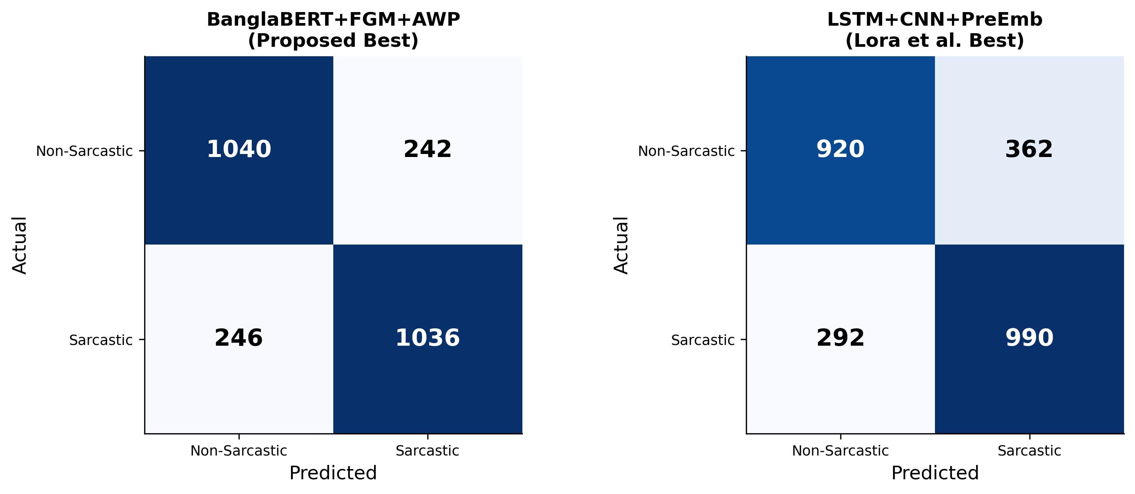
Figure F3. Confusion Matrices: Proposed Best (BanglaBERT+FGM+AWP) vs. Lora et al. Best (LSTM+CNN+PreEmb)
Left: 1040 TP + 1036 TN, 488 total errors. Right: 920 TP + 990 TN, 654 total errors. Proposed model reduces total errors by 25.4%.

7.4 Calibration Analysis
Figure F6 surfaces a counterintuitive result. Even though the proposed BanglaBERT model has the highest accuracy, it also has the highest ECE (0.1294), so it is noticeably overconfident. The author-side models are better calibrated, despite being less accurate. This matches what is generally seen with fine-tuned transformers in the calibration literature, and it has a practical implication: any deployment that needs reliable confidence scores would have to apply post-hoc calibration (temperature scaling, for example) on top of BanglaBERT.
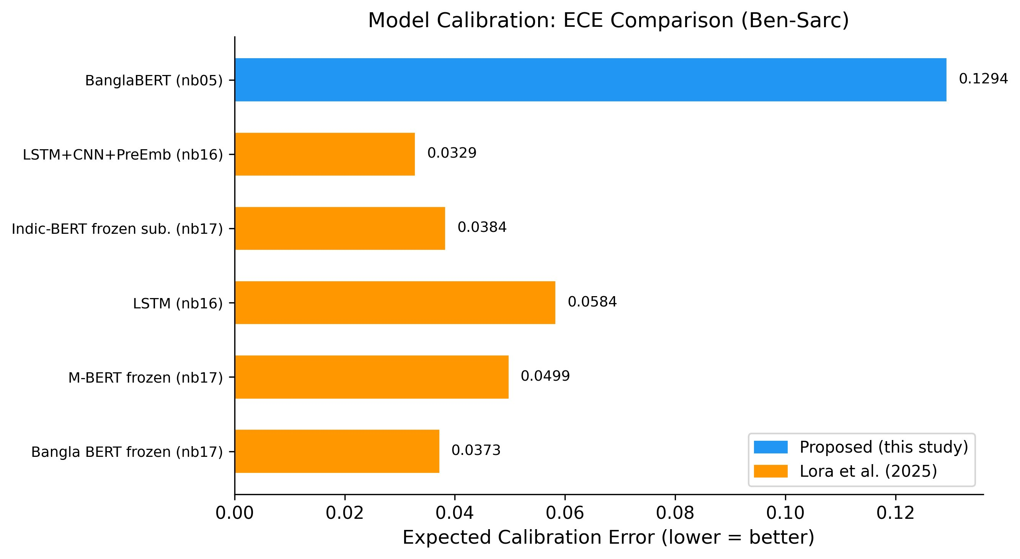
Figure F6. Calibration: Expected Calibration Error Comparison (Ben-Sarc)

7.5 Approach Family Summary
Figure F12 rolls the results up to the approach-family level. The thesis adversarial family (best=0.8097) sits at the top, full fine-tuning (best=0.8018) comes in second, and the three author-side families all cluster below 0.75. This family-level view is probably the most readable high-level summary of what the thesis contributes.
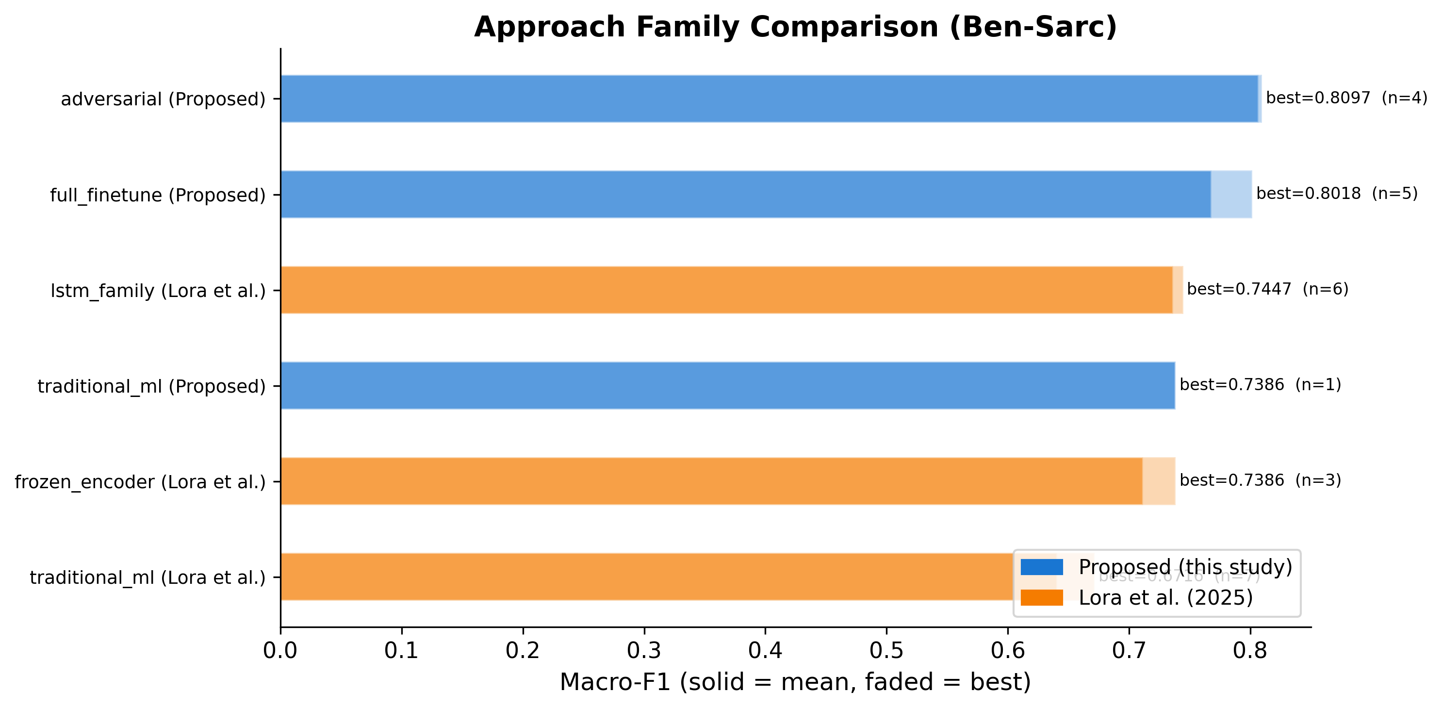
Figure F12. Approach Family Comparison (Ben-Sarc, Macro-F1)
Blue = proposed methods. Orange = Lora et al. Solid = mean family performance; faded = best. Adversarial family leads; all author-side families fall below 0.75.
8. Challenges Faced
- Reproducibility gap: The original Indic-Transformers Bengali BERT referenced in Lora et al. (2025) is no longer publicly available on HuggingFace. The thesis flags this directly and falls back to l3cube-pune/bengali-bert as a documented substitute, which is clearly marked everywhere it appears in the tables and code.
- Computational cost of adversarial training: FGM+AWP loops run about 2.5× slower than vanilla fine-tuning. The cost was kept manageable through FP16 mixed precision on a Kaggle 2×T4 GPU, gradient checkpointing, and gradient accumulation (effective batch size of 8).
- Dataset heterogeneity: The three datasets came with different column names, label conventions, and class distributions, so a four-notebook standardization pipeline (nb00–03) had to be built before any modeling could start.
- Ternary labeling ambiguity: The ternary task on BanglaSarc3 stayed harder than the binary tasks across every model family. The best adversarial model only reached macro-F1 = 0.6618 here, which suggests that the neutral/sarcastic boundary is still an open problem.

9. Remaining Work & Timeline
Task | Priority | Target Date
Thesis document writing (all chapters) | High | Late April – May 2026
Seminar presentation (PPT) with figures embedded | High | Late April-May 2026
Paper submission | Medium | Post-thesis submission

Timeline
Period | Milestone
Jan 2026 | Dataset preparation, EDA, fixed splits (nb00–03)
Feb 2026 | Classical ML baseline, transformer fine-tuning, multi-backbone experiments (nb04–09)
Mar 2026 | Regularization studies, adversarial sweep, ensemble & cross-dataset (nb10–14)
Apr 2026 | Author-method reproduction (nb15–17), comparison (nb18), full analysis (nb19–22), all diagrams
Apr–May 2026 | Thesis document writing across all chapters + seminar presentation
May 2026 | Final submission

10. Expected Contributions

Academic
- The first multi-backbone, multi-technique Bengali sarcasm-detection benchmark spanning three datasets.
- Empirical evidence that full fine-tuning with adversarial perturbation beats the frozen-encoder approach used in the reference paper, with a +8.7% relative macro-F1 gain (p < 0.001).
- A documented reproducibility gap in the Ben-Sarc paper, which is part of why this work argues for a reproducibility-first culture in Bengali NLP.
- Publishable negative results: on this task, R-Drop, label smoothing, and supervised contrastive learning do not improve over adversarial fine-tuning.

10.2 Practical
- Open-source pipeline of 22 notebooks: github.com/Sefayet-Alam/Sarcasm_detection
- Architecture diagrams and 12 publication-quality figures, all ready for journal or conference submission.
- A fixed evaluation protocol that future Bengali NLP work can reuse for benchmarking.

11. References
[1] Lora, K. N., et al. (2025). Ben-Sarc: A self-annotated corpus for sarcasm detection from Bengali social media comments and its baseline evaluation. Natural Language Processing, Cambridge University Press. DOI: 10.1017/nlp.2024.11
[2] Devlin, J., Chang, M.-W., Lee, K., & Toutanova, K. (2019). BERT: Pre-training of deep bidirectional transformers for language understanding. In Proceedings of NAACL-HLT, pp. 4171–4186.
[3] Khatun, A., et al. (2023). BanglaBERT: Language model pretraining and benchmarks for low-resource language understanding evaluation in Bangla. In Findings of NAACL.
[4] Conneau, A., et al. (2020). Unsupervised cross-lingual representation learning at scale. In Proceedings of ACL, pp. 8440–8451.
[5] Jiang, H., et al. (2020). SMART: Robust and efficient fine-tuning for pre-trained NLMs through principled regularized optimization. In Proceedings of ACL, pp. 2177–2190.
[6] Barrantes, A., et al. (2020). Adversarial training for NLP: A review of methods and applications. arXiv preprint.
[7] Liang, X., et al. (2021). R-Drop: Regularized dropout for neural networks. In Advances in NeurIPS.
[8] Khosla, P., et al. (2020). Supervised contrastive learning. In Advances in NeurIPS, pp. 18661–18673.
[9] Guo, C., et al. (2017). On calibration of modern neural networks. In Proceedings of ICML, PMLR 70:1321–1330.
[10] Islam, M. R., et al. (2022). Sentiment analysis for Bengali text: A transformer-based approach. Journal of King Saud University — Computer and Information Sciences.

12. Declaration
I hereby declare that this progress report is my own original work, carried out under the supervision of my thesis supervisor at the Department of Computer Science & Engineering, Rajshahi University of Engineering & Technology. The experimental results, figures, and tables shown here come from notebooks and analysis pipelines that I implemented myself. Any methods, datasets, or findings drawn from prior work have been cited accordingly.
Signature of Student:  ________________________________  Khandoker Sefayet Alam  Roll: 2003121 | Reg: 663  Date: ____________________ | Signature of Supervisor:  ________________________________  Prof. Dr. Md. Rabiul Islam  Professor, Dept. of CSE, RUET  Date: ____________________

