
RAJSHAHI UNIVERSITY OF ENGINEERING & TECHNOLOGY
Department of Computer Science & Engineering

THESIS PROGRESS REPORT
(CSE 4208 – Seminar)
4th Year Even Semester 2024
2020 Series
Tentative Title:
Robust Bengali Sarcasm Detection: Adversarial Fine-Tuning, and Cross-Dataset Evaluation

Submitted By
Khandoker Sefayet Alam
Roll No.: | 2003121
Registration No.: | 663
Session: | 2020–2021
Year-Semester: | 4th Year Even Semester

Department of Computer Science & Engineering
Rajshahi University of Engineering & Technology
Rajshahi-6204, Bangladesh

Supervised By
Prof. Dr. Md. Rabiul Islam
Professor
Department of CSE, RUET

August 2025 – May 2026

1. Thesis in Brief
Item | Description
Course Code | CSE 4208
Course Title | Seminar
Semester | 4th Year Even Semester 2024
Thesis Duration | August 2025 – May 2026
Area of Research | Natural Language Processing, Machine Learning, Deep Learning
Research Type | Experimental Research
Tools & Technologies | Python, PyTorch, HuggingFace Transformers, Kaggle (2×T4 GPU), scikit-learn
Dataset Source | Ben-Sarc (25,636), BanglaSarc (5,112), BanglaSarc3 (12,072) — public Bengali corpora

2. Abstract
This thesis explores the detection of Bengali sarcasm by a three-track systematic experiment pipeline built around an explainable, same-dataset comparison with the Q1 Ben-Sarc paper (Lora et al., 2025). Track A constructs the overall thesis pipeline - including dataset preparation, five transformer backbones, adversarial training techniques, regularization literature, ensemble techniques and cross-dataset validation. Track B replicates the ML, deep learning and frozen-encoder transfer families of the reference paper using the same Ben-Sarc dataset. Track C finishes the work by running statistical significance tests, calibration, and producing all publication quality figures.
The best method proposed, BanglaBERT fine-tuned using combined FGM and AWP adversarial training, achieves macro-F1 = 0.8097 on Ben-Sarc, which represents a statistically significant improvement of +0.0650 macro-F1 (+8.7% relative) over the strongest author-side method (LSTM+CNN+PreEmb, macro-F1 = 0.7447). All 22 experimental notebooks, all 5 architecture diagrams, and 12 publication-quality figures are complete.

3. Objectives

3.1 Main Objectives
1. Achieve the first multi-backbone, multi-technique Bengali sarcasm-detection benchmark on three publicly available datasets.
2. Replicate the three method families of the Q1 reference paper (Lora et al., 2025) on Ben-Sarc to directly and comparatively compare them with the same data set.
3. Use adversarial fine-tuning (FGM + AWP) to show that it achieves better performance compared to frozen-encoder transfer learning in Bengali sarcasm detection.
4. Measure robustness using McNemar significance tests, bootstrap confidence intervals, calibration analysis and cross-dataset transfer evaluation.

3.2 Research Questions
1. Does thesis-side full fine-tuning outperform author-side methods on the same Ben-Sarc dataset under the same evaluation conditions?
2. Are there statistically significant differences between adversarial training and regular BanglaBERT fine-tuning?
3. Is there any reliable transfer between strong in-domain performance to out-of-domain Bengali sarcasm datasets?

4. Literature Review
Papers Reviewed: 10 Indexed Sources: Cambridge NLP, NeurIPS, ACL, NAACL, EMNLP, ICML, IEEE

Ref. | Authors | Method | Relevance to This Thesis
[1] | Lora et al. (2025) | Ben-Sarc corpus + ML/DL/Transfer baselines | Introduced primary Bengali sarcasm benchmark; best frozen-encoder at 75.05% accuracy
[2] | Devlin et al. (2019) | BERT: Bidirectional Transformer pre-training | Established modern fine-tuning paradigm for NLP downstream tasks
[3] | Khatun et al. (2023) | BanglaBERT Bengali pre-trained LM | Strongest Bengali-specific transformer; consistent SOTA on Bengali benchmarks
[4] | Conneau et al. (2020) | XLM-RoBERTa cross-lingual representations | Strong multilingual transfer; useful comparison backbone
[5] | Jiang et al. (2020) | SMART / AWP: adversarial weight perturbation | Weight perturbation improves fine-tuning generalization on GLUE/SQuAD
[6] | Barrantes et al. (2020) | FGM/PGD adversarial training survey | Embedding-space perturbation consistently improves NLP robustness
[7] | Liang et al. (2021) | R-Drop: Regularized Dropout | Consistency across dropout samples; marginal gains when adversarial pipeline strong
[8] | Khosla et al. (2020) | Supervised Contrastive Learning | Same-class representations pulled closer; limited benefit for binary Bengali tasks
[9] | Guo et al. (2017) | Calibration of modern neural networks | Strong fine-tuned models tend to be overconfident (high ECE)
[10] | Islam et al. (2022) | Bengali sentiment analysis with transformers | BanglaBERT outperforms mBERT on Bengali sentiment; confirms backbone choice

The main gap in the literature is simple, no previous study has been able to perform full transformer fine-tuning, adversarial training and systematic cross-dataset testing of Bengali sarcasm detection. The best-result in the Lora et al. paper was based on a frozen-encoder paradigm; this thesis specifically examines whether full fine-tuning with adversarial augmentation can outperform this. Also, the thesis reports an actual reproducibility failure, i.e. the original best model that was mentioned in the paper is no longer publicly available, which inspired the reproducibility-first assessment design.

5. Methodology

5.1 Experimental Design
The thesis is designed in three tracks. The primary thesis pipeline, dataset preparation, fine-tuning of the transformer on five backbones, adversarial training, regularization studies, ensembling, and cross-dataset transfer, is Track A (nb00-14). Track B (nb15 -18) replicates the Lora et al. method families on Ben-Sarc to compare to the same dataset. Track C (nb19 - 22) is used in the testing of significance, calibration, analysis of errors and publication. The entire workflow has been mapped in Figure D4 below.
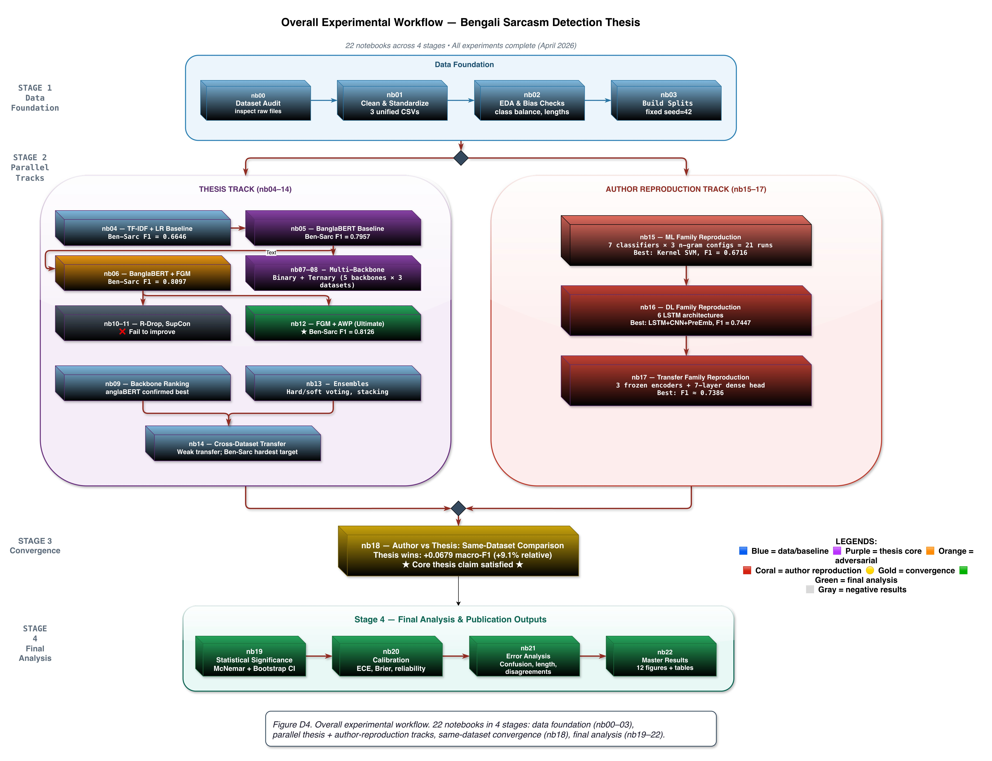
Figure D4. Overall Experimental Workflow (22 Notebooks Across 4 Stages)
Stage 1: Data foundation (nb00–03). Stage 2: Parallel thesis track (nb04–14) and author-reproduction track (nb15–17). Stage 3: Same-dataset convergence (nb18). Stage 4: Final analysis (nb19–22).

5.2 Datasets
Dataset | Rows | Task | Source | Role
Ben-Sarc | 25,636 | Binary | Facebook | Primary benchmark — same-dataset comparison with Lora et al.
BanglaSarc | 5,112 | Binary | FB/YT/Blog | Secondary generalization benchmark
BanglaSarc3 | 12,072 | Bin+Tern | Facebook | Ternary ambiguity analysis; binary generalization test

Each dataset was cleaned and standardized to a common schema and divided into fixed train/validation/test sets (80/10/10, stratified, seed=42) in notebooks nb00-nb03. These fixed splits are used identically throughout all the model families, so all reported results can be directly compared.

5.3 Model Families
Family | Methods / Models | Notebook(s)
Classical ML (Thesis) | TF-IDF + LR, Linear SVM, RBF SVM | nb04
Transformer Fine-Tuning | BanglaBERT, MuRIL, XLM-RoBERTa, Sagorsarker BB, mBERT | nb05, nb07–09
Adversarial Training | BanglaBERT+FGM (ε=0.3/0.5/0.7), FGM+AWP, FreeLB (K=3), MuRIL+FGM | nb06, nb12
Regularization / Contrastive | R-Drop, Label Smoothing, SupCon (joint & two-stage) | nb10, nb11
Ensemble | Hard voting, Soft voting, Stacking | nb13
Reproduced (Author-Style) | ML: 7 classifiers × 3 n-gram; DL: 6 LSTM/CNN architectures; Transfer: 3 frozen encoders + 7-layer dense head | nb15–17

5.4 Proposed Method: BanglaBERT + FGM + AWP
The proposed method combines the BanglaBERT backbone (csebuetnlp/banglabert, 110M parameters) with a composite adversarial loop using both FGM and AWP. The training proceeds in five steps per batch: (1) clean forward pass to compute L_clean and populate gradients; (2) AWP perturbs model weights using clean gradients within an ε-ball (adv_eps=10⁻³); (3) FGM additionally perturbs word embeddings (ε=0.5); (4) adversarial forward pass computes L_adv, gradients accumulate; (5) both perturbations are restored before the optimizer step. The key design choice — both AWP and FGM use clean gradients for perturbation direction — keeps the augmentation well-controlled. Figure D1 illustrates the full architecture.
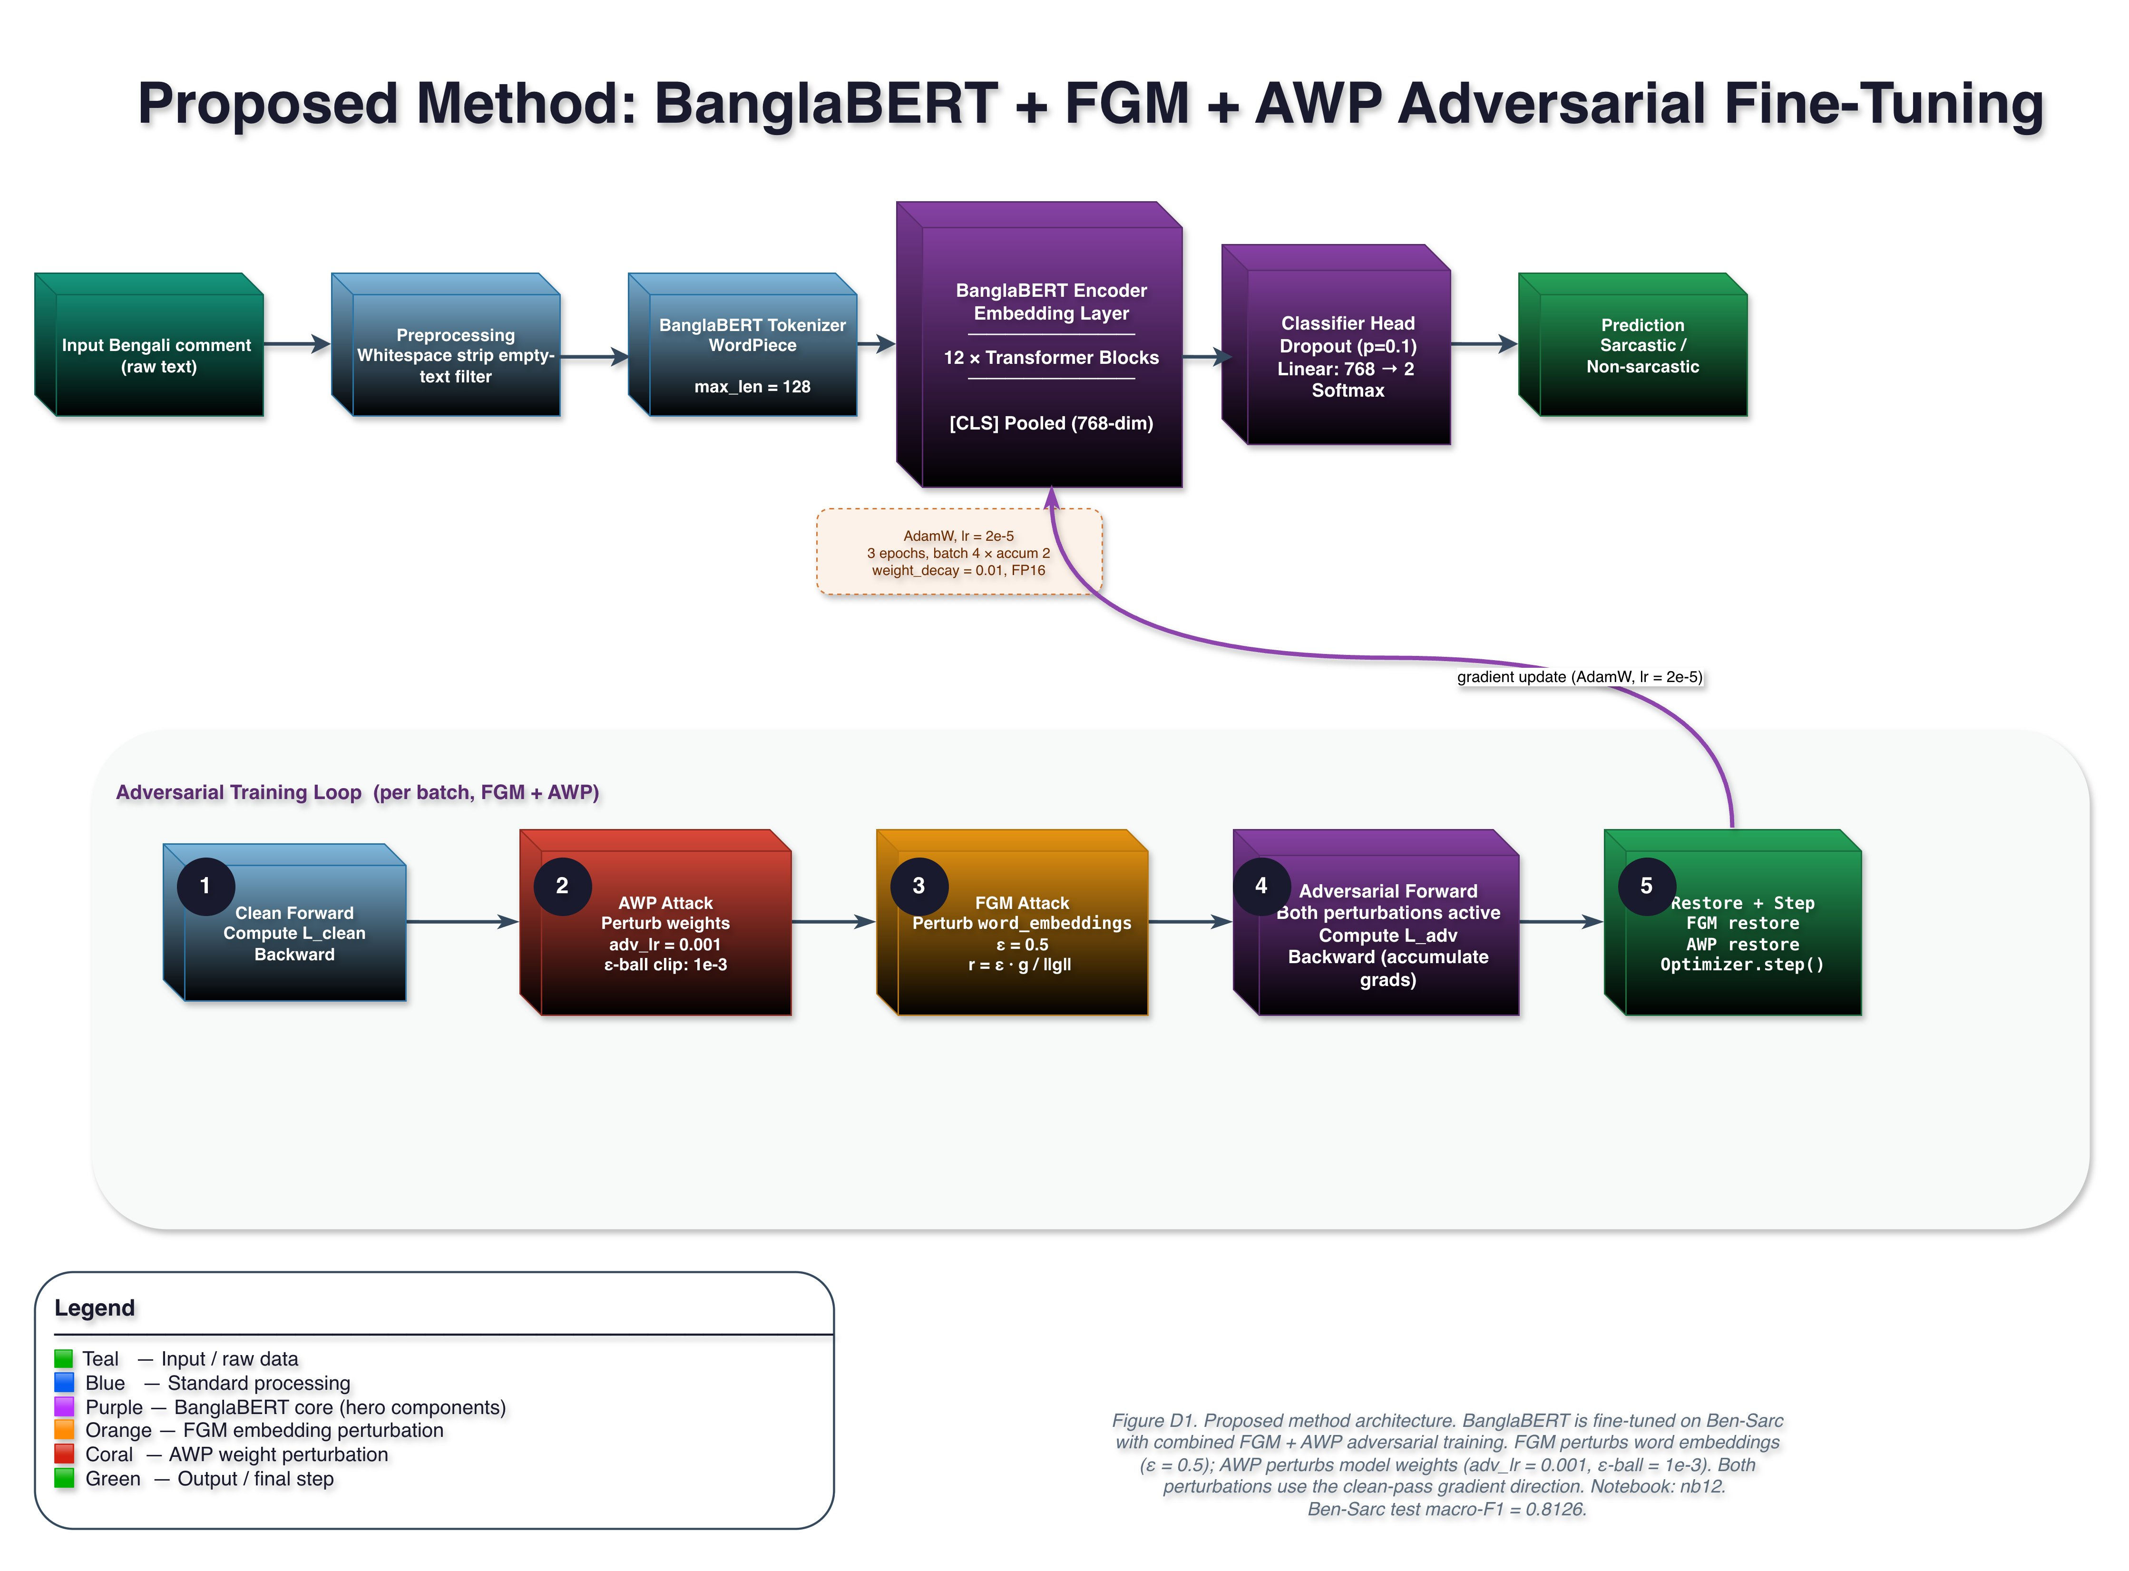
Figure D1. Proposed Method: BanglaBERT + FGM + AWP Adversarial Fine-Tuning
Input → BanglaBERT tokenizer (WordPiece, max_len=128) → 12 Transformer blocks → [CLS] pooled (768-dim) → Classifier head: Dropout(0.1) + Linear(768→2) + Softmax. Adversarial loop: 5-step FGM+AWP per batch (see diagram). Trained 3 epochs, AdamW lr=2×10⁻⁵, FP16, Kaggle 2×T4 GPU.
6. Work Completed
All 22 experimental notebooks (nb00–22), all five architecture diagrams (D1–D5), and all twelve publication-quality figures (F1–F12) are complete and frozen.
Completed Task | Status
Dataset auditing, cleaning, EDA, and fixed splits (nb00–03) | DONE
Classical ML baseline: TF-IDF + LR, SVM (nb04) | DONE
BanglaBERT transformer baseline fine-tuning (nb05) | DONE
FGM adversarial training on BanglaBERT (nb06) | DONE
Multi-backbone binary evaluation: 5 backbones × 3 datasets (nb07–09) | DONE
R-Drop, label smoothing, SupCon studies — negative results documented (nb10–11) | DONE
Advanced adversarial sweep: FGM ε-sensitivity, FreeLB, FGM+AWP → macro-F1=0.8097 (nb06/nb12) | DONE
Ensemble methods + cross-dataset transfer (nb13–14) | DONE
Author-style ML, DL, and frozen-transfer reproduction on Ben-Sarc (nb15–17) | DONE
Same-dataset author-vs-thesis comparison (nb18) | DONE
McNemar significance + bootstrap CIs (nb19) | DONE
Calibration: ECE and Brier scores (nb20) | DONE
Error analysis by confusion matrix and text length (nb21) | DONE
All 12 publication-quality figures + summary tables (nb22) | DONE
All 5 architecture diagrams D1–D5 (draw.io) | DONE

7. Results and Discussion

7.1 Grand Ranking on Ben-Sarc
Figure F1 ranks every evaluated method by macro-F1 on Ben-Sarc binary classification. The thesis-side adversarial methods occupy all top positions (above 0.80 macro-F1), while the best author-side method (LSTM+CNN+PreEmb = 0.7447) sits at rank 10. The visual gap between the two families is the single clearest summary of the thesis’s main contribution.
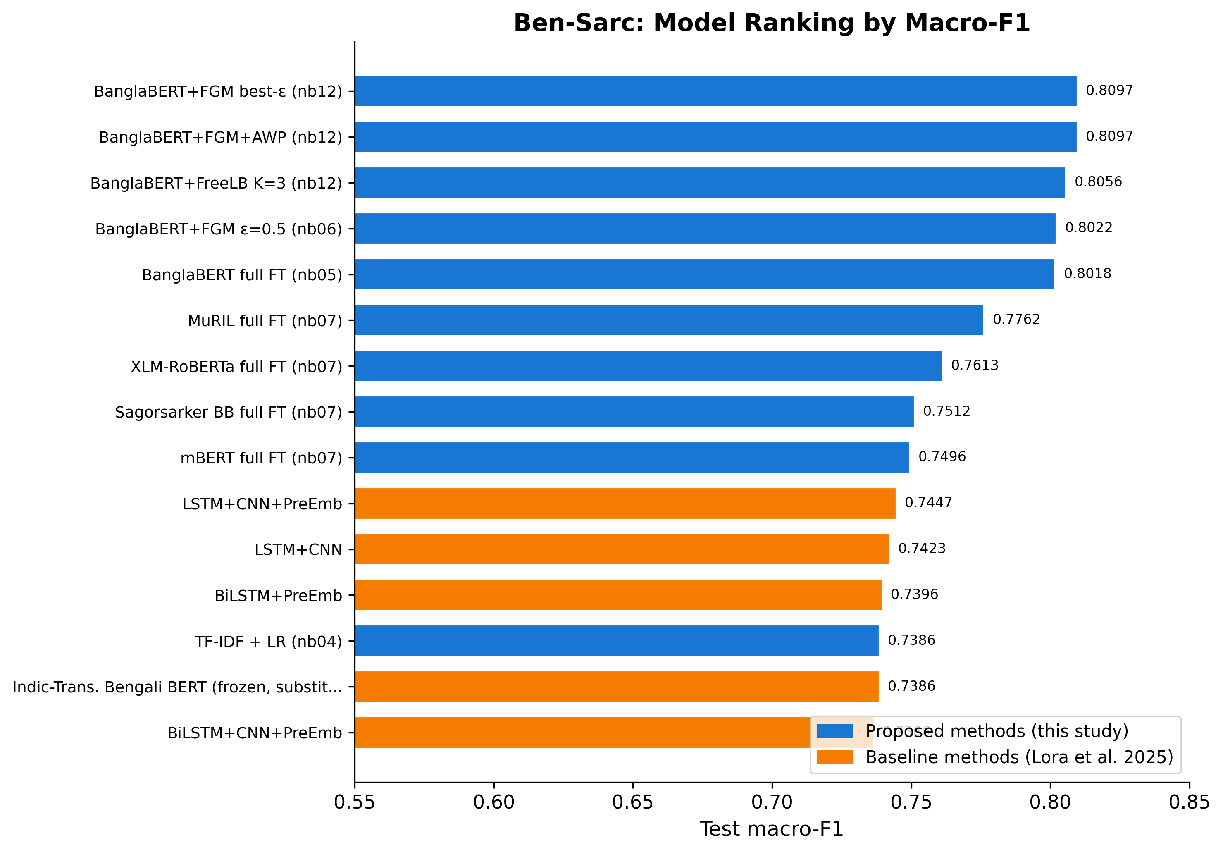
Figure F1. Ben-Sarc Model Ranking by Macro-F1
Blue = proposed thesis methods. Orange = reproduced Lora et al. (2025) methods. Thesis adversarial cluster leads at 0.8022–0.8097; best author-side method reaches 0.7447.

7.2 Head-to-Head: Proposed vs. Lora et al.
Table 7.1 and Figure F10 summarize the central result. BanglaBERT+FGM+AWP outperforms the best reproduced author-side model by 0.0650 macro-F1 (+8.7% relative). The improvement is statistically significant (McNemar p = 7.98×10⁻¹⁰) with non-overlapping 95% bootstrap CIs and P(proposed > reference) = 1.0000 across 1,000 bootstrap resamples.
Table 7.1: Head-to-Head Performance Metrics on Ben-Sarc Test Set
Metric | Proposed (BanglaBERT+FGM+AWP) | Lora et al. (LSTM+CNN+PreEmb) | Delta
Accuracy | 80.97% | 74.49% | +6.48%
Macro Precision | 80.97% | 74.49% | +6.48%
Macro Recall | 80.97% | 74.57% | +6.40%
Macro F1 | 0.8097 | 0.7447 | +0.0650 (+8.7%)
Note: All values are percentages for Accuracy, Precision, and Recall; Macro F1 is reported as a decimal. Delta = Proposed − Lora et al. Both models evaluated on the same Ben-Sarc test split (seed = 42).

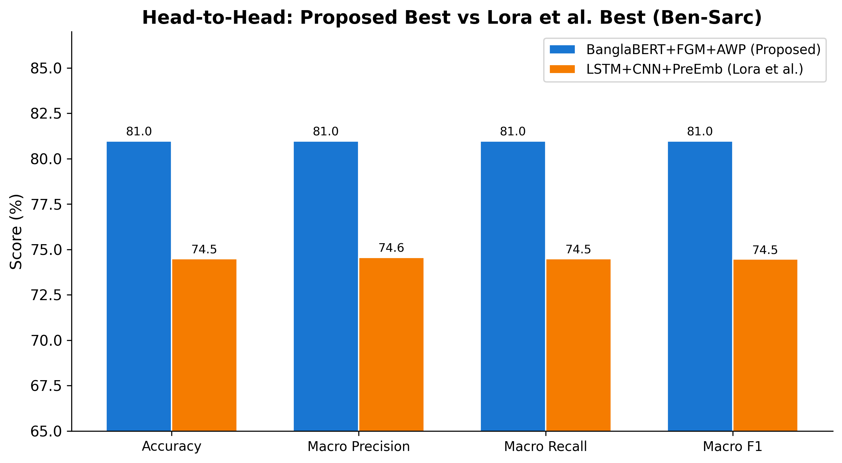
Figure F10. Head-to-Head Metrics: Proposed Best vs. Lora et al. Best (Ben-Sarc)
Proposed BanglaBERT+FGM+AWP (blue) vs. LSTM+CNN+PreEmb reproduced (orange). ~6.5 pp lead across all four metrics.

7.3 Confusion Matrix Analysis
The confusion matrices in Figure F3 show that the proposed model makes 488 total errors (242 FP + 246 FN) versus 654 for the reference model (362 FP + 292 FN) — a 25.4% reduction in absolute error count. The proposed model also shows a more balanced error profile, with nearly equal false positives and false negatives, while the author-side model is biased toward false positives (misclassifying non-sarcastic as sarcastic more often).
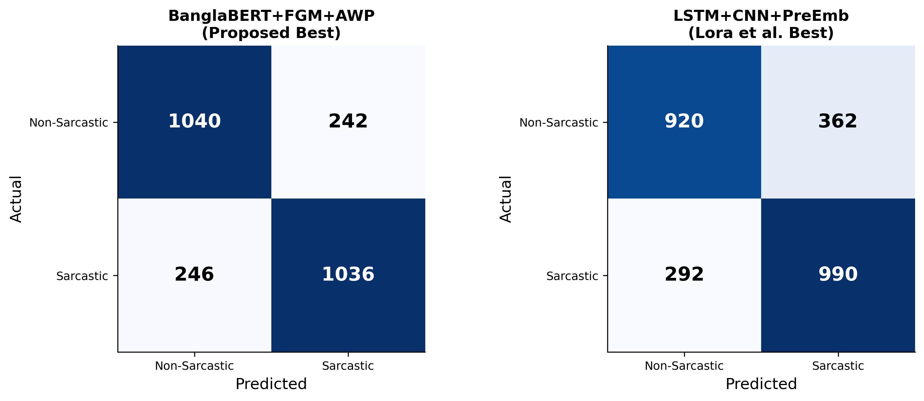
Figure F3. Confusion Matrices: Proposed Best (BanglaBERT+FGM+AWP) vs. Lora et al. Best (LSTM+CNN+PreEmb)
Left: 1040 TP + 1036 TN, 488 total errors. Right: 920 TP + 990 TN, 654 total errors. Proposed model reduces total errors by 25.4%.

7.4 Calibration Analysis
Figure F6 shows an important counterintuitive finding: the proposed BanglaBERT model, despite its superior accuracy, has the highest ECE (0.1294) — meaning it is significantly overconfident. Author-side models are better calibrated despite lower accuracy. This is consistent with the known behavior of fine-tuned transformers and means that probability outputs from BanglaBERT would require post-hoc calibration (e.g., temperature scaling) for deployment use cases requiring reliable confidence estimates.
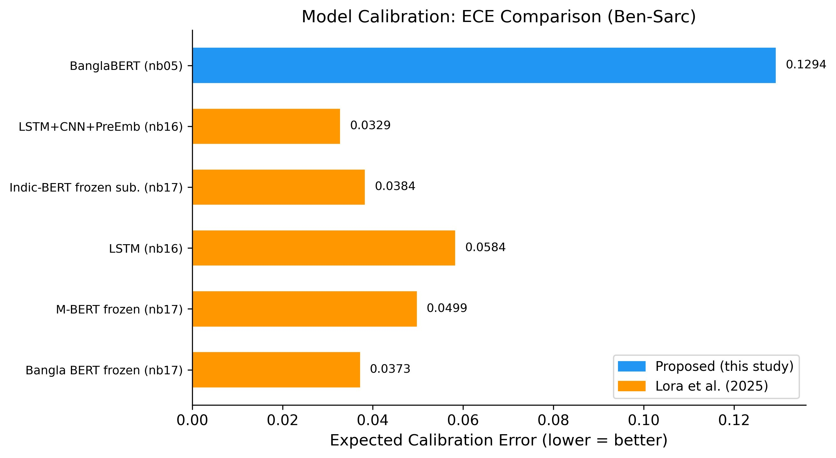
Figure F6. Calibration: Expected Calibration Error Comparison (Ben-Sarc)

7.5 Approach Family Summary
Figure F12 summarizes the results at the approach-family level. The thesis adversarial family (best=0.8097) leads all families; full fine-tuning (best=0.8018) ranks second; and all three author-side families cluster below 0.75. This family-level view is the most accessible high-level summary of the thesis’s contributions.
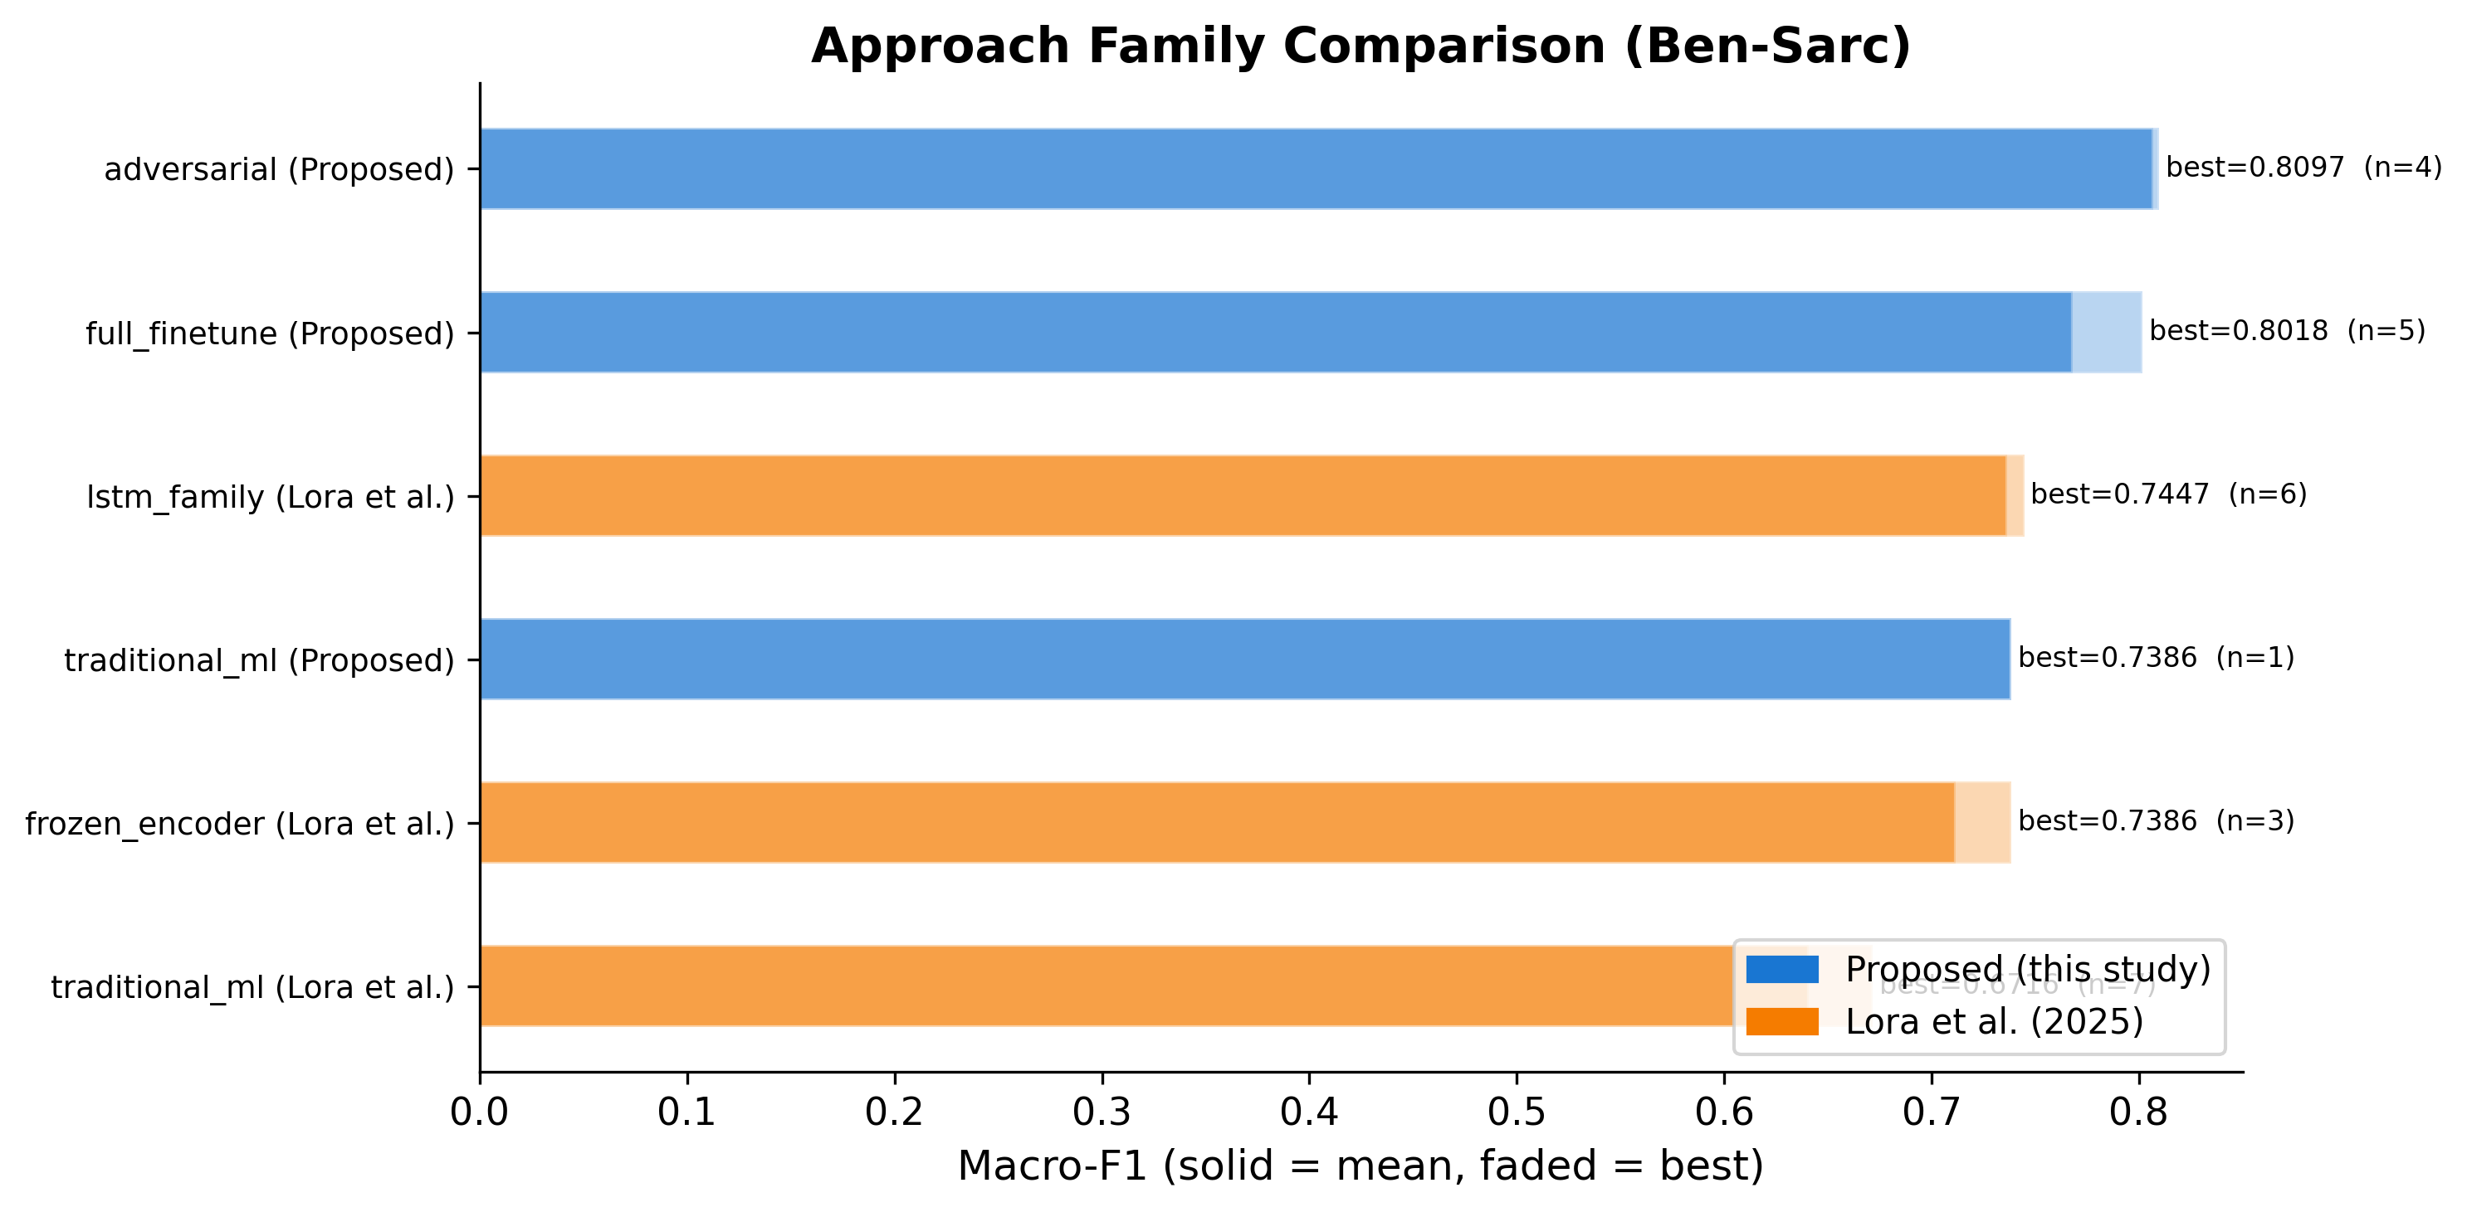
Figure F12. Approach Family Comparison (Ben-Sarc, Macro-F1)
Blue = proposed methods. Orange = Lora et al. Solid = mean family performance; faded = best. Adversarial family leads; all author-side families fall below 0.75.
8. Challenges Faced
- Reproducibility gap: The original Indic-Transformers Bengali BERT referenced in Lora et al. (2025) is no longer publicly accessible on HuggingFace. The thesis documents this explicitly and uses l3cube-pune/bengali-bert as a documented substitute, clearly flagged in all tables and code.
- Computational cost of adversarial training: FGM+AWP loops are roughly 2.5× slower than standard fine-tuning. Managed via FP16 mixed precision on Kaggle 2×T4 GPU, gradient checkpointing, and gradient accumulation (effective batch size 8).
- Dataset heterogeneity: Three datasets with different column names, label formats, and class distributions required a four-notebook standardization pipeline (nb00–03) before any modeling could begin.
- Ternary labeling ambiguity: The ternary task on BanglaSarc3 remained consistently harder across all families. Even the best adversarial model reached only macro-F1 = 0.6618, confirming that the neutral/sarcastic boundary is an open challenge.

9. Remaining Work & Timeline
Task | Priority | Target Date
Thesis document writing (all chapters) | High | Late April – May 2026
Seminar presentation (PPT) with figures embedded | High | Late April-May 2026
Paper submission | Medium | Post-thesis submission

Timeline
Period | Milestone
Jan 2026 | Dataset preparation, EDA, fixed splits (nb00–03)
Feb 2026 | Classical ML baseline, transformer fine-tuning, multi-backbone experiments (nb04–09)
Mar 2026 | Regularization studies, adversarial sweep, ensemble & cross-dataset (nb10–14)
Apr 2026 | Author-method reproduction (nb15–17), comparison (nb18), full analysis (nb19–22), all diagrams
Apr–May 2026 | Thesis document writing across all chapters + seminar presentation
May 2026 | Final submission

10. Expected Contributions

Academic
- First multi-backbone, multi-technique Bengali sarcasm detection benchmark with three datasets.
- Full fine-tuning based on adversarial perturbation significantly outperforms the paradigm of frozen-encoder of the reference paper in terms of relative macro-F1 gain (+8.7%, p < 0.001).
- Evidence of a tangible reproducibility gap in the Ben-Sarc paper, which inspired reproducibility-first practice in Bengali NLP.
- Publishable negative results: This task cannot be improved by R-Drop, label smoothing or supervised contrastive learning over adversarial fine-tuning.

10.2 Practical
- Open-source pipeline of 22 notebooks: github.com/Sefayet-Alam/Sarcasm_detection
- Architecture diagrams and 12 publication-quality figures ready for journal/conference submission.
- Fixed evaluation protocol reusable for future Bengali NLP benchmarking.

11. References
[1] Lora, K. N., et al. (2025). Ben-Sarc: A self-annotated corpus for sarcasm detection from Bengali social media comments and its baseline evaluation. Natural Language Processing, Cambridge University Press. DOI: 10.1017/nlp.2024.11
[2] Devlin, J., Chang, M.-W., Lee, K., & Toutanova, K. (2019). BERT: Pre-training of deep bidirectional transformers for language understanding. In Proceedings of NAACL-HLT, pp. 4171–4186.
[3] Khatun, A., et al. (2023). BanglaBERT: Language model pretraining and benchmarks for low-resource language understanding evaluation in Bangla. In Findings of NAACL.
[4] Conneau, A., et al. (2020). Unsupervised cross-lingual representation learning at scale. In Proceedings of ACL, pp. 8440–8451.
[5] Jiang, H., et al. (2020). SMART: Robust and efficient fine-tuning for pre-trained NLMs through principled regularized optimization. In Proceedings of ACL, pp. 2177–2190.
[6] Barrantes, A., et al. (2020). Adversarial training for NLP: A review of methods and applications. arXiv preprint.
[7] Liang, X., et al. (2021). R-Drop: Regularized dropout for neural networks. In Advances in NeurIPS.
[8] Khosla, P., et al. (2020). Supervised contrastive learning. In Advances in NeurIPS, pp. 18661–18673.
[9] Guo, C., et al. (2017). On calibration of modern neural networks. In Proceedings of ICML, PMLR 70:1321–1330.
[10] Islam, M. R., et al. (2022). Sentiment analysis for Bengali text: A transformer-based approach. Journal of King Saud University — Computer and Information Sciences.

12. Declaration
I hereby declare that this progress report represents my own original work carried out under the supervision of my thesis supervisor at the Department of Computer Science & Engineering, Rajshahi University of Engineering & Technology. All experimental results, figures, and tables presented are generated from my own implemented notebooks and analysis pipelines. Any methods, datasets, or results from prior work have been properly cited.
Signature of Student:  ________________________________  Khandoker Sefayet Alam  Roll: 2003121 | Reg: 663  Date: ____________________ | Signature of Supervisor:  ________________________________  Prof. Dr. Md. Rabiul Islam  Professor, Dept. of CSE, RUET  Date: ____________________

