tallinn University of technology
IT College
Marko Linde 176292IADB

calculator
Javascript (ICD0006)
Instructor: |  | Andres Käver

Table of Contents
1 Assignment 3
2 Overview 4
2.1 Calculator logic 4
2.2 Display 6
2.3 Functionality 7
2.3.1 Main 7
2.3.2 Evaluations after calculate command 7
2.3.3 Calculation command 7
Annex 1 – index.js 8

Assignment
Write simple calculator using Bootstrap (or any other css lib) based design and simple js functionality.
Provide basic functions - +, -, *, /, C
Write your calculator using an object oriented approach. Separate code between business logic and ui.
Please implement classical calculator UI - like you have in your mobile phone.
Nice to have - calculator is done in responsive design. Fits full-screen, both on desktop and on mobile.
Use modules/exports/imports.
UI has to be generated fully in JS.
Only allowed element inside <body> tag is bootstrap import and single custom js import.
Support multiple calculators on page in parallel (every calculator is separate from each other).
Implement UI for dynamic adding and removal

Overview
Index.html and index.css taken from calculator example . Index.js is written by document author.

Calculator logic
Basic idea comes from logic, that the functionality of the calculator can be expanded.
- All calculator clicks are saved in a long string only array which allows:
  - to display the entire equation to the user

Drawing 1. Equation view

  - to add undo button functionality
  - to add calculate only parts of the equation functionality
  - to add click on equation element and repair it directly functionality
  - to make calculator more scientific
- Calculator starts to calculate only when clicking the equal sign
- In EQ mode the calculations are done from left to right with rule: first multiply or divide then add or subtract
- In Not EQ mode the calculations are done from left to right
- Backspace removes last equation entry
- X mark closes calculator
- Calculator business logic with calculator module are injected into Calculator UI
- Index.html is segregated into navbar and main sections
- Calculator receives distinct ID (differentiates calculators) by card1…..n

- ID is generated by static class (id is not needed, but in case required later, it is kept)

- Close button is inside calculator module

- Calculator add but in navbar.

Display
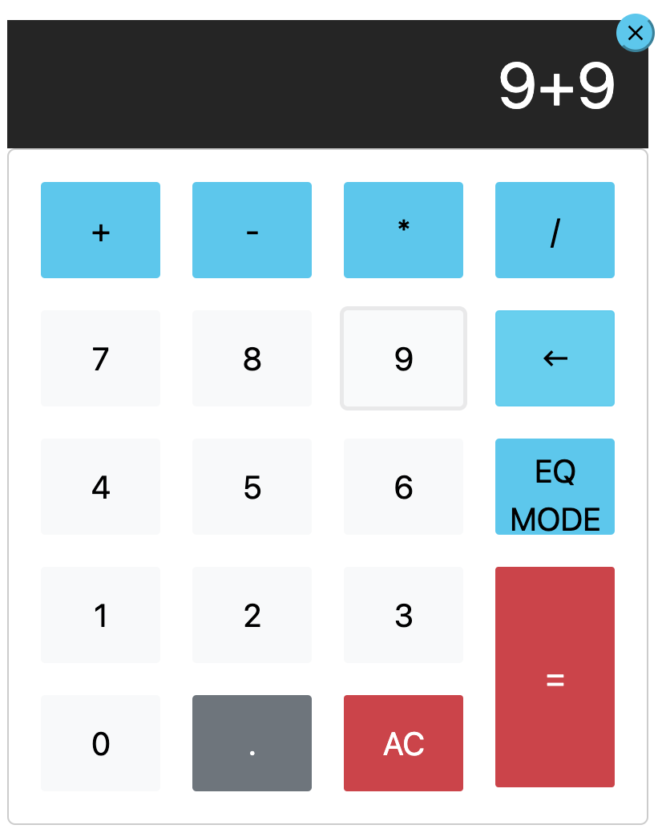

Drawing 2. Calculator screen
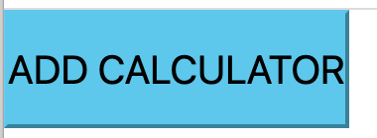
Drawing 3. Add calculator button

Functionality

Main
- Elements are observed through node lists
- Html calculator is generated by module class
- Every button click value is inserted into equations array separately
- Equal button clicking calls calculation function
- AC button click calls overwriting of the previous array by empty array
- Backspace removes last equation entry
- EQ mode switches between two calculation modes
- X button closes calculator
- Add button on navbar adds calculator

Evaluations after calculate command
- Operators the start (except minus) and end equation are evaluated – that they don’t exist
- Two operators straight are not allowed
- Two dots straight are not allowed
- Operator and dot are not allowed

Calculation command
- Number of operators is searched
- First calculation operator is searched from the equation and its index is returned.
- All numbers between operators are converted to full numbers
- Calculated value is inserted back into the equation
- New calculation command iteration will begin

Annex 1 – index.js
import { ModuleId } from "../public/moduleId";
/**
* Class which groups together all html elements for calculator
*/
export class CalculatorModule{

calculatorContent;
calculatorScreen;
calculatorKeyModule;
closeKey;
moduleId;

constructor(){
this.moduleId=ModuleId.getNextId();
this.calculatorContent = document.createElement("div");
this.calculatorContent.className = "calculator card"+this.moduleId;
this.calculatorContent.style.display = 'inline-block';

this.closeKey = this.calculatorKey('close','material-icons','btn-info','button-close')
this.calculatorContent.appendChild(this.closeKey);

this.calculatorScreen = this.setCalculatorScreen("calculator-screen","z-depth-1");
this.calculatorContent.appendChild(this.calculatorScreen);

this.calculatorKeyModule = this.setCalculatorKeyModule();
['+','-','*','/'].forEach(operator =>{
this.calculatorKeyModule.appendChild(this.calculatorKey(operator,'btn-info','btn'));
});
['7','8','9'].forEach(operator =>{
this.calculatorKeyModule.appendChild(this.calculatorKey(operator,'btn-light','waves-effect','btn'));
});
this.calculatorKeyModule.appendChild(this.calculatorKey('keyboard_backspace','operator','material-icons','btn-info','btn'));
['4','5','6'].forEach(operator =>{
this.calculatorKeyModule.appendChild(this.calculatorKey(operator,'btn-light','waves-effect','btn'));
});
this.calculatorKeyModule.appendChild(this.calculatorKey('EQ MODE','operator','btn-info','btn'));
['1','2','3','0'].forEach(operator =>{
this.calculatorKeyModule.appendChild(this.calculatorKey(operator,'btn-light','waves-effect','btn'));
});
this.calculatorKeyModule.appendChild(this.calculatorKey('.','decimal','function','btn-secondary','btn'));
this.calculatorKeyModule.appendChild(this.calculatorKey('AC','all-clear','function','btn-danger','btn-sm','btn'));
this.calculatorKeyModule.appendChild(this.calculatorKey('=','equal-sign','operator','btn-danger','btn-sm','btn'));

this.calculatorContent.append(this.calculatorKeyModule);
}

freeModuleId(){
ModuleId.freeId(this.moduleId);
}

setCalculatorScreen(...cssClasses){
let calculatorScreen = document.createElement("input");
calculatorScreen.type = "text";

cssClasses.forEach(cssClass => {
calculatorScreen.classList.add(cssClass);
});

calculatorScreen.value = "";
calculatorScreen.disabled = true;
return calculatorScreen;
}

setCalculatorKeyModule(){
let calcModule = document.createElement("div");
calcModule.className = "calculator-keys"
return calcModule;
}

calculatorKey(text,...cssClasses){
let button = document.createElement("button");

cssClasses.forEach(cssClass => {
button.classList.add(cssClass);
});

button.value = text;
button.textContent = text;
return button;
}
}

import { CalculatorModule } from "./calculatorModule";
/**
* Takes care of calculator user interface, which
* relays the information from web page to calculation
* and pack
*/
export class CalculatorUI{

constructor(calculus,module){
this.calculus = calculus;
this.module = module;

module.closeKey.onclick = (() => {
this.module.freeModuleId();
this.module.calculatorContent.remove();
});

module.calculatorKeyModule.childNodes.forEach(child =>{
if (child){
child.onclick = (() => {
this.action(child.getAttribute('value'));
if (child.getAttribute('value') === 'EQ MODE'){
child.style.color= (child.style.color === 'red') ? 'black' : 'red';
}
});
}
});
}

action = (action) => {
this.calculus.actionCaller(action);
this.refresh();
}

//refershes display
refresh = () => {
this.module.calculatorScreen.value = this.calculus.getEquationState();
}
}

import { Equation } from "./equation";
/**
* Businesslogic class to perform calculations and find errors
* Todo: move errors to separate class
*/
export class Calculus {

equation;
equationState;
operators;
eqMode;

constructor(){
this.equation = new Equation();
this.equationState = undefined;
this.operators = ['+','-','*','/'];
this.eqMode = 0;
}

actionCaller = (action) =>{
console.log(action);
console.log(JSON.stringify(this.equation));

if (!(this.findErrorAction(action))){
switch (action) {
case 'AC':
this.equation.clear();
break;
case '=':
this.equation.convertEquationToFullNumbers(this.operators);
this.calculate();
break;
case 'keyboard_backspace':
this.equation.removeLast();
break;
case 'EQ MODE':
this.eqMode = this.setEqMode();
console.log("Eqmode :" + JSON.stringify(this.eqMode));
break;
default:
this.equation.addElement(action);
}
}
this.equationState = this.equation.getConcatEquation();
}

//switches system between mathematical standard and linear calculation modes
setEqMode = () =>{
return (this.eqMode === 1) ? 0 : 1;
}

//returns equation to screen
getEquationState = () =>{
return this.equationState;
}

//find user enetered problems
findErrorAction = (action) =>{
let error = 0;
if (this.equation.getConcatEquation().length === 0 && this.equation.getIndex(this.operators,action) > -1 &&
action !== '-') error = 1;
else if ((this.isPreviousEntryAnOperator(this.operators) || this.isPreviousEntryAnOperator(['.'])) &&
action === '=') error = 1;
else if ((this.isPreviousEntryAnOperator(this.operators) || this.isPreviousEntryAnOperator(['.'])) &&
(this.equation.getIndex(this.operators,action) > -1 || action === '.')) error = 1;
return error;
}

isPreviousEntryAnOperator = (operators) =>{
return (this.equation.getIndex(operators,
this.equation.equation[this.equation.equation.length-1]) > -1) ? 1 : 0;
}

calculate = () =>{
while(this.equation.getNumberOfSymbolsInEquation(this.operators)){
if (this.eqMode === 1) this.calculateIndexValue(this.getNextCalculationIndex());
else this.calculateIndexValue(1);
}
}

//calculate equation value on index operator with before and after numbers
//and inserts subcalculation back to equation
calculateIndexValue = (startIndex) =>{
let value = NaN;

switch(this.equation.getIndexValue(startIndex)) {
case '*':
value = parseFloat(this.equation.getPreviousValue(startIndex)) *
parseFloat(this.equation.getNextValue(startIndex));
break;
case '/':
value = parseFloat(this.equation.getPreviousValue(startIndex)) /
parseFloat(this.equation.getNextValue(startIndex));
break;
case '+':
value = parseFloat(this.equation.getPreviousValue(startIndex)) +
parseFloat(this.equation.getNextValue(startIndex));
break;
case '-':
value = parseFloat(this.equation.getPreviousValue(startIndex)) -
parseFloat(this.equation.getNextValue(startIndex));
break;
default:
value;
}
console.log('Index calculation value: ' + value);
this.equation.changeEquation(startIndex,value.toString());
console.log('Equation: ' + JSON.stringify(this.equation.equation));
}

//based on mathemathical logic get first calcualtion operator
getNextCalculationIndex = () =>{
let startIndex = NaN;

if (((this.getEquationIndex('*') !== -1) && (this.getEquationIndex('*') < this.getEquationIndex('/'))) ||
((this.getEquationIndex('/') === -1) && (this.getEquationIndex('*') > this.getEquationIndex('/'))))
startIndex = this.getEquationIndex('*');
else if (this.getEquationIndex('/') >= 1) startIndex = this.getEquationIndex('/');
else if (this.getEquationIndex('+') >= 1) startIndex = this.getEquationIndex('+');
else if (this.getEquationIndex('-') >= 1) startIndex = this.getEquationIndex('-');

console.log('Starting with index: ' + startIndex);
return startIndex;
}

getEquationIndex = (value) =>{
return this.equation.getIndex(this.equation.equation,value);
}
}

/**
* Equation is class to preserve user clicked
* information and perform basic operations with
* array equation
*/
export class Equation {

equation = [];

constructor(){
this.equation = [];
}

clear(){
this.equation = [];
this.number= [];
console.log(JSON.stringify(this.equation));
}

addElement = (elem) => {
this.equation.push(elem);
console.log(JSON.stringify(this.equation));
}

// all individual numeric elements between symbols are converted to full numbers
convertEquationToFullNumbers = (operators) =>{
let index=0;
let number="";
let compressedEquation=[];

this.equation.forEach(elem =>{
if (this.getIndex(operators,elem) > -1 && !(elem === '-' && index === 0)){
compressedEquation.push(number);
compressedEquation.push(elem);
number="";
} else {
if (number === "") number = elem;
else number = number.concat(this.equation[index]);
}
index++;
});
if (number !== ""){
compressedEquation.push(number);
}

this.equation = compressedEquation;
console.log(this.equation);
}

getNumberOfSymbolsInEquation = (operators) =>{
let counter = 0;

this.equation.forEach(elem => {
if (this.getIndex(operators,elem) > -1) counter +=1;
});

return counter;
}

getIndex(operators,sign){
return operators.findIndex((element) => element === sign);
}

getConcatEquation = () =>{
return this.equation.join('');
}

getIndexValue = (index) => {
return this.equation[index];
}

getPreviousValue = (index) => {
return this.equation[index-1];
}

getNextValue = (index) => {
return this.equation[index+1];
}

changeEquation = (index,value) =>{
if (index >= 0) this.equation.splice(index - 1,3,value);
}

removeLast = () =>{
this.equation.pop();
}
}

/**
* Keeps distinct id-s.
*/
export class ModuleId {
static idCounter = 0;
static freeIds = [];

static getNextId() {
if (this.freeIds.length > 0) return this.freeIds.pop();
else return ++this.idCounter;
}

static freeId(id) {
this.freeIds.push(id);
}
}

<html>
<head>
<link href="https://cdn.jsdelivr.net/npm/bootstrap@5.1.3/dist/css/bootstrap.min.css" rel="stylesheet" integrity="sha384-1BmE4kWBq78iYhFldvKuhfTAU6auU8tT94WrHftjDbrCEXSU1oBoqyl2QvZ6jIW3" crossorigin="anonymous">
<link href="https://fonts.googleapis.com/icon?family=Material+Icons" rel="stylesheet">
</head>
<body>
</body>
</html>

"use strict";
import css from "./index.css"
import { CalculatorModule } from "../public/calculatorModule";
import { CalculatorUI } from "../public/calculatorUI";
import { Calculus } from "../public/calculus";

/**
* Setting up WebPage areas
*/
let navBar = document.createElement('div');
let navBarButton = document.createElement('button');
navBarButton.textContent = 'ADD CALCULATOR';
navBarButton.classList = ('btn','btn-info');

navBar.appendChild(navBarButton);
document.body.appendChild(navBar);

let centerArea = document.createElement('div');

document.body.appendChild(centerArea);

function addCalculator(){
navBarButton.onclick = function() {
let calcMod = new CalculatorModule();
centerArea.appendChild(calcMod.calculatorContent);
new CalculatorUI(new Calculus(),calcMod);
}
}

addCalculator();

