tallinn University of technology
IT College
Marko Linde 176292IADB

calculator
Javascript (ICD0006)
Instructor: |  | Andres Käver

Table of Contents
1 Assignment 3
2 Overview 3
2.1 Calculator logic 3
2.2 Display 4
2.3 Functionality 5
2.3.1 Main 5
2.3.2 Evaluations after calculate command 5
2.3.3 Calculation command 5
Annex 1 – index.js 6

Assignment
Write simple calculator using Bootstrap (or any other css lib) based design and simple js functionality.
Use only js functionality learned in class.
Provide basic functions - +, -, *, /, C

Overview
Index.html and index.css taken from calculator example . Index.js is written by document author.

Calculator logic
Basic idea comes from logic, that the functionality of the calculator can be expanded.
- All calculator clicks are saved in a long string only array which allows:
  - to display the entire equation to the user

Drawing 1. Equation view

  - to add undo button functionality
  - to add calculate only parts of the equation functionality
  - to add click on equation element and repair it directly functionality
  - to make calculator more scientific
- Calculator starts to calculate only when clicking the equal sign
- Calculations are done from left to right with rule: first multiply or divide then add or subtract

Display

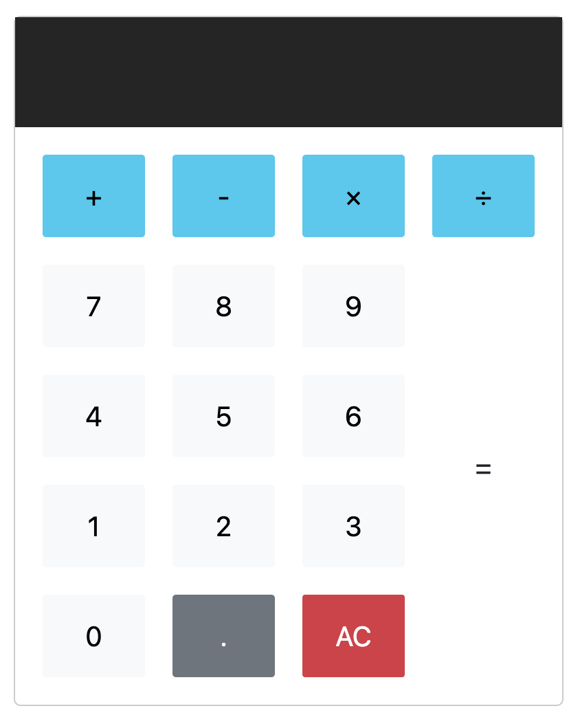
Drawing 2. Calculator screen

Functionality

Main
- All buttons have class “btn” and are observed through it.
- All buttons have distinct values assigned to them and differentiated by those values
- Every button click value is inserted into equations array separately (needs to change at next iteration for evaluate right away functionality - is faster and simpler)
- Equal button clicking calls calculation function
- AC button click calls overwriting of the previous array by empty array

Evaluations after calculate command
- Minus sign at the start is converted to a minus and number at the start and since the numbers are strings, even -0 can be saved correctly.
- Operators the start and end equation are evaluated – that they don’t exist

Calculation command
- Calculation operator is searched from the equation and its index is returned.
- The previous and after numbers are generated and the subset calculation is performed
- Calculated value is inserted back into the equation
- New calculation command iteration will begin

Annex 1 – index.js
"use strict";
/**/import css from "./index.css";

/*https://developer.mozilla.org/en-US/docs/Web/API/Document/querySelectorAll */
/*https://sebhastian.com/javascript-queryselectorall/ */
const buttons = document.querySelectorAll('.btn');
const screen = document.querySelector('.calculator-screen');
const operators = ["+","-","/","*"];

let equation = [];

buttons.forEach(button =>{
button.onclick = function(event){
let btnValue = button.getAttribute('value');
console.log(btnValue);

switch(btnValue) {
case 'all-clear':
clearEquationElement();
break;
case '=':
convertFirstMinusToFullNegative();
calculateValue(equation);
break;
default:
addEquationElement(btnValue);
}
displayOnScreen(concatParams(equation));
}
})
function calculateValue(equation){
while(countSymbolsInEquation(operators)>0){
calculateIndexValue(getNextCalculationIndex());
}}

function convertFirstMinusToFullNegative(){
if ((equation[0] === '-') && (Number.isInteger(parseInt(equation[1])))){
equation.splice(0,2,equation[0].concat(equation[1]));}
else {
clearEquationElement();
displayOnScreen(equation);
}
console.log('Equation: ' + JSON.stringify(equation));
}

function countSymbolsInEquation(operators){
let symbolCount = 0;
let counter = 0;
let symbolError = 0;
equation.forEach(elem => {
counter +=1;
operators.forEach(operator =>{
if (elem === operator) symbolCount+=1;
if (((elem === operator) && (counter === 1)) ||
((elem === operator) && (counter === equation.length))) {symbolError = 1};
})
})
console.log('Symbol error: ' + symbolError);
console.log('Symbols present: ' + symbolCount);
return (symbolError ? 0 : symbolCount);
}

function getNextCalculationIndex(){
let startIndex = NaN;

if (((getIndex('*') !== -1) && (getIndex('*') < getIndex('/'))) ||
((getIndex('/') === -1) && (getIndex('*') > getIndex('/')))) startIndex = getIndex('*');
else if (getIndex('/') >= 1) startIndex = getIndex('/');
else if (getIndex('+') >= 1) startIndex = getIndex('+');
else if (getIndex('-') >= 1) startIndex = getIndex('-');

console.log('Starting with index: ' + startIndex);
return startIndex;
}
function calculateIndexValue(startIndex){
let value = NaN;

switch(equation[startIndex]) {
case '*':
value = parseFloat(getPreviousNumber(startIndex, operators)) * parseFloat(getNextNumber(startIndex, operators));
break;
case '/':
value = parseFloat(getPreviousNumber(startIndex, operators)) / parseFloat(getNextNumber(startIndex, operators));
break;
case '+':
value = parseFloat(getPreviousNumber(startIndex, operators)) + parseFloat(getNextNumber(startIndex, operators));
break;
case '-':
value = parseFloat(getPreviousNumber(startIndex, operators)) - parseFloat(getNextNumber(startIndex, operators));
break;
default:
value;
}
console.log('Index calculation value: ' + value);
insertCalculationToEquation(startIndex,operators,value.toString());
console.log('Equation: ' + JSON.stringify(equation));
}
function insertCalculationToEquation(startIndex, operators, value){
let previousIndex = getPreviousSymbolIndex(startIndex, operators);
let nextIndex = getNextSymbolIndex(startIndex, operators);

console.log('previousIndex: ' + previousIndex);
console.log('nextIndex: ' + nextIndex);

if (startIndex >= 0) equation.splice(previousIndex + 1,nextIndex-previousIndex-1,value);
}

function getPreviousSymbolIndex(startIndex, findOperators){
let previousIndex = startIndex-1;
while(!(findOperators.includes(equation[previousIndex])) && previousIndex >= 0){
previousIndex--;
}
return previousIndex;
}
function getNextSymbolIndex(startIndex, findOperators){
let nextIndex = startIndex+1;
while(!(findOperators.includes(equation[nextIndex])) && nextIndex < equation.length){
nextIndex++;
}
return nextIndex;
}
function getPreviousNumber(startIndex, findOperators){
let previousIndex = startIndex-1;
let previousNumber = NaN;
while(!(findOperators.includes(equation[previousIndex])) && previousIndex >= 0){

if (!isNaN(previousNumber)) {previousNumber = equation[previousIndex].concat(previousNumber);}
else {previousNumber = equation[previousIndex];}
previousIndex--;
}
return previousNumber;
}
function getNextNumber(startIndex, findOperators){
let nextIndex = startIndex+1;
let nextNumber = NaN;

while(!(findOperators.includes(equation[nextIndex])) && nextIndex < equation.length){

if (!isNaN(nextNumber)) {nextNumber = nextNumber.concat(equation[nextIndex]);}
else {nextNumber= equation[nextIndex];}
nextIndex++;
}
return nextNumber;
}

function getIndex(sign){
return equation.findIndex((element) => element === sign);
}

function addEquationElement(elem){
equation.push(elem);
console.log(JSON.stringify(equation));
}

function clearEquationElement(){
equation = [];
console.log(JSON.stringify(equation));
}

function displayOnScreen(value){
screen.value = value;
}

function concatParams(params){
return params.join('');
}

