tallinn University of technology
IT College
Marko Linde 176292IADB

calculator
Javascript (ICD0006)
Instructor: |  | Andres Käver

Table of Contents
1 Assignment 3
2 Overview 3
2.1 Calculator logic 3
2.2 Display 4
2.3 Functionality 5
2.3.1 Main 5
2.3.2 Evaluations after calculate command 5
2.3.3 Calculation command 5
Annex 1 – index.js 6

Assignment
Write simple calculator using Bootstrap (or any other css lib) based design and simple js functionality.
Provide basic functions - +, -, *, /, C
Write your calculator using an object oriented approach. Separate code between business logic and ui.
Please implement classical calculator UI - like you have in your mobile phone.
Nice to have - calculator is done in responsive design. Fits full-screen, both on desktop and on mobile.

Overview
Index.html and index.css taken from calculator example . Index.js is written by document author.

Calculator logic
Basic idea comes from logic, that the functionality of the calculator can be expanded.
- All calculator clicks are saved in a long string only array which allows:
  - to display the entire equation to the user

Drawing 1. Equation view

  - to add undo button functionality
  - to add calculate only parts of the equation functionality
  - to add click on equation element and repair it directly functionality
  - to make calculator more scientific
- Calculator starts to calculate only when clicking the equal sign
- In EQ mode the calculations are done from left to right with rule: first multiply or divide then add or subtract
- In Not EQ mode the calculations are done from left to right
- Backspace removes last equation entry

Display
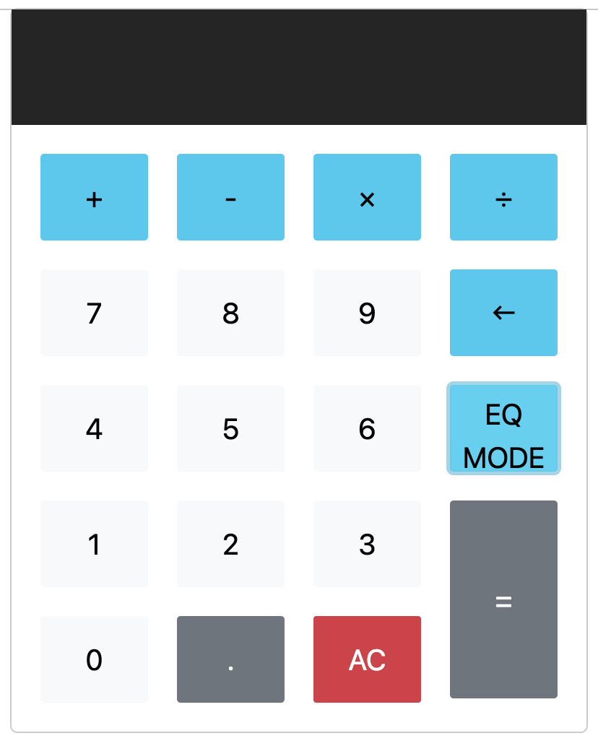

Drawing 2. Calculator screen

Functionality

Main
- All buttons have class “btn” and are observed through it.
- All buttons have distinct values assigned to them and differentiated by those values
- Every button click value is inserted into equations array separately (needs to change at next iteration for evaluate right away functionality - is faster and simpler)
- Equal button clicking calls calculation function
- AC button click calls overwriting of the previous array by empty array
- Backspace removes last equation entry
- EQ mode switches between two calculation modes

Evaluations after calculate command
- Operators the start (except minus) and end equation are evaluated – that they don’t exist
- Two operators straight are not allowed
- Two dots straight are not allowed
- Operator and dot are not allowed

Calculation command
- Number of operators is searched
- First calculation operator is searched from the equation and its index is returned.
- All numbers between operators are converted to full numbers
- Calculated value is inserted back into the equation
- New calculation command iteration will begin

Annex 1 – index.js
"use strict";
import css from "./index.css";

/**
* Equation is class to preserve user clicked
* information and perform basic operations with
* array equation
*/
class Equation {

equation = [];

constructor(){
this.equation = [];
}

clear(){
this.equation = [];
this.number= [];
console.log(JSON.stringify(this.equation));
}

addElement = (elem) => {
this.equation.push(elem);
console.log(JSON.stringify(this.equation));
}

// all individual numeric elements between symbols are converted to full numbers
convertEquationToFullNumbers = (operators) =>{
let index=0;
let number="";
let compressedEquation=[];

this.equation.forEach(elem =>{
if (this.getIndex(operators,elem) > -1 && !(elem === '-' && index === 0)){
compressedEquation.push(number);
compressedEquation.push(elem);
number="";
} else {
if (number === "") number = elem;
else number = number.concat(this.equation[index]);
}
index++;
});
if (number !== ""){
compressedEquation.push(number);
}

this.equation = compressedEquation;
console.log(this.equation);
}

getNumberOfSymbolsInEquation = (operators) =>{
let counter = 0;

this.equation.forEach(elem => {
if (this.getIndex(operators,elem) > -1) counter +=1;
});

return counter;
}

getIndex(operators,sign){
return operators.findIndex((element) => element === sign);
}

getConcatEquation = () =>{
return this.equation.join('');
}

getIndexValue = (index) => {
return this.equation[index];
}

getPreviousValue = (index) => {
return this.equation[index-1];
}

getNextValue = (index) => {
return this.equation[index+1];
}
changeEquation = (index,value) =>{
if (index >= 0) this.equation.splice(index - 1,3,value);
}
removeLast = () =>{
this.equation.pop();
}
}
/**
* Selector class is html similar pointers perserver.
*/
class Selector{
constructor(tag,selector){
this.tag = tag;
this.atribute = document.querySelectorAll(selector);
}
}

/**
* Takes care of calculator user interface, which
* relays the information from web page to calculation
* and pack
*/
class CalculatorUI{
constructor(calculus){
this.calculus = calculus;
this.selectors = [];

this.selectors.push(new Selector('button','.btn'));
this.selectors.push(new Selector('screen','.calculator-screen'));

//iterate through all monitored elements
this.selectors.forEach(selector =>{
if (selector.tag === 'button'){
selector.atribute.forEach(elem =>{
if (elem){
elem.onclick = (() => {
this.action(elem.getAttribute('value'));
if (elem.getAttribute('value') === 'eqMode'){
elem.style.color= (elem.style.color === 'red') ? 'black' : 'red';
}
})}
})
}
});
}

action = (action) => {
this.calculus.actionCaller(action);
this.refresh();
}

//refershes display
refresh = () => {
this.selectors.forEach(selector =>{
if (selector.tag === 'screen'){
selector.atribute.forEach(elem =>{
if (elem){
elem.value = this.calculus.getEquationState();
}
})
}
});
}
}

/**
* Businesslogic class to perform calculations and find errors
* Todo: move errors to separate class
*/
class Calculus {

equation;
equationState;
operators;
eqMode;

constructor(){
this.equation = new Equation();
this.equationState = undefined;
this.operators = ['+','-','*','/'];
this.eqMode = 0;
}

actionCaller = (action) =>{
console.log(action);
console.log(JSON.stringify(this.equation));

if (!(this.findErrorAction(action))){
switch (action) {
case 'all-clear':
this.equation.clear();
break;
case '=':
this.equation.convertEquationToFullNumbers(this.operators);
this.calculate();
break;
case 'undo':
this.equation.removeLast();
break;
case 'eqMode':
this.eqMode = this.setEqMode();
console.log("Eqmode :" + JSON.stringify(this.eqMode));
break;
default:
this.equation.addElement(action);
}
}
this.equationState = this.equation.getConcatEquation();
}

//switches system between mathematical standard and linear calculation modes
setEqMode = () =>{
return (this.eqMode === 1) ? 0 : 1;
}
//returns equation to screen
getEquationState = () =>{
return this.equationState;
}

//find user enetered problems
findErrorAction = (action) =>{
let error = 0;
if (this.equation.getConcatEquation().length === 0 && this.equation.getIndex(this.operators,action) > -1 &&
action !== '-') error = 1;
else if ((this.isPreviousEntryAnOperator(this.operators) || this.isPreviousEntryAnOperator(['.'])) &&
action === '=') error = 1;
else if ((this.isPreviousEntryAnOperator(this.operators) || this.isPreviousEntryAnOperator(['.'])) &&
(this.equation.getIndex(this.operators,action) > -1 || action === '.')) error = 1;
return error;
}

isPreviousEntryAnOperator = (operators) =>{
return (this.equation.getIndex(operators,
this.equation.equation[this.equation.equation.length-1]) > -1) ? 1 : 0;
}

calculate = () =>{
while(this.equation.getNumberOfSymbolsInEquation(this.operators)){
if (this.eqMode === 1) this.calculateIndexValue(this.getNextCalculationIndex());
else this.calculateIndexValue(1);
}
}

//calculate equation value on index operator with before and after numbers
//and inserts subcalculation back to equation
calculateIndexValue = (startIndex) =>{
let value = NaN;

switch(this.equation.getIndexValue(startIndex)) {
case '*':
value = parseFloat(this.equation.getPreviousValue(startIndex)) *
parseFloat(this.equation.getNextValue(startIndex));
break;
case '/':
value = parseFloat(this.equation.getPreviousValue(startIndex)) /
parseFloat(this.equation.getNextValue(startIndex));
break;
case '+':
value = parseFloat(this.equation.getPreviousValue(startIndex)) +
parseFloat(this.equation.getNextValue(startIndex));
break;
case '-':
value = parseFloat(this.equation.getPreviousValue(startIndex)) -
parseFloat(this.equation.getNextValue(startIndex));
break;
default:
value;
}
console.log('Index calculation value: ' + value);
this.equation.changeEquation(startIndex,value.toString());
console.log('Equation: ' + JSON.stringify(this.equation.equation));
}

//based on mathemathical logic get first calcualtion operator
getNextCalculationIndex = () =>{
let startIndex = NaN;

if (((this.getEquationIndex('*') !== -1) && (this.getEquationIndex('*') < this.getEquationIndex('/'))) ||
((this.getEquationIndex('/') === -1) && (this.getEquationIndex('*') > this.getEquationIndex('/'))))
startIndex = this.getEquationIndex('*');
else if (this.getEquationIndex('/') >= 1) startIndex = this.getEquationIndex('/');
else if (this.getEquationIndex('+') >= 1) startIndex = this.getEquationIndex('+');
else if (this.getEquationIndex('-') >= 1) startIndex = this.getEquationIndex('-');

console.log('Starting with index: ' + startIndex);
return startIndex;
}

getEquationIndex = (value) =>{
return this.equation.getIndex(this.equation.equation,value);
}
}

/**
* Calling calculation program
*/
new CalculatorUI(new Calculus());

