tallinn University of technology
IT College
Marko Linde 176292IADB

ProdROAD
Distributed Systems (ICD0021)
Instructor: | Andres Käver

Author declaration
The purpose of the project is to make a simple and user friendly, easily understandable and partly automated production planning tool. It is meant for small production companies (some of my own friends) and gives an opportunity to offer ten times cheaper alternative to many APP-s out there. Normal usable ready solutions start at 50 dollars per month, which is way too expensive for starting business and real small productions. Not mentioning the scale up of price by users and features.
Abbreviations and definitions
DTO | Data transfer object, object, that is meant for keeping data without functionality
C# | C sharp, third generation programming language
REST | Representational state transfer, application communication standard which separates client from the server.
MVC | Model-View-Controller, architectural pattern, that separates API to structural logical components. Model represents program logical component, View represents user component and controller the interface between user and server
API | Application programming interface, interface which helps the program to communicate to outside world
DAL | Data Access Layer
BLL  JSON | Business Logic Layer  JavaScript Object Notation, structure for data transfer
JWT | JSON web token,
UI | User interface,
DOM | Document Object Model, Html API
UX | User experience,
CRUD | Create-Read-Update-Delete,
CI | Continuous Integration,
E2E | End to End, testing structure
POP | Page Object Pattern, testing pattern, where the html components or pages are kept inside objects.
SOLID
UOW
FP
GIT
AOP

Table of Contents
1 Assignment 6
2 Overview 7
2.1 Client side business requirements 7
2.2 User interface 8
2.3 Main user functionality preliminary 10
2.4 User functionality 10
Annex 1 – DB Model 11
Annex 2 12

Assignment
APP where the program server component is written on C#. The frontend APP should end up eventually as mobile APP and as browser APP. The application should work in multiple canvas modes:
- Calendar mode is the view where user can make a roadmap for their teams, production lines and get a grasp of work collisions, workloads and rising problems in flow.
- Modular mode should give a view in different user created tasks. These tasks depend on company specific production flow (like assembly, packaging, production, sales, delivery and so on)
- Analytical mode is about giving feedback how planning and reality fit together. How different teams perform and what can be made better
- Resource mode should show stock of materials and when will they run out and give ordering predictions based on last arrivals from suppliers
Production Manager APP v0.1 and this project scope includes planning and communication between different production parties.
Future aspect includes mobile API for easier component utilization and notification management and reaction. API must have the possibility to synchronize data between several different warehouses. Possible future solution should include export and import of warehouse component list and basic logistics for delivery and warehouse planning.

Overview
ProdRoad APP v0.1 gives the production workflow planning and communication between designer and different production teams.
Server side DTO-s will be constructed from visual ERD-CASE diagram and database update and initialization will come through migration. Code first script files for database generation will be included at the end of this document.

Client side business requirements
- program has to be written in C# language using Net Core 6.x. Class libraries have to use 6.x aswell.
- program has to follow clean SOLID architecture and MVC pattern
- program features have to be layered for easy change.
- Data will be stored using UNKNOWN and using taltech provided schema.
- Entity Framework Core will be used as wrapper over database and takes care of information mapping and virtual structure generation of DAL DTO-s
- DAL layer
- BLL layer
- API layer
- user creation and user activities basics are left for .Net individual authentication and identitycontext.
- User roles are segregated between Super, Main and Regular
- Role groups are segregated between Super user created Teams
- user client authorization will be with stateless JWT. JWT will get a secret which will expire with new key. JWT will also be added to every user request.

User interface
Main views made in Figma and interactive link:
https://www.figma.com/proto/B3btV75evn32c4pV20fqPO/ProductionAPP?node-id=31%3A26&scaling=min-zoom&page-id=0%3A1&starting-point-node-id=31%3A26&show-proto-sidebar=1
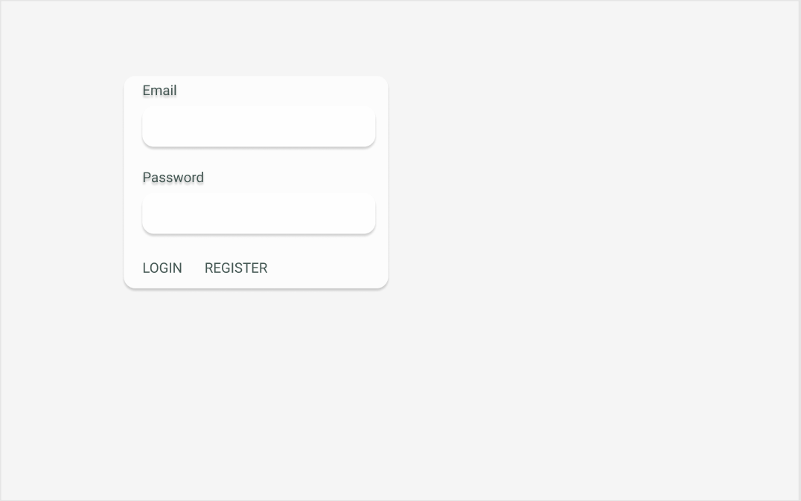
Drawing 1. Login screen
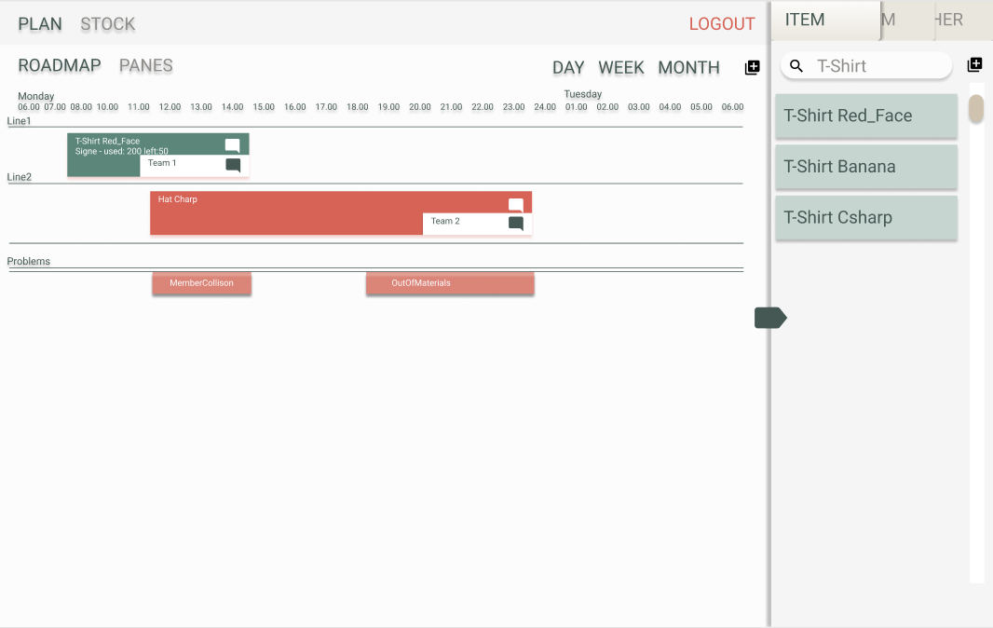
Drawing 2. Production plan screen

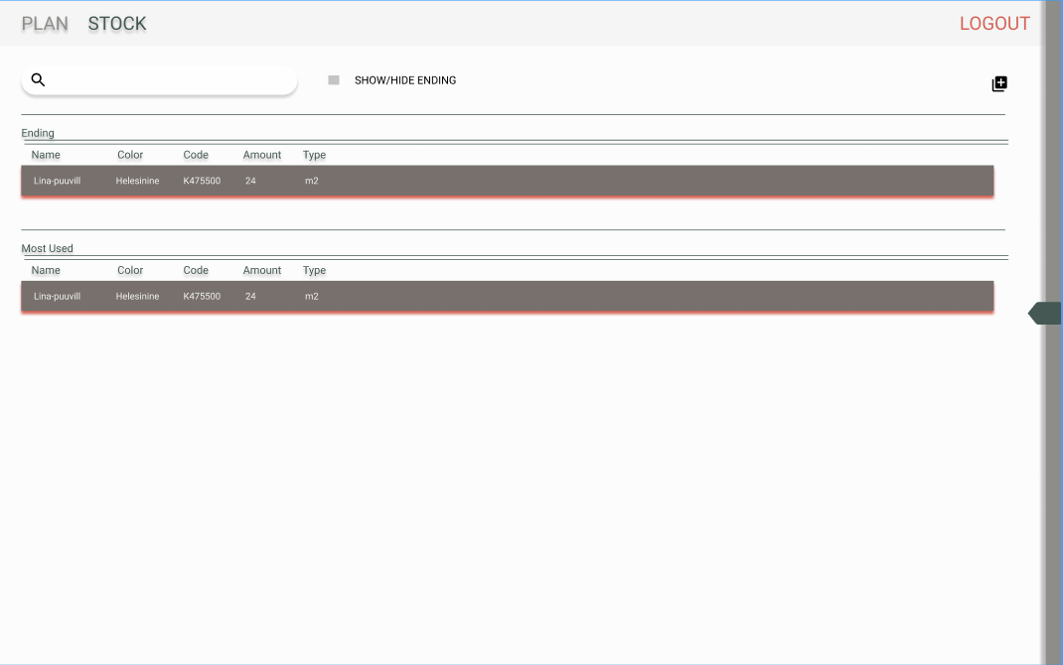
Drawing 3. Stock overview

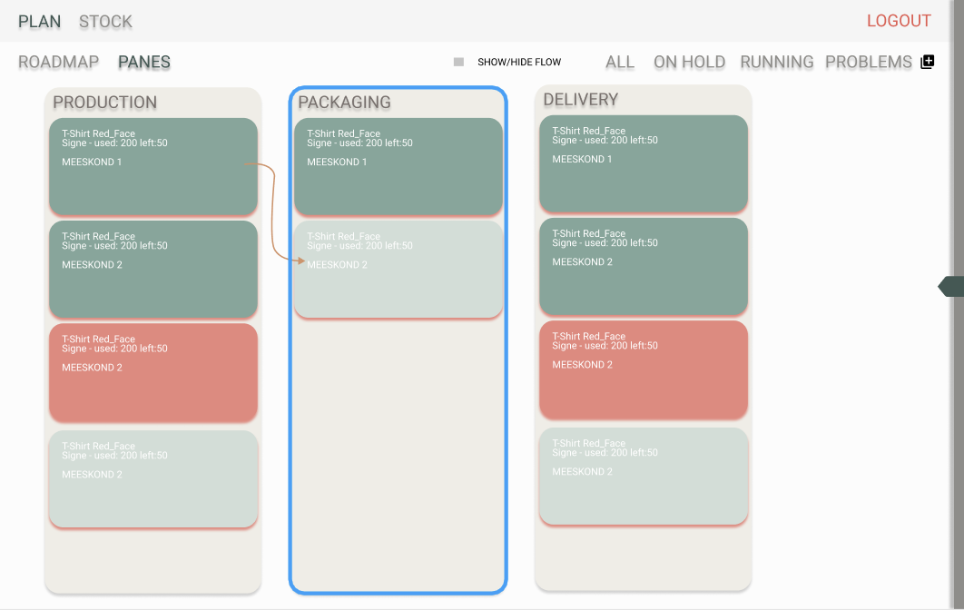
Drawing 4. Pane overview

- Server-client communication datatype will be JSON
- UI development for lesser mistakes will be held in typescript
- UI and some UX will be configured by Materialize library.

Main user functionality preliminary
- ROLE based authentication

User functionality
- notifications CRUD
- fulfilling orders, marking extensions and problems

Annex 1 – DB Model
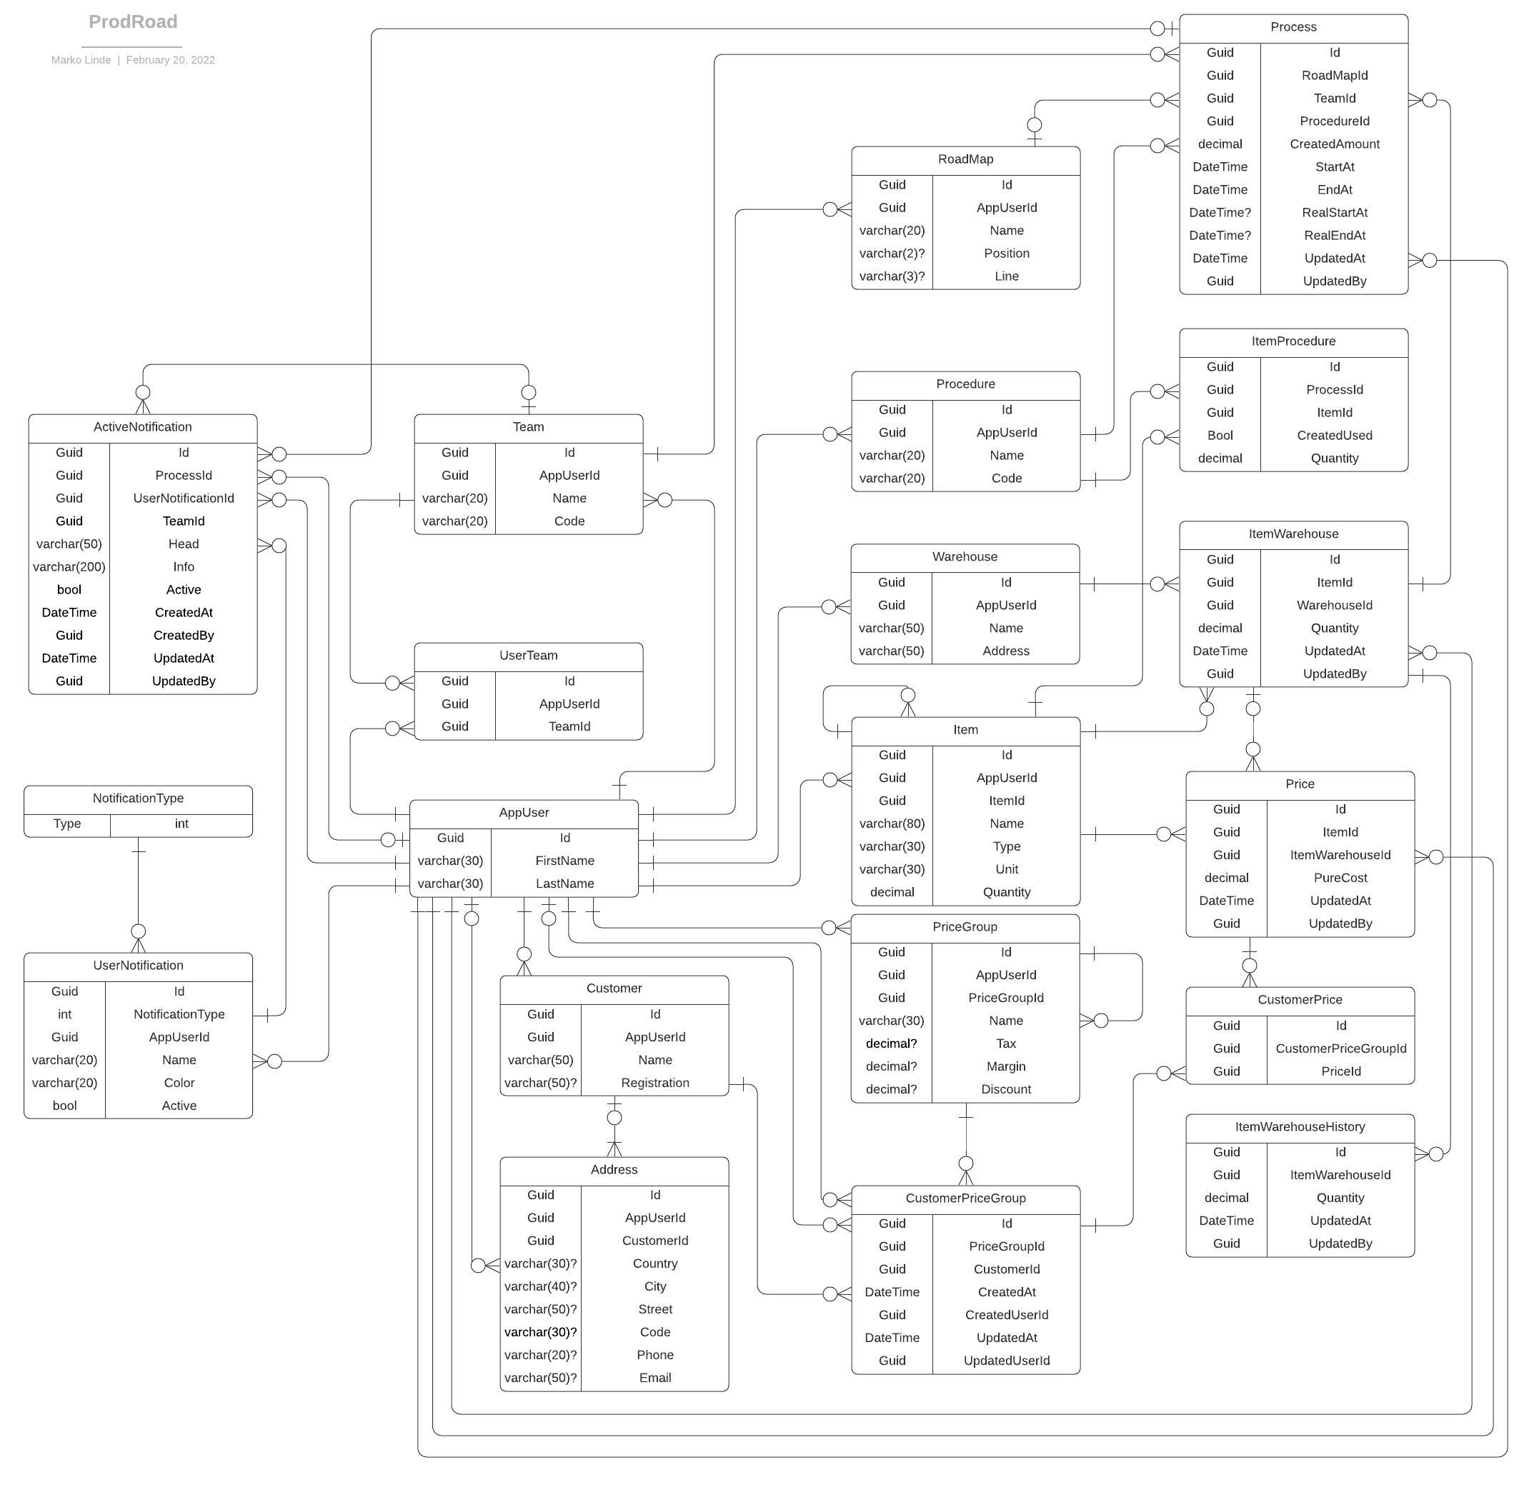

Annex 2

