ENGINEERING PROJECT / TECHNICAL PROGRESS REPORT
ULTRASONIC DOPPLER
GESTURE SENSING
Experimental progress report
Contact-free gesture detection using a laptop speaker and microphone
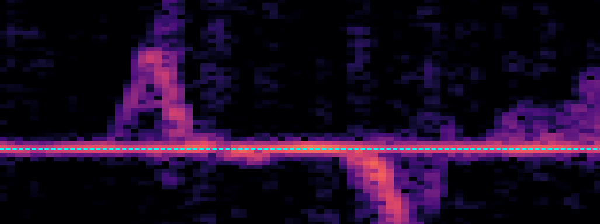
Recorded 19 kHz Doppler response during hand movement | experimental spectrogram, 15 October 2026
PROJECT TEAM
Saif Eldin Hany | 222007569
Amr Mohamed | 221017812
Mohamed Alaa | 222007542
DOCUMENT INFORMATION
Reporting period | 10–16 October 2026
Document version | 0.5 | 17 October 2026
University / course | [To be completed before submission]
Experimental evidence and measurements recorded through 16 October 2026.

Table of Contents
All chapters, numbered subsections, references and appendices
Chapter 1. Team Organization and Responsibilities 4
1.1 Team roster and recorded work 4
1.2 Suggested development ownership 4
1.3 Reproducibility and versioning 4
Chapter 2. Project Overview and Objectives 5
2.1 Project status and summary 5
2.2 Project idea and operating principle 5
2.3 Functional objectives 6
2.4 Boundary conditions 6
Chapter 3. Technical Background and System Architecture 7
3.1 Doppler shift from a moving reflector 7
3.2 Digitization and time–frequency analysis 7
3.3 Implementation architecture 7
Chapter 4. Development Environment and Hardware Setup 9
4.1 Installation and isolation 9
4.2 Audio device discovery 9
4.3 Windows audio-processing intervention 9
Chapter 5. Implementation and Experimental Results 11
5.1 Timeline of implemented milestones 11
5.2 Frequency-response troubleshooting 11
5.3 Baseline and movement recording 12
5.4 Baseline vs motion spectrogram 12
Chapter 6. Live Doppler Sensing and Direction Detection 14
6.1 Real-time acoustic visualization 14
6.2 Controlled toward-versus-away observations 14
6.3 Implemented rule-based live detector 15
TABLE OF CONTENTS / CONTINUED
Chapter 7. Multichannel and Left–Right Gesture Investigation 16
7.1 Why left/right is not equivalent to toward/away 16
7.2 Four-channel acquisition 16
7.3 First two-channel sideband ratio test 17
7.4 Two batches of five trials per swipe direction 17
7.5 Temporal-ratio feature exploration 18
7.6 Audible snap time-difference experiment 19
Chapter 8. Summary of Results and Validation Status 20
Chapter 9. Limitations, Uncertainties and Risks 21
9.1 Technical limitations 21
9.2 Methodological limitations 21
9.3 Safety and data integrity 21
Chapter 10. Future Work and Verification Plan 22
10.1 Suggested experimental protocol 22
Chapter 11. Conclusion 23
References 24
Appendix A. Code and File Inventory 25
Appendix B. Detailed Test and Session Log 26
Appendix C. Evidence Archive and Update Instructions 27
Appendix D. Revision History 28
D.1 Document revision record 28

Chapter 1. Team Organization and Responsibilities

1.1 Team roster and recorded work
MEMBER | PROPOSED RESPONSIBILITY
Saif Eldin Hany (222007569) | Audio setup, hardware feasibility, experiment capture and integration
Amr Mohamed (221017812) | Signal processing, feature engineering, classification and analysis
Mohamed Alaa (222007542) | Documentation review, controlled test assistance and validation

1.2 Suggested development ownership
A practical split is acquisition/device reliability and integration for Saif; DSP analysis and classifier evaluation for Amr; controlled test execution, dataset labeling and report checks for Mohamed. Regardless of allocation, each claim in the final report should be supported by a file, version and reviewer.

1.3 Reproducibility and versioning
Keep code on D: in D:\PythonProjects\UltrasonicDoppler. Organize files into src/, captures/, results/ and docs/ as the project grows. Name raw recordings by date, class, trial and session rather than overwriting motion_test.wav. Save Python package versions (python -m pip freeze > requirements.txt) and record each hardware or audio-setting change. Update the report version whenever experiments or interpretations change.

Chapter 2. Project Overview and Objectives

2.1 Project status and summary
This project develops a contact-free gesture sensing prototype using only a laptop speaker and microphone. A continuous 19 kHz tone is emitted while the microphone receives direct sound plus reflections from a moving hand. Frequency components above or below the carrier are inspected with a short-time Fourier transform (STFT) and used in a simple live direction indicator. This document chronicles the setup and experiments recorded between 10 and 16 October 2026.
The central feasibility hurdle was initially severe high-frequency attenuation. Early 19 kHz measurements were near zero; after Windows Realtek microphone enhancements were disabled, a 19 kHz FFT amplitude of 0.021680810 was observed at a reported 25% speaker volume. The user subsequently captured a stationary baseline, a movement recording, a live Doppler spectrogram and visible above/below-carrier patterns. A threshold-based prototype displayed TOWARD / AWAY / NO MOTION and was reported to work during interactive trials. No formally scored confusion matrix or blinded accuracy assessment has yet been completed.
Left/right swipe discrimination remains unresolved. A two-channel power-ratio method produced widely overlapping results in two sets of ten gesture trials. Separate finger-snap tests showed location-dependent channel timing differences; this supports further investigation of spatial methods, but narrowband 19 kHz phase ambiguity and acoustic multipath must be addressed before making directional claims.
Evidence note. Numerical values are transcribed from the recorded console output. Images are experimental screenshots or explicitly identified analytical plots. Comments on apparent reliability describe exploratory observations, not validated accuracy scores.

2.2 Project idea and operating principle
Ultrasonic Doppler Gesture Sensing is a miniature active-sonar experiment. The laptop emits a high-frequency acoustic carrier (nominally 19 kHz), and its built-in microphone acquires the received waveform. Hand movement creates reflected components with frequency shifts dependent on the changing acoustic path. The STFT reveals these components in time; a lightweight classifier interprets them as gestures [1].
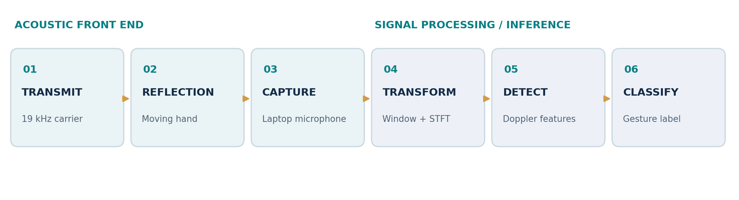
Figure 1. Functional signal-processing pipeline (project diagram).
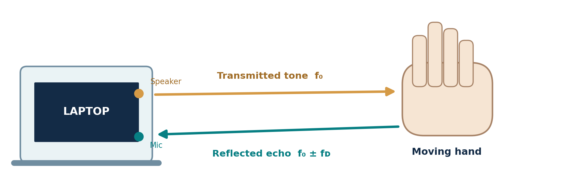
Figure 2. Speaker–hand–microphone reflection geometry (conceptual diagram).

2.3 Functional objectives
- Generate and capture a repeatable 18–20 kHz acoustic carrier using only built-in laptop hardware.
- Produce baseline, movement and real-time spectrograms around the selected 19 kHz carrier.
- Recognize approach and retreat gestures, and explicitly identify non-motion intervals.
- Investigate whether left/right swipes can be distinguished with built-in multichannel recordings.
- Document repeatable experiments, accurate limitations, measured performance and reproducible code.

2.4 Boundary conditions
No external ultrasonic sensor, camera, Arduino or wearable device is required. The first implementation is specific to one Windows laptop and Realtek audio path. Classifying left/right, estimating actual hand speed or guaranteeing recognition on other laptops remain research targets rather than achieved deliverables.

Chapter 3. Technical Background and System Architecture

3.1 Doppler shift from a moving reflector
For a reflector moving approximately along the acoustic path, the first-order monostatic approximation is:
Δf ≈ (2 f₀ vᵣ) / c
Δf: reflected frequency offset; f₀: transmitted carrier; vᵣ: radial reflector speed; c: approximate sound speed in air.
For f₀ = 19,000 Hz, c ≈ 343 m/s and a radial speed of 0.5 m/s, the idealized shift magnitude is about 55 Hz. Approaching movement tends to create frequencies above 19 kHz, while receding movement tends to create frequencies below it. For real laptops, separate speaker and microphone locations, reflection geometry and multipath modify this simplified relationship.
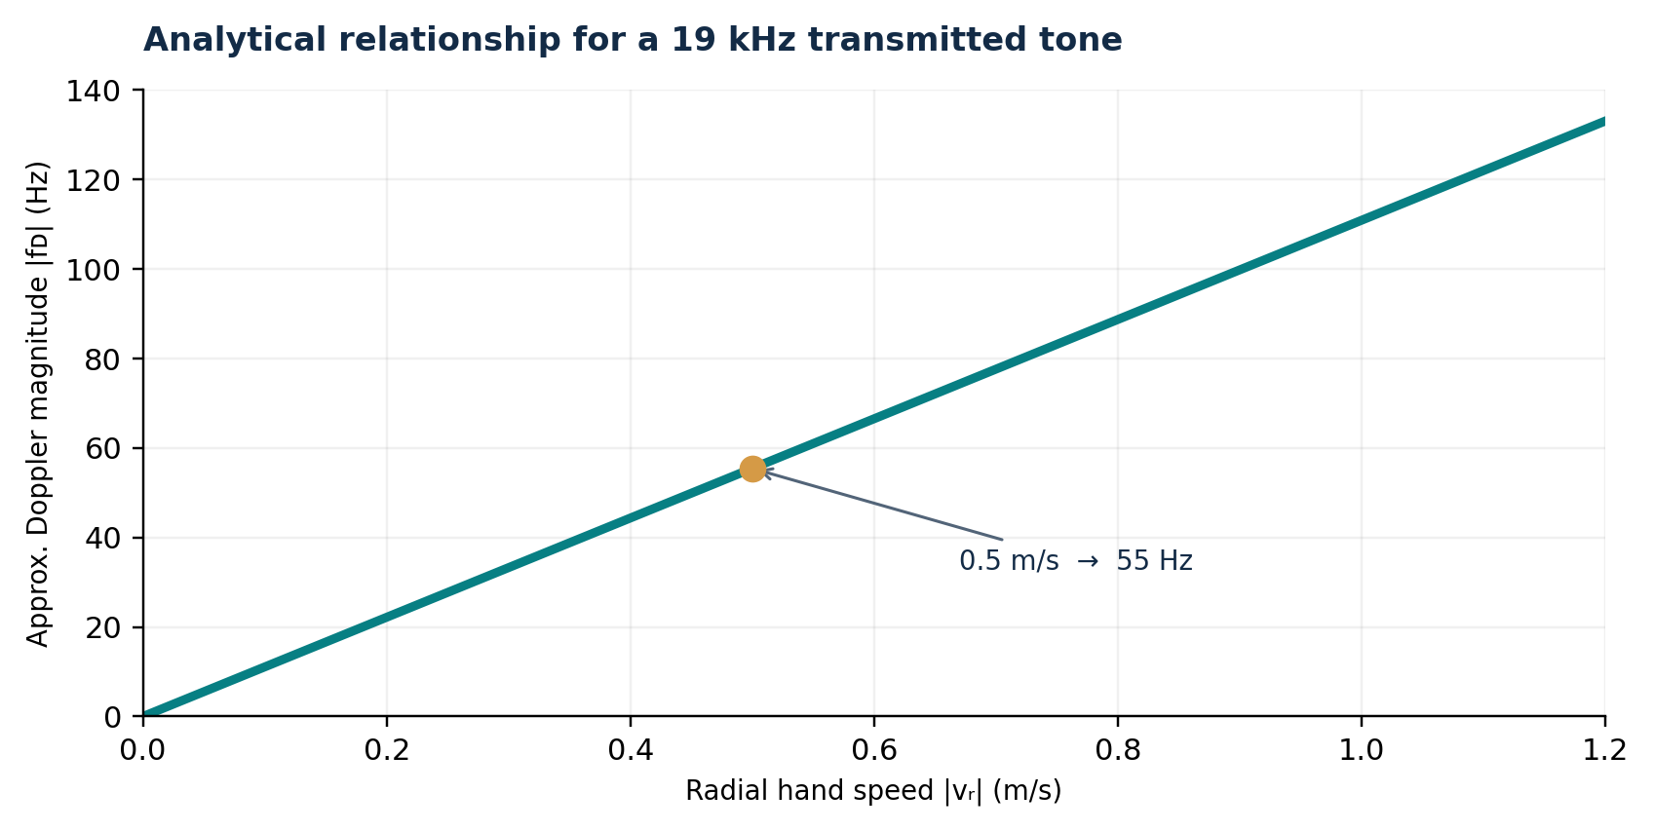
Figure 3. Analytical first-order Doppler shift versus radial hand speed. This is a theoretical illustration, not measured velocity.

3.2 Digitization and time–frequency analysis
The confirmed sampling rate was 48,000 samples/s, which exceeds twice the 19 kHz carrier frequency. The analysis uses windowed FFTs and spectrograms; an 8192-sample FFT at 48 kHz yields nominal frequency-bin spacing of approximately 5.86 Hz. The reported live program uses an 8192-point window and a 2048-sample hop (about 42.7 ms).
Δf_bin = fₛ / N = 48,000 / 8,192 ≈ 5.86 Hz
Frequency bin spacing is not a guarantee of estimator accuracy or minimal detectable Doppler shift.
The recorded microphone signal contains a strong unshifted carrier due to direct sound leakage. Moving-hand reflections may appear as faint time-varying components beside this line. The prototype inspects bands on either side of the carrier while excluding the strongest near-carrier bins.

3.3 Implementation architecture
The acoustic source, simultaneous capture, STFT and band-energy decision path were implemented as separate Python scripts during development. The first classifier is rule-based; no machine-learning model has been trained.
Figure 4. Signal chain from tone generation through gesture indication (project architecture).

Chapter 4. Development Environment and Hardware Setup

4.1 Installation and isolation
COMPONENT | RECORDED CONFIGURATION / IMPLEMENTATION
Laptop | HP EliteBook 845 G8 Notebook PC (PowerShell Win32_ComputerSystem output, 16 Oct).
Interpreter | Python 3.13.16 via Microsoft Store Python install manager.
Project directory | D:\PythonProjects\UltrasonicDoppler
Virtual environment | D:\PythonProjects\UltrasonicDoppler\.venv
pip cache | D:\PythonProjects\pip-cache (user environment variable PIP_CACHE_DIR).
Temporary installation files | D:\PythonProjects\temp (TEMP and TMP for the active PowerShell session).
Libraries | numpy, scipy, matplotlib, sounddevice; Python audio code executed through the .venv interpreter.

PowerShell initially blocked .venv\Scripts\Activate.ps1. A process-scoped execution policy change (Set-ExecutionPolicy -Scope Process -ExecutionPolicy RemoteSigned) enabled activation without changing the persistent machine-wide setting. A ModuleNotFoundError for sounddevice occurred in an unactivated terminal and was resolved once the .venv interpreter was used.

4.2 Audio device discovery
Device enumeration found Realtek audio endpoints. The WASAPI input and output endpoints used by the tests were microphone device 9 (reported four input channels) and speaker device 8 (two output channels). Checking 48 kHz with one input channel raised PortAudioError -9998 (invalid number of channels); requesting four microphone channels and two speaker channels succeeded.
PARAMETER | VALIDATED / USED VALUE
Sampling rate | 48,000 Hz
Carrier frequency | 19,000 Hz
Speaker output | WASAPI 8, stereo (2 channels)
Microphone input | WASAPI 9, 4 reported channels
Source tone amplitude | 0.02 peak in generated floating-point samples
Speaker setting | About 25% during successful post-enhancement frequency scan and many later tests
Enhancements | Realtek microphone Audio enhancements switched to Off
Input level | Reduced from 100 to approximately 40 during clipping troubleshooting; verify current value before new tests

4.3 Windows audio-processing intervention
The first scans recorded extremely small high-frequency components despite successful 48 kHz device-format checks. Inspection of the Windows microphone properties revealed “Device Default Effects” enabled. Microphone audio enhancements were switched to Off, followed by a major increase in recorded high-frequency levels. This strongly implicates the audio-processing path, although the comparisons were not performed with calibrated, identical volume and gain settings.
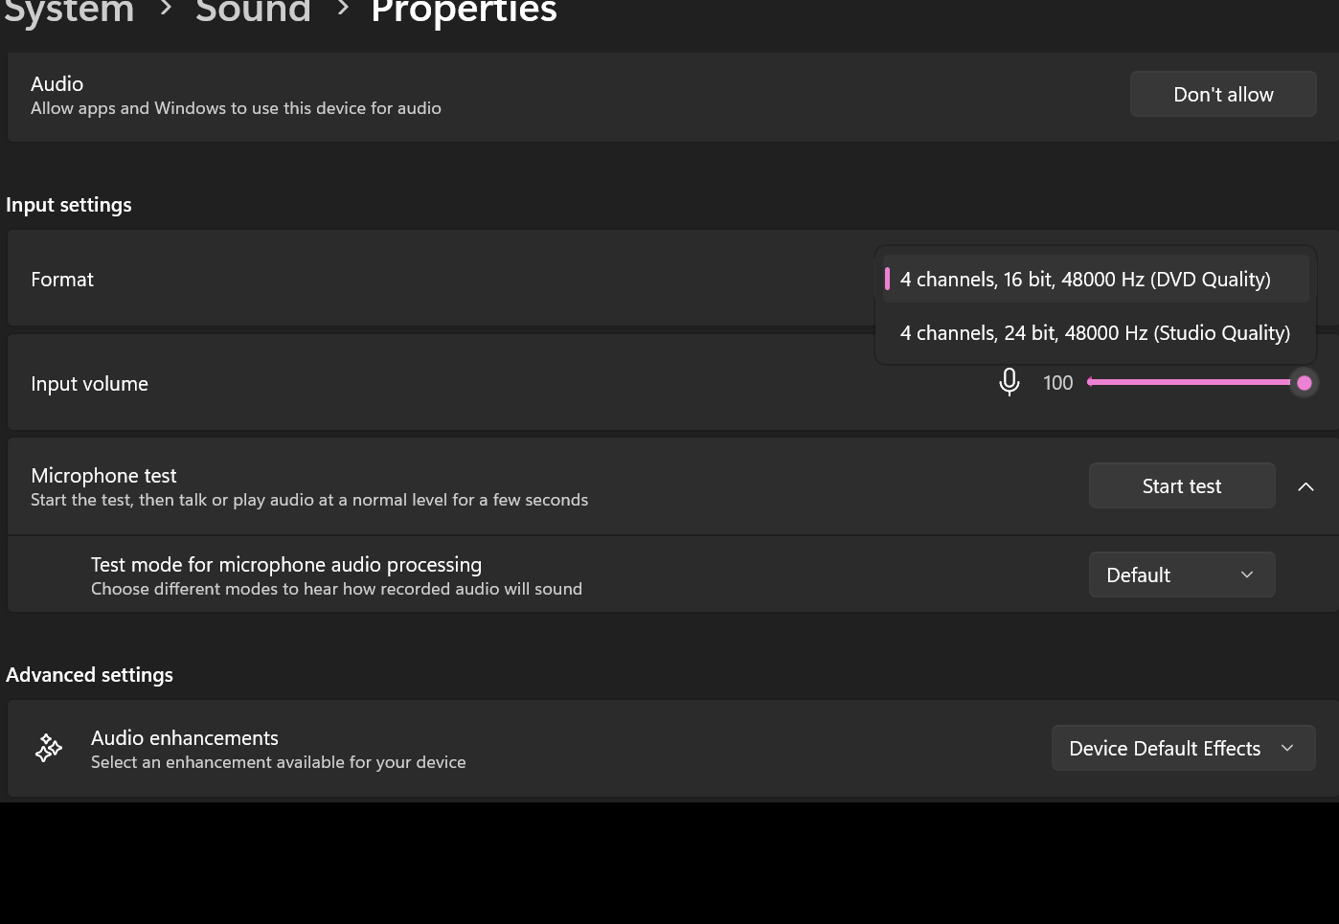
Figure 5. Windows Realtek microphone properties during troubleshooting; enhancement settings were subsequently switched Off (experimental screenshot, 15 Oct).

Chapter 5. Implementation and Experimental Results

5.1 Timeline of implemented milestones
DATE | DEVELOPMENT ACTIVITY | EVIDENCE / OUTCOME
10 Oct | Project concept, task split and initial report | Defined laptop-only ultrasonic workflow and reporting requirements.
15 Oct | Python 3.13.16, .venv on D:, dependencies | Working isolated interpreter and installed signal-processing/audio packages.
15 Oct | Microphone/speaker discovery and 48 kHz configuration | WASAPI 4-input/2-output channel settings accepted.
15 Oct | FFT frequency-scan troubleshooting | High-frequency signal increased after disabling microphone enhancements.
15 Oct | Baseline and hand-motion WAV recording | Baseline peak 0.03793483; later acceptable motion peak 0.03831267.
15 Oct | Offline and live 19 kHz spectrograms | Captured visible motion-related sidebands.
15 Oct | Toward/away live rule-based indicator | The prototype returned expected live labels in qualitative tests; no independently scored test set is available.
16 Oct | Left/right studies and four-channel comparisons | Channels 0/1 useful; channel-power ratios unreliable for swipe direction.
16 Oct | Broadband finger-snap microphone delay tests | Sign changes corresponded with actual physical side for tested snaps.

5.2 Frequency-response troubleshooting
Two six-frequency scans made before the enhancement change yielded high-frequency FFT measurements close to the printed precision floor. For example, at 19 kHz they returned approximately 1.6 × 10⁻⁸ and 1.0 × 10⁻⁸. After enhancements were switched Off, the 19 kHz reading was 0.021680810 at a reported 25% speaker volume. These figures are FFT amplitude measures from a narrow bin region, not calibrated acoustic sound pressure levels.
TONE | BEFORE SCAN A | BEFORE SCAN B | AFTER DISABLING EFFECTS
1 kHz | 0.001030532 | 0.000714232 | 0.002128695
8 kHz | 0.000000206 | 0.000000051 | 0.012209976
10 kHz | 0.000000018 | 0.000000025 | 0.011808527
12 kHz | 0.000000010 | 0.000000007 | 0.017625228
16 kHz | Printed 0.000000000 | Printed 0.000000000 | 0.025464895
19 kHz | 0.000000016 | 0.000000010 | 0.021680810

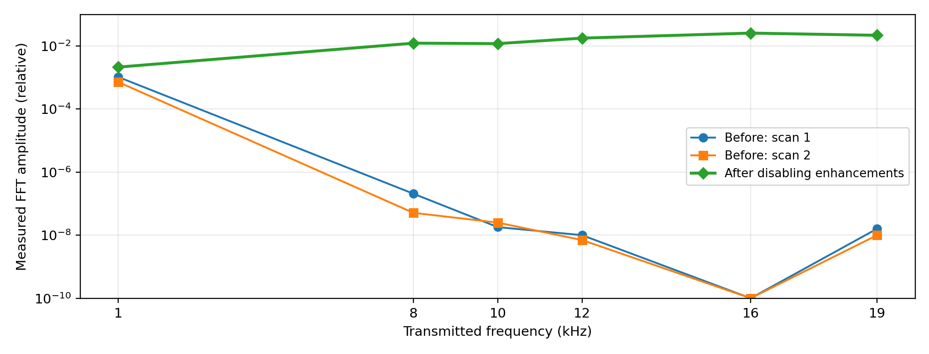
Figure 6. Comparison generated from the actual console values. Log-scale zeros shown at a plotting floor of 10⁻¹⁰; conditions were not fully gain-calibrated.
Interpretation: the laptop can produce and capture a substantial component at 19 kHz in the tested configuration. The observed before/after difference is consistent with suppressive audio processing, but does not by itself isolate whether the processing acted on playback, recording or both.

5.3 Baseline and movement recording
The baseline script transmitted a 19 kHz sine tone for 5 seconds and saved captures/baseline_still.wav from microphone channel 0. The baseline run printed a peak sample magnitude of 0.03793483. Subsequent movement recordings saved captures/motion_test.wav, initially yielding peaks above 1.0 in float samples (1.5494825, 1.9912436 and 1.277102). Since the first script clipped to ±1 when writing int16 WAV, those runs were not suitable as clean quantitative evidence. After reducing microphone input level, a later run printed 0.03831267, with no clipping indicated by that measured peak.
CAPTURE | PEAK SAMPLE MAGNITUDE | INTERPRETATION
baseline_still.wav | 0.03793483 | Reference stationary recording.
motion_test.wav (early run) | 1.5494825 | Out-of-range samples; WAV clipping risk.
motion_test.wav (early repeat) | 1.9912436 | Out-of-range samples; WAV clipping risk.
motion_test.wav (intermediate) | 1.2771020 | Out-of-range samples; WAV clipping risk.
motion_test.wav (later) | 0.03831267 | Acceptable peak; repeated runs overwrote the same filename.

5.4 Baseline vs motion spectrogram
STFT plots were produced around 18.5–19.5 kHz using nperseg=8192 and noverlap=7168. The stationary recording showed a narrow, stable 19 kHz line, whereas the motion recording contained short bursts of broadening around the carrier. This is consistent with acoustic disturbances and plausible Doppler energy, but the first offline figure did not label precise motion onsets.
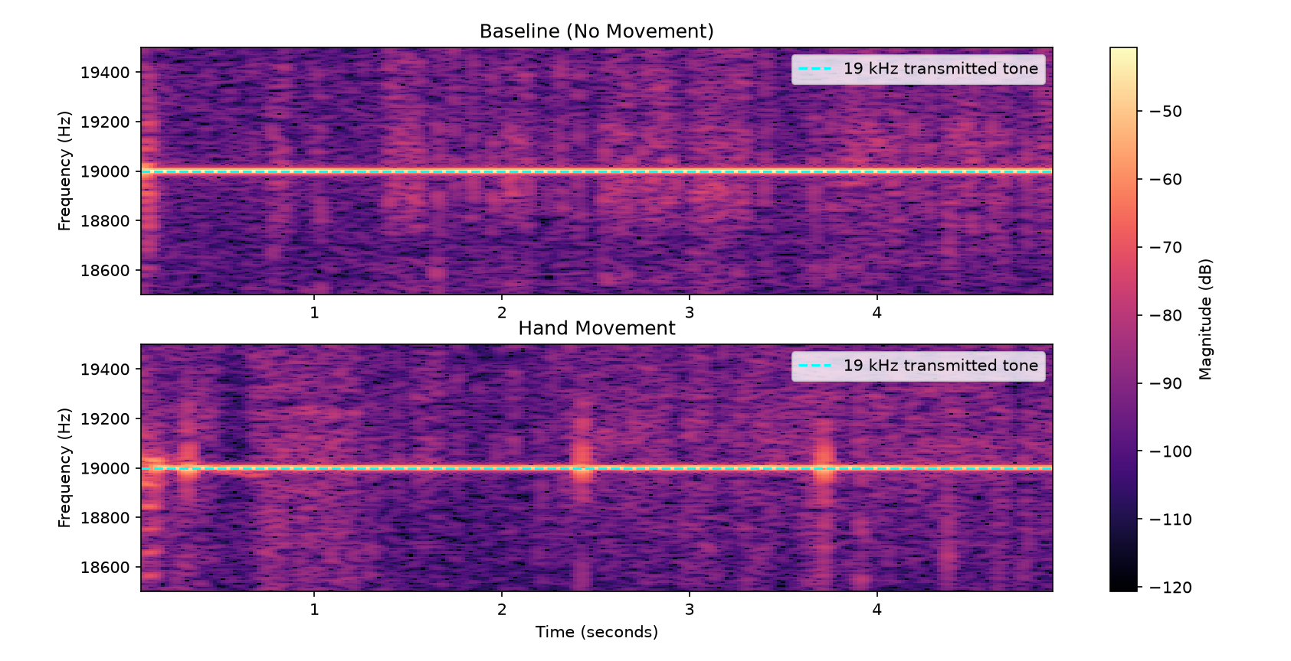
Figure 7. Actual baseline (top) and hand-motion (bottom) STFT screenshots supplied on 15 Oct; cyan dashed line indicates the 19 kHz carrier.

Chapter 6. Live Doppler Sensing and Direction Detection

6.1 Real-time acoustic visualization
The live_doppler.py script implemented a continuous full-duplex sounddevice stream: phase-continuous 19 kHz stereo output, four-channel audio capture, ring buffering for approximately four seconds and animated STFT updates approximately every 120 ms. One microphone channel supplied the displayed signal. A stable carrier and moving-hand sidebands were visible in real time.
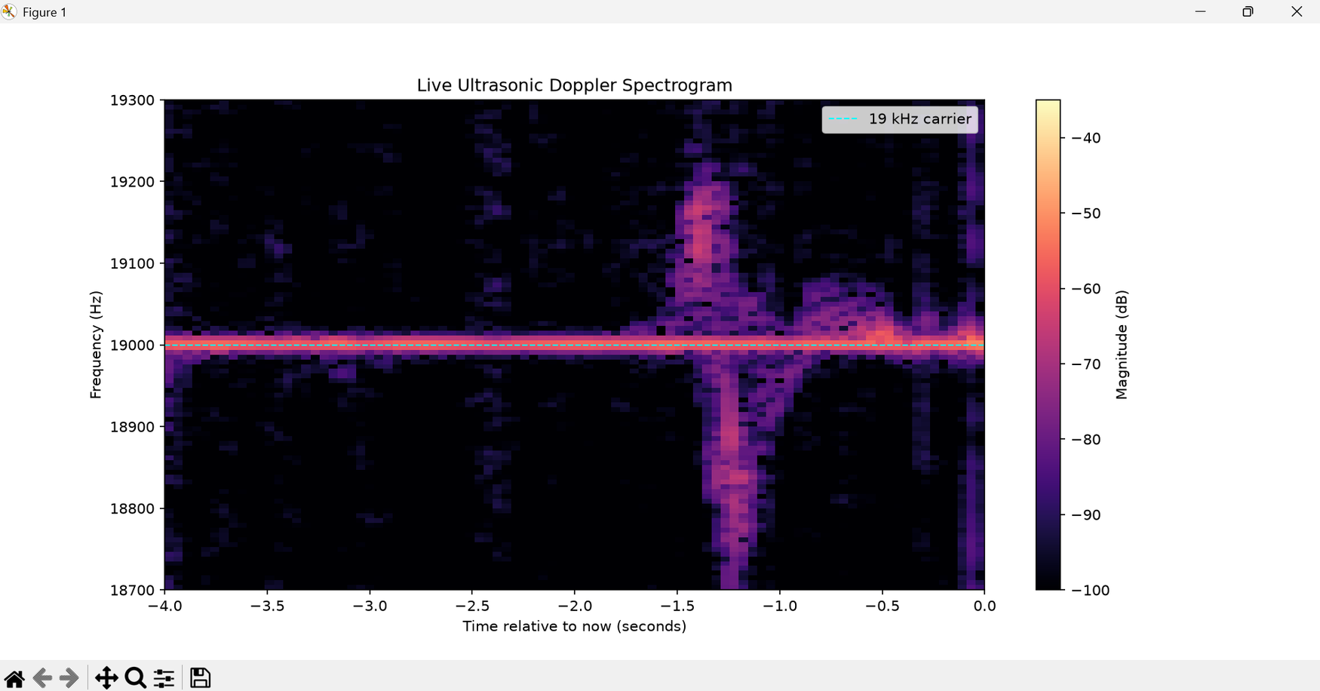
Figure 8. Original live Doppler screenshot showing transient energy both above and below the otherwise stable 19 kHz carrier during arm movement.

6.2 Controlled toward-versus-away observations
In a directional test, the palm was moved toward the laptop screen and then retracted at a similar moderately high speed. The recorded spectrogram shows energy above 19 kHz during approach and below 19 kHz during retreat, consistent with the expected Doppler sign.
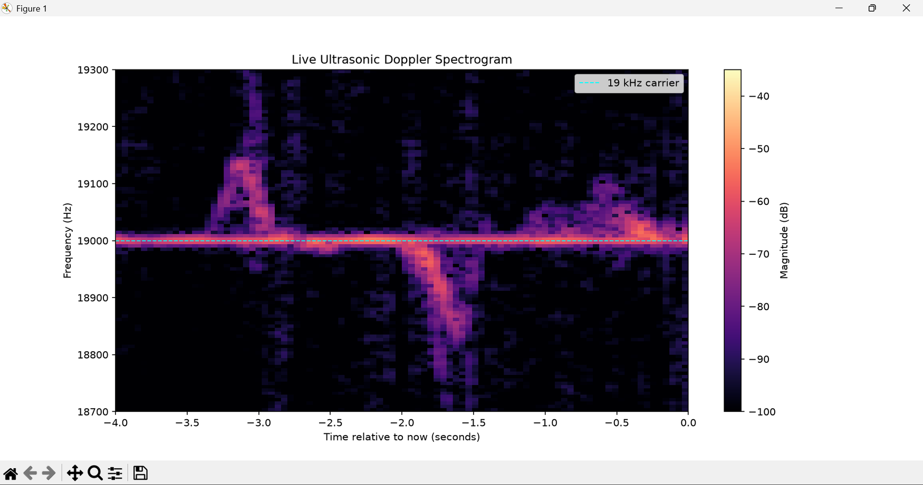
Figure 9. Real-time spectrogram after a toward/away test: a transient component rises above 19 kHz and a later component falls below 19 kHz.

6.3 Implemented rule-based live detector
The live_direction_detector.py prototype compared STFT magnitude in nominal 19,020–19,180 Hz (upper) and 18,820–18,980 Hz (lower) bands, with the ±20 Hz region near the carrier excluded. It selected the stronger band from recent frames, required a fixed -78 dB level threshold, and applied a 2.5 dB difference margin to assign TOWARD, AWAY, NO MOTION or MOTION / UNCERTAIN. The displayed levels were FFT-derived relative magnitudes, not calibrated dB SPL.
LIVE OUTPUT | LOGIC IN PROTOTYPE | OBSERVED STATUS
TOWARD | Upper sideband greater than lower by more than margin | Reported to work interactively.
AWAY | Lower sideband greater than upper by more than margin | Reported to work interactively.
NO MOTION | Both sidebands below fixed threshold | Reported to work interactively.
MOTION / UNCERTAIN | Activity without sufficient directional margin | Implemented fallback label, not formally measured.

The live detector displayed the expected approach, retreat and no-motion labels during interactive testing. These observations demonstrate functionality, but the test sequence did not generate a verified confusion matrix or numerical accuracy estimate.

Chapter 7. Multichannel and Left–Right Gesture Investigation

7.1 Why left/right is not equivalent to toward/away
A single scalar Doppler shift reflects the rate of change of acoustic path length, not left/right motion directly. During a lateral swipe, the hand may first approach and then recede from the screen’s central acoustic region. Consequently, movement from either outer side toward the middle produced rising components, while moving from the middle outward produced falling components. These patterns cannot distinguish left→right from right→left by Doppler sign alone.
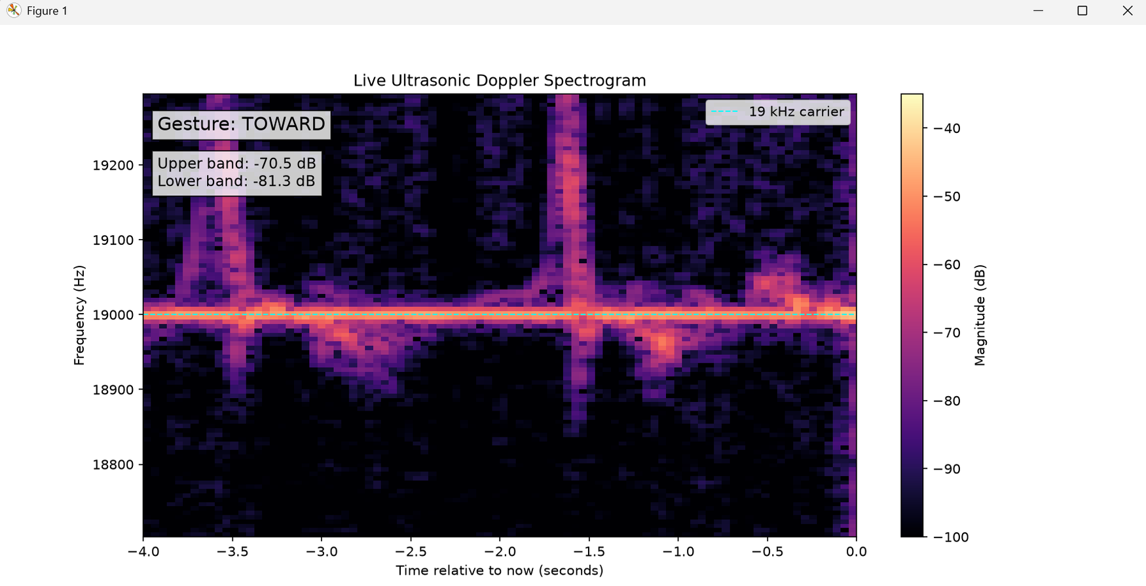
Figure 10. Experimental screenshot of left/right experiments; successive swipe components appear on either side of the 19 kHz carrier.
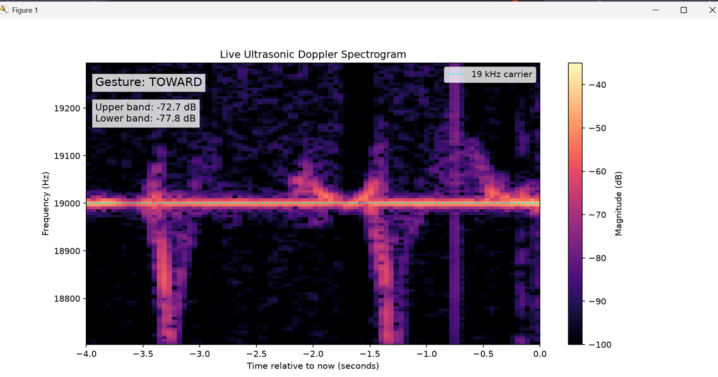
Figure 11. Second experimental screenshot from the sideways-gesture experiment illustrating similar Doppler patterns across opposite swipes.

7.2 Four-channel acquisition
The WASAPI endpoint exposed four input channels. In a five-second left/right recording, channel peaks were 0.233929, 0.208245, 0.393065 and 0.406746, and maximum differences relative to channel 0 were 0.178974345, 0.386712432 and 0.400392741. This established that the delivered numeric channel streams were not identical. It did not establish that all four represent independent physical microphones. The four-channel spectrogram showed clear 19 kHz sidebands in channels 0 and 1, and substantially less near-carrier activity in channels 2 and 3 under the same plotting limits.
RECORDED CHANNEL | PEAK AMPLITUDE | MAX |CH 0 – CH I|
0 | 0.233929 | Reference
1 | 0.208245 | 0.178974345
2 | 0.393065 | 0.386712432
3 | 0.406746 | 0.400392741

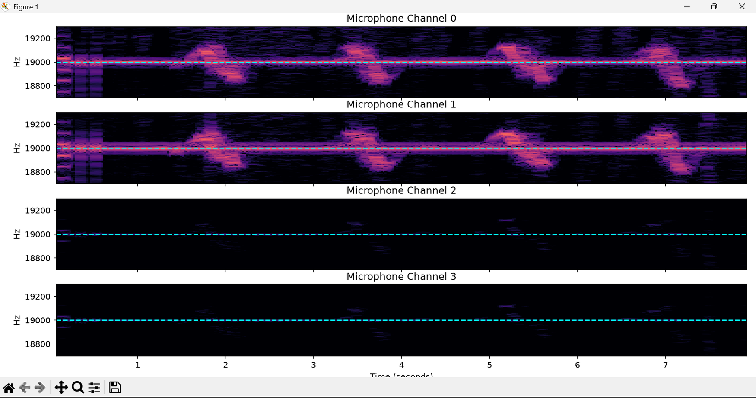
Figure 12. Actual four-channel STFT comparison; channels 0 and 1 show strong motion-associated spectral components, channels 2 and 3 much weaker near 19 kHz.

7.3 First two-channel sideband ratio test
The analyze_lr.py script computed Welch-estimated energy in sidebands offset about 25–200 Hz from 19 kHz and compared channels 0 and 1. One left→right window returned -0.54 dB; one right→left window returned -2.61 dB. This 2.07 dB difference was hypothesis-generating only, not a calibrated class boundary.

7.4 Two batches of five trials per swipe direction
The experiment was repeated with separate two-second recordings and five trials per class, twice. The values below were copied from terminal outputs. Both distributions overlapped substantially, and the apparent class separation was smaller than the within-class spread. These results do not support a reliable static ratio threshold.
BATCH | SWIPE DIRECTION | FIVE RECORDED RATIOS (DB) | MEAN ± SD (DB)
A | Left → right | -0.79, -2.37, -0.79, -0.63, -0.88 | -1.09 ± 0.64
A | Right → left | +0.04, -1.56, -1.03, -1.73, +0.22 | -0.81 ± 0.81
B | Left → right | +0.16, +1.02, -3.11, -2.90, -1.81 | -1.33 ± 1.65
B | Right → left | -1.90, -1.66, -3.88, -1.05, -0.70 | -1.84 ± 1.11

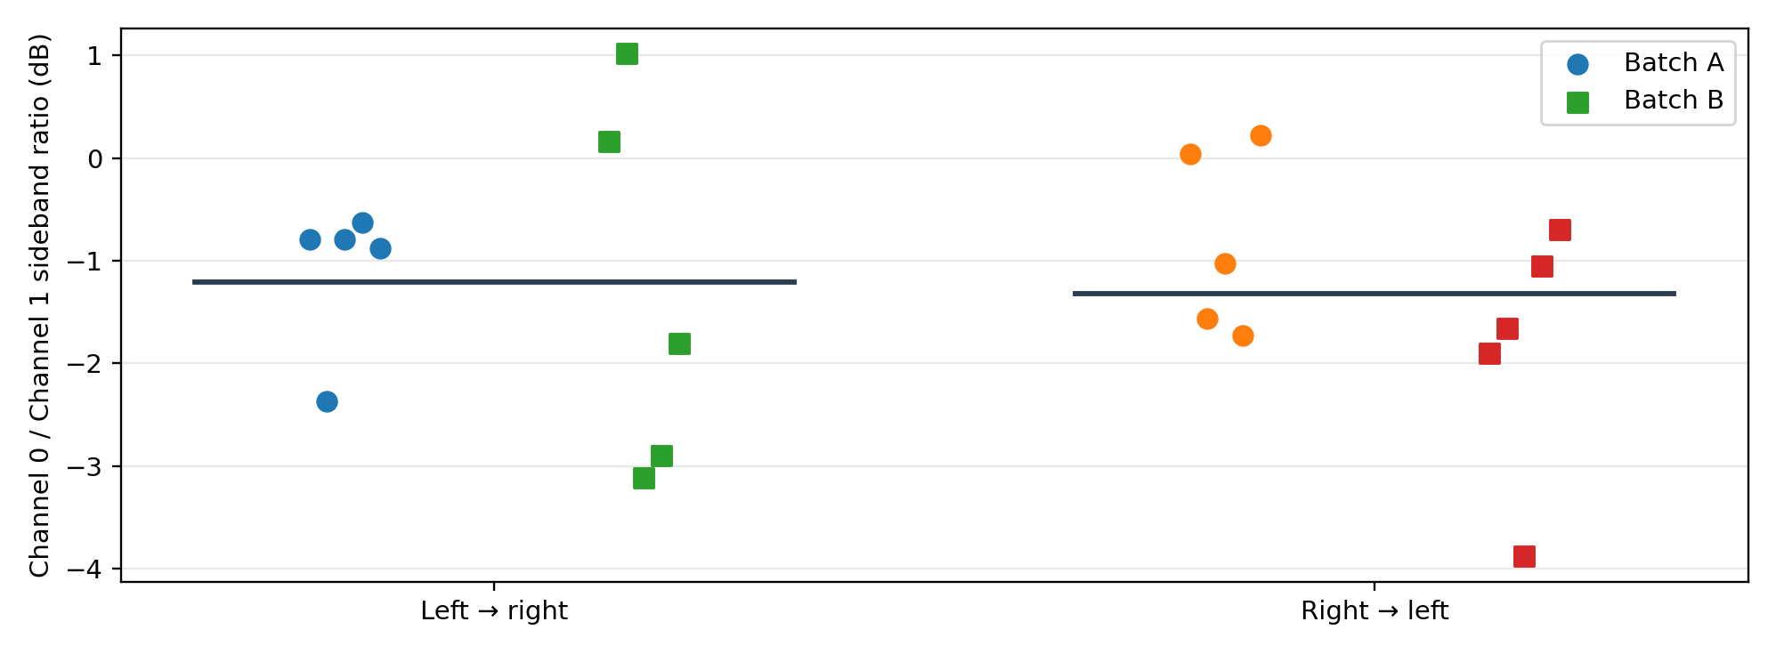
Figure 13. Original terminal data replotted as a two-batch channel-power-ratio comparison (10 trials per class overall); horizontal bars are pooled group means.

7.5 Temporal-ratio feature exploration
A second analysis calculated time-varying band-power ratios using windowed STFTs and median filtering. Two sets of temporal-ratio plots were generated. Different trials showed spikes with inconsistent signs, timing and amplitude; the patterns overlapped across gestures. Power ratios can become numerically unstable during weak reflections because they divide two small signals. No trained or held-out left/right temporal classifier has yet been evaluated.
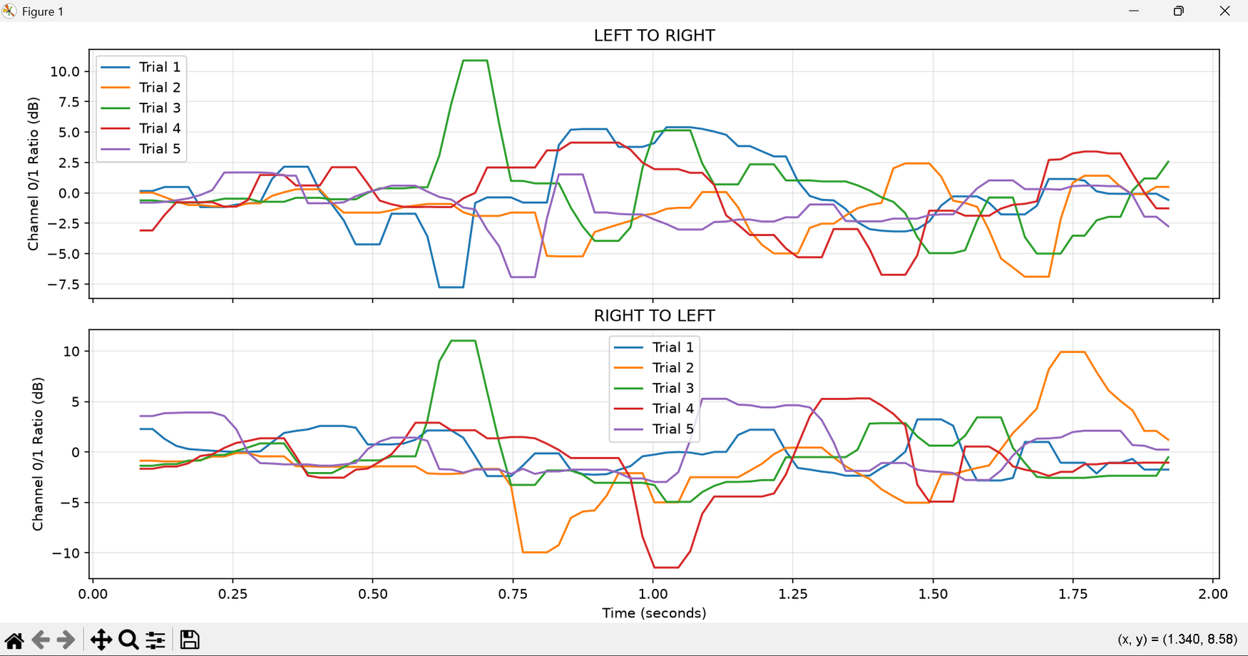
Figure 14. User-supplied first temporal channel-ratio experiment (five traces per class); strong cross-trial variability is visible.
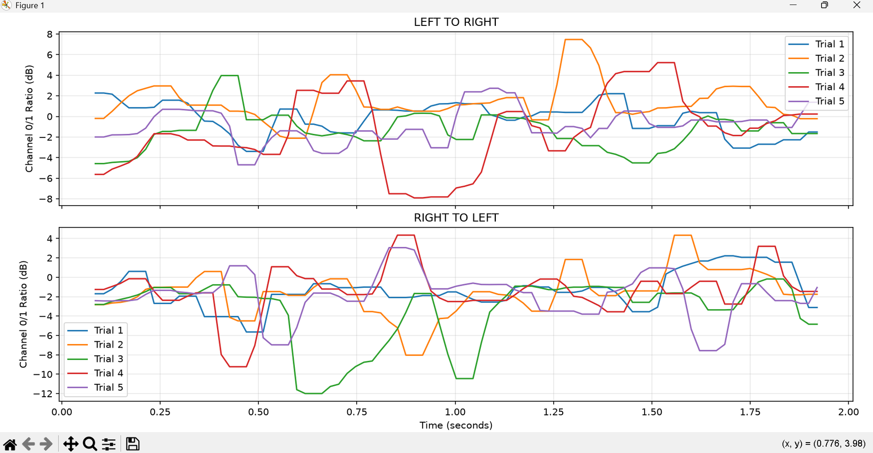
Figure 15. User-supplied second temporal channel-ratio experiment; no stable direction-specific profile is evident.

7.6 Audible snap time-difference experiment
To test whether the channels encode spatial timing, a separate test recorded broadband finger snaps near the left and right sides of the laptop with no 19 kHz transmission. The first two runs estimated negative channel-0-relative-to-channel-1 delays for snaps on the physical left and positive delays for snaps on the physical right. A third run deliberately swapped the physical location relative to the spoken prompt; the sign followed the actual side, not the prompt label. Similarity scores varied, and the estimates do not prove ultrasonic left/right gesture recognition.
RUN | PROMPT LABEL | ACTUAL PHYSICAL SIDE | DELAY CH0 VS CH1 | CORRELATION SIMILARITY
1 | LEFT | Left | −187.5 µs | 0.852
1 | RIGHT | Right | +333.3 µs | 0.509
2 | LEFT | Left | −187.5 µs | 0.880
2 | RIGHT | Right | +187.5 µs | 0.459
3 | LEFT | Right (deliberate swap) | +479.2 µs | 0.386
3 | RIGHT | Left (deliberate swap) | −187.5 µs | 0.853

These delays correspond to about 9–23 samples at a 48 kHz sampling rate. A pure 19 kHz tone completes one cycle approximately every 52.6 µs, so cross-channel phase can wrap many times over the reported snap delays. Spatial estimation at 19 kHz therefore requires phase-ambiguity treatment, microphone geometry, multipath mitigation and ideally a richer signal than one continuous sinusoid.

Chapter 8. Summary of Results and Validation Status
PROJECT CAPABILITY | CURRENT EVIDENCE | ASSESSMENT
Full-duplex 19 kHz audio | Successful 48 kHz duplex recordings; high-frequency FFT after enhancements disabled | Demonstrated on tested HP laptop.
Stationary 19 kHz reference | baseline_still.wav run and uploaded baseline spectrogram | Demonstrated.
Movement-associated sidebands | Uploaded offline and live spectrogram screenshots | Demonstrated qualitative response.
Toward vs away label | Real-time label and directional hand-motion observation | Working prototype; not scored.
Left vs right via sideband-power ratio | 20 saved directional-trial measurements across two batches, plus temporal graphs | Not sufficiently separable.
Audible-source spatial timing | Six snap results; physical-side reversal experiment | Promising preliminary evidence.
Ultrasonic spatial gesture recognition | No robust phase/arrival-time model or independent test results | Not demonstrated.
Accuracy / confusion matrix | No scored per-class predictions retained | Not established.

Evidence hierarchy: terminal output and saved experiment parameters document what was measured; screenshots support visual inspection; contemporaneous test notes describe real-time behavior. Formal performance numbers require labeled trial-by-trial ground truth and predictions collected under a fixed evaluation protocol.

Chapter 9. Limitations, Uncertainties and Risks

9.1 Technical limitations
LIMIT OR RISK | OBSERVED CONSEQUENCE / MITIGATION
Windows enhancements, AGC and endpoint processing | Near-zero early high-frequency readings; disable enhancements and log exact settings each run.
Uncalibrated acoustic amplitude | Reported 25% system volume is not physical SPL; hold settings constant and avoid loud 19 kHz exposure.
Clipping and WAV conversion | Early float peaks >1; save unmodified float32 multichannel WAV and reject clipped trials.
Carrier leakage and strong stationary 19 kHz line | Masks weak sidebands; use static-background subtraction and exclude central bins.
Single-tone phase ambiguity | 52.6 µs carrier period; phase-only arrival-time estimates can alias or wrap.
Unknown physical mapping of four driver channels | Numerical differences are not proof of four microphone elements; inspect channel routing and geometry.
Limited controlled dataset | 20 left/right gesture windows with overlap; multiple locations, speeds, operators and held-out tests still needed.
Gesture geometry | Left/right sweeps induce inward/outward path change; Doppler sign alone is not horizontal direction.
Environmental multipath and audio noise | Room reflections and hands near screen affect spectrum; repeat under documented conditions.
Classifier thresholds fixed by inspection | -78 dB threshold and 2.5 dB margin may be device-dependent and overfit; calibrate on training data only.

9.2 Methodological limitations
The printed frequency-scan amplitudes do not constitute a frequency-response calibration; uncontrolled speaker and microphone gains complicate causal interpretation. The real-time toward/away program has no saved predictions, event timestamps, ground-truth labels, per-class metrics or independent observer verification. The interpretation of screenshots relies on the user’s reported timing of hand movements. A positive difference between LEFT and RIGHT means in one session did not replicate as a reliable discriminator when repeated.

9.3 Safety and data integrity
High-frequency output can be audible to some individuals and animals. Maintain a modest playback level, limit repeated exposure, do not place ears near the speakers and stop if discomfort occurs. Sample magnitudes beyond ±1 represent a clipping risk during integer conversion. Preserve raw float32 four-channel WAV files, metadata and the unmodified analysis scripts so results can be reproduced.

Chapter 10. Future Work and Verification Plan
PRIORITY | PLANNED EXPERIMENT | ACCEPTANCE / DECISION CRITERION
P1 | Automated data logger with timestamp, device IDs, sample rate, speaker/input settings, motion label and clipping flag | Every trial yields lossless raw file + machine-readable metadata.
P1 | Toward/away/no-motion study: ≥20 trials per class with fixed movement distance, speed category and operator | Confusion matrix and per-class precision/recall; do not preclaim target accuracy.
P2 | Validate channel mapping: static sound-source movement, channel correlation, response timing, physical microphone location | Confirm which channels represent independent spatial signals.
P2 | Study phase/complex STFT at 19 kHz with stationary direct-path suppression | Repeatable left/right spatial feature across multiple sessions.
P2 | Consider short chirp/multi-tone probe if single-tone phase ambiguity dominates | Improvement must remain speaker+mic only, and must not disrupt baseline milestones.
P3 | Train classifier only after repeatable controlled gesture features exist | Compare against majority/chance baselines using held-out complete sessions.
P3 | Final demo + test report | Reproducible procedure, plots, numerical results and documented failure cases.

10.1 Suggested experimental protocol
- Record at least 1–2 s of stationary baseline before each trial and write four channels as float32.
- Announce randomized ground-truth gesture order; standardize starting position and approximate distance.
- Keep the speaker and microphone gain unchanged across compared trials and note environmental conditions.
- Discard or flag clipped, incomplete or visibly corrupted sessions before feature calculation.
- Compute features on labeled training recordings only; freeze decision rules before blind testing.
- Report total test trials, correct and incorrect predictions by class and overall confusion matrix.

Chapter 11. Conclusion
Between 10 and 16 October 2026 the project advanced from a planned laptop-only gesture sensing concept to a practical 19 kHz full-duplex prototype with offline and live spectrograms and a working user-observed toward/away/no-motion direction indicator. The largest engineering obstacle a high-frequency acquisition path that appeared ineffective was mitigated by disabling Windows microphone audio enhancements. Multiple recordings and screenshots now document motion-associated spectral features.
Left/right recognition is not yet validated. Static and time-varying channel-power ratios were tested and showed substantial overlap between horizontal gestures. Broadband finger-snap delays give a reason to investigate the spatial properties of the built-in microphone system, but do not establish a solution for narrowband ultrasonic gesture classification. The next phase should focus on carefully labeled data, reproducible metrics, clipping protection, microphone-channel validation and spatial feature experiments.

References
[1] S. Gupta, D. Morris, S. N. Patel and D. Tan, “SoundWave: Using the Doppler Effect to Sense Gestures,” Proceedings of CHI 2012, pp. 1911–1914, 2012. DOI: 10.1145/2207676.2208331.
[2] SciPy Developers, “scipy.signal.spectrogram / scipy.signal.stft,” SciPy Signal Processing documentation. https://docs.scipy.org/doc/scipy/reference/signal.html
[3] python-sounddevice contributors, “Simultaneous Playback and Recording” and “Streams,” Python sounddevice documentation. https://python-sounddevice.readthedocs.io/en/latest/
[4] Python Software Foundation, “venv — Creation of virtual environments,” Python 3.13 documentation. https://docs.python.org/3.13/library/venv.html
[5] Internal project evidence, Saif Eldin Hany, screenshots and console outputs from interactive experiments dated 15–16 October 2026. Experimenter-provided data; not externally peer-reviewed.

Appendix A. Code and File Inventory
SOURCE SCRIPT / FILE | ROLE AND CURRENT STATUS
audio_test.py | Initial 2-second tone/playback + microphone peak/FFT checks; experimental settings modified during testing.
frequency_scan.py | Six carrier-frequency checks at 1, 8, 10, 12, 16 and 19 kHz; amplitudes reported in Section 4.
doppler_capture.py | Five-second baseline/motion capture; earlier int16-save routine clipped values above ±1.
doppler_visualize.py | Offline comparison of baseline_still.wav and motion_test.wav with STFT.
live_doppler.py | Full-duplex continuous carrier and rolling four-second spectrogram.
live_direction_detector.py | Real-time upper/lower sideband rule-based classification.
check_channels.py | Per-channel peak and difference measurements for four-channel capture.
compare_channels.py | Eight-second four-channel STFT export to captures/four_channels.wav.
analyze_lr.py | Welch-band power ratio analysis of early LEFT/RIGHT test windows.
lr_reliability_test.py | Separate two-second gesture recordings; 5 left and 5 right per batch, run twice.
lr_temporal_analysis.py | Time-varying channel ratio plots from saved swipe recordings.
mic_spatial_test.py | Broadband snap lag and normalized cross-correlation comparison.
captures/baseline_still.wav | Referenced raw baseline recording (not supplied with this document).
captures/motion_test.wav | Overwritten by repeated trials; last referenced acceptable peak 0.03831267.
captures/four_channels.wav | Four-channel long recording (not supplied with this document).
captures/lr_tests/*.wav | Separate short left/right trial recordings (not supplied with this document).

The executable Python project and raw WAV files are maintained separately in the local project folder. The filenames and logic in this appendix follow the code and terminal outputs recorded during prototype development; verify against the current VS Code workspace before submission.

Appendix B. Detailed Test and Session Log
SESSION | REPORTED FACTS / KEY DECISIONS
15 Oct: configuration | PowerShell execution policy was adjusted for the active session; .venv selected at D:; missing sounddevice module resolved by activating the virtual environment.
15 Oct: device format | One input channel with WASAPI raised PaErrorCode -9998; four microphone channels + two speaker channels at 48 kHz succeeded.
15 Oct: early frequency scan | At 1 kHz the two recorded values were 0.001030532 and 0.000714232; higher frequency readings were near the reporting floor.
15 Oct: enhancements | Windows Properties showed 4 channels, 16-bit, 48 kHz and “Device Default Effects”; user switched enhancements Off. Subsequent 19 kHz amplitude was 0.021680810.
15 Oct: baseline / motion | Baseline peak 0.03793483; initial movement captures clipped when exported to int16; later recorded peak 0.03831267.
15 Oct: visualization | Baseline and movement STFT image shared; live waterfall shared; toward and away confirmed by user as higher/lower spectral components.
15 Oct: live labels | Live detection behaved as expected in interactive tests; detailed trial-by-trial scores were not retained.
16 Oct: swipe geometry | Inward lateral motions (from either side toward center) showed positive offsets; outward motions showed negative offsets in the observed setup.
16 Oct: channel recording | Ch0/1 had conspicuous STFT motion energy; Ch2/3 comparatively little around the carrier.
16 Oct: LR ratios | Single recording ratios -0.54 and -2.61 dB; repeatability batches produced overlap, motivating rejection of simple threshold.
16 Oct: snap lag | Three left/right snap sessions produced location-dependent lag signs; third run deliberately swapped physical sides.

Appendix C. Evidence Archive and Update Instructions
Figures incorporated from user-shared screenshots: Windows microphone properties (15 Oct); baseline vs motion STFT (15 Oct); first live spectrogram and toward/away example (15 Oct); two sideways-gesture snapshots (16 Oct); four-channel STFT comparison (16 Oct); two temporal channel-ratio plots (16 Oct). Measurement comparison charts are newly generated from user-supplied terminal outputs and are explicitly identified as replots. Conceptual diagrams come from version 0.1.
For the next revision: (1) add new raw-data summaries and experiment IDs, (2) insert new screenshots with a date and test caption, (3) add complete per-class scores and a confusion matrix, (4) record each limitation and failed approach, (5) update the team contribution record with verifiable evidence, and (6) update the contents page numbers after adding material.

Appendix D. Revision History

D.1 Document revision record
VERSION | DATE | DESCRIPTION
0.1 | 10 Oct 2026 | Initial project proposal, technical background, objectives, planned workflow and risk register.
0.2 | 16 Oct 2026 | Revised with actual installation notes, hardware tests, frequency scans, spectrogram screenshots, real-time classification, multi-channel studies, reliability results and limitations.
0.3 | 16 Oct 2026 | Restyled as a conventional academic engineering report; experimental results and figures retained.
0.4 | 16 Oct 2026 | Reordered into numbered chapters; team responsibilities are first; TOC is on a separate front-matter page.
0.5 | 17 Oct 2026 | Redesigned title page and complete chapter/subsection contents

