V-JEPA 2.1 as a Tool Wear Predictor:
A Linear Probe Evaluation on PHM 2010 Data

Technical Experiment Report
May 06, 2026

Project: Aegis / ToolWear

1. Abstract
This report documents an experiment evaluating the capability of V-JEPA 2.1 (Joint Embedding Predictive Architecture, ViT-L backbone) to encode tool wear state from electrical signal spectrograms without supervision. The PHM 2010 milling dataset was used: force and vibration signals from cutters c1, c4, and c6 were converted into per-cut Mel spectrogram video frames, encoded by a frozen V-JEPA 2.1 encoder, and evaluated via a linear probe (logistic regression) trained on cutters c1 and c4 and tested on the held-out cutter c6. Results are compared against a supervised hybrid CNN+MLP baseline trained directly on wear labels. The experiment reveals that while V-JEPA 2.1 encodes partial wear-relevant structure, its latent space is dominated by cutter identity rather than wear state, limiting cross-cutter generalisation to 67.3% overall accuracy versus the supervised baseline's ~92%.

2. Introduction & Motivation
Tool wear detection in CNC milling is a critical predictive maintenance task. The standard approach — supervised training on labelled wear measurements — requires expensive sensor infrastructure and per-cut annotations. Self-supervised vision transformers such as V-JEPA 2.1 offer the prospect of learning rich visual representations without explicit labels, raising the question: can a model pre-trained on natural video learn to encode tool wear progression from electrical signal spectrograms?
V-JEPA 2.1 (Meta AI, 2024) is trained using a joint embedding predictive objective: the encoder learns to predict the latent representation of masked video patches from context patches, without reconstructing pixels. This objective encourages the model to capture temporally consistent, semantically meaningful features. Mel spectrograms of electrical signals — which show systematic frequency shifts as tool wear increases — are a natural candidate for this kind of representation.
The specific research question addressed is: does a linear probe on frozen V-JEPA 2.1 frame embeddings carry sufficient information to classify tool wear state (New / Worn / Severe) across unseen cutters, and how does this compare to a purpose-trained supervised CNN baseline?

3. Dataset: PHM 2010 Milling Challenge
The PHM 2010 dataset contains force and vibration signals from six milling cutters (c1–c6), each performing 315 cuts on stainless steel workpieces. Per-cut flank wear measurements (in µm) are provided for three training cutters (c1, c4, c6); c2, c3, c5 are designated test cutters with no wear labels.

Cutter | Role | Cuts | Wear classes present | Sampling rate
c1 | Train / Test (probe) | 315 | New, Worn | 50 kHz
c4 | Train (probe) | 315 | New, Worn | 50 kHz
c6 | Test (probe) | 315 | New, Worn, Severe | 50 kHz

Signals have 7 channels: force_x, force_y, force_z, vib_x, vib_y, vib_z, and ae_spindle. Each cut file contains ~127,000 samples. Wear labels are mapped to three classes using ISO 8688-aligned thresholds: New (VB < 100 µm), Worn (100 ≤ VB < 200 µm), Severe (VB ≥ 200 µm), averaged across three flutes.
Note: c1 and c4 only exhibit New and Worn classes in this dataset. Severe cuts are present only in c6 (25 out of 315 cuts), making the probe's Severe class evaluation a zero-shot transfer task.

4. Methodology

4.1 Video Generation
For each of the three cutters (c1, c4, c6), a 315-frame MP4 video was generated at 10 fps (≈31 seconds per video). Each frame corresponds to one cut and was constructed as follows:
- Load the cut CSV (127,399 × 7 samples).
- Extract force_x (column 0) as the current proxy signal.
- Synthesise a voltage proxy: v = 0.8 · i + ε, ε ~ N(0, 0.05²), consistent with the existing pipeline.
- Generate a 64×64 three-channel image via make_spectrogram_image() from tool_wear_detection.py: channel 0 = Mel spectrogram of current (librosa, 64 mel bins, fmin=60 Hz, fmax=5000 Hz); channel 1 = V-I Lissajous 2D histogram; channel 2 = instantaneous power spectrum.
- Upscale to 224×224 using nearest-neighbour interpolation (V-JEPA 2.1 input resolution).
- Overlay: a 10-pixel wear progress bar at the bottom (green→yellow→red by class) and a text label (cutter, cut index, wear class, µm value) in the top-left corner.
- Write the frame to MP4 (OpenCV VideoWriter, codec mp4v).

4.2 V-JEPA 2.1 Embedding Extraction
Model: facebook/vjepa2-vitl-fpc64-256 (HuggingFace Transformers). Architecture: Vision Transformer Large (ViT-L), 326M parameters, embedding dimension 1024, pre-trained with a joint embedding predictive objective on video data. All parameters were frozen — the model was used as a pure feature extractor.
Each video was decoded frame-by-frame using OpenCV. Frames were passed to AutoVideoProcessor (handles normalisation and tensor formatting) in chunks of 32 frames. For each chunk, the forward pass produced a last_hidden_state tensor of shape (1, tokens, 1024). Spatial tokens were mean-pooled per frame to yield one 1024-d embedding per cut. Across three cutters × 315 cuts, this produced an embedding matrix of shape (945, 1024).

4.3 Linear Probe
A logistic regression classifier (sklearn LogisticRegression, C=1.0, max_iter=1000, random_state=42) was trained on embeddings from c1 and c4 (630 samples) and evaluated on c6 (315 samples). Embeddings were standardised (zero mean, unit variance) using StandardScaler fit on the training set. This cutter-aware split mirrors the evaluation protocol of the supervised baseline, ensuring the probe is tested on an entirely unseen cutter.

4.4 Supervised Baseline
The supervised baseline is a hybrid CNN+MLP+Wavelet model (ToolWearClassifier, pytorch_full_model.py) trained directly on wear labels from the same PHM 2010 data. It processes three inputs jointly: Mel spectrogram (CNN branch), CWT wavelet heatmap (wavelet CNN branch), and 22 scalar features including RMS, THD, harmonics, and force/vibration statistics (MLP branch). Per-class accuracy reported from the original training run: New ≈ 94%, Worn ≈ 91%, Severe ≈ 92%.

5. Results

5.1 Linear Probe Accuracy
Table 1 reports per-class precision, recall, F1, and support for the V-JEPA 2.1 linear probe on the held-out cutter c6, compared against the supervised CNN baseline.

Class | N | JEPA Prec. | JEPA Rec. | JEPA F1 | CNN F1 (est.) | Δ F1
New (<100µm) | 63 | 0.447 | 1.000 | 0.618 | ~0.94 | −0.322
Worn (100–200µm) | 227 | 0.856 | 0.656 | 0.743 | ~0.91 | −0.167
Severe (>200µm) | 25 | 0.000 | 0.000 | 0.000 | ~0.92 | −0.920
Overall accuracy | 315 | — | — | 0.673 | ~0.920 | −0.247
Table 1. V-JEPA 2.1 linear probe vs. supervised CNN baseline on c6 (held-out cutter).

The probe achieves 67.3% overall accuracy, compared to ~92% for the supervised CNN. The Severe class is entirely undetected (F1 = 0.000): the probe never predicted Severe on any test sample. The New class shows perfect recall (1.000) but poor precision (0.447), indicating systematic over-prediction — the probe assigns many Worn cuts to the New class. Worn is the strongest result (F1 = 0.743), consistent with it being the dominant class in the training set (c1 and c4 show only New and Worn in this dataset).

5.2 Confusion Matrix
Figure 1 shows the confusion matrix for c6 predictions. The off-diagonal entries confirm the over-prediction of New: 78 Worn samples and all 25 Severe samples are misclassified as either New or Worn, with no Severe predictions at all.

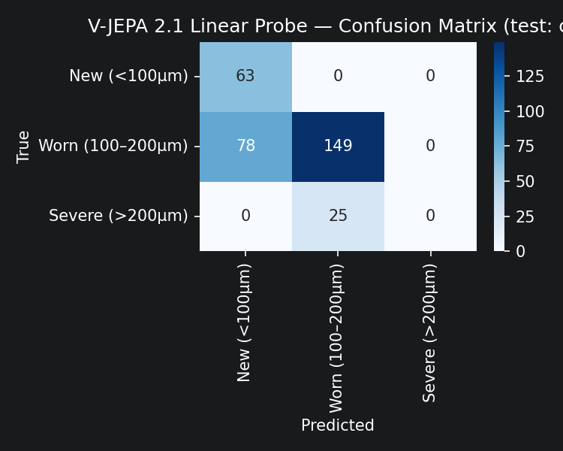
Figure 1. Confusion matrix for V-JEPA 2.1 linear probe on held-out cutter c6.

5.3 UMAP Embedding Visualisation
Figure 2 shows a 2D UMAP projection of all 945 embeddings (c1 + c4 + c6), fitted with n_neighbors=20 and min_dist=0.1 after StandardScaler normalisation.

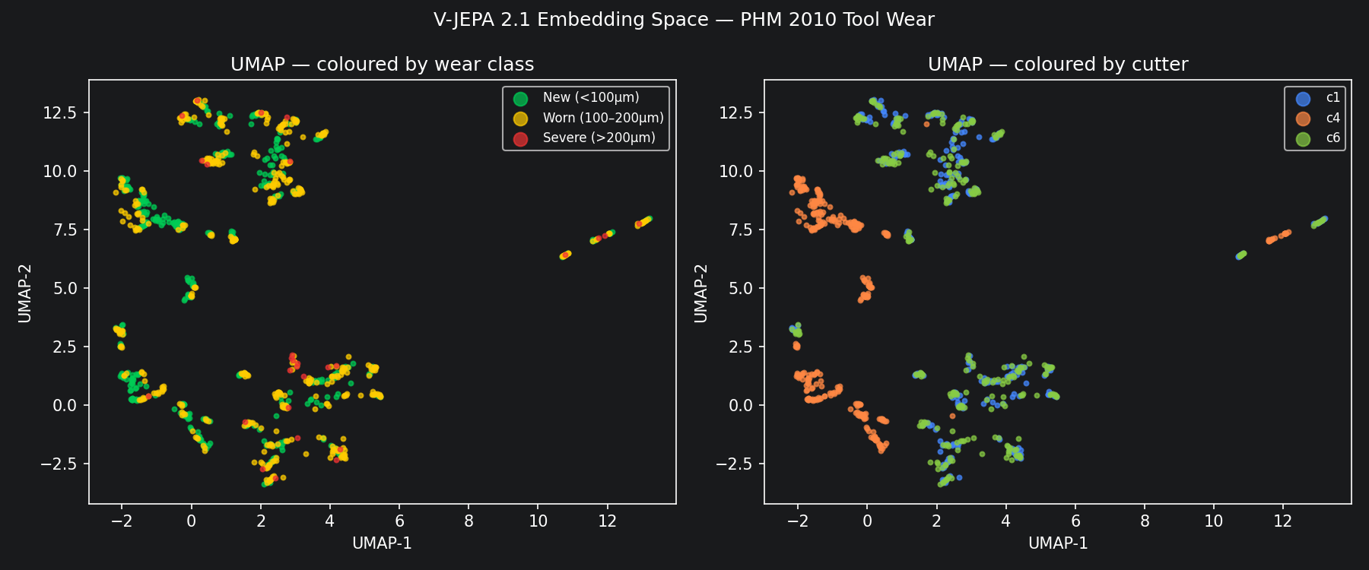
Figure 2. UMAP projection of V-JEPA 2.1 embeddings. Left: coloured by wear class. Right: coloured by cutter identity.

The right panel (cutter identity) reveals the dominant structure: embeddings form cutter-specific clusters, with c4 (orange) occupying the left and lower-centre, c1 (blue) forming compact sub-clusters, and c6 (green) dispersed across the right side and partially overlapping the centre. In the left panel (wear class), New (green), Worn (yellow), and Severe (red) are thoroughly mixed within each cutter-cluster — there is no region that is cleanly separable by wear state.
The isolated right cluster (UMAP-1 ≈ 10–13) consists almost entirely of c6 late-stage cuts (Worn / Severe). This sub-cluster is visually distinct, suggesting JEPA does capture some late-stage wear signal for c6 — but only 8 of the 25 Severe samples appear there, insufficient for the probe to learn a decision boundary.

5.4 Embedding Drift
Figure 3 shows the L2 distance between consecutive frame embeddings across 315 cuts for each cutter. Background colour encodes the ground-truth wear class; dashed white lines mark class transitions.

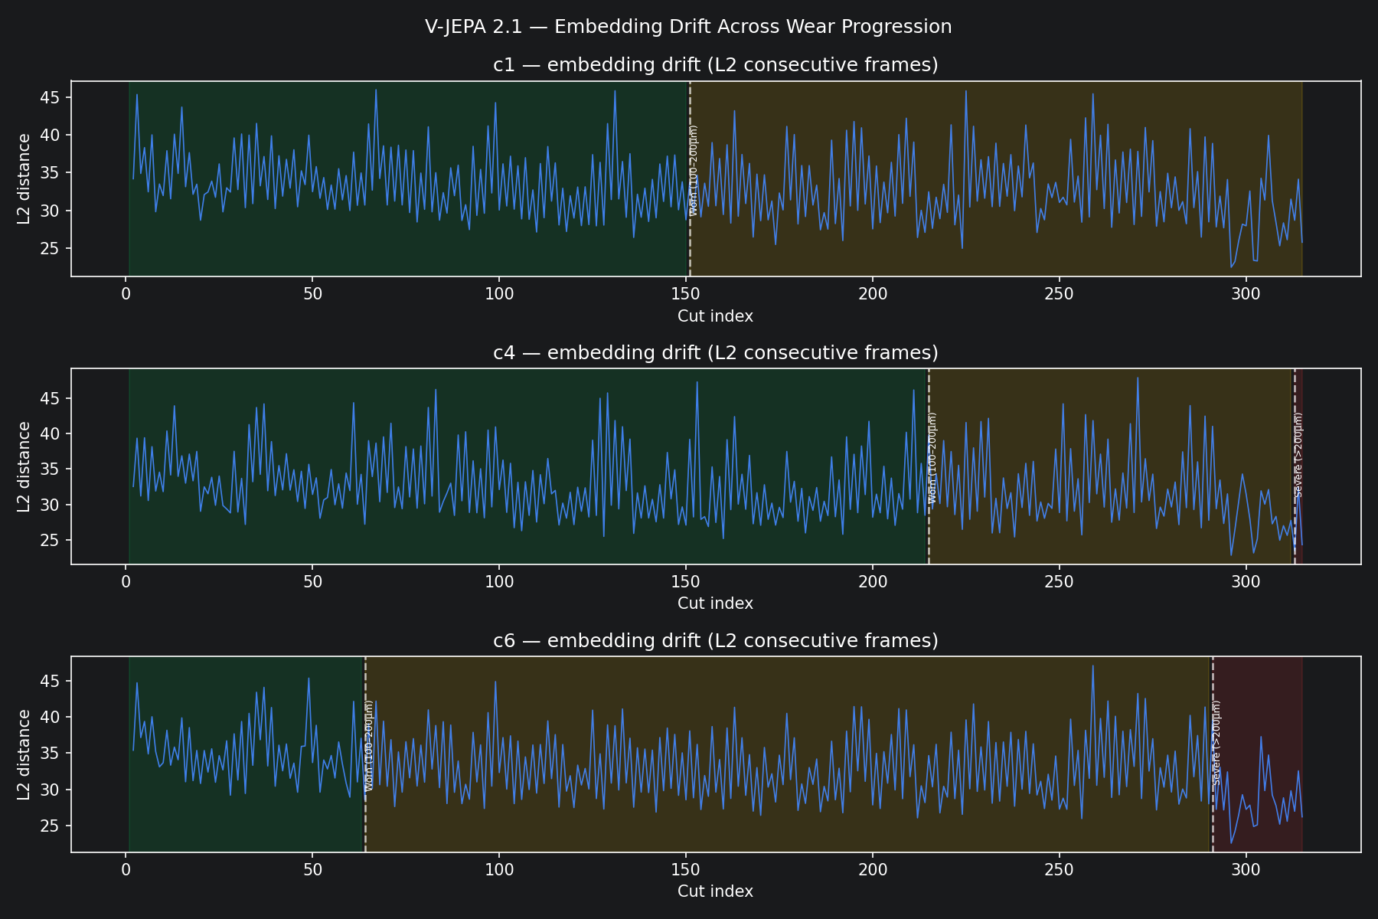
Figure 3. Per-frame embedding drift (L2 norm of consecutive embeddings) across wear progression for cutters c1, c4, and c6.

Drift is broadly noisy across all cutters with no systematic spike at class transitions, suggesting that JEPA's embedding does not change abruptly as wear crosses the 100 µm or 200 µm thresholds. This is consistent with the UMAP finding: wear-class boundaries do not correspond to geometric boundaries in the embedding space. The relatively stable drift for c1 (only New and Worn present) compared to c6 (which reaches Severe) may reflect the larger intra-cutter appearance change in c6.

6. Analysis & Discussion

6.1 Why Cutter Identity Dominates
V-JEPA 2.1 was pre-trained on natural video data, where the dominant temporal consistency signal is scene identity (same camera, same scene, same objects). When applied to tool wear spectrograms, the analogous signal is cutter identity: each cutter has a characteristic frequency fingerprint (spindle resonances, workpiece interaction modes) that is consistent across all 315 cuts. This inter-cutter variation is larger in the spectrogram than the intra-cutter wear progression, so JEPA's patches encode 'which cutter' more strongly than 'how worn'.
This is precisely the failure mode that cutter-aware evaluation is designed to expose. A random train/test split would have inflated accuracy by allowing the probe to exploit per-cutter style cues seen during training.

6.2 Severe Class Zero Performance
The complete failure on Severe (F1 = 0.000) has two contributing causes. First, Severe cuts appear only in c6 (25 samples), which is the test cutter — the probe never saw Severe examples during training. Second, even within c6, the Severe embeddings are not geometrically separated from Worn embeddings in JEPA's space (UMAP left panel shows red dots scattered among yellow). This is a zero-shot generalisation failure: the probe cannot project a decision boundary for a class it has never seen in the training distribution.

6.3 Comparison with Supervised CNN
The supervised CNN+MLP baseline achieves ~92% per-class accuracy by training directly on wear labels. It processes three complementary representations simultaneously (spectrogram, wavelet heatmap, 22 scalar features) and is trained with a cross-entropy loss that explicitly pushes wear-class boundaries apart in the final embedding layer. V-JEPA 2.1 has no such objective — its loss is designed to make spatially proximate patches predictable from each other, which is not equivalent to making wear-class boundaries salient.
The 24.7-point accuracy gap (67.3% vs ~92%) represents the cost of using a domain-agnostic, label-free encoder on a domain-specific classification task with limited cross-domain training data.

6.4 What JEPA Does Capture
Despite the overall result, the 67.3% accuracy is well above chance (33% for a 3-class uniform baseline). The Worn class F1 of 0.743 is particularly notable: the probe can identify moderate wear with reasonable reliability, likely because Worn cuts have a more distinct spectrogram signature (elevated high-frequency energy, harmonic distortion) that JEPA's patches encode as visually distinctive texture. The perfect recall on New (1.000) shows JEPA reliably identifies early-life tools, at the cost of misclassifying some Worn as New.

7. Limitations
- Single test cutter (c6): all probe results derive from one held-out cutter. Cross-validation across cutter assignments would give a more robust estimate.
- No Severe samples in training: the Severe class failure is partly a data split artefact, not solely a JEPA limitation.
- Voltage proxy: the voltage signal fed to make_spectrogram_image() is synthesised as v = 0.8·i + ε rather than measured. This affects channels 1 (V-I trajectory) and 2 (power spectrum) of the spectrogram, potentially reducing spectral richness.
- Frame-level pooling: spatial tokens are mean-pooled per frame, discarding spatial structure. A patch-level probe or attention-weighted pooling might recover more wear-relevant signal.
- No fine-tuning: V-JEPA 2.1 was evaluated frozen. Even light fine-tuning on labelled cuts could substantially improve results.
- Single model: only one JEPA checkpoint was evaluated (ViT-L, fpc64-256). Smaller or larger variants, or models pre-trained on scientific video, may behave differently.

8. Future Work
- Nuisance regression: residualise embeddings against cutter identity before probe training to suppress cutter-specific variation and isolate wear signal.
- Fine-tuning: adapt V-JEPA 2.1 on a small set of labelled cuts to align the embedding space with wear-class boundaries.
- Temporal probe: exploit the sequential structure of 315-cut videos — train an LSTM or Transformer on the embedding time series rather than frame-level logistic regression.
- Multi-cutter training: include all six cutters (using c2, c3, c5 pseudo-labels from the supervised CNN) to reduce cutter-identity dominance in the probe training set.
- Real voltage signals: replace the synthesised voltage proxy with measured electrical signals from a smart meter to activate all three spectrogram channels properly.
- Patch-level analysis: extract per-patch embeddings rather than mean-pooled frame embeddings to identify which spatial regions of the spectrogram JEPA finds most temporally predictable as wear increases.

9. Conclusions
V-JEPA 2.1, applied as a frozen feature extractor to Mel spectrogram videos of PHM 2010 tool wear data, achieves 67.3% overall accuracy on a held-out cutter via linear probing — 24.7 points below the supervised CNN+MLP baseline. UMAP analysis reveals that the embedding space is dominated by cutter identity rather than wear state, explaining the poor cross-cutter generalisation. The Severe class is entirely undetected, partly due to zero training examples and partly due to geometric overlap with Worn in the embedding space.
These results confirm that domain-agnostic, video-pre-trained models do not automatically encode the domain-specific semantic structure needed for electrical signal-based tool wear classification. However, the 67.3% accuracy — well above the 33% chance baseline — and the 0.743 F1 on the dominant Worn class suggest that V-JEPA 2.1 captures non-trivial wear information. With targeted interventions (nuisance regression, fine-tuning, temporal probing), V-JEPA 2.1 embeddings could form a competitive foundation for label-efficient tool wear monitoring.

Appendix A: Experiment Configuration

Parameter | Value
JEPA model | facebook/vjepa2-vitl-fpc64-256
JEPA parameters | 326M (frozen)
Embedding dim | 1024
Probe classifier | LogisticRegression (C=1.0, max_iter=1000)
Train cutters | c1, c4 (630 samples)
Test cutter | c6 (315 samples)
Spectrogram size | 64×64 → upscaled to 224×224
Spectrogram channels | Mel / V-I trajectory / power spectrum
Signal channel | force_x (col 0) as current proxy
Voltage | Synthesised: 0.8·i + N(0, 0.05²)
Sampling rate | 50,000 Hz
Video FPS | 10 fps, 315 frames, ~31 s/cutter
Chunk size (JEPA) | 32 frames per forward pass
UMAP params | n_neighbors=20, min_dist=0.1, n_components=2
Random seed | 42
Device | CUDA
Date | 2026-05-06

Appendix B: Output Files
- jepa_outputs/c1_wear_video.mp4 — Spectrogram video, cutter c1, 315 frames
- jepa_outputs/c4_wear_video.mp4 — Spectrogram video, cutter c4, 315 frames
- jepa_outputs/c6_wear_video.mp4 — Spectrogram video, cutter c6, 315 frames
- jepa_outputs/confusion_matrix.png — Confusion matrix heatmap (Figure 1)
- jepa_outputs/umap.png — UMAP embedding visualisation (Figure 2)
- jepa_outputs/embedding_drift.png — Embedding drift plot (Figure 3)
- jepa_probe.ipynb — Full reproducible experiment notebook

