Project Report Template

**1 INTRODUCTION**

* 1. Overview

The project aim is to provide real-time knowledge for all the students who have basic knowledge of salesforce and looking for a real-time project. This project will also help those professionals who are in cross-technology and want to switch to salesforce. Maintain a good relationship with parents they are the backbone of your school and their opinions and suggestions are welcome. Intract with your students, make them feel that the school is an important place to be, You need to keep close tabs on spending but understand that managing costs doesn’t have to mean a trade off in quality. With the support of this project they will gain knowledge and can include it into their resume as well. As a manager you need to moniter and take out time to moniter. Combine your strictness and your gentle nature without being scarcy or taken for granted, be aware of your limits, there are managing for students.

* 1. Purpose

It is used for view student’s full history and profile including all correspondence, program and financial info. It is purpose of get the details using reporting by current students, drop out students, no shows, outstanding payments, etc. View grades by course or program as well as pass or fail reporting, easily print transcripts, report cards, etc. Set up a convenient payment plan, alert when payments are due and integrate with our bank so students can pay online.

1. **Problem Definition & Design Thinking**
   1. Empathy Map

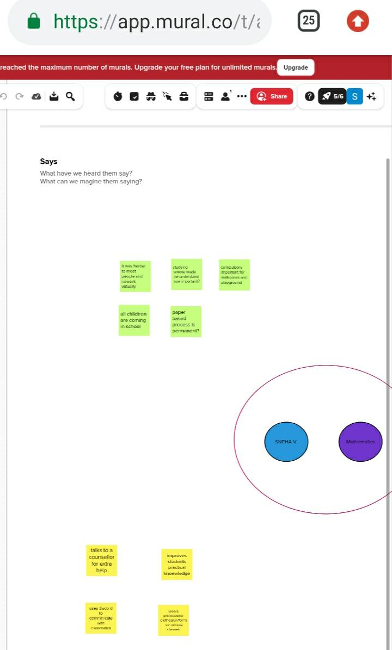

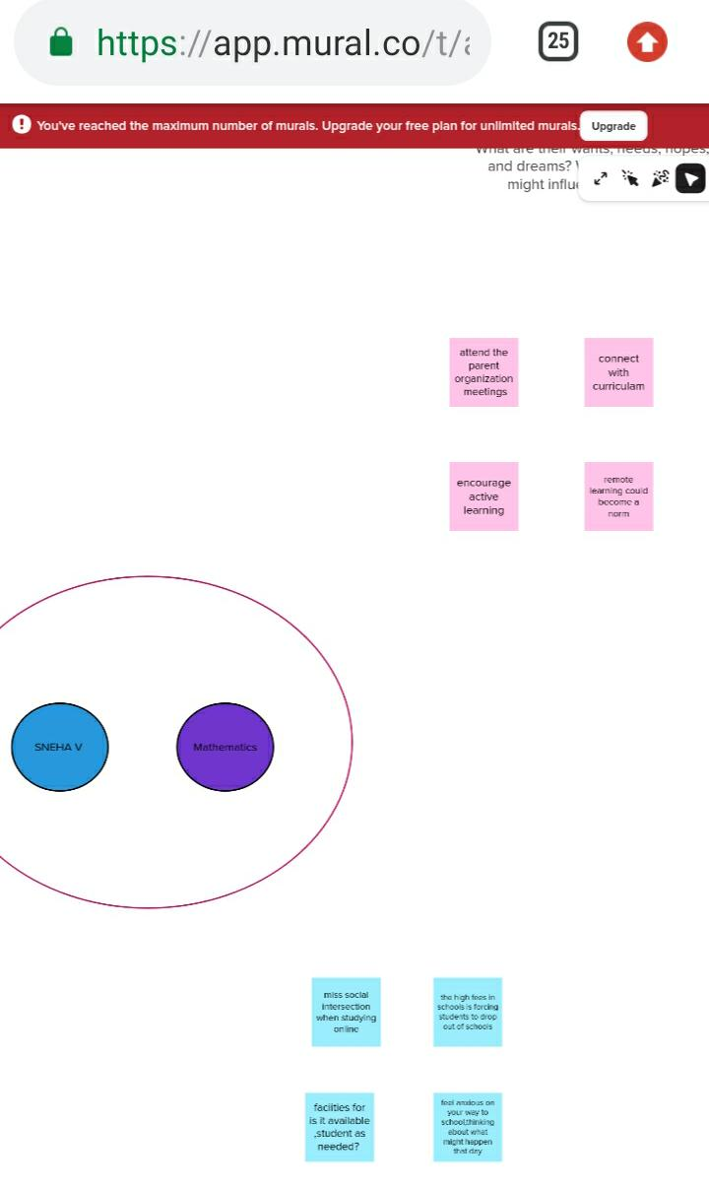

* 1. Ideation & Brainstorming Map

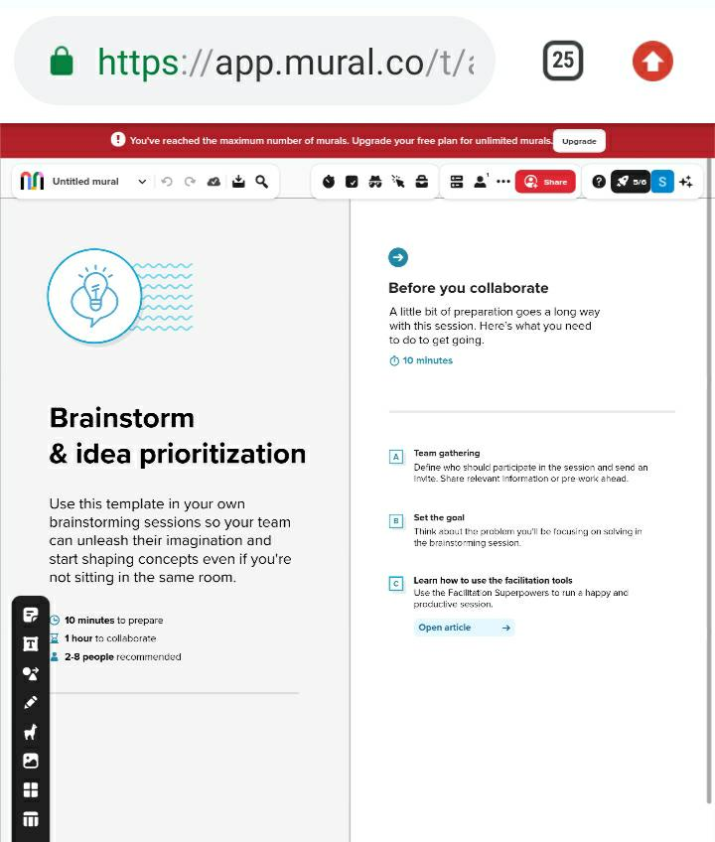

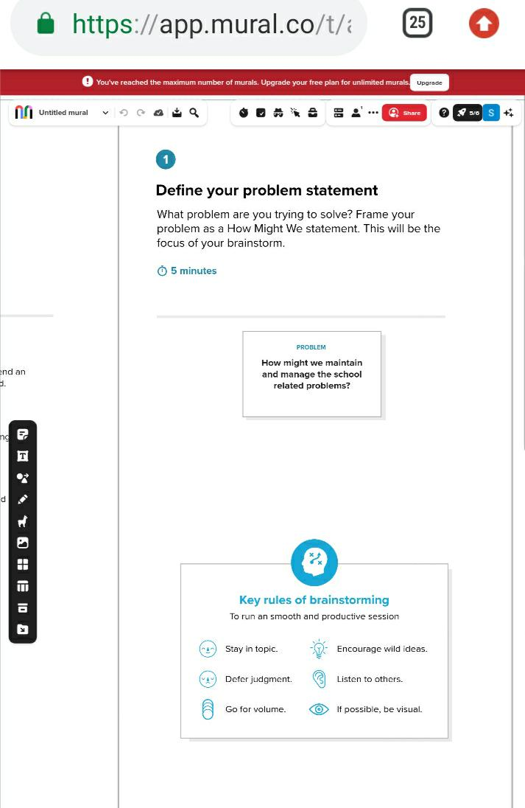

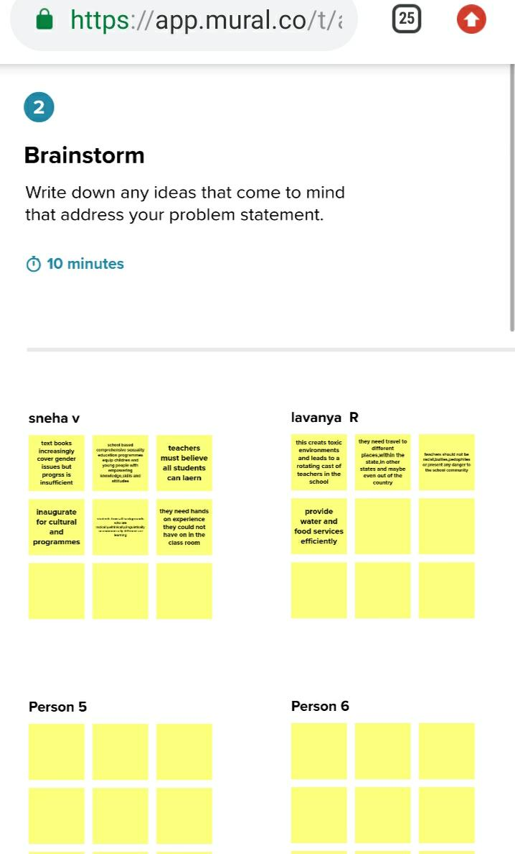

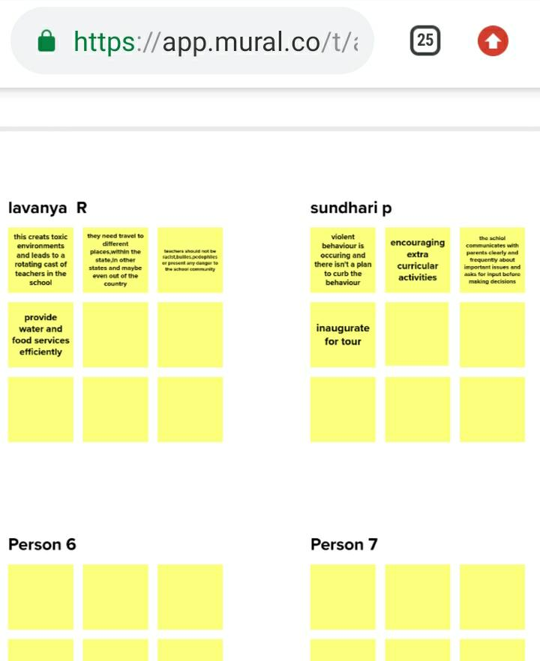

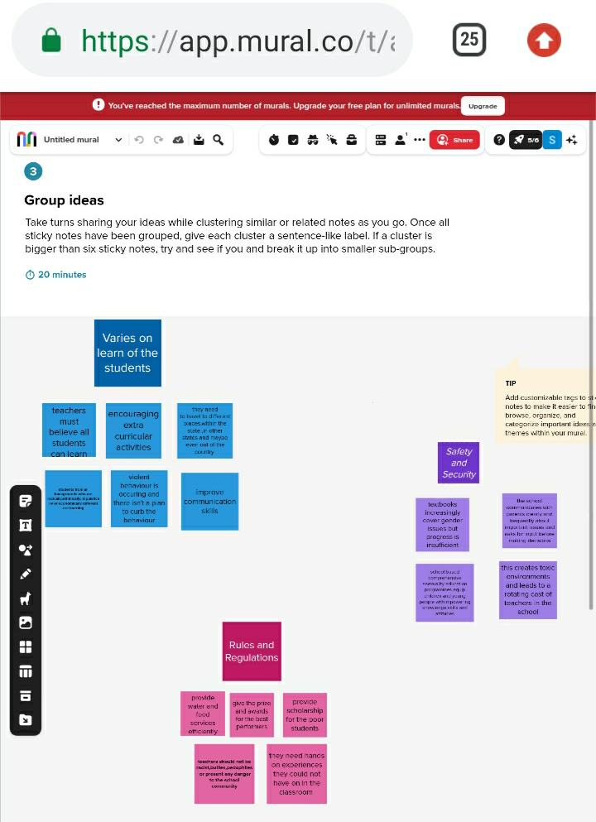

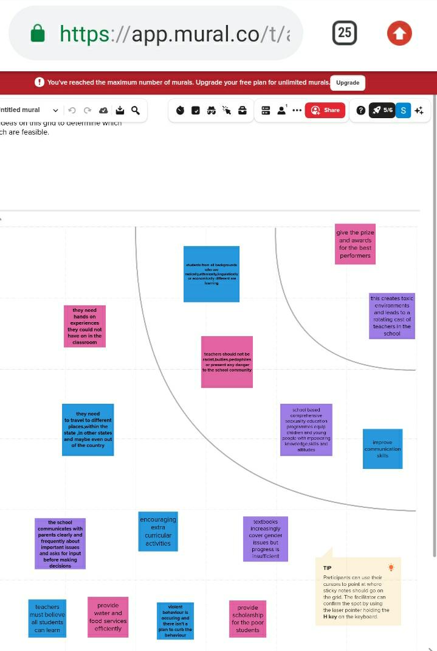

1. **RESULT**

3.1 Data model**:**

|  |  |
| --- | --- |
| **Object name** | **Fields in the Object** |
| School | |  |  | | --- | --- | | Field label | Data type | | Address | Text | | District | Text | | State | Text | | School websites | Text | | Phone number | Phone | | Number of students | Roll-up summary | | Highest marks | Roll -up summary | |
| Student | |  |  | | --- | --- | | Field label | Data type | | Phone number | Phone | | School | Master-detail relationship | | Results | Picklist | | Class | Number | | Marks | Number | |
| Parent | |  |  | | --- | --- | | Field label | Data type | | Parent address | Text | | Parent number | Phone | |

3.2 Activity & Screenshot

**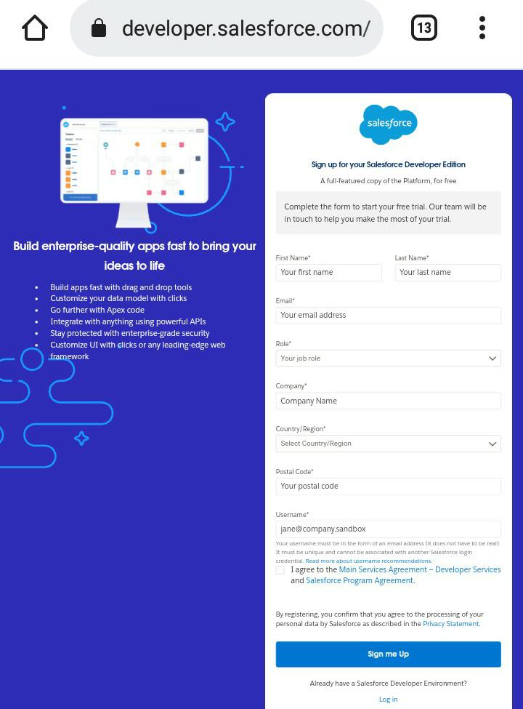  
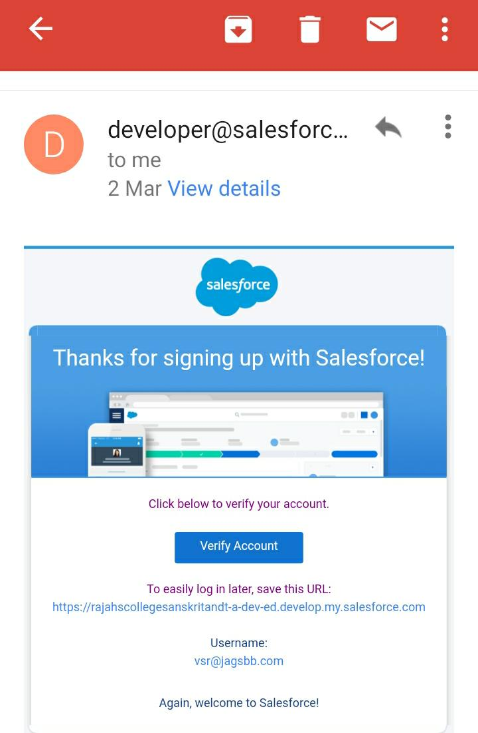**

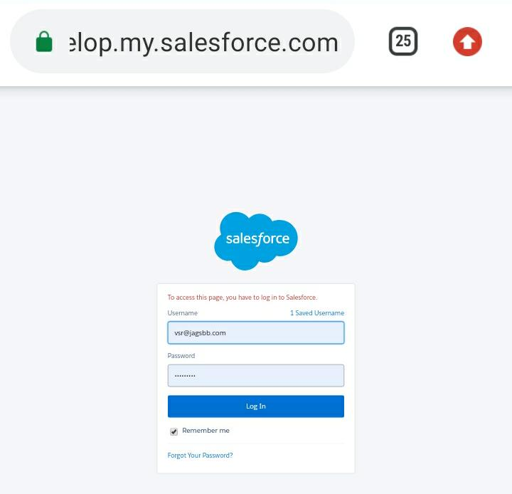

A CRM developer is a software developer who specializes in implementing enhancements for a CRM system based on any business’ requirements.

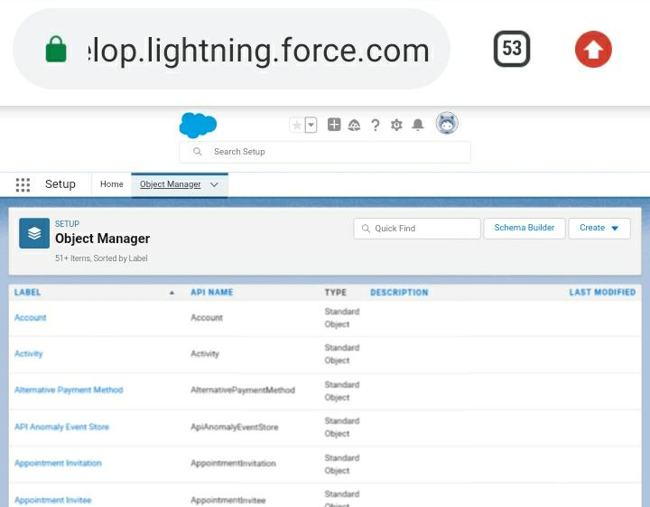

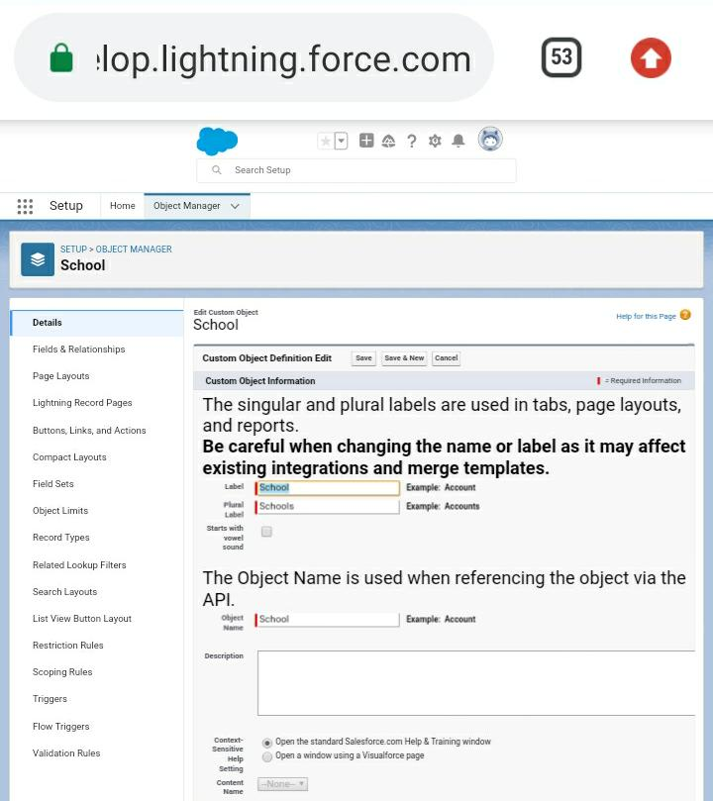

Executing on this objective is the most sure-fire way to see positive results across your business.

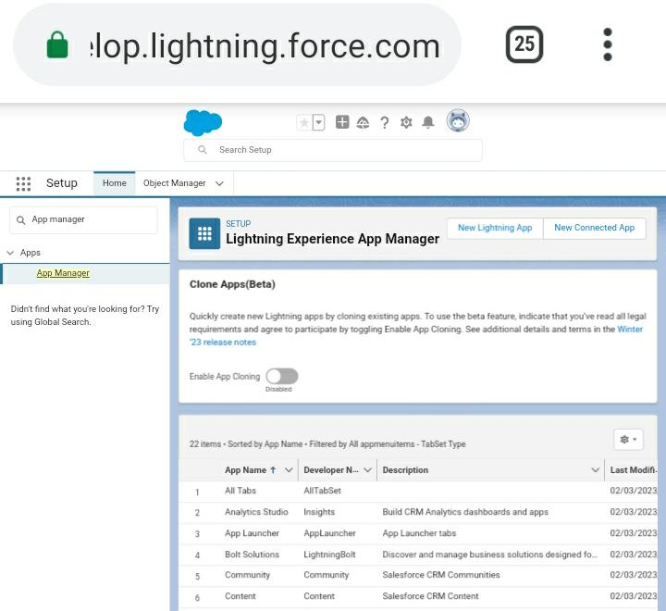

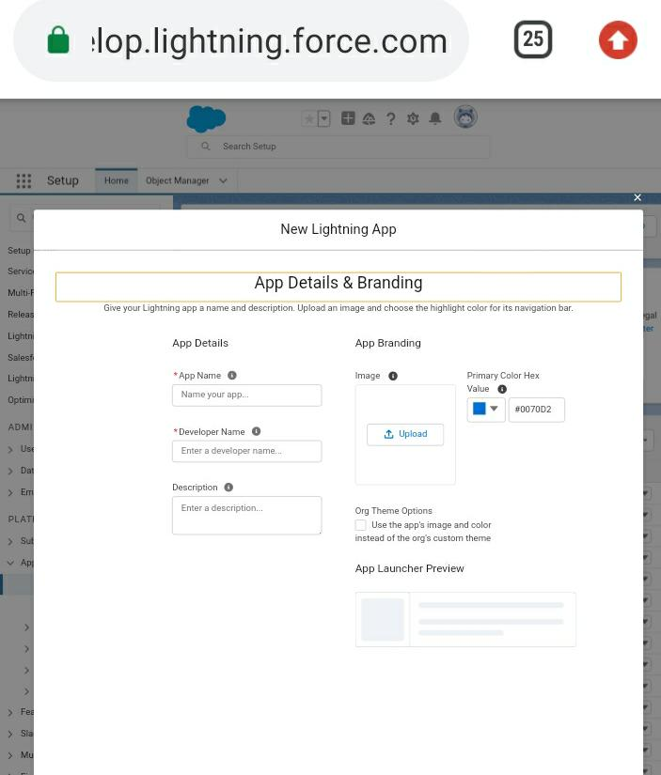

Dashboard-style apps, such as apps to track top sales prospects or key leads for the quarter.

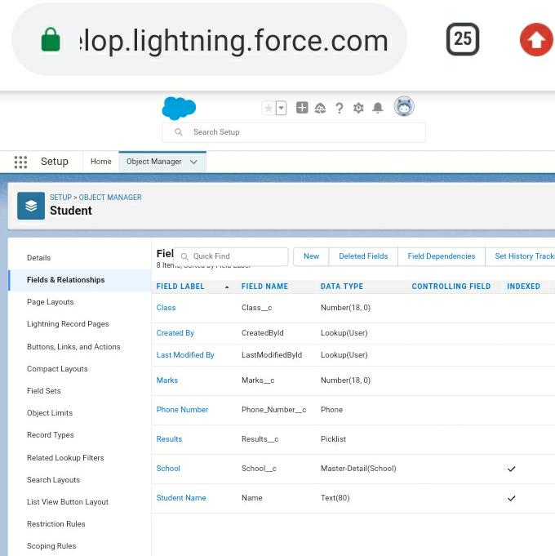

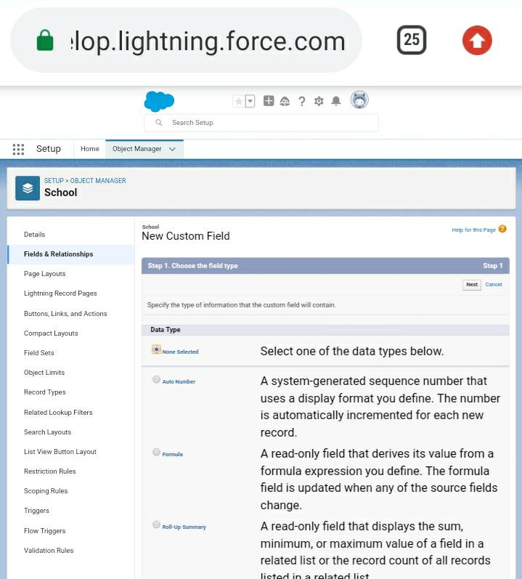

A CRM is a system that helps schools manage the entire lifecycle of a potential customer- sometimes also referred to as a lead.

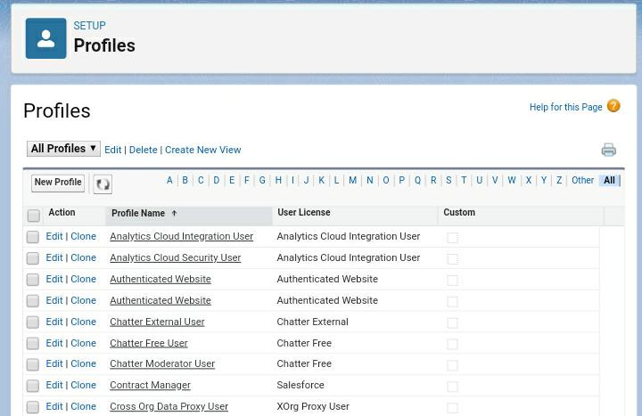

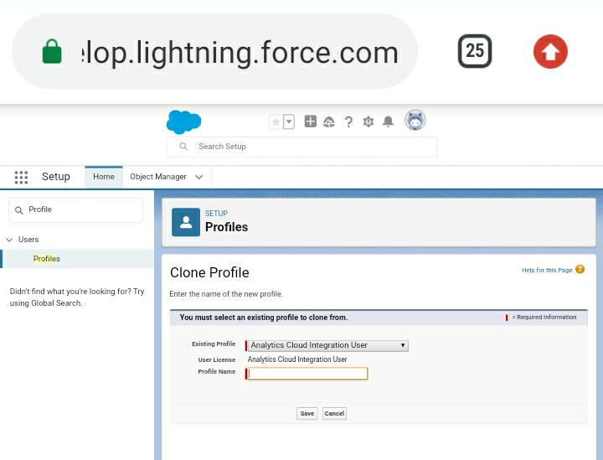

A customer profile is a concise description of any particular classification of customer. You find customer profiles within your CRM software that track existing or prospective customers.

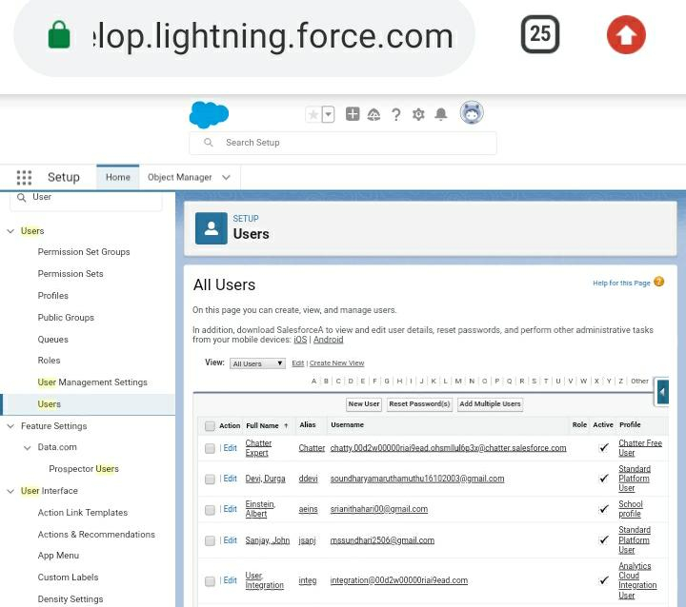

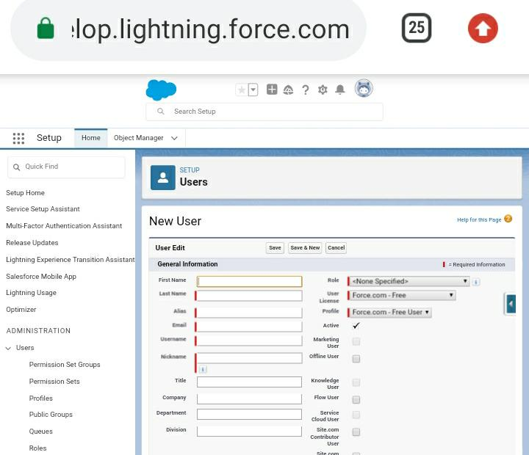

The primary users of CRM systems are sales and marketing teams, many departments and groups now access and update the system.

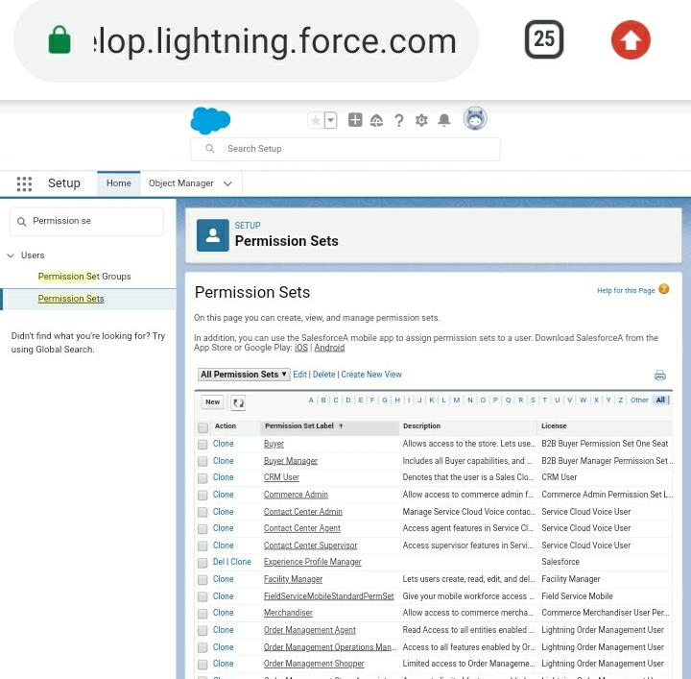

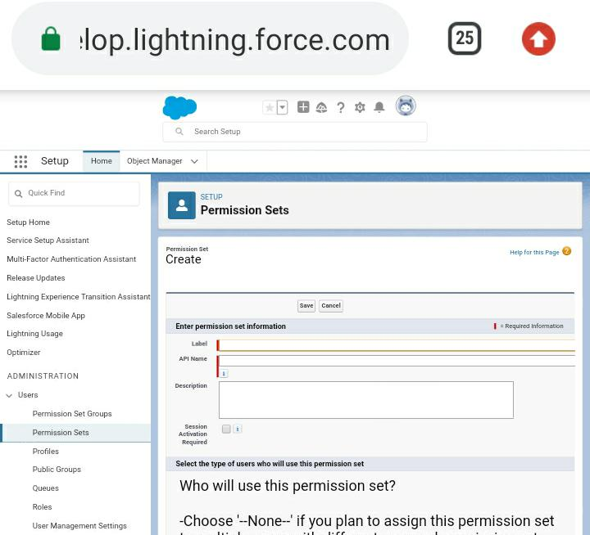

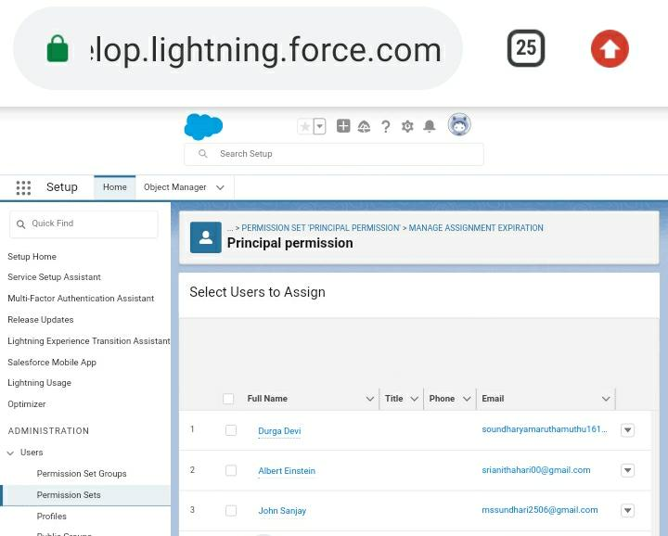

Each CRM analytic growth permission set license to use the CRM analytics platform.

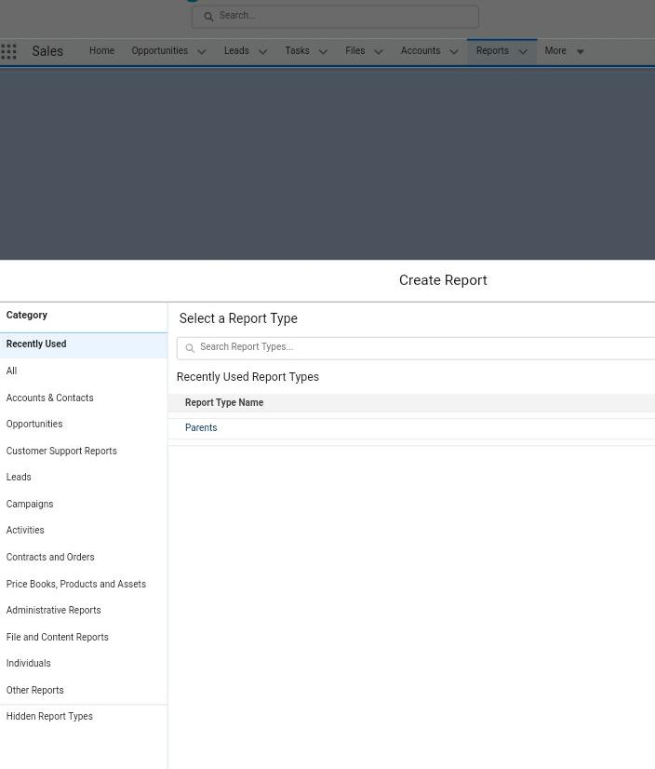

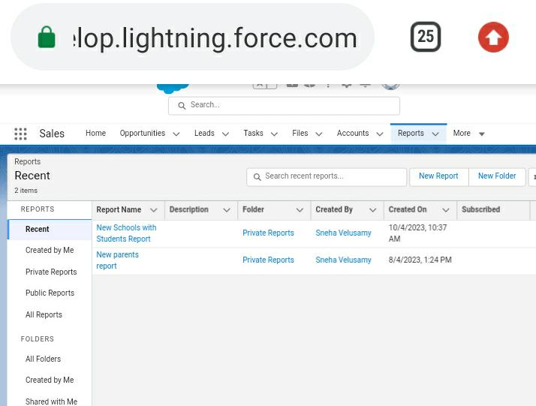

This report typically includes information such as the number of sales calls made, meetings held, leads generated, and deals closed.

1. **Trailhead Profile Public URL**

Team lead- <https://trailblazer.me/id/svelusamy13>

Team member 1- <https://trailblazer.me/id/lkumar439>

Team member 2- <https://trailblazer.me/id/spanjanathan>

Team member 3- <https://trailblazer.me/id/smaruthamuthu2>

1. **Advantages & Disadvantages**

**Advantages:**

* Create personalized emails for each stage of enrolment and send text messages to remind parents of their enrolment status.
* With a CRM you can turn your families into school champions by building better connections and more meaningful relationships.
* Build meaningful reports with the data you need to keep all stakeholders properly informed.

**Disadvantages:**

* CRM tools can be responsible for losing the customers information as some CRM software keeps track of customers information using remote internet connections.
* Every business can’t afford CRM for data collection and connecting with customers.
* Small business may not require it, but large business use CRM on a large scale.

1. **Applications**

* Contract lifestyle management automates and streamlines contract process during key stages. These stages include initiation, authoring, process and workflow, negotiation and approval, execution, ongoing management and compliance (within the repository), contract renewal.
* Using CRM software, organizations can collect and evaluate customer data. Based on the evaluation results, they can handle marketing campaigns, set prices of their products and services, and manage transactions. It also helps in maintaining good customer relationships.

1. **Conclusion**

One of the best features of CRM is that it can connect with other business tools, such as document-sharing apps and online chat. Before technology, customer data or CRM was based on papers, but slowly, companies started tracking customer-related data with spreadsheets, emails, address book, and other ways.

1. **Future Scope**

CRM is a technology for managing all your company’s relationships and interaction with customers and potential customers. The goad is simple: Improve business relationships. A CRM system help companies stay connected to customers, streamline processes, and improve profitability.

* Using CRM software, organizations can collect and evaluate customer data. Based on the evaluation results, they can handle marketing campaigns, set prices of their products and services, and manage transactions. It also helps in maintaining good customer relationships.