Payment Gateway

This application was designed with ASP.NET Core MVC 2. After building in Visual Studio 2017 it can be started from a Windows Powershell prompt by navigating to the project folder and executing the command dotnet run

The application has a web interface allowing a user to create payments and view details of previous ones, as well as an externally accessible JSON based API. A sqlite database is used for persistent storage. It can be accessed from <http://localhost:5000>.

# 

Figure :Home

Validation features are supported and payment success or failure has been randomized.

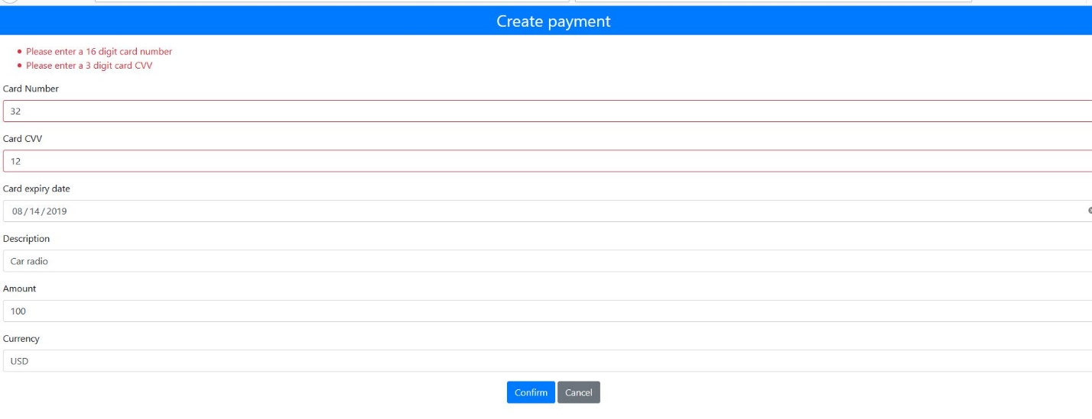

Figure :Validation

# 

Figure :Payment success

# 

Figure :Payment failure

# API

The API supports GET, POST and DELETE operations. It uses the base URL <http://localhost:5000/api/payment>

Examples of API requests from powershell follow.

## Retrieve details for all payments

Invoke-RestMethod -Uri "http://localhost:5000/api/payment" -Method Get

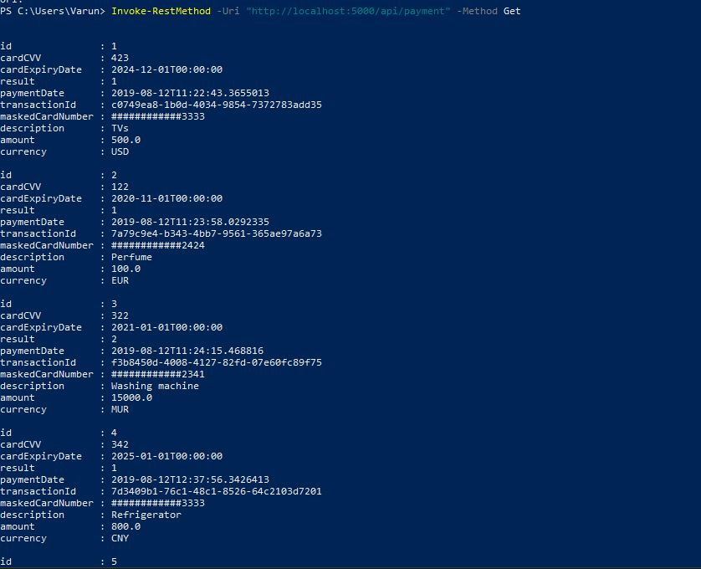

## Retrieve payment details by id

Invoke-RestMethod -Uri "http://localhost:5000/api/payment/3" -Method Get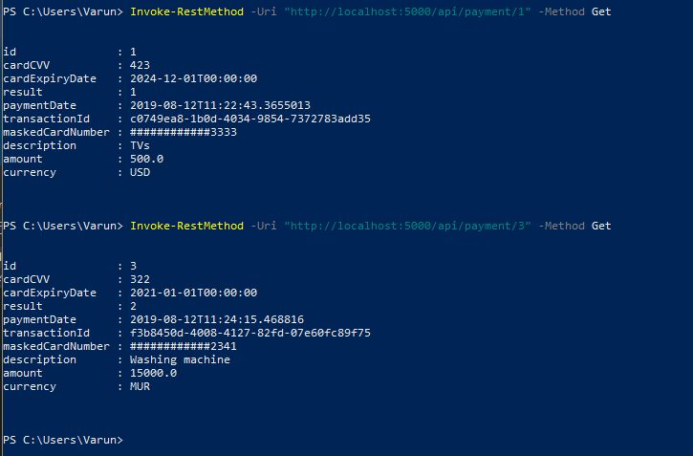

## Retrieve payment details by transaction id

Invoke-RestMethod -Uri "http://localhost:5000/api/payment/guid/7d3409b1-76c1-48c1-8526-64c2103d7201" -Method Get

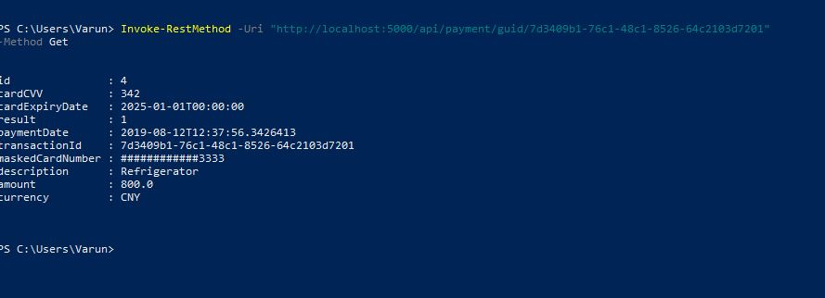

## Make a payment request

Invoke-RestMethod "http://localhost:5000/api/payment" -Method POST -Body (@{CardNumber="7777777777777777"; CardCVV="555"; CardExpiryDate="2021-05-01"; Amount=10000; Currency="MUR"; Description="Furniture"} | ConvertTo-Json) -ContentType "application/json"

A payment request through the API uses the fields CardNumber, CardCVV, CardExpiryDate, Amount , Currency and Description.

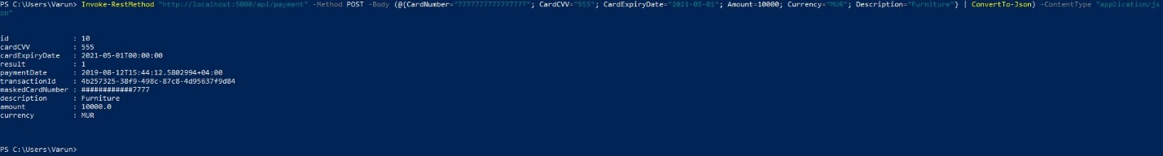

## Delete a payment

Invoke-RestMethod "http://localhost:5000/api/payment/10" -Method Delete

If deletion was successful a JSON representation of the deleted payment is received.

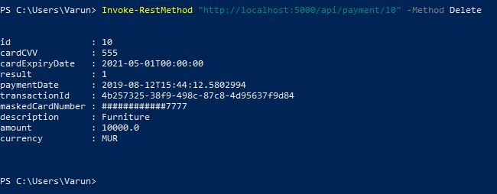

# Unit tests

Unit tests are located in the project PaymentGateway.Tests. To run them the application must first be listening on port 5000.

# Improvement suggestions

* Authentication
* Encryption
* Query optimization
* Better user interface
* Support for delete operations in the UI
* Alternative database: sqlite does not support concurrent access from multiple threads.
* Compatibility testing with other browsers. Only Chrome and Firefox were used.