No. 15 Regent Street,

Abubo, Nnewichi Nnewi,

Anambra State.

02/12/2023

The Provost,

College of Nursing Science,

Nnamdi Azikiwe University

**LETTER OF CONSENT ON BEHALF OF MY DAUGHTER**

To whom it may concern. I introduce to you my first daughter **Chinecherem Emerebe.**

I can testify, that my daughter has grown to be a lady of respectable character that is worthy of emulation.

Her obedient and responsible behavior in the home and the immediate environment has earned her a place even in the church as a role model.

I firmly attest to her personality that she is a lady of good behavior and willing to sponsor her all through time as a student to ensure she completes her course of study. Please extend your hand of fellowship to help her actualize her goals.

Yours Faithfully

………………………………………

[asoothingliving.co](https://server3.noxtools.com/analytics/overview/?db=us&device=desktop&currency=usd&q=asoothingliving.com&searchType=domain)m

[sharethumb.com](https://server4.noxtools.com/analytics/overview/?db=in&device=desktop&currency=usd&q=sharethumb.com&searchType=domain)

[gradecam.com](https://server4.noxtools.com/analytics/overview/?db=in&device=desktop&currency=usd&q=gradecam.com&searchType=domain)

[happybirthdayall.c](https://server4.noxtools.com/analytics/overview/?db=in&device=desktop&currency=usd&q=happybirthdayall.com&searchType=domain)om

different types of skirt

type of faucet

most expensive nike

bossie fade haircut

noses types

cheap alternatives to dry wall

extreme fear of snow

aloe vera varieties

fleshy nose shape

deipnophobi

types of lingere

best qualities of a husband

This analysis involves a company sales performance in year 2016, with data referencing specific area like:segment, states, code, countries and more. The analysis is meant to delve into where more attention should be paid to. Pointers will be developed on how the company will perform better and make informed decision to enhance progress. The analysis is meant to provide KPI’s on the company’s data and answer questions that will enable a more productive outing next year

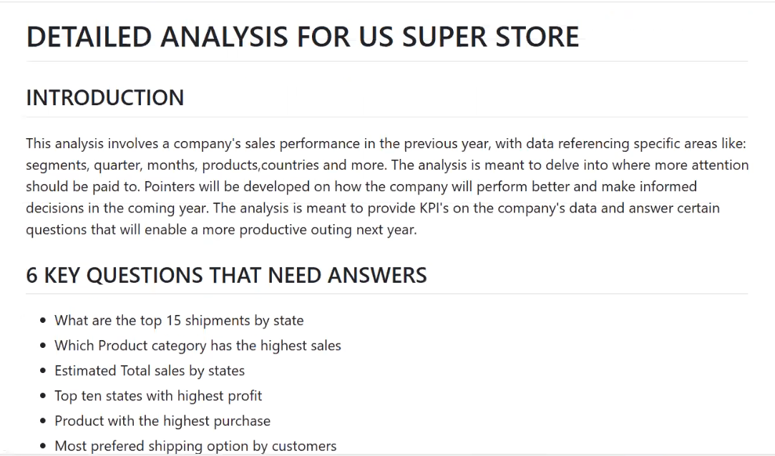

An evaluation of the company's sales performance in 2023 is underway, with a focus on various elements such as segments, states, codes, category and products. The primary goal is to identify areas necessitating heightened attention. Recommendations will be formulated to guide the company in enhancing performance and making informed decisions for progress. The analysis seeks to yield KPIs based on the company's data, that will play a central role in driving innovation and addressing inquiries that will facilitate a more productive year in the future.

**Key Questions That Need Answers**

Quantity of units sold for each product category

States with the highest number of transaction

Top-selling products and those with lower sales.

Total Profits made from each region

Total revenue by each region

Variation and highest ship mode utilized for products

Subcategory with the highest sales

Quantity of goods requested in each category

Discount given to each category

Cost of Goods Sold (COGS)

**Results from KPIs**

