# Enhanced Border-to-Coast LGPS Data Report

## Summary Overview

Total Assets Invested: GBP 59421393258.30

UK Investment Exposure: GBP 11152147454.39

## Asset Class Breakdown

|  |  |
| --- | --- |
| Asset Class | Total Base Value (GBP) |
| Bonds | 14659341079.56 |
| Other | 26366302.00 |
| Public Stocks | 44735685876.74 |

Chart: Asset Class Breakdown

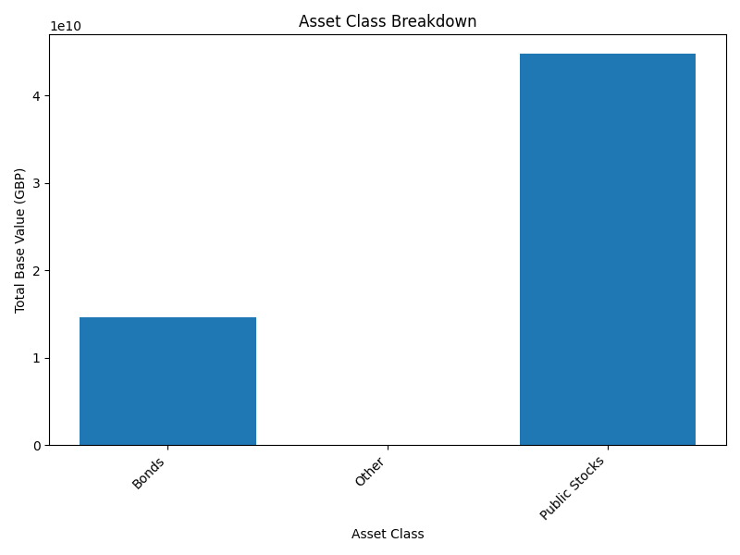

## Direct vs Indirect Investments

|  |  |
| --- | --- |
| Investment Type | Total Base Value (GBP) |
| Direct | 26366302.00 |
| Indirect | 59395026956.30 |

Chart: Direct vs Indirect Investments

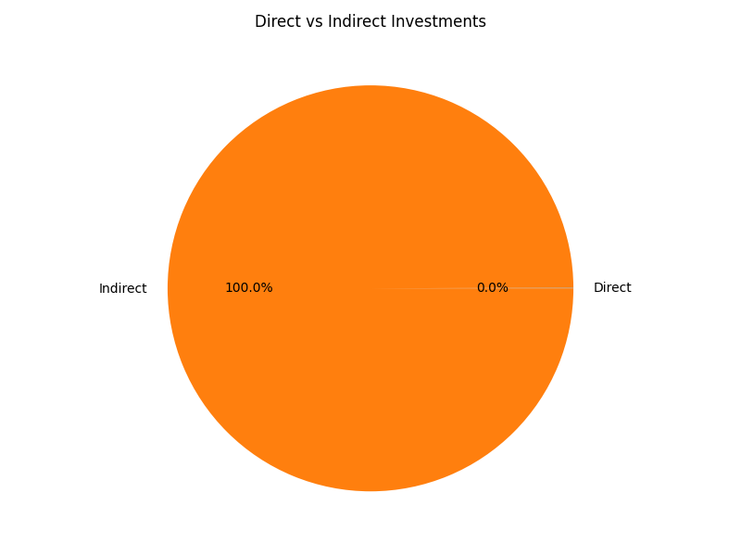

## Base Value by Fund

This chart shows the Base Value for each fund:

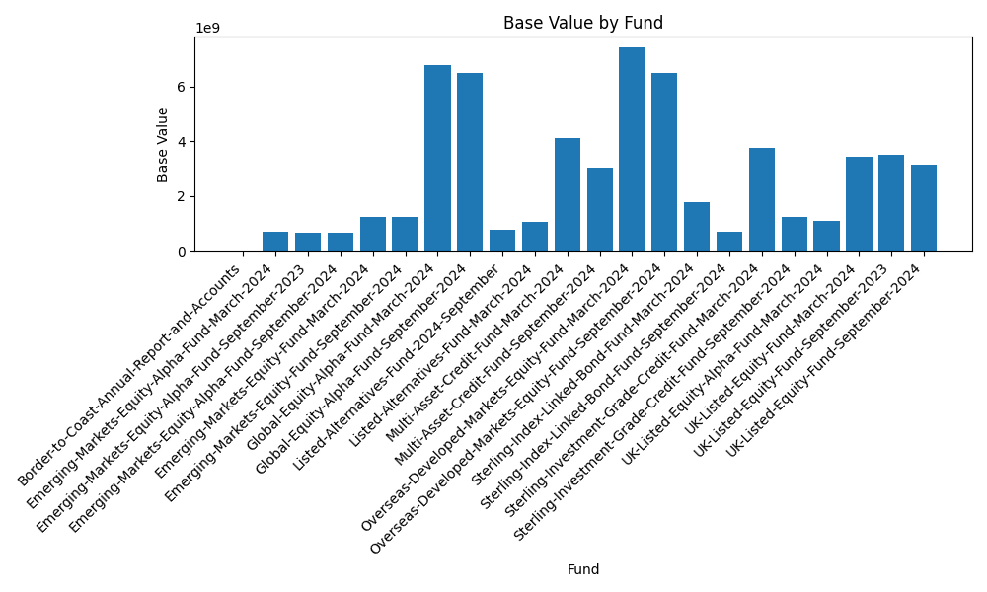

## Sector Breakdown

|  |  |
| --- | --- |
| Sector | Total Base Value (GBP) |
| Bonds | 14659341079.56 |
| Emerging Markets | 4526720002.27 |
| Global Equities | 13284825894.20 |
| Other | 15798358827.88 |
| Public Stocks | 11152147454.39 |

Chart: Sector Breakdown

