

Computer Engineering Dept.

Jordan University of Science and Technology

CPE 760 - Advanced Operating Systems

First Stage report of

Building OS from Scratch #1

Students:

Esra'a Faoury

Seham Nasr

Raghad Rabi

OCT 15, 2018

**1. Objectives**

Implementing the first assignment of building an operating system from scratch, writing a simple boot sector program that prints a short message on the screen, burn its binary code to a bootable USB drive then boot from it.

**2. Implementing Environment**

Work on Ubuntu 14.04 LTS running on VMware workstation.. (Figure2.1); use group of programs such as:

* **Terminal:** Run commands.
* **Gedit:** Text editor to write the assembly code.
* **NASM:** An 80x86 assembler.
* **QEmu:** CPU emulator.
* **Bless:** Hexadecimal editor.

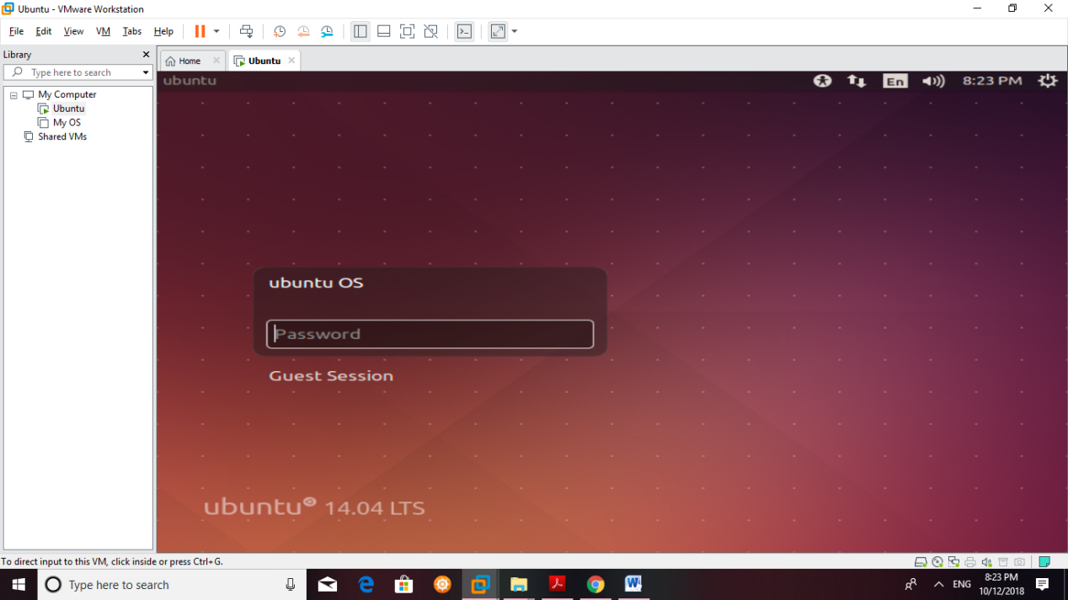

**Figure 2.1:** VMware with Ubuntu 14.04

**3. Implementation:**

1- Write the boot sector using the assembly language.(Figure3.1 & Figure3.2):

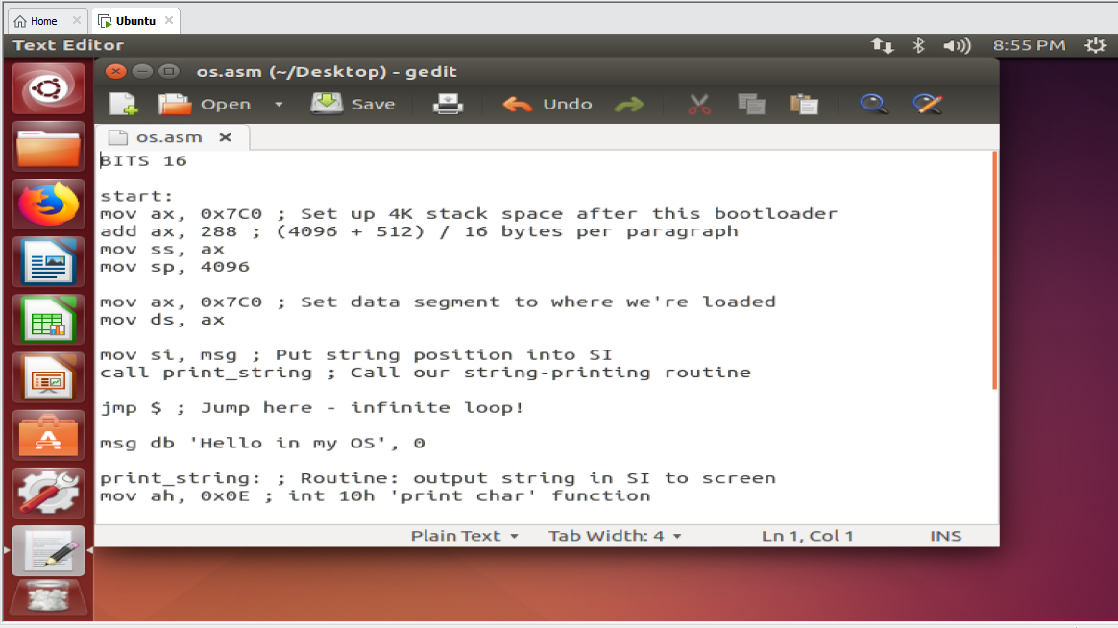

**Figure 3.1:** Boot sector written in assembly language

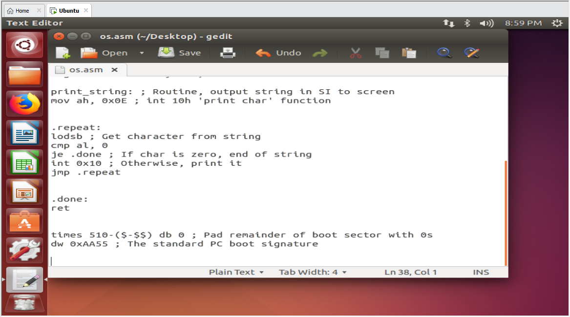

**Figure 3.2:** Boot sector written in assembly language

2. Assemble into machine actual code using NASM  
$nasm boot_sect.asm -f bin -o boot_sect.bin

3. Display the bytes the assembler created in hexadecimal format using terminal  
$od -t x1 -A n boot_sect.bin

4. Test the program using QEmu  
$qemu-system-i386 boot_sect.bin

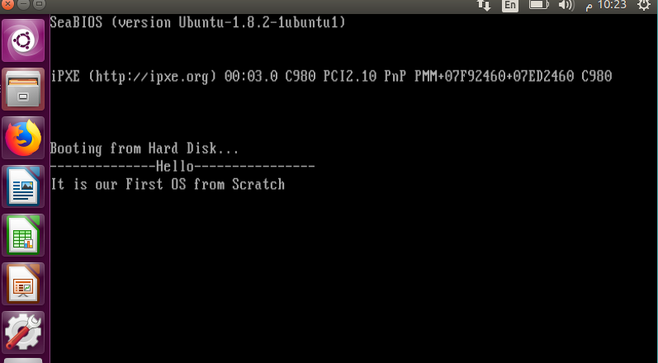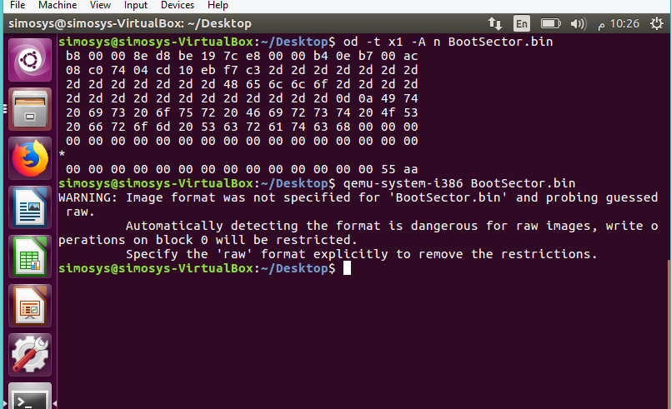

**Figure 3.3** print out the binary file and then simulate the Os using Qemu

5. Display the boot sector in binary in hexadecimal format using Bless editor

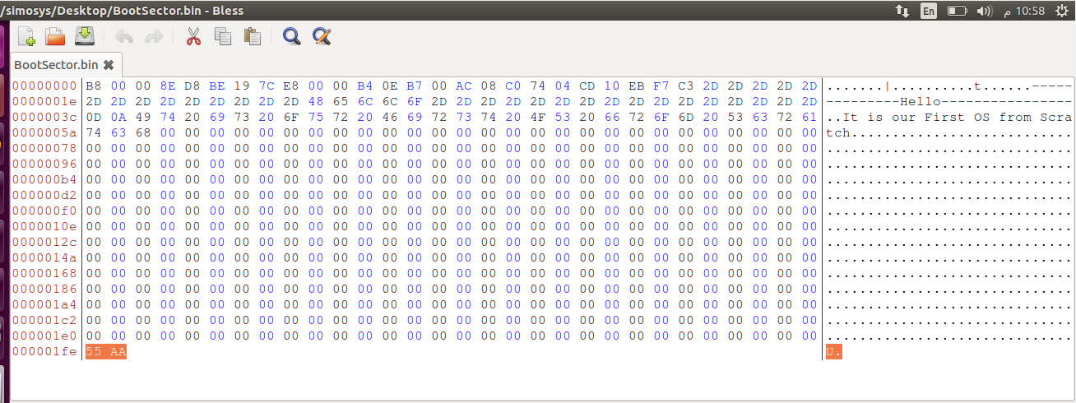As **Figure 3.4** shows, the program is 512-Byte sector with the last two bytes set to the magic  
number 0xaa55.

**Figure 3.4** Show of the Boot Sector machine code with Hex byte

**6. Format a USB drive with FAT32 file system.**

$sudo fdisk – l

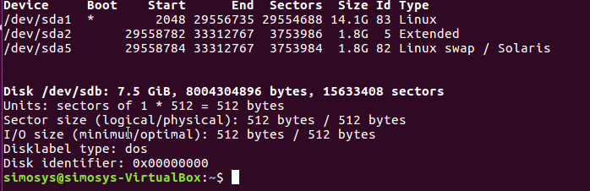

**Figure 3.5** Find USB flash path

Our flash circled above which also shows it’s place (/dev/sdb);

As following we choose to format the flash with FAT32 file system because that will fit our tiny os which is just 512 byte. Moreover, FAT32 is able to work with different os.

$sudo mkfs -t vfat -I /dev/sdb



**Figure 3.7** Format USB flash with FAT32

**7. Install the boot sector on the USB drive.**

First change the directory to our file location “path” here in our state the file is on the Desktop:

$ cd ~/Desktop

$sudo umount /dev/sdb

$sudo dd if=boot_sect.bin of=/dev/sdb && sync

This makes the USB drive bootable and boot with our boot sector bytes.

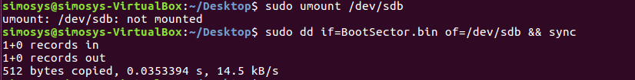

**Figure 3.8** mount boot sector to the USB flash drive

8. Now it’s the most exciting moment “Booting”

Reboot the computer and change the boot order to boot from the bootable USB from the BIOS settings.

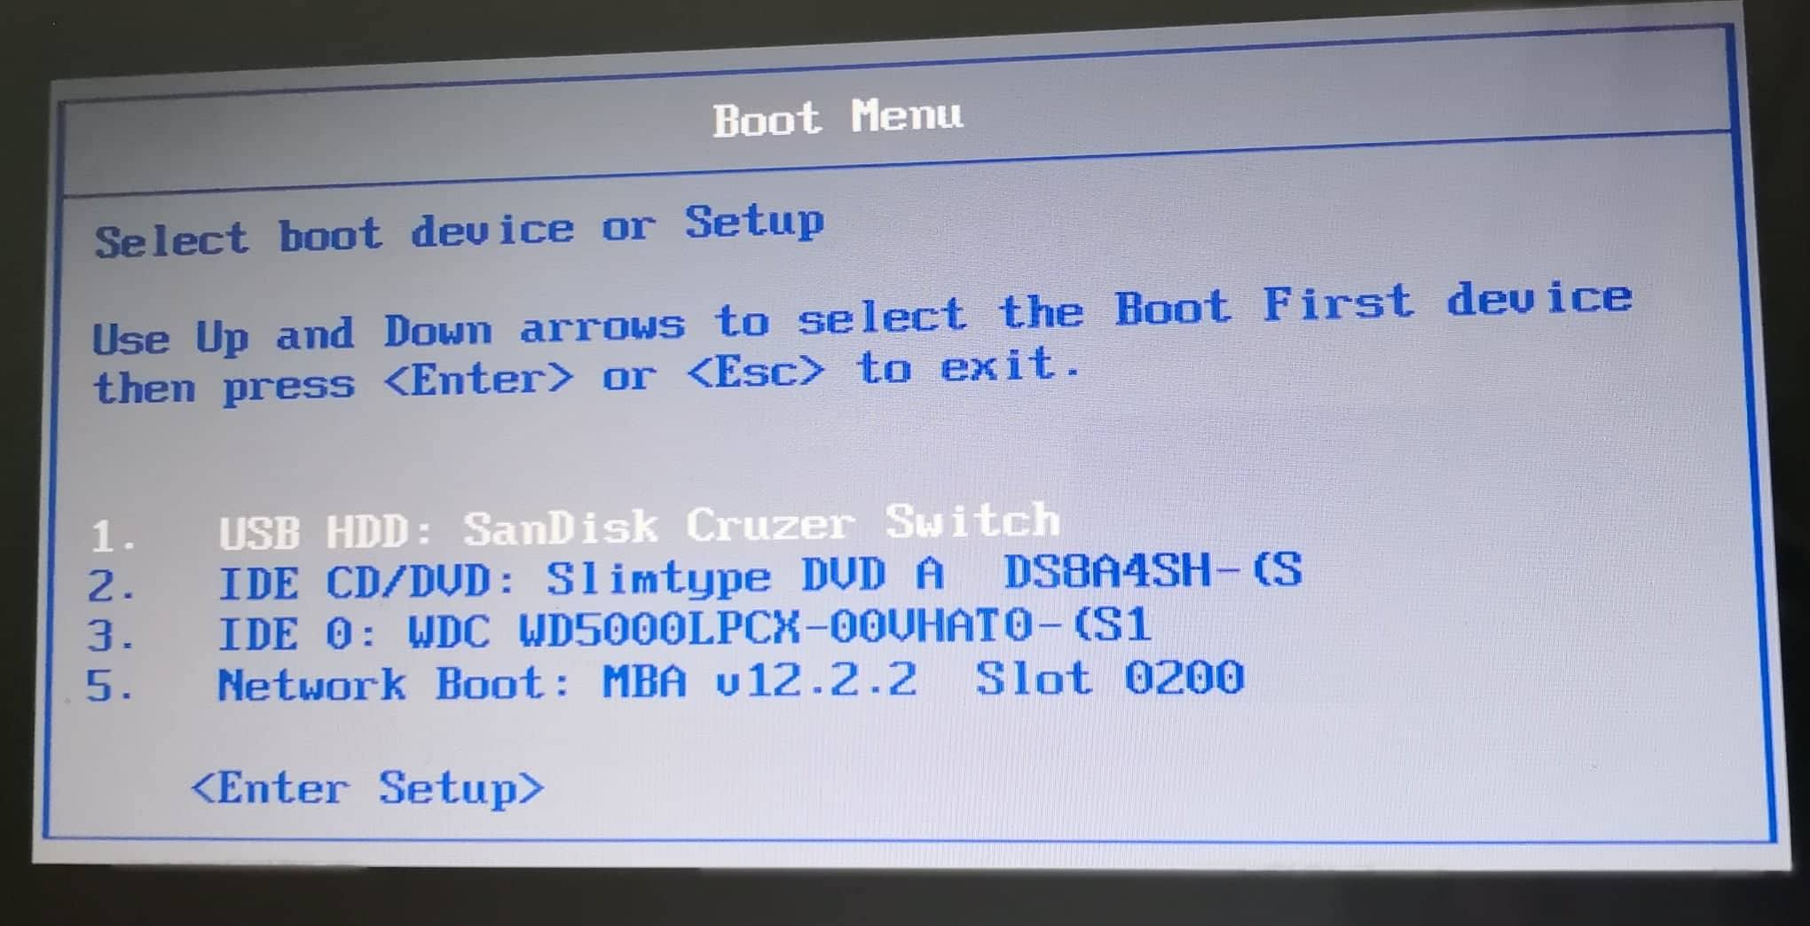

**Figure 3.9** changing the boot order from BIOS setting

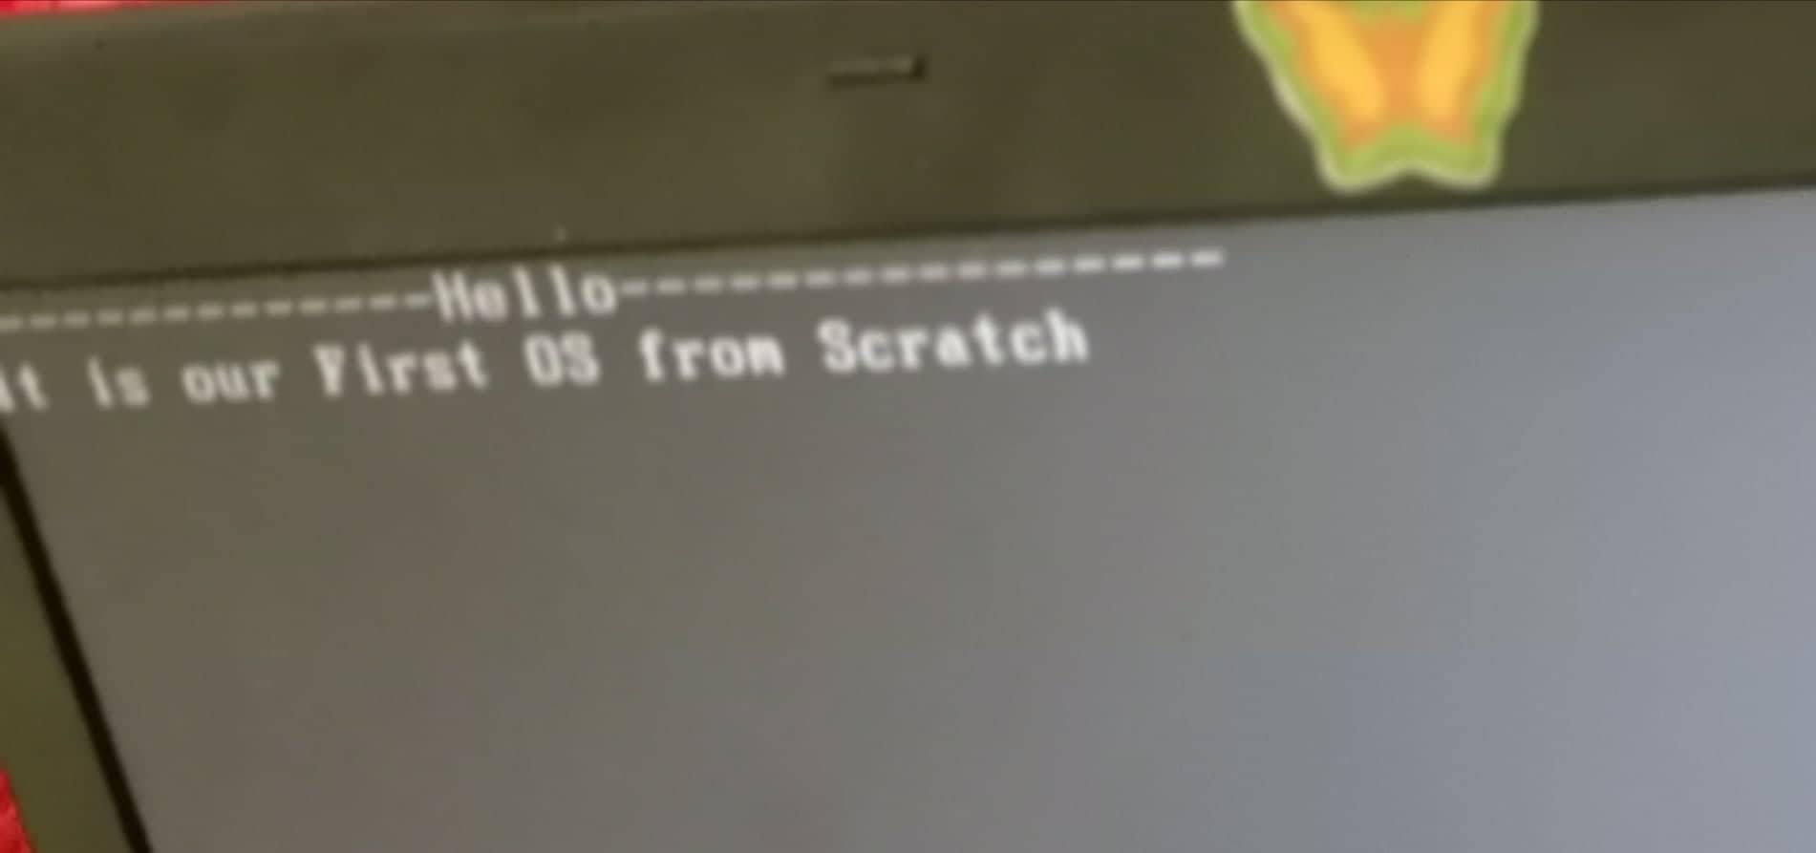

**Figure 3.10** Testing, Our first os from scratch