PA1: From Bellman Updates to TD Control
<Your name> · <Student ID> · Reinforcement Learning (Graduate)
Implementation details, conventions, seeds and reproduction commands are in README.md. All graded numbers come from results.json (spec settings, seeds 0–4). Experiments marked [supp.] are supplementary: they reuse the same update rules and agent.epsilon_greedy (a check confirms bit-identical Q tables to agent.sarsa/agent.q_learning) and use 20 seeds where stated (python extra_experiments.py).

1 Policy iteration vs value iteration
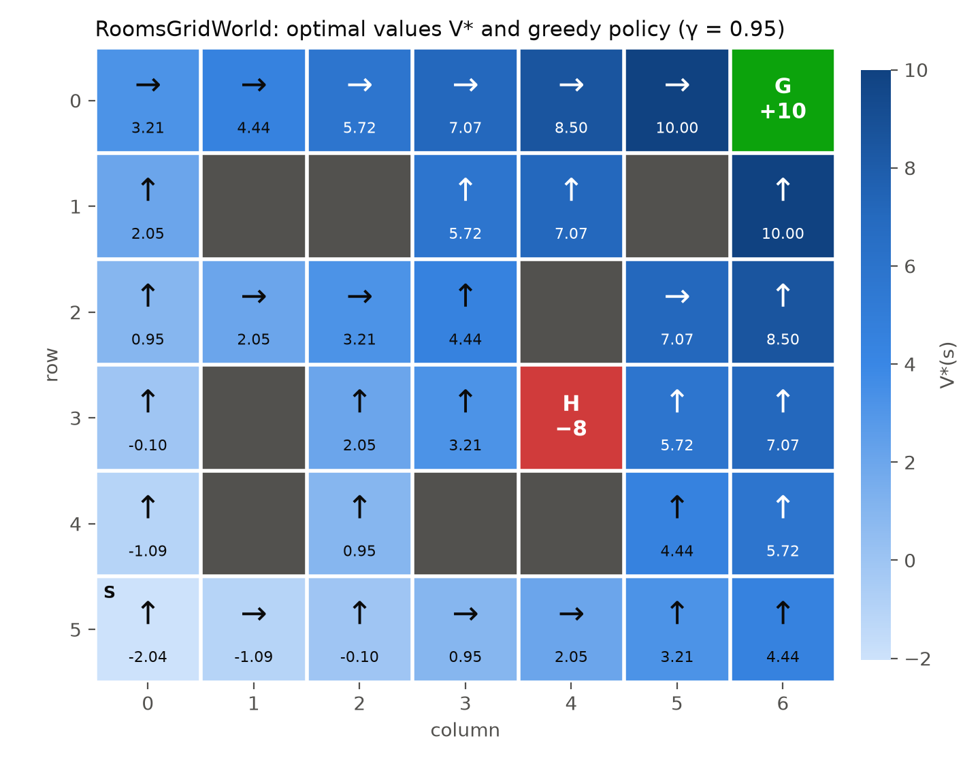  Figure 1. RoomsGridWorld: V* (colour, value in cell) and the greedy policy (arrows). PI and VI produce exactly this map. | Both methods reach the same optimal policy and the same values. The largest difference between V_PI and V_VI is exactly 0.0, every state gets the same action, and the greedy path from S (up the left column, then right along the top row) reaches G in 11 steps with undiscounted return 0 (V*(S) = −2.038). At S, up and right are exactly tied (Q = −2.0379 for both); the lowest-index rule selects up.  The counts differ because they count different things. PI needs 9 rounds, VI 12 sweeps, but every PI round contains a complete policy evaluation. Counted in sweeps, PI does 3,276 evaluation sweeps (6 × 540 + 3 × 12) versus 12 for VI, about 270 times more backups (Table 1, Figure 2).  Table 1. DP summary (values identical to results.json).
   | Policy iteration | Value iteration
  Iterations | 9 rounds | 12 sweeps
  Total sweeps | 3,276 (+9 improv.) | 12
  V*(S), action at S | −2.038, up | −2.038, up
  max |V_PI − V_VI| | 0.0 | 0.0
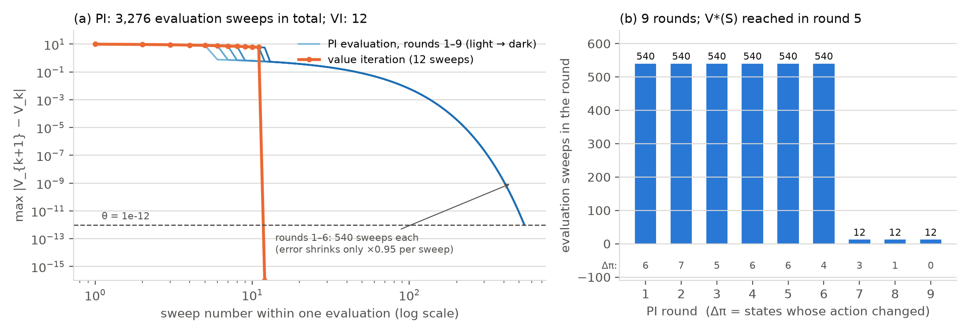
Figure 2 [supp.]. (a) Largest value change per sweep. Each light-to-dark blue curve is one PI evaluation; orange is VI. (b) Evaluation sweeps per PI round and the number of states whose action changed (Δπ).
Why PI rounds 1–6 cost 540 sweeps. The initial all-up policy makes most states bump into a wall or the top border forever, so their value is −1/(1−γ) = −20. For a fixed policy, the evaluation error shrinks only by a factor γ = 0.95 per sweep, and reaching θ = 10⁻¹² needs 0.95ᵏ < 10⁻¹², i.e. k ≈ 539, which is exactly the 540 observed. Each improvement step only re-routes the few states next to already-good states (Δπ = 4–7), so V(S) stays at −20 until round 5. From round 7 every state's path terminates, and evaluation of a deterministic, terminating policy is exact after 12 sweeps. Why VI needs only 12. VI applies the max in every sweep, so correct values spread outward from G by one cell per sweep: the largest change follows 10 × 0.95ᵏ (10, 9.5, 9.03, …, 5.99). S is the farthest state at 11 steps, so after 11 sweeps every value is exact and sweep 12 confirms Δ = 0. PI takes few large steps (policy improvement is a Newton-like jump), each paid for by a full evaluation; VI takes many cheap steps. On this small deterministic grid, VI is far cheaper.

2 The paths learned by SARSA and Q-learning
Q-learning learns the shortest path along the cliff edge; SARSA learns a detour through the top rows. Q-learning's greedy path runs along row 3, directly above the cliff, on every seed: 11 steps, return −11, highest_row = 3.0, identical to the DP optimum. SARSA's path climbs to the top of the grid before crossing: 15–17 steps, return −16.6, highest_row = 0.2 (four seeds reach row 0, one row 1). With 20 seeds the picture is the same (Q-learning 3.0; SARSA rows 0–1 only).
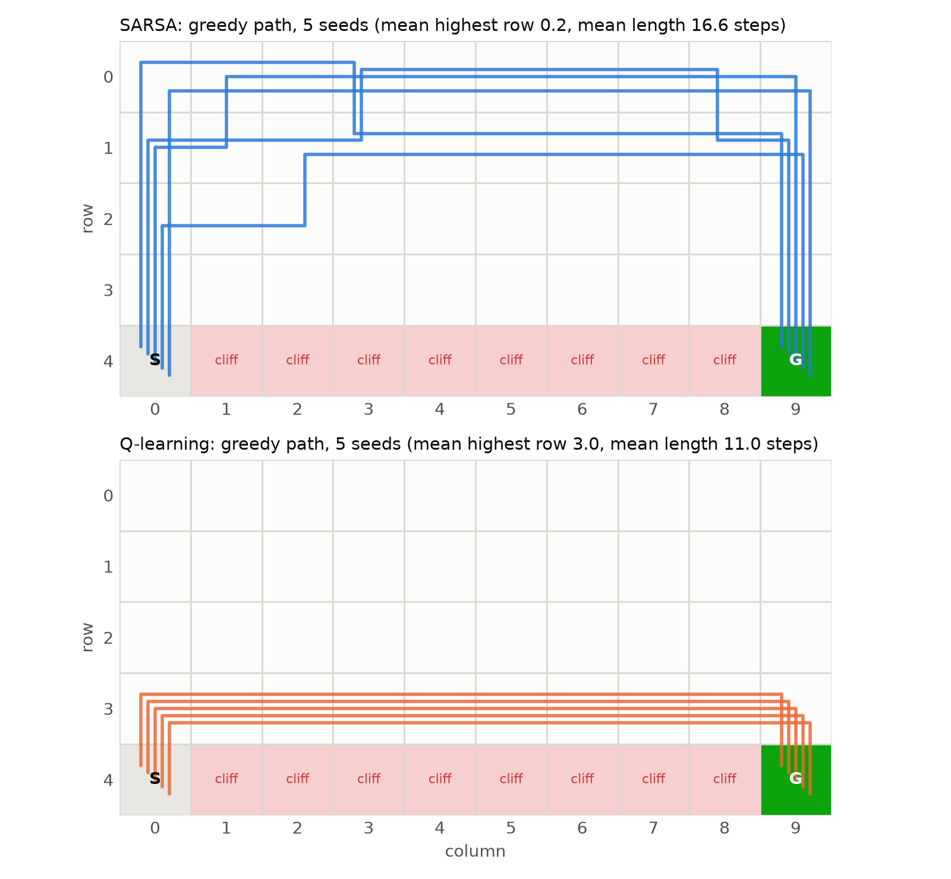  Figure 3. Greedy path of every seed (0–4), slightly offset. Q-learning: identical on all seeds. | Why. The two update targets estimate different things. Q-learning's target r + γ·max Q(s′,·) assumes the agent acts greedily from the next step on, so it learns q*, the value of the optimal policy, regardless of the exploration it actually performs (Bellman optimality). SARSA's target r + γ·Q(s′,a′) uses the action the ε-greedy policy actually takes, so it learns q_π for the ε-greedy policy itself (Bellman expectation). On row 3 every step has a 0.1 × ¼ = 2.5 % chance of a random down move: −75 and a restart at S. SARSA's values price that risk in; Q-learning's do not.  Figure 4 makes this visible: along row 3 the learned value is −12.5 for SARSA but −5.4 for Q-learning (= V* exactly), while SARSA rates the top row higher (−10.6), so its greedy policy goes up.  How far up also depends on α. The exact point SARSA converges to, q*_ε (the optimal ε-greedy values, computed from the model), keeps only one row of margin at ε = 0.1: row 2, 13 steps, −13. With α = 0.1 all 20 seeds learn exactly that path. With the spec's α = 0.5 each fall (−75) pulls an estimate halfway towards one catastrophic target, so values near the edge stay too low and SARSA overshoots to rows 0–1 (Table 4).
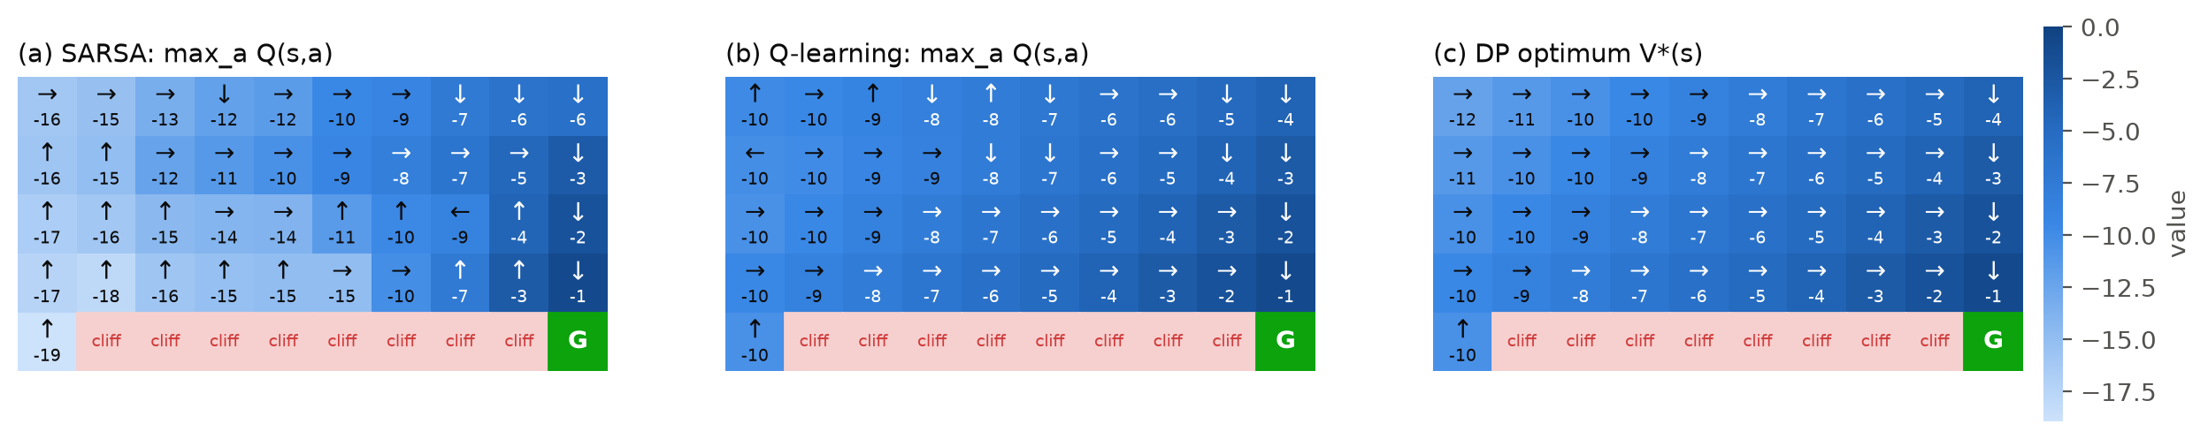
Figure 4 [supp.]. Learned state values max_a Q(s,a) (mean of seeds 0–4) with the greedy action of seed 0, next to the DP optimum. Q-learning recovers V*; SARSA's values drop sharply near the cliff.

3 The effect of ε
We trained both algorithms with ε ∈ {0.01, 0.05, 0.1, 0.2, 0.3}, everything else fixed (5 seeds in results_sweep/, repeated with 20 seeds [supp.]; the conclusions agree, and 20-seed numbers are reported). Besides the three requested quantities we measured exploration cost (share of training episodes containing a cliff fall) and greedy stability: at the end of each of the last 500 training episodes, does the greedy policy at that moment reach G?
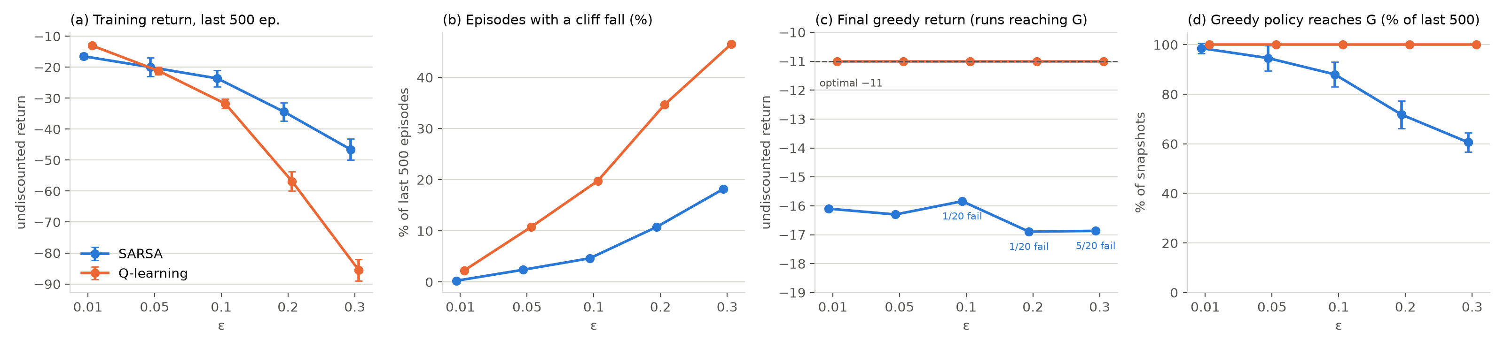
Figure 5 [supp.]. ε sweep, 20 seeds, mean ± 1 std. (c) Final greedy return over runs that reach G; annotations count runs whose final greedy policy never reaches G. (d) Share of late-training greedy snapshots that reach G.
ε | Training return S / Q | Episodes with fall S / Q | Final greedy S / Q | SARSA greedy reaches G | SARSA highest row (median)
0.01 | −16.5 / −13.0 | 0.2 % / 2.3 % | −16.1 / −11 | 20/20 · 98.6 % | 0
0.05 | −20.0 / −21.2 | 2.4 % / 10.7 % | −16.3 / −11 | 20/20 · 94.6 % | 0
0.1 | −23.6 / −31.8 | 4.6 % / 19.8 % | −15.8 / −11 | 19/20 · 88.0 % | 1
0.2 | −34.4 / −56.8 | 10.7 % / 34.6 % | −16.9 / −11 | 19/20 · 71.8 % | 0
0.3 | −46.6 / −85.5 | 18.2 % / 46.5 % | −16.9 / −11 | 15/20 · 60.6 % | 0
Table 2 [supp.]. 20 seeds; S = SARSA, Q = Q-learning; bold = better training return. Q-learning's greedy policy reaches G on 20/20 seeds and in 100 % of snapshots at every ε. Final greedy S averages runs that reach G; failures are analysed in Table 4.
Exploration. Larger ε means more random actions and more falls, but the cost depends on where the agent walks: Q-learning, on the edge, falls in 2.3 % → 46.5 % of episodes as ε goes from 0.01 to 0.3; SARSA, away from the edge, in only 0.2 % → 18.2 %. Training return therefore drops for both, much faster for Q-learning (−13.0 → −85.5 vs −16.5 → −46.6). The ranking even reverses: at ε = 0.01 Q-learning trains better (−13.0 vs −16.5), at 0.05 they are equal, and from 0.1 on SARSA is better (Figure 6). Final greedy evaluation separates the methods sharply. Q-learning's greedy policy is optimal (−11) at every ε and seed: its target does not depend on ε, and in this deterministic task its estimates converge to q* even with a constant α. SARSA's greedy path stays on the safe detour at every ε, and it becomes less reliable as ε grows: the share of late snapshots whose greedy policy reaches G falls from 98.6 % to 60.6 %, and 5 of 20 final policies fail at ε = 0.3.
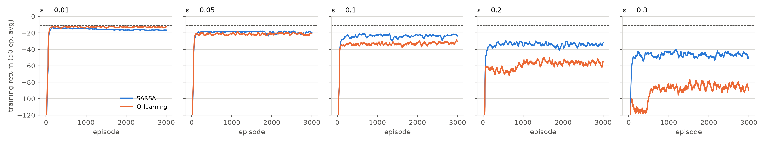
Figure 6 [supp.]. Training return (50-episode moving average, 20 seeds) per ε. Dashed: optimal −11. The SARSA–Q-learning gap opens as ε grows.
Are these failures a bug? The spec warns that a greedy policy that fails to reach G indicates a bug at convergence, so we tested whether SARSA had converged (Table 4). (i) Its convergence target q*_ε, solved exactly from the model, has a greedy policy that reaches G at every ε. (ii) On the same seeds, a smaller (α = 0.1) or decaying step size removes every failure (0/20 at all ε) and makes the greedy policy stable in 98–100 % of snapshots, and α = 0.1 lands exactly on q*_ε's path at ε = 0.1. (iii) The code matches a reference SARSA bit for bit. With α = 0.5, SARSA's target samples a′ from the exploring policy (a random a′ near the cliff is worth about −100) and each sample moves Q halfway, so Q never settles and near-tied actions keep swapping, which occasionally creates a loop (e.g. ε = 0.2, seed 3: Q(S, up) = −24.02 < Q(S, down) = −23.85, and down bumps the border). The failures are therefore non-convergence under the prescribed constant α, not an implementation error. Q-learning is unaffected because its max-target involves no sampled action, so in this deterministic task it converges to q* even with α = 0.5. All graded runs (ε = 0.1, seeds 0–4) reach G.
ε | Converged target q∗_ε: path | SARSA α = 0.5 (spec): fails · stable · rows | SARSA α = 0.1: fails · stable · rows | SARSA α = 0.5/(1+n/50): fails · stable · rows
0.01 | row 3, −11 (edge) | 0/20 · 98.6 % · 0–1 | 0/20 · 99.7 % · 2–3 | 0/20 · 100 % · 1–2
0.1 | row 2, −13 | 1/20 · 88.0 % · 0–1 | 0/20 · 99.8 % · 2 (all) | 0/20 · 100 % · 1–2
0.2 | row 2, −13 | 1/20 · 71.8 % · 0–1 | 0/20 · 99.5 % · 1–2 | 0/20 · 100 % · 1
0.3 | row 1, −15 | 5/20 · 60.6 % · 0–1 | 0/20 · 97.9 % · 0–2 | 0/20 · 100 % · 1
Table 4 [supp.]. Diagnosis of SARSA's greedy failures (20 seeds, 3,000 episodes). fails = final greedy policy never reaches G; stable = share of the last 500 greedy snapshots that reach G; rows = highest rows of the final greedy paths. n = visits to (s,a).
Small ε has a cost too: too little exploration. At ε = 0.01 the edge path is also optimal for SARSA's own objective: q*_ε is the edge path (Table 4), and executing Q-learning's policy with ε = 0.01 yields −12.8 versus −17.0 for SARSA's (Figure 8). Yet SARSA does not find it: in a 20,000-episode run at ε = 0.01 (Figure 9c), the greedy path drifts from row 0 to rows 1–2 at best (one seed reaches row 2 and −13) but never reaches the edge. Early episodes, with Q initialised at 0, fall off the cliff many times, so the edge actions start with very negative values; with ε = 0.01 they are almost never tried again, so those early estimates are not corrected (even with α = 0.1, only 1 of 20 seeds reaches the edge). In short, ε trades training cost against discovery and, for SARSA, against greedy reliability.

4 Worse training return, better greedy return
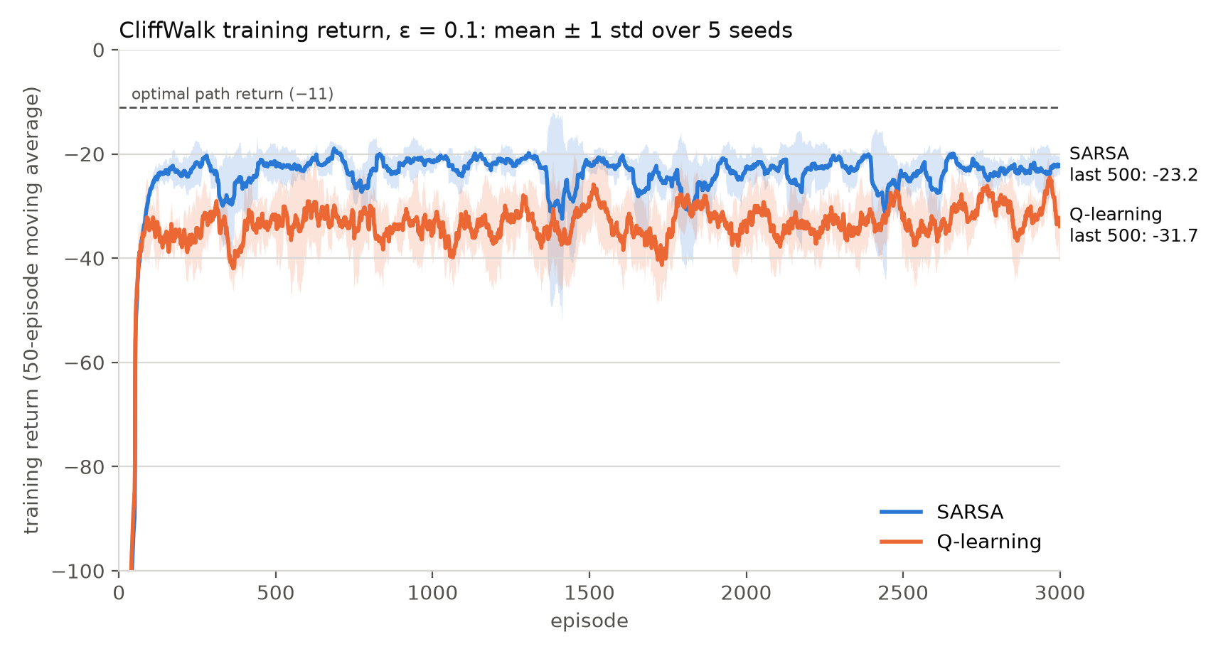  Figure 7. Training return at ε = 0.1, mean ± 1 std over seeds 0–4 (50-episode moving average; y-axis clipped at −100). Labels: raw last-500 means, as in results.json. | Both facts hold because each algorithm optimises the return of a different policy. At the spec settings (ε = 0.1, seeds 0–4), Q-learning's training return is worse (−31.7 vs −23.2) while its greedy return is better (−11 vs −16.6). The training return measures the ε-greedy behaviour policy while it learns; the greedy return measures the learned policy with exploration switched off.  To separate the two effects we froze each learned Q and executed its policy, without learning, at different ε (Table 3, Figure 8). Executed with ε = 0.1, SARSA's policy earns −20.9 and Q-learning's −31.7, which is the same as the DP-optimal policy executed ε-greedily (−31.8). Executed greedily, the order flips (−16.6 vs −11.0). The lines cross near ε ≈ 0.04.  Table 3. Seeds 0–4; frozen-policy rows [supp.] are averages of 2,000 episodes per seed.
   | SARSA | Q-learning
  Training return (ε = 0.1, learning) | −23.2 | −31.7
  Policy run at ε = 0.1, no learning | −20.9 | −31.7
  Cliff falls per episode at ε = 0.1 | 0.03 | 0.24
  Greedy return (ε = 0) | −16.6 | −11.0
  highest_row | 0.2 | 3.0
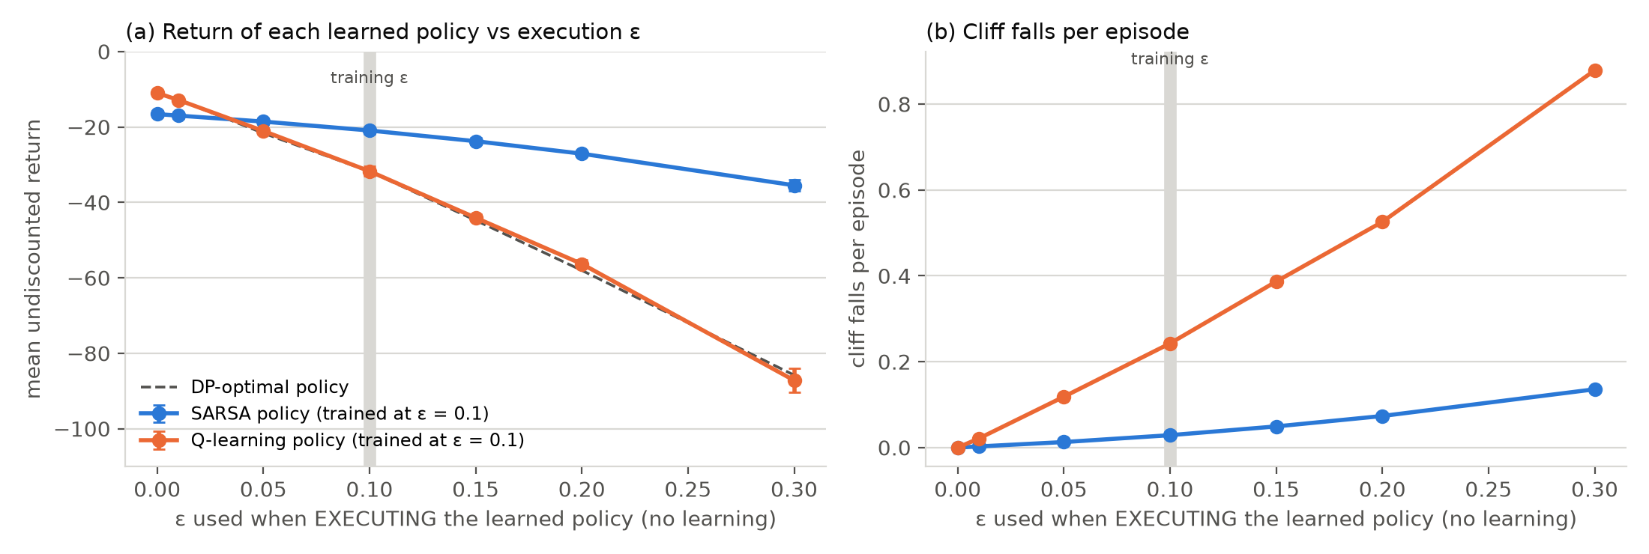
Figure 8 [supp.]. Frozen policies (trained at ε = 0.1) executed at different ε without learning. (a) Return; dashed: DP-optimal policy. (b) Cliff falls per episode.
What each algorithm is estimating. Q-learning is off-policy: it estimates q*, the value of acting optimally, which assumes no future random moves. Its greedy policy is therefore optimal once exploration stops, but during training that policy is executed ε-greedily on the most dangerous route, with about 0.24 cliff falls per episode. SARSA is on-policy: it estimates q_π of the ε-greedy policy it actually runs, including its random moves. It therefore converges towards the policy that is best given that it keeps exploring, which is a safer route with fewer falls and a better training return, but not the greedy optimum. Neither is wrong; they answer different questions, and the right choice depends on whether exploration continues when the policy is used.
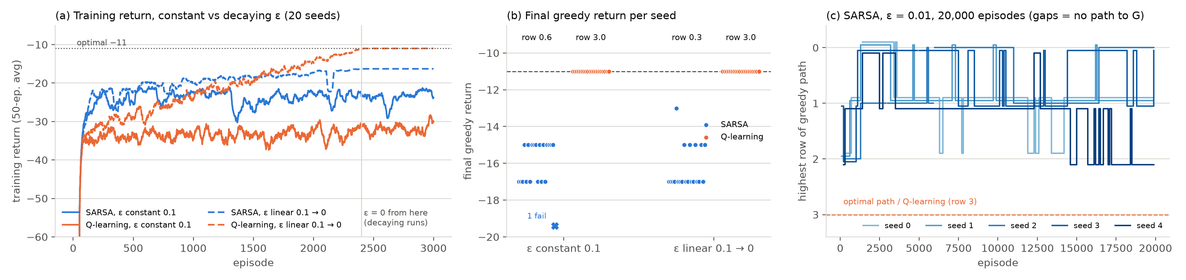
Figure 9 [supp.]. (a, b) ε decayed linearly from 0.1 to 0 over the first 2,400 of 3,000 episodes, 20 seeds. Labels in (b): mean highest row. (c) SARSA's highest row during a 20,000-episode run at ε = 0.01 (gaps: greedy policy does not reach G).
Removing exploration removes the training gap. With ε decayed to 0 (Figure 9), Q-learning's training return converges to the optimum −11, so training return equals greedy return. SARSA's also equals its greedy return (−16.3, 20/20 seeds stable) but stays on the safe detour (highest row 0.35). Theory guarantees SARSA reaches the optimum only under GLIE exploration and decreasing step sizes (Singh et al., 2000). With a constant α = 0.5 and a finite budget, its early pessimism about the edge is locked in, as the 20,000-episode run also shows.

5 Conclusions
- DP: PI and VI give identical V* and policies. VI needs 12 sweeps; PI needs 9 rounds but 3,276 evaluation sweeps, because early policies loop and evaluation converges only at rate γ.
- On- vs off-policy: Q-learning learns q* and the edge path (highest_row 3, return −11). SARSA learns the value of its ε-greedy behaviour, prices in the 2.5 % per-step fall risk, and takes a detour (highest_row ≈ 0, −16.6). Its converged target keeps one row of margin (row 2, −13); the extra distance comes from the large constant α.
- ε: higher ε raises falls and lowers training return, far more for Q-learning, and makes SARSA's greedy policy unstable (98.6 % → 60.6 % reliable). This is non-convergence under α = 0.5, not a bug: with a smaller or decaying α, failures drop to 0/20. Very small ε reverses the training-return ranking and starves SARSA of the exploration it needs to revise early estimates.
- Training vs greedy: SARSA wins while exploring (−20.9 vs −31.7 at ε = 0.1), Q-learning wins without exploration (−11.0 vs −16.6). The crossover is at ε ≈ 0.04.
Limitations. Graded results use 5 seeds (the supplementary runs use 20). The prescribed constant α = 0.5 prevents SARSA from converging, so its final greedy policy is a snapshot of a moving estimate (Table 4). All findings are from one small deterministic environment. Reference: Sutton & Barto (2018), Reinforcement Learning: An Introduction, 2nd ed., Ex. 6.6; Singh, Jaakkola, Littman & Szepesvári (2000), Machine Learning 38:287–308.

