PA1: From Bellman Updates to TD Control
Seher Kanwal · Student ID · Reinforcement Learning (Graduate) · October 2026
All graded numbers are those in results.json (spec settings: α = 0.5, ε = 0.1, 3,000 episodes, 400-step cap, seeds 0–4). Items marked [supp.] are supplementary: they come from extra_experiments.py, which reuses agent.epsilon_greedy and the same update rules (a check confirms it reproduces agent.sarsa / agent.q_learning bit for bit) and uses 20 seeds where stated. The report figures are drawn by report_figures.py; reproduction commands, seeds and versions are in README.md.
1 Policy iteration vs value iteration
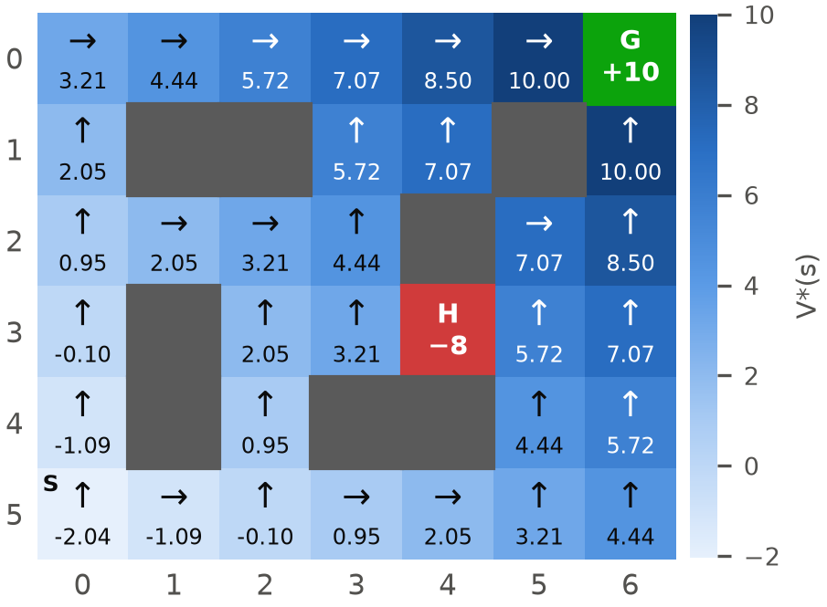  Figure 1. RoomsGridWorld: V* (colour and value) and the greedy policy (arrows). PI and VI produce exactly this map. | Both methods reach the same optimal policy and values. max |V_PI − V_VI| = 0 and every state gets the same action. The greedy path from S reaches G in 11 steps with undiscounted return 0 and V*(S) = −2.038. At S, up and right are exactly tied (Q = −2.038 for both; each route is 11 steps), and the lowest-index rule selects up.  The counts differ because they count different things. A PI round contains a complete policy evaluation; a VI sweep is a single backup of every state. Counted in sweeps, PI needs 3,276 against 12 for VI, about 270 times more backups (Table 1).  Table 1. DP summary; values identical to results.json.
   | Policy iteration | Value iteration
  Iterations | 9 rounds | 12 sweeps
  Eval. sweeps per round | 540 (rounds 1–6), 12 (7–9) | —
  Total sweeps | 3,276 + 9 improvements | 12
  V*(S), action at S | −2.038, up | −2.038, up
Why rounds 1–6 cost 540 sweeps each. The initial all-up policy drives most states into a wall or the top border forever, so their value is −1/(1−γ) = −20. Under a fixed policy the change per sweep shrinks only by γ = 0.95, and 0.95ᵏ⁻¹ < 10⁻¹² gives exactly k = 540. Each improvement re-routes only the 4–7 states next to already-good ones, so some state keeps looping until round 6. From round 7 every path terminates, and evaluating a deterministic terminating policy is exact after 12 sweeps. Each evaluation starts from V = 0; warm-starting from the previous V would lower the sweep total but not the 9 rounds, since every evaluation reaches the same fixed point.
Why VI needs only 12. The max lets correct values spread outward from G one cell per sweep: the largest change is exactly 10·0.95ᵏ⁻¹ (10, 9.5, 9.03, …, 5.99). S is the farthest state, 11 steps away, so after 11 sweeps every value is exact and sweep 12 confirms Δ = 0. PI takes a few large, expensive steps (policy improvement is a Newton-like jump); VI takes many cheap ones. On this small deterministic grid VI is far cheaper.
2 The paths learned by SARSA and Q-learning
Q-learning learns the shortest path along the cliff edge; SARSA learns a detour through the top rows (Figure 2). Q-learning's greedy path runs along row 3 on every seed: 11 steps, return −11.0, highest_row = 3.0, identical to the DP optimum. SARSA's path climbs to row 0 (four seeds) or row 1 (one seed) before crossing: 15–17 steps, return −16.6 ± 0.8, highest_row = 0.2. With 20 seeds [supp.] the picture is the same: Q-learning 3.0 on every seed, SARSA rows 0–1 only.
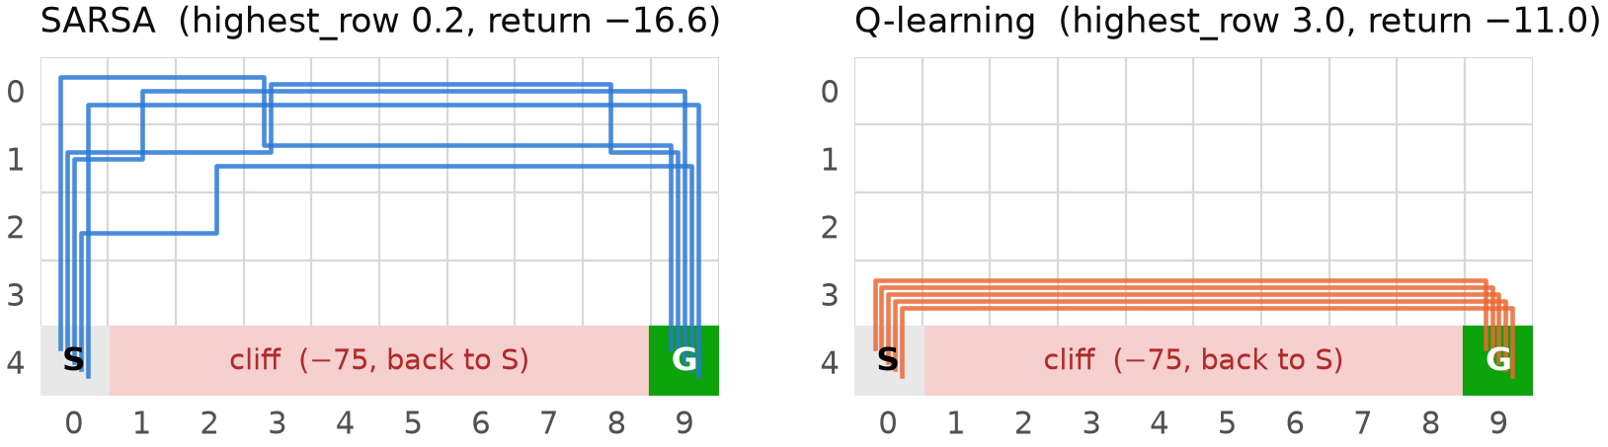
Figure 2. Greedy path of each seed (0–4), drawn slightly offset. Q-learning's path is identical on all seeds.
Why it leaves the edge. Q-learning's target r + γ·max_a′ Q(s′,a′) assumes greedy behaviour from the next step on, so it estimates q*, the value of the optimal policy, whatever exploration is actually performed (Bellman optimality). SARSA's target r + γ·Q(s′,a′) uses the action the ε-greedy policy actually takes, so it estimates q_π of the ε-greedy policy itself (Bellman expectation). On row 3 every step has a 0.1 × ¼ = 2.5 % chance of a random down move: −75 and a restart at S. SARSA's values price that risk in; Q-learning's do not. Figure 3 shows this: averaged over row 3 (columns 1–8), SARSA's value is −14.6 while Q-learning's is −5.35, exactly V*. (Q-learning matches V* on rows 2–3 and at S; only the rarely visited rows 0–1 are still optimistic, by up to 2.4, because Q starts at 0.)
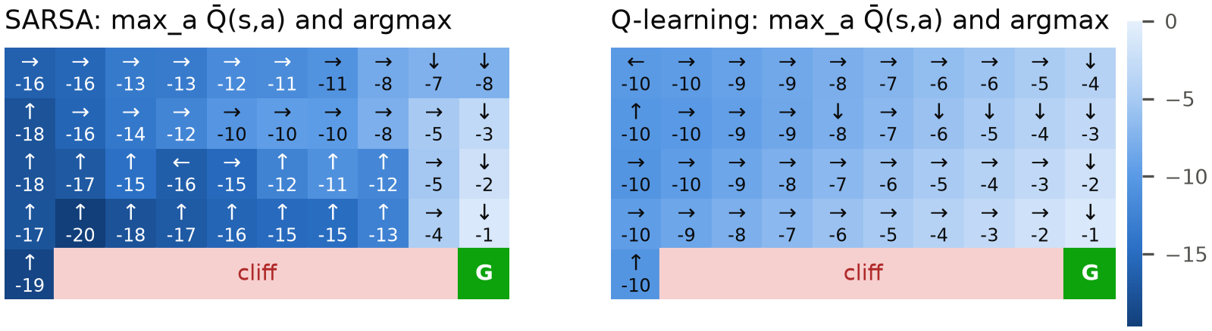
Figure 3 [supp.]. Learned values max_a Q̄(s,a) and greedy action argmax_a Q̄(s,a) of the seed-averaged Q̄ (seeds 0–4). SARSA's values drop sharply next to the cliff; Q-learning's equal V* along the edge.
Why it goes as far as rows 0–1. The risk explains leaving the edge, but not the full detour. SARSA's convergence target, the fixed point q*_ε of its expected update under ε-greedy behaviour (solved exactly from the model), keeps only one row of distance at ε = 0.1: its greedy path runs along row 2 with return −13 (Table 4). The extra climb to rows 0–1 (−16.6) comes from the constant α = 0.5 and the finite budget. On the same 20 seeds, α = 0.1 learns q*_ε's row-2 path on every seed (−13.0). With α = 0.5 each update moves Q halfway towards a single sampled target, so values next to the cliff stay noisy and are repeatedly knocked down by single fall-driven samples, and the greedy policy keeps more distance than the expected risk justifies. highest_row therefore measures two things: the on-policy objective (row 3 → 2) and the step-size noise (row 2 → 0–1).
ε | q*_ε (exact) | α = 0.5 (spec) | α = 0.1 | α = 0.5 / (1 + n/50)
0.01 | row 3 · −11.0 | rows 0–1 · −16.1 | rows 2–3 · −12.9 | rows 1–2 · −13.2
0.1 | row 2 · −13.0 | rows 0–1 · −15.8 · 1 fail | row 2 · −13.0 | rows 1–2 · −13.8
0.2 | row 2 · −13.0 | rows 0–1 · −16.9 · 1 fail | rows 1–2 · −14.5 | row 1 · −15.0
0.3 | row 1 · −15.0 | rows 0–1 · −16.9 · 5 fail | rows 0–2 · −15.1 | row 1 · −15.0
Table 4 [supp.]. SARSA's convergence target vs what it learns (20 seeds, 3,000 episodes). Each cell: highest row of the greedy path · greedy return (mean over runs that reach G) · number of the 20 final greedy policies that never reach G. q*_ε is the exact fixed point under ε-greedy behaviour; n is the visit count of (s, a).
3 The effect of ε
We trained both algorithms with ε ∈ {0.01, 0.05, 0.1, 0.2, 0.3}, everything else fixed, with 5 seeds (results_sweep/) and again with 20 seeds [supp.]. The conclusions agree; Figure 4 and Table 2 report the 20-seed runs, which is why their ε = 0.1 row differs slightly from results.json. Besides training return and final greedy return we measured how many training episodes contain a cliff fall, and greedy stability: at the end of each of the last 500 episodes, does the current greedy policy reach G?
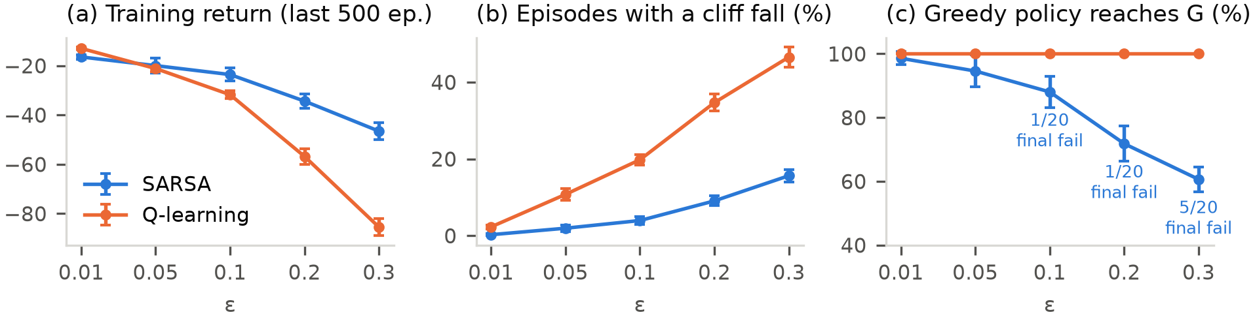
Figure 4 [supp.]. ε sweep, 20 seeds, mean ± 1 std across seeds; (a, b) over the last 500 training episodes. (c) Share of late-training greedy snapshots that reach G; the labels count runs whose final greedy policy never reaches G.
ε | Training return S / Q | Episodes with a fall S / Q | SARSA greedy reaches G | SARSA greedy return: reached / all | SARSA late snapshots reaching G
0.01 | −16.5 ± 0.9 / −13.0 ± 0.5 | 0.2 % / 2.3 % | 20/20 | −16.1 / −16.1 | 98.6 %
0.05 | −20.0 ± 3.0 / −21.2 ± 1.3 | 1.9 % / 10.7 % | 20/20 | −16.3 / −16.3 | 94.6 %
0.1 | −23.6 ± 2.7 / −31.8 ± 1.5 | 3.9 % / 19.8 % | 19/20 | −15.8 / −35.0 | 88.0 %
0.2 | −34.4 ± 2.9 / −56.8 ± 3.1 | 9.1 % / 34.6 % | 19/20 | −16.9 / −36.0 | 71.8 %
0.3 | −46.6 ± 3.4 / −85.5 ± 3.4 | 15.6 % / 46.5 % | 15/20 | −16.9 / −112.7 | 60.6 %
Table 2 [supp.]. 20 seeds, mean ± std; S = SARSA, Q = Q-learning; bold = better training return. Falls: share of the last 500 training episodes with at least one cliff transition (reward −75). SARSA's greedy return is given over the runs that reach G and over all 20 runs, where a policy that never reaches G scores −400 at the 400-step cap. Q-learning reaches G on 20/20 seeds with return −11 and in 100 % of snapshots at every ε.
Exploration and training return. Larger ε means more random moves and more falls, but the cost depends on where the agent walks. On the edge, Q-learning falls in 2.3 % → 46.5 % of episodes as ε goes from 0.01 to 0.3; SARSA, away from the edge, in 0.2 % → 15.6 %. Training return drops for both, much faster for Q-learning (−13.0 → −85.5 vs −16.5 → −46.6), and the ranking reverses: Q-learning trains better at ε = 0.01, they are level at 0.05, and SARSA is better from 0.1 on.
Final greedy evaluation. Q-learning's greedy policy is optimal (−11) at every ε and seed, because its target does not depend on ε. SARSA's greedy path stays on the detour at every ε and becomes less reliable as ε grows: the share of late snapshots whose greedy policy reaches G falls from 98.6 % to 60.6 %. At ε = 0.3, 5 of 20 final policies never reach G, which pulls the all-seed mean (capped at 400 steps) to −112.7 although the successful runs average −16.9.
These failures are not a bug. The spec notes that a greedy policy which fails to reach G signals a bug, because this cannot happen at convergence. Constant-α SARSA does not converge: its target samples a′ from the exploring policy (a random a′ near the cliff is worth about −100), and with α = 0.5 each noisy target moves Q halfway, so near-tied actions keep swapping. A greedy policy can then contain a loop. For example, at S (ε = 0.2, seed 3) Q(up) = −24.02 < Q(down) = −23.85, and down bumps the border, so the greedy agent never leaves S; the ε-greedy behaviour escapes such loops, so training is unaffected. Table 4 confirms the diagnosis: q*_ε reaches G at every ε, and on the same 20 seeds α = 0.1 or a decaying α gives no failures at any ε (late-snapshot stability 98–100 %). Q-learning, whose target has no sampled action, never fails, and all five graded SARSA runs (ε = 0.1, results.json) reach G.
Too little exploration also has a cost. At ε = 0.01 the edge is optimal even for SARSA's own objective (q*_ε runs along row 3, Table 4), yet SARSA rarely finds it: 1 of 20 runs with α = 0.1, none with α = 0.5. In a 20,000-episode run at ε = 0.01 [supp.] its greedy path only drifts from row 0 to rows 1–2. Early episodes, with Q initialised at 0, fall off the cliff often, so edge actions start with very negative values; with ε = 0.01 they are almost never retried, and those estimates are not corrected. In short, ε trades training cost against discovery and, for SARSA, against greedy reliability.
4 Worse training return, better greedy return
Both facts hold because the two numbers measure different policies. At the spec settings, Q-learning's training return is worse (−31.7 vs −23.2) while its greedy return is better (−11.0 vs −16.6). Training return measures the ε-greedy behaviour policy while it learns; greedy return measures the learned policy with exploration switched off (Figure 5).
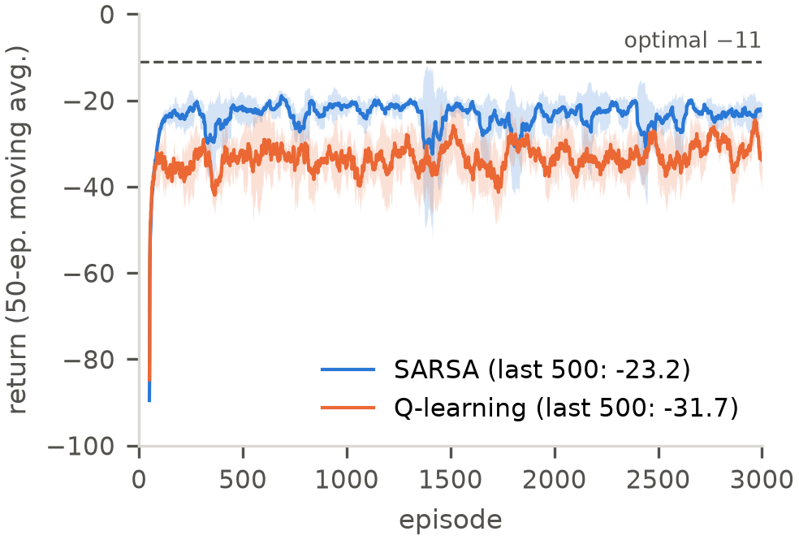  Figure 5. Training return at the spec settings (ε = 0.1), mean ± 1 std over seeds 0–4, 50-episode moving average, y-axis clipped at −100. Legend: raw last-500 means, as in results.json. | To separate the two, we froze each learned Q and executed its policy without learning at different ε [supp.]. At ε = 0.1, SARSA's policy earns −20.9 and Q-learning's −31.7, the same as the DP-optimal policy executed ε-greedily (−31.8). At ε = 0 the order flips. The curves cross near ε ≈ 0.04 (Table 3, Figure 6).  Table 3. Mean ± std over seeds; frozen-policy rows average 2,000 episodes per seed.
  Seeds 0–4 | SARSA | Q-learning
  Training return (ε = 0.1, learning) | −23.2 ± 1.8 | −31.7 ± 0.6
  Frozen policy at ε = 0.1 [supp.] | −20.9 ± 0.9 | −31.7 ± 1.3
  Cliff falls / episode at ε = 0.1 [supp.] | 0.03 | 0.24
  Greedy return (ε = 0) | −16.6 ± 0.8 | −11.0 ± 0.0
  highest_row | 0.2 | 3.0
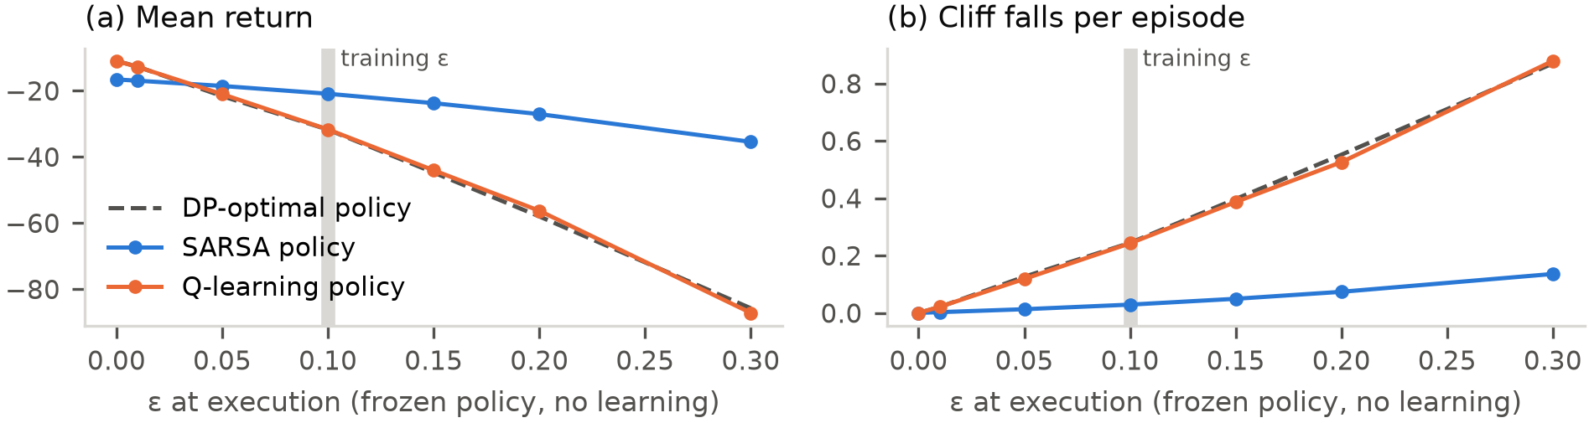
Figure 6 [supp.]. Policies learned at ε = 0.1, frozen and executed at different ε. Q-learning's policy behaves exactly like the DP-optimal one (dashed).
What each algorithm is estimating. Q-learning is off-policy: it estimates q*, the value of acting optimally with no future random moves. Its greedy policy is therefore optimal once exploration stops, but during training that policy is executed ε-greedily on the most dangerous route (0.24 falls per episode). SARSA is on-policy: it estimates q_π of the ε-greedy policy it actually runs, random moves included, so it tracks the policy that is best given that it keeps exploring: a safer route with fewer falls and a better training return, but not the greedy optimum. Neither is wrong; the right choice depends on whether exploration continues when the policy is used. Decaying ε linearly from 0.1 to 0 [supp.] confirms this: Q-learning's training return then reaches −11, equal to its greedy return, while SARSA's training and greedy returns both settle at −16.3 on the detour. With constant α and a finite budget, SARSA's early pessimism about the edge is locked in; reaching the optimum requires GLIE exploration and decreasing step sizes (Singh et al., 2000).
5 Conclusions
- DP: PI and VI give identical V* and policies. VI needs 12 sweeps; PI needs 9 rounds but 3,276 evaluation sweeps, because early policies loop and (cold-started) evaluation converges only at rate γ.
- On- vs off-policy: Q-learning learns q* and the edge path (highest_row 3.0, return −11). SARSA learns the value of its ε-greedy behaviour and prices in the 2.5 % per-step fall risk; that alone moves it one row up (q*_ε: row 2, −13), and the constant α = 0.5 adds the rest (highest_row 0.2, return −16.6).
- ε: higher ε raises falls and lowers training return, far more for Q-learning, and makes SARSA's greedy policy less reliable (98.6 % → 60.6 %), a step-size effect that vanishes with α = 0.1. Very small ε reverses the training-return ranking and starves SARSA of the exploration it needs to revise early estimates.
- Training vs greedy: SARSA wins while exploring (−20.9 vs −31.7 at ε = 0.1), Q-learning wins without exploration (−11.0 vs −16.6); the crossover is near ε ≈ 0.04.
Limitations. Graded results use 5 seeds (supplementary runs use 20). α is constant, so SARSA does not converge and its final greedy policy is a snapshot of a moving estimate. All findings come from one small deterministic environment. Further supplementary figures (PI/VI convergence trace, learning curves per ε, decaying-ε and 20,000-episode runs) are in figures/extra_*.png.
References. R. S. Sutton & A. G. Barto (2018), Reinforcement Learning: An Introduction, 2nd ed., Example 6.6. S. Singh, T. Jaakkola, M. L. Littman & C. Szepesvári (2000), Convergence results for single-step on-policy RL algorithms, Machine Learning 38:287–308.

