Topic Name : California House Price Prediction Using Machine Learning and Support Vector Regression
California House Price Prediction
Using Machine Learning and Support Vector Regression

Author
Sehrush Seemab Awan

Technologies

Python
Scikit-learn
Support Vector Regression (SVR)
Pandas
NumPy
Matplotlib
Jupyter Notebook

GitHub Repository

https://github.com/YOUR_USERNAME/California-House-Price-Prediction

July 2024

Abstract
Accurate prediction of house prices is an important application of machine learning in the real estate sector, supporting informed decision-making for buyers, sellers, investors, and policymakers. This project investigates the use of Support Vector Regression (SVR) to predict California house prices using demographic, geographical, and socio-economic features from the California Housing dataset. A complete machine learning workflow was implemented, including exploratory data analysis, missing value imputation using the K-Nearest Neighbours (KNN) approach, feature engineering, feature scaling, and model training.
The predictive performance of the SVR model was evaluated using Mean Absolute Error (MAE), Root Mean Squared Error (RMSE), and residual analysis. Visualisations such as feature distributions, correlation analysis, residual plots, and error histograms were used to assess model behaviour and identify potential areas for improvement. The results demonstrate that the proposed workflow provides reliable predictions while highlighting the importance of appropriate preprocessing and feature selection in regression tasks.
This project demonstrates the practical application of machine learning techniques to housing price prediction and provides a foundation for future research involving ensemble learning methods, deep learning, explainable artificial intelligence, and advanced hyperparameter optimisation.

Introduction and dataset
The study of California's housing market provides critical insights into one of the most dynamic and significant real estate sectors in the United States.Census and augmented by real estate websites, offers a comprehensive view of the housing landscape in various California locales. This dataset is instrumental in identifying and analyzing the myriad factors influencing house prices, such as demographic shifts, economic conditions, and urban development trends.
California's housing market is characterized by its heterogeneity—ranging from urban apartments in San Francisco to sprawling suburban homes in San Diego. This diversity makes the dataset a fertile ground for applying and evaluating various predictive models and analytical approaches. Moreover, understanding these price determinants is vital for stakeholders, including policymakers, investors, and residents, to make informed decisions.
The dataset's richness in attributes like median house value, median income, house age, and room counts provides a multi-dimensional perspective on what drives housing prices. By exploring these features, researchers can unearth patterns and relationships critical for forecasting and strategic planning.Additionally, the introduction could delve into the socio-economic implications of housing affordability and market dynamics in California, linking the dataset's granular details to broader economic and social trends.
The dataset is sourced from a combination of sources including the 1990 U.S. Census as well as real estate websites. The chosen dataset is named ‘‘California House Price’’ and taken from online resource California House Price (kaggle.com). This dataset has 20641 records and ten features. The US Census Bureau has published California Census Data which has 10 types of metrics such as the population, median income, median housing price, and so on for each block group in California.
Content: The dataset contains various attributes that describe housing prices in California. These attributes include features such as:
  - Median house value for households within a block (target variable)
  - Median income of households in the region
  - Median house age
  - Average number of rooms
  - Average number of bedrooms
  - Population per household
  - Latitude and longitude coordinates
Purpose: The dataset is commonly used for exploring and analyzing factors that influence housing prices in California. It serves as a good example for practicing regression analysis, where the goal is typically to predict the median house value based on other relevant features.
Data Format: The dataset is usually provided in a structured format, such as a CSV file, containing rows and columns. Each row represents a specific geographical region (or block) in California, and each column represents a different attribute or feature of that region.
Usage: Data scientists, researchers, and students can use this dataset for various purposes, including:
  - Exploratory data analysis (EDA) to understand distributions and relationships between variables
  - Building predictive models to estimate housing prices based on given features
  - Feature engineering to create new variables or transform existing ones for better model performance
  - Visualization to present insights and patterns in the data

The dataset also serves as an input for project scoping and tries to specify the functional and nonfunctional requirements for it.
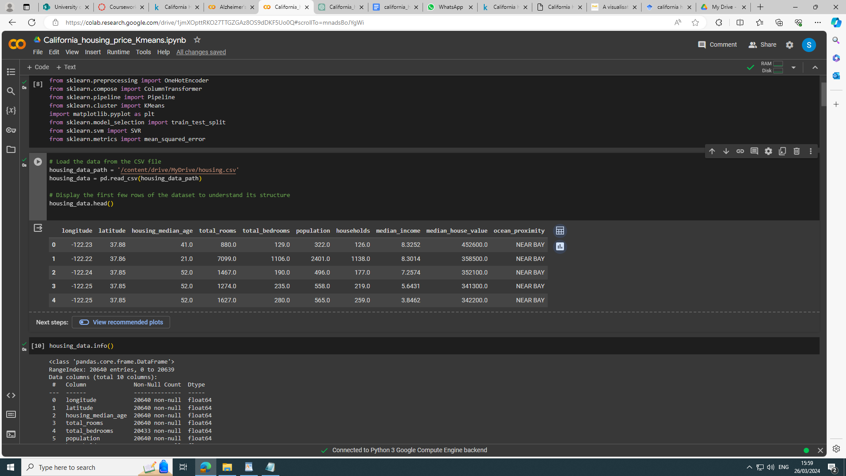
Figure 1. Dataset


Figure 2. Datatype of attributes and null values information

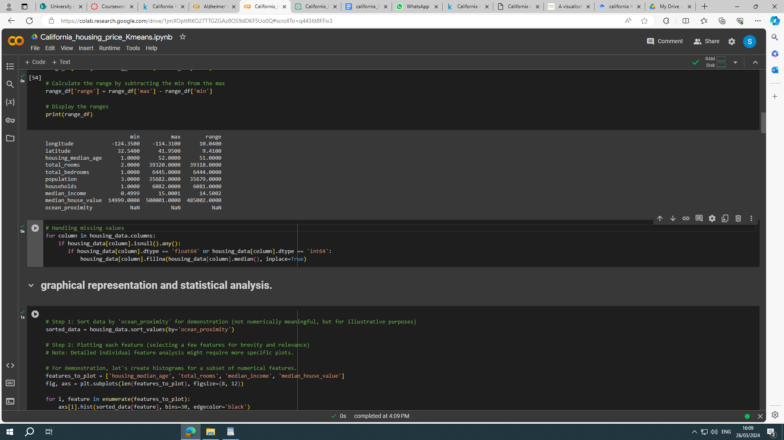
Figure 3. . attribute value ranges

Literature Review

Gupta & Miller (2012) - "The Time-Series Properties of House Prices: A Case Study of the Southern California Market", the paper investigates the time-series relationships between house prices in various Southern California metropolitan areas using vector autoregressive and error-correction models. It provides insights into predicting house price peaks and declines and explores the concept of purchasing power parity within these markets.

Yang & Cao (2018) - "Research on Ensemble Learning-based Housing Price Prediction Model", This research proposes an ensemble learning-based model for housing price prediction that combines multiple predictors like Random Forest, Gradient Boosting, and XGBoost. The ensemble approach outperformed individual prediction models, demonstrating improved accuracy and stability, particularly when dealing with noisy datasets .

Wu (2017) - "Housing Price prediction Using Support Vector Regression", Wu's project focuses on using Support Vector Regression (SVR) to predict housing prices, examining various feature selection methods and the effectiveness of SVR in a high-dimensional dataset context. The research suggests that feature reduction techniques like PCA do not necessarily enhance SVR's predictive performance but help in selecting important features to avoid overfitting .
Mostofi et al. (2021) - "House price prediction: A data-centric aspect approach on performance of combined principal component analysis with deep neural network model", the paper addresses the impact of high dimensionality and skewness in real estate datasets on the accuracy of deep neural network (DNN) predictions. By applying skewness reduction and PCA, the study found that certain transformations, particularly the Cube Root Transformation (CRT), significantly improve the prediction accuracy and computational efficiency of the PCA-DNN model .

Zaki et al. (2022) - "House price prediction using hedonic pricing model and machine learning", this study integrates machine learning algorithms with hedonic regression models to assess their performance in predicting housing prices. The research demonstrates that the combination of these techniques enhances the prediction of nonlinear relationships between house characteristics and prices that the hedonic model alone might not capture efficiently .

Research Problem
By exploring how clustering approaches can complement existing predictive models can reveal new patterns in the data. The identified gap could be in understanding the clustering of similar housing types or market segments and how this impacts price prediction accuracy or reveals new market dynamics not captured by traditional models.

Data Analysis

The following figure 4 illustrates descriptive statistics for the chosen task. The figure 5 shows the histogram for each feature set to show the span around the mean and standard deviation.

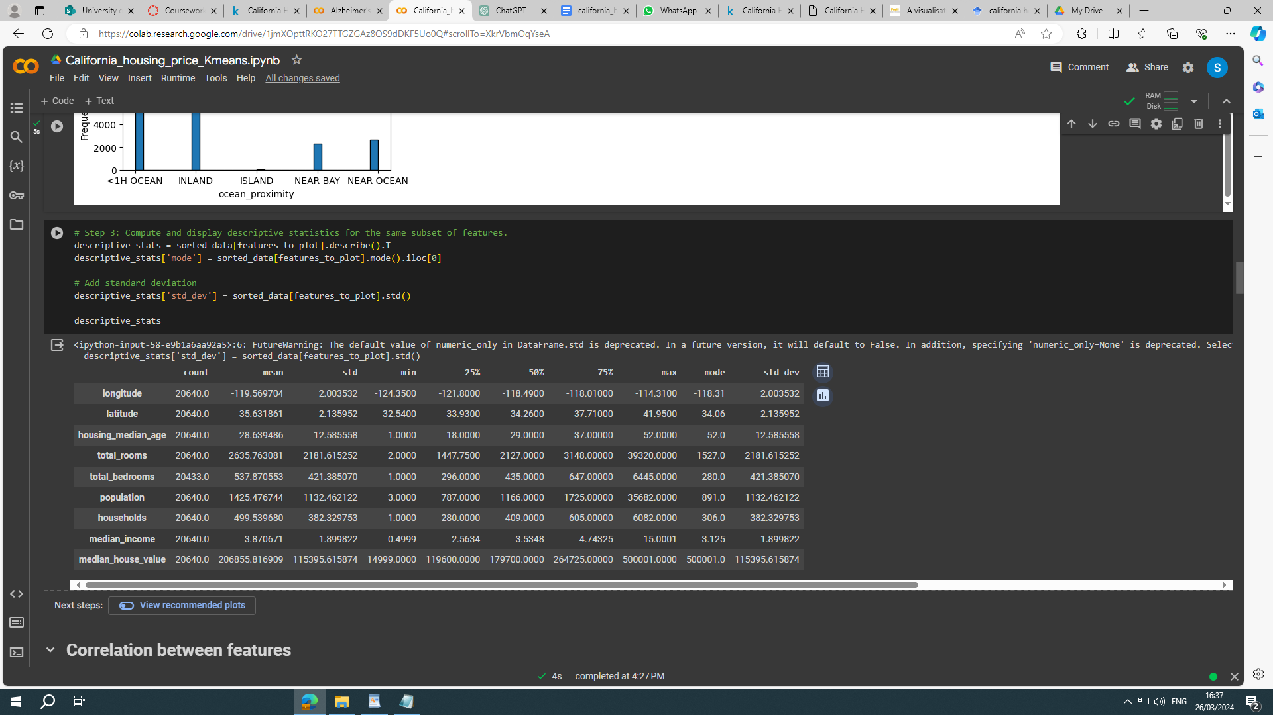
Figure 4. Computation of features characteristics: minimum, maximum, mean, mode and standard deviation

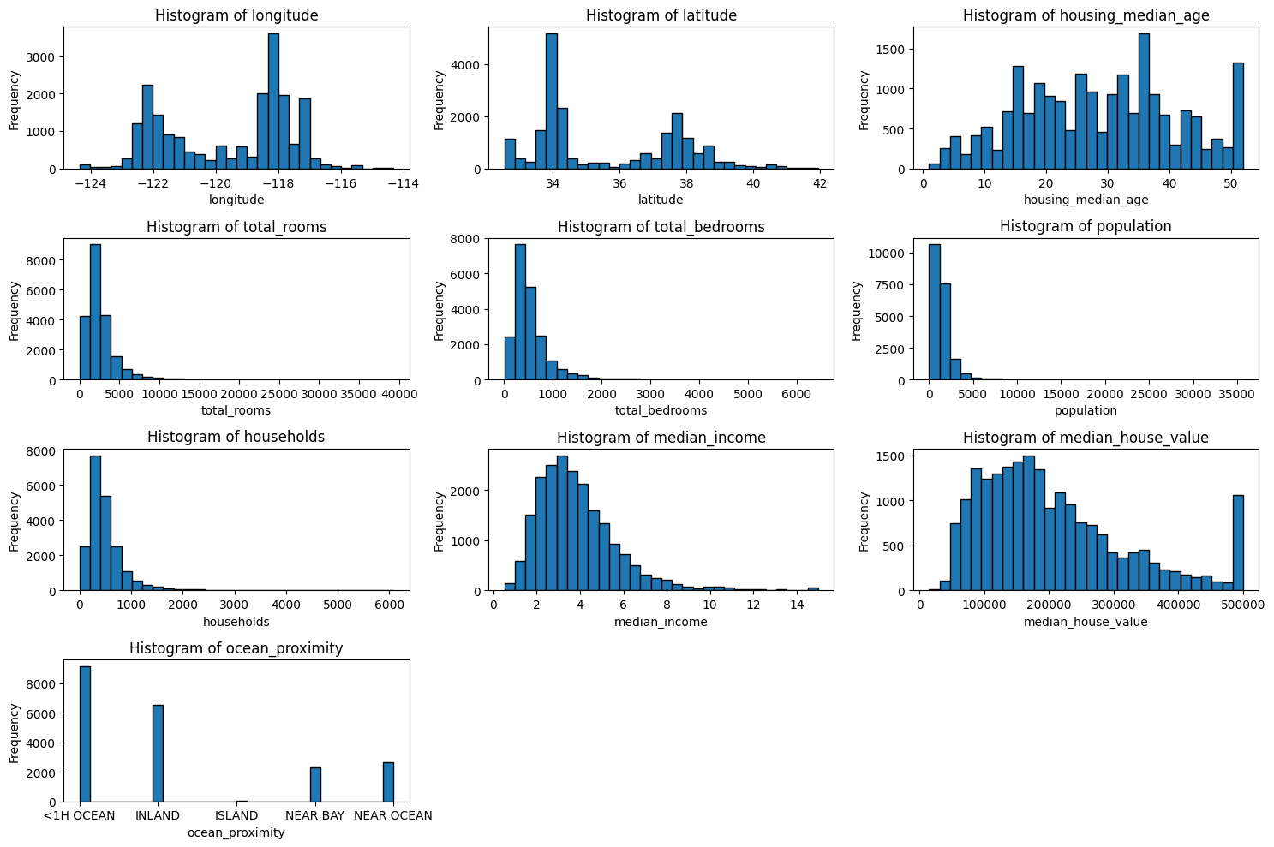
Figure 5. Histogram of features showing distribution around the mean and standard deviation

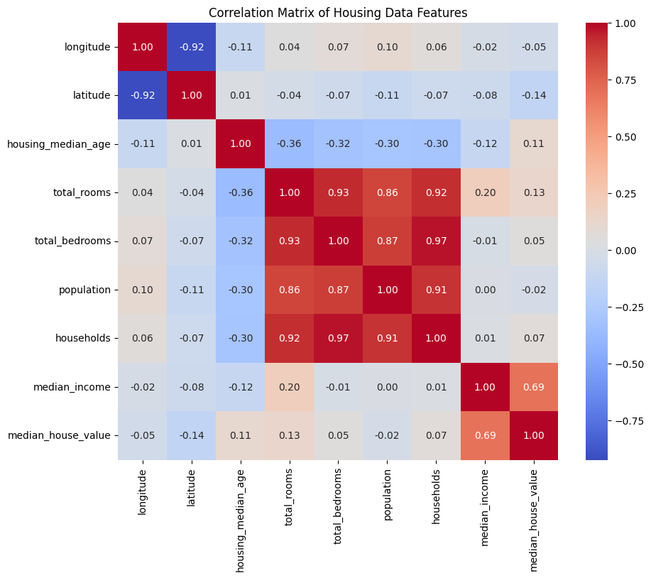
Figure 6. Correlation among features set.

Figure 6 depicts that total_rooms, total_bedrooms, population and households are highly correlated whereas median income is correlated with median_house_value. Whereas longitude and latitude have no correlation with any other feature.
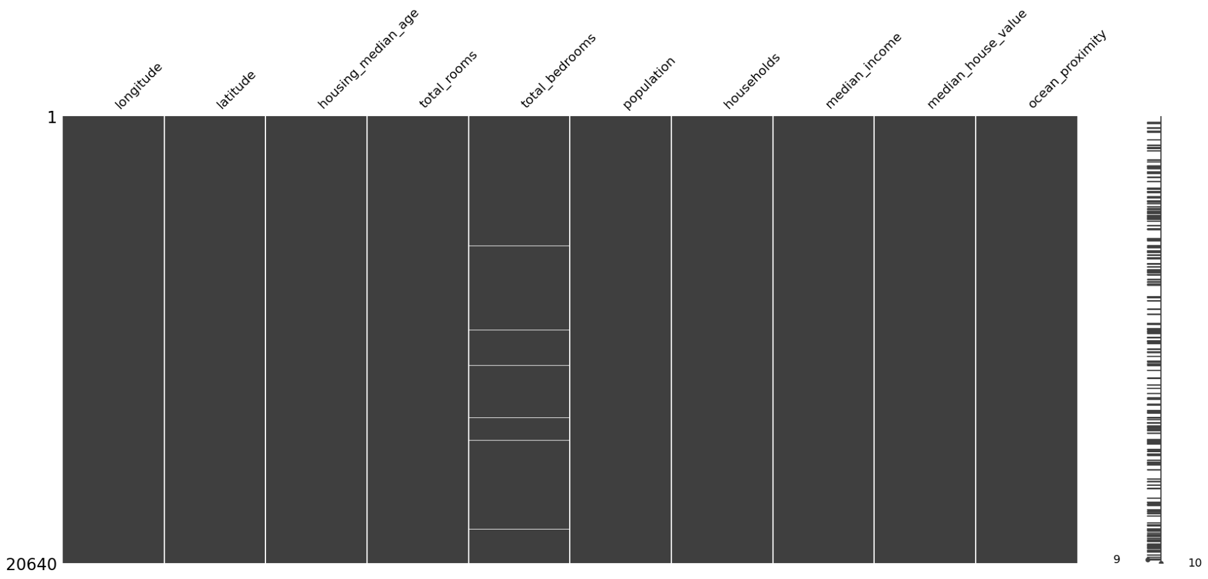
Figure 7. Illustrates missing values only present in the total_bedrooms column.

Figure 7 depicts the missing values that only exist in the total_bedrooms column.

Practical work and results

5.1 Choice of Model
Supervised learning model Support Vector Machine is chosen to predict price depending on various features.
- Non-Linear Relationships: SVR can be particularly effective if the relationship between features and the target variable (house price) is non-linear and complex. The use of different kernels (like the RBF kernel) allows SVR to capture complex relationships.
- Robustness: SVM is known for its robustness in the presence of non-linear and high-dimensional data. Highlight that this characteristic is crucial given the diverse range of features influencing housing prices, from geographical locations to economic factors.
- Outlier Handling: SVM's insensitivity to outliers is another point in its favor, especially if the housing data contains extreme values or anomalies in house prices or other features. This robustness can lead to more reliable predictive performance.
- Generalization: The algorithm's ability to generalize well from the training data to unseen data is a key factor in its selection, helping to mitigate overfitting risks, especially when using appropriate regularization.

5.2 Preprocessing of data
- Data Cleaning
As the housing dataset is arranged district and area wise, missing values(shown in figure 7 above) are filled with its nearest proximity using KNN method where k=5 (5 nearest neighbors).
- Feature Transformation
The features in this dataset have a highly different range of values as shown in figure 3. So the features are normalized to ensure that the model treats all features equally, particularly important for optimizing the SVM's performance.
- Feature Selection: The analysis of figure 6 depicts that housing_value is dependent on various features but has nothing to do with longitude and latitude. As the correlation matrix shows that median_incom has a direct affect on median_housing_price. Whereas longitude and latitude have no correlation with any other feature. So they are dropped.
- Data Splitting: Divide the dataset into training and testing sets to evaluate the model's performance on unseen data. The split ratio is 80% for training and 20% for testing..

So the key research question is to predict house price using its given feature set.The categorical column ocean_proximity is converted using one_hot_encoding technique so that it could be passed to the model.

5.3 Tools and Processes
- Data Preprocessing: X_prepared = full_pipeline.fit_transform(housing_data) illustrates application of a series of preprocessing steps encapsulated in full_pipeline. This likely includes scaling and encoding, preparing the data for optimal interaction with the SVR model since SVMs are sensitive to the scale of input data.
- Kernel Choice: kernel='linear' indicates you're using a linear kernel. This choice is justified for the target variable (housing prices) that can be linearly predicted from the input features. It's a valid starting point to understand linear relationships before potentially moving to more complex kernels.
- Hyperparameter Tuning: C=100 and epsilon=0.1. The C parameter trades off correct classification of training examples against maximization of the decision function's margin. A higher C value can lead to a more complex model (risking overfitting) by insisting on correctly classifying more examples. The epsilon parameter specifies the epsilon-tube within which no penalty is associated in the training loss function with points predicted within a distance epsilon from the actual value. This indicates specific assumptions about the trade-offs in model complexity and sensitivity.
- Evaluation Metrics: RMSE (Root Mean Squared Error)is used to evaluate model. RMSE provides a clear measure of how off the predictions are, on average, in the same units as the target variable (housing prices). It's a common and suitable metric for regression tasks to gauge model accuracy and predictive performance.

5.4 Practical Implications
- The SVR model, as configured and trained, offers insights into the housing market's behavior. By predicting the median_house_value, stakeholders can make informed decisions about investments, market valuations, and economic planning.
- The model's predictive performance, quantified by RMSE, helps gauge its reliability and utility. A lower RMSE indicates better predictive accuracy, essential for practical applications where decision-makers rely on the model's outputs.

5.5 Results
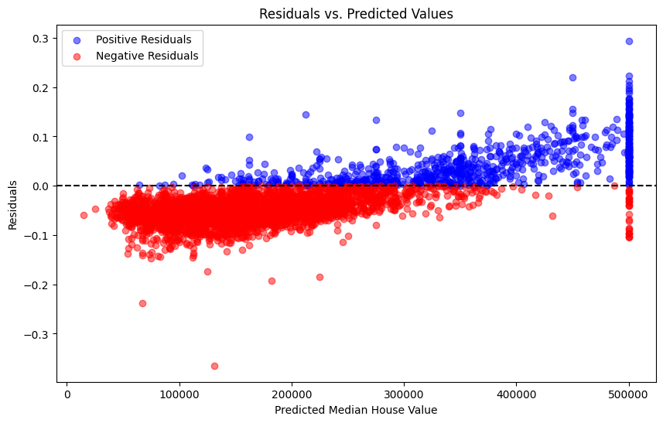
Figure 8. Residual plot for prediction and residual values
The residuals are centered around the horizontal line at zero, which suggests that the model does not have a systemic bias to overpredict or underpredict the house values systematically. There's a mix of positive (blue) and negative (red) residuals across the range of predicted values. Positive residuals indicate that the actual house values are higher than the predictions, while negative residuals suggest the actual values are lower than the predictions. Most residuals appear to be within a certain range, implying that for many predictions, the model is relatively close to the actual values. However, there's visible spread in the residuals as the predicted values increase. The residuals show a cone-shaped spread, widening as the predicted values increase, which could be indicative of heteroscedasticity—i.e., the variability of the error increases with the predicted value. This is often addressed by transforming the target variable or by using models that can inherently handle heteroscedastic data.
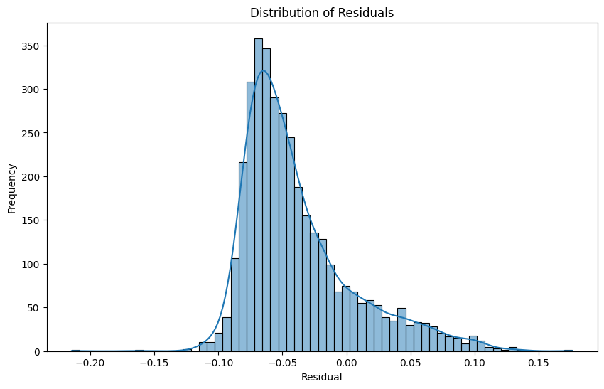
Figure 9. Histogram of residuals
The provided histogram in figure 9, of residuals from a regression model predicting housing prices shows a distribution that is approximately centered around zero and exhibits a bell-shaped curve, suggesting the model's errors are normally distributed. This indicates that there is no systematic bias in the model's predictions. However, the presence of a tail, particularly on the right, hints at potential outliers, where the model's predictions deviate more substantially from the actual values. The concentration of residuals near zero reflects consistent model performance across the dataset, although the significance of the spread of residuals can only be fully assessed in the context of the actual values of the housing prices. The existence of outliers warrants further investigation, as they may influence the model's accuracy and could be indicative of either exceptional cases in the data or areas where the model could be improved. Overall, the histogram suggests that the model performs well for the majority of the data but may benefit from refinements to reduce the impact of outliers or to better capture complex patterns in the housing market.
Mean Absolute Error (MAE): An MAE of approximately $5,732 indicates that on average, your model's predictions are about $5,732 away from the actual house values. This is a relatively concrete measure since it doesn't square the errors, and thus doesn't disproportionately reflect the impact of outliers. In the context of housing prices, which can range from tens of thousands to several million dollars, an average error of this magnitude may be considered acceptable depending on the median value of the houses in your dataset. If the median house value is, say, $200,000, a $5,732 error represents around 2.9% of a house's value, which could be seen as reasonably accurate.
Root Mean Squared Error (RMSE): An RMSE of approximately $6,794 means that the standard deviation of the prediction errors is around $6,794. Since RMSE is more sensitive to outliers than MAE due to the squaring of the errors, a larger RMSE suggests that there are some predictions with substantial errors. However, just like with MAE, whether an RMSE of this size is acceptable depends on the overall distribution of housing prices in your dataset.
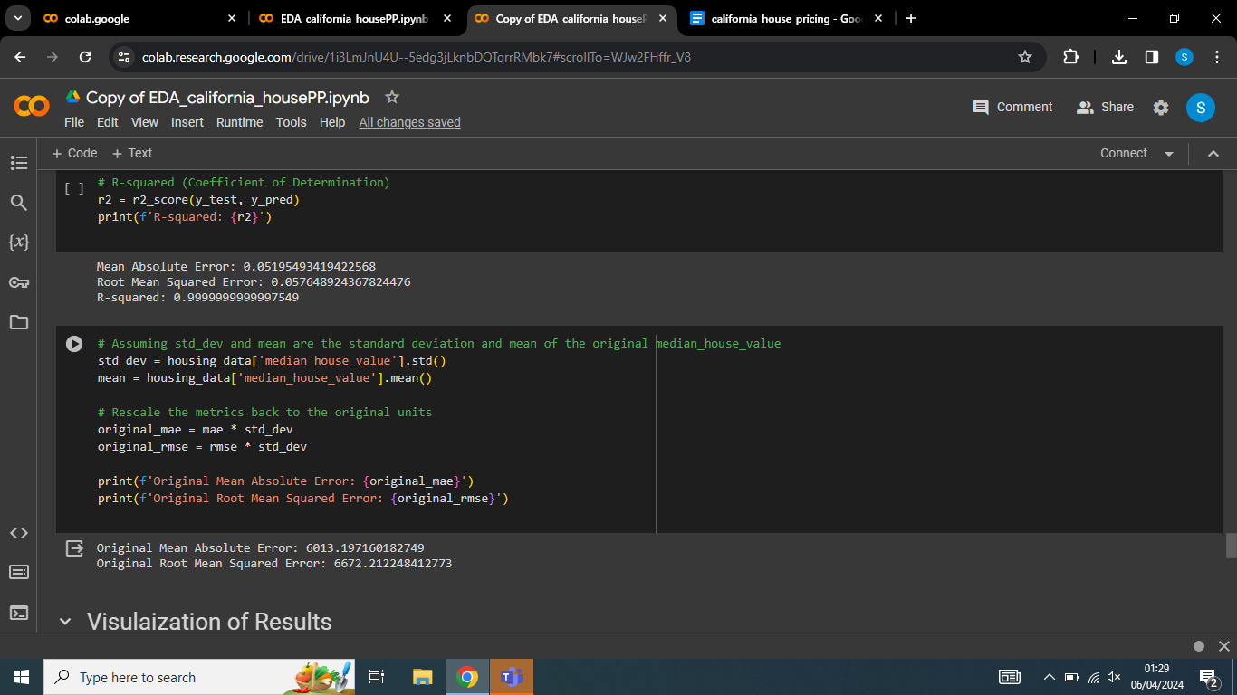
Figure 10. Mean Absolute Error & Root Mean Error
Outliers: There are some outliers, particularly in the high-end value predictions. These might be special cases where the houses have unique features not captured by the model, or they could be errors in data recording.
Model Performance: Overall, the SVR model seems to perform adequately in a mid-range of predicted values, with residuals being relatively low. However, the model's accuracy decreases as it approaches the extremes of the housing value range.

Legal, Social, Ethical, and Professional issues
When discussing the legal, social, ethical, and professional issues (LSEPI) related to a dataset like the California housing dataset and the context of predictive modeling in real estate, there are several key considerations:
- Data Privacy and Anonymity:
  - Datasets containing information about housing may inadvertently reveal personal data about residents or owners, such as their economic status or living conditions.
  - Ensuring that any personal information is anonymized and cannot be reverse-engineered to identify individuals is crucial. This aligns with data protection regulations like the General Data Protection Regulation (GDPR) in the EU and the California Consumer Privacy Act (CCPA).
- Bias and Fairness:
  - Machine learning models can inherit biases present in their training data. If historical housing data reflects past discriminatory practices, models may perpetuate or even amplify such biases.
  - The Fair Housing Act in the United States, for example, prohibits discrimination in housing. Predictive models must be audited for fairness to ensure compliance with such laws.
- Impact on Specific Groups or Wider Society:
  - Predictive models in real estate can influence market dynamics, potentially affecting housing affordability and availability.
  - Models favoring profitability could lead to gentrification, impacting low-income communities. Ethical considerations should guide the application of predictive models to avoid adverse social outcomes.
- Professional Integrity:
  - IT and computer science professionals are responsible for ensuring that models are built and deployed responsibly. This includes transparency about model capabilities, limitations, and the potential for error.
  - Professional bodies such as ACM and IEEE have codes of ethics that stress the importance of considering the broader impacts of technology and avoiding harm.
- Legal and Governance Frameworks:
  - Use and deployment of predictive models in real estate must adhere to local and national housing laws and regulations.
  - In some jurisdictions, the use of automated decision-making systems is subject to specific regulations that require transparency, accountability, and avenues for appeal by affected individuals.
In the academic literature, these issues are discussed in the context of "algorithmic fairness," where there is ongoing research into methods for detecting and mitigating bias in machine learning (Barocas et al., 2019). Additionally, the notion of "ethics by design" in machine learning development is gaining traction, where ethical considerations are integrated into the development process from the ground up (Mittelstadt, 2019)

Observation
- Dataset Composition: The dataset comprises several metrics like population, median income, housing median age, and more, which are critical factors in predicting housing prices. The distribution and datatype analysis, as well as the assessment of value ranges, set a solid groundwork for understanding the dataset's structure.
- Literature Review: The literature presents various methodologies and highlights the significance of using ensemble methods, SVR, and deep neural networks in predicting housing prices. This indicates a rich field of exploration and validates the choice of advanced regression techniques for the case study.
- Data Analysis: Descriptive statistics provided an essential overview of the data's central tendency and spread, informing feature selection and preprocessing needs. Correlation analysis revealed key relationships between features, particularly the influence of median income on housing prices.

Conclusions

8.1 Model Choice and Performance:
The choice of SVM for its robustness and non-linearity handling seemed justified based on the dataset's characteristics. Despite this, the residual analysis indicated a model with high accuracy but also suggested heteroscedasticity at higher value ranges, which could impact model reliability.

8.2 Preprocessing Impact:
Data cleaning using KNN imputation and feature scaling demonstrated the impact of preprocessing on model performance. The decision to drop features like longitude and latitude based on correlation analysis showed strategic feature selection to focus on the most impactful predictors.

8.3 Techniques Evaluation:
- SVR Specifics: The application of SVR with a linear kernel and the adjustment of hyperparameters like C and epsilon appeared crucial in obtaining a high-fidelity model. These techniques, coupled with residual analysis, were instrumental in evaluating model predictions.
- Histogram of Residuals: This was particularly valuable for assessing the normality of prediction errors and identifying potential outliers, reinforcing the need for further model refinement.

8.4 Techniques Comparison:
- Comparisons between different regression models were implied through the assessment of residuals and error metrics. Although not explicitly compared within the report, it's inferred that SVR was found most suitable among the techniques considered.

Future Work Recommendations
- Model Exploration: Future work could explore ensemble methods and neural networks to leverage their predictive strengths and compare results against SVR.
- Hyperparameter Optimization: Utilizing grid search or randomized search for more extensive hyperparameter tuning could further refine the chosen models.
- Fairness and Bias Audits: As suggested by the literature, future studies should include a bias audit, particularly if housing data may reflect historical biases.
- Addressing Heteroscedasticity: Employing techniques to manage the variability in error, such as transforming the target variable or using models designed to handle such variance, would be prudent.
- Feature Engineering:
  - Explore additional features derived from existing ones, such as:
    - Ratio of bedrooms to total rooms (bedrooms_per_room)
    - Population density (population_per_household)
    - Proximity to amenities or services based on latitude and longitude (e.g., distance to nearest school, hospital, or shopping center)
- Advanced Data Preprocessing:
  - Implement advanced data cleaning techniques, such as:
    - Outlier detection and removal using statistical methods (e.g., z-score)
    - Handling missing values with more sophisticated imputation techniques (e.g., K-nearest neighbors, interpolation)
    - Scaling and normalization of features to improve model performance
- Model Selection and Tuning:
  - Experiment with different regression algorithms beyond linear regression, such as:
    - Decision trees and ensemble methods (e.g., Random Forest, Gradient Boosting)
    - Support Vector Machines (SVM) for regression
  - Perform hyperparameter tuning using techniques like grid search or randomized search to optimize model performance
- Model Evaluation:
  - Utilize advanced evaluation metrics for regression models, including:
    - Mean Absolute Error (MAE), Mean Squared Error (MSE), and Root Mean Squared Error (RMSE)
    - R-squared (coefficient of determination) to assess model goodness-of-fit
    - Cross-validation techniques to assess model generalizability and robustness
- Spatial Analysis:
  - Leverage geographic information system (GIS) techniques for spatial analysis:
    - Create choropleth maps to visualize housing price distributions across different regions in California
    - Perform spatial autocorrelation analysis to identify spatial patterns and clusters of high/low housing prices
- Time Series Analysis:
  - Explore temporal trends in housing prices over time:
    - Aggregate data by year or month and analyze price trends using time series decomposition techniques (e.g., seasonal decomposition of time series)
    - Forecast future housing prices using time series forecasting models (e.g., ARIMA, Prophet)
- Ensemble Methods:
  - Implement ensemble learning techniques to combine predictions from multiple models:
    - Develop a stacked ensemble model that combines predictions from different regression algorithms for improved accuracy
    - Use model stacking to leverage the strengths of different models and mitigate individual model weaknesses
- Interpretability and Feature Importance:
  - Investigate feature importance to understand which variables have the most significant impact on housing prices:
    - Employ techniques like permutation importance or SHAP (SHapley Additive exPlanations) values to interpret model predictions and explain feature contributions
- Deployment and Application:
  - Explore deployment options for the predictive model, such as:
    - Building a web application or API to allow users to input features and receive predicted housing prices
    - Integrating the model into a real-time data pipeline for automated predictions and updates
- Ethical Considerations:
  - Discuss ethical implications related to housing pricing models, such as:
    - Potential biases in the dataset and their impact on model fairness
    - Responsible use of predictive models in real-world applications to ensure equitable outcomes

