**Various operations on sets using Venn Diagram**

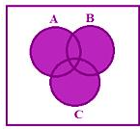

**A ∪ B ∪ C**

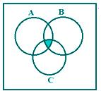

**A ∩ B ∩ C**

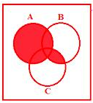

**A ∪ (B ∩ C)**

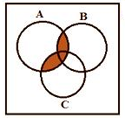

**A ∩ (B ∪ C)**

However, if A is a finite set, then

The number of elements in A is denoted by n(A),

The number of elements in B is denoted by n(B),

The number of elements in (A ∪ B) is denoted by n(A ∪ B) etc.

**Set theory in practical problems**

**For two sets**

Let A and B be two finite sets, then two cases arise:

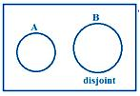

**Case 1:**

A and B are disjoint.   
  
Here, we see that there is no common element in A and B.   
  
Therefore, n(A ∪ B) = n(A) + n(B) - n(A ∩ B)

For disjoint sets, n(A ∩ B) =  0

Then, n(A ∪ B) =  n(A) + n(B)

**Case 2:**

When A and B are not disjoint, we have from the figure   
  
(i) n(A ∪ B) = n(A) + n(B) - n(A ∩ B)   
  
(ii) n(A ∪ B) = n(A - B) + n(B - A) + n(A ∩ B)   
  
(iii) n(A) = n(A - B) + n(A ∩ B)    
  
(iv) n(B) = n(B - A) + n(A ∩ B)

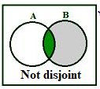

**For three sets**

**Case 1:**

A, B and C are disjoint.   
  
Here, we observe that there is no common element in A, B and C. 

n(A u B u C)  =  n(A) + n(B) + n(C) - n(A n B) - n(B n C)  - n(A n C) + n(A n B n C)

For disjoint sets A, B and C

n(A n B)  = 0,

n(B n C)  =  0,

n(A n C)  =  0,

n(A n B n C)  =  0

Therefore, n(A ∪ B ∪ C) = n(A) + n(B) + n(C)

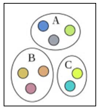

**Case 2:**

When A and B are not disjoint, we have from the figure

Let A, B, C be any three finite sets, then   
  
n(A ∪ B ∪ C) = n[(A ∪ B) ∪ C]   
  
                  = n(A ∪ B) + n(C) - n[(A ∪ B) ∩ C]   
  
                  = [n(A) + n(B) - n(A ∩ B)] + n(C) - n [(A ∩ C) ∪ (B ∩ C)]   
  
                  = n(A) + n(B) + n(C) - n(A ∩ B) - n(A ∩ C) - n(B ∩ C) + n(A ∩ B ∩ C)   
  
                     [Since, (A ∩ C) ∩ (B ∩ C) = A ∩ B ∩ C]   
  
Therefore, n(A ∪B ∪ C) = n(A) + n(B) + n(C) - n(A ∩ B) - n(B ∩ C) - n(C ∩ A) + n(A ∩ B ∩ C)

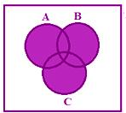

**Basic Formulas**

* **n(AuB)**  =  Total number of elements related to any of the two events A & B.
* **n(AuBuC)**  =  Total number of elements related to any of the three events A, B & C.
* **n(A)**  =  Total number of elements related to  A.
* **n(B)**  =  Total number of elements related to  B.
* **n(C)**  =  Total number of elements related to  C.
* **For  two events A & B, we have**
* **n(A) - n(AnB)** =  Total number of elements related to A only.
* **n(B) - n(AnB)** =  Total number of elements related to B only.
* **For  three events A, B & C, we have**
* **n(AnB)**  =  Total number of elements related to both A & B
* **n(BnC)**  =  Total number of elements related to both B & C
* **n(AnC)**  =  Total number of elements related to both A & C
* **n(AnB) - n(AnBnC)**  =  Total number of elements related to both (A & B) only.
* **n(BnC) - n(AnBnC)** =  Total number of elements related to both (B & C) only.
* **n(AnC) - n(AnBnC)**  =  Total number of elements related to both  (A & C) only
* **n(A) - [n(AnB) + n(AnC) - n(AnBnC)]**  =  Total number of elements related to A only.
* **n(B) - [n(AnB) + n(BnC) - n(AnBnC)]** =  Total number of elements related to B only.
* **n(C) - [n(BnC) + n(AnC) + n(AnBnC)]**  =  Total number of elements related to C only

**Example-1**

In a group of students, 65 play foot ball, 45 play hockey, 42 play cricket, 20 play foot ball and hockey, 25 play foot ball and cricket, 15 play hockey and cricket and 8 play all the three games. Find the total number of students in the group.

**Solution**

Let F, H and C represent the set of students who play foot ball, hockey and cricket respectively.

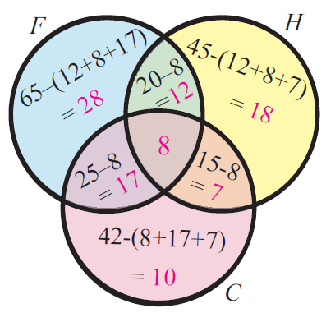

Given

No. of students who play foot ball = 65

No. of students who play hockey = 45

No. of students who play cricket = 42

No. of students who play both foot ball &  hockey = 20

No. of students who play both hockey & cricket = 15

No. of students who play both foot ball and cricket = 25

No. of students who play all the three games = 8

No. of students who play both (foot ball & hockey) only = 12

No. of students who play both (hockey & cricket) only = 7

No. of students who play both (foot ball and cricket) only = 17

No. of students who play foot ball only = 28

No. of students who play hockey only = 18

No. of students who play cricket only = 10

Total number of students in the group = 65 + 45 + 42 -20 - 25 - 15 + 8 = 100

**Basic Formula**

**Step 1 :**

Let F, H and C represent the set of students who play foot ball, hockey and cricket respectively.

**Step 2 :**

From the given information, we have

|  |  |  |
| --- | --- | --- |
| n(F) = 65,  n(H) = 45,  n(C) = 42 | n(FnH) = 20,  n(FnC) = 25,  n(HnC) = 15 | n(FnHnC) = 8 |

**Step 3 :**

Total number of students in the group = n(FuHuC)

                    = n(F) + n(H) + n(C) - n(FnH) - n(FnC) - n(HnC) + n(FnHnC)

                    = 65 + 45 + 42 -20 - 25 - 15 + 8

                    = 100

Hence, the total number of students in the group is 100

**Using Venn Diagram**

Total number of students in the group

                                =  28 + 12 + 18 + 7 + 10 + 17 + 8

                                = 100

**Example-2**

In a survey of university students, 64 had taken Mathematics course, 94 had taken**C**hemistry course, 58 had taken Physics course, 28 had taken Mathematics and physics, 26 had taken Mathematics and Chemistry, 22 had taken Chemistry and**P**hysics course, and 14 had taken all the three courses. Find how many had taken one course only.

**Solution**

**By using Basic Formula**

**Step 1 :**

Let M, C, P represent sets of students who had taken mathematics, chemistry and physics respectively

**Step 2 :**

From the given information, we have

|  |  |  |
| --- | --- | --- |
| n(M) = 64 ,  n(C) = 94,  n(P) = 58, | n(MnP) = 28,  n(MnC) = 26,  n(CnP) = 22 | n(MnCnP) = 14 |

**Step 3 :**

No. of students who had taken only **Math**

                                = n(M) - [n(MnP) + n(MnC) - n(MnCnP)]

                                = 64 - [28+26-14]

                                = 64 - 40

                                = 24

**Step 4 :**

No. of students who had taken only **Chemistry**

                                = n(C) - [n(MnC) + n(CnP) - n(MnCnP)]

                                = 94 - [26+22-14]

                                = 94 - 34

                                = 60

**Step 5 :**

No. of students who had taken only **Physics**

                                = n(P) - [n(MnP) + n(CnP) - n(MnCnP)]

                                = 58 - [28+22-14]

                                = 58 - 36

                                = 22

**Step 6 :**

Total no. of students who had taken **only one** course

                                  = 24 + 60 + 22

                                 = 106

Hence, the total number of students who had taken only one course is 106

**Using Venn Diagram**

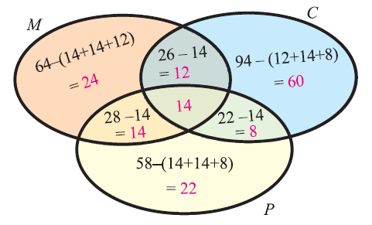

**Step 1 :**

From the Venn diagram above, we have

No. of students who had taken only math = 24

No. of students who had taken only chemistry = 60

No. of students who had taken only physics = 22

**Step 2 :**

Total no. of students who had taken only one course

                                  = 24 + 60 + 22

                                 = 106

Hence, the total number of students who had taken only one course is 106

**Example-3**

In a class of 60 students, 40 students like Math, 36 like Science, 24 like both the subjects. Find the number of students who like

(i) Math only, (ii) Science only  (iii) Either Math or Science (iv) Neither Math nor science

**Solution :**

**Step 1 :**

Let M and S represent the set of students who like math and science respectively.

**Step 2 :**

From the information given in the question, we have

n(M) = 40, n(S) = 36, n(MnS) = 24

**Step 3 :**

**Answer (i) :** No. of students who like Math only

                                   = n(M) - n(MnS)

                                   = 40 - 24

                                  = **16**

**Step 4 :**

**Answer (ii) :** No. of students who like Science only

                                   = n(S) - n(MnS)

                                   = 36 - 24

                                  = **12**

**Step 5 :**

**Answer (iii) :** No. of students who like either math or science

                                  = n(M or S)

                                  = n(MuS)

                                  = n(M) + n(S) - n(MnS)

                                  = 40 + 36 - 24

                                  = **52**

**Step 6 :**

**Answer (iv) :**

Total no. students who like any of the two subjects = n(MuS) = 52

No. of students who like neither math nor science

                                         = 60 - 52

                                         = **8**

Let us look at the next problem on "Venn diagram problems and solutions"

**Example-4**

At a certain conference of 100 people there are 29 Indian women and 23 Indian men. Out of these Indian people 4 are doctors and 24 are either men or doctors. There are no foreign doctors. Find the number of women doctors attending the conference.

**Solution :**

**Step 1 :**

Let M and D represent the set of Indian men and Doctors respectively.

**Step 2 :**

From the information given in the question, we have

n(M) = 23, n(D) = 4, n(MuD) = 24,

**Step 3 :**

From the basic stuff, we have

                              n(MuD) = n(M) + n(D) - n(MnD)

                                      24 = 23 + 4 - n(MnD)

                             n(MnD) = 3

n(Indian Men and Doctors) = 3

**Step 4 :**

So, out of the **4** Indian doctors, there are **3** men.

And the remaining **1** is Indian women doctor.

Hence, the number women doctors attending the conference is 1