Pintos phase 1
+- - - - - - - - - - +
| CS 3204 |
| PROJECT 1: THREADS |
| DESIGN DOCUMENT |
+--------------------+

---- GROUP ----

Rewan Khaled Abdulkariem 19015677
Radwa Mahmoud Mohammed 19015663
Omar
Seif
Assem

---- PRELIMINARIES ----
Pintos is a simple instructional operating system framework for x86 instruction set architecture. It supports kernel threads, loading and running user programs and a file system, but it implements all of these in a very simple way.
In this project, the objective is to accomplish the thread part of Pintos.
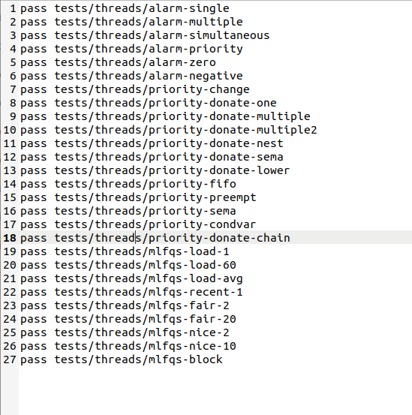
---- Result of Task 1 to 3 -----
ALARM CLOCK
===========

---- DATA STRUCTURES ----

In thread.h: Update the header file to include new attribute that will indicate the remaining number of ticks before the thread is to be awakened. This attribute will be represented by an integer type and named 'ticks_blocked’

struct thread
{
....
int64_t ticks_blocked; /* Ticks that the thread need to be blocked. */
}

---- ALGORITHMS ----
Based on the analysis of the 'timer_sleep' function, it was discovered that during 'thread_yield', if the current thread is not idle, it is placed at the end of the queue, and its state is changed to 'THREAD_READY'. Consequently, threads repeatedly transition between the ready queue and the run queue, which leads to the constant consumption of CPU resources and problems such as busyness.
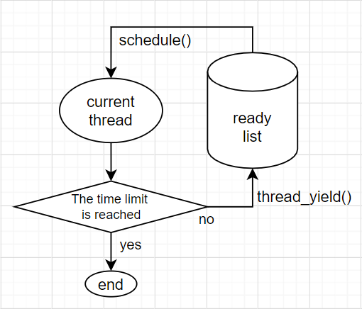
To address this, we propose to block the thread and record the remaining time that it is blocked. This will be accomplished by creating a new attribute, 'ticks_blocked'. We will then use the clock interrupt to monitor the state of all threads and decrement the 'ticks_blocked' value for each blocked thread by one on each interrupt. If the value reaches zero, the corresponding thread will be woken up.
To iterate through all threads during a clock interrupt, the 'thread_foreach' function is used. This function will be called within the 'timer_interrupt' function in the 'timer.c' file. To ensure the correct implementation of this function, we will declare a new function called 'checkInvoke' in the 'thread.h' file, which will then be implemented in the 'thread.c' file. Finally, we will modify the 'timer_sleep' function to block the current thread for a specified number of ticks in an atomic operation.

---- SYNCHRONIZATION ----

>> A4: How are race conditions avoided when multiple threads call
>> timer_sleep() simultaneously?
By disabling interrupts and blocking the thread, the function ensures that no other thread can interfere with the sleeping thread's ticks_blocked variable. This avoids race conditions that could occur if multiple threads attempted to sleep for the same amount of time simultaneously.
Interrupts are disabled to ensure that the current thread is not preempted and that the ticks_blocked variable is not modified by an interrupt handler. Once the thread has been blocked, interrupts are enabled again to allow other threads to run and handle interrupts as usual.

>> A5: How are race conditions avoided when a timer interrupt occurs
>> during a call to timer_sleep()?
In the provided implementation, race conditions are avoided when a timer interrupt occurs during a call to timer_sleep() by disabling interrupts temporarily using intr_disable().

---- RATIONALE ----

>> A6: Why did you choose this design? In what ways is it superior to
>> another design you considered?
We chose this design because it is simple and efficient.Threads are put to sleep without wasting CPU cycles. Disabling interrupts before modifying any list ensures that no race conditions can occur.Overall, this design strikes a balance between efficiency, responsiveness, synchronization.
I decided to use the simpler design because it was sufficient for the needs of the project. The project did not need to handle a large number of threads, so the performance benefits of using a semaphore were not necessary.

PRIORITY SCHEDULING
===================

---- DATA STRUCTURES ----
1- In thread.h:
Add three attributes in the struct thread

struct thread
{
. . . .
int base_priority; /* Used to record thread's priority when it's not being donated. */
struct list locks_holding; /* List of locks the thread is holding. */
struct lock *lock_waiting4; /* The lock the thread is waiting for. */
}
2- In synch.h:
Add two attributes in the struct

struct lock
{
struct list_elem elem; /* The list element stored for priority donation. */
int max_priority; /* The maximum priority among the priorities of threads acquiring the lock. */
};
>> B2: Explain the data structure used to track priority donation.
>> Use ASCII art to diagram a nested donation. (Alternately, submit a
>> .png file.)
priority: 3 priority: 3 priority: 3
-------- -------- --------
| Thread A | waits for X | Thread B| waits for Y |Thread C|
|base_pri:1| <------------ |base_pri:2| <------------ |base: 3 |
| locks: X | | locks: Y| | |
-------- ---------- --------

When a thread is blocked waiting for a lock, it sets its lock_waiting field to point to the lock it is waiting for. When the thread is unblocked and acquires the lock, it removes itself from the semaphore_elem list for the lock and updates its own priority based on the highest priority of any threads waiting on the lock.
If a thread donates its priority to another thread, the donated priority is recorded in the base_priority field of the receiving thread. When the thread releases the lock, its priority is restored to its original base_priority value.

Thread A (priority 1) is holding Lock X.
Thread B (priority 2) is blocked waiting for Lock X and donates its priority to Thread A.
Thread C (priority 3) is blocked waiting for Lock Y, which is held by Thread B.

---- ALGORITHMS ----

>> B3: How do you ensure that the highest priority thread waiting for
>> a lock, semaphore, or condition variable wakes up first?
In lock_acquire():
When a call to lock_acquire(), the first thing to do is the priority donation. Before sema_down(), we can judge whether a lock is held or not by checking if the holder is null.
If the priority of the holder is smaller than that of the current thread, then update the "donated" priority of the lock and the holder.
If the holder is also locked by other locks, then repeat the above procedures, recursively.
After sema_down(), the current thread will hold the lock. Put the lock into the locks_holding of the thread. Update priority of the lock and the current thread.
If next thread to run in the ready_list has a higher priority than the current thread, yield the CPU.

in sema_down():
we insert the seam waiter threads in sema waiters list according to priority through list_insert_ordered().

In cond_signal():
we sort the threads waiting for the condition according to their priorities in cond waiters list and when we call sema_up() we take the first thread in the list and sema_up its semaphore.
>> B4: Describe the sequence of events when a call to lock_acquire()
>> causes a priority donation. How is nested donation handled?
When a thread calls lock_acquire(), it tries to acquire the lock associated with the semaphore. If the lock is already held by another thread, the calling thread will be blocked, and a priority donation may occur.
A priority donation happens when a thread donates its priority to another thread that is holding a lock that the calling thread is waiting for. The priority of the holding thread is temporarily boosted to that of the waiting thread, so that the holding thread can execute and release the lock more quickly. This priority donation continues until the lock is released.
If nested donation occurs, it means that multiple threads are waiting for locks that are held by other threads. In this case, priority donation may occur in a chain-like manner. For example, if Thread A holds Lock 1 and Thread B holds Lock 2, and Thread C is waiting for Lock 1, and Thread D is waiting for Lock 2, then if Thread C donates its priority to Thread A, and Thread D donates its priority to Thread B, this will result in nested donation. In this case, Thread A's priority will be boosted by the priority of Thread C, and Thread B's priority will be boosted by the priority of Thread D.
To handle nested donation, each thread that receives a donated priority must keep track of the original base_priority, which is its initial priority before any donations occur. When a lock is released, the thread's priority is restored to its base_priority. This ensures that the donated priority is only in effect for as long as the thread is holding the lock. When the lock is released, the thread's priority returns to its original value, and the priority donation chain is unwound in reverse order.

>> B5: Describe the sequence of events when lock_release() is called
>> on a lock that a higher-priority thread is waiting for.
When lock_release() is called on a lock that a higher-priority thread is waiting for, a priority inversion may occur. To avoid this, the waiting thread donates its priority to the current thread that is releasing the lock. Once the lock is released, the waiting thread is scheduled to run if its priority is higher than the current thread. The sequence of events includes selecting the highest-priority waiting thread, comparing its priority to the current thread's priority, and releasing the lock. If there are no threads waiting for the lock, it is simply released.

---- SYNCHRONIZATION ----

>> B6: Describe a potential race in thread_set_priority() and explain
>> how your implementation avoids it. Can you use a lock to avoid
>> this race?
A potential race condition in the provided implementation of thread_set_priority() could occur if two threads attempt to modify the same thread's priority at the same time. This could result in the thread's priority being set to the wrong value, or in the thread yielding the CPU when it should not have.
To avoid this race condition, the implementation uses the intr_disable() and intr_set_level() functions to disable interrupts while the thread's priority is being updated. This ensures that no interrupt handler can run concurrently and modify the thread's priority.
Additionally, the implementation checks if the thread is holding any locks and if the new priority is higher than the thread's base priority or any of the lock holder's priorities. If so, the thread's priority is updated and it yields the CPU to allow higher-priority threads to run

---- RATIONALE ----

>> B7: Why did you choose this design? In what ways is it superior to
>> another design you considered?
The design of the priority donation algorithm was chosen because it is simple to implement and efficient. It works by having the thread that acquires a lock donate its priority to the thread that was previously holding the lock. This ensures that the thread that was holding the lock is always the highest priority thread that is waiting to acquire the lock.
Another design that was considered was to have the thread that acquires a lock simply yield the CPU to the thread that was previously holding the lock. This design is also simple to implement, but it is not as efficient. The reason for this is that the thread that was holding the lock may have to wait for a long time to acquire the lock again, even though it is the highest priority thread that is waiting to acquire the lock.

ADVANCED SCHEDULER
==================

Task 3: Multi-level Feedback Queue Scheduler

#### Data structures and functions

1. In `thread.h`:

Add TWO attributes to the struct `thread`:

`nice` determines how “nice” the thread should be to other threads,

`recent_cpu` measures the amount of CPU time a thread has received "recently,

```c
struct thread
{
...
int nice; /* Nice value. */
fixed_t recent_cpu; /* Recent CPU. */

};
```

2. In `thread.c`:

Add a global variable `load_avg`, which estimates the average number of threads ready to run over the past minute.

```c
static fixed_t load_avg;
```

#### Algorithms

##### Advanced Scheduler

Different from TASK 2, there is no priority donation in the MLFQ scheduler, as the priority of threads are not set by users, but calculated by the OS itself.

Firstly we have to maintain a variable: the system load average, denoted as `load_avg`, and it's actually a weighted moving average of the amount of waiting threads in `ready_list` and the current thread (except for the `idle_thread`). At system boot, it's initialized to 0. Per second thereafter, it is updated according to the following formula:
$$
load\_avg = \frac{59}{60} \times load\_avg + \frac{1}{60} \times (\#\ of\ ready\ threads)
$$
In every thread, there will be two attributes named `recent_cpu` and `nice`. The meanings of these two variables have been explained in **Data Structures and Functions**.

`recent_cpu` is a exponentially weighted moving average of `nice`. Each time a timer interrupt occurs, recent_cpu is incremented by 1 for
the running thread only. In addition, once per second recalculated `recent_cpu` of all threads according to the following formula:
$$
recent\_cpu = \frac{2 \times load\_avg}{2 \times load\_avg + 1} \times recent\_cpu + nice
$$
`nice` is not dynamic, but set by users, with a default value 0. The value of `nice` is between -20 to 20.

The `priority` of a thread is calculated as follows:
$$
priority = PRI\_MAX - \frac{recent\_cpu}{4} - (2 \times nice)
$$
For every four ticks, recalculate the `priority` of the current thread. And then, call `thread_yield()` if there are waiting threads which have higher priority than the current thread.

#### Synchronization

The usage and the assignment of the global variable `load_avg` may conflict with each other, and it's the same for the other struct-specific variables.

To avoid these problems, always disable the interrupt when changing and using these variables.

```c
enum intr_level old_level = intr_disable ();
...
intr_set_level (old_level);
```

#### Rationale

1. My design is actually a quite natuaral and simple designing. Only the needed calculations are taken, which could be considered as an advantage.
2. The fixed point number calculations are defined as macros in `fixed_point.h`. In the test, there are always some strange differences between the result and the expectation output. But when I turned the 15.16 FP into the 16.15 FP, the outputs of my codes meet the requirements. This may be due to a difference in accuracy.

## Additional Questions

### 1.

> Suppose threads A, B, and C have nice values 0, 1, and 2. Each has a recent_cpu value of 0. Fill in the table below showing the scheduling decision and the recent_cpu and priority values for each thread after each given number of timer ticks. We can use R(A) and P(A) to denote the recent_cpu and priority values of thread A, for brevity.

Suppose threads A, B, and C have nice values 0, 1, and 2. Each has a recent_cpu value of 0. The table below shows the scheduling decision and the priority and recent_cpu values for each thread after each given number of timer ticks. To simplify the problem, assume that `TIMER_FREQ` is greater than 36.

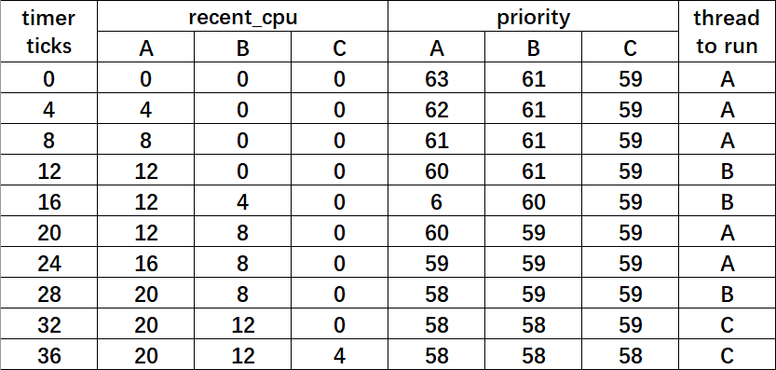
### 2.

> Did any ambiguities in the scheduler specification make values in the table (in the previous question) uncertain? If so, what rule did you use to resolve them?

Yes.

Actually, after the priority has been changed, the thread yielding does not happen in my codes (or in the tests), and the yielding is forbidden in the interrupt context.

Therefore, unless the running thread calls thread_yield(), I didn't switch it to a higher priority thread.

>C4: How is the way you divided the cost of scheduling between code
inside and outside interrupt context likely to affect performance?

to reduce the time spent inside the interrupt context , Our code performs most of the expensive operations, such as sorting the ready queue or donating priorities, outside the interrupt context. This approach allows the interrupt context to quickly resume the execution of the interrupted process, improving the system's responsiveness

SURVEY QUESTIONS
================

Answering these questions is optional, but it will help us improve the
course in future semesters. Feel free to tell us anything you
want--these questions are just to spur your thoughts. You may also
choose to respond anonymously in the course evaluations at the end of
the semester.

>> In your opinion, was this assignment, or any one of the three problems
>> in it, too easy or too hard? Did it take too long or too little time?

>> Did you find that working on a particular part of the assignment gave
>> you greater insight into some aspect of OS design?

>> Is there some particular fact or hint we should give students in
>> future semesters to help them solve the problems? Conversely, did you
>> find any of our guidance to be misleading?

>> Do you have any suggestions for the TAs to more effectively assist
>> students, either for future semesters or the remaining projects?

>> Any other comments?

