

FACULTY OF ENGINEERING

PROJECT PROPOSAL

VETS 7016-1: Industrial Project Planning & Implementation

Project Title:
Failure Analysis and Yield Improvement Methodology on Structural Based Functional Test [SBFT] Design

Name: Mah Wey Sen Winson
Supervisor: Dr. Chinnaiyan Senthilpari
Program: Micro-credentials in M.Eng. Microelectronics

Declaration of originality:

I declare that all sentences, results, and data included in this report are from my own work. All work derived from other authors have been listed in the references. I understand that failure to do this is considered plagiarism and will be penalized.

Note that collaboration and discussions in conducting the experiments are allowed but copying and any act of cheating in the report, results and data are strictly prohibited.

Signature: ________________________________________________________

Date: ____________________________________________________________

Abstract
Yield is a key performance to measure in semiconductor manufacturing and has a dominant effect on semiconductor industry. In the dynamic landscape of semiconductor testing, the Structural Based Functional Test [SBFT] design represents a critical component in ensuring the reliability and functionality of integrated circuits. This project endeavors to conduct a cases study in-depth investigation into the causes of failure analysis within the SBFT framework and proposed a technical comprehensive Yield Improvement Methodology. The research will deploy advanced failure analysis techniques to scrutinize the intricacies of SBFT design failures, aiming to pinpoint root causes and vulnerabilities. In this industry project proposed plan, a systematic methodology of wait time optimization will be developed in SBFT design to enhance the yield of the testing process. This methodology will encompass innovative strategies for mitigating common failure modes, optimizing test parameters, and improving overall test efficiency. The outcomes are expected to contribute not only to the advancement of testing methodologies but also to the overall quality and reliability of semiconductor devices. As the semiconductor industry continues to evolve, the insights derived from this research have the potential to significantly impact the field of SBFT, contributing to advancements in semiconductor testing and electrical quality assurance towards Yield enhancement.
1.0 Introduction
SBFT can be defined as “Structural Based Functional Test”. It is involving functional tests on a chip outside of a system by loading data and content pattern string into a cache internally to run useful code. Functional test is an important part of the overall testing methodology of a modern SOC (System-On-Chip), which usually consist one of more CPUs, large and several memory structures, and many logic interfaces like for example Finite State Machine (FSM), Instruction Register (IR), Instruction Decode Logic (IDL), Data Register (DR) and Test Data Output Multiplexer [TDO MUX] which involve Scan Test. Furthermore, SBFT is functional testing where the results output will be executed through chips pin. Once the test is completed, we can read the core string and iteration results of the chips with performing analysis of shmoo plot that run on automated test equipment (ATE) known as High Density Modular Test (HDMT) tools.

1.1 Problem Statement(s)
There are many reasons why SBFT design cannot be avoided even in a full-scan design to achieve high quality levels of chips architecture. The main benefits of SBFT Design are the ability to test the chip at the “Silicon Wafer Sorting” stage which is before the chips is packaging in manufacturing. This upfront testing SBFT analysis helps to identify the defective chips before they are packaged, ultimately help saving costs for the semiconductor manufacturing industry example like Intel, AMD, Lattice etc.
- SBFT design serve as a complementary test suite to stuck-at tests also the pattern content known as “ca1tf” by significantly increasing defect coverage since not all defects can be modeled well by the stuck-at fault model.
- The activity caused inside a chip by SBFT design is proximity to the conditions that will be observed in its system operation which can results in localized VDD drops and certain crosstalk conditions, which, in turn can stress pattern content propagations paths more than scan-based at-speed tests. Functional test can be particularly useful for speed testing.
- The SOC architecture of logic usually untestable during scan-testing mode to satisfy certain design rules for ATPG [Automatic Test Pattern Generation] tools. These blocks of logic can be exercised by functional test. And finally, some custom CPU design may still not be full scan, which makes that SBFT design architecture is an essential part of their testing methodology.
1.2 Project Objectives
- To conduct the first cut standard high level of failure analysis debugging steps in SBFT design flow towards Yield enhancement.
- To perform and implement the experiment on the duty cycle optimization for the SBFT Chipsets pattern modification which can help on the test time reduction in SBFT content. The SBFT design verification test and outcome of the shmoo plot comparison before and after the propose technical fix plan can be demonstrated by using the Automated Test Equipment (ATE).
- The final objective is to analysis the Yield data percentage graph comparison between Initial and after the implement of the Methodology based on the second objectives achievement.

1.3 Project Scope
In this industry projects, the main scope we going to target performing the high level of debugging and validation methodology for SBFT design and propose some experiment the implementation technical fix plan on the test module and pattern content inside the chips architecture.
- Based on the defective chips to understand the Root Cause failure with 1st cut analysis of SBFT data which is causing by design flow, environment factors, electrical stresses, or manufacturing defects.
- We going to collect the shmoo graphical plot to visualize the performance of the integrated circuit under various combination of input timing and voltage. Thirdly, based on the behavior of shmoo plot we can understand the acceptable operating range for integrated circuit to meet the correct timing margin and vmin testpoint to achieve the passing range.
- To propose some technical experiment for example with change the pattern ordering, wait time modification and voltage incrementation setup to have the disposition plan to the defective chipsets.
Hence, all the simulation experiment will be carried out in the Automated Test Equipment (ATE) and in final objectives we going to use the JMP and Excel Software to perform the line and bar chart on comparison the Yield percentage after the experiment being implemented. This industry project proposes fix plan experiment had been carried out and it able to help disposition for the weekly monitoring defective chips towards save cost in manufacturing semiconductor industry.

Analysis the Chipset History
Reproduce the SBFT design failure in the HDMT Tools
Architecture Design

Understand the root cause why it is fail?
& Application Identification
Execute Test Program

Analysis SBFT Design Flow

Perform the 1st cut SHMOO
Propose Fix Solution
Collect the Yield Percentage
Preparation of Presentation
START
END
MODIFICATIONS
Preparation Final report writing
STAGE 4: Completion SBFT Project and thesis writing
STAGE 1: Investigation of 1st cut of SBFT circuit design

STAGE 2: SBFT Design verified by collect shmoo and perform the pattern content analysis.

STAGE 3: Perform the high level technical solution to fix the failure and collect the Yield Percentage.

Fig. 2 Design of Flow Diagram

2.0 Literature Review
Based on my industry proposal, Failure Analysis and Yield Improvement Methodology of SBFT design being discussed. These literature review below are the citing and references which relate to my project title. There will be more studies of journal and paper may need to further review in order to understand further the improvement we can be implementing into future work.
Reference Number | Journal Title and Year | Method | Advantage | Disadvantage | Improvement needed to perform
1. | DFFT design for functional stability, 2004 | Propose the new design of RTL mechanisms for functional test for example like clock domain crossing and adding new chip pins design inside the reset content help to indicate pass on the ATE. | Improve the speed and frequency of the RTL design towards increase the memory with RAM which help smooth debugging process during the transition to an ATE. | More RTL and flip-flops being added into the functional design will cause miss-match communication of the Chip pins architecture. | Split out the rising clock/reset edges into two clock domains in parallel to achieve the stabilize asynchronous interface of processors.
2. | Realizing the Benefits of Structural Test for Intel Microprocessor, 2002 | Design a narrow bus logic to detect a timing glitch and speed path | Reduce the test costs and increase the device complexity. | Required high temperature of voltage to stress the scan-based logic test | Enabled the single structural socket test towards optimize tester capability and pattern content distribution.

3. | Automated Shmoo Data Analysis: A Machine Learning Approach, 2014 | A Machine Learning AI method being proposed to shmoo for HVM test content development | More accuracy to discover VMIN and smoother to detect new issue quicker | Very high cost to labeling the process of Vector Machine and Neural Networks | We can tune the algorithm to utilize the data from neighboring test points with implement more accurate of frequency and bus ratio
4. | Yield Improvement Methodology with addressing Design Systematics during Production Ramp-up, 2022 | Design features Extraction based on technology pinch point, NPI Characterization signals & WPs from historic learning | All the layout analysis and pattern are matching was performed very detailing inline margins | Pinpoint diagnosis of the chip weak due to complicated design | Can proposed more systematic Metal Void design to achieve more Yield percentage
5. | Scan based testing: the only practical solution for testing ASIC/consumer products, 2002 | Apply SBFT combination with Scan ATPG test to enlarge the stability of the Chipsets architecture. | High coverage for the all-digital embedded system | Take longer time to debug the test development which may cause the chip testing cost increase before release to customer. | Reduce the number of IO pins and implement in the more stabilize pattern content

3.0 Proposed Methodology and/or Materials
Below summary of flowchart will be the overall methodology of the industry of my project. The project task involved the SBFT design analysis and simulation of the SBFT design will be carried out in the ATE tools. The simulation works are emphasizing on obtaining the experiment being listed and review the outcome of the Yield percentage going to achieve the minimum passing score 80% of the SBFT design performance.
Perform the 1st cut Root Cause Analysis of the SBFT design and flow module configurations.

Identify the problem and define the objective of failure analysis of this industry proposal.
Performing the simulation in the HDMT ATE Tools by collecting the shmoo graph and reproduce the 1st cut failure.

Performing the methodology of EAP [Execution all pattern] and analyze the shmoo data collection to find the 2nd cut technical fix plan Solution.

Debug defective chipset and implement the experiment solution into the Engineering Test program to get the passing results and capturing the correct expected output.
- Change the pattern ordering/burst-off enabling and wait time modification.
- Change the voltage and timing of the test instance.
- Moving the pattern content to the previous location [Temperature test] to kill the bad content of the defective chipset at upfront socket.

Interpret the experiment results.

Draw Conclusion and communication the output finding.
Monitoring the implement experiment solution with collect the Yield Percentage to see the outcome of the results.

3.1 Gantt Chart
Attach table schedule plan below are the 5 months duration of preparation the industry project.
Activity | Start Date | End Data | Duration (Days)
Propose the Industry Project Title | 4/11/2023 | 28/11/2023 | 24
Assigned of Project Supervisor | 28/11/2023 | 13/12/2023 | 15
Literature Review | 13/12/2023 | 5/1/2024 | 23
Industry Proposal Softcopy Submission | 5/1/2024 | 21/1/2024 | 16
Experiment & Design Flow with Simulation | 21/1/2024 | 11/2/2024 | 21
Data collection of the experiment | 11/2/2024 | 17/3/2024 | 35
Data Analysis of the Experiment | 17/3/2024 | 31/3/2024 | 14
Draft Report softcopy submission | 31/3/2024 | 24/4/2024 | 24
Project Presentation Physical | 24/4/2024 | 27/4/2024 | 3
Final Report & Conclusion | 27/4/2024 | 10/5/2024 | 13

The Estimation of the Gantt Chart Week.
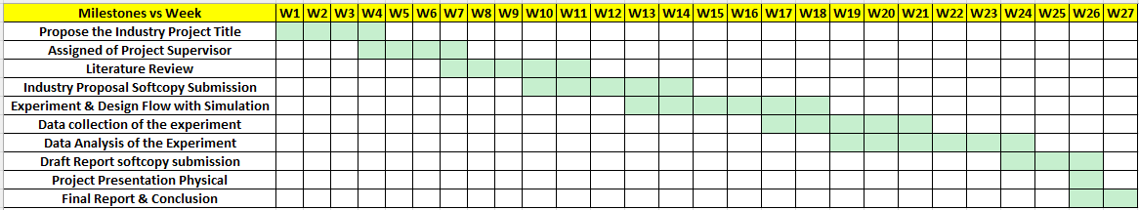

4.0 Preliminary Results (if any)
Example 1: Case of Experiment this defective chipset failing at temperature of 92’C during development milestone and ramp-up stage.
At Intel, we do monitor a bunch of approximately 6 thousand of chipset weekly to monitor the electric quality assurance (EQA) defective unit and performing the validation error before the product being stabilized released to our customer with good quality and save the cost of production.
Step 1: Perform the simulation in HDMT [High Density Modular Tester] to reproduce the error.
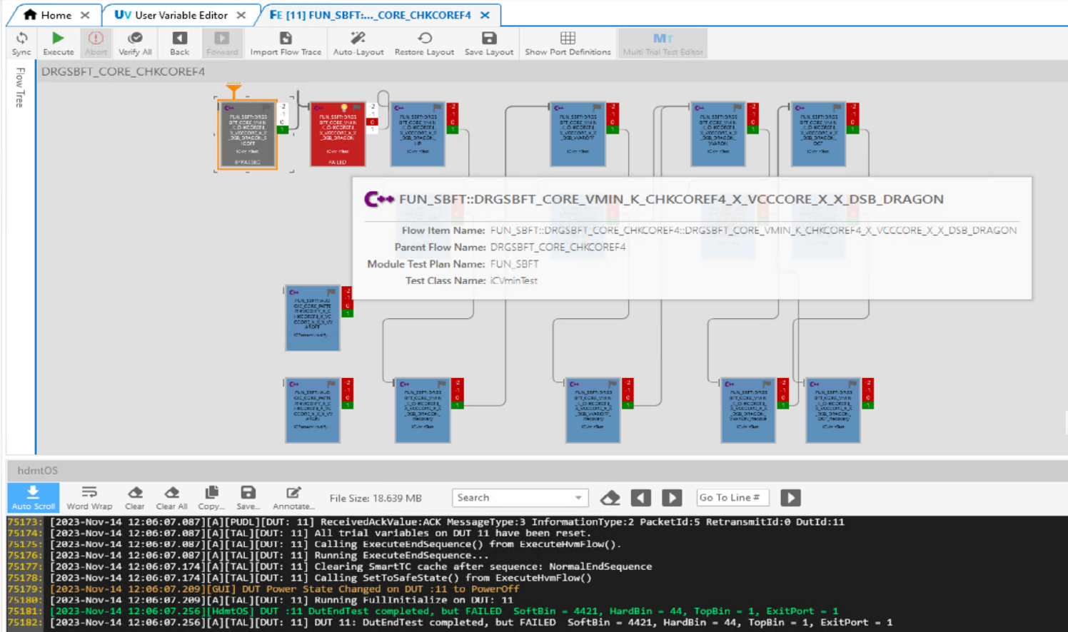
Step 2: Perform the analysis of the chipset history results.
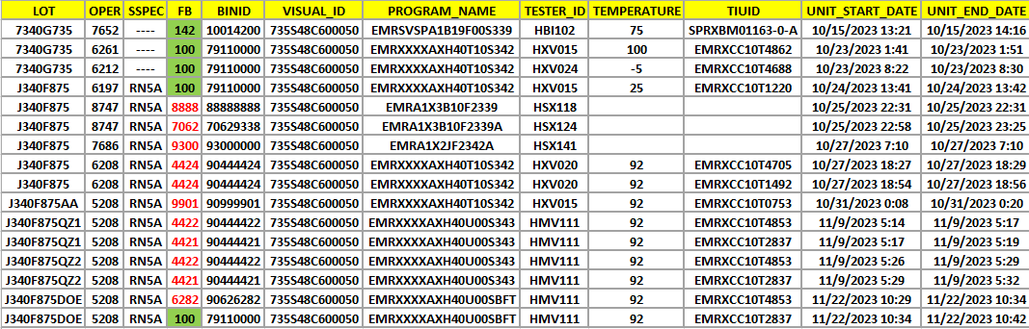
Step 3: Analyze the Vmin Testpoint for the Core/RAM that fail inside the chipsets.
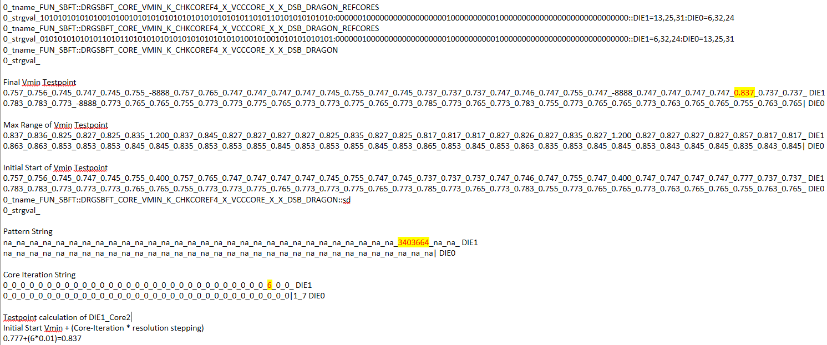
Step 4: Correlate the Vmin testpoint analysis in step3 and mapping with the shmoo plot below.
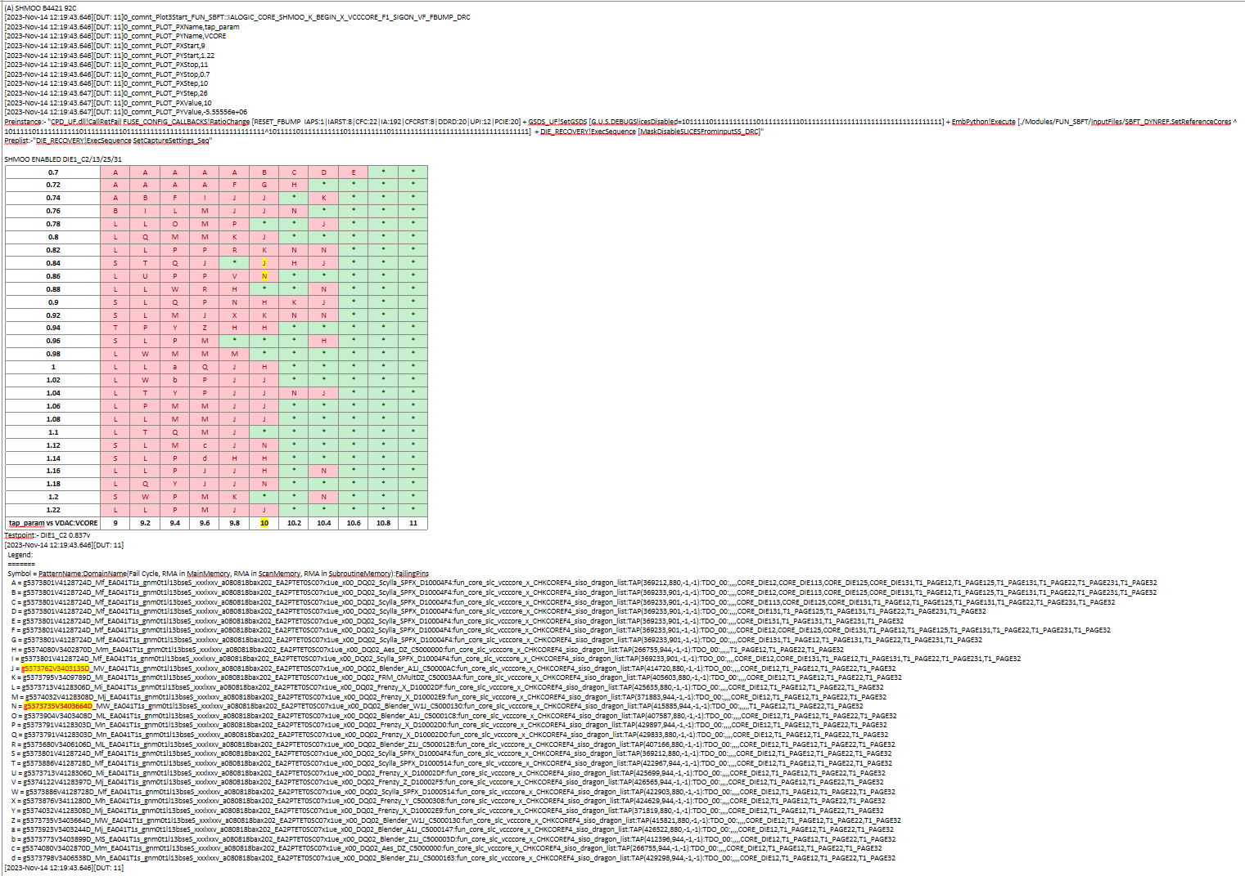

4.1 Expected Outcomes
We do expect to propose an technical fix plan by modified the wait timing for the particular failure pattern content to achieve the passing vmin testpoint for the defective unit.
Initial Failing Timing String for the pattern content
+ SBFT_WAITTIME MAIN PAT g5373735V3403664D_MW_EA041T1s_gnm0t1l13bseS_xxxlxxv_a080818bax202_EA2PTET0SC07x1ue_x00_DQ02_Blender_W1J_C5000130:STF STF_TEST_WAIT_END -10 OPCODE_OPERAND IT_LOOPSET 20000
+ SBFT_WAITTIME MAIN PAT g5373735V3403664D_MW_EA041T1s_gnm0t1l13bseS_xxxlxxv_a080818bax202_EA2PTET0SC07x1ue_x00_DQ02_Blender_W1J_C5000130:TAP TAP_TEST_WAIT_END -5 OPCODE_OPERAND IT_LOOPSET 5000
+ SBFT_WAITTIME MAIN PAT g5373762V3403135D_MV_EA041T1s_gnm0t1l13bseS_xxxlxxv_a080818bax202_EA2PTET0SC07x1ue_x00_DQ02_Blender_A1J_C50000AC:STF STF_TEST_WAIT_END -10 OPCODE_OPERAND IT_LOOPSET 20000
+ SBFT_WAITTIME MAIN PAT g5373762V3403135D_MV_EA041T1s_gnm0t1l13bseS_xxxlxxv_a080818bax202_EA2PTET0SC07x1ue_x00_DQ02_Blender_A1J_C50000AC:TAP TAP_TEST_WAIT_END -5 OPCODE_OPERAND IT_LOOPSET 5000
+ SBFT_WAITTIME MAIN PAT g5373818V3406013D_Ma_EA041T1s_gnm0t1l13bseS_xxxlxxv_a080818bax202_EA2PTET0SC07x1ue_x00_DQ02_Blender_Z1J_C500011E:STF STF_TEST_WAIT_END -10 OPCODE_OPERAND IT_LOOPSET 6000
+ SBFT_WAITTIME MAIN PAT g5373818V3406013D_Ma_EA041T1s_gnm0t1l13bseS_xxxlxxv_a080818bax202_EA2PTET0SC07x1ue_x00_DQ02_Blender_Z1J_C500011E:TAP TAP_TEST_WAIT_END -5 OPCODE_OPERAND IT_LOOPSET 1500
+ SBFT_WAITTIME MAIN PAT g5374080V3402870D_Mm_EA041T1s_gnm0t1l13bseS_xxxlxxv_a080818bax202_EA2PTET0SC07x1ue_x00_DQ02_Aes_DZ_C5000000:STF STF_TEST_WAIT_END -10 OPCODE_OPERAND IT_LOOPSET 8000
+ SBFT_WAITTIME MAIN PAT g5374080V3402870D_Mm_EA041T1s_gnm0t1l13bseS_xxxlxxv_a080818bax202_EA2PTET0SC07x1ue_x00_DQ02_Aes_DZ_C5000000:TAP TAP_TEST_WAIT_END -5 OPCODE_OPERAND IT_LOOPSET 2000

After the New Experiment Implementation of Timing String for the pattern content
+ SBFT_WAITTIME MAIN PAT g5373735V3403664D_MW_EA041T1s_gnm0t1l13bseS_xxxlxxv_a080818bax202_EA2PTET0SC07x1ue_x00_DQ02_Blender_W1J_C5000130:STF STF_TEST_WAIT_END -10 OPCODE_OPERAND IT_LOOPSET 60000
+ SBFT_WAITTIME MAIN PAT g5373735V3403664D_MW_EA041T1s_gnm0t1l13bseS_xxxlxxv_a080818bax202_EA2PTET0SC07x1ue_x00_DQ02_Blender_W1J_C5000130:TAP TAP_TEST_WAIT_END -5 OPCODE_OPERAND IT_LOOPSET 15000
+ SBFT_WAITTIME MAIN PAT g5373762V3403135D_MV_EA041T1s_gnm0t1l13bseS_xxxlxxv_a080818bax202_EA2PTET0SC07x1ue_x00_DQ02_Blender_A1J_C50000AC:STF STF_TEST_WAIT_END -10 OPCODE_OPERAND IT_LOOPSET 60000
+ SBFT_WAITTIME MAIN PAT g5373762V3403135D_MV_EA041T1s_gnm0t1l13bseS_xxxlxxv_a080818bax202_EA2PTET0SC07x1ue_x00_DQ02_Blender_A1J_C50000AC:TAP TAP_TEST_WAIT_END -5 OPCODE_OPERAND IT_LOOPSET 15000
+ SBFT_WAITTIME MAIN PAT g5373818V3406013D_Ma_EA041T1s_gnm0t1l13bseS_xxxlxxv_a080818bax202_EA2PTET0SC07x1ue_x00_DQ02_Blender_Z1J_C500011E:STF STF_TEST_WAIT_END -10 OPCODE_OPERAND IT_LOOPSET 24000
+ SBFT_WAITTIME MAIN PAT g5373818V3406013D_Ma_EA041T1s_gnm0t1l13bseS_xxxlxxv_a080818bax202_EA2PTET0SC07x1ue_x00_DQ02_Blender_Z1J_C500011E:TAP TAP_TEST_WAIT_END -5 OPCODE_OPERAND IT_LOOPSET 6000
+ SBFT_WAITTIME MAIN PAT g5374080V3402870D_Mm_EA041T1s_gnm0t1l13bseS_xxxlxxv_a080818bax202_EA2PTET0SC07x1ue_x00_DQ02_Aes_DZ_C5000000:STF STF_TEST_WAIT_END -10 OPCODE_OPERAND IT_LOOPSET 16000
+ SBFT_WAITTIME MAIN PAT g5374080V3402870D_Mm_EA041T1s_gnm0t1l13bseS_xxxlxxv_a080818bax202_EA2PTET0SC07x1ue_x00_DQ02_Aes_DZ_C5000000:TAP TAP_TEST_WAIT_END -5 OPCODE_OPERAND IT_LOOPSET 4000

Expected of output results will be passing at the good range of test point.
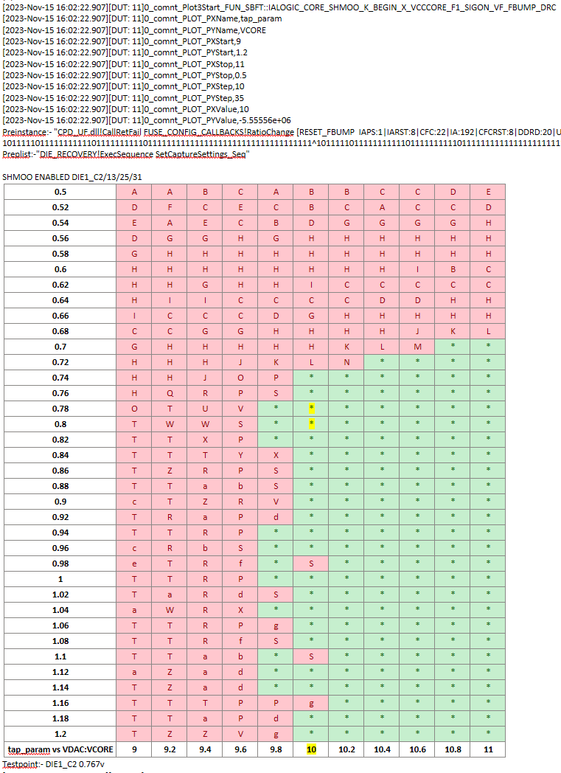
5.0 Conclusion
To conclude this industry project proposal is the SBFT flow configuration overview had been developed and designed and the simulation work need to be further executed and bring into the tools to test to achieve the objectives. The evaluation of the results implementation needs to be further analysis and the Yield percentage graph will need to be sketching out in the graphical plot to show the acceptable percentage which fulfill the passing range. Hence, the extension more journal review needs to continue in order to have more methodology to be carried out in simulation experiment.

6.0 References
[1] H. Konuk and L. Mao, "DFFT design for functional testability," International Test Conference, 2003. Proceedings. ITC 2003., Charlotte, NC, USA, 2003, pp. 1105-1114, doi: 10.1109/TEST.2003.1271099.
[2] M. Mayberry, J. Johnson, N. Shahriari and M. Tripp, "Realizing the benefits of structural test for Intel microprocessors," Proceedings. International Test Conference, Baltimore, MD, USA, 2002, pp. 456-463, doi: 10.1109/TEST.2002.1041795.
[3] W. Wang, "Automated Shmoo data analysis: A machine learning approach," Fifteenth International Symposium on Quality Electronic Design, Santa Clara, CA, USA, 2014, pp. 212-218, doi: 10.1109/ISQED.2014.6783327.
[4] K. Jayaraman, V. M. Vedula and J. A. Abraham, "Native mode functional self-test generation for Systems-on-Chip," Proceedings International Symposium on Quality Electronic Design, San Jose, CA, USA, 2002, pp. 280-285, doi: 10.1109/ISQED.2002.996752.
[5] J. Yin et al., "Yield Improvement Methodology with addressing Design Systematics during Production Ramp-up," 2022 33rd Annual SEMI Advanced Semiconductor Manufacturing Conference (ASMC), Saratoga Springs, NY, USA, 2022, pp. 1-4, doi: 10.1109/ASMC54647.2022.9792517.
[6] V. Raghavan, "Application of decision trees for integrated circuit yield improvement," 13th Annual IEEE/SEMI Advanced Semiconductor Manufacturing Conference. Advancing the Science and Technology of Semiconductor Manufacturing. ASMC 2002 (Cat. No.02CH37259), Boston, MA, USA, 2002, pp. 262-265, doi: 10.1109/ASMC.2002.1001615.
[7] J. Zeng, M. Abadir, G. Vandling, L. Wang, A. Kolhatkar and J. Abraham, "On correlating structural tests with functional tests for speed binning of high performance design," 2004 International Conferce on Test, Charlotte, NC, USA, 2004, pp. 31-37, doi: 10.1109/TEST.2004.1386934.
[8] J. Zeng, M. Abadir, G. Vandling, L. Wang, A. Kolhatkar and J. Abraham, "On correlating structural tests with functional tests for speed binning of high performance design," 2004 International Conferce on Test, Charlotte, NC, USA, 2004, pp. 31-37, doi: 10.1109/TEST.2004.1386934.
[9] P. Maxwell, I. Hartanto and L. Bentz, "Comparing functional and structural tests," Proceedings International Test Conference 2000 (IEEE Cat. No.00CH37159), Atlantic City, NJ, USA, 2000, pp. 400-407, doi: 10.1109/TEST.2000.894231.
[10] P. Nigh, "Scan-based testing: the only practical solution for testing ASIC/consumer products," Proceedings. International Test Conference, Baltimore, MD, USA, 2002, pp. 1198-, doi: 10.1109/TEST.2002.1041905.
End of Project Proposal

