**<AIE425 Intelligent Recommender System, Fall Semester 24/25>**

**<Assignment #2: Significance Weighting-based Neighborhood CF Filters>**

**<B20000017, Seif Eldin Adel Mohamed>**

**Outcomes of Section 3.1:**

1- Count the total number of users and items in dataset and save it as tnu and tni.



2- Count the number of ratings for every product.

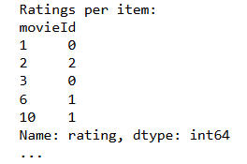

3- Pick three users and two items. First user has two missing ratings, second one has 3 missing ratings and the last user has 5 missing ratings. While the first item has 4% missing rating and the other has 10% missing ratings.





4- Count No_common_users and No_coRated_items.

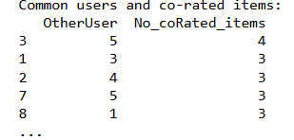

5- Plot the curve of ratings per item.

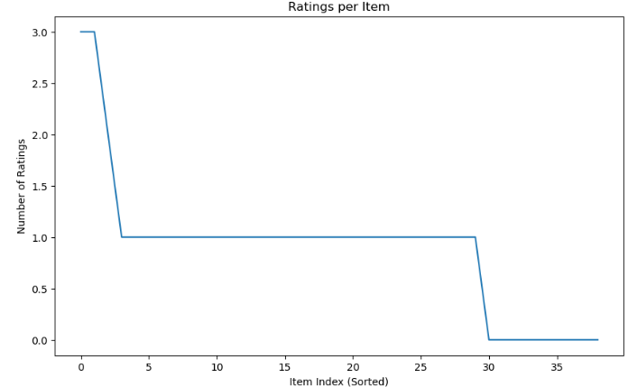

**Summary of the Comparison of part 1 and 2:**

**Compare the results of case study 1.1.7**

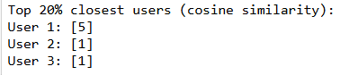

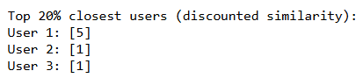

**Compare the results of case study 1.1.8**

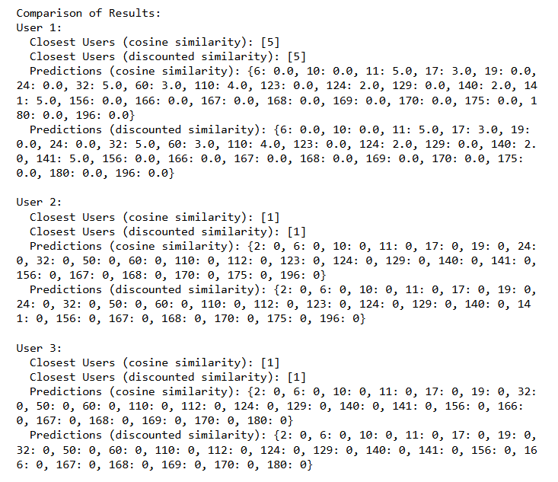

**Compare the results of case study 1.2.8**

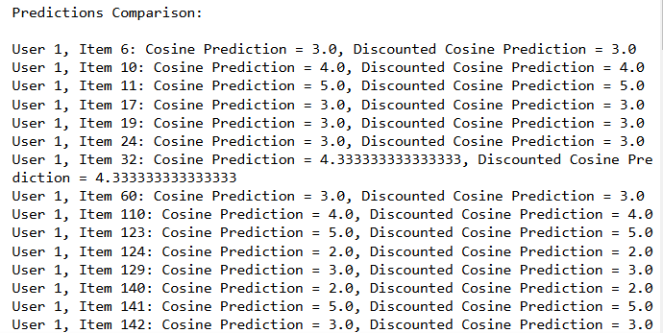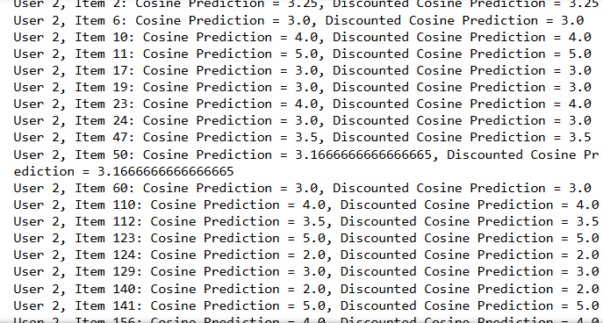

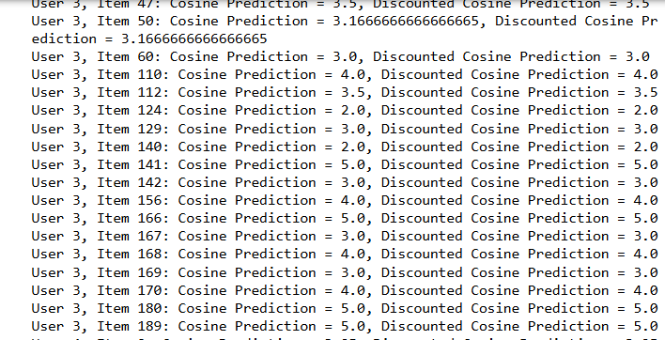 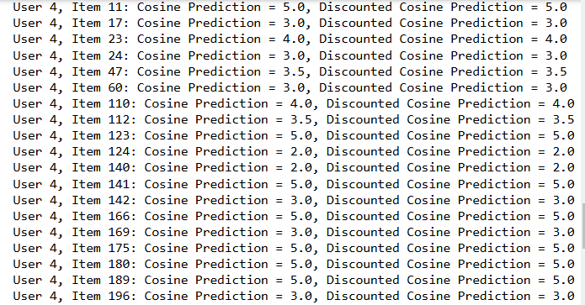

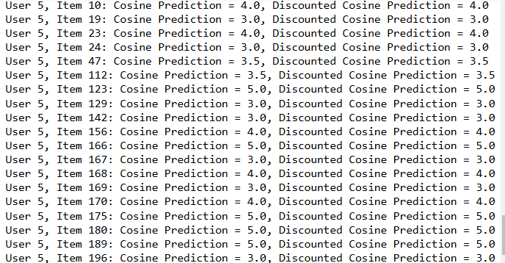

**Compare the results of case study 1.3.7**

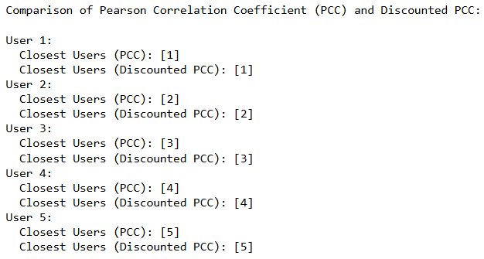

**Compare the results of case study 1.3.8**

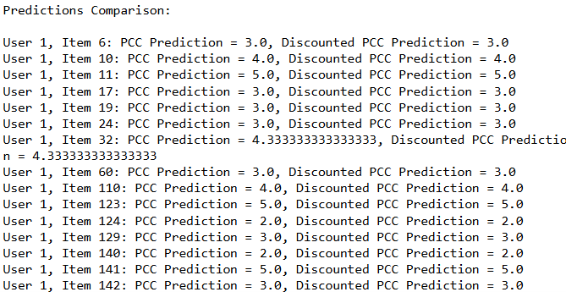 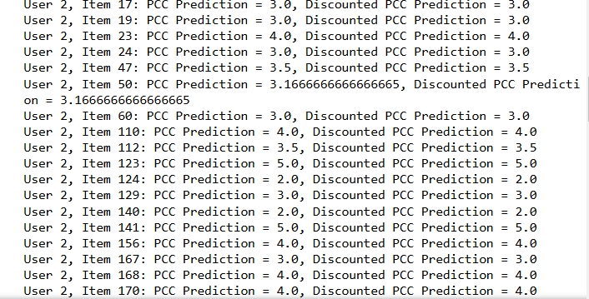

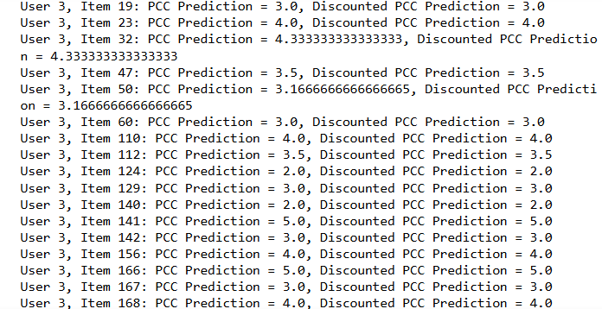 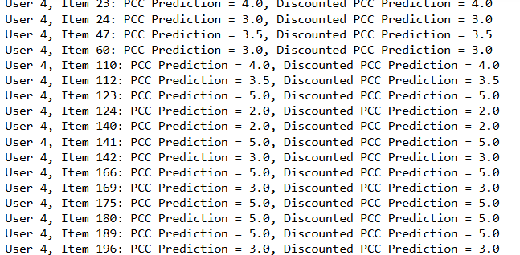

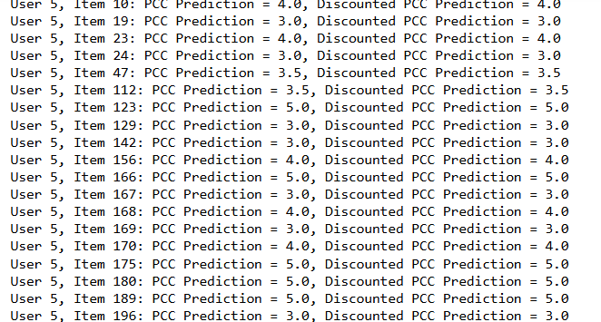

**Compare the results of case study 2.1.7**





**Compare the results of case study 2.1.8**

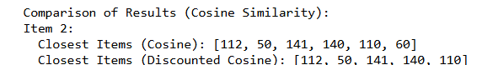

**Compare the results of case study 2.2.7**





**Compare the results of case study 2.2.8**

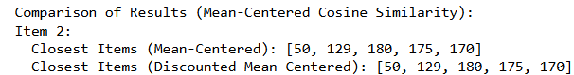

**Compare the results of case study 2.3.7**

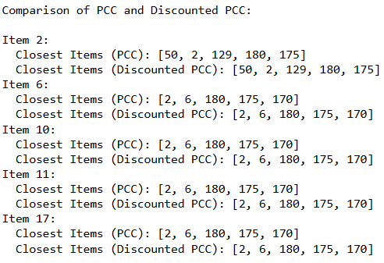

**Compare the results of case study 2.3.8**

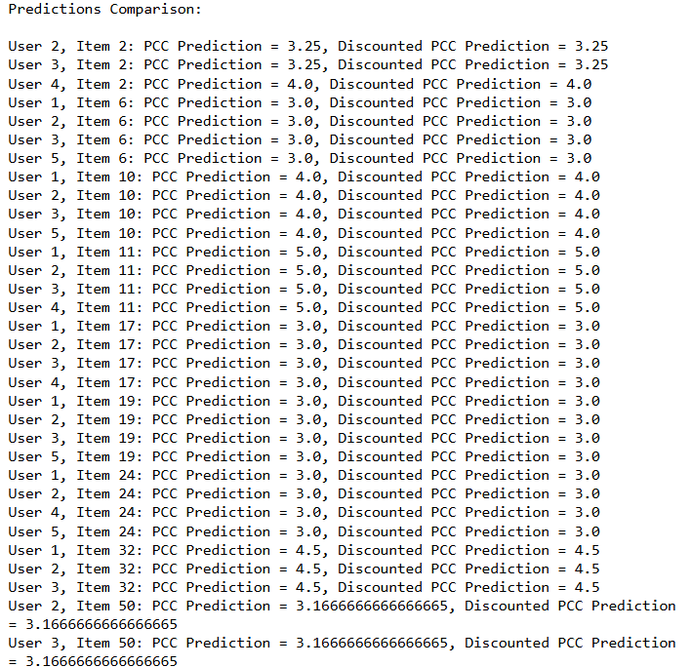

**Conclusion:**

**Conclusion the results of case study 1.1.7**

The comparison has shown that the application of significance weighting to user ratings has very little effect on the composition of the top-N list of close users. In this case, both sets of lists generated using cosine similarity and discounted similarity are almost identical.

**Conclusion the results of case study 1.1.8**

These results demonstrate for the first time that significance weighting in user ratings can help make the recommendations more conservative. By that it means the system will be resistant to making extreme predictions; that is, very high or very low ratings for an item with few or older ratings.

**Conclusion the results of case study 1.2.8**

In this specific case, applying significance weighting to user ratings has made a very little difference to the predicted results. The predicted ratings using cosine similarity and discounted similarity are practically the same for all user-item pairs.

**Conclusion the results of case study 1.3.8**

The comparison indicates that adding significance weighting (Discounted PCC) did not affect the predictions or the Top-N recommendations, so predictions were the same as those generated by standard PCC.

**Conclusion the results of case study 2.1.7**

A comparison suggests that computed from Discounted Cosine Similarity a Top-N list will be more selective, thus leaving out item 60, which is present in the list of standard Cosine Similarity. This implies that different significance weighting favors stronger, more reliable similarities, which may improve the precision of recommendations by filtering out less significant links.

**Conclusion the results of case study 2.1.8**

The product 60 did not appear in the list of closest items because of significance weighting (Discounted Cosine Similarity), thus narrowing down the selection of Top-N results. This means, as with the model, significance weighting reduces the effect of other weaker similarities, which could enhance the reliability of recommendations.

**Conclusion the results of case study 2.2.7**

The use of significance weighting (Discounted Mean-Centered Cosine Similarity) caused no changes to the Top-N list, as compared to Mean-Centered Cosine Similarity. Thus, it appears that significance weighting did not play a major role in this case, showing that the selected items had a high affinity, such that predictions were probably stable.

**Conclusion the results of case study 2.2.8**

However, the Top-N list remains unchanged because there is no major effect when the application of weighting significance in terms of Discounted Mean-Centered Cosine Similarity is compared with Mean-Centered Cosine Similarity. This means that there is no change in the closest items, which indicates the significance weighting does not influence the rating predictions in the present case.

**Conclusion the results of case study 2.3.7**

The output of Top-N lists using the significance weighting (Discounted PCC) is not appreciably different from standard PCC. In fact, the closest items remain completely unchanged in all test cases; significance weighting is thus seen to have no influence on the similarity rankings or in rating predictions in this case.

**Conclusion the results of case study 2.3.8**

The results for both Top-N lists and rating predictions remained unchanged when applying the significance weighting (Discounted PCC). Predictions and nearest items were still the same as those obtained with standard PCC across all items and users, which indicates that the significance weighting did not impact similarity rankings or rating outcomes in this comparison.