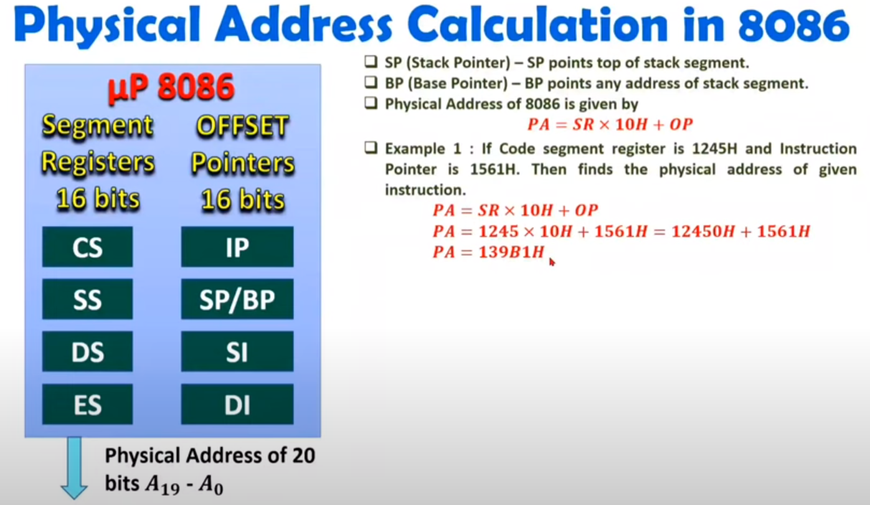

Why do the CS,DS,SS,ES segments have 0100 as a default value?

[The 8086 processor has 4 memory segments: Stack Segment, Code Segment, Data Segment, and Extra Segment, with the corresponding segment registers (SS, CS, DS, ES)](https://stackoverflow.com/questions/37954812/intel-8086-why-4-memory-segments) . [The reason for having 4 segments is to allow for more than 64KB of code and data, which would not be possible with only one segment register](https://stackoverflow.com/questions/37954812/intel-8086-why-4-memory-segments) .

[The default value of 0100 in the segment registers is equivalent to 0001 0000 0000 0000 in binary, which means that the segment starts at address 10000h 1](https://stackoverflow.com/questions/37954812/intel-8086-why-4-memory-segments). [This value was chosen because it is the first address after the interrupt vector table](https://stackoverflow.com/questions/37954812/intel-8086-why-4-memory-segments) .

[The Extra Segment (ES) temporarily access a segment outside of DS, for instance, video memory](https://stackoverflow.com/questions/37954812/intel-8086-why-4-memory-segments) . [By splitting up CS and DS, you can easily create a program where CS is in one 64KB segment and DS is in another](https://stackoverflow.com/questions/37954812/intel-8086-why-4-memory-segments) .

Part -1

This is just brain storming

We need

1. 8088
2. 8255 try to set it up , and have the 8088 send signals to it

8088:

How do we enable minimum MODE?

By connecting the MN/MX pin with VCC, note: the MX is MX BAR so it gets a 0 signal but if the MN/MX pin is connected to ground , it is in MAXIMUM mode.

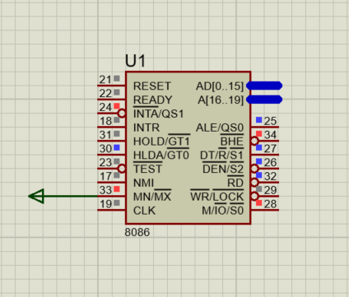

Notice the running pins.

Generating the control signals in MINIMUM MODE

Using the 74ALS138 Decoder

